**Q1.**          A gene was broken into fragments using enzyme **Z**. The mixture of fragments produced was then separated by electrophoresis.

(a)     What type of enzyme is enzyme **Z**?

......................................................................................................................

**(1)**

The table shows the number of base pairs present in the fragments.

|  |  |
| --- | --- |
| **Fragment** | **Number of base pairs (× 103)** |
| 1 | 4.65 |
| 2 | 5.72 |
| 3 | 10.71 |
| 4 | 2.39 |
| 5 | 5.35 |
| 6 | 7.53 |

The diagram shows the electrophoresis gel used. The mixture of fragments was placed at the start point marked **S** and the process started. The boxes indicate the positions reached by the different fragments.

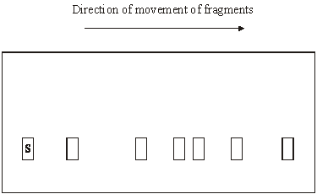

(b)     Explain why base pairs are a suitable way of measuring the length of a piece of DNA.

......................................................................................................................

......................................................................................................................

......................................................................................................................

......................................................................................................................

**(2)**

(c)     (i)      Write **6** above the appropriate box on the diagram to show the position you would expect fragment **6** to have reached.

**(1)**

(ii)     Explain how you arrived at your answer.

.............................................................................................................

.............................................................................................................

**(1)**

(d)     Enzyme **Z** recognises a particular sequence of bases in the gene. How many times does this sequence appear in the DNA of this gene?

......................................................................................................................

**(1)**

**(Total 6 marks)**

**Q2.**          Some strains of the bacterium that causes gonorrhoea are resistant to antibiotics. This makes the disease difficult to treat. One way of testing the effectiveness of antibiotics is to use discs of paper soaked in antibiotic. These are placed in the centre of an agar plate covered by bacteria. A clear zone forms around the disc if the antibiotic is effective.

The table shows some results of an investigation into the effect of four different antibiotics on gonorrhoea bacteria.

|  |  |  |
| --- | --- | --- |
| **Antibiotic** | **Diameter of clear zone / mm** | **Minimum diameter of clear zone if antibiotic is effective / mm** |
| **A** | 47 | 52 |
| **B** | 30 | 28 |
| **C** | 22 | 40 |
| **D** | 33 | 34 |

(a)     Give **two** reasons why it would be important to use sterile techniques during this investigation.

1 ...................................................................................................................

......................................................................................................................

2 ...................................................................................................................

......................................................................................................................

**(2)**

(b)     (i)      The antibiotic reached the bacteria by diffusion. Suggest why an effective antibiotic may produce only a small clear zone.

.............................................................................................................

.............................................................................................................

**(1)**

(ii)     Which antibiotic used in the investigation would be most useful for treating gonorrhoea? Explain your answer.

Antibiotic ...............................................................

Explanation .........................................................................................

.............................................................................................................

**(2)**

**(Total 5 marks)**

**Q3.**          (a)     In an investigation, two sterile agar plates were inoculated with bacteria from the same culture. Then, using a syringe, 2 cm3 of an antibiotic solution were added to plate **1** and 2 cm3 of sterile water were added to plate **2**. The diagram shows the plates after 24 hours.

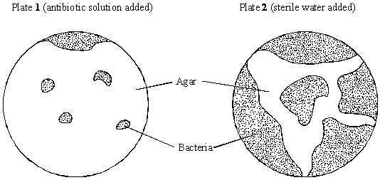

(i)      At the start of the investigation, the agar was sterilised. Explain why.

.............................................................................................................

.............................................................................................................

**(1)**

(ii)     The water was added to plate **2** as a control. Explain why this control was necessary.

.............................................................................................................

.............................................................................................................

**(1)**

(b)     Explain why some bacteria were able to grow on plate **1**.

......................................................................................................................

......................................................................................................................

**(1)**

**(Total 3 marks)**

**Q4.S**       Urease is an enzyme which hydrolyses urea to ammonia and carbon dioxide. The ammonia produces an alkaline solution.

In an experiment, a solution of urease was placed in tubing made from a partially permeable membrane. This tubing was put into a large test tube containing urea solution, as shown in the diagram. A control was set up with urease solution in the tubing and water outside.

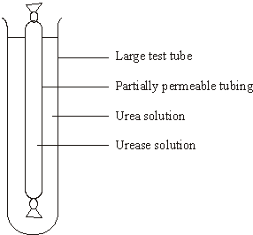

After 5 minutes, samples were taken from inside and outside the tubing in each of the test tubes. The samples were tested with an indicator that is yellow below pH 8.0 and blue above pH 8.0. The results are shown in the table.

|  |  |  |  |  |
| --- | --- | --- | --- | --- |
| **Tube** | **Contents** | | **Colour with indicator after 5 minutes** | |
|  | **Inside tubing** | **Outside tubing** | **Inside tubing** | **Outside tubing** |
| **A**  **B** | Urease solution  Urease solution | Urea solution  Water | Blue  Yellow | Yellow  Yellow |

(a)     Explain the result for tube **A**.

......................................................................................................................

......................................................................................................................

......................................................................................................................

......................................................................................................................

......................................................................................................................

......................................................................................................................

**(3)**

(b)     The solutions inside and outside the tubing in tube **B** were tested after 30 minutes for the presence of protein.

(i)      Describe how the presence of protein in a sample of a solution could be detected.

.............................................................................................................

.............................................................................................................

.............................................................................................................

.............................................................................................................

**(2)**

(ii)     What results of the tests for protein would you expect for tube **B**? In each case explain your answer.

Inside the tubing

.............................................................................................................

.............................................................................................................

.............................................................................................................

Outside the tubing

.............................................................................................................

.............................................................................................................

.............................................................................................................

**(2)**

(c)     Describe how you would carry out an investigation to find the optimum temperature for the activity of urease.

......................................................................................................................

......................................................................................................................

......................................................................................................................

......................................................................................................................

......................................................................................................................

......................................................................................................................

**(3)**

**(Total 10 marks)**

**Q5.**          Climatic factors, such as temperature and rainfall, vary greatly over short distances across mountain ranges. In an investigation, populations of the plant, *Achillea lanulosa*, were sampled from several sites on a transect across a mountain range. At each sampling site, seeds were collected at random. Each batch of seeds was germinated and grown to maturity under the same experimental conditions.

The diagram shows

•        a profile indicating the position and altitude of the sampling sites

•        the mean height of mature plants grown from each sample of seeds

•        the standard deviation of heights of the mature plants grown from each sample of seeds.

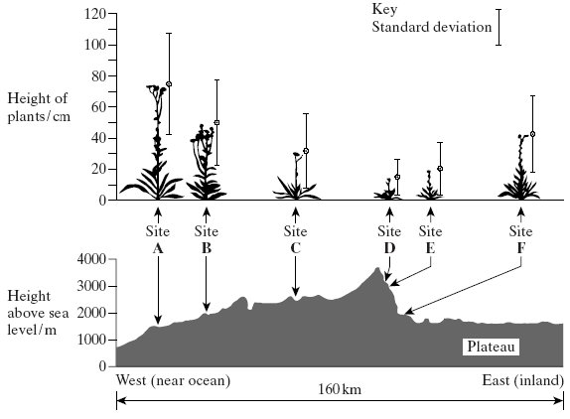

(a)     (i)      Give **one** limitation of using a line transect to collect these data.

.............................................................................................................

.............................................................................................................

**(1)**

(ii)     Suggest how plants should be chosen at each sampling site to avoid bias and to be representative.

.............................................................................................................

.............................................................................................................

.............................................................................................................

.............................................................................................................

**(2)**

(b)     (i)      What information does the bar representing standard deviation give about the plants in a sample?

.............................................................................................................

.............................................................................................................

**(1)**

(ii)     Describe what the results show about the variation of the height of the plants in relation to altitude.

.............................................................................................................

.............................................................................................................

.............................................................................................................

.............................................................................................................

**(2)**

    (iii)     There was a significant difference between the mean heights of the plants grown from seeds taken from sites **A** and **D**. Describe the evidence from the information given which shows that this is likely to be due to genetic differences between the two populations.

.............................................................................................................

.............................................................................................................

**(1)**

**(Total 7 marks)**

**Q6.**          (a)     In an investigation, carrot seeds were planted at different densities. After 120 days, the dry mass of the carrot plants was measured. The results are shown in the graph. 4

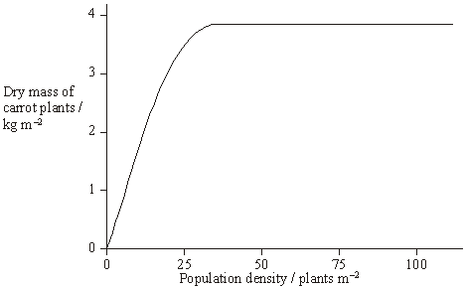

(i)      What is the advantage of measuring the dry mass rather than the total mass of the carrot plants?

.............................................................................................................

**(1)**

(ii)     What type of competition is shown in this investigation?

.............................................................................................................

**(1)**

(iii)Explain the shape of the curve.

.............................................................................................................

.............................................................................................................

.............................................................................................................

.............................................................................................................

**(2)**

**S**       (b)     Commercial growers want all the carrots to be the same size when harvested. Suggest **two** ways in which they can try to ensure this.

1 ...................................................................................................................

......................................................................................................................

2 ...................................................................................................................

......................................................................................................................

**(2)**

**(Total 6 marks)**

**Q7.**          In an investigation into carbohydrase activity, the contents from part of the gut of a small animal were collected. The contents were added to starch solution at pH 7 and kept in a water bath at 25°C. At one-minute intervals, samples were removed and added to different test tubes containing dilute iodine solution. The colour intensity of each sample was determined. The graph shows the results.

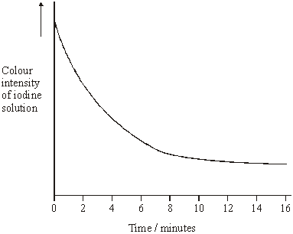

(a)     Explain the change in colour intensity.

......................................................................................................................

......................................................................................................................

......................................................................................................................

......................................................................................................................

**(2)**

(b)     Draw clearly labelled curves on the graph to show the expected result if the experiment was repeated

(i)      at 35 °C;

(ii)     at pH 2.

**(2)**

(c)     Explain how

(i)      raising the temperature to 35 °C affects carbohydrase activity;

.............................................................................................................

.............................................................................................................

.............................................................................................................

.............................................................................................................

.............................................................................................................

.............................................................................................................

.............................................................................................................

.............................................................................................................

(ii)     decreasing the pH affects carbohydrase activity.

.............................................................................................................

.............................................................................................................

.............................................................................................................

.............................................................................................................

.............................................................................................................

.............................................................................................................

.............................................................................................................

.............................................................................................................

.............................................................................................................

.............................................................................................................

**(7)**

**(Total 11 marks)**

**Q8.**          Mitochondria were isolated from the liver tissue using differential centrifugation. The tissue was chopped in cold, isotonic buffer solution. A buffer solution maintains a constant pH. The first stages in the procedure are shown in the diagram.

Tissue chopped               Homogenised                                      Centrifuged

 in cold isotonic                                                                          at low speed

  buffer solution                                                                        for 10 minutes

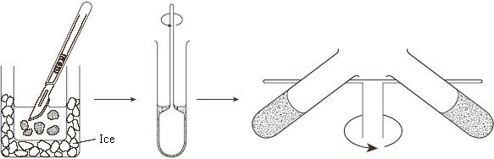

**Stage 1                          Stage 2                                              Stage 3**

(i)      The tissue was chopped in cold, isotonic buffer solution. Explain the reason for using

a *cold* solution;

......................................................................................................................

......................................................................................................................

an *isotonic* solution;

......................................................................................................................

......................................................................................................................

a *buffer* solution.

......................................................................................................................

......................................................................................................................

**(3)**

(ii)      Why is the liver tissue homogenised?

......................................................................................................................

......................................................................................................................

**(1)**

(iii)     Describe what should be done after **Stage 3** to obtain a sample containing only mitochondria.

......................................................................................................................

......................................................................................................................

......................................................................................................................

......................................................................................................................

**(2)**

**(Total 6 marks)**

**Q9.**          **S**       A large number of roots from many genetically identical bean plants were cut into short pieces. The pieces were sorted into groups, depending upon their distance from the root tip. Some pieces from each group were used to find the mean dry mass of their cells. Thin sections cut from other pieces were examined with a light microscope to find the proportion of dividing cells and the mean volume of the cells.

The graph shows the results. The diagrams below the graph show the appearance of cells in light microscope sections at different distances from the root tip.

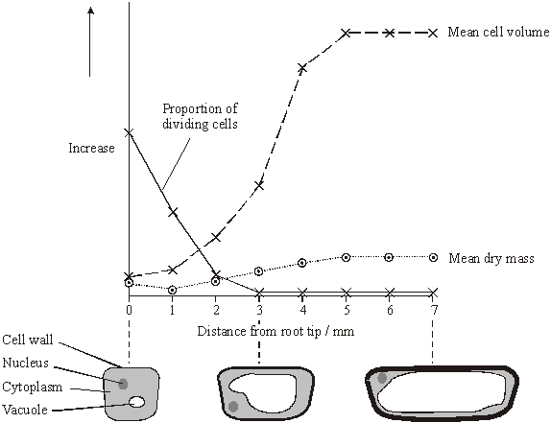

(a)     Suggest **two** variables, other than genotype, which need to be controlled to ensure similar root growth in different plants. In each case give the reason for your answer.

1 ...................................................................................................................

......................................................................................................................

......................................................................................................................

2 ...................................................................................................................

......................................................................................................................

......................................................................................................................

**(2)**

(b)     Suggest how the proportion of dividing cells in a thin section could be determined.

......................................................................................................................

......................................................................................................................

......................................................................................................................

......................................................................................................................

**(2)**

(c)     Explain the change in the proportion of dividing cells with increasing distance from the root tip.

......................................................................................................................

......................................................................................................................

......................................................................................................................

......................................................................................................................

**(2)**

(d)     Using the graph and diagrams, suggest how a root tip gets longer.

......................................................................................................................

......................................................................................................................

......................................................................................................................

......................................................................................................................

......................................................................................................................

......................................................................................................................

......................................................................................................................

......................................................................................................................

**(3)**

**(Total 9 marks)**

**Q10.** A flatworm is a simple soft-bodied animal. The diagram shows the movements of an aquatic flatworm in light and in shade. The path followed by the flatworm over a period of three minutes was traced on the side of a tank.

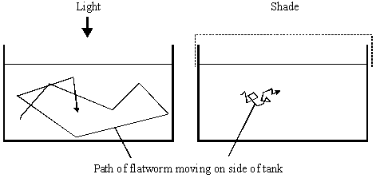

(i)      Name the type of behaviour shown. Give a reason for your answer.

Type of behaviour .........................................................................................

Reason .........................................................................................................

......................................................................................................................

**(2)**

(ii)      Suggest **one** advantage of the behaviour shown in the diagram.

......................................................................................................................

......................................................................................................................

**(1)**

**(Total 3 marks)**

**Q11.**          Mayflies are insects which lay their eggs in streams and rivers. The nymphs which hatch from the eggs live in the water for several years.

Mayfly nymphs were collected by disturbing the gravel of a stream bed. A net placed immediately downstream caught any animals which were washed out of the gravel. Eight samples were collected from shallow, fast-flowing parts of the stream and eight from deeper, slow-flowing parts. Nymphs from two different families of mayfly were found. The results are given in the table.

|  |  |  |  |  |  |
| --- | --- | --- | --- | --- | --- |
|  |  | **Family Caenidae** | | **Family Baetidae** | |
|  |  | **Shallow water** | **Deep water** | **Shallow water** | **Deep water** |
|  | **Mean number of nymphs** | 2.38 | 12.88 | 24.50 | 6.00 |
|  | **Standard deviation** | 1.51 | 7.92 | 6.72 | 1.51 |

(a)     Describe how you would have collected the samples in order to ensure they were representative of the habitats being investigated and could be compared with each other.

......................................................................................................................

......................................................................................................................

......................................................................................................................

......................................................................................................................

......................................................................................................................

......................................................................................................................

**(3)**

(b)     Which **one** of the four samples showed the greatest variation within the sample? Give evidence from the table for your answer.

......................................................................................................................

......................................................................................................................

**(1)**

(c)     The two families of mayfly nymph occupy different ecological niches.

(i)      What is meant by the term *ecological niche*?

.............................................................................................................

.............................................................................................................

**(1)**

(ii)     Describe the evidence in the table which suggests that the two families of mayflies occupy different ecological niches.

.............................................................................................................

.............................................................................................................

**(1)**

(iii)     Explain the advantage to these two families of mayflies of occupying different ecological niches.

.............................................................................................................

.............................................................................................................

.............................................................................................................

.............................................................................................................

**(2)**

**(Total 8 marks)**

**Q12.**          (a)     Amylase is an enzyme which hydrolyses starch to maltose. Some amylase and starch were mixed and the mixture incubated at 37 °C until the reaction was complete.

(i)      Sketch a curve on the axes below to show the progress of this reaction.

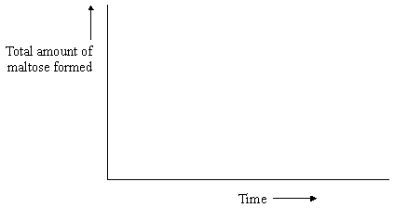

**(1)**

(ii)     Explain why the rate of the reaction decreases as the reaction progresses.

.............................................................................................................

.............................................................................................................

.............................................................................................................

**(2)**

The effect of temperature on the rate of reaction of an enzyme was investigated. A test tube containing the enzyme and a test tube containing the substrate were incubated separately at each of the temperatures being investigated. After 5 minutes, they were mixed and the rate of reaction was determined. The experiment was repeated but, this time, the enzyme and the substrate were left for 60 minutes before they were mixed. The results of the investigation are shown in the graph.

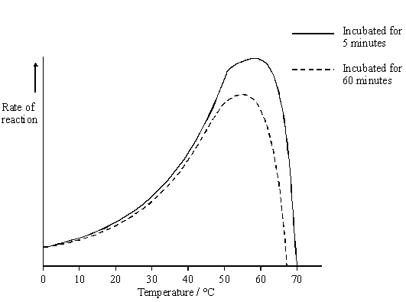

(b)     The enzyme solution used in this investigation was made by dissolving a known mass of enzyme in a buffer solution. Explain why a buffer solution was used.

......................................................................................................................

......................................................................................................................

**(1)**

(c)     (i)      Use the graph to describe how incubation time affects the rate of the reaction.

.............................................................................................................

.............................................................................................................

.............................................................................................................

.............................................................................................................

**(2)**

(ii)     The maximum rate of reaction with an incubation time of 60 minutes is less than the maximum rate of reaction with an incubation time of 5 minutes. Explain why.

.............................................................................................................

.............................................................................................................

.............................................................................................................

.............................................................................................................

.............................................................................................................

.............................................................................................................

**(3)**

(d)     Explain how inhibitors affect the rate of enzyme-controlled reactions.

......................................................................................................................

......................................................................................................................

......................................................................................................................

......................................................................................................................

......................................................................................................................

......................................................................................................................

......................................................................................................................

......................................................................................................................

......................................................................................................................

......................................................................................................................

......................................................................................................................

**(6)**

**(Total 15 marks)**

**Q13.** The drawing shows an electron micrograph of a section through part of an alveolus from a lung.

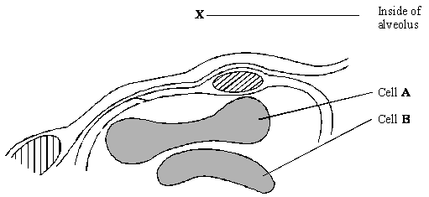

(a)     Describe the path of a molecule of oxygen from the air in the alveolus at **X** to the plasma membrane of cell **A**.

......................................................................................................................

......................................................................................................................

**(1)**

(b)     Cell **A** is a eukaryotic cell. Give **two** features that may be found in a prokaryotic cell which are not found in cell **A**.

1 ...................................................................................................................

......................................................................................................................

2 ...................................................................................................................

......................................................................................................................

**(2)**

(c)     Cells **A** and **B** are biconcave discs. Explain **one** advantage of a biconcave disc over a spherical cell of the same volume in transporting oxygen.

......................................................................................................................

......................................................................................................................

......................................................................................................................

......................................................................................................................

**(2)**

(d)     The diameter of a human red blood cell is 7 µm.

(i)      Calculate the magnification of the drawing. Show your working.

Magnification = ...............................

**(2)**

(ii)     In calculating the magnification, what assumption did you have to make about how the section was cut?

.............................................................................................................

.............................................................................................................

**(1)**

**(Total 8 marks)**

**Q14.**          (a)     Explain the meaning of these ecological terms.

Population ....................................................................................................

......................................................................................................................

Community ...................................................................................................

......................................................................................................................

**(2)**

(b)     Some students used the mark-release-recapture technique to estimate the size of a population of woodlice. They collected 77 woodlice and marked them before releasing them back into the same area. Later they collected 96 woodlice, 11 of which were marked.

(i)      Give **two** conditions necessary for results from mark-release-recapture investigations to be valid.

1 ……...................................................................................................

.............................................................................................................

2 ……...................................................................................................

.............................................................................................................

**(2)**

(ii)     Calculate the number of woodlice in the area under investigation. Show your working.

Answer ......................................................

**(2)**

(c)     Explain how you would use a quadrat to estimate the number of dandelion plants in a field measuring 100 m by 150 m.

......................................................................................................................

......................................................................................................................

......................................................................................................................

......................................................................................................................

......................................................................................................................

......................................................................................................................

**(3)**

(d)     Two similar species of birds (species **A** and species **B**) feed on slightly different sized insects and have slightly different temperature preferences. The diagram represents the response of each species to these factors.

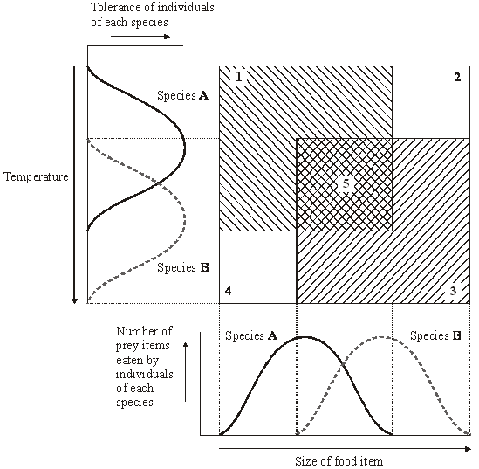

(i)      Which of the numbered boxes describes conditions which represent

the niche of species **A**;                                                                              .............

the niche of species **B**;                                                                              .............

insects too small for species **B** and temperature too warm for species **A**; .............

insects too large for species **A** and temperature too cool for species **B**?  .............

**(2)**

(ii)     These two species are thought to have evolved as a result of sympatric speciation. Suggest how this might have occurred.

.............................................................................................................

.............................................................................................................

.............................................................................................................

.............................................................................................................

.............................................................................................................

.............................................................................................................

.............................................................................................................

**(4)**

**(Total 15 marks)**

**Q15.**          Termites are insects. Some species live in colonies in the soil. Although most termites are wingless, winged termites are sometimes produced. The winged termites fly from the soil, mate and start new colonies.

A scientist studied the behaviour of winged termites. He divided these termites into three groups.

•        Group **A** had their eyes covered.

•        Group **B** had their antennae removed.

•        Group **C** was the control group.

He put individual winged termites on a sloping board that was illuminated from one side. The diagram shows the direction of movement of a typical termite from each of the three groups.

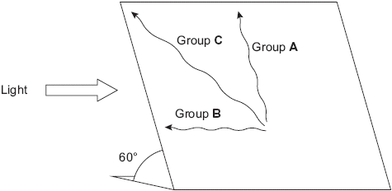

(a)     (i)      What type of behaviour was shown by the termite from group **B**?

.............................................................................................................

**(1)**

(ii)     Give the evidence for your answer.

.............................................................................................................

.............................................................................................................

**(1)**

(b)     Explain what the results from group **A** suggest about the factors controlling the behaviour of winged termites.

......................................................................................................................

......................................................................................................................

......................................................................................................................

......................................................................................................................

......................................................................................................................

......................................................................................................................

**(3)**

(c)     Suggest **one** advantage to the termites from group **C** of the behaviour shown in the investigation.

......................................................................................................................

......................................................................................................................

......................................................................................................................

......................................................................................................................

**(2)**

**(Total 7 marks)**

**Q16.**Lettuce is classified in the same family as dandelions. Dandelions commonly grow on roadside verges and may accidentally be sprayed with salt when salt is added to the road in winter.

Describe how you could use a transect to investigate whether the distribution of dandelions changed with increased distance from the road.

..................................................................................................................................

..................................................................................................................................

..................................................................................................................................

..................................................................................................................................

..................................................................................................................................

..................................................................................................................................

..................................................................................................................................

..................................................................................................................................

*(Extra space)* ...........................................................................................................

..................................................................................................................................

..................................................................................................................................

..................................................................................................................................

**(Total 4 marks)**

**Q17.**          (a)     Starch and protein are biologically important polymers.

(i)      Explain what is meant by a polymer.

.............................................................................................................

.............................................................................................................

**(1)**

(ii)     Give **one** example of a biologically important polymer other than starch or protein.

.............................................................................................................

**(1)**

(b)     In an investigation, the enzyme amylase was mixed in a test tube with a buffer solution and a suspension of starch. The amylase broke down the starch to maltose. When all the starch had been broken down, a sample was removed from the test tube and tested with biuret reagent.

(i)      Explain why a buffer solution was added to the amylase-starch mixture.

.............................................................................................................

.............................................................................................................

.............................................................................................................

**(2)**

(ii)     What colour would you expect the sample to go when tested with biuret reagent?

.............................................................................................................

**(1)**

(iii)     Give an explanation for your answer to part (ii)

.............................................................................................................

.............................................................................................................

.............................................................................................................

**(2)**

**(Total 7 marks)**

**Q18.**          Catalase is an enzyme. It catalyses the breakdown of hydrogen peroxide in the reaction:

2H2O2    →    2H2O    +    O2

hydrogen         water      oxygen

peroxide

In an investigation, samples of different substances were added to hydrogen peroxide in a series of test tubes. The rate of reaction was measured by recording the rate at which bubbles of oxygen were produced. A scale going from 0 for no bubbles to 5 for the maximum rate of bubbling was used to measure this. The results are shown in the table.

|  |  |  |
| --- | --- | --- |
| **Tube** | **Substance added** | **Rate at which bubbles of oxygen were produced** |
| **A** | Piece of liver | 4 |
| **B** | Ground liver and sand | 5 |
| **C** | Sand | 0 |
| **D** | Piece of cooled, boiled liver | 0 |

(a)     Explain the difference between the rate at which bubbles were produced in.

(i)      tubes **A** and **B**;

..............................................................................................................

.............................................................................................................

.............................................................................................................

.............................................................................................................

**(2)**

(ii)     tubes **A** and **D**.

.............................................................................................................

.............................................................................................................

.............................................................................................................

.............................................................................................................

.............................................................................................................

.............................................................................................................

**(3)**

(b)     Explain the purpose of tube **C**.

......................................................................................................................

......................................................................................................................

**(1)**

(c)     The graph shows the energy changes which take place during the reaction in which hydrogen peroxide is converted to water and oxygen.

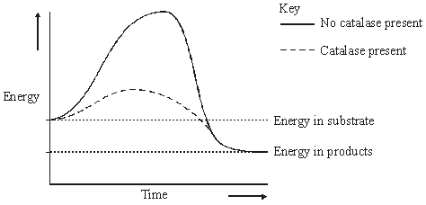

Use the graph to explain why

(i)      hydrogen peroxide breaks down at a lower temperature when catalase is present than when it is not present;

.............................................................................................................

.............................................................................................................

**(1)**

(ii)     test tubes **A** and **B** became warmer when the reaction was taking place.

.............................................................................................................

.............................................................................................................

.............................................................................................................

.............................................................................................................

**(2)**

**(Total 9 marks)**

**Q19.**          Detritivorous insects feed on the dead remains of plants. Some students estimated the numbers of detritivorous insects at two different sites in an ecosystem. They also obtained data about the net primary production of the sites to see if this influenced the numbers of insects present. Net primary production is a measure of plant biomass formed per year. The results are shown in the table.

|  |  |  |  |
| --- | --- | --- | --- |
|  | **Site** | **Number of insects per m2** | **Net primary production / g m–2 y–1** |
|  | **A** | 316 | 1440 |
|  | **B** | 90 | 550 |

(a)     Explain how the students could use the mark-release-recapture technique to estimate the numbers of insects.

......................................................................................................................

......................................................................................................................

......................................................................................................................

......................................................................................................................

......................................................................................................................

......................................................................................................................

......................................................................................................................

......................................................................................................................

**(4)**

(b)     The students used the chi-squared (χ2) test to test the hypothesis that there was no significant difference between the numbers of insects per square metre at sites **A** and **B**. The value they obtained was 125.8. They checked this value in χ2 tables.

(i)      How many degrees of freedom should they check against?

.............................................................................................................

**(1)**

(ii)     What level of probability is normally used to judge whether a difference is statistically significant?

.............................................................................................................

**(1)**

(iii)     The value of χ2 for the 0.001 level of probability for this number of degrees of freedom is 10.8. What does the value obtained by the students suggest about the difference in numbers of the insects per square metre between the two sites?

Explain your answer.

.............................................................................................................

.............................................................................................................

.............................................................................................................

.............................................................................................................

**(2)**

(c)     (i)      Explain why the net primary production of an area does not represent the total amount of plant biomass formed per year by photosynthesis.

.............................................................................................................

.............................................................................................................

.............................................................................................................

.............................................................................................................

**(2)**

(ii)     Suggest how the difference in net primary production of sites **A** and **B** might explain the difference in the number of insects between the sites.

.............................................................................................................

.............................................................................................................

**(1)**

**(Total 11 marks)**

**Q20.**          The human body-louse is an insect which lives and feeds on the surface of the skin. A louse was placed in a chamber, half of which was kept at 35 °C and half at 30 °C. The diagram shows the pattern of movement of the louse.

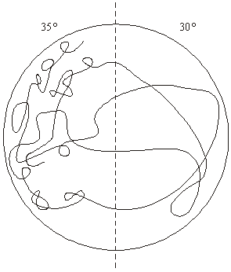

(a)     Name the type of behavioural response shown by the body-louse in this investigation.

Give evidence for your answer.

......................................................................................................................

......................................................................................................................

......................................................................................................................

......................................................................................................................

**(2)**

(b)     Suggest and explain **one** advantage of this behaviour to the human body-louse.

......................................................................................................................

......................................................................................................................

......................................................................................................................

......................................................................................................................

**(2)**

**(Total 4 marks)**

**Q21.**          (a)     The main stages in anaerobic respiration in yeast are shown in the diagram.

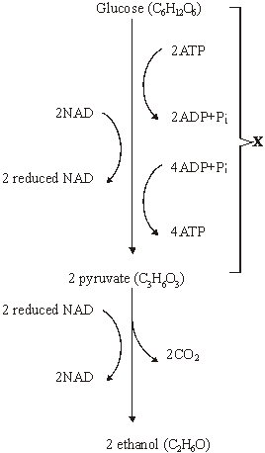

(i)      Name process **X**.

.............................................................................................................

**(1)**

(ii)     Give **one** piece of evidence from the diagram which suggests that the conversion of pyruvate to ethanol involves reduction.

.............................................................................................................

.............................................................................................................

**(1)**

(iii)     Explain why converting pyruvate to ethanol is important in allowing the continued production of ATP in anaerobic respiration.

.............................................................................................................

.............................................................................................................

.............................................................................................................

.............................................................................................................

**(2)**

(b)     Give **two** ways in which anaerobic respiration of glucose in yeast is

(i)      similar to anaerobic respiration of glucose in a muscle cell;

1 ..........................................................................................................

.............................................................................................................

2 ..........................................................................................................

.............................................................................................................

**(2)**

(ii)     different from anaerobic respiration of glucose in a muscle cell.

1 ..........................................................................................................

.............................................................................................................

2 ..........................................................................................................

.............................................................................................................

**(2)**

(c)     Some students investigated the effect of temperature on the rate of anaerobic respiration in yeast. The apparatus they used is shown in the diagram. The yeast suspension was mixed with glucose solution and the volume of gas collected in five minutes was recorded.

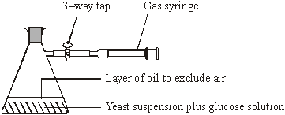

(i)      Each student repeated the experiment and the results were pooled. Explain the advantages of collecting a large number of results.

.............................................................................................................

.............................................................................................................

.............................................................................................................

.............................................................................................................

**(2)**

(ii)     At 30 °C, one student obtained the following results.

|  |  |  |  |  |
| --- | --- | --- | --- | --- |
|  | Volume of gas collected in 5 minutes / cm3 | Result 1 | Result 2 | Result 3 |
|  | 38.3 | 27.6 | 29.4 |

Calculate the mean rate of gas production. Give your answer in cm3 s–1.

Answer ............................... cm3 s–1

**(2)**

(iii)     If aerobic respiration had been investigated rather than anaerobic respiration, how would you expect the volumes of gas collected at 30°C to differ from these results?

Explain your answer.

.............................................................................................................

.............................................................................................................

.............................................................................................................

.............................................................................................................

.............................................................................................................

.............................................................................................................

**(3)**

**(Total 15 marks)**

**Q22.**          A student investigated the stages of mitosis in a garlic root. The root tip was placed on a microscope slide with a stain. A cover slip was placed on top and the root tip was firmly squashed.

(a)     Explain why

(i)      a root tip was used;

.............................................................................................................

.............................................................................................................

**(1)**

(ii)     a stain was used;

.............................................................................................................

.............................................................................................................

**(1)**

(iii)     the root tip was firmly squashed.

.............................................................................................................

.............................................................................................................

**(1)**

(b)     The student examined the cells in the garlic root tip under the microscope, and obtained the following data.

|  |  |  |
| --- | --- | --- |
|  | **Stage** | **Number of cells** |
|  | Interphase | 872 |
|  | Prophase | 74 |
|  | Metaphase | 18 |
|  | Anaphase | 10 |
|  | Telophase | 8 |

(i)      Calculate the percentage of these cells in which the chromosomes are visible and would consist of a pair of chromatids joined together. Show your working.

Answer .........................................

**(2)**

(ii)     A different set of results was obtained when the count was repeated on another occasion with a different garlic root tip. Give **two** reasons for the difference in results.

1 ..........................................................................................................

.............................................................................................................

2 ..........................................................................................................

.............................................................................................................

**(2)**

**(Total 7 marks)**

**Q23.**          An investigation was carried out into the effect of carbon dioxide concentration and light intensity on the rate of photosynthesis in a species of plant.

(a)     The temperature was kept constant during this investigation. Explain why.

......................................................................................................................

......................................................................................................................

**(2)**

(b)     The table shows the effect of increasing carbon dioxide concentration on the rate of photosynthesis in maize.

|  |  |
| --- | --- |
| **Carbon dioxide concentration / arbitrary units** | **Rate of photosynthesis / arbitrary units** |
| 30 | 10 |
| 60 | 20 |
| 100 | 30 |
| 150 | 40 |
| 230 | 50 |
| 300 | 60 |
| 400 | 60 |

Describe and explain the effect of increasing carbon dioxide concentration on the rate of photosynthesis.

......................................................................................................................

......................................................................................................................

......................................................................................................................

......................................................................................................................

......................................................................................................................

......................................................................................................................

**(3)**

**(Total 5 marks)**

**Q24.**          (a)     A plant cell was observed with an optical microscope. Describe how the length of the cell could be estimated.

......................................................................................................................

......................................................................................................................

......................................................................................................................

......................................................................................................................

**(2)**

(b)     The water potential of a plant cell is –400 kPa. The cell is put in a solution with a water potential of –650 kPa. Describe and explain what will happen to the cell.

......................................................................................................................

......................................................................................................................

......................................................................................................................

......................................................................................................................

......................................................................................................................

......................................................................................................................

**(3)**

(c)     A group of students investigated the effect of sucrose concentration on the change in length of cylinders of tissue cut from a young carrot. They measured the initial lengths of the carrot cylinders, then placed one in each of a number of sucrose solutions. After 18 hours, they removed the carrot cylinders and measured their final lengths. Some of the results are shown in the table.

|  |  |  |
| --- | --- | --- |
|  | **Concentration of sucrose / mol dm–3** | **Percentage decrease in length of carrot cylinder** |
|  | 0.4 | 4.2 |
|  | 0.5 | 8.7 |
|  | 0.6 | 13.0 |
|  | 0.7 | 16.8 |
|  | 0.8 | 18.1 |
|  | 0.9 | 18.1 |
|  | 1.0 | 18.1 |

(i)      The carrot cylinders were left for 18 hours in the sucrose solutions. Explain why they were left for a long time.

.............................................................................................................

.............................................................................................................

**(1)**

(ii)     Explain how you would use a graph to predict the concentration of sucrose that would result in no change in length of the carrot cylinders.

.............................................................................................................

.............................................................................................................

.............................................................................................................

.............................................................................................................

**(2)**

(iii)     Young carrots store sugars in their tissues but, in older carrots, some of this is converted to starch. How would using cylinders of tissue from older carrots affect the results obtained for a sucrose solution of 0.6 mol dm–3? Give a reason for your answer.

.............................................................................................................

.............................................................................................................

.............................................................................................................

.............................................................................................................

**(2)**

**(Total 10 marks)**

**Q25.**          Ions of metals such as zinc often pollute rivers. The effect of zinc ions on gas exchange and respiration in fish was investigated. Fish were kept in tanks of water in a laboratory.

The fish in one group (**X**) had a solution of a zinc compound injected directly into their blood and were then put in a tank of zinc-free water. A second group (**Y**) was not injected but had the solution of the zinc compound added to the water in the tank.

The partial pressure of oxygen in the blood of both groups of fish was then monitored. The results are shown in the graph.

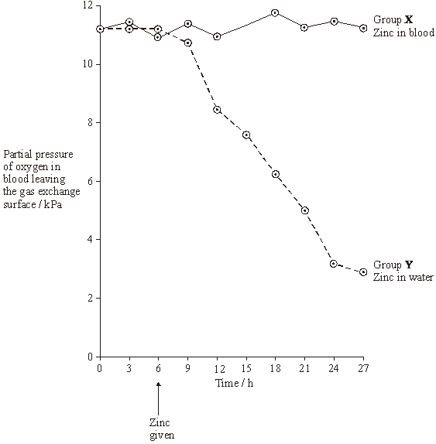

(a)     During this investigation, the water temperature in the tanks was kept constant. Explain why changes in the water temperature might lead to the results of the investigation being unreliable.

......................................................................................................................

......................................................................................................................

**(1)**

(b)     The results from the two groups were compared using a statistical test.

(i)      Suggest a null hypothesis that could be tested.

.............................................................................................................

**(1)**

(ii)     Explain why it is important to use a statistical test in analysing the results of this investigation.

.............................................................................................................

.............................................................................................................

.............................................................................................................

.............................................................................................................

**(2)**

(c)     Two suggestions were made to explain the results shown in the graph.

**A**       Zinc ions reduce the rate at which oxygen is taken up from the water and passes into the blood.

**B**       Zinc ions reduce the ability of haemoglobin to transport oxygen.

Which of these suggestions is the more likely? Explain the evidence from the graph that supports your answer.

......................................................................................................................

......................................................................................................................

......................................................................................................................

......................................................................................................................

**(2)**

(d)     During the investigation, the pH of the blood was also monitored. It decreased in group **Y**. Suggest an explanation for this decrease in pH.

......................................................................................................................

......................................................................................................................

......................................................................................................................

......................................................................................................................

......................................................................................................................

......................................................................................................................

**(3)**

(e)     Leaves were collected from sycamore trees growing in a polluted wood and the concentration of some metal ions in samples of these leaves was measured. Woodlice were then fed with the leaves. After 20 weeks, the concentration of the ions in the bodies of the woodlice was measured. Some of the results are shown in the table.

|  |  |  |  |  |
| --- | --- | --- | --- | --- |
|  | **Concentration of ions / µg g–1** | | | |
|  | Copper | Cadmium | Zinc | Lead |
| Leaves | 52 | 26 | 1430 | 908 |
| Woodlice | 1130 | 525 | 1370 | 132 |

(i)      Which of the elements shown in the table is concentrated most by the woodlice? Use suitable calculations to support your answer.

**(2)**

(ii)     Suggest what happens to most of the lead ions in the leaves eaten by the woodlice.

.............................................................................................................

.............................................................................................................

**(1)**

(iii)     Explain the difference in the copper ion concentration between the leaves and the woodlice.

.............................................................................................................

.............................................................................................................

.............................................................................................................

.............................................................................................................

**(2)**

(f)      Yorkshire fog is a species of grass. Two varieties of Yorkshire fog were studied. One variety was tolerant to arsenic, while the other variety was not. In a series of investigations, it was found that

•        Arsenic-tolerant plants grow in soil which contains a high concentration of arsenic.

•        Arsenic-tolerant plants growing in soil containing high concentrations of arsenic and phosphorus-containing compounds have very low concentrations of arsenic in their cells. They also have low concentrations of phosphates in their cells. Arsenic and phosphorus are chemically similar.

•        Plants that are not tolerant to arsenic grow poorly on soil which has a high concentration of both arsenic and phosphorus-containing compounds.

•        Tolerance to arsenic in Yorkshire fog is caused by a single gene with the allele, **a**, for tolerance recessive to the allele, **A**, for non-tolerance.

(i)      What caused the allele for tolerance to first arise?

.............................................................................................................

.............................................................................................................

**(1)**

(ii)     Give **two** functions of phosphates in plant cells.

1 ..........................................................................................................

.............................................................................................................

2 ..........................................................................................................

.............................................................................................................

**(2)**

(iii)     Arsenic-tolerant Yorkshire fog plants are very rare in areas with low concentrations of arsenic in the soil, even where the soil has a high concentration of phosphate. Explain why they are unable to compete in these conditions with plants that are not tolerant to arsenic.

.............................................................................................................

.............................................................................................................

.............................................................................................................

.............................................................................................................

.............................................................................................................

.............................................................................................................

**(3)**

**(Total 20 marks)**

**Q26.**Yield can be determined by measuring the dry mass of plants.

(a)     Suggest how you could determine the dry mass of a sample of plant material.

.........................................................................................................................

.........................................................................................................................

.........................................................................................................................

.........................................................................................................................

**(2)**

(b)     What is the advantage of using dry mass and not fresh mass to compare the yield of plants?

.........................................................................................................................

.........................................................................................................................

.........................................................................................................................

.........................................................................................................................

**(2)**

**(Total 4 marks)**

**Q27.**          (a)     There are two forms of nitrogen. These different forms are called isotopes. 15N is a heavier isotope than the normal isotope 14N.

In an investigation, a culture of bacteria was obtained in which all the nitrogen in the DNA was of the 15N form. The bacteria (generation 0) were transferred to a medium containing only the normal isotope, 14N, and allowed to divide once. A sample of these bacteria (generation 1) was then removed. The DNA in the bacteria of generation 1 was extracted and spun in a high-speed centrifuge.

The bacteria in the 14N medium were allowed to divide one more time. The DNA was also extracted from these bacteria (generation 2) and spun in a high speed centrifuge.

The diagram shows the results of this investigation.

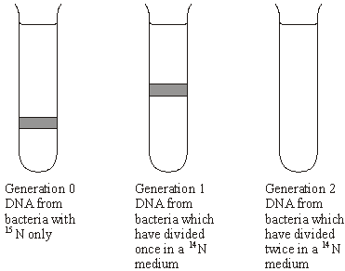

(i)      Which part of the DNA molecule contains nitrogen?

.............................................................................................................

**(1)**

(ii)     Explain why the DNA from generation 1 is found in the position shown.

.............................................................................................................

.............................................................................................................

.............................................................................................................

.............................................................................................................

**(2)**

(iii)     Complete the diagram to show the results for generation 2.

**(2)**

(b)     The table shows the percentage of different bases in the DNA of different organisms.

|  |  |  |  |  |
| --- | --- | --- | --- | --- |
| Organism | Adenine% | Guanine% | Thymine% | Cytosine% |
| Human |  | 19 |  |  |
| Bacterium | 24 | 26 | 24 | 26 |
| Virus | 25 | 24 | 33 | 18 |

(i)      Complete the table to show the percentages of different bases in human DNA.

**(2)**

(ii)     The structure of virus DNA is different from the DNA of the other two organisms. Giving evidence from the table, suggest what this difference might be.

.............................................................................................................

.............................................................................................................

.............................................................................................................

.............................................................................................................

**(2)**

**(Total 9 marks)**

**Q28.**          The flowchart shows how chloroplasts may be obtained from leaves.

|  |
| --- |
| Leaves homogenised by grinding in cold buffer solution |

**↓**

|  |
| --- |
| Homogenised leaves filtered. Filtrate centrifuged at low speed |

**↓                               ↓**

|  |  |  |
| --- | --- | --- |
| Pellet **A** |  | Supernatant centrifuged at high speed |

**↓              ↓**

|  |  |  |
| --- | --- | --- |
| Pellet **B** containing chloroplast |  | Supernatant C |

(a)     In the first step in this procedure, the leaves were homogenised by grinding in cold buffer solution. Explain why

(i)      the leaves were homogenised,

.............................................................................................................

.............................................................................................................

**(1)**

(ii)     a buffer solution was used.

.............................................................................................................

.............................................................................................................

.............................................................................................................

.............................................................................................................

**(2)**

(b)     The table shows some of the organelles present in the leaf cells.

|  |  |  |  |
| --- | --- | --- | --- |
| Organelle | **X** | **Y** | **Z** |
| Fraction containing organelle |  |  |  |

(i)      Complete the table to show in which of pellet **A**, pellet **B** or supernatant **C** you would expect to find each of these organelles.

**(2)**

(ii)     Organelle **X** is found in large numbers in cells which take up substances by active transport. Explain why.

.............................................................................................................

.............................................................................................................

.............................................................................................................

.............................................................................................................

**(2)**

**(Total 7 marks)**

﻿

**Q29.**          Tradescantia is a house plant. There are small hairs on its flowers. These hairs are made of cells. **Figure 1** shows the appearance of cells from one of these hairs after 20 minutes in distilled water. **Figure 2** shows cells from another hair after 20 minutes in a solution of potassium nitrate.

**Figure 1** (in distilled water)

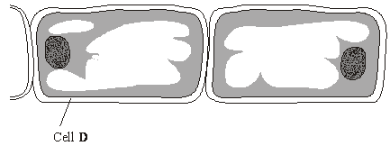

**Figure 2** (in potassium nitrate solution)

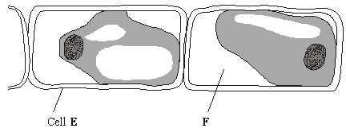

(a)     What does **Figure 2** suggest about the permeability of the plasma membranes surrounding these cells?

......................................................................................................................

......................................................................................................................

**(1)**

(b)     What is present in the space labelled **F**? Explain your answer.

......................................................................................................................

......................................................................................................................

......................................................................................................................

......................................................................................................................

**(2)**

(c)     How would the water potential of the sap in the vacuole of cell **E** differ from the water potential of the sap in the vacuole of cell **D**? Explain your answer.

......................................................................................................................

......................................................................................................................

......................................................................................................................

......................................................................................................................

......................................................................................................................

......................................................................................................................

**(3)**

**(Total 6 marks)**

**Q30.**          The diagram shows a carrot.

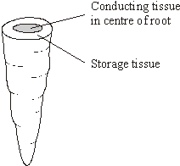

A group of students investigated the effect of sucrose concentration on the length of cylinders cut from a carrot.

(a)     The students used a cork borer to cut cylinders from the carrot. Describe how the students should cut these cylinders to make sure that this was a fair test and would produce reliable results.

......................................................................................................................

......................................................................................................................

......................................................................................................................

......................................................................................................................

**(2)**

(b)     They measured the initial length of each cylinder then placed the cylinders into test tubes containing different concentrations of sucrose solution. Bungs were placed in the tubes and the tubes were left overnight. Explain why the bungs were placed in the tubes.

......................................................................................................................

......................................................................................................................

......................................................................................................................

......................................................................................................................

**(2)**

(c)     The students then measured the final lengths of the carrot cylinders. Their results are shown in the table.

|  |  |
| --- | --- |
| Concentration of sucrose / mol dm–3 |  |
| 0.0 | 1.4 |
| 0.2 | 1.4 |
| 0.4 | 1.2 |
| 0.6 | 1.1 |
| 0.8 | 0.9 |

(i)      The students used these results to find the concentration of sucrose that has the same water potential as the carrot cylinders. Describe how they could have done this.

.............................................................................................................

.............................................................................................................

.............................................................................................................

.............................................................................................................

**(2)**

(ii)     Was it important in this investigation that the carrot cylinders had the same initial length? Explain your answer.

.............................................................................................................

.............................................................................................................

.............................................................................................................

**(1)**

**(Total 7 marks)**

**Q31.**Bromelain is a protein-digesting enzyme found in pineapples. Some people claim that bromelain tablets have benefitial effect on health. These effects include reducing swelling and pain after surgery and reducing growth of cancers.

Bromelain is absorbed from the gut into the blood. Scientists gave a group of volunteers 3 g of bromelain in tablets each day for three days. They then measured the maximum mass of bromelain in the blood of each volunteer. The mean value for the maximum mass of bromelain in the blood of the volunteers was 0.025 mg.

(a)     There is a difference between the mass of bromelain that the volunteers were given and the maximum mass of bromelain in their blood. Suggest **one** explanation for this difference.

........................................................................................................................

........................................................................................................................

**(1)**

(b)     The scientists measured the concentration of bromelain in the blood. What else did they need to measure to calculate the total mass of the bromelain in the blood of a volunteer?

........................................................................................................................

........................................................................................................................

**(1)**

**(Total 2 marks)**

**Q32.**          (a)     In the USA, members of the public found many frogs with deformed legs. Scientists investigated this. They collected samples of the frogs. They wanted to get reliable data. Give **one** feature of the sample, other than a large sample size, that would help to make sure that their data were reliable.

......................................................................................................................

......................................................................................................................

**(1)**

The team of scientists then investigated frogs in ponds. The team measured many different factors and then analysed their results. The graph shows the relationship between the percentage of frogs with deformed legs and the mean number of parasitic worms found in the frogs.

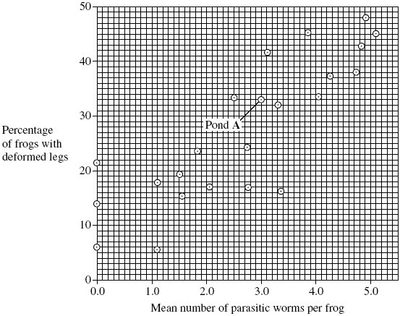

(b)     The scientists collected a sample of three frogs from pond **A**. What was the total number of parastic worms found in these three frogs?



**(1)**

(c)     One scientist suggested that the parasites caused the deformed legs found in frogs.

Does the graph support this suggestion? Explain your answer.

......................................................................................................................

......................................................................................................................

......................................................................................................................

......................................................................................................................

......................................................................................................................

......................................................................................................................

......................................................................................................................

**(4)**

(d)     The scientists wrote a paper. In their discussion they wrote that they found very few ponds that were free from human influence. The few that they did find were only in mountainous areas.

The scientists could not draw any reliable conclusions about whether human influence contributed to the frogs’ deformed legs. Explain why each of the following meant that they could not draw reliable conclusions.

(i)      There were very few ponds free from human influence.

.............................................................................................................

.............................................................................................................

**(1)**

(ii)     The ponds free from human influence were found only in mountainous areas.

.............................................................................................................

.............................................................................................................

.............................................................................................................

.............................................................................................................

**(2)**

In a second investigation, another research team investigated deformed legs in frogs in a different way.

•        They chose six ponds, all of which contained parasitic worms. Three of the ponds were close to fields and received agricultural run-off from these fields. The other three ponds did not receive agricultural run-off.

•        They built two cages in each of the six ponds. One cage in each pond allowed parasitic worms to enter and one cage did not.

•        They put frogs that were not infected with parasitic worms into all twelve cages.

The table shows the results of this second investigation.

|  |  |  |  |  |  |  |
| --- | --- | --- | --- | --- | --- | --- |
|  | **Percentage of frogs with deformed limbs** | | | | | |
|  | Ponds with agricultural run-off | | | Ponds with no agricultural run-off | | |
| Pond number | 1 | 2 | 3 | 4 | 5 | 6 |
| Cage with mean mesh diameter of 500 µm | 22 | 27 | 24 | 3 | 4 | 7 |
| Cage with mean mesh diameter of 75 µm | 0 | 0 | 0 | 0 | 0 | 0 |

(e)     One of the boxes in the table has been shaded. Describe the information given in the shaded box.

......................................................................................................................

......................................................................................................................

......................................................................................................................

......................................................................................................................

**(2)**

(f)      What conclusions can you draw from the data in the table about the factors causing deformed leg in frogs? Explain your answer.

......................................................................................................................

......................................................................................................................

......................................................................................................................

......................................................................................................................

......................................................................................................................

......................................................................................................................

......................................................................................................................

......................................................................................................................

**(4)**

**(Total 15 marks)**

**Q33.**The diagram shows a mitochondrion.

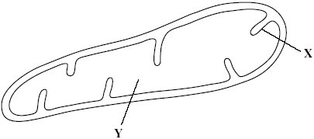

(a)     Name the parts labelled **X** and **Y**.

(i)      **X** .............................................................

(ii)     **Y** ..............................................................

**(2)**

Scientists isolated mitochondria from liver cells. They broke the cells open in an ice-cold, isotonic solution. They then used a centrifuge to separate the cell organelles. The diagram shows some of the steps in the process of centrifugation.

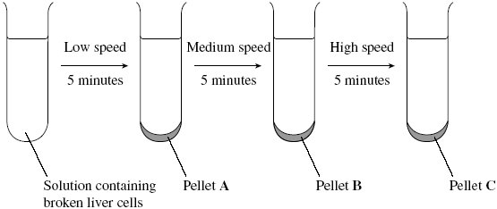

(b)     Suggest which pellet, **A**, **B** or **C** contained the mitochondria.



**(1)**

(c)     Explain why the solution used was

(i)      ice-cold

.............................................................................................................

.............................................................................................................

**(1)**

(ii)     isotonic.

.............................................................................................................

.............................................................................................................

.............................................................................................................

.............................................................................................................

**(2)**

(d)     People with mitochondrial disease have mitochondria that do not function properly.

Some people with mitochondrial disease can only exercise for a short time. Explain why a person with mitochondrial disease can only exercise for a short time.

......................................................................................................................

......................................................................................................................

......................................................................................................................

......................................................................................................................

**(2)**

**(Total 8 marks)**

**Q34.**Students investigated the effect of different concentrations of sodium chloride solution on discs cut from an apple. They weighed each disc and then put one disc into each of a range of sodium chloride solutions of different concentrations. They left the discs in the solutions for 24 hours and then weighed them again. Their results are shown in the table.

|  |  |  |  |  |
| --- | --- | --- | --- | --- |
|  | **Concentration of sodium chloride solution / mol dm–3** | **Mass of disc at start / g** | **Mass of disc at end / g** | **Ratio of mass at start to mass at end** |
|  | 0.00 | 16.1 | 17.2 | 0.94 |
|  | 0.15 | 19.1 | 20.2 | 0.95 |
|  | 0.30 | 24.3 | 23.2 | 1.05 |
|  | 0.45 | 20.2 | 18.7 | 1.08 |
|  | 0.60 | 23.7 | 21.9 |  |
|  | 0.75 | 14.9 | 13.7 | 1.09 |

(a)     (i)      Calculate the ratio of the mass at the start to the mass at the end for the disc placed in the 0.60 mol dm–3 sodium chloride solution.

Answer ......................................

**(1)**

(ii)     The students gave their results as a ratio. What is the advantage of giving the results as a ratio?

.............................................................................................................

.............................................................................................................

.............................................................................................................

.............................................................................................................

.............................................................................................................

**(2)**

(iii)    The students were advised that they could improve the reliability of their results by taking additional readings at the same concentrations of sodium chloride.

Explain how.

.............................................................................................................

.............................................................................................................

.............................................................................................................

.............................................................................................................

.............................................................................................................

**(2)**

(b)     (i)      The students used a graph of their results to find the sodium chloride solution with the same water potential as the apple tissue. Describe how they did this.

.............................................................................................................

.............................................................................................................

.............................................................................................................

.............................................................................................................

.............................................................................................................

**(2)**

(ii)     The students were advised that they could improve their graph by taking additional readings. Explain how.

.............................................................................................................

.............................................................................................................

.............................................................................................................

.............................................................................................................

.............................................................................................................

**(2)**

**(Total 9 marks)**

**Q35.**          (a)     The biochemical pathway of aerobic respiration involves a number of different steps.

Name **one** step in which carbon dioxide is produced.

......................................................................................................................

**(1)**

In an investigation, scientists transferred slices of apple from air to anaerobic conditions in pure nitrogen gas. They measured the rate of carbon dioxide production.

(b)     The scientists kept the temperature constant throughout the investigation. Explain how a decrease in temperature would affect the rate of carbon dioxide production.

......................................................................................................................

......................................................................................................................

......................................................................................................................

......................................................................................................................

......................................................................................................................

**(2)**

(c)     When the apple slices were transferred to nitrogen, the following biochemical pathway took place.

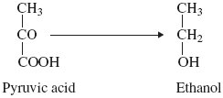

Use this pathway to explain the part played by reduced NAD when the apple slices were transferred to nitrogen.

......................................................................................................................

......................................................................................................................

......................................................................................................................

......................................................................................................................

**(2)**

(d)     The rate of carbon dioxide production was higher when the apple slices were in nitrogen than when they were in the air. Explain why.

......................................................................................................................

......................................................................................................................

......................................................................................................................

......................................................................................................................

......................................................................................................................

......................................................................................................................

**(3)**

**(Total 8 marks)**

**M1.**          (a)     Endonuclease / restriction enzyme;

**1**

(b)     DNA made of base pairs;  
Each base pair is same length / occupies same distance  
along backbone;

**2**

(c)     (i)      Second blank box from left labelled 6;

**1**

(ii)     Distance moved depends on length / number of base pairs /   
second longest fragment / second shortest distance identified;

**1**

(d)     5;

**1**

**[6]**

**M2.**          (a)     To prevent contamination of apparatus with other microorganisms / bacteria;  
To prevent personal contact with bacteria;  
To prevent release of bacteria into air;

**max 2**

(b)     (i)      Diffuses slowly;

**1**

(ii)     B;  
Produces inhibition zone greater than the minimum diameter;

**2**

**[5]**

**M3.**          (a)     (i)      to ensure that no unwanted bacteria will be present;

**1**

(ii)     to check that bacteria cells do not die anyway / to show  
water / solvent has no effect on growth;

**1**

(b)     some bacteria are resistant / some areas of dish have no antibiotic /   
antibiotic not spread evenly;

**1**

**[3]**

**M4.**          (a)     urea diffused into / entered the tubing and was hydrolysed / broken down (inside tubing);  
ammonia increases pH / makes (solution) more alkaline and indicator turns blue as pH above 8 / due to alkalinity / due to ammonia;  
idea that outside stays yellow because urease does not pass out;

**3**

(b)     (i)      add biuret solution / add sodium hydroxide + copper  
sulphate (solution);

*(disqualify heat / boil, but accept warm)*

violet / lilac / purple colour;

**2**

(ii)     inside: protein present, as enzyme is protein;  
outside: no protein, as urease / enzyme / protein unable to pass  
through membrane / out;

*(accept correct result of biuret test as indicator of protein)*

**2**

(c)     method to maintain range of temperatures, e.g. water baths;  
method to measure rate of activity - e.g. time taken to turn indicator blue;

*(principle - measure rate of activity over range of temperatures = 1 mark, if neither point)*

other conditions kept constant / named examples,  
e.g. volumes of solutions,  
starting pH, sample time;  
method of refining optimum, e.g. repeats at narrower range;

**3 max**

**[10]**

**M5.**          (a)     (i)      transect line may not go through representative areas / may avoid certain areas;

**1**

(ii)     large sample;  
how random coordinates are generated / how random places  
chosen;

**2**

(b)     (i)      spread of values around the mean height of the plant;

**1**

(ii)     smaller plants at higher altitude;  
greater the altitude the lower the standard deviation ;  
reference to figures to make a comparison;

**2 max**

(iii)     the plants measured were grown under uniform conditions;

**1**

**[7]**

**M6.**          (a)     (i)      true indication of growth / water mass may vary;

**1**

(ii)     intraspecific;

**1**

(iii)     the denser the planting the greater the yield;  
above a planting density of approx 30 competition for  
named resource / named limiting factor / population density  
not limiting;

*(accept nutrients / space reject food)*

**2**

(b)     use genetically identical plants / clones / asexual reproduction /   
tissue culture; maintain identical environmental conditions / named  
condition; reference to density of planting;

**2 max**

**[6]**

**M7.**          (a)     colour results from starch-iodine reaction;  
decrease due to breakdown of starch by carbohydrase / enzyme;

**2**

(b)     (i)      curve drawn below curve on graph and starting at same point;

**1**

(ii)     curve drawn above curve on graph and starting at same point but  
finishing above;

*(allow curve or horizontal line)*

*(allow alternative curve for pH if explanation in (ii) is consistent)*

**1**

(c)     (i)      1. increase in temperature increases kinetic energy;  
2. increases collisions (between enzyme / active site and substrate) / increases formation of enzyme / substrate complexes;  
3. increases rate of breakdown of starch / rate of reaction / carbohydrase activity;

(ii)     4. (decrease in pH) increases H+ ions / protons which attach / attracted to amino acids;  
5. hydrogen / ionic bonds disrupted / broken which denatures enzyme / changes tertiary structure;  
6. changes shape / charge of active site so active site / enzyme unable to combine / fit with starch /  enzyme-substrate complex no longer able to form;  
7. decreases rate of breakdown of starch / rate of reaction / carbohydrase activity;

*(allow alternative explanation for pH if consistent with line   
drawn in (ii))*

**7**

**[11]**

**M8.**          (i)      cold - no / reduced enzyme action / e.g. stops autolysis;

*(reject “cell activity reduced”)*

isotonic - stops osmotic effects / description of effect on  
cells or organelles;

buffer - prevents damage to enzymes / proteins;

**3**

(ii)      break open the cells / release the cell contents;

**1**

(iii)     supernatant / liquid above the pellet;  
spun at a high(er) speed;

*(mark as independent points)*

**2**

**[6]**

**M9.**          (a)     *two environmental or developmental variables and explanation;*

*examples*,

all plants of the same age, so same time for cell divisions / differentiation;  
all plants given the same watering, so same amount of water for  
cell expansion;  
*(reject reference to photosynthesis)*all plants given same light, so same rate of photosynthetic;  
same temperature, so enzymes / named metabolic process at  
optimum temperature;  
same named ion / minerals in soil(e.g. nitrate),  
so same available for a named function,  
(e.g. amino acid / protein synthesis);

**2 max**

(b)     count cells using microscope;  
count number of cells in cell division / where chromosomes visible;  
and then the total number of cells in field of view;

**2 max**

(c)     only cells at tip have ability to divide / cells further back don’t divide;  
cells further back differentiating / named example of  
*(accept reference to loss of totipotent cells)*differentiated tissue / too old / reduction in plant hormone;  
cell wall too thick / vacuole too large to allow division;

**2 max**

(d)     new cells added at tip;  
cells increase in volume / larger;  
increase in length (of cells);  
as vacuole s get larger;  
due to uptake of water (by osmosis);

**3 max**

**[9]**

**M10.**          (i)      kinesis;  
movement is random / rate of turning changes /   
does not move towards / away from light;

**2**

(ii)      advantage related to light / shade;  
e.g. remains in shade so avoids predators

**1**

**[3]**

**M11.**          (a)     Samples collected at random;  
Method for choosing random sites – random  
coordinates / position from tables / calculator / other suitable  
means;

Other named factor constant e.g.:

Same size of net / same width of opening of net / use of one  
quadrat / Quadrats of same size / of stated size / same area  
disturbed / collect each   
Sample for same time;

**3**

(b)     *Caenidae* in deep water – because highest standard  
deviation / ‘S.D.= 7.92’

**1**

(c)     (i)      An organism’s role / in the ecosystem / community;  
[ALLOW refs. To trophic levels / named]

*(IGNORE refs. To habitat)*

**1**

(ii)     *Caenidae* found mainly in deep water AND *Baetidae* in  
shallow water / one family mainly in deep water AND the  
other in shallow water;

**1**

(iii)     Reduces competition for named factor – e.g. food / shelter / O2 ;  
To ensure both types survive / otherwise better adapted   
type displaces other type;  
OR  
Ref. to ‘Competitive exclusion principle’ = 2 marks

**max 2**

**[8]**

**M12.**          (a)     (i)      Curve rising and levelling out;

**1**

(ii)     Substrate becomes limiting / falls / gets less;  
Fewer collisions / complexes formed;

**2**

(b)     To keep pH the same / optimum pH / so change in pH does not affect reaction;

**1**

(c)     (i)      For temperature up to 40 – 50 °C has no effect;  
Over temperature (of 40 – 50 °C) reduces rate of reaction;

*Note. Award one mark for general statement about the  
longer the incubation time, the slower the rate of reaction.*

**2**

(ii)     Bonds (holding tertiary structure) broken;  
More enzyme denatured / tertiary structure destroyed /   
active sites lose shape / no longer fit;  
Fewer enzyme-substrate complexes formed;

*Note. Award marks if clearly in the context of more denaturation. Allow credit here for converse relating to exposure for 5 minutes.*

**3**

(d)     Competitive  
2 Similarity of shape of inhibitor and substrate;  
3 Inhibitor can enter / bind with active site (of enzyme);

Non-competitive  
4 Affect / bind to enzyme other than at active site;  
5 Distorts shape of active site;

Inhibitors  
6 Prevent entry of / binding of substrate to active site;  
7 Therefore fewer / no enzyme-substrate complexes formed;

**6**

**[15]**

**M13.**          (a)     Epithelium of alveolus, capillary wall / epithelium / endothelium, plasma;

**1**

(b)     Cell wall;  
Capsule;  
Flagellum;  
Mesosomes;  
Plasmid;  
Genetic material / DNA / nucleoid;  
Ribosomes;

*Accept references to size only if some idea of range is given*

**max 2**

(c)     Large (surface) area;  
For diffusion;  
     or  
Short distance to centre of cell / to all haemoglobin;  
For diffusion;

**2**

(d)     (i)      Correct answer of approximately 7800 / 8000 = 2 marks  
Incorrect answer but clearly derived by  
dividing diameter of cell A by 7                        = 1 mark

**2**

(ii)     Idea of cut through maximum diameter / middle;

**1**

**[8]**

**M14.**          (a)     Population – organisms of one species in an ecosystem / habitat / area;  
Community – organisms of all species / all populations in an  
ecosystem / habitat / area;

**2**

(b)     (i)      No immigration / migration (Ignore references to emigration);  
No reproduction *(Ignore references to death)*;  
Idea of mixing;  
Marking does not influence behaviour / increase vulnerability  
to predation;  
Sample / population large enough;

**max 2**

(ii)     ; 672;

*Correct answer (however derived) scores 2 marks  
Incorrect answer with evidence of correct method scores 1 mark.*

**2**

(c)     Principle of randomly placed quadrats and method of producing random  
quadrats; *(Reject ‘throwing’)*Valid method of obtaining no. dandelions in given area (mean per  
quadrat / total no. in many quadrats);  
Multiply to give estimate for total field area;

**3**

(d)     (i)      Niche of A – 1;  
Niche of B – 3;  
Too small for B / too hot for A – 4;  
Too large for A / too cold for B – 2;  
*All four correct = 2 marks; any 2 correct = 1 mark*

**2**

(ii)     Original population living in one area / 2 species evolved in  
the area;  
Idea of genetic variability;  
Concept of reproductive isolation;  
Possible mechanism;  
Gene pools become increasingly different;  
Until interbreeding does not produce fertile offspring;

**max 4**

**[15]**

**M15.**          (a)     (i)      Taxis;

*Ignore references to positive and negative, and prefixes such as photo-  
Accept taxes / tactic  
Allow phonetic spelling*

**1**

(ii)     Moves towards stimulus / towards light;

*Direction must be correct.*

**1**

(b)     Gravity;

Antennae involved;

Doesn’t show light is involved / doesn’t respond to light as they are  
unable to see / as eyes are covered;

*Accept geotaxis*

**3**

(c)     Helps them to leave the soil / ground / reach the surface;

Disperse / produce new colonies;

Avoid competition;

**2 max**

**[7]**

**M16.**Lay tape / rope at right angle / perpendicular to road;  
Take samples at regular / stated intervals;  
Using a quadrat;  
Count numbers / percentage cover of dandelions;  
Use several transects;

**4 max**

**[4]**

**M17.**          (a)     (i)      (Molecule) made up of many identical / similar molecules / monomers / subunits;

*Not necessary to refer to similarity with monomers.*

**1**

(ii)     Cellulose / glycogen / nucleic acid / DNA / RNA;

**1**

(b)     (i)      To keep pH constant;  
A change in pH will slow the rate of the reaction / denature  
the amylase / optimum for reaction;

**2**

(ii)     Purple / lilac / mauve / violet;  
*Do not allow blue or pink.*

**1**

(iii)     Protein present / the enzyme / amylase is a protein;  
Not used up in the reaction / still present at the end of  
the reaction;

**2**

**[7]**

**M18.**          (a)     (i)      (Grinding) breaks open cells / increases surface area (of liver);  
Releases catalase / enzyme / more catalase / allows more hydrogen peroxide into liver;

**2**

(ii)     Heating causes bonds (maintaining tertiary structure) to break;  
Denatures / changes tertiary structure so active site changed;  
Substrate no longer fits / ES complex not formed;

**3**

(b)     (Control) to show that sand did not affect reaction (with ground liver);

**1**

(c)     (i)      Lower activation energy / less energy required to bring about reaction;

**1**

(ii)     Energy in products / water and oxygen less than energy in substrate / reactants / hydrogen peroxide;  
(Difference) given out as heat / exothermic;

**2**

**[9]**

**M19.**          (a)     collect a sample (of insects in each area) and mark unobtrusively / in a way not harmful to insects;  
release and allow time to re-integrate with rest of population / eq.;  
collect second sample and count number marked;  
number in population estimated by:





**4**

(b)     (i)      1;

**1**

(ii)     (p =) 0.05 / 5%;

*(ignore 95%)*

**1**

(iii)     value for χ2 exceeds critical value / 125.8 > 10.8 ;  
Results unlikely to be due to chance / have a biological cause;  
P < 0.1% / < 5% ;

**2 max**

(c)     (i)      biomass respired / GPP – respiration = NPP;  
biomass lost as CO2;

**2**

(ii)     more food for insects;

**1**

**[11]**

**M20.**          (a)     kinesis;  
*(ignore ‘ortho-’ / ‘klino-’, allow ‘thermo-’, reject ‘photo-’ / ‘chemo-’ / etc)*

*random movements = 1 mark, eg  
/* degree of turning / number of turns depends on strength of stimulus /   
on temperature / allow specific ref. to more turning at 35° than at 30° /   
non-directional stimulus / response;

*ignore ‘speed’*

**2**

(b)     stays longer in warmer area / at 35° / tends to leave cooler area /   
to leave 30°   / stays in favourable conditions ;

remains near food source / on host;

**2**

**[4]**

**M21.**          (a)     (i)      glycolysis;

**1**

(ii)     oxygen removed from pyruvate / reduced NAD is oxidised / donates hydrogen / donates electrons;

**1**

(iii)     allows NAD to be recycled / re-formed;  
so that glycolysis / described / candidates answer to (i) can proceed / so that (more) glucose can be converted to pyruvate / so that process X can continue;

**2**

(b)     (i)      ATP formed / used;  
pyruvate formed / reduced;  
NAD / reduced NAD;  
glycolysis involved / two stage process;

**2 max**

(ii)     ethanol / alcohol formed by yeast, lactate (*allow lactic acid)*by muscle cell; CO2 released by yeast but not by muscle cell;

*(note: need both parts of the comparison for the mark)*

**2**

(c)     (i)      allows anomalies to be identified / increases reliability (of means /   
averages / results);  
allows use of statistical test;

**2**

(ii)      = 31.8 / 31.76 / 31.77;

*(units not required)*

÷ (5 × 60) = 0.106 / 0.11 / 0.1;

*(correct answer scores two marks, however derived.)  
(correct mean volume (31.8 cm3) however derived scores 1 mark)*

**2**

(iii)     Volume(s) less / no gas evolved;  
So (volume) CO2 evolved = (volume of) O2 taken in;

**3**

**[15]**

**M22.**          (a)     (i)      where mitosis / division / growing / occurs  
*(reject growing cells)*

**1**

(ii)     to distinguish chromosomes / chromosomes not visible  
without stain;

**1**

(iii)     to let light through / thin layer;

**1**

(b)     (i)      74 + 18 / 982;  
= 9.4% / 9%;

**2**

*(allow 1 mark for identifying prophase & metaphase i.e.92 or correct method using wrong figures)*

(ii)     genetic differences / different types of garlic;  
time of day;  
chance;  
age of root tip;  
water availability;  
temperature;  
nutrient availability;

*(environmental factors = 1 but cannot be awarded in addition to a named environmental factor)*

**2 max**

**[7]**

**M23.**          (a)     Temperature affects photosynthesis; Affects enzyme activity;  
So that any change in photosynthesis rate is result of carbon dioxide / light intensity;

**max 2**

(b)     Carbon dioxide increases rate of photosynthesis;  
Up to max;  
Something else / correct suggestion is a limiting factor;

**3**

**[5]**

**M24.**          (a)     Measure diameter of field with ruler; And proportion taken up by the cell; or Measure length with (eyepiece) graticule / eyepiece scale;  
Calibrated against stage micrometer / something of known length;

*Reject divide apparent length by magnification*

**2**

(b)     Membrane / cytoplasm shrinks / pulls away from cell wall / cell plasmolysed / goes flaccid; Water moves down water potential gradient / to lower / more negative water potential; By osmosis;

**3**

(c)     (i)      Reaches equilibrium / no further / maximum change in length;

*Reject osmosis takes time*

**1**

(ii)     Line / curve of best fit; Extrapolate (and read off) / find where it crosses x-axis;

**2**

(iii)     Greater decrease / length smaller; More water removed;  
Greater difference in water potential / cell with higher / less negative water potential; Starch is insoluble / has no effect on osmosis

**max 2**

**[10]**

**M25.**          (a)     (variation in) temperature will affect the solubility of oxygen / rate of respiration / use of oxygen by cells / diffusion / gas exchange;  
*to gain credit point made must concern oxygen*

**1**

(b)     (i)      there is no difference between the partial pressure of oxygen in the two groups / the partial pressure of oxygen is the same in each group;

**1**

(ii)     results may have been due to chance and statistical test allows us to determine the probability of this / of the difference between results   
being significant;  
enables acceptance or rejection of null hypothesis;  
*The key points here are chance and probability used in the correct context.*

**2**

(c)     **A**;  
because partial pressure of oxygen only reduced when zinc in water / in **Y** / because when injected zinc / in **X** has no effect on partial pressure of oxygen in blood;

**2**

(d)     less oxygen transport to cells / in fish / in blood;   
anaerobic respiration;  
lactic acid produced / less carbon dioxide removed (from gills);  
more H+;

**3 max**

(e)     (i)      copper;  
calculation based on comparing concentration in woodlice with that in leaves;  
*accept any suitable method here, giving marks for the method and explanation. For example, calculating ratio of concentration in woodlice to concentration in leaves.*

**2**

(ii)     not absorbed from gut / passes out in faeces / egested / urine / excreted;

**1**

(iii)     woodlice eat large amount of leaves;  
copper stored / accumulates in body;

**2**

(f)      (i)      mutation;

**1**

(ii)     (as a component of) nucleic acids / DNA / RNA / nucleotides;  
phospholipids;   
ATP / ADP;

**2 max**

(iii)     arsenic-tolerant plants would not be able to take up phosphates / take up a little phosphate;  
since likely to involve same mechanism / same carrier / protein;   
(process of ) growth would be poorer than non-tolerant plants;

**3**

**[20]**

**M26.**(a)     Heat at 100°C / heat to temp to evaporate water;

*Value which would not burn material*

Weigh and heat until no further change in mass;

**2**

(b)     Amount of water present will vary;

This will affect fresh mass / will not affect dry mass;

**2**

**[4]**

**M27.**          (a)     (i)      base / named bases;

*reject nucleotide or uracil*

**1**

(ii)     it has been produced by semi-conservative  
replication / one old strand and one new;   
One strand has 15N bases and the other 14N;

*Accept light / heavy N (therefore) it is less dense / lighter;*

**2**

(iii)     one band is in same position as generation 1;  
one band higher;  
*accept a line. N.B. need a visible gap*

**2**

(b)     (i)      A = 31 and JT = 31;  
C = 19;

**2**

(ii)     viral DNA single-stranded / not double-stranded;  
evidence from table e.g. not equal amount of A and T  
/ C and G / all different;

**2**

*ignore no base-pairing In this* ***Question*** *assume It’ means viral DNA*

**[9]**

**M28.**          (a)     (i)      break open cells / release cell contents;

**1**

(ii)     keep pH the same / controls pH;  
prevent change to / denaturing of proteins / enzymes;

**2**

(b)     (i)

|  |  |  |
| --- | --- | --- |
| (supernatant) **C** | (pellet) **B**; | (pellet) **A**; |

**2**

(ii)     site of respiration which releases energy / ATP;  
required for movement against concentration gradient;  
*ignore first point for thermodynamically incorrect statements   
such as “making energy”.*

**2**

**[7]**

**M29.**          (a)     partially / selectively permeable *accept semi-permeable*allows water to pass through but not potassium nitrate / solute;

**1**

(b)     potassium nitrate (solution);  
cell wall permeable;

**2**

(c)     water potential more negative / lower in cell E; water removed;  
greater solute / sap concentration (in cell);

**3**

**[6]**

**M30.**          (a)     Lengthways / down the root;

Through one tissue only / through same part / same proportion of tissues;

**2**

(b)     To prevent the water from evaporating / prevent evaporation;

Changing the concentrations / water potential (of solution);

**2**

(c)     (i)      Plot data on a graph;

Find (sucrose concentration) from the graph where the ratio is 1;

**2**

(ii)     No, because the results are given as a ratio / as a proportion of initial length;

**1**

**[7]**

**M31.**(a)     (Most of) bromelain is digested / not absorbed / broken down in blood;

**1**

(b)     Total volume of blood;

**1**

**[2]**

**M32.**          (a)     Randomly collected / collected from many ponds / same species / same time of year;

*Accept other answers providing they might reasonably impact on data*

**1**

(b)     9;

**1**

(c)     Curve / line of best fit;

Shows upward slope / positive correlation / description of positive correlation;

Correlation does not necessarily mean causation;

Some other factor might be involved;

Some ponds had no worms but had frogs with deformed legs;

***Q*** *No mark awarded for “yes” or “no”*

**4 max**

(d)     (i)      Sample too small to establish a pattern / to be representative / to identify anomalies;

**1**

(ii)     Must compare like with like / must be a fair test;

*Note that fair test is acceptable if used in context defined in How Science Works glossary*

Some factors differ in mountains / named factor differs in mountains;

**2**

(e)     27% of the frogs had deformed legs in pond 2;

Agricultural run-off and cage mesh diameter of 500 µm;

**2**

(f)      Worms cause deformed legs;

Deformed legs in 500 µm mesh cages / deformed legs when worms in cage;

Run off (on its own) does not cause deformed legs;

No deformed legs with run off and 75 µm mesh / no worms;

When run off present makes effect of worms worse;

Quantitative statement e.g. increased by factor of 7 to 8 times;

**4 max**

**[15]**

**M33.**(a)     (i)      Crista / inner membrane;

**1**

(ii)     Matrix;

**1**

(b)     B;

**1**

(c)     (i)      Reduce / prevent enzyme activity;

**1**

(ii)     Prevents osmosis / no (net) movement of water;

So organelle / named organelle does not burst / shrivel;

***Q*** *Allow reference to cell rather than organelle for first mark point only.*

*Regard damage as neutral*

**2**

(d)     (Mitochondria) use aerobic respiration;

Mitochondria produce ATP / release energy required for muscles (to contract);

***Q*** *Do not accept reference to making / producing energy.*

**2**

**[8]**

**M34.**(a)     (i)      1.08;

*Must be to 3 significant figures, as in the table*

**1**

(ii)     Allows comparison / shows proportional change;

*Neutral: sizes / amounts*

         Idea that discs had different starting masses / weights;

*Neutral: different masses*

**2**

(iii)    (Allows)

*Accept: outliers instead of anomalies*

Anomalies to be identified / effect of anomalies to be reduced / effect of variation in data to be minimised;

*Reject: idea of not recording anomalies / preventing anomalies from occurring*

         A mean to be calculated;

*Neutral: average*

**2**

(b)     (i)      Plot (sodium chloride) concentration against ratio / draw line of best fit;

*Reject: if wrong axes or type of graph*

Find (sodium chloride concentration from the graph) where the ratio is 1 / there is no change in mass;

**2**

(ii)     Line / curve of best fit is more reliable / precise;

*Neutral: graph*

         Intercept / point where line crosses axis is more reliable / precise;

*Reject: references to ‘more accurate’*

**OR**

         Can plot SD values / error bars;

(To show) variability about the mean / how spread out the results are;

**2**

**[9]**

**M35.**          (a)     Krebs cycle / link reaction / pyruvate to acetylcoenzyme A;

***Q*** *Accept valid alternative for any of these steps.*

**1**

(b)     (Respiratory reactions controlled by) enzymes;

Rate decreases as less kinetic energy / fewer collisions (between substrate and active site) fewer E-S complexes formed;

**2**

(c)     Requires hydrogen / electrons / is reduction;

Hydrogens from reduced NAD / reduced NAD reduces (pyruvic acid) / reduced NAD oxidised;

*Information may be on diagram*

**2**

(d)     Respiring anaerobically;

(Anaerobic respiration / respiration with nitrogen) less efficient / produces less ATP;

More anaerobic respiration / more glucose / substrate must be respired to produce same amount of ATP (so more carbon dioxide produced);

**3**

**[8]**