**3.7.1 Inheritance**

**Section 1 – Recall**

**What does this section contain and why?** Activities to develop your recall of information you covered in the previous topics that are linked to inheritance. If you don’t have a mini whiteboard (MWB) please do invest in one, they are great for revision and recall. Once you have done the recall activity quickly check what you have done with the student booklets from that topic.

**Topics covered**: Inheritance

|  |  |  |  |
| --- | --- | --- | --- |
| **Topic** | **Recall activities** | **Understanding**  *Please write down any questions you have when completing this activity.* | **Completed** |
| **Biological molecules** | List 5 adaptions of DNA that enable it to carry out its functions. |  |  |
| **DNA, genes & Protein synthesis** | List 3 features of the genetic code? |  |  |
| Define gene, allele, sister chromatids, homologous chromosomes and locus (you need to learn and memorise these) |  |  |
| Draw and annotate all the stages of meiosis with a cell of diploid number of 6 (ensure you can do this from memory) |  |  |

**Section 2 – Student booklet framework**

Once you have finished learning this topic ensure that you go through the table below to check your knowledge and highlight areas that you need to revisit

|  |  |  |  |  |
| --- | --- | --- | --- | --- |
| **Key info** | **Topic:** Inheritance  **Synoptic Link:** Biological molecules, DNA, genes and protein synthesis  **Text book pages:** 418-447 | | | |
| **Step 1** | **Use the tutorial (GOL), presentation (GOL), video links and text book to complete the pack.** | | | |
| **Step 2** | **Learning outcome** | **I understand this** | **I can recall this** | **I need to revisit this** |
| Understand that the genotype is the genetic constitution of an organism. |  |  |  |
| Understand that the phenotype is the expression of this genetic constitution and its interaction with the environment. |  |  |  |
| Know that there may be many alleles of a single gene. |  |  |  |
| Understand that alleles may be dominant, recessive or codominant. |  |  |  |
| Understand that in a diploid organism, the alleles at a specific locus may be either homozygous or heterozygous. |  |  |  |
| Be able to draw fully labelled genetic diagrams to interpret, or predict, the results of:  monohybrid and dihybrid crosses involving dominant, recessive and codominant alleles  crosses involving sex-linkage, autosomal linkage, multiple alleles and epistasis. |  |  |  |
| Understand how to use of the chi-squared (X2) test to compare the goodness of fit of observed phenotypic ratios with expected ratios. |  |  |  |
| **Step 3** | **In lesson:** you will be undertaking activities to develop your understanding of the learning objectives and able to add to your notes. | | | |

**Inheritance**

In 1886 Gregor Mendel suggested that the characteristics of organisms were determined by ‘units’ which were handed on from generation to generation. These ‘units’ have been identified as genes which were carried on and transmitted by chromosomes.

Mendel’s Experiments and Conclusions

In the space below, add summary notes on Mendel’s experiments and the conclusions that he made.

Genes have 3 main characteristics:

* They can separate and combine
* They can mutate
* They code for the production of specific polypeptides

Define the terms below.

Try and do this from memory and then check your definitions as this is a good check of your knowledge

|  |  |
| --- | --- |
| Gene |  |
| Allele |  |
| Locus |  |
| Homologous chromosome |  |
| Genome |  |

A LOCUS – where the gene is found e.g. fur colour in mice

Black fur allele (B) White fur allele (b)

Pair of homologous chromosomes

Genetic Terms

Genotype: describes the alleles that an organism has and is represented by a single letter for each allele. As most organisms have homologous chromosomes their genotype will be represented by 2 letters. (E.g. TT, Tt or tt)

Phenotype: is the appearance of an organism determined by its genotype. So this will be a description in words as to the appearance seen in an organism. (E.g. can roll your tongue or can’t roll your tongue

Dominant allele: if an allele is dominant it will always be expressed in the phenotype and is represented by a capital letter. The letter chosen is usually the one from the dominant trait (e.g. T is the dominant allele for being able to roll your tongue)

Recessive allele: this allele will only be expressed in the phenotype when there are 2 recessive alleles. Recessive alleles are represented by lower case letters. (e.g. t is the recessive allele for not being able to roll your tongue)

Homozygous: if both alleles on each homologous chromosome is the same then that organism is homozygous for that gene. The alleles in the genotype will both be capital letters or lower case letters (E.g. TT homozygous dominant genotype, tt homozygous recessive genotype)

Heterozygous: the alleles in the genotype are different. (e.g. Tt heterozygous – this person can roll their tongue)

F1: First generation of offspring

F2: Second generation of offspring

Carrier: A person carrying an allele which is not expressed in the phenotype but that can be passed on to offspring

Check your understanding of the above genetic terms by doing the questions below:

1. For each genotype indicate whether they are heterozygous (HE) or homozygous (HO).

|  |  |  |  |  |  |
| --- | --- | --- | --- | --- | --- |
| AA | ……………. | Ff | ……………. | Kk | ……………. |
| Bb | ……………. | GG | ……………. | Ll | ……………. |
| Cc | ……………. | HH | ……………. | Mm | ……………. |
| Dd | ……………. | Ii | ……………. | OO | ……………. |
| Ee | ……………. | Jj | ……………. | Pp | ……………. |

2. For each of the genotypes below, determine the phenotype.

|  |  |  |  |
| --- | --- | --- | --- |
| *Purple flowers are dominant to white flowers* | | *Brown eyes are dominant to blue eyes* | |
| PP | …………………………………………………… | BB | …………………………………………………… |
| Pp | …………………………………………………… | Bb | …………………………………………………… |
| pp | …………………………………………………… | bb | …………………………………………………… |
|  |  |  |  |
| *Round seeds are dominant to wrinkled* | | *Bobtails are recessive (long tails dominant)* | |
| RR | …………………………………………………… | TT | …………………………………………………… |
| Rr | …………………………………………………… | Tt | …………………………………………………… |
| rr | …………………………………………………… | tt | …………………………………………………… |

3. For each phenotype, list the genotypes. (Remember to use the letter of the dominant trait)

|  |  |  |  |
| --- | --- | --- | --- |
| *Straight hair is dominant to curly* | | *Pointed heads are dominant to round heads* | |
| ……. | straight | ……. | pointed |
| ……. | straight | ……. | pointed |
| ……. | curly | ……. | round |

Monohybrid Crosses

The inheritance of one gene (two alleles) from a homologous pair of chromosomes is called monohybrid inheritance.

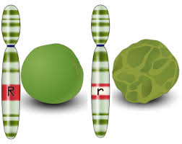

R r

http://lbc.msu.edu/evo-ed/Pages/peas/genetics.html

* Let R = dominant allele for Round peas
* Let r = recessive allele for wrinkled peas

**Setting out a genetic cross**

When doing any genetic inheritance cross, you must set it out as below. **Do not skip steps** as when the problems get more complicated it will lead to mistakes.

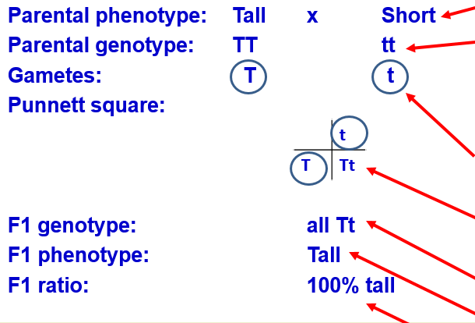…………………………………………………………

…………………………………………………………

…………………………………………………………

…………………………………………………………

…………………………………………………………

…………………………………………………………

…………………………………………………………

…………………………………………………………

…………………………………………………………

…………………………………………………………

…………………………………………………………

…………………………………………………………

**Cross 1:**

Cross pollinate homozygous round pea plants with homozygous wrinkled pea plants (**pure breeding**)

Parental Phenotypes: round x wrinkled

Parental Genotypes: RR x rr

Gamete genotypes*: R R x r r

* At meiosis the homologous

chromosomes/alleles are separated

**Put the gametes in a circle as this differentiates gametes from genotypes**

Punnett Square:

|  |  |  |
| --- | --- | --- |
|  | R | R |
| r | Rr | Rr |
| r | Rr | Rr |

## F1/offspring genotype: all Rr (heterozygous)

F1/offspring phenotype: all round peas (F1)

Phenotype ratio: 100% round peas

**Cross 2:**

Cross pollinate/interbreed heterozygous round pea plants (F1)

Parental Phenotypes: round x round

Parental Genotypes: Rr x Rr

Gamete genotypes: R r x R r

Punnett square:

|  |  |  |
| --- | --- | --- |
|  | R | r |
| R | RR | Rr |
| r | Rr | rr |

**This is always the ratio for crossing 2 heterozygous parents in monohybrid inheritance**

## F2/Offspring genotype: RR, Rr and rr

F2/Offspring phenotype: Round and wrinkled

Phenotype ratio 3:1 always

Task:

1. Watch the video

[Inheritance problems 1 - Godalming College eStream - Powered by Planet eStream](https://estream.godalming.ac.uk/View.aspx?id=17128~5g~7ONkMROGdB)

1. Then complete your cross for the problem below.

Sickle cell anaemia is caused by a recessive allele. Show how two healthy individuals can produce a child with the condition.

Parental Phenotypes:

Parental Genotypes:

Gamete genotypes:

Punnett square:

## F2/Offspring genotype:

F2/Offspring phenotype:

Phenotype ratio

Probability and Genetic Crosses

Genetic crosses allow us to determine the probability of producing a particular phenotype in the offspring. This probability can be written as a ratio or percentage. Ratios give us a measure of the relative size of groups expressed as a proportion. E.g. if there are 60 dogs and 30 cats then there is a ratio of 60:30 which is simplified to 2:1. For comparisons, ratios are simplified so the smallest value is 1.

In reality, crosses rarely end up with this exact ratio as it is completely random which gametes will fuse at fertilisation. The larger the sample size (number of crosses) the closer to the theoretical ratio the results will be.

Test Crosses

This is done to find out if an individual with the dominant characteristic/phenotype e.g. Round pea, is homozygous RR or heterozygous Rr:

* Take the Unknown plant genotype i.e. RR or Rr and cross with homozygous recessive genotype (rr). Set out the **two crosses** – what feature will you look for to determine whether genotype is RR or Rr?
* If the unknown genotype is RR, all phenotypes of the offspring will be dominant:

|  |  |  |
| --- | --- | --- |
|  | R | R |
| r | Rr | Rr |
| r | Rr | Rr |

* + If the unknown genotype is Rr, 50% of the offspring will have phenotypes that are dominant, 50% phenotypes will be recessive:

|  |  |  |
| --- | --- | --- |
|  | R | r |
| r | Rr | rr |
| r | Rr | rr |

Task:

1. Watch the video (up to 3 min 20 sec)

[Inheritance problems 2 - Godalming College eStream - Powered by Planet eStream](https://estream.godalming.ac.uk/View.aspx?id=17129~5h~zBbJwQ8QBD)

1. Pause the video and complete your cross for the problem below.

Red hair is caused by a recessive allele. Show how a test cross could be used to determine the genotype of a non red haired person.

Knowledge Check Questions

Complete these questions on a separate piece of paper and ensure that you draw full genetic diagrams for each question.

1. A TT (tall plant is crossed with a tt (short plant). What Percentage of the offspring will be tall?
2. A Tt plant is crossed with a Tt plant. What percentage of the offspring will be short?
3. A heterozygous round seeded plant is crossed with a homozygous round seeded plant. What percentage of the offspring will be homozygous?
4. In pea plants purple flowers are dominant to white flowers. If two white flowered plants are crossed, what percentage of their offspring will be white flowered?
5. In guinea pigs, the allele for short hair is dominant. Show the cross for a pure breeding short haired guinea pig and a long haired guinea pig. What percentage of the offspring will have short hair.
6. Show the cross for two heterozygous guinea pigs. What is the ratio of offspring with short hair to offspring with long hair.
7. Two short haired guinea pigs are mated several times. Out of 100 offspring, 26 of them have long hair. What are the probable genotypes of the parents? Draw a genetic cross to show this.

**Co-dominance**

**Task:**

1. **Watch the video (from 3 min 20 secs) and follow the notes below**

[Inheritance problems 2 - Godalming College eStream - Powered by Planet eStream](https://estream.godalming.ac.uk/View.aspx?id=17129~5h~zBbJwQ8QBD)

1. Pause the video and complete the cross for blood grouping (below the notes)

Instead of one allele being dominant, both alleles are expressed in the phenotype, neither are dominant. To show these crosses, there is a different way of showing the alleles:

* + There is a capital letter for the **Characteristic**
  + Capital letters for alleles are placed **superscript** on the characteristic letter
  + [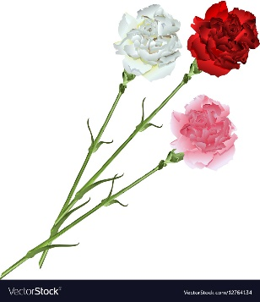](https://www.google.com/url?sa=i&url=https%3A%2F%2Fwww.vectorstock.com%2Froyalty-free-vector%2Fbouquet-of-white-pink-and-red-carnations-vector-12764134&psig=AOvVaw1sMCh5L0tuAX6AlP8snkkI&ust=1590078081951000&source=images&cd=vfe&ved=0CAIQjRxqFwoTCJDk6svswukCFQAAAAAdAAAAABAK)E.g. Colour of petals in carnations – red, white, pink
    - Let C = colour
    - Let CR= red allele
    - Let CW= white allele
    - A pink flower has a genotype CRCW

**Cross:**

Flower colour is determined by 2 co-dominant alleles. CR gives red coloration, CW gives white, and heterozygotes show an intermediate phenotype of pink. Use a genetic diagram to work out the phenotypes of the offspring of 2 pink flowers.

Parental Phenotypes: pink x pink

Parental Genotypes: CR CW x CR CW

Gamete genotypes: CR  CW x CR CW

Punnett square:

|  |  |  |
| --- | --- | --- |
|  | CR | CW |
| CR | CR CR | CR CW |
| CW | CR CW | CW CW |

Often called hybrids

## Offspring genotype: CR CR : CRCW : CWCW

Offspring phenotype: red : pink : white

Phenotype ratio: 1:2:1

**Multiple Alleles**

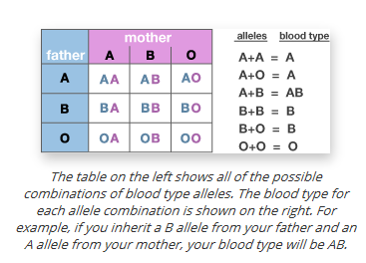Multiple alleles occur when a gene has more than two alleles. Human blood grouping is an example of this. Human ABO group is controlled by the immunoglobulin gene I which leads to the presence of different antigens on the cell-surface membrane of red blood cells.

* + The immunoglobulin gene has 3 alleles IA, IB, I0
  + alleles IA  leads to the production of antigen A
  + alleles IB  leads to the production of antigen B
  + alleles IO  does not lead to the production of either antigen
* Only 2 alleles can be present in a diploid cell → IAIB is codominant, I0 recessive
* [**http://learn.genetics.utah.edu/content/basics/blood/**](http://learn.genetics.utah.edu/content/basics/blood/)

**Question:**

Blood type is determined by 3 alleles. A and B are co-dominant. O is recessive.

Show how parents with blood type A and B can produce offspring with 4 different blood types.

Inheritance of Sex

One pair of the homologous pairs of chromosomes are the sex chromosomes which carry the genes coding for male and female sexual characteristics. The non sex chromosomes are called autosomes.

Humans have 23 homologous chromosomes, the first 22 are autosomes the 23rd pair are the sex chromosomes:

X = female sexual characteristics

Y = male sexual characteristics

Females are XX (homogametic) and produce eggs/ova that always have X chromosome present.

Males are XY (heterogametic) i.e. sperm produced can either have an X or Y chromosome:

**Cross a male and female**

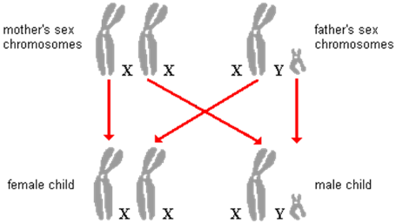Parental Phenotypes: male x female

Parental Genotypes: XY x XX

Gamete genotypes: X Y x X X

|  |  |  |
| --- | --- | --- |
|  | X | Y |
| X | XX | XY |
| X | XX | XY |

Punnett square: https://slideplayer.com/slide/9237237/

Offspring genotype: XX : XY

Offspring phenotype: Male : Female

Phenotype ratio: 1:1

# Sex linked inheritance

**Task:**

1. **Watch the video and follow the notes below**

[Inheritance problem 3 - Godalming College eStream - Powered by Planet eStream](https://estream.godalming.ac.uk/View.aspx?id=17130~59~q4KsSyoqW8)

1. Pause the video and complete the cross for colour blindness (below the notes)

Some alleles are carried on the **X chromosome** and not on the Y chromosome, so are described as **sex linked**.

The **Y chromosome** is much **smaller** than the X and carries **very few genes**, therefore in the male any **recessive genes** carried on the X chromosome will express themselves in the phenotype because the genes are unpaired i.e. on X not on Y, and so there is **no dominant gene** present

Jenny Graves,

<http://scitechconnect.elsevier.com/sex-genes-y-chromosome-future-of-men/>

This special form of inheritance is called **sex-linkage**. An example of sex-linkage is **Haemophilia** (failure to clot blood):

* Haemophilia is a potentially lethal condition. The gene that codes for **Factor VIII**, an important protein involved in blood clotting is a sex linked gene located on the X chromosome.
* The inability of the blood to clot leads to slow and persistent bleeding.

Sex linked disorder genetic diagrams use the allele letter superscript on the X chromosomes. Y chromosomes do not have an allele so have no letter:

* + XH XH – healthy female
  + XH Xh – carrier female
  + XhXh – affected female
  + XH Y – healthy male
  + Xh Y – affected male

Affected male Female carrier

X Y X X

H allele = normal blood clotting h allele = missing clotting factor

Non

homologous

h h H

**Question:**

Haemophilia is caused by a mutation in a single gene on the X chromosome.

Show how two healthy parents can produce a haemophiliac child and calculate the probability of this occurring.

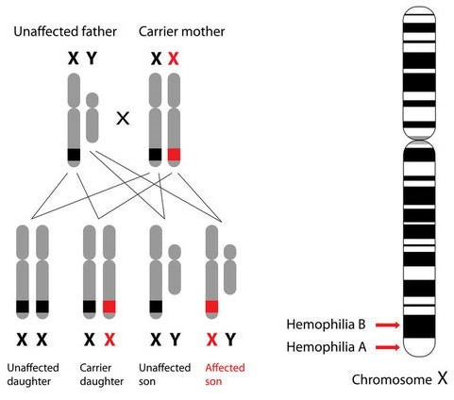Parental Phenotypes: carrier female x healthy man

Parental Genotypes: XH Xh x XH Y

Gamete genotypes: XH Xh x XH  Y

|  |  |  |
| --- | --- | --- |
|  | XH | Y |
| XH | XH XH | XH Y |
| Xh | XH Xh | Xh Y |

Punnett square:

<https://www.ck12.org/book/cbse_biology_book_class_xii/section/6.4/>

## Offspring genotype: XH XH : XH Xh : XH Y : Xh Y

Offspring phenotype: healthy female : carrier female : healthy male : haemophiliac male

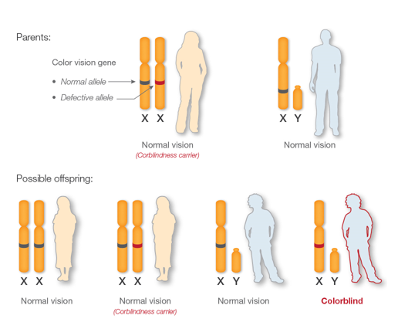Phenotype ratio: 1:1:1:1

There is a 25% or 1 in 4 chance of having a haemophiliac child

**Question:**

Colour blindness can be caused by a mutation in a gene on the X chromosome. The colour blindness allele is recessive

Work out the probability of two parents producing colour blind children if the mother is colour blind, and the father has normal vision. Draw a genetic diagram as above to show this cross.

**Dihybrid Inheritance**

Task:

1. Watch the video and follow the notes below

[Inheritance problems 4 - Godalming College eStream - Powered by Planet eStream](https://estream.godalming.ac.uk/View.aspx?id=17131~5a~RR8RCxzLsX)

1. Pause the video and complete your cross for the guinea pig question below the notes.

The inheritance of two genes (four alleles) from different homologous pairs of chromosomes is called dihybrid inheritance.

At meiosis the pairs of homologous chromosomes are separated, **one** of each pair into one of the two gametes formed. But there is **random/independent segregation** of chromosomes so all the allele combinations are possible:

Consider the inheritance of two genes:

Two pairs of homologous chromosomes

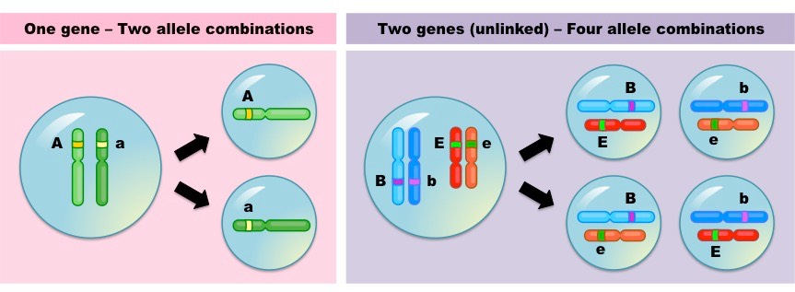Genotype: Aa Bb

A a

B b

https://ib.bioninja.com.au/higher-level/topic-10-genetics-and-evolu/102-inheritance/dihybrid-crosses.html

AB Ab aB ab = **Possible gametes**

**Cross 1:**

Seed colour and seed shape are 2 genes carried on different chromosomes. Yellow is dominant over green and round shape is dominant over wrinkled. The alleles are represented by the letters below.

* + Let R = round allele (dominant) r = wrinkled allele(recessive)
  + Let Y = yellow allele (dominant) y = green allele (recessive)

The genetic diagram below shows a homozygous dominant (for both genes) and a homozygous recessive being crossed.

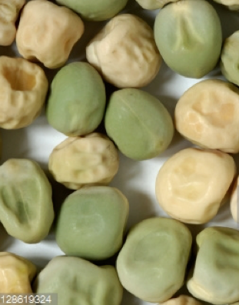Parental Phenotypes: round and yellow x wrinkled and green

Parental Genotypes: RR YY x rr yy

Gamete genotypes: RY x ry

## F1/Offspring genotype: all Rr Yy

F1/Offspring phenotype: all round and yellow peas

**Cross 2:**

If the F1  heterozygotes are crossed (from the diagram above), the genetic diagram below shows the possible F2 phenotypes and their ratios

Parental Phenotypes: round and yellow x round and yellow

Parental Genotypes: Rr Yy x Rr Yy

Gamete genotypes: RY Ry rY ry x RY Ry rY ry

Don’t include replicate gametes in a Punnett square in other crosses

|  |  |  |  |  |
| --- | --- | --- | --- | --- |
|  | RY | Ry | rY | ry |
| RY | **RR YY** | **RR Yy** | **Rr YY** | **Rr Yy** |
| Ry | **RR Yy** | **RR yy** | **Rr Yy** | **Rr yy** |
| rY | **Rr YY** | **Rr Yy** | **rr YY** | **rr Yy** |
| ry | **Rr Yy** | **Rr yy** | **rr Yy** | **­­­­rr yy** |

Punnett square:

## F2/Offspring genotype: **RR YY,RR Yy, Rr YY, Rr Yy, RR Yy, Rr YY,Rr Yy, Rr Yy, Rr Yy : RR yy, Rr yy, Rr yy : rr YY, rr Yy, rr Yy : ­­­­rr yy**

## F2/Offspring phenotype: **round and yellow : round and green : wrinkled and yellow : wrinkled and green**

Phenotype ratio: 9:3:3:1

**Question:**

Guinea pigs can be short or long haired. This trait is controlled by a single gene with 2 alleles. Short hair is dominant

Their hair colour can be white, black or grey. It is controlled by a single gene with 2 codominant alleles.

Use a genetic diagram to show the offspring produced by a guinea pig with grey, long hair, and one that is pure breeding for black short hair.

**Chi squared test (x2)**

A chi-squared test enables us to find the probability of the difference between the observed and expected numbers being due to chance and hence whether there is a significant difference and whether the genetic ratios are supported.

We can know if some other factor is responsible for the difference.

Looking at Mendel’s heterozygous dihybrid cross the **expected** ratio of phenotypes in the offspring is 9:3:3:1. This ratio represents the probability of getting these phenotypes.

|  |  |  |  |  |
| --- | --- | --- | --- | --- |
|  | round and yellow | round and green | wrinkled and yellow | wrinkled and green |
| Observed seed phenotype (total counted) | 315 | 108 | 101 | 32 |
| Phenotype Ratio  (from genetic cross) | 9 | 3 | 3 | 1 |

The Chi squared test (x2) is used to **compare** the **observed** results with those **expected**. It is a way of estimating the **probability** that **differences between observed and expected results** are due to **chance alone** and not some **other factor** influencing the results:

**How to do a chi-squared test.** Using the data above from a dihybrid cross.

1. Start with your **Null Hypothesis** e.g. There is no difference between the numbers observed in the experiment and those expected (according to the ratio) from the theory.
2. Calculate the expected values (E).
   * Add up all the parts of the ratio ( 9 + 3 + 3 + 1 = 16),
   * Add up all the numbers of observed individuals/phenotypes and divide by sum of ratio parts (16)
   * For each expected value multiple the above figure by the phenotype ratio

E.g. Expected seed phenotype ‘round and yellow = 315 + 108 + 101 + 32 x 9

16

= 313

1. Fill these in the ‘Expected’ column in the table
2. Calculate the difference between the observed (O) and expected (E) results
3. Square the differences
4. Use the formula to calculate x2 using the equation below
5. Calculate you chi-squared value

|  |  |  |  |  |
| --- | --- | --- | --- | --- |
|  | round and yellow | round and green | wrinkled and yellow | wrinkled and green |
| Observed seed phenotype (O) | 315 | 108 | 101 | 32 |
| Phenotype Ratio  (from genetic cross) | 9 | 3 | 3 | 1 |
| Expected number (E) | 312.75 | 104.25 | 104.25 | 34.75 |
| O - E | 315 – 312.75  = 2.25 | 108 – 104.25  = 3.75 | 101 – 104.25  = -3.25 | 32 – 34.75  = -2.75 |
| (O – E)2 | 5.0625 | 14.0625 | 10.5625 | 7.5625 |
| (O – E)2  E | = 0.016 | = 0.135 | = 0.101 | = 0.218 |

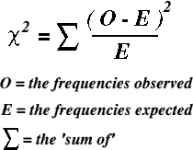

Need to add up all your values for (O – E)2/E

Chi-squared = 0.016 + 0.135 + 0.101 + 0.218

= 0.47

* Using the x2 table it is deemed that if the **probability** (P) is **5% or lower** (P<5%),e.g. 2%/1%, the difference between observed and expected results is said to be **significant** i.e. the difference is **not due to chance alone** and some **other factor** is influencing the results

|  |
| --- |
|  |

Calculated chi-squared value Critical value at p=0.05

**Using a probability table**

* Calculate Degrees of Freedom (DF): **Number of Categories – 1 or (n-1)**
  + We have 4 phenotypes, so we must find n-1 for degrees of freedom so 4 -1 = 3
* Look along the row for 3 degrees of freedom and find the critical value at P=0.05.
  + Critical value at p=0.05 is 7.81
* If the calculated chi-squared value is equal or larger than the critical value then the null hypothesis is rejected. The difference between the observed and expected results is significant and not due to chance
* If the calculated chi-squared value is smaller than the critical value then you accept the null hypothesis. The difference between the observed ad expected results is not significant and is due to chance.
  + The chi-squared value = 0.47 which is smaller than the critical value = 7.81 so the null hypothesis is accepted. Therefore, in this case the difference from the 9:3:3:1 ratio is not significant and is due to chance alone

**Autosomal Linkage**

Linkage occurs when **2 different genes** occur on the **same chromosome**. Therefore, genes on the same chromosome will tend to be **inherited together** because they move together during meiosis and appear in the same gamete.

**Worked example**

The genes for red hair and dimples are found on the same chromosome. Red hair is recessive. Dimples are dominant.

The dominant alleles are found on the same chromosome

What are the expected phenotypic ratios when 2 parents heterozygous for both traits had children.

Parental Phenotypes: non-red hair & dimples x non-red hair & dimples

Parental Genotypes: RrDd x RrDd

Genes R&D/r&d are linked together as they are on same chromosome

R r R r

D d D d

Gamete genotypes: RDrd x RDrd

|  |  |  |
| --- | --- | --- |
|  | RD | rd |
| RD | RRDD | RrDd |
| rd | RrDd | rrdd |

Punnett square:

## Offspring genotype: RRDD : RrDd : rrdd

Offspring phenotype: non-red hair & dimples : red hair & no dimples

Phenotype ratio: 3 : 1

There is a 0% chance of having a child with red hair and dimples, 75% chance of having a non-red haired child with dimples and a 25% chance of having a red haired child with no dimples.

Task:

1. Watch the video

[**Inheritance problems 5 - Godalming College eStream - Powered by Planet eStream**](https://estream.godalming.ac.uk/View.aspx?id=17208~5f~xexIbGDiGL)

1. **Pause the video and answer the question 1a and b below.**

**Question 1a**

Colour in *Drosophila* is determined by a single gene locus, with two alleles B (black) and b (brown). Black is dominant

Wing shape is determined by a single gene locus with two alleles, N (normal) and n (vestigial wings). Normal wings are dominant. The loci for these two genes are on the same (non sex) chromosome. B and N are linked. b and n are linked.

A female, heterozygous for both traits, was taken and crossed with true breeding, brown, vestigial winged male.

1600 offspring were produced.

Work out the phenotypes and calculate the expected number of offspring of each type.

Parent phenotype:

Parent genotype:

Gametes:

Punnett square:

F1 genotypes:

F1 phenotypes:

F1 ratio:

Expected number of offspring of each type (show your calculations)

………………………………………………………………………………………………………………………………………………………………………………………………………………………………………………………………………………………………………………………………

**Unusual Recombinants**

Sometimes unusual recombinants that are unexpected occur in autosomal linkage. Recombination of DNA occurs when alleles are exchanged as part of **crossing over** in meiosis. Crossing over can put new alleles together in combination on the same chromosome, causing them to go into the same gamete.

The **further apart** the 2 genes on a chromosome are, there **more chance** there is of **crossing over** taking place and the genes being **separated**.

**Question 1b**

The offspring were actually produced in the following ratio:

85 brown normal winged flies Genotype: ………………..

728 black normal winged flies Genotype: ………………..

712 brown vestigial winged flies Genotype: ………………..

75 black vestigial winged flies Genotype: ………………..

Write the genotypes of the flies above.

Explain why this ratio is different from your expected results.

………………………………………………………………………………………………………………………………………………………………………………………………………………………………………………………………………………………………………………………………………………………………………………………………………………………………………………………………………………………………

**Epistasis**

In epistasis the phenotypic expression of a gene at one locus alters that of a gene at a second locus. It is another example where Mendelian expected ratios do not occur.

Epistasis is the interaction of different gene loci so that the allele of one gene masks or suppresses the expressions of the alleles of other genes.

Task:

1. Watch the video

[Inheritance problems 6 - Godalming College eStream - Powered by Planet eStream](https://estream.godalming.ac.uk/View.aspx?id=17210~58~PtuQhod2y7)

1. Fill in the answers below

Flower colour in a particular species of plant is controlled by two genes, both of which code for enzymes. The gene A produces and enzyme that converts a white pigment to yellow. The gene B codes for and enzyme that converts yellow pigment to red.

Both genes have a non-functional allele that is recessive.

Use the video to draw a diagram in the space below to show how epistasis occurs in this scenario.

What are the possible genotypes for white flowers?

………………………………………………………………………………………………………………………………………………………….

**Pedigree Analysis**

Pedigree analyses are used to trace the inheritance of traits through generations so is a form of family tree.

The symbols in pedigree charts are always the same:

Each row represents a generation

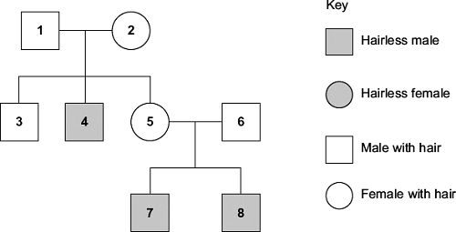

Squares represent males

Circles represent females

Line between individuals in a generation indicate parents

Shading represents individuals showing the trait

Questions involving pedigree analysis often want you to identify the genotypes of individuals and give evidence that the traits are recessive or dominant. Or give evidence that the trait is sex-linked or not.

When answering questions always:

* + Write the genotypes of individuals using the information you have been given.
  + Remember that each individual acquired one allele from each parent
  + Use a Punnett square if you need to help work out genotypes
  + Use the number of individuals given in the chart in your answers.

**Tips on answering pedigree analysis questions**

1. If a question asks; “What evidence is there that the disorder is recessive?”

Look for an **affected child** with **normal parents**

Answer: Both sets of parents are normal, and yet their children are affected. If the allele for disorder were dominant, then at least one of the parents would be affected.

1. If a question asks; “What evidence is there that this is not sex linked?”

Look for an **affected female** with a **normal father**

Answer: For female to be affected she must receive an allele for disorder

### from **both parents**. Father is **unaffected**, therefore **not** sex linked

### **Do not say: “Female is affected”**

**Task**

1. **Watch the video below**

**[Inheritance questions using pedigree analysis - Godalming College eStream - Powered by Planet eStream](https://estream.godalming.ac.uk/View.aspx?id=17699~5t~NVDsRyCO6E)**

1. **Follow the video and annotate and answer the questions below.**

(b)     Tay-Sachs disease is a human inherited disorder. Sufferers of this disease often die during childhood. The allele for Tay-Sachs disease **t,** is recessive to allele **T**, present in unaffected individuals. The diagram shows the inheritance of Tay-Sachs in one family.

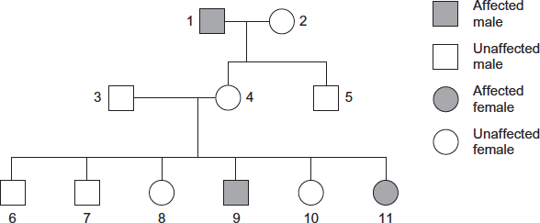

(i)      Explain **one** piece of evidence from the diagram which proves that the allele for Tay-Sachs disease is recessive.

______________________________________________________________

______________________________________________________________

______________________________________________________________

______________________________________________________________

**(2)**

(ii)     Explain **one** piece of evidence from the diagram which proves that the allele for Tay-Sachs disease is **not** on the X chromosome.

______________________________________________________________

______________________________________________________________

______________________________________________________________

______________________________________________________________

______________________________________________________________

**(2)**

**Stop the video and answer this question**

Duchenne muscular dystrophy is a sex-linked inherited condition which causes degeneration of muscle tissue. It is caused by a recessive allele. The diagram shows the inheritance of muscular dystrophy in one family.

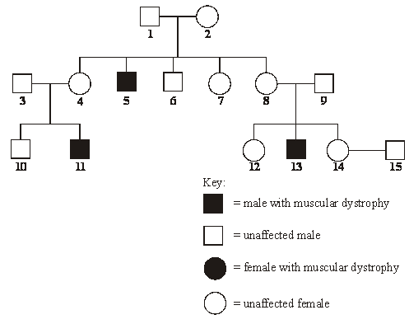

(a)     Give evidence from the diagram which suggests that muscular dystrophy is

(i)      sex-linked; _____________________________________________________

______________________________________________________________

**(1)**

(ii)     caused by a recessive allele. ______________________________________

______________________________________________________________

**(1)**

(b)     Using the following symbols,

**XD** = an X chromosome carrying the normal allele

**Xd** = an X chromosome carrying the allele for muscular dystrophy

**Y** = a Y chromosome

give **all** the possible genotypes of each of the following persons.

**5** _________________________________________________________________

**6** _________________________________________________________________

**7** _________________________________________________________________

**8** _________________________________________________________________

**(2)**

(c)     A blood test shows that person **14** is a carrier of muscular dystrophy. Person **15** has recently married person **14** but as yet they have had no children. What is the probability that their first child will be a male who develops muscular dystrophy?

___________________________________________________________________

**(1)**

**(Total 5 marks)**