**3.7.4. Investigating Populations**

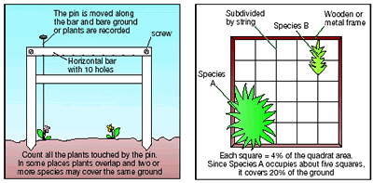**Specification Content**

The size of a population can be estimated using

randomly placed quadrats, or quadrats along a belt transect, for slow-moving or non-motile organisms.

**References**

Make sure you spend time consolidating work done in this lesson by reading back over the notes attached and reading text books and other references linked to this topic.

AQA Biology Text Book (Toole & Toole) Pg 481-483

Factsheets – found in Articles and Resources folder on Godalming online

| Word | Definition |
| --- | --- |
| Reliability |  |
| Validity |  |
| Bias |  |
| Abundance |  |
| Frame quadrat |  |
| Point quadrat |  |
| Belt transect |  |
| Random sampling |  |
| Systematic sampling |  |
| Frequency |  |
| Percentage cover |  |

**Why Investigate Populations?**

Ecologists need to know population sizes (i.e. counting numbers of individuals from samples) to:

* Study the dynamics of a population
* Look at the distribution of the members of a population to see if they are influenced by a biotic or an abiotic factors
* Compare differences between communities and species
* Impact assessments (measuring effects of disturbance from changes in ecosystems)
* Restoration ecology (restoring ecological systems that have been damaged)
* Set harvest limits on commercial and game species (e.g. fish, deer, etc.)
* Controlling pest populations

**Difficulties with investigating populations**

It can be difficult or simply not possible to count all of the individuals in the target area.

Therefore you need to estimate population size using some form of sampling technique.

There are numerous types of sampling techniques. Some are designed for specific types of organisms (e.g. non-mobile vs. mobile animals).

**Quadrats** – used for non-mobile/sessile organisms (plants and invertebrates)

**Mark-release-recapture** – used for motile animals (covered in another lesson)

**Sampling**

The object is to collect as many randomly selected samples as possible (so as to increase the proportion of the total population sampled).

The accuracy of an estimate increases with the number of samples taken. This is because the number of individuals found in any given sample will vary from the number found in other samples. By collecting numerous samples, the effect of these variations can be averaged out.

The purpose for collecting the samples randomly is to avoid biasing the data. Data can become biased when individuals of some species are sampled more frequently, or less frequently, than expected at random. Such biases can cause the population size to be either over estimated or under estimated, and can lead to erroneous estimates of population size.

**Random Sampling**

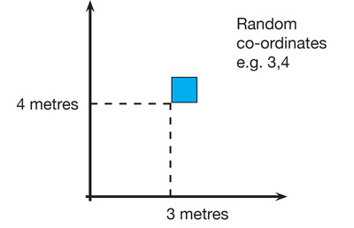

Method

1. Lay out 2 long tapes at right angles in the study area
2. Obtain a series of coordinates by using random numbers taken from a table or computer
3. Place a quadrat at the intersection of each pair of coordinates and record number of individuals of the target species.

**Systematic Sampling**

To investigate changes in habitats where there is an environmental gradient or along lines of succession (sand dunes, rocky shores) systemic sampling is more appropriate.

Line Transects

Transects are used:

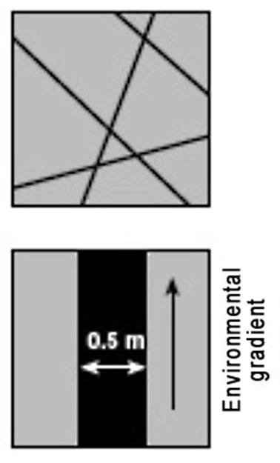**Line transect** - records all of the species which actually touch the rope or tape stretched across the habitat. A lot of organisms could be missed out so this method is less representative.

**Belt transect** – a frame quadrat is laid down along a straight line and species recorded in the transect

**Interrupted belt transect** - records all those species present in a number of quadrats places at fixed points along a line stretched across the habitat.

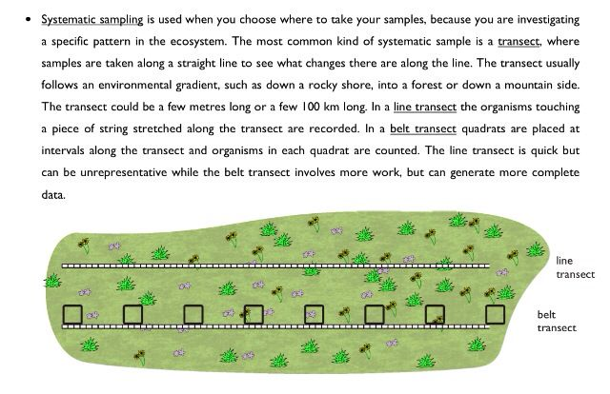

Belt Transect

**Line transect video**

<http://www.bing.com/videos/search?q=using+quadrats&&view=detail&mid=48C6E5A75A89FB9823BB48C6E5A75A89FB9823BB&FORM=VRDGAR>

**Using Quadrats**

The quadrat method is used primarily in studies of plant populations, or where animals are immobile.

**Size of quadrat** – depends on size of plants/animals and their distribution.

Larger species = larger quadrats

Species not evenly distributed = larger number of smaller quadrats

**Number of sample quadrats taken**

More sample quadrats = more reliable results

Greater number of species present = more quadrats samples needed

**Position of quadrat**

To produce statistically significant data random sampling used

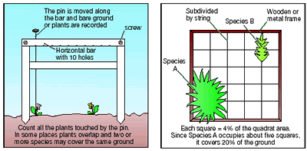

**Point Quadrats**

* This quadrat is made of a horizontal bar with 10 holes that a long pin can be dropped through.
* Each species the pin touches is recorded (hit).
* Used to estimate percentage cover where there is short vegetation (becomes difficult with long vegetation). It is less subjective than using frame quadrat so gives more reliable results.
* To calculate percentage cover = number of hits x 100

total number of pins

**Frame Quadrats**

* Squares of different sizes used to look at plant communities and small slow moving invertebrates.
* Can be used to look at abundance of species or simply species diversity
* It is assumed that the contents of a quadrat are representative of the whole sampling area
* Placed in different locations and abundance of each species recorded.

**Random sampling with a frame quadrat video**

[**http://www.bing.com/videos/search?q=using+quadrats&&view=detail&mid=45D8E03FDC5EF69EC1E545D8E03FDC5EF69EC1E5&FORM=VRDGAR**](http://www.bing.com/videos/search?q=using+quadrats&&view=detail&mid=45D8E03FDC5EF69EC1E545D8E03FDC5EF69EC1E5&FORM=VRDGAR)

**Measuring Abundance**

Abundance = the number of individuals of a species in a given area.

Using quadrats for sessile organisms, abundance can be measured in different ways.

1. Density*
2. Frequency
3. Percentage cover
4. Biomass*

*\*Your specification does not state the need for knowing density or biomass but it is useful to know these as they come up in other parts of the environment topic*

**Density**

Density = the mean number of individual per unit area.

Achieved by counting numbers of organisms within a quadrat

Advantage: objective measure

Disadvantage: time consuming if the size or number of sampling units is large

**Frequency**

Frequency = likelihood of a particular species occurring in a quadrat.

If a species is present in 15 out of 30 quadrats then the frequency of its occurrence is 50%.

Advantage: good method to use for species that are hard to count e.g. grass

quick assessment of general distribution

Disadvantage: no information about density and detailed distribution of a species

no measure of actual numbers of species

**Percentage Cover**

Percentage cover = estimate of the area within a quadrat that a particular species covers

Advantages: avoid needing to count individuals so is faster

useful for identifying species where it’s hard to see individuals e.g. mosses, lichens and sponges

Disadvantages: it can be difficult to do with overlapping organisms (plants)

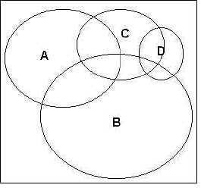To record percentage cover of species in a quadrat, look down on the quadrat from above and estimate the percentage cover occupied by each species (e.g. species A - D *left*).

Species often overlap and there may be several different vertical layers. Percentage cover may therefore add up to well over 100% for an individual quadrat.



The estimation can be improved by dividing the quadrat into a grid of 100 squares each representing 1% cover. If the plant takes up a square that will represent 1% cover.

This is only practical if the vegetation in the area to be sampled is very short, otherwise the string/wire will impede the laying down of the quadrat over the vegetation.

**Biomass**

Biomass = measure of the dry weight of plants and animals in a certain area

Advantage: Biomass can reflect the amount of energy stored in the vegetation, which can indicate the potential productivity at the site.

Disadvantage: Need to harvest organisms which is disruptive

Time consuming

**Investigating how the distribution of plants is affected by light intensity.**

You are going carry out a continuous belt transect from under the canopy of a tree into open space to investigate the distribution of plants whilst considering light intensity.

**Method.**

1. Run a tape from the fence out towards the library and lay the tape on the ground.
2. Starting at the fence (0m), place your quadrat down.
3. Observe and identify the plant species within the quadrat. You will need to use the key to identify any unknown plant species.
4. Record the percentage cover of the different plant species within the quadrat.
5. Move the quadrat to 1m and repeat steps 3-4.
6. Do this belt transect for 5m.

**Results sheet**

Date and weather conditions ……………………………………………………………………………………………………………………………………………………………………

Other observations

……………………………………………………………………………………………………………………………………………………………………

……………………………………………………………………………………………………………………………………………………………………

……………………………………………………………………………………………………………………………………………………………………

|  |  |  |  |  |  |  |  |  |  |
| --- | --- | --- | --- | --- | --- | --- | --- | --- | --- |
| **Distance from tree trunk (m)** | **Light reading (Lux)** | **Bare ground (%)** | **Moss**  **(%)** | **Common mouse-ear**  **(%)** | **Dandelion**  **(%)** | **Greater plantain**  **(%)** | **Fine-leaved grasses**  **(%)** | **Other**  **(%)** | **Total number of different species** |
| 0.0 |  |  |  |  |  |  |  |  |  |
| 1.0 |  |  |  |  |  |  |  |  |  |
| 2.0 |  |  |  |  |  |  |  |  |  |
| 3.0 |  |  |  |  |  |  |  |  |  |
| 4.0 |  |  |  |  |  |  |  |  |  |
| 5.0 |  |  |  |  |  |  |  |  |  |
| **Average** |  |  |  |  |  |  |  |  |  |

**Conclusion:**

Write a conclusion below. You should include detail on:

* Plant diversity (number of species) in relation to the light intensity
* Distribution of plant species in relation to light intensity
* Consider any other abiotic factors that could have affected your results

………………………………………………………………………………………………………………

………………………………………………………………………………………………………………

………………………………………………………………………………………………………………

………………………………………………………………………………………………………………

………………………………………………………………………………………………………………

………………………………………………………………………………………………………………

………………………………………………………………………………………………………………

………………………………………………………………………………………………………………

………………………………………………………………………………………………………………

………………………………………………………………………………………………………………

………………………………………………………………………………………………………………

………………………………………………………………………………………………………………

**Evaluation**

Write an evaluation below. You should consider the following:

* Were your results reliable and why?
* Was there any bias in your results and if so how could this have been avoided?
* What improvements would you make to this investigation? Include any follow up work that you could do.

………………………………………………………………………………………………………………

………………………………………………………………………………………………………………

………………………………………………………………………………………………………………

………………………………………………………………………………………………………………

………………………………………………………………………………………………………………

………………………………………………………………………………………………………………

………………………………………………………………………………………………………………

………………………………………………………………………………………………………………

………………………………………………………………………………………………………………

**Using a statistical test- Spearman’s Rank Correlation coefficient**

A Correlation coefficient allows you to work out the degree of association between different measurements from the same sample. It gives a value between 1 and -1. A value of 1 indicates a positive correlation, 0 means there is no correlation and -1 is a strong negative correlation.

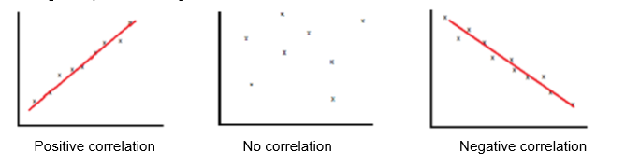

When the points on a graph clearly fit onto a line of best fit it is easy to determine whether a correlation exists. However, as the points become further placed from each other it is hard to make an accurate judgement. This is where statistics is used; to clarify how confident we are that a correlation exists.

When doing Spearman’s rank the two variables are used to construct the null hypothesis. The null hypothesis always assumes there is no relationship.

**“There is no correlation between (variable 1) and (variable 2)”**

Write a null hypothesis comparing light intensity (variable 1) and % Fine leaved grasses (variable 2)

……………………………………………………………………………………………………………………...........................................................................................................................................................................

**Rank the data**

For each set of data assign ranks from lowest to highest. The lowest value in a column will be

given the rank of 1, the next smallest number will be given a 2 etc. If there are tied scores each of those will share the ranks and be given the average (mean) rank.

|  |  |  |  |  |  |
| --- | --- | --- | --- | --- | --- |
| Light Intensity | Rank | % Fine leaved grasses | Rank | Difference between ranks (D) | D2 |
|  |  |  |  |  |  |
|  |  |  |  |  |  |
|  |  |  |  |  |  |
|  |  |  |  |  |  |
|  |  |  |  |  |  |
|  |  |  |  |  |  |

Next you have to work out D2 ; this is the difference in the rankings, squared

Then we calculate the value of Spearman’s rank correlation, rs, using the equation below.

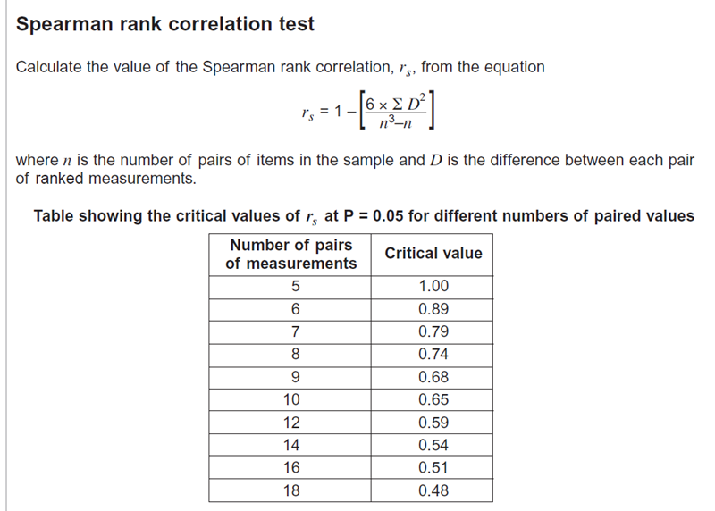

D = difference between the rank of the paired measurements

n = number of paired measurements (in this case n=6)

∑ = the sum of

Add up the D2 column to get ∑D2.

∑D2 =

Now using the eqaution above work out rs

**Interpret the results**

The closer rS is to 1 or -1 the more likely the correlation. A perfect positive correlation has an rS value of 1, a perfect negative correlation has a value of -1.

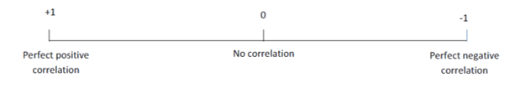

If the value lies between -1 and 1 we need to carry out a test for significance.

Before we can interpret our results we need to work out the ‘critical value’. The **critical value** represents the borderline between accepting or rejecting our null hypothesis.

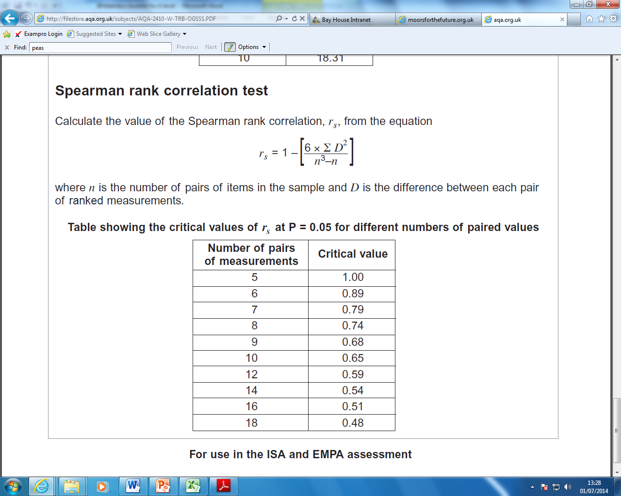

You have 6 paired values. What is the critical value? Critical Value = ……………….

Is your rs value greater or less than the critical value? ……………………..

If the calculated value is bigger than the critical value we must reject the null hypothesis. In doing this we are saying that there is a relationship (a positive correlation) between light intensity and % fine leaved grasses. What the critical value (where **p = 0.05**) means is that there is less than **5% probability** that the positive correlation between light intensity and % fine leaved grasses is **due to chance**.

If the rs value is **less** than the **critical value** then you must accept the null hypothesis, i.e. that there is no relationship (correlation) between light intensity and % fine leaved grasses.

Do you accept or reject the null hypothesis?

Use the paragraph below to interpret your statistical test results

The value of Spearman’s rank correlation coefficient, rs is **larger/smaller** than the critical value of ………….

There is **less/more** than 5% probability that the positive correlation between the light intensity and % cover of fine leaved grass is due to chance.

We **reject/accept** our null hypothesis.

.

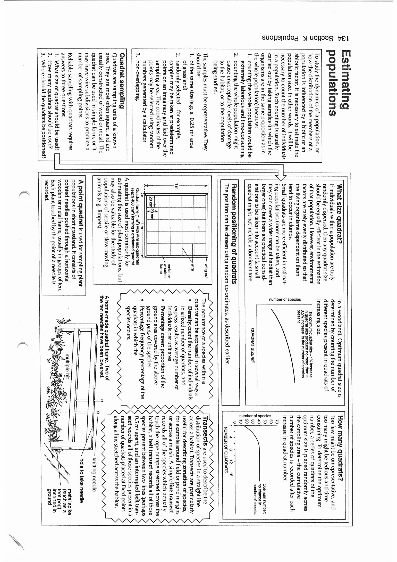

**Mark-release-recapture and Lincoln Index**

*How can the population size of a mobile organism be measured?*

**Background:**

The best way to measure the size of a population is to count all the individuals in that population. When determining the population sizes of trees or other relatively immobile organisms, this method is practical. If the organism is mobile, however, such as a fish, counting every individual would be difficult. Some individuals might be counted twice or not at all. In determining populations of a variety of species, one method biologists use is tagging. Sometimes the ‘tags’ are stickers, ear clips, or notches made in the fins of fish. The purpose of these tags is to track migration patterns, health, and range as well as to help determine population numbers of species in an area.

**Aim**

In this investigation, you will **model** a population of trout, capture and make a sample of the population, and then capture a second sample. You will then **estimate** the size of the model population using the Lincoln Index. The accuracy of the Lincoln Index will be inferred by counting the model population.

**Mark-release-recapture** (to estimate the size of a population)

* Capture a sample of animals (the sampling method will depend on the animal). The larger the sample the better the estimate works.
* Count all the animals in this sample (n1) and mark (using one of methods below) then so that they can be recognised later. Release all the animals where they were caught and give them time to mix with the rest of the population (typically one day).
* Capture a second sample of animals using the same trapping technique.
* Count the total animals in the second sample (n2), and the number of marked (i.e. recaptured) animals in the second sample (m).
* Calculate the population estimate using the Lincoln Index

**Lincoln Index**

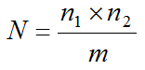N = population

n1 = total number first caught and marked

n2= total number caught in second sample

m = number of marked individuals in second sample

The Lincoln Index makes several assumptions that must be met if the estimate is to be accurate. These assumptions are:

* Proportion of marked to unmarked individuals in the second sample is the same as the proportion in the population as a whole
* Marked individuals released from the first sample distribute themselves evenly amongst the remainder of the population (and have time to do this)
* The population has a definite boundary – no immigration/emigration
* Few deaths and births
* Method of marking is non-toxic and does not make individuals more conspicuous and susceptible to predation
* The mark id not lost/rubbed off during the investigation

**Estimating trout population size using the Lincoln index**

**Materials**

* Paper bags with beans in – represent different habitats and a population of trout
* Permanent marker pens

**Testing the accuracy of the mark-release-recapture method of calculating population size**

Method

1. Collect your population of fish (either from lake A or lake B)
2. Remove a handful of beans from the model habitat. (More than 20 beans but less than half of the total population.)
3. Using a permanent marker pen draw a line on each side of the beans.
4. Count the beans and record this number as n1 for trials 1-6 in the data table.
5. Place the beans back into the habitat. Mix them well by shaking the bag.
6. Remove another handful of beans. Count the total number of beans in the second sample (n2) and record in the table.
7. Count the marked number of beans and record as m for Trial 1. (If m is zero, do this step over again.)
8. Return the organisms to their habitat and mix them well.
9. Repeat steps 6 & & five more times giving you a total of six trials.
10. Using the Lincoln Index, calculate N (population size)
11. Remove all beans and count the total population size and record this below your table. Put the beans back in the bag and keep on your table.

Data Table

|  |  |  |  |  |
| --- | --- | --- | --- | --- |
|  | **n1**  **Number of marked beans in sample** | **n2**  **Size of second (recaptured) sample** | **m**  **Number of marked beans recaptured in second sample** | **N**  **Population Estimate** |
| Trial 1 |  |  |  |  |
| Trial 2 |  |  |  |  |
| Trial 3 |  |  |  |  |
| Trial 4 |  |  |  |  |
| Trial 5 |  |  |  |  |
| Trial 6 |  |  |  |  |

Note: n1 will be the same for all trials**.**

**Actual population size:**  ………………………………..

**Analysis Questions**

1. Use your data to estimate the average size of the mobile population in the model habitat.
2. Calculate the percent error of the average population estimate calculated with the Lincoln Index to the actual size of the population. If you get a negative number, take the absolute value and make it positive.



1. Did your results differ greatly from the actual number of individuals in the model habitat? Discuss at least 3 factors that might affect the accuracy of your estimates.
2. To get an accurate estimate, why is it important that the beans “caught” during the first sampling are returned to the habitat unharmed?
3. When estimating an organism’s population size, why is it important that the time between first and second samples be a short time compared to the organism’s life span?
4. Based on what you observed in this exercise, do you think that the mark-recapture method is a good way to estimate population? Explain your answer.

**Using Student t-test to compare different population sizes.**

Statistical tests are used to analyse data mathematically so you can be more confident in your conclusions. The Student’s t-test is used when you have **two sets of data that you want to compare**. The t-test is used to test for a significant difference between two sets of normally distributed data. It compares the mean and standard deviation (the spread of the data) of both sets to determine if they are significantly different.

Lake A and B are situated close to each other, are similar ecosystems and the same size. Lake A however has been polluted for the last year and environmentalists would like to compare the population sizes of the trout in these lakes to see if the pollution has had an effect on the trout numbers.

Use the class data to do a student t-test to see if there are significant differences between the 2 lake trout populations’ sizes.

Null hypothesis:

1. **Collect the data from the class for each lake (use each groups average estimate)**

|  |  |
| --- | --- |
| **Estimated population sizes** | |
| **Lake A** | **Lake B** |
|  |  |
|  |  |
|  |  |
|  |  |
|  |  |
|  |  |
|  |  |

1. **Complete the table below**

Use your calculator to calculate the standard deviation

|  |  |  |
| --- | --- | --- |
|  | **Lake A** | **Lake B** |
| **Mean** |  |  |
| **n** |  |  |
| **s (standard deviation)** |  |  |
| **s2** |  |  |
| **s2 ÷ n** |  |  |

Where n = number of samples

1. **Calculate t**

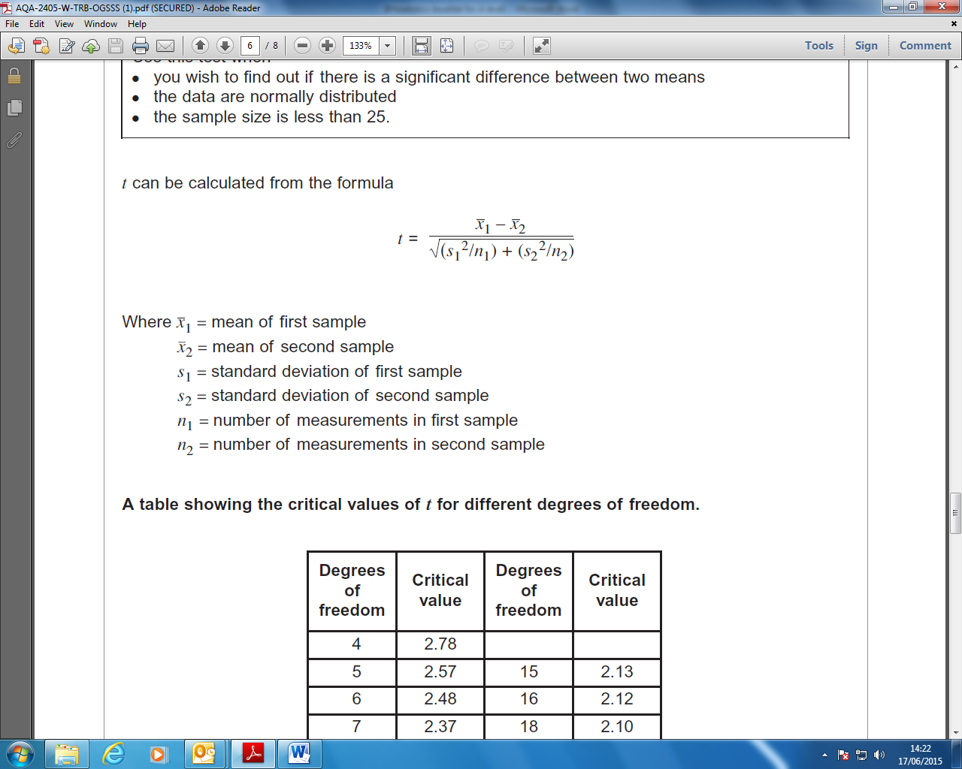

Calculations:

|  |  |
| --- | --- |
| **Degrees of freedom** | **Critical value**  **p = 0.05** |
| 8 | 2.306 |
| 9 | 2.262 |
| 10 | 2.228 |
| 11 | 2.201 |
| 12 | 2.179 |
| 13 | 2.16 |
| 14 | 2.145 |
| 15 | 2.131 |
| 16 | 2.12 |
| 17 | 2.11 |
| 18 | 2.101 |
| 19 | 2.093 |
| 20 | 2.086 |
| 21 | 2.08 |
| 22 | 2.074 |
| 23 | 2.069 |
| 24 | 2.064 |
| 25 | 2.060 |
| 26 | 2.056 |
| 27 | 2.052 |
| 28 | 2.048 |
| 29 | 2.043 |
| 30 | 2.042 |

Before we can interpret our results we need to work out the ‘critical value’. The critical value represents the borderline between accepting or rejecting our null hypothesis. We get the critical value from the data sheet, but this depends on the number of ‘degrees of freedom’.

'Degrees of freedom' is a term that can be bit confusing. A simple (though not completely accurate) way of thinking about degrees of freedom is to imagine you are picking people to play in a team. You have eleven positions to fill and eleven people to put into those positions. How many decisions do you have? In fact you have ten, because when you come to the eleventh person, there is only one person and one position, so you have no choice. You thus have ten 'degrees of freedom' as it is called. So 11 categories but only 10 ‘degrees of freedom’

In the student t-test you have to take into account that you are comparing **two** data sets. Therefore the degrees of freedom is always **n1+n2-2.** Where n is the number of measurements taken for sample 1 (n1) and sample 2 (n2).

1. **Work out the degrees of freedom of your data.**

n1 + n2 - 2 =

1. **Work out your critical value using the table provided. These critical values give 95% confidence.**

Critical value =

1. **Interpret your results using the paragraph below**

The calculated value of t is **less/greater than** the critical value of t.

There is **less/more** than 5% probability that the differences in the means (population of trout in lake A and population of trout in lake B) **are/not** due to chance.

We **accept/reject** our null hypothesis.