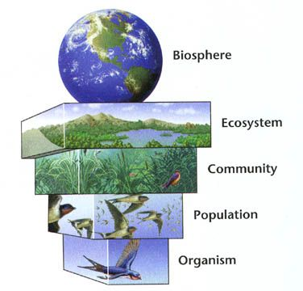**3.7.4 Populations in Ecosystems**

**Specification**

Populations of different species form a community. A community and the non-living components of its environment together form an ecosystem. Ecosystems can range in size from the very small to the very large.

Within a habitat, a species occupies a niche governed by adaptation to both abiotic and biotic conditions.

An ecosystem supports a certain size of population of a species, called the carrying capacity. This population size can vary as a result of:

* the effect of abiotic factors
* interactions between organisms: interspecific and intraspecific competition and predation.

The size of a population can be estimated using:

* randomly placed quadrats, or quadrats along a belt transect, for slow-moving or non-motile organisms
* the mark-release-recapture method for motile organisms. The assumptions made when using the mark-release-recapture method.

Ecosystems are dynamic systems.

Primary succession, from colonisation by pioneer species to climax community.

At each stage in succession, certain species may be recognised which change the environment so that it becomes more suitable for other species with different adaptations. The new species may change the environment in such a way that it becomes less suitable for the previous species.

Changes that organisms produce in their abiotic environment can result in a less hostile environment and change biodiversity.

Conservation of habitats frequently involves management of succession.

**Students should be able to:**

* show understanding of the need to manage the conflict between human needs and conservation in order to maintain the sustainability of natural resources
* evaluate evidence and data concerning issues relating to the conservation of species and habitats and consider conflicting evidence
* use given data to calculate the size of a population estimated using the mark-release-recapture method.

**Maths Skills**

* Students could use a logarithmic scale in representing the growth of a population of microorganisms.

**Introduction**

This topic looks at how living organisms form communities within ecosystems through which energy is transferred and elements are recycled.

Populations of different species live in communities and competition for survival arises both within and between these populations. Populations in a single community are affected by living and non-living factors in an ecosystem.

Ecology is the study of the inter relationships between organisms and their environment. The environment includes both non-living factors such as rain fall and temperature and living factors such as competition and predation.

**Preparatory Work**

Watch the following video: <https://www.youtube.com/watch?v=GlnFylwdYH4>

Use your text book to define all of the words written in **bold** in the specification. Make sure that you understand the definitions and aim to use this **key vocabulary** in your exam answers.

| Word | Definition |
| --- | --- |
| Population |  |
| Community |  |
| Ecosystem |  |
| Habitat |  |
| Niche |  |
| Abiotic |  |
| Biotic |  |
| Carrying capacity |  |
| Interspecific competition |  |
| Intraspecific competition |  |
| Predation |  |

The image below shows part of an oak woodland ecosystem. It is a **dynamic system** made up of a community and all the non-living factors of the environment. Look carefully at the diagram and answer the questions that follow.



Name two populations of organisms that are found within the oak woodland ecosystem.

…………………………………………….....

…………………………………………….....

…………………………………………….....

List four organisms that make up the community

…………………………………………….....

…………………………………………….....

…………………………………………….....

…………………………………………….....

Name three habitats within the oak woodland ecosystem.

…………………………………………….....

…………………………………………….....

…………………………………………….....

**Population Size**

Populations are **dynamic**, they **vary in size** and **composition** over time. Watch the following video that focuses on how the human population size has changed over time:

<http://www.npr.org/2011/10/31/141816460/visualizing-how-a-population-grows-to-7-billion>

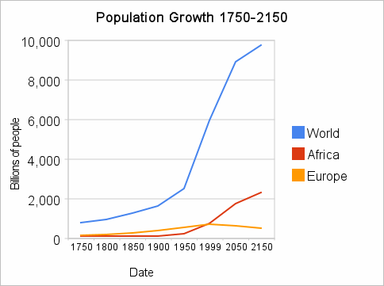The human global population has doubled in less than 50 years and now totals over 7 billion.

The video used glasses with coloured water to model how the population had changed over time.

What did water dripping **in** represent?

…………………………………………………………………

What did water dropping **out** represent?

…………………………………………………………………

The UN says that population will level out at 10 billion at the end of the century. Can the world hold that many people? What are the 3 main issues?

………………………………………………………………………………………………………….…………

………………………………………………………………………………………………………….…………

It is the balance between birth rate and death rate that determines whether a human population increases, decreases or stays the same. Individual populations are further affected by migration. What are the two types of migration?

………………………………………………………………………………………………………….…………

………………………………………………………………………………………………………….…………

What else effects population size?

………………………………………………………………………………………………………….…………

………………………………………………………………………………………………………….…………

**Maths Skills:**

* Population growth = (births + immigration) - (deaths + emigration)
* Percentage population growth rate = population change during the period x 100

(in a given period) population at the start

**Exam Question**

The figures below show some population statistics for a Country.

Total population at the start of 2007 = 1 million

Birth rate in 2007 = 25 per 1000 of population

Death rate 2007 = 20 per 1000 of population

Calculate the percentage population growth for this country in 2007. **Show your working.**

**How do Bacterial populations grow?**

Watch the following short you tube video <http://www.youtube.com/watch?v=UJ6ZXyHFK8Q> and then look at the small animation of bacterial growth on this site <http://www.biology.arizona.edu/biomath/tutorials/Applications/Population.html>

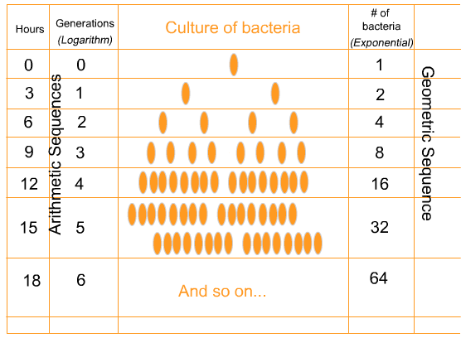

Under ideal conditions the population of bacteria doubles every 3 hours by ………………………… ……………………producing …………………………… **growth.**

Where a population grows in size slowly over a period of time it is possible to plot a graph of numbers against time. In the case of bacterial populations a simple graph of numbers against time has issues. Look at the data below and the graph of the data

|  |  |
| --- | --- |
| Time (hrs) | Number of bacteria |
| 12 | 10 |
| 24 | 100 |
| 36 | 1000 |
| 48 | 10000 |
| 60 | 100000 |

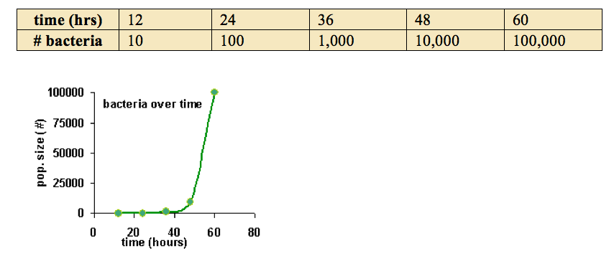

What’s the problem with the graph?

………………………………………………………………………………………………………….…………

………………………………………………………………………………………………………….…………

|  |  |  |
| --- | --- | --- |
| Time (hrs) | Number of bacteria | Log (number of bacteria) |
| 12 | 10 | 1 |
| 24 | 100 | 2 |
| 36 | 1000 | 3 |
| 48 | 10000 | 4 |
| 60 | 100000 | 5 |

Every hour, the number of bacteria increases by a factor of 10. A logarithmic scale is a multiplicative scale, it tells you how many times the number has been multiplied by 10.

In the table 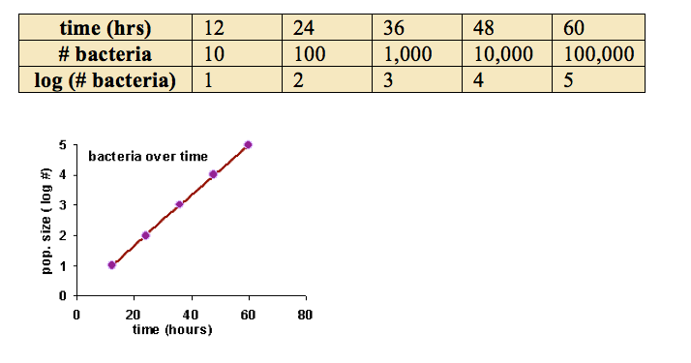below the log of the data has been taken and used to plot a new graph.

When growth happens by multiplying the population by a constant number each time step, we call it **exponential growth**. And any time you have exponential growth, taking the log of the population size will turn the graph into a straight line that is more meaningful.

**Look at the exam question below:**

Work out the logarithms of the bacteria shown and write them alongside the table.

Make sure you convert the number to millions first. Then use the log button on the calculator (put log in first then your number, in millions). Then answer the rest of the question.

A student prepared a pure culture of anaerobic bacteria into a nutrient medium and recorded the number of bacteria per cm3. The results are shown in the table

|  |  |  |
| --- | --- | --- |
| **Time (hours)** | **Number of bacteria(millions per cm3)** | **Log (number of bacteria)** |
| 0 | 1.0 |  |
| 1 | 1.0 |  |
| 2 | 1.0 |  |
| 3 | 1.2 |  |
| 4 | 1.8 |  |
| 5 | 3.5 |  |
| 6 | 6.9 |  |
| 7 | 13.8 |  |
| 8 | 28.0 |  |
| 9 | 57.0 |  |
| 10 | 113.8 |  |
| 11 | 225.0 |  |
| 12 | 375.0 |  |
| 13 | 440.0 |  |
| 14 | 460.0 |  |
| 15 | 482.0 |  |
| 16 | 484.0 |  |
| 17 | 486.0 |  |
| 18 | 488.0 |  |
| 19 | 488.0 |  |
| 20 | 488.0 |  |

Calculate the percentage increase in population size between 7 and 8 hours after introduction of the bacteria into the nutrient. Show your working.

[2]

………………………………………………………………………………………………………….…………

………………………………………………………………………………………………………….…………

………………………………………………………………………………………………………….…………

………………………………………………………………………………………………………….…………

How do you account for the low rate of population growth in the first three hours of the experiments?

[2]

………………………………………………………………………………………………………….…………

………………………………………………………………………………………………………….…………

………………………………………………………………………………………………………….…………

The stage of rapid growth in population size is described as being exponential. What is meant by the term exponential growth?

[1]

………………………………………………………………………………………………………….…………

………………………………………………………………………………………………………….…………

Give 2 reasons which could lead to a decline in population growth in this culture.

[2]

………………………………………………………………………………………………………….…………

………………………………………………………………………………………………………….…………

………………………………………………………………………………………………………….…………

………………………………………………………………………………………………………….…………

In the early stages the bacterial cells divide rapidly because all of the factors needed for growth are present. There are no **limiting factors**. In time, however, things change. For example:

* Nutrients are consumed as the population gets bigger.
* The population becomes so large that there is a buildup of toxic waste products
* There may be competition with other species
* Space becomes limited
* Disease could arise as a result of overcrowding

No population continues to grow indefinitely. Each has a certain size, a **carrying capacity** that can be sustained over a relatively long period. The **carrying capacity** is determined by the limiting factors.

**Limiting Factors**

Consider an island where we parachute in a pair of very young 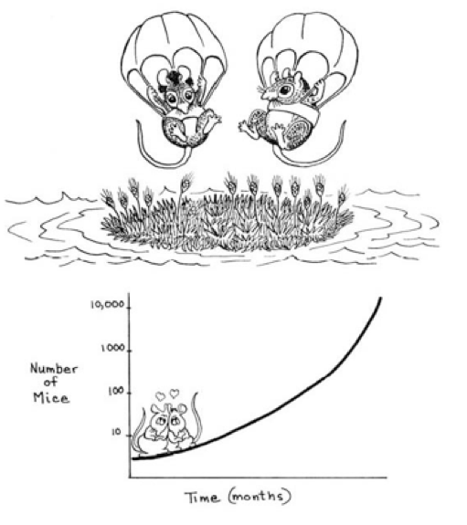mice. In the early stages population growth is slow. Why?

…………………………………………………………………………

…………………………………………………………………………

…………………………………………………………………………

Under ideal conditions exponential growth occurs.

What are the limiting factors? Use slides on GoL to help you.

Limiting factors that could slow down population growth

Indicate on the diagram which factors are abiotic and which are biotic?

**Abiotic factors**

Watch the following video [http://www.youtube.com/watch?v=rNfmew9C508 Bozeman](http://www.youtube.com/watch?v=rNfmew9C508)

The abiotic environment is the non-living environment. Abiotic factors would include temperature, humidity, pH, light, oxygen availability, water availability, volcanic eruptions, tsunamis and earthquakes. In harsh environments it is abiotic factors that govern who survives

Why are high temperatures an issue?

………………………………………………………………………………………………………….…………

Why are low temperatures an issue?

………………………………………………………………………………………………………….…………

Why is light a limiting factor?

………………………………………………………………………………………………………….…………

Why is pH a limiting factor?

………………………………………………………………………………………………………….…………

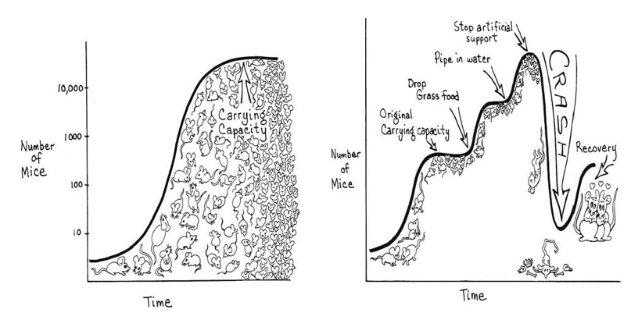

The population of mice stabilises at the carrying capacity. If one factor becomes in short supply, then this can limit the growth of the population, which then goes into decline. The population may fluctuate around the carrying capacity, but negative feedback mechanisms normally hold it close to the mean. What could cause a crash?

**Biotic Factors**

These are living factors such as competition for resources, predation, parasites, food supply and disease. In mild environments biotic factors govern who survives.

**Competition**

Where two or more individuals share any resource that is insufficient to satisfy all their requirements fully then competition results. Where such competition arises between members of the same species it is called intraspecific competition. Where it arises between members of different species it is termed interspecific competition.

**Intraspecific Competition**

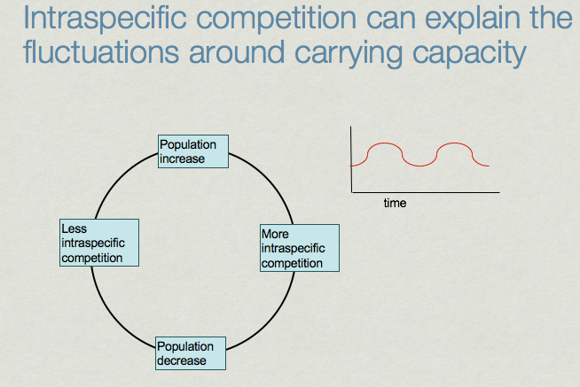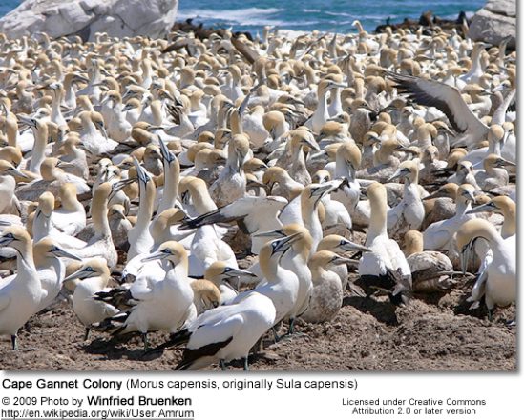

Give 3 examples of intraspecific competition:

1. ……………………………………………………………………………………..

2. ……………………………………………………………………………………..

3. ……………………………………………………………………………………..

**Interspecific**

Visit the virtual lab,Google Glencoe Mcgraw-Hill population virtual lab

<http://www.mhhe.com/biosci/genbio/virtual_labs_2K8/pages/PopulationBiology.html>

Follow the instructions and complete the results table and questions. Please note Questions 1 and 2 should be answered before you have collected data and after you have read the information about paramecia follow the instructions and complete the table and questions on the following page.

Print off your graph and attach it to the booklet.

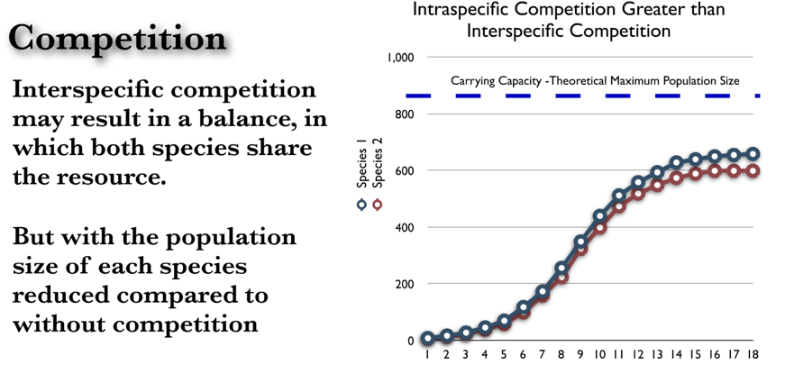Interspecific competition may result in a balance, in which both species share the resource.

But with the population size of each species reduced compared to without competition.

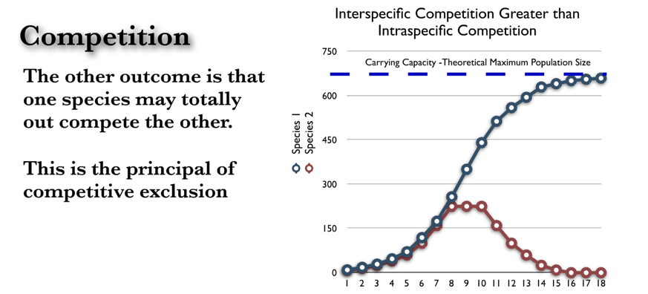

The other outcome is that one species may totally outcompete the other.

This is the principal of competitive exclusion

**Student Activity**

Research one more example of interspecific competition and write short notes below. Be prepared to share your example with your class.

**Predation**

The predator/prey relationship is a specific type of interspecific relationship. A predator is an organism that feeds on another organism, the prey.

As predators have evolved they have become better adapted for capturing their prey - faster movement, more effective camouflage, better means of detecting their prey. Prey have become equally adept at avoiding their predators - better camouflage, more protective features such as spines and concealment behaviour.

In other words the predator and prey have evolved alongside each other. If either of them had not matched the adaptations of the other it would most probably have become extinct.

**Effect of predator prey relationship on population size**

* Predators eat their prey, thereby reducing the population of prey.
* With fewer prey available the predators are in greater competition with each other for the prey that are left.
* The predator population is reduced as some individuals are unable to obtain enough prey for their survival or to reproduce.
* With fewer predators left, fewer prey are eaten and so more survive and are able to reproduce.
* The prey population therefore increases.
* With more prey available as food, the predator population in turn increases.

**Lynx and Snowshoe Hare Example**

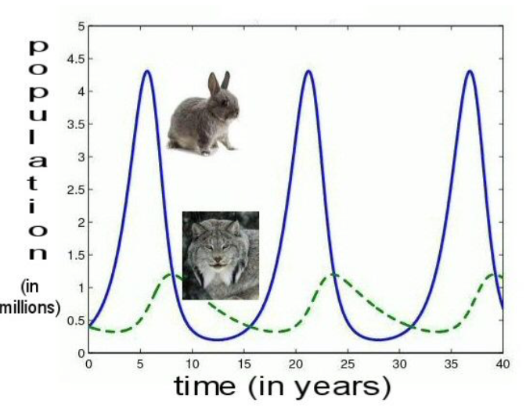

Use the information above to describe and explain the graph.

……………………………………………….

……………………………………………….

……………………………………………….

……………………………………………….

……………………………………………….

……………………………………………….

……………………………………………….

……………………………………………….

……………………………………………….

**Wolf and Moose Example**

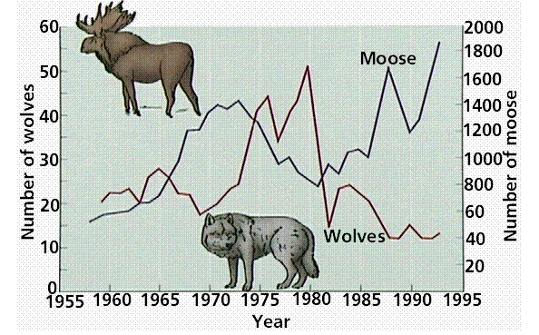

The graph shows fluctuations in predator (wolf) and prey (moose) populations over a 40-year span. Notice the effects of declines in the wolf population in the late 1960s and again in the early 1980s on the moose population.

Note

You should know the effect of predator prey relationships for your exams and be able to apply the information to new sets of data. Be mindful though that in natural ecosystems organisms eat a range of foods and so the fluctuations seen in the previous graphs are often less severe. Disease and climate can also play a role in population sizes.

Lab Investigations

Explain why a predator population often exterminates a prey population in a laboratory but rarely does it do so in natural habitats?

………………………………………………………………………………………………………….…………

………………………………………………………………………………………………………….…………

………………………………………………………………………………………………………….…………

………………………………………………………………………………………………………….…………

………………………………………………………………………………………………………….…………