**3.7.4 Populations and Ecosystems**

**Succession and Habitat Conservation**

**Section 1 – Recall**

**What does this section contain and why?** Activities to develop your recall of information you covered in the previous topics that are linked to succession. If you don’t have a mini whiteboard (MWB) please do invest in one, they are great for revision and recall. You should do this before you start the work on this topic. Once you have done the recall activity quickly check what you have done with the student booklets from that topic.

**Topics covered**: Carbohydrates

|  |  |  |  |
| --- | --- | --- | --- |
| **Topic** | **Recall activities** | **Understanding**  *Please write down any questions you have when completing this activity.* | **Completed** |
| **Ecosystems and populations and investigating populations** | On the MWB/scrap paper, define the following terms – abiotic, biotic, ecosystem, community, habitat and niche |  |  |
| On the MWB/scrap paper, draw a population curve showing how this would change and explain what factors control the carrying capacity |  |  |
| On a scrap piece of paper/MWB explain the difference between intraspecific and interspecific competition with examples |  |  |
| On a scrap piece of paper/MWB explain the difference between random and systematic sampling techniques and when you would use them |  |  |
| On a scrap piece of paper/MWB draw a predator-prey graph and explain the curves on the graph |  |  |

**Section 2 – Independent pack framework**

|  |  |  |  |  |
| --- | --- | --- | --- | --- |
| **Key info** | **Topic:** Succession  **Synoptic Link:** Populations and ecosystems, predation, competition, variation in population size and investigating populations  **Textbook pages: 484-499** | | | |
| **Step 1** | **Use the tutorial (GOL), presentation (GOL), video links and textbook to complete the pack.** | | | |
| **Step 2** | **Learning outcome** | **I understand this** | **I can recall this** | **I need to revisit this** |
| Understand that ecosystems are dynamic systems |  |  |  |
| Know the stages of succession starting from pioneers to climax community |  |  |  |
| Explain the stages of succession in terms of how hostile the environment is and how the abiotic and biotic factors change. |  |  |  |
| Explain the difference between primary and secondary succession |  |  |  |
| Know the names of the key species in the succession of bare rock |  |  |  |
| Explain how the conservation of habitats involves management of succession and can name the management activities |  |  |  |
| Understand the need to manage the conflict between human needs and conservation in order to maintain the sustainability of natural resources. |  |  |  |
|  |  |  |  |
| **Step 3** | **In lesson:** confidently work through activities to show your knowledge of the above | | | |

**Succession**

**Before starting this topic, watch the 2 videos below:**

1. Estream link
2. Bozeman succession video: <https://www.youtube.com/watch?v=V49IovRSJDs>

* Ecosystems are made up of all the interacting biotic and abiotic factors in a particular area within which there are a number of communities.
* A ***community*** consists of all the plants and animals that occupy a particular area.
* The individual populations within a community ***interact*** with each other.
* The community is a constantly changing and ***dynamic unit***, which passes through a number of stages from its ***origin*** to its ***climax***.
* Therefore, ecosystems constantly change, sometimes slowly, sometimes rapidly
* Succession is the term used to describe these changes

**Primary Succession**

Changes that organisms produce in their **abiotic** environment can result in a **less hostile** environment and change **biodiversity**.

The change in an ecosystem from initial colonisation to a stable state is known as **ecological succession**.

In the boxes below, sketch diagrams and notes to explain the different stages of succession.

**Primary succession – stage 1.**

**Primary Succession – stage 2**

**Primary succession stage 3**

**Primary succession final stage – climax community**

**Summary of Succession**

* pioneer species colonise an area and change the abiotic conditions.
* The environment become less hostile. It is now less suitable for the pioneers and new species colonise.
* The new species out-compete the existing species and they in turn change the abiotic conditions making it less hostile.
* In turn, these species are succeeded, until a stable state with a high ecological diversity is reached which is known as the climax community**.**

**Common features of succession**

* The non-living (abiotic factors) environment becomes less hostile which leads to
* A greater number and variety of habitats and niches which produces
* Increased biodiversity which leads to
* More complex food webs leading to
* Increase biomass

**Primary and secondary succession**

Complete the table below to show the differences between primary and secondary succession.

|  |  |  |
| --- | --- | --- |
|  | Primary succession | Secondary succession |
| Outline of the process |  |  |
| Specific examples of where it occurs |  |  |
| Speed of succession |  |  |

**Task: Sand Dune Succession**

Research sand dune succession using the presentation on GOL and the internet.

In the space below make a flow chart showing the stages of sand dune succession starting from the drift line to the climax community. You must add detail of the following:

* abiotic and biotic factors are each stage
* which species appear to be pioneers
* which species are dominant at each stage
* the species diversity (number of species present)
* any adaptations of individual species that you have researched

**Glossary**

Firstly, try and fill the definitions in without looking them up.

Then check your definitions with an A ‘level textbook or A ‘level website

|  |  |
| --- | --- |
| **Term** | **Definition** |
| Succession |  |
| Biomass |  |
| Biodiversity |  |
| Climax community |  |
| Pioneer Species |  |
| Ecological Niche |  |
| Abiotic factor |  |
| Biotic factor |  |

**Conservation of Habitats**

What is conservation? Conservation is the management of the Earth’s natural resources by humans in such a way that maximum use of them can be made of them in the future. This involves active intervention by humans to maintain ecosystems and biodiversity.

There are four main reasons for conservation

1. **Personal** - to maintain our planet and therefore our life support system
2. **Ethical** - respect for living things, other species should be allowed to coexist
3. **Economic** - living organisms have a huge gene pool and may have the capacity to make millions of substances
4. **Cultural and aesthetic** - habitats enrich our lives and inspire writers, poets etc who entertain and fulfil us

Why do we need biodiversity?

Go to this website <https://www.beep.ac.uk/content/182.0.html> and write short notes on each picture in the diagram above. Hold your mouse over each picture to get the information.

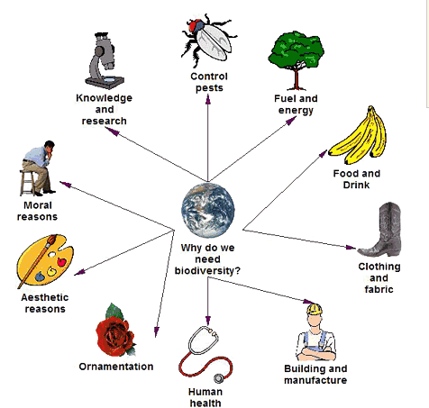

Management conservation by managing succession.

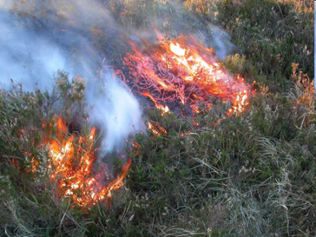

A climax community has undergone a series of successional changes to reach its current state. Many of the species that existed in the earlier stages are no longer present as part of the climax community. This is because their habitats have disappeared as a result of succession.

One way of conserving these habitats is by managing succession in a way that prevents a change to the next stage e.g. burning of heather and grazing sheep prevent formation of the climax community as young tree saplings are destroyed and therefore succession to a deciduous woodland is prevented.

**Heathland management**

Heathlands need to be carefully managed in order to maximize their conservation potential and prevent their succession to woodland habitats. To ensure a healthy habitat, managers of heathland sites should aim to achieve the following:

* Ensure the nutrient content of the soil remains at a low level.
* Reduce the cover of trees, scrub and bracken.
* Ensure the plants are different ages to create structurally diverse vegetation
* Meet the specific requirements of rare or threatened species.

There are several techniques available to heathland managers that may allow them to improve heathland habitats. These techniques include controlled burning, grazing, heather cutting, tree removal, turf stripping, bracken bruising and the chemical control of bracken. Each technique has advantages and disadvantages in relation to nutrient removal, control of trees, scrub and bracken, and the production of different aged/structurally diverse vegetation.

**Task**

Read through the environmental science fact sheet Habitat protection and management (on GOL) and answer the questions below.

a) Describe an example of arrested succession in the Factsheet.

b) Why does secondary succession proceed faster than primary succession?

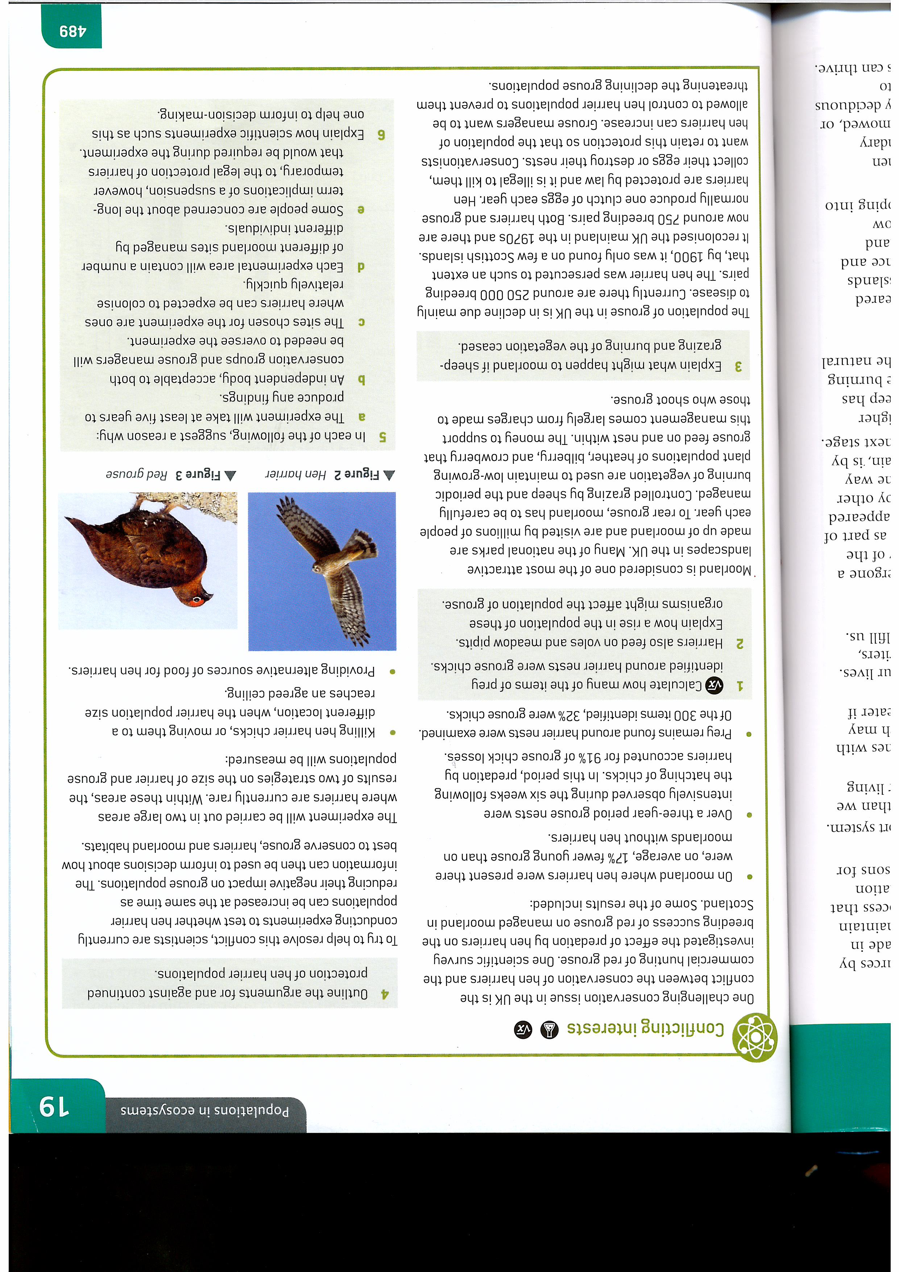Work through the questions below.

Answers to questions

1.

2.

3.

4.

5a.

b.

c.

d.

e.

6