**Godalming College**

Booklet Checked by: _____________

Grade: U/S 1 2 3

Comment: _______________________________________________________________________________________________________________________________________________________

**Sociology Department**

**Patterns, trends and explanations of inequality and difference:**

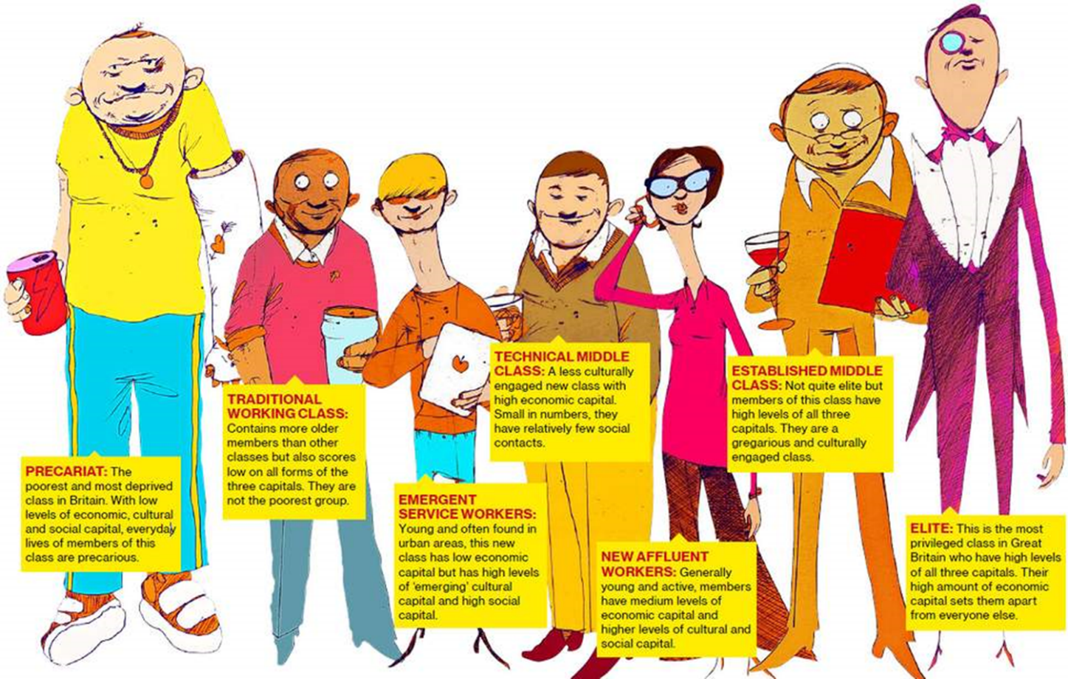**SOCIAL CLASS**

**Workbook 2: Stratification**

|  |  |  |
| --- | --- | --- |
| Name: | Set: | Group: |

**Learning objectives of this booklet**

* Demonstrate knowledge and understanding of social class and the difficulties of defining and measuring it (AO1).
* Demonstrate knowledge and understanding of the distinction between subjective and objective ways of measuring class and of different class schemas (AO1).
* Apply knowledge and understanding of problems of measuring class (AO2).
* Evaluate the strengths and weaknesses of different class schemas (AO3).
* Understand how the political focus on inequality in the UK has moved from class to social exclusion to ‘troubled families’ in recent years (AO1).
* Demonstrate knowledge of growing income and wealth inequality in the UK and how this can be explained (AO1).
* Apply knowledge and understanding of the links between class and life-chances (AO2).
* Analyse the links between class and life-chances (AO2).
* Analyse the links between class and life-chances in relation to education and health (AO3).
* Evaluate the continuing relevance of class inequalities to life-chances (AO3).

KEY WORDS

|  |  |
| --- | --- |
| Class |  |
| Inequality |  |
| Ascribed status |  |
| Achieved status |  |
| Meritocracy |  |
| Life chances |  |
| Blue collar worker |  |
| White collar worker |  |
| Stratification |  |
|  |  |

**PROBLEMS OF MEASURING AND DEFINING SOCIAL CLASS**

**What is social class?**

Class refers to economic differences between groups of people. These groups are arranged in some kind of hierarchy.

**Is class easy to define?**

Not really. Class are multifaceted and include at least 4 aspects:

* A shared economic situation.
* Shared attitudes, beliefs, values and behaviour e.g. class subcultures.
* Awareness of membership (class consciousness).
* Action to promote their shared interests (class action e.g. trade unions)

**What class do you think you are?**

**Why do you say this (or if you’re not sure, why is this?)**

**Define the concept OPERATIONALISATION**

**How could we operationalise class?**

**FOCUS ON SUBJECTIVE CLASS IDENTITIES: Mike Savage**

**Based on the different views of class that we have looked at on the powerpoint and Savage’s study, what problems are there with measuring class?**

**SCALES OF SOCIAL CLASS**

Using p.323-330 of Browne make notes of the following classification systems. Include their categories, usefulness, applications, probelsm etc.:

**Registrar Generals Classification system**.

**NS-SEC**

**The Hope-Goldthorpe Scale**

**Great British Class Survey (Savage et al, 2013)**

**A feminist alternative: the Surrey Occupational Class Scheme**

What subjective indicators might a sociologist use to measure class?

**DIMENSIONS OF INEQUALITY: SOCIAL CLASS**

|  |  |
| --- | --- |
| **ADVANTAGE** | **DISADVANTAGE** |
| **Workplace/income** | **Workplace/income** |
| **Education** | **Education** |
| **Politics** | **Health** |
| **Health** | **Crime** |
| **Wealth** | **Wealth** |

Outline two ways someone’s social class identity may advantage them in society [10 marks]

Outline two ways someone’s social class identity may disadvantage them in society [10 marks]

**THEORIES OF CLASS INEQUALITY**

Use the notes you already have on theoretical views of inequality, further research and p.195-197 of the OCR textbook (at the end of this booklet).

|  |  |
| --- | --- |
| Theory | Explanation |
| Functionalist |  |
| New Right |  |
| Marxist |  |
| Neo-Marxist |  |
| Weberian |  |
| Feminist |  |
| Postmodernist |  |

**CHANGING CLASS STRUCTURE IN THE UK: DEBATE**

**You will complete an A3 sheet, in addition to looking at the third powerpoint on Godalming Online. This will cover the key debates related to changes in the class structure in the UK.**

**More sources of info on this can be found in:**

OCR Sociology, Waugh, p.186-208 (at the end of your booklet)

Sociology AQA A-Level, Year 2, Chapman (at the end of your booklet)

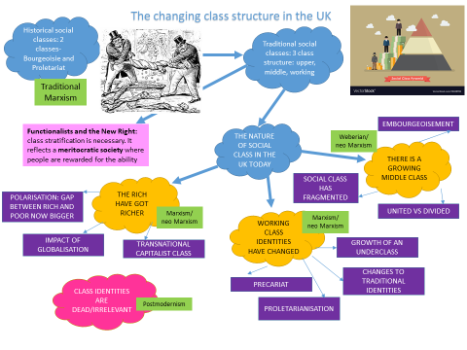Sociology for AQA, Browne (in the classrooms or library)

**Exam Practice**

Outline two ways someone’s social class identity may advantage them in society [10 marks]

Outline two ways someone’s social class identity may disadvantage them in society [10 marks]

Outline two reasons why it is difficult to state that the middle class is homogeneous in its identity [10 marks]

Outline two ways that globalisation has had an impact on the nature of social class identities in the UK today [10 marks]

Outline two ways in which the elite promote their shared (class) interests [10 marks]

Outline and explain two problems with using the occupation of the father to explain the social class position of the whole family [10 marks]

Outline and explain why consumption may not have replaced class as an indicator of social class (10 marks)

**Item A**

Postmodernists suggest that subjective class is as important as occupation in defining a person’s social class, as in our flued occupational structure an individual may change jobs many times, thus changing their identity. Consumption patterns may play a part in their self-classification. Marxists, however, would suggest that objective social class is the most important aspect of an individual’s position in society.

Applying material from Item A, analyse two problems with using subjective class as an indicator of an individual’s position in society [10 marks]

**Item B**

Marxists suggest that occupation is still the most efficient way of describing social class of both an individual and the family they belong to at any point in their lives. Most studies have concentrated on the occupation of the main in the household. Some feminists would argue that to fully understand the class position of a family the occupation of both parents should be considered.

Applying material from item B and your knowledge, evaluate the extent to which occupation is a useful indicator of an individual’s social class [20 marks]

Item A

Due to the deskilling of many occupations, both those formerly considered middle class and those considered working class, it no longer makes sense to speak of the UK as being divided into upper, middle and working class. Rather, sociologists argue there are a multitude of classes. However, Marxists would disagree.

Applying material from Item A, analyse two reasons for suggesting that class definitions based on occupation are no longer relevant to the UK today (10 marks)

Item O: The differences between the classes seem to be blurred to such an extent that many people would not define their social class in the same way that sociologists might. Some sociologists would even claim that class is a dead concept. Whereas other sociologists believe that despite the way that people reject the idea of social classes, it is still important in our society. We are just less aware of it than people were in the past. It affects our life chances and our life styles, with high earning people enjoying a superior standard of living and better life chances than those from more deprived backgrounds.

Applying material from Item O, analyse the view that social class is becoming less significant in the contemporary UK [20]

Analyse the view that the middle class does not have a united identity [20]

Analyse the view that social class is still an important feature of the contemporary UK [20]

**50:50 Extension Tasks**

To help reinforce your learning and understanding in A-Level Sociology it is important to go beyond the set homework. Knowledge only stays in our heads if it is regularly reinforced and built upon. These tasks will help you do so. It is up to you what you do as people learn in different ways but it is important that you spend the same time on your work as you do in lessons, so 50:50

Social class and stratification:

* Practice additional 10 mark questions
* Practice additional 20 mark questions
* - Create a quizlet or Kahoot for the different theories <https://quizlet.com/en-gb> <https://kahoot.com/>
* - Write the key concepts (which can be found in the booklet) as flashcards or as a quizlet.
* Read all of the textbook sources in the social class ‘reader’ and make notes on them – use these notes to add additional information to that in this booklet.
* Create a mindmap/notes that covers the following: measurements of social class (their differences, advantages/disadvantages and issues with using objective and subjective measures), theoretical views of social class, debates about the changes in the middle class, debates around whether class is still important, debates around whether there is a growing underclass in the UK.

**How the rich get richer** (shown on Channel 4 2014, Dispatches)

**London is home to more billionaires than anywhere on the planet**

**Over last 6 years we have endured:**

**What trends have we seen happen in the last 6 years that have further separated the rich and poor in this country?**

**2,500 top earning households had the same amount of wealth as the bottom 5 million before the crash, today it is closer to:**

**Compare the life expectancy of Park Head, to Down Hill in Glasgow, which are 5 miles apart from each other:**

**Why has social mobility become more difficult?**

**What has made the rich richer?**

**The richest 2,500 of households are how much more wealthy than they were in 2008?**

**How is the system against the people at the bottom of society?**

**What problems are there with the minimum wage and zero hours contracts?**

**Why would some people be better off on benefits?**

**Give some statistics for the poorest estates in the country?**

**What is the social divide between rich and poor (relate to education and work opportunities)**

**Wealth Inequality in the UK video notes** (link on Godalming Online)

Write down some key statistics from the ICM poll