**Godalming College**

Booklet Checked by: _____________

Grade: U/S 1 2 3

Comment: _______________________________________________________________________________________________________________________________________________________

**Sociology Department**

**Patterns, trends and explanations of inequality and difference:**

**Ethnicity**

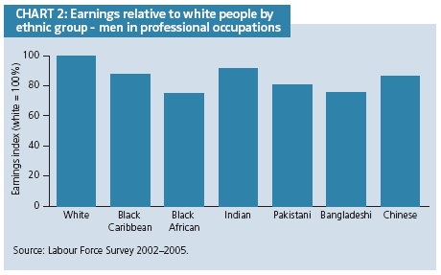

**Stratification Workbook 3**

|  |  |  |
| --- | --- | --- |
| Name: | Set: | Group: |

Ethnicity

**Expectations:**

You will be expected to complete this workbook using the material covered within lessons, as well as material on Godalming Online and within your OCR textbook.

If completed well this workbook should provide you with some useful revision materials for the upcoming examination.

We expect you to look regularly at the material on Godalming Online (including the extension materials to develop your understanding further.)

**It is your responsibility if you do not understand something to discuss this with your subject tutor.**

**Key Terms**

**Race & Ethnicity**

“**Race**” relates to supposed biological differences such as differences in skin colour, hair texture or shape of eyes between different social groups .

However, this term does not take into account significant cultural differences that may exist between people who would be categorised in the same “race”. E.g. people from the Indian subcontinent may all be categorised as belonging to the Asian race, but there are hundreds of different languages spoken and religions practiced by these people.

For this reason most sociologists do not consider “race” to be a meaningful concept, and some see it as a dangerous concept which can lead to the persecution of one “race” by another.

The term **ethnicity** relates to cultural differences which may exist between different social groups and sociologists see this term as more useful than “race” for the analysis of different social groups

**Racism and Associated Terms**

**Racism –** broad term relating to negative beliefs, attitudes and possibly actions towards a racial or ethnic group

**Intentional racism –** overt and conscious e.g. not offering work to a Pakistani Muslim woman because of her ethnicity

**Unintentional racism –** more hidden and covert e.g. school English curriculum which focuses on work of white British writers could be said to be **ethnocentric** in not valuing literary works from other cultures

**Racial Prejudice –** when people hold racist beliefs but do not necessarily act upon them

**Racial Discrimination –** *Acting* upon prejudices to disadvantage those from racial or ethnic backgrounds different to our own

**Cultural racism –** negativity relating to values and attributes associated particular ethnic groups e.g. ***Islamophobia –*** hostility towards Islam and those who practice it

**Institutional Racism -** The Lawrence Inquiry defined this as follows: *“The collective failure of an organisation to provide an appropriate and professional service to people because of their colour, culture or ethnic origin. It can be seen or detected in processes and behaviour which amount to discrimination through unwitting prejudice, ignorance, thoughtlessness and racist stereotyping that disadvantage ethnic minority people. It persists because of a failure of the organisation openly and adequately to recognise and address its evidence and causes by policy, example and leadership. Without recognition and action to eliminate such racism it can prevail as part of the ethos or culture of an organisation. It is a corrosive disease.”*  **In short it is to do with the institutions and organisations rather than individuals, and the way in which the practices and processes of these institutions can result in discrimination.**

**Classifying Ethnic Minorities**

The table below shows the way in which the government tried to classify ethnic groups at the last census in 2011, compared to 2001

[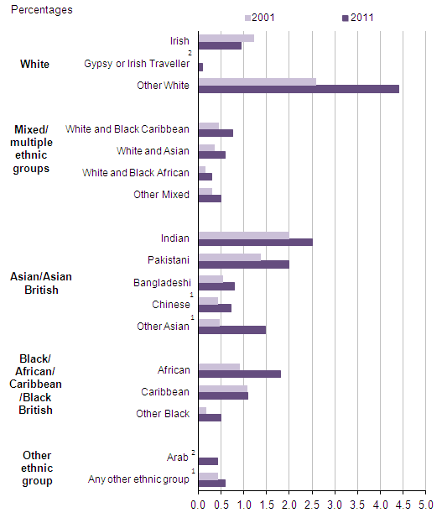](http://www.google.co.uk/url?sa=i&rct=j&q=&esrc=s&frm=1&source=images&cd=&cad=rja&uact=8&ved=0ahUKEwjI87W47NvKAhXKOhQKHdYiDpkQjRwIBw&url=http://www.ons.gov.uk/ons/rel/census/2011-census/key-statistics-for-local-authorities-in-england-and-wales/rpt-ethnicity.html&psig=AFQjCNHWLfkmK1p3KDCByTu08x0bSf_owg&ust=1454597590267182)

**Questions: 1. Can you see any problems with the categories used in the table above?**

**2. What issues might affect the reliability of the census data on ethnicity?**

**Inequalities relating to ethnicity:**

Sociological research shows that some ethnic groups are significantly disadvantaged in the contemporary UK, whilst others enjoy a relatively advantaged position. Using pages 221 – 223 of your OCR textbook, the other textbook sources on Godalming online, knowledge from other modules, and the PowerPoint presentation delivered in class (available on Godalming Online) include studies, statistics and contemporary evidence to show how ethnic inequality exists in following areas:

*(It is important that you supplement your notes from your textbook with notes from previous units and other source, as the textbook is a little “sketchy” on some of these sections).*

|  |  |  |
| --- | --- | --- |
|  | **ETHNIC GROUPS THAT ARE ADVANTAGED** | **ETHNIC GROUPS THAT ARE DISADVANTAGED** |
| Workplace |  |  |
| Education |  |  |
| Crime |  |  |
| Media |  |  |
| Politics |  |  |

**Theoretical explanations of patterns and trends in ethnic inequality:**

Using the information on pages 224-226 summarise how the different theories explain patterns and trends in ethnic inequality:

|  |  |
| --- | --- |
| **Theory:** | **Explanation** |
| Functionalism |  |
| Marxism |  |
| Neo-Marxism |  |

**Theoretical explanations of patterns and trends in ethnic inequality:**

|  |  |
| --- | --- |
| **Theory:** | **Explanation** |
| Weberianism |  |
| Postmodernism |  |
| **Which approach(es) do you feel offer the most valid explanations and why?** | |

**Key Terms:**

All of these words will be covered within your lessons. You should define these key terms in your own words to ensure your understanding. Wherever possible use an example to illustrate the term.

|  |  |
| --- | --- |
| **KEY TERM** | **DEFINITION** |
| Race |  |
| Ethnicity |  |
| Racism |  |
| Institutional Racism |  |
| Racial discrimination |  |
| Islamophobia |  |
| Super-diversity |  |
| Ethnic Penalty |  |
| Assimilation |  |
| Ethnocentricity |  |

**Key Studies:**

To achieve top AO1 (Knowledge and Understanding) marks, as well as AO2 (Interpretation and Analysis) marks you will also need to show awareness of relevant sociological research. As we go through this topic use your text book (pages 219-226) and any other sources to note down details of these pieces of research/sociologists:

|  |  |  |
| --- | --- | --- |
| **Study:** | **Perspective (and methodological approach if known/relevant)** | **Summary of study:** |
| Verotec | Postmodernist |  |
| Runnymede Trust |  |  |
| Macpherson (Stephen Lawrence Enquiry) |  |  |
| **Workplace** | | |
| Modood & Berthhoud (1997) |  |  |
| Heath & Yi Cheung (2006) |  |  |
| Mason (2003) |  |  |

**Key Studies:**

|  |  |  |
| --- | --- | --- |
| **Study:** | **Perspective (and methodological approach if known)** | **Summary of study:** |
| **Education (p75-79 in textbook)** | | |
| Sewell (1997) |  |  |
| Bolognani (2007) |  |  |
| Briggs et al (2006) |  |  |
| Archer & Francis (2006) |  |  |
| Wright (1992) |  |  |
| Gilbourn & Youdell (2000) |  |  |

|  |  |  |
| --- | --- | --- |
| **Study:** | **Perspective (and methodological approach if known)** | **Summary of study:** |
| Mirza |  |  |
| Strand (2008) |  |  |
| Coard |  |  |
| Sewell |  |  |
| Haynes (2006) |  |  |
| **Crime (p27-30 of textbook)** | | |
| Park (1950) | Functionalist |  |
| Castles & Kosack (1973) | Marxist |  |
| Hall et al (1979) |  |  |
| Gilroy (1983) |  |  |
| Desai (1999) |  |  |
| Abbas (2005) |  |  |
| Phillips & Bowling (2002) |  |  |
| Hood (1992) |  |  |
| **Media (p117-119 of textbook)** | | |
| Moore et al (2005) |  |  |
| Van Dijk (1991) |  |  |
| Malik (2002) |  |  |
| Barker (1999) |  |  |

**(Please note: This is not an exhaustive list of studies you can use, look through your OCR textbook for others, and also consider which studies you could use from the previous modules.)**

**Examination Questions:**

1. Outline two factors that can lead to the disadvantage of some ethnic groups in the UK [10]
2. Outline and explain two reasons why the occupational status of ethnic minorities may not offer a satisfactory understanding of their social class position [10].
3. Assess Weberian [or insert any other theoretical perspective covered in this booklet] explanations of ethnic inequality in the contemporary UK. **[20]**
4. **Item B: A truly open labour market is one where from an equal base everyone has the same chances of recruitment and advancement. It assumes that workers are employed and progressed on the basis of merit rather than privilege, favour or background.**

Applying material from item B and your knowledge, evaluate the view that an open and non-discriminatory labour market exists in the UK [20]*This question should use content from across the material covered on class, gender and ethnicity (and could eventually include age and disability]*