**Godalming College**

Booklet Checked by: _____________

Grade: U/S 1 2 3

Comment: _______________________________________________________________________________________________________________________________________________________

**Sociology Department**

**The nature and significance of social mobility: pulling together the topics of stratification**

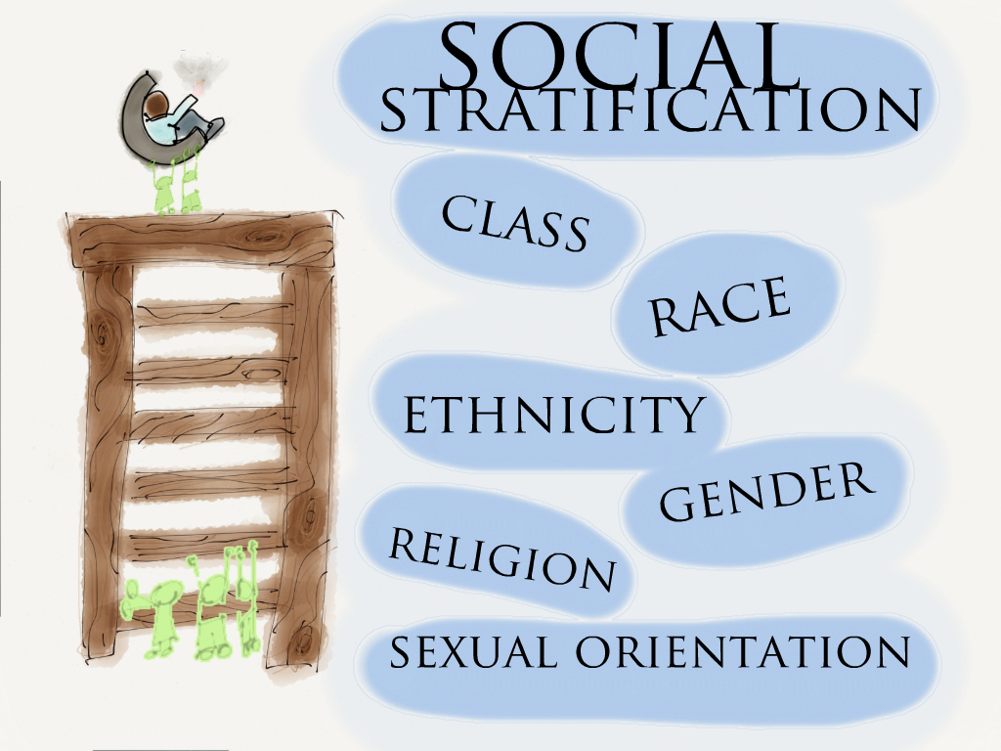

**STRATIFICATION WORKBOOK 6**

|  |  |  |
| --- | --- | --- |
| Name: | Set: | Group: |

**Issues to cover:**

What do we mean by social mobility?

Is our society meritocratic?

How do we measure social mobility?

What have different studies found?

Is there a difference between ethnic groups and gender?

**Key concepts**

|  |  |
| --- | --- |
| **OPEN SOCIETY** |  |
| **CLOSED SOCIETY** |  |
| **EQUAL OPPORTUNITIES** |  |
| **MERITOCRACY** |  |
| **SOCIAL MOBILITY** |  |
| **ABSOLUTE MOBILITY** |  |
| **RELATIVE MOBILITY** |  |

**What do we mean by the term SOCIAL MOBILITY?**

Social mobility is important sociologically because it represents the major way in which economic inequalities are legitimised in modern societies and because social mobility influences the formation of social class subcultures.

**Equal Opportunity**

The idea that we should all have an equal opportunity to be upwardly mobile is a relatively new idea. Well into the 20th century people were expected to ‘know their place’ and make the best of the life they had been given by chance.

**What social policies have enabled people to become socially mobile in the last 100 years?**

**Meritocracy**

**Today, at least on paper, the idea of equal opportunities is embraced by all political parties. The question is do all people have an equal chance of changing the nature of their lives for the better?**

What reinforces this view is that we live in a meritocratic society:

**What does the word meritocracy mean?**

How would different theories consider the concept of meritocracy?

|  |  |
| --- | --- |
| **FUNCTIONALISTS** | **MARXISTS** |
|  |  |

**New Right thinker Peter Saunders (2013) claims there are no social barriers to social mobility, arguing that the inequalities that we see in society are mainly the result of differences in effort and intelligence. He goes on to highlight four social mobility myths:**

1.That the UK has a serious problem with social mobility: *CHALLENGE - over ½ the population is now living in a different social class (compares to Goldthorpe’s three class schema) – the majority of people have moved up a social class.*

2. The problem is getting worse and the working class in particular have poor opportunities for mobility: *CHALLENGE - the middle class is shrinking but relative mobility has stayed the same.*

3. That intelligence is irrelevant: *CHALLENGE - this is not evident. More intelligent children end up doing better.*

4. Education reform is needed to achieve more social mobility: *CHALLENGE – hard work is more important. The education system is not biased against working class children.*

*CONCLUSION: the underclass is the problem (inadequate parenting, particularly lone parent mothers)*

**Sources of mobility**

**STRUCTURAL/ABSOLUTE MOBILITY:** this is where the shape of the stratification system changes e.g. more higher-status jobs increases, will lead to increased social mobility even if there is no change to the openness of the society.

**RELATIVE MOBILITY:** depends on how open the society is e.g. that you are not restricted to staying in the same social position as your parents. In our society today we are able to get jobs that are different to our parents, allowing us to intragenerationally change our social position.

Relative mobility is also relative to the chances of individuals from different social class positions being able to change their position i.e. Kellner and Whilby (1980) found sons with fathers with professional jobs were more likely to stay in this class than sons of working-class fathers. Education has a very significant impact on the potential for mobility.

**Social mobility studies**

**THE OXFORD MOBILITY STUDY (OMS)**

Conducted by Goldthorpe (1980) – used a large sample survey to examine the positions of sons in 1972 relative to their fathers.

Fathers and sons were classified on the 7-point Hope-Goldthorpe scale.

Found relatively high rates of both ‘long range mobility’ (movement across several classes) and ‘absolute mobility’ (changes due to an increase in higher status jobs).

This absolute mobility was linked to middle class families having fewer children, which led to more people from the working class being able to move into these jobs (which had also grown in number).

Problems: only looked at males, did not look at the very top level of the class structure.

**THE SUTTON TRUST and social mobility**

The Sutton Trust (2012)

Compared people born in the 1950s to those in the 1970s.

It found the current state of social mobility in the UK was actually quite low.

It also highlighted the disproportionately favourable effect of attending the most affluent independent schools e.g. 5 elite schools sent more pupils to Oxford and Cambridge universities than nearly 2000 state schools, which amounts to 2/3 of the entire state sector.

Unequal education is the key limiter to social mobility e.g. poorest fifth of families have seen graduation rates rise from 6 to 9%, for the richest it has gone from 20 to 47%.

Found social mobility is lower than for any other advanced country.

**CENTRE FOR ECONOMIC PERFORMANCE (2005)**

This study conducted by Blanden, Greg and Machin found relative social mobility was actually declining.

Used cohort studies from children born in 1958 and 1970 and found the 1970 cohort’s income was more closely linked to that of their parents than the 1958 cohort.

The study has been very influential in promoting the view that social mobility has stalled.

Problems with the research: started with a sample of 17,000 and ended with samples of 2000 – representative?

**Patterns and trends**

**Gender and social mobility**

As previously noted there are problems with mobility studies in that they have excluded women.

Goldthorpe (1980) in the Oxford Mobility Study argued that the family is the appropriate unit to measure social mobility and typically men make more money, therefore they are the better indicator. He later said that the inclusion of women made no difference in the relative deprivation, although there were differences in the absolute mobility.

Wilkinson (1994) argues at the end of the 20th century there was a ‘genderquake’ in female attitudes. Females were increasingly prioritising employment and careers over having children.

**Ethnicity and social mobility**

According to the Centre on Dynamics of Ethnicity (2013) ethnic minorities in Britain were experiencing increasing absolute upward mobility with the growth of managerial and professional employment, but still face significant barriers when compared to their white counterparts (relative mobility).

First generation immigrants have lower rates of social mobility than the rest of British society. But Platt argues (2005) second and third generation have experience rates of upward mobility similar to their white counterparts.

However second and third generations still face significant ethnic penalties in the labour market.

**Examination Questions:**

Outline and explain two ways that social mobility can be measured. [10]

Item: women are clearly doing a lot better than they were and now make up nearly half of the workforce. Women are upwardly mobile in absolute terms, but there remains a more sizable gender gap in terms of relative mobility.

Applying material from the item, analyse two reasons why women may experience less social mobility than men [10]

Item: A society is said to be open when there is movement of individuals between identified social strata in a society. Such movement is referred to as social mobility which can be both upward and downwards.

Applying material from the item and your knowledge, evaluate the view that the United Kingdom is and open society [20 marks]