**[](https://www.etsy.com/listing/160873125/musical-themed-digital-print-of-abstract?ref=tre-2723133043-13)**

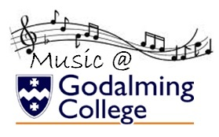

**As/a level**

**MUSIC**

**COURSE GUIDE**

Please email Ceilidh Botfield (Head of Music) if you have any questions regarding this course [CHB@godalming.ac.uk](mailto:CHB@godalming.ac.uk)



**James Ingham**

*Teacher of Music & Music Technology*

*Music Practitioners Qualification*

*Course Leader*

**JHI@godalming.ac.uk**

**Ceilidh Botfield**

*Head of Music & Music Technology*

*Arts Award Course Leader*

**CHB@godalming.ac.uk**

We are looking forward to teaching you!

Welcome to

|  |  |  |
| --- | --- | --- |
| **AS Level Music**  **(Standalone qualification)** | | |
| **Unit 1**  Performing | You will perform a recital of at least **6 minutes** of continuous performance that will be recorded. Minimum standard of playing should be **Grade 6.** | 30%  Coursework |
| **Unit 2**  Composing | You will compose **two compositions** – one from a choice of set briefs and the other can be a free composition or another choice from the set briefs. Total length of both compositions must be at least **4.5 minutes.** | 30%  Coursework |
| **Unit 3**  Appraising | You will study the following types of music: vocal, instrumental, film, pop and jazz, fusions and new directions. The exam will contain listening tests and essays on the set works and associated music. | 40%  1.5 hour exam |
| **A Level Music**  **(Standalone qualification)** | | |
| **Unit 1**  Performing | You will perform a recital of at least **8 minutes** of continuous performance that will be recorded. Minimum standard of playing should be **Grade 7**. | 30%  Coursework |
| **Unit 2**  Composing | You will complete one composition. This can be a free choice or chosen from a list of briefs. You will also complete one technical study from a choice of Bach Chorale, 2 part counterpoint, an arrangement or a remix. Combined, these compositions must total at least **6 minutes.** | 30%  Coursework |
| **Unit 3**  Appraising | You will study the following types of music: vocal, instrumental, film, pop and jazz, fusions and new directions. The exam will contain listening tests and essays on the set works and associated music. | 40%  2 hour exam |

[](http://www.google.co.uk/url?url=http://www.buryfocus.co.uk/news-features/83/ramsbottom/51374/rammys-got-talent&rct=j&frm=1&q=&esrc=s&sa=U&ved=0ahUKEwiom86U2crNAhVLL8AKHRWqAD04FBDBbgg4MBE&usg=AFQjCNE1-trheeGLR0sFGzzduoe_8TqrOw)AS LEVEL MUSIC

UNIT 1: Performance

The purpose of this component is to assess students’ performing skills in a solo and/or ensemble context. They should be given the opportunity to rehearse and refine performances on their chosen instrument or voice, developing technical control, expression and interpretative skills.

This component will encourage students to develop creative thinking, aesthetic sensitivity, critical awareness, self-confidence, self-motivation and their own musical interests and skills, including the ability to make music individually and/or in groups, and perform with control, using phrasing and dynamics appropriate to their chosen styles and moods of music.

Students must perform:

* A minimum of one piece, performed live and uninterrupted as a recital
* Performance can be solo, as part of an ensemble, improvisation, realisation using music technology, or a combination of these
* Total performance time across the recital must be a minimum of 6 minutes of music. Timing does not include the time taken to tune the instrument or any gaps between pieces.
* The average level of the pieces performed should be of at least grade 6 standard.

[Image result for music notes](http://www.google.co.uk/url?url=http://emodiva990.deviantart.com/favourites/56796853/Musical-Notes&rct=j&frm=1&q=&esrc=s&sa=U&ved=0ahUKEwialf7S2srNAhVhB8AKHfjvCEYQwW4IHjAE&usg=AFQjCNEyBvO-8CM5dWUIYgWLWn0PKHgciQ)as LEVEL MUSIC

UNIT 2: COMPOSITION

The purpose of this component is to assess students’ skills in composing music. It allows students to appreciate the process of creating music. Students will learn more of the processes involved in creating music through developing the technical and expressive skills needed by a composer.

Composing music is the creative process by which most of the music we experience came into being. Students will be encouraged to explore a range of compositional starting points, investigate a range of techniques for developing and manipulating ideas. They will then turn their ideas into completed pieces of music.

Students can also explore the skills needed to compose for different musical forces.

Students must submit two compositions, of a combined duration of at least four minutes and 30 seconds:

* One composition to a brief set by Pearson and one other composition, either free composition or also to a brief
* Each composition must be at least 2 minutes in duration.
* Total time across both submissions must be a minimum of four minutes and 30 seconds.
* Each composition carries 50% of the marks available for this component.

AS LEVEL MUSIC

UNIT 3: APPRAISING

The purpose of this component is for students to develop their listening and appraising skills through the study of music across a variety of styles and genres. The content is grouped into six areas of study, each of which contains two set works.

This component gives students the opportunity to reflect on, analyse and evaluate music in aural and/or written form. To achieve this objective they need to use their knowledge and understanding of musical elements, context and language to make critical judgements about the repertoire and context of music within the areas of study. These critical judgements will require the use of specific music vocabulary associated with a particular style or genre.

Students will learn the content of musical elements, context and language through six compulsory areas of study as listed below:

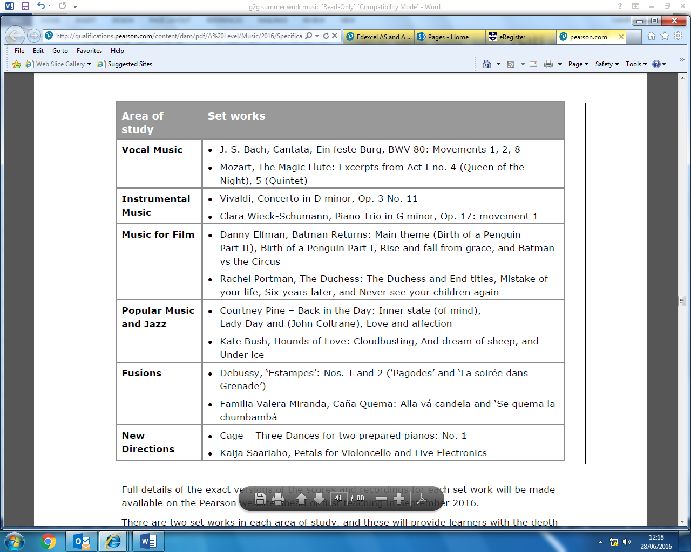

[](http://www.google.co.uk/url?url=http://www.endcliffeorchestra.org.uk/about-us/development-programme/performances-with-soloists&rct=j&frm=1&q=&esrc=s&sa=U&ved=0ahUKEwj-k66g28rNAhUrBMAKHbpeAB0QwW4IKjAK&usg=AFQjCNF8ZyotpjdR3ui-v1zVHcvdmObneA)A LEVEL MUSIC

UNIT 1: performance

The purpose of this component is to assess students’ performing skills in a solo and/or ensemble context. They should be given the opportunity to rehearse and refine performances on their chosen instrument or voice, developing technical control, expression and interpretative skills.

This component will encourage students to develop creative thinking, aesthetic sensitivity, critical awareness, self-confidence, self-motivation and their own musical interests and skills, including the ability to make music individually and/or in groups, and perform with control, using phrasing and dynamics appropriate to their chosen styles and moods of music.

Students must perform:

* A minimum of one piece, performed live and uninterrupted as a recital
* Performance can be solo, as part of an ensemble, improvisation, realisation using music technology, or a combination of these
* Total performance time across the recital must be a minimum of 8 minutes of music. Timing does not include the time taken to tune the instrument or any gaps between pieces.
* The average standard of the pieces performed should be at least grade 7 standard.

[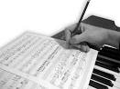](http://www.google.co.uk/url?url=http://cellobello.com/blog/index.php/composing-and-playing-music-how-composing-helps-your-playing/&rct=j&frm=1&q=&esrc=s&sa=U&ved=0ahUKEwjUrYTV28rNAhWKCcAKHSx_CYgQwW4IFjAA&usg=AFQjCNE4-arVOAuLg_lvZBPs7aALHLUP1w)

A LEVEL MUSIC

UNIT 2: composition

The purpose of this component is to assess students’ skills in composing music. It allows students to appreciate the process of creating music. Students will learn more of the processes involved in creating music through developing the technical and expressive skills needed by a composer.

Composing music is the creative process by which most of the music we experience came into being. Students will be encouraged to explore a range of compositional starting points, investigate a range of techniques for developing and manipulating ideas. They will then turn their ideas into completed pieces of music.

Students can also explore the skills needed to compose for different musical forces.

Students must submit two compositions, of a combined duration of at least 6 minutes:

* One composition (Free choice composition) can be chosen from six briefs relating to areas of study, or free composition, carrying 40 of the marks for the composing assessment. This composition must be at least 4 minutes in duration.
* One composition must be from a list of four briefs assessing technique, carrying 20 of the marks for the composing assessment. This composition must be at least 1 minute in duration.

A LEVEL MUSIC

UNIT 3: appraising

The purpose of this component is for students to develop their listening and appraising skills through the study of music across a variety of styles and genres. The content is grouped into six areas of study, each of which contains three set works.

This component gives students the opportunity to reflect on, analyse and evaluate music in aural and/or written form. To achieve this objective they need to use their knowledge and understanding of musical elements, context and language to make critical judgements about the repertoire and context of music within the areas of study. These critical judgements will require the use of specific music vocabulary associated with a particular style or genre.

Students will learn the content of musical elements, context and language through six compulsory areas of study as listed below:

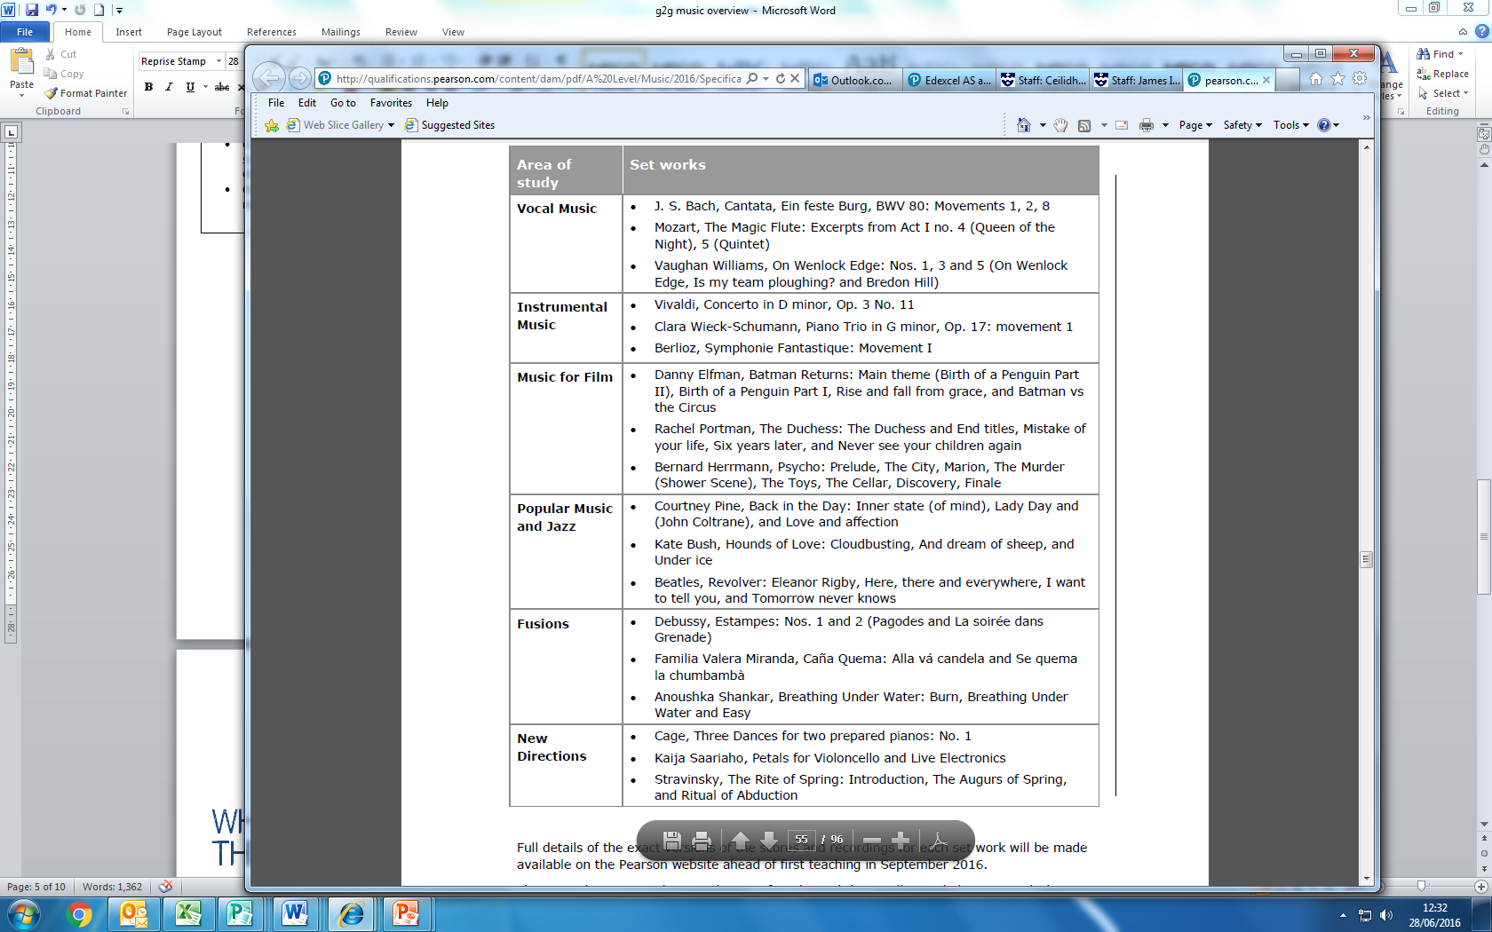

EXTRA SUPPORT OUTSIDE OF LESSONS

**Unit 1 Performance**

If you would like Ceilidh or James to listen to your recital at times other than mock and official recitals, please approach them about this. They are happy to listen to you perform and provide extra feedback during a mutually convenient time outside of lessons.

**Unit 2 Composition**

One to one tutorials with James are available outside of lessons throughout the year. Please approach him if you would like some extra support.

**Unit 3 Appraising**

Revision sessions will be held after college in the term leading up to the exam. It is our expectation that all students will make it a priority to attend these sessions. There may also be revision sessions at lunchtimes – please keep an eye on emails about this. Students are welcome to produce extra essays and or listening test answers at any point in the year. Ceilidh will always mark extra work. One to one sessions with Ceilidh are also available. Please approach her if you would like to book a session.

Don’t suffer in silence! We are always happy to help students!

Come and talk to us if you are ever worried about any aspect of the course. We want you to do as well as you possibly can.

☺

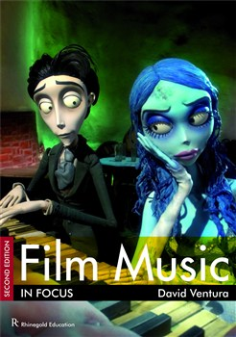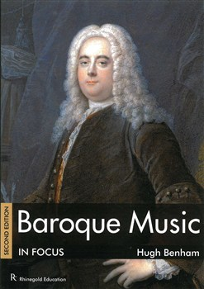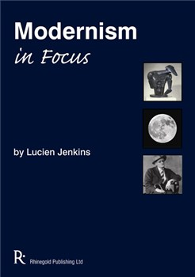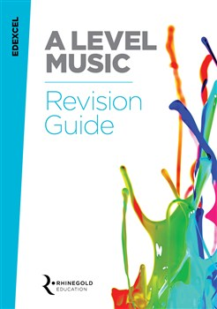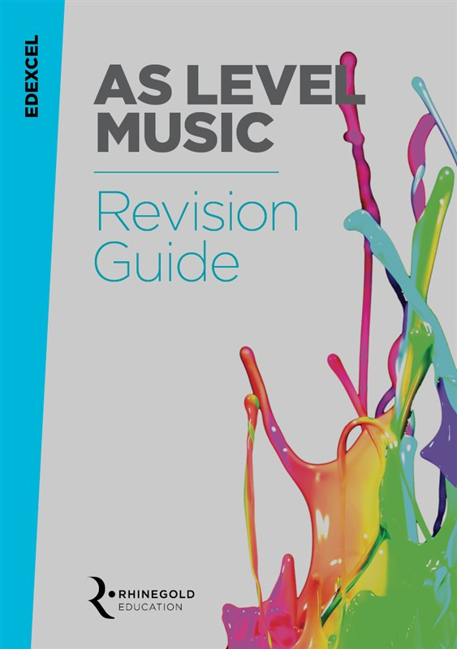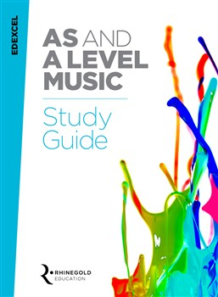SUGGESTED FURTHER READING

Film Music In Focus by David Ventura

Baroque Music In Focus by Hugh Benham

Edexcel A level Music Revision Guide

Edexcel AS level Music Revision Guide

*All books available for www.musicroom.com*

Edexcel AS & A level Music Study Guide

Modernism In Focus by Lucien Jenkins

Bringing in instruments

There is an instrument store cupboard that students are welcome to use. The key for this cupboard in kept in the Music office and can be accessed at any time between 8.15am-4.30pm. The college cannot accept responsibility for instruments left in the cupboard and it is advised that you take out instrument insurance. It is not recommended that you leave your instruments in the cupboard for long periods of time without checking on them.

Using practise rooms

You are welcome to use practise rooms at any point during the college day. The key for the practise rooms is kept in the Music office and can be accessed at any time between 8.15-4.30pm. Currently we do not have a booking system for practise rooms as there is almost always one free. If there becomes a problem with availability then a booking system will be instigated. Please leave practise rooms tidy and clear them when you leave. NO EATING OR DRINKING ALLOWED.

Music activities

There are a wide range of music activities and ensembles for students to join. It is expected that all Music A level students commit to at least one ensemble and attend the weekly rehearsals, however it is common for Music students to want to attend several different ensembles. Details of the ensembles running each year will be given to you at the start of September.

College concerts

There will be at least 3 big college concerts each year either held internally or at an external venue. There are likely to be some smaller performer opportunities, such as Recital Evenings too. Dates of concerts will be given at the start of September. It is expected that all Music students will participate in the concerts through performing in an ensemble and solo performance opportunities.

Progression from

Music A level

Every year we have a number of students progressing to top Music Colleges and Universities to study Music at degree level.

Here are some of the institutions that our Music A level students have progressed to in the last two years:

Birmingham University

Manchester University

Cardiff University

Southampton University

Durham University

Kingston University

Trinity College Of Music

Royal Welsh College of Music & Drama

Brighton Institute of Modern Music

Birmingham Conservatoire

Royal College of Music

Royal Academy of Music

Leeds College of Music

Oxford University

Surrey University

Berkley College of Music (USA)

Royal Holloway University

Leeds University

[](http://www.google.co.uk/url?url=http://www.abdn.ac.uk/alumni/benefits-services/replacement-degree-certificates-192.php&rct=j&frm=1&q=&esrc=s&sa=U&ved=0ahUKEwjmipzF0crNAhUqB8AKHeslA0EQwW4IFjAA&usg=AFQjCNHVAxNQ343uYwpzLeK1iuWNIBcdJQ)

CAREER PROGRESSION IDEAS FOR MUSIC GRADUATES

**Event management**

**Festival organising**

**Stage management**

**Teacher**

**Music software development**

**Record companies**

**Instrument technology**

**Sound engineer**

**Music publishing**

**Performance**

**Arts administration**

**TV and radio production**

**Music journalism**

**Music therapy**

**Composing**

**To find out more about Music careers, visit one of the following websites:**

**ISM Website (incorporated Society of Musicians) – “Careers with Music”**

<http://www.ism.org/training/article/careers_with_music_general_information>

**Careers in Music (more focused on popular music)**

<http://www.careersinmusic.co.uk/>

[](https://www.google.co.uk/url?url=https://www.pinterest.com/explore/treble-clef/&rct=j&frm=1&q=&esrc=s&sa=U&ved=0ahUKEwiB-5rIpsjNAhWFK8AKHYt2BVwQwW4IKjAK&usg=AFQjCNEEYpjnzgRar28tr4WMibr0ol3AJg)<http://www.careersinmusic.co.uk/music-jobs-and-opportunities/>

**UKP-Arts: Profiles of people working in music**

<http://www.ukperformingarts.co.uk/music/profiles/>

**Prospects – Graduate careers website**

<http://www.prospects.ac.uk/options_music.htm>