|  |  |  |  |  |  |  |
| --- | --- | --- | --- | --- | --- | --- |
| Piece | Composer | Approx. Length | Grade standard | Unaccompanied  solo? | CD backing track? | Piano accompaniment? |
|  |  |  |  |  |  |  |
|  |  |  |  |  |  |  |
|  |  |  |  |  |  |  |

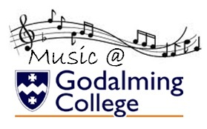

**REMEMBER! Your pieces should be grade 6 (or higher) standard and last for at least 6 minutes in total.**

**Any piano accompaniments must be given in by Friday 14th October; otherwise you will have to provide your own accompanist!**

AS music Recital Plan

Name: Instrument/Voice: