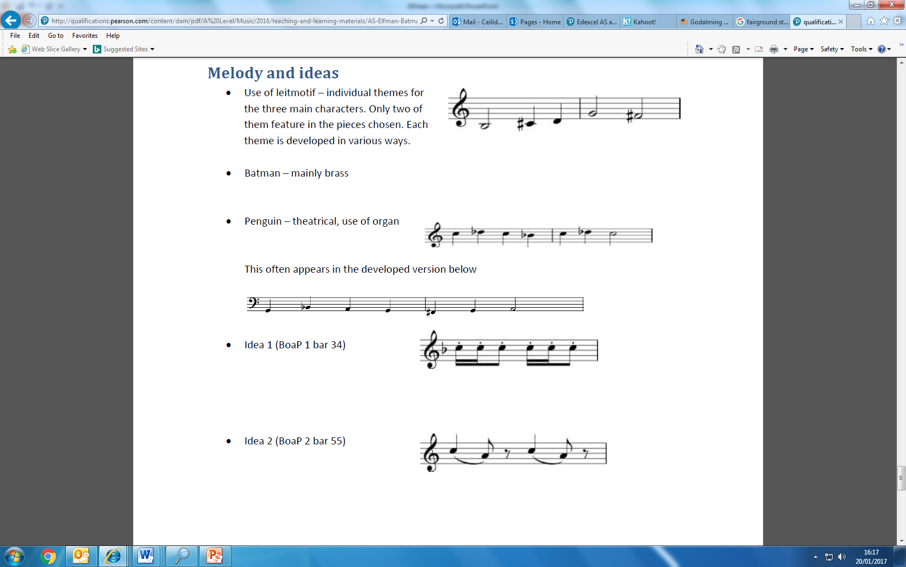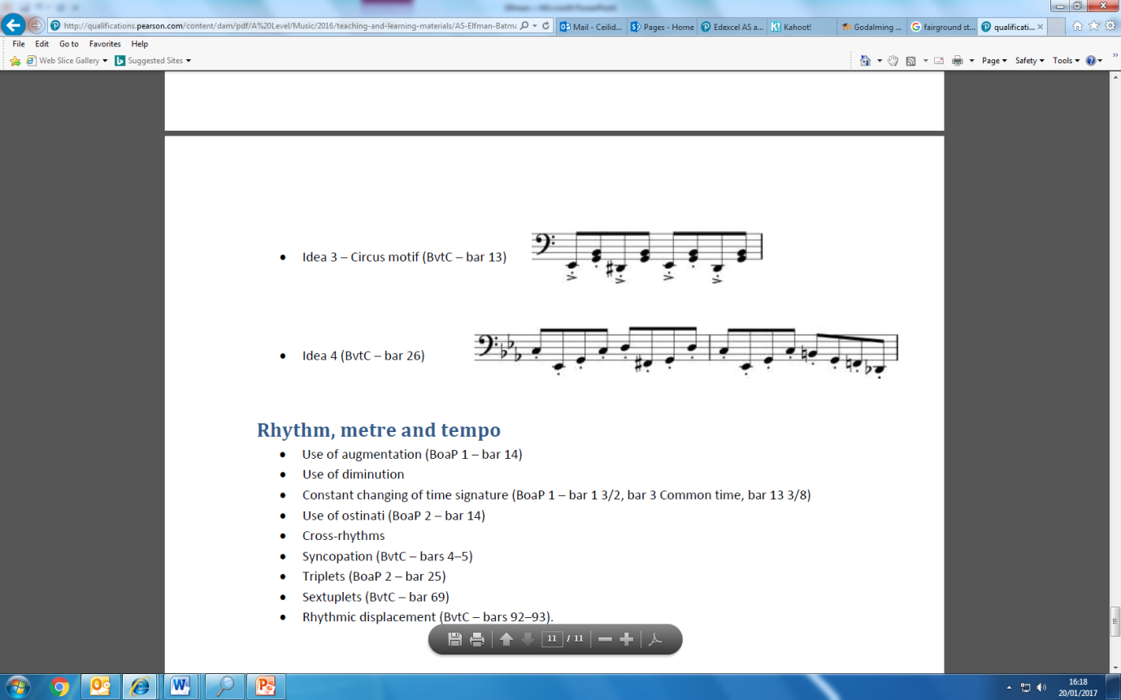[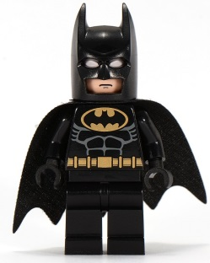](http://www.google.co.uk/url?sa=i&rct=j&q=&esrc=s&source=images&cd=&cad=rja&uact=8&ved=0ahUKEwivy9OxlNHRAhVG0hoKHfokBdUQjRwIBw&url=http%3A%2F%2Flego.wikia.com%2Fwiki%2FBatman_(Theme)&bvm=bv.144224172,d.d2s&psig=AFQjCNFjluQipmHVvQCJjwFat5xOMXtmbg&ust=1485016681852784)

**Other melodic ideas**

**Idea 1 (BoaP 1 bar 34)**

**Idea 2 (BoaP 2 bar 55)**

**Idea 3 ‘Circus motif’ (BvtC – bar 13)**

**BATMAN** Mainly appears brass instruments

**PENGUIN** Theatrical sounding, use of organ. Often appears in the developed version.

BATMAN RETURNS

**LEITMOTIFS** (A recurring idea associated with a person, theme or place)

[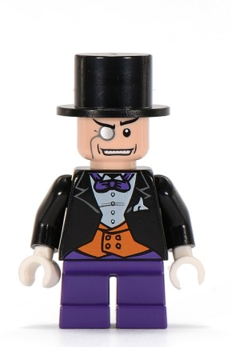](http://www.google.co.uk/url?sa=i&rct=j&q=&esrc=s&source=images&cd=&cad=rja&uact=8&ved=0ahUKEwjqwo7HlNHRAhVDExoKHffmDc0QjRwIBw&url=http%3A%2F%2Flego.wikia.com%2Fwiki%2FThe_Penguin&bvm=bv.144224172,d.d2s&psig=AFQjCNH7LWCfEZG9oSyfSXiD_p2roCzAgA&ust=1485016721180348)

**Idea 4 (BvtC – bar 26)**