**Learning Aim C - Create and Review Storyboards for Digital Creative Media Production**

In Learning Aim B you explored and produced a range of storyboards for various platforms; it is now time to choose **TWO** of these ideas to take forward to completion for **Learning Aim C**. Choose either your Moving Image, Animation or Video Game.

**TASK ONE** - Proposal

In Word, write a proposal based on your exploratory work (in Learning Aim B). You must produce a **proposal** outlining and **justifying** your final decisions on how the following will be presented within your **TWO** storyboard ideas. Use the below bullet points as subheadings in your proposal:

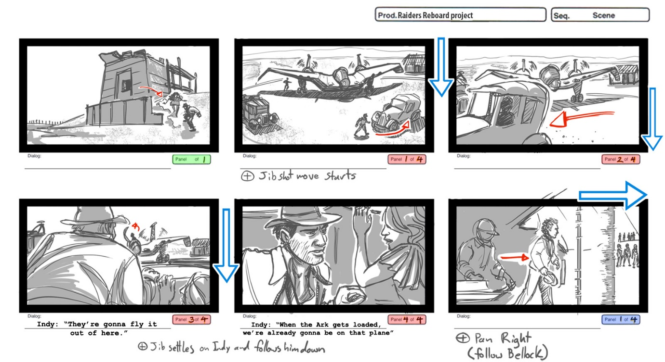● Format and aesthetic appearance

● Content

● Stage directions

● Character and location design

● Camera angles and movements

● Edits and transitions

● Sound content and sound cues.

Within the proposal you must include feedback on **fitness for purpose** and **ease of use** of your storyboards from your **teachers.**

**TASK TWO –** Producing the storyboards

Produce a detailed storyboard for **TWO** ideas; *12 panels.* All panels should fully communicate the following visual aspects:

* locations
* characterisation
* mise-en-scène

Annotations of panels must also identify the visual aspects, stage and camera directions, sound content and transitions:

* character movement
* camera movement
* camera angles and framing
* effects and transitions
* the use of diegetic and non-diegetic sound

You are encouraged to create your storyboard **to a larger scale** and **in colour.**

**TASK THREE -** Reviewing your storyboards.

Produce a PowerPoint reviewing the creative processes of producing your storyboards. You must also include reference to any changes made or considered in response to feedback from others.

You must also justify all your creative and technical decisions and evaluate the appropriateness and fitness for purpose of your storyboards, including;

● storyboard style/content/format

● drawing and design techniques used

● shot types, movements, angles and framing

● use of edits and transitions to create meaning

● sound directions

● suitability compared to original intentions

**EVIDENCE to be uploaded to your blog:**

* Proposal (Word doc)
* Final drafts of storyboard (A4 or A3 and in colour where possible)
* Reviewing of storyboard (PowerPoint)

Deadline for LA C Friday 1st July