**AS and A level French**

**Essay writing**

As a rough guide you should spend about 10 minutes planning your essay, 50 minutes writing it and 5 minutes checking it.

1. **Planning your essay:**

It is important to plan your essay well. Make points clearly and logically so that the examiner can follow your argument. Take time to devise a plan before you start writing. This avoids rambling account and allow a structure which is easy to follow. You might find that the following points help you to plan your essay well:

* Read the question carefully. Make sure you have understood what you are being asked to do (the question may be in two parts)
* If you are completing an AS examination, the question will also have a list of bullet points to help you focus on the question. Make sure you engage with this guidance points BUT be aware that they do not in themselves give you the structure of the essay!
* It is sensible to plan your essay in French. This will prevent you writing ideas you are not able to express in the target language.
* Focus on the key words. For example, you may be asked to analyse, evaluate, explore or explain.
* Select the main point you want to make in your essay and then break this down into 3 or 4 sub-sections. They will become your paragraphs.
* Choose relevant information only!
* Decide on the order of your paragraphs. It might be a good idea to keep your strongest idea for your last paragraph. Note down linking words or phrases you can use between paragraphs to make your essay flow as a coherent and logical argument.
* Select one or two relevant and concise quotations which you can use to illustrate some of the points you make.
* Think about the suggested word count for the essay. It should always be possible to write a meaningful essay within the allocated number of words. So try to answer concisely.
* Think about how to introduce and conclude your essay, ensuring that you have answered the question set.

You might find the following template helpful to plan your essay:

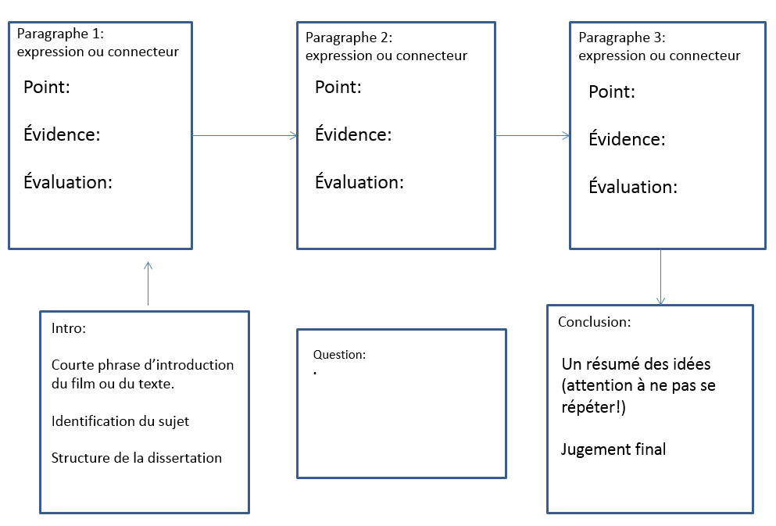

1. **Writing the essay:**

* Remember that you are writing for a person who is reading your essay: the content should be interesting and should communicate your meaning with clarity and coherence.
* Stick to your plan and do not get side tracked into developing an argument or a point that is not relevant to the question set.

**Structure:**

**Introduction:**

* It should be a single paragraph (approx. 5 lines)
* You can use a **short** sentence to introduce the film or the text you have studied.
* Show your understanding of the question: you should explain to your reader what you understand the question to mean, identify the issue it raises and how you are going to tackle them.

Example:

Question: Examinez le personnage de Saïd dans le film La Haine.

Introduction :

**Dans le film La Haine, Mathieu Kassovitz nous fait suivre la journée la plus importante de trois jeunes de banlieue. Aux premiers abords, les trois amis semblent similaires mais certains traits les distinguent. Je vais me concentrer ici sur le personnage de Saïd et analyser son rôle dans l’histoire.**

**Development :**

* This part will be divided into a number of interconnected paragraphs, each of which will pick up and develop the points raised in your introduction.
* Each paragraph should be introduced with a sentence stating what the paragraph is about.
* Make sure you are following a clear pathway through your paragraphs leading to your conclusion. You should move from one facet of your argument to the next, linking them conceptually by, for example, contrast, addition or comparison.
* Each paragraph must have an internal logic whereby you examine a separate point, making your argument, supporting it with evidence and possibly quotations and drawing conclusions.
* Try to have balanced paragraphs (with about the same amount of content).

Example (last paragraph):

**Enfin, ses origines sont un autre aspect très significatif de ce protagoniste. Saïd est maghrébin et il représente la communauté maghrébine dans les banlieues. À travers lui, Mathieu Kassovitz expose le problème de discrimination. En effet, Saïd fait référence à la façon dont ils sont traités lorsqu’il dit qu’ “un arabe dans un commissariat il ne tient pas plus d’une heure“. Une scène qui illustre bien cette citation est la scène du passage à tabac au commissariat de Paris et dans laquelle nous sommes témoins du traitement injuste dont les maghrébins sont victimes. Les intentions du cinéaste sont clairs, en utilisant le personnage de Saïd, il veut dénoncer l’ampleur du racisme qui existait dans les années 90, surtout par rapport aux jeunes descendants d’immigrés maghrébins issus des cités et perçus comme des boucs émissaires des problèmes de société.**

**Conclusion :**

* Read through what you have written again and THEN write your conclusion.
* It should summarise your arguments succinctly
* Be careful not to simply lift passages from your development!

Example:

**En guise de conclusion, je dirais que bien que Saïd soit un des trois personnages principaux, je pense que son rôle dans l’intrigue et le dénouement de l’histoire est secondaire comparé à Vinz et Hubert qui sont des personnages plus charismatiques. Cependant, il est essentiel de constater que le réalisateur lui a donné une fonction très importante qui est celle de représenter le peuple maghrébin dans les banlieues.**

1. **Check your work :**

* Review your essay carefully and check for errors of: grammar, punctuation, accents and spelling.
* Check especially: verb endings, tenses and moods, and adjectival agreements.
* You should employ a good range of vocabulary and include terminology related to film and literature.