Godalming College
Booklet checked by
Grade: U/S 1 2 3
Comments:

Sociology and Anthropology Department

THE ROLE OF EDUCATION IN SOCIETY
- Introduction to the sociology of education.
- Macro theories
- Educational policies since 1945

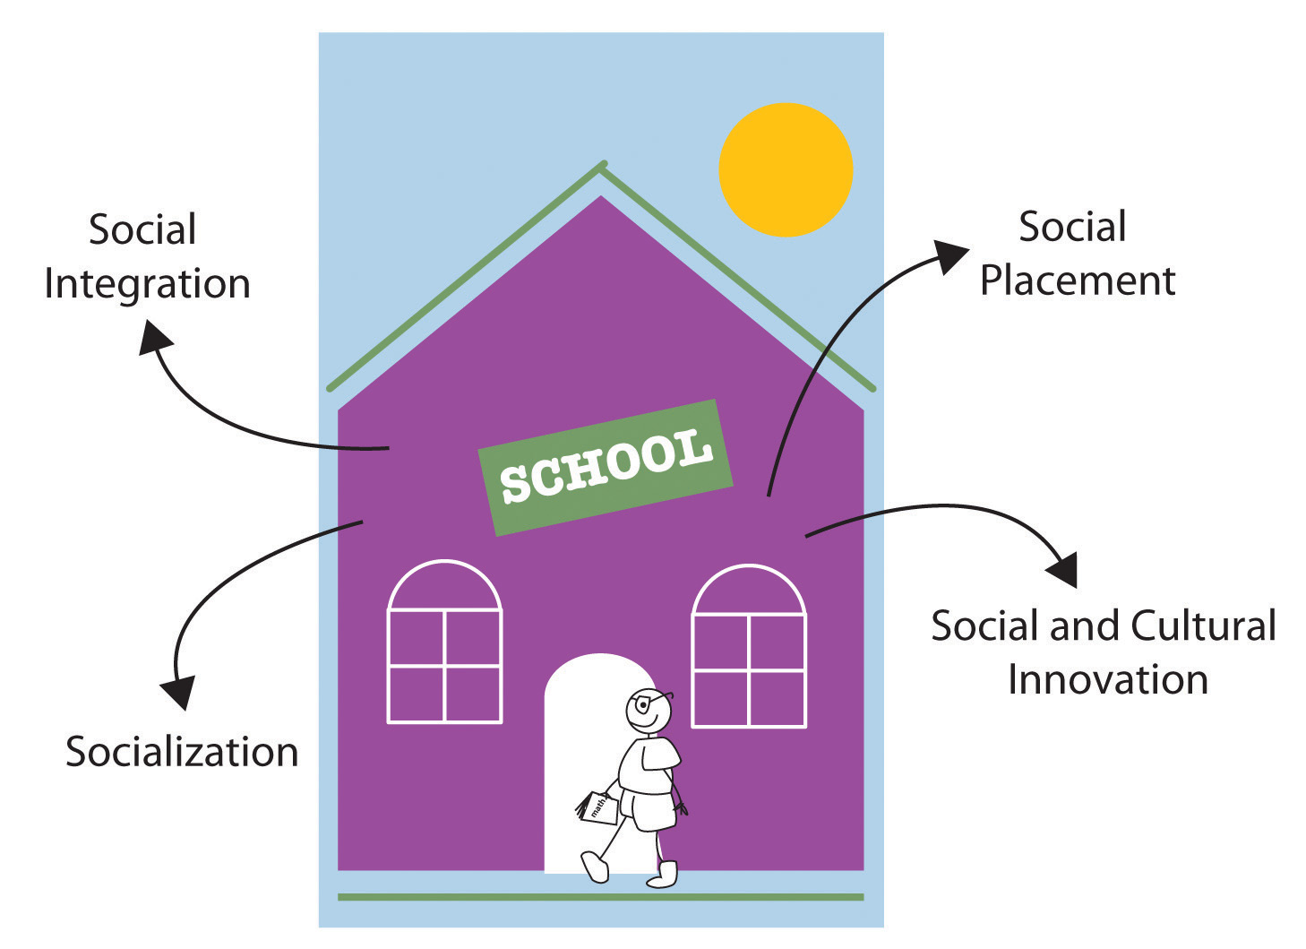

The Sociology of Education (Paper 1)
Workbook 1
Name | Set | Group

Learning Objectives:

- To understand and evaluate key concepts associated with functionalist, New Right and Marxist sociologists’ views of education.
- To understand how these approaches explain the function of education and examine the link between education and work wider society.

Specification

We will address elements of the following section:

A Level
Students are expected to be familiar with sociological explanations of the following content:
- the role and functions of the education system, including its relationship to the economy and to class structure

After studying this Topic, you should:
- Know the functions of education that functionalists identify.
- Understand the neoliberal and New Right views of the role of the market in education.
- Understand different Marxist views of the role of education, particularly the reproduction and legitimation of class inequality.
- Be able to evaluate the functionalist, neoliberal and New Right, and Marxist views of education.

Introduction to the Sociology of Education
The education system is one of the most influential institutions in society. Children are educated from the age of 4 or 5, over a period of 11 years. The education system provides children with a vast amount of knowledge, attitudes and skills. Either through formal education or more informally through what is known as the ‘hidden curriculum’

EDUCATION = KNOWLEDGE

FORMAL CURRICULUM
HIDDEN CURRICULUM

Formal and Informal Education:
When we think of education we think of sitting in a school or college and being taught by teachers. However this is not the only way of being educated. Sociologists make distinction between;
Formal Education = Delivered by agencies specifically designed for teaching and learning – for instance, schools, colleges, universities
Informal Education = Used to refer to all of the agencies and institutions, which, although not explicitly existing to encourage learning, nevertheless play an important educational role.

We will focus mainly on Formal Education throughout this unit although it is important to keep the latter in mind. Remember that learning is a lifelong process, which begins before formal education and continues after.
Activity
Outline in the box below the things you learn directly through the formal curriculum and then the things you learn indirectly through the hidden curriculum.
FORMAL CURRICULUM | HIDDEN CURRICULUM

MERITOCRACY

A key argument in the sociology of education is whether the education system in the UK is meritocractic. Find out what this means and write below:

Meritocracy:

Thinking about your own experience of education what makes it meritocratic, and what does not?

Education is meritocratic | Education is not meritocratic

What potential issues would there be with the idea of meritocracy? E.g. is it easy to see/measure?
Intro to education: A History of the British Education System

Educational policy in Britain before 1988 (pages 77-78 Webb)
- Briefly describe the main features of the tripartite system.

2. Briefly describe the main features of the comprehensive school system.

Insert education timeline here- you need to have a good awareness of policy changes since 1944, which we will come back to later in the course. NB- keep this timeline in your folder- you will need it again

Make sure your timeline also highlights:
- Which political party the education policy is associated with.
- Add some more discussion around each point to show what the policy meant.

Intro to education: Types of school
Type of school- what is its purpose? When were they introduced? Numbers | Admission policy- is it meritocratic? | How is it funded and who is it governed by?
Comprehensive

Independent/private/public

Grammar schools

Faith schools

Academies and Free Schools (since 2010)

City Technology colleges

Special schools

Home school

Sociological Perspectives and Education:

In the last module we studied how different sociological perspectives viewed the family. We will in this module look at what Functionalist, Marxist, Feminist and Interactionist sociologists view education.

Activity
In pairs, create a brainstorm to identify the purposes of education for society and its members.

THE PURPOSE OF EDUCATION

Activity
Now highlight in one colour the purposes that relate to the individual, and then in another colour highlight those relating to society.

Structuralists are sociologists who view aspects of social life such as education, in terms of how they affect whole groups of people and institutions on society. They are more interested in how education affects the economy and stability of the country than in how education affects the individual. (These sociologists are also known as macro sociologists)

Not all sociologists are macro sociologists. Some sociologists are less concerned with studying large social systems. Micro sociologists are more interested in how people react to, and influence each other in small groups – for example, in classrooms.

Functionalist views of education
The functionalist approaches highlight a number of core functions of education. These are:
- Teaching the skills needed for economic growth.
- Secondary socialisation.
- Role allocation.
(You may have identified some or all of these in your table in workbook 1)

The functionalist account of education is largely based upon the concept of meritocracy. This is a social order within which social position is achieved (based on universal merit) and not ascribed. Functionalists believe that society is meritocratic and that those who develop their skills and work hard are rewarded regardless of social background.

Emile Durkheim (1858 – 1917): SOLIDARITY AND SKILLS
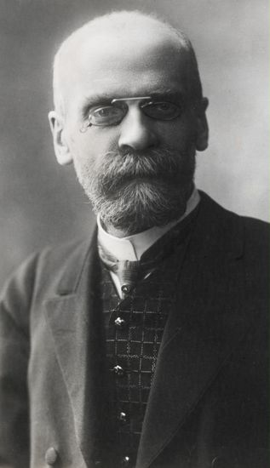
Durkheim was one of the founding fathers of sociology and is a functionalist sociologist. He took the view that all institutions within society exist because they have useful functions, and contribute toward the general good. This might be regarded as politically conservative. (Remember functionalists are often criticised for having an overall positive view of all institutions as they only focus on the positive functions and not the dysfunctions.)

Moral education: A study of the Theory and Application of the Sociology of Education:

According to Durkheim, as everyone has to coexist with other people one of the main functions of education should be to socialise children to the norms and values agreed by society – the value consensus.

Durkheim’s priority was an orderly and cohesive society.

Durkheim stressed that the chief role of education should be to encourage in children a sense of social solidarity – a feeling of identification with the group and responsibility towards others. Education consists of a systematic socialisation of the younger generation.

School also acts as a ‘society in miniature’, preparing us for life in wider society. For example, both in school and work we have to cooperate with people who are neither family nor friends.

Schools are also necessary to provide a workforce with a diverse range of skills for an industrial society. It is necessary for people to be able to cooperate and work together but also bring a variety of abilities to the workplace.

Activity
How do schools resemble ‘a society in miniature’?

Social Solidarity was especially important in modern industrialised societies, where rapid changes were thrusting people from many different social backgrounds together. According to Durkheim:
- Increasing rates of crime were signs of egoism – people pursuing their own goals rather than the good of the community.
- Higher levels of suicide were symptomatic of anomie – a lack of shared values and a feeling of moral confusion.
- Education had an essential binding role to play in societies where religion had become less influential.
Activity
In pairs think of ways in which schools and colleges might foster group solidarity more effectively:

What is meant by the term VALUE CONSENSUS?

What do sociologists aim to explain why studying education?

Talcott Parsons: MERITOCRACY
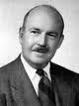
The family is the primary agent of socialisation - in the family we are judged on particularistic terms - because we gain ascribed status from the family. That is to say we are judged in terms of our status as brother, sister, daughter, son etc...
Education is the main secondary agent of socialisation. In advanced industrial society we are judged in terms of achieved status and universalistic values. That is to say we are judged in terms of what we achieve and schools prepare us for this. At school our conduct is measured against the universal school rules and our status is achieved through examination.
For Parsons, schools operate on meritocratic principles. Everyone is treated in the same way and has the same chances to succeed (equality of opportunity) so those that achieve the most in school do on their own merit (Ability + Effort = Merit).
Schools operate on this principle and reward the most ability and those who try hardest with exam success. This is important as it ensures that these best people will fill the most important jobs in society. Therefore schools ensure that the best people will perform the most important jobs - and this will benefit society as a whole.
Schools therefore instil: -
- The value of achievement – by rewarding those who achieve through exam success.
- The value of equality of opportunity – by offering everyone an equal chance to succeed.
These values are very important as they ensure that the best people fill the most important positions and that people of all levels accept their position as they know everyone had the same opportunity to succeed at school.
The Parental Home | The School | The Adult World
Particularistic values  The child is treated by other family members - especially parents - as their particular child.  Anything else would be too harsh. |  | Universalistic values  The citizen and employee is treated according to rules common to all with regard to employment rights, etc.  The motorist has to obey rules which everyone follows  Anything else would be unfair and dysfunctional
Parsons believed that schools are a miniature version of wider society, which reflects the values of the wider society. Young people are required to act in terms of these values in the classroom, preparing children for adult roles (role allocation).
Students will eventually be selected for jobs according to their skills that they have developed at school and the qualifications that they have gained. In large industrialised societies, there has to be objective measures by which employers can easily assess the suitability of employees. These measures are provided by the exam system. Most people accept this as a fair system.
Activity
Think of reasons why the system of role allocation as described by Parsons may not be as fair as it sounds.
(Hint: Do all sociological perspectives believe in meritocracy?)

Davis and Moore: ROLE ALLOCATION

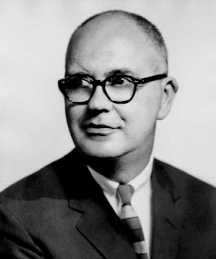
Functionalist sociologists Davis and Moore developed Parsons idea of 'Role Allocation', and link it to Social Stratification.
Social Stratification is a means of ensuring that the most talented people fill the positions that are most functionally important for society. The high rewards for these top strata’s act as the incentives for the most able people to compete for these functionally important positions.
For Davis and Moore education is the:-
"Proving ground for ability... a selective agency for placing people according to their capacities."
Education therefore ‘sifts and sorts’ and grades people in terms of ability which is rewarded in exam success, those with the most ability are then rewarded in society in terms of economic rewards to ensure the best people fill the most functionally important roles. Davis and Moore believe this is possible because there is an equality of opportunity in our society, which means no matter your background everyone has the same chance to succeed.
Activity
What is meant by equality of opportunity?

According to Davis and Moore, why is it important for role allocation to be meritocratic?

Schultz: Human Capital

Schultz argues high levels of spending on education and training are justified to develop people’s knowledge and skills, and this investment is an important factor in a successful economy. Functionalists see this development of human capital as necessary to provide a properly trained, qualified and flexible labour force that have high levels of skill and knowledge to undertake a wide range of jobs, which arise in a specialised division of labour. They argue the people with the best skills who are most qualified end up in the jobs requiring the greatest skills and responsibilities.

What is human capital?

EVALUATION OF FUNCTIONALIST VIEWS OF EDUCATION
Using Sociology for AQA, Volume 1 (Browne) p.29, and AQA A Level Sociology Book One (Webb) p.68 write at least 4 evaluation points for the functionalist view of education. These should be detailed.

Marxist views of education
The Marxist approach is similar to the Functionalist approach in many ways. They are both Macro sociological approaches Marxism suggests that education prepares children for the world of work. This however takes the form of education transmitting ruling class ideology to justify inequality and the capitalist system, rather than through role allocation.
A quick revision of Marxism
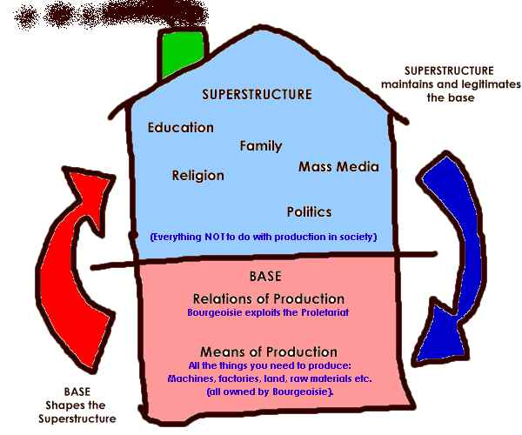
The diagram above outlines the basic principles of Marxism. Essentially the proletariat accept their dull and impoverish life’s which are produced by capitalism, because the economic base of capitalism is reinforced by a superstructure of institutions, which teaches people through the means of ideological control to accept their position within society.
Based on what you already know about Marxism, what do you think Marxists see as the main role of education?

Louis Althusser

Althusser, a French Marxist, claimed that a range of formal and informal agencies of social control are necessary to maintain capitalism. Althusser argued that if people were simply forced to co-operate with capitalism, that they would eventually reject the system. Therefore Althusser argued that people are manipulated into loving the system so that they find it harder to challenge it. He described these two mechanisms as the Repressive state apparatus (RSA) such as the police and the army and the Ideological state apparatus (ISA) such as education, where students are rewarded for working hard. Althusser argued that capitalism is maintained by carefully manipulating people into accepting an unfair system as well as using force to control them.
According to Althusser:
- Schools transmit an ideology that Capitalism is fair and just.
- Schools prepare children for their roles in the workforce. They are taught to accept their future exploitation.
Althusser argued that ideology in capitalist society is fundamental to social control.
Activity
1. What is the difference between Repressive state apparatus and Ideological state apparatus?

2. Give three examples of ways in which students are rewarded in school.

- How might rewards at school prevent people from challenging the system?

- Sort the following agencies into ideological state apparatus or repressive state apparatus:
police | family | law/legal system
media | courts | education
military forces | peer groups/subcultures | religion

Ideological state apparatus | Repressive state apparatus
Bowles and Gintis: The correspondence principle


Samuel Bowles and Herbert Gintis were American Marxist economists who tried to apply Althusser’s ideas within a case study of 237 students in an American Junior High School. In their book, Schooling in Capitalist America, they used a range of materials including IQ tests to look at the ways in which schools engaged in ideological control and the social reproduction of class relations.

According to Bowles and Gintis, schools operate through both the formal curriculum (and how it is organsised) and the hidden curriculum to reproduce existing class inequalities in the new generation. They identify a close correspondence between social relationships in the classroom and in the workplace. This correspondence is vital for social reproduction – the reproduction of new generations of workers appropriately schooled to accept their roles in capitalist society. (correspondence theory)

Bowles and Gintis recognise that schools are based on hierarchies – like wider society. Teachers give orders, students obey! Students have little control over their work and the curriculum they follow. Schools reward obedience and hard work; they discourage creativity, independence and critical awareness. This is directly inline with how workers are treated in capitalist society.

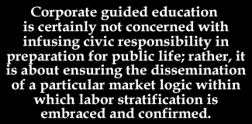

The education system benefits the existing economic and social system in two key ways:

- Schooling for the capitalist economy
Schools provide an appropriate work force for capitalism which is both docile and cheap
  - In the way that schools reward obedience and docility rather than independent thinking, schools produce a docile workforce. This is referred to as a “mug and jug” model of teaching, encouraging dependence on the teacher (with their “jugs” full of knowledge) on the part of pupils (with their empty “mugs” waiting to be filled by the teacher). Bowles and Gintis are highly critical of this enforced passivity.
  - By teaching a surplus of basic skills and knowledge to the working class (Bowles and Gintis refer to this as “over-education”), the education system produces an excess of skilled labour. This means increased competition for work among workers, enabling capitalist enterprises to offer lower wages.

- The myth making machine and social control
Bowles and Gintis oppose the idea of meritocracy as identified by Functionalist, Social Democratic or even New Right theorists as an obtainable ideal within the current social and economic system. Instead they regard it as a myth, and schools, colleges, and the rest of the education system as a myth making machine. Rather than the education system enabling all to have an equal chance or even trying to do so in a meaningful way.

Schooling perpetuates unfairness by offering radically different chances to all. But the important thing is that schooling, whilst remaining unfair, is perceived to be fair by those at the bottom, legitimating inequality between social classes through the pretence of fairness. This supports Althusser’s ideas of ideological control through schooling.

Why do Bowles and Gintis use the term “myth”?

Activity
Imagine completing a day in the life of one job. (It may be a part-time job you have or an imaginary one) and note down how this corresponds to school/ college life.
 | School | Work
Hierarchy

Subservience

Fragmentation

Motivation.

Neo- Marxist Approaches to Education

Paul Willis: Learning to Labour: How working class kids get working class jobs.


Paul Willis attempted to take a different approach to the study of the education system from a Marxist point of view. Whilst he substantially agreed with the basic outlook of the Marxist approach, as outlined above, he also tried to combine a Marxist approach with an understanding of the culture of the school, using ethnographic research to look at the process of schooling from the point of view of working class pupils themselves. He studied a Midlands secondary school over 3 years in the 1970s, at a time that the school leaving age was being raised from 15 to 16, focusing on interviews with a core group – the “lads” – consisting of 12 working class boys who felt that the school was simply wasting their time and who showed a realistic understanding of the lack of opportunity that their future lives entailed.
Willis identified this not untypical group as a counter-school subculture which corresponded to the life of these working class pupils in their homes and eventually on the shop-floor.

His approach differed radically from other Marxists already reviewed because of his concern to understand the meanings of working class subcultures and to focus on the lads as actively constructing their world in the classroom rather than simply passively accepting their role at the hands of teachers.
The pupils construct their own world rather than simply having education handed to them by teachers, schools or authorities. The school has an effect, but it is not that intended by those working within it.
Main Features of lads’ counter school culture
- The lads felt superior to both their teachers and "conformist" students who they referred to as "ear 'oles"
- The lads attached little or no value to academic work and had little interest in gaining qualifications
- the lads did everything they could to avoid lessons and when they were forced to go tried to do as little work as possible - they would boast when they had managed to go weeks without putting pen to paper!
- The lads resented school trying to take over their time and constantly attempted to win physical and symbolic "space" from the institution and its rules.
- The lads avoided work in lessons by "having a laff" through misbehaviour such as sabotaging school equipment, continuous fidgeting, sprawling all over chairs or making a huge fuss when asked to do something
- The lads couldn't wait to get out of school into the male adult world of manual work
- The lads counter school culture was both highly sexist and highly racist - school work and conformist pupils were seen as "cissy", ethnic minorities as inferior.
- Manual work was seen by the lads as superior to mental work
- The lads had appeared to have worked out that the sort of jobs and marginally better pay jobs requiring qualifications would bring them were not worth the extra years of study and loss of freedom and independence

Willis' Conclusions
- The education system was failing to produce ideal compliant workers for the capitalist system
- The lads were far from the obedient and docile workers that other Marxists Bowles and Gintis said capitalism required. However, the lads were paradoxically well prepared for the manual work they would eventually do
- When Willis followed the lads into their first jobs he found similarities between counter school culture and shop floor culture - "having a laff" was just as important in the attempt to relieve boredom, the lads and their fellow workers would do everything they could to control the pace of the work they had to do and relieve the boredom of it.
- Willis claimed that counter school culture and shop floor culture though in part oppositional to "the system" don't challenge the institution "head on". There is recognition in both of the need to do some work or risk expulsion or dismissal
- Willis suggests that counter school culture contains some perceptive insights into the nature of capitalism for workers. .
- Willis suggests that it is actually their rejection of school which prepares the lads for their futures in manual work
  - The lads recognise that there is no equal opportunity in capitalism and that no matter how hard they work they are unlikely to be very upwardly socially mobile.
  - The lads recognise that individual effort is likely to achieve little for themselves and that the collective loyalty between themselves as a group is far more important.
  - The lads can see through the careers advice given them at school. Even if they were to work really hard the changes of advancement are very limited
They “suss” the system, penetrating the veil of ideology
Willis does not suggest that the lads or shop floor workers have a sophisticated understanding of capitalism and he is particularly critical of their sexism and racism.
Paul Willis: Structuralist and Interactionist?

Structuralist elements | Interactionist elements
MACRO SOCIOLOGY  Critical application of theories of cultural and social reproduction  Concerned with issues and definitions of social class and its influence on identity  Concerned with widespread social change and institutions | MICRO SOCIOLOGY  Ethnographic approach to research involving the use of  - Unstructured group interviews  - Observation  Use of anecdotal qualitative evidence on the life experience of the lads and ear’oles  Outlining of elements of class culture and their meanings to the respondents

Pierre Bourdieu: REPRODUCTION OF PRIVILEGE AND CLASS INEQUALITIES

Bourdieu (1977) regards a key role of the education system is to legitimise and reproduce the existing class structure. In doing so it replicates privilege. He argues each social class possesses its own cultural framework and set of values which he calls habitus. This varies between different social classes in terms of what is seen as good taste, good books, tv, fashion etc. It is learnt through socialisation in the family. The dominant culture i.e. the upper or middle class, have the ability to impose its own habitus on the education system. Those who come from better-off, middle and upper class backgrounds have more access to the experience and knowledge needed to succeed in the education system. Bourdieu calls this cultural capital. These groups may also have higher levels of social capital (who you know) and economic capital (what money and other assets you possess). Success and failure is based on cultural capital. Those with lower levels don’t possess the needed attributes for the education system, in doing so education reproduces the class inequalities that were already there.

Define and give examples for (p.23-24 Webb):
Cultural capital
Social capital
Economic capital


Glenn Rikowski: COMMODIFICATION AND MARKETIZATION: A RETURN TO TRADITIONAL MARXISM?
Rikowski adopts a Marxist framework to review recent developments in the education system and, especially the view of education as a commodity to be bought and sold rather than a right. He argues that “educational services are increasingly operating in markets” and “being transformed into commodities”.
There is still a long way to go, but the “business takeover of schools” has begun and is evident. The process is that
- The State raises the finance for schools
- More and more of the school’s functions are subcontracted to private industry
- Profit is made by running these functions for less than the contract price
- As a result, educational activities are steadily being transformed into commodities
Labour throughout their time in office were increasingly keen to
- Increase links between schools and business, particularly business sponsorship of academies
- “Marketize” schools – i.e., have schools compete with each other for “customers”
- Make schools operate as commercial enterprises – selling their products and succeeding or failing as a result of consumer demand for their services.
In this, Labour simply continued processes already in place from the previous Conservative government. If this process continues, Rikowski argued, then privatization will be the result with schools and universities run “primarily for the benefit of shareholders”. The increasing emphasis on fees and benefits to individual students and consumers of education may be seen as further aspect of this process.
Globalization and Capitalism
Rikowski also focuses on Marx’s emphasis on the need for markets to expand, thus creating a world market (the Marxist version of globalization theory) and sees education as a part of this process, becoming another global commodity, driven by profit.

What issues does Rikowski identify with the marketization of education?

Evaluation

Provide 4 evaluation points for the Marxist view of education

Social Democratic vs New Right views of Education Policy
The arguments of Functionalists and Marxists underpin many of the key ideas related to meritocracy, equality of opportunity, marketization and privatisation, but they are often not related to the British education system or can be directly linked to certain policies. There are two key political theories that do this. They are opposed to each other and have influenced different education policies since 1945.
They are:
Social democrats: linked to the education policies of the left, namely old Labour, pre 1997. Their policies included the introduction of the tripartite system in 1945.
New Right/Neo Liberal- associated with the political right, namely the Conservative party, in particular Margaret Thatcher’s government and the formation of the Education Reform Act 1988.
Please note- New Labour policies (1997-2010) can be a seen as a mix of these two views, as was the Coalition Government (2010-2015).
Activity: go back to your timeline and using different colours show which policies are New Right ones and which ones are Social Democratic.
Social Democratic
Whilst this view has been associated with the political left, Social Democratic views should not be confused with Marxist ones. This approach is associated with education policies pre 1979 (when the Conservatives come to power). Social Democratic views are associated with a belief in the Welfare State and the necessity for governments to intervene on behalf of those who are weakest or who need support, often through tax-and-spend policies, redistributing wealth through services and benefits (so-called “Robin Hood” policies).
In response to the problem of educational inequality, Social Democratic approaches have attempted to make the system fairer by ensuring an equal chance for all. For them, meritocracy is only possible with the provision of equality of opportunity.
Define equality of opportunity:

The tripartite system which sprang from the 1944 Education Act may be seen as part of this legacy as it attempted to offer:
- Free secondary education for all
- Higher education for all qualified to attend and selected by the appropriate university
- Maintenance grants to support those in higher education
The subsequent growth of higher education was felt to benefit everyone in society with
- the greater provision of skilled workers for the economy and
- the increased taxes that these groups would generate for the government.
As it became apparent that the tripartite system benefitted middle class children with a greater likelihood of attending grammar schools, the logic of the Social Democratic position enforced the comprehensivization of education, offering common schools to all classes and abilities.
More recently, Social Democratic approaches have focused on financial support in the home through tax credits, and interest in Affirmative Action or positive discrimination policies, to ensure support for those lest privileged (e.g. through the Office of Fair Access for Higher Education – OFFA – or initiatives such as AimHigher).
Social Democratic advocates often claim that the expansion of the pool of talent that equality of opportunity brings will make the country more economically more successful.
Summarise the main view of social democrats below:

What makes the social democratic view similar to Marxists?

Social democrats are critical of Functionalists saying meritocracy exists because of the different life chances that children have. They aim for meritocracy but do not believe it has happened yet because there is not a true equality of opportunity. Arguments for this include:

Sharon Gerwirtz (1995) found that the amount of choice involved in selecting a school was limited by the ability of schools and by the ability of parents to discriminate between them. She argues that because of this parents did not have an equal choice.
Gerwirtz identifies three broad groups of parents:

- Privileged/skilled choosers- strongly motivated parents who have the ability to understand the nature of different schools. Often have time and money to make a range of choices to assist their children.
- Semi-skilled choosers- ‘have strong inclination but limited capacity to engage with the market’. They are concerned by do not possess the experience or inside knowledge of the education system e.g. less likely to appeal if their child does not get into their preferred school.
- Disconnected choosers- are not inclined to get very involved with the education market. They tend to consider the closest schools to where they lived. They tend to believe there is no real difference between schools.
Thinking about what you know about factors that affect people’s life chances, what issues could surround the idea that all parents have the same ability to choose the education of their children?

What allows for parents to have more choice? | What means parents have less choice or less ability to make choices?

Stephen Ball (1994)- saw a shift in school attitudes, after the introduction of the 1988 Education Act: ‘there is a shift of emphasis from student needs to student performance: from what the school can do for the students to what the students can do for the school’. Competition between local schools to attract students, who are now regarded as commodities, creates winners and losers.

What problems are there with the social democratic view?

NEW RIGHT/NEO LIBERAL APPROACHES TO EDUCATION (a political rather than sociological approach to education)
The New Right is a conservative political view that incorporates neoliberal economic ideas (these ideas have influenced governments since 1979 with the belief that governments should encourage competition, private businesses and not overly regulate the market).
The New Right, now more commonly known as Neoliberal, position has grown out of a critique of Social Democratic views, which they regard as beyond what the country can afford without inhibiting economic growth. The education system from the state needs to be leaner and more efficient, offering a safety net for those who absolutely need it rather than a necessary service for all. Policies associated with the New Right can be seen as the basis of the 1988 Education Act and several subsequent important pieces of legislation.
The New Right approach to education policy reflects many of the ideas of the functionalist perspective. They argue that education should not be concerned with promoting equality of opportunity but with training the workforce, ensuring the most skilled and capable are recruited into the most important jobs, whilst others are prepared for lower-level employment.

Similarities and differences between the Functionalist and New Right approach to education

Similarities | Differences
Both believe that some people are naturally more talented than others. This means that equality of opportunity whilst present will not lead to everyone being able to get to the same point. | The New Right do not believe that the current education system achieves these goals because it is run by the state.
Because of this both favour an education system run on meritocratic principles of open competition, and one that serves the needs of the economy by preparing young people for work. | The New Right argue the state education system takes a ‘one size fits all’ approach, which imposes uniformity and rejects local needs. State education systems are seen as unresponsive and inefficient.
Both believe that education should socialise pupils into shared values, such as competition, and instil a sense of national identity. | The New Right think education needs to be marketized, whereby the users of education become consumers, picking and choosing the best option for them in an open market.

New Right views: Chubb and Moe
Their solution?
To create an ‘education market’ to provide more competition between schools to empower consumers; the aim being to introduce more choice, diversity and efficiency within the system.
New Right theorists like Chubb and Moe believe an education system controlled by the state and local authorities (local councils) is not the best means of achieving the aim of training an effective workforce. They argue there should be a free market in education that provides parents and local communities with choice. There should be a range of schools that are independently managed, run like private business and accountable to the wishes and needs of local communities. This marketization would lead to more competition, which would drive up standards.
What recent Coalition and Conservative government policies demonstrate education being a market?

State 4 criticisms of the New Right (p.70 of Webb textbook)

The relationship between education and work
Successive governments have focused on the relationship between school and skills for employment. This has led to a range of policies that you will research and evaluate in the next part of the booklet. As background, these are the aims of the Conservative and Labour parties during their leadership.
When the Conservative party was elected in 1979 their aims, related to education were to:

- Develop an education system which met the needs of industry
- Raise standards throughout Britain’s schools and colleges
Their policy was known as New Vocationalism. This policy aimed to address the large numbers of unemployed young people. Previously, vocational training (training for work) was regarded as the responsibility for employers, however the new government felt schools should take responsibility for the creation of skills for industry.

Labour continued a similar policy from 1997, focusing on two main areas:
- Providing the training needed for a high wage/high skill economy to allow the UK to compete internationally.
- Reducing youth unemployment and addressing the problem of young people identified as NEETs (Not in Education, Employment or Training).

RECENT POLICIES- summary using Webb textbook
Marketisation (pages 78-81 Webb)
  - Define marketisation.

  - Which sociological perspectives favour marketisation?

- What is parentocracy and how do those who favour it say it benefits education?

- Define the following:
a. Cream-skimming

b. Silt-shifting

- How do league tables enable these two processes to take place?

- What is the impact of the funding formula on differences between schools?

New Labour and inequality (page 80 Webb)
1.List the New Labour policies aimed at reducing inequality.

2.What is the ‘New Labour paradox’?

Coalition government policies since 2010 (p.81-82 Webb)
1. Give a brief outline of the following policies:
a. Academies

b. Free schools

2. What criticisms have been made of free schools?

3. Fragmented centralisation Define the following:
a. Fragmentation

b. Centralisation
4. What criticism has been made of the Pupil Premium?

5. What Coalition policies may have reduced opportunities for working-class pupils?

Summarise the following aspects of privatisation (pages 82-83)
1.Blurring the public/private boundary

2.Privatisation and the globalisation of education policy

3.The cola-isation of schools

4. Education as a commodity

Using p.70 of the Webb textbook and the information above, address the following question: Does introducing the market to the education system benefit everyone?

KEY TERM | DEFINITION
Meritocracy
Value Consensus
Social Solidarity

Secondary Socialisation
Social mobility
Functional prerequisites
Egoism
Anomie
Ascribed Status
Achieved Status
Role Allocation
Ideology
Neo Liberalism
New Right

Correspondence Principle

Cultural capital

Social capital

Economic capital

Marketization

Privatization

Equality of opportunity

NEETs

Examples of Possible Exam Questions

Outline two criticisms of the comprehensive school system [4]

Outline two ways in which globalisation has influenced educational policies [4] [O’Leary revision book]

Outline two ways in which the education system might not be meritocratic [2]

Outline two ways in which the education system promotes social solidarity [2]

Outline two ways in which the school acts as an agent of secondary socialisation [2]

Outline three ways in which schooling reflects the workplace [6]

Outline three functions that the education system performs for society [6]

Outline three ways in which government educational policies have attempted to reduce inequality in achievement between social classes [6]

Outline three ways in which the correspondence principle operates in schools [6]

Item A: Some sociologists argue that a major role of the education system is that it should provide equal opportunities for all pupils to succeed so they can be allocated to their most appropriate role in the economy. However, statistics on achievement suggest that schools systematically fail the majority of working-class pupils. Sociologists critical of this view have put forward a number of reasons why working class students end up in working class jobs. [O’Leary revision book]

Applying material from Item A, analyse two ways in which the education system legitimates or reproduces social inequalities [10]

Analyse two ways in which schools reinforce social solidarity [10]

Analyse two ways in which the education system supports the economy.[10]

Analyse the effects of two marketization policies [10]

Analyse two roles that education fulfils according to functionalists [10]
(10 mark questions will be accompanied by an extract to help you)

Item B: Until the 1980s, most education was provided by elected local education authorities, directed and funded by central government. However, the 1988 Education Reform Act began the marketization of education, aimed at raising standards by increasing parental choice and competition between schools. After 2010, there was a substantial move towards the privatisation of increasing parental choice and competition between schools. After 2010, there was a substantial move towards the privatisation of education through policies such as the growth of chains of academies run by private businesses. Some sociologists claim that the main impact of marketization and privatisation policies has not been to raise standards, but to increase educational inequality.

Applying material from Item B and your knowledge, evaluate the claim that marketization and privatisation policies have increased educational inequality [30]

Item B: Functionalist and Marxist sociologists are interested in similar aspects of the role of the education system. For example, both examine the relationship between education and work. Both perspectives also look at how norms and values are transmitted through education. However, while Marxists and functionalists focus on similar issues, they reach very different conclusions about the role of education.

Applying material from Item B and your knowledge, evaluate the view that ‘while Marxists and functionalist approaches focus on similar issues, they reach very different conclusions about the role of education’. [30]

