There is no greater equality in conjugal roles (i.e. inequality remains)

***Domestic Labour***

**Outline -**

* 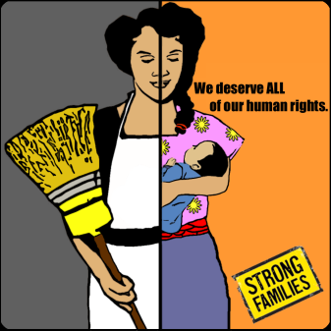The feminist perspective supported by Ann Oakley is that there is no greater equality to roles concerning domestic labour.
* Domestic labour – housework/cleaning, emotional support, looking after children, cooking.
* Women are still working the triple shift even more than they were before because they have more access to education which means that they have better jobs and have to work more. When they get home they have to give emotional support to husbands and also look after the children and do domestic labour.

**Evidence -**

* Ann Oakley (1974)
  + Dismissed the idea that marriages are increasingly equal partnerships.
  + Argued that sociologies studies of “equality” in marriage started with the assumption that cooking, cleaning and childcare are supposedly women’s responsibilities.
  + “Jointly” does not mean equal.
* Jean Duncombe and Dennis Marsden (1995)
  + Says that married women are taking on paid employment and they end up doing the triple shift.
    - Paid work, emotional support of care and nurturing.
  + Women do the majority of the cooking and cleaning whereas the men do the minority.
* UK 2000 Time Use Survey (Office for National Statistics: interview with 6,500 households, including 11,700 individuals) The respondents kept detailed diaries of how they spent their time on one day during the week and on one day at the weekend:

|  |  |
| --- | --- |
| **Average Daily Housework & Main Chores** | |
| **Men**  (2 hrs 20 mins) | **Women**  (4 hrs) |
| Cooking Childcare Gardening Pet care | Cooking Childcare Cleaning house Laundry |

* + Ironing and laundry – 60% of men and 92% of women.
  + Unemployment or retirement – increases female housework hours, and reduces her partners.
  + Housework – men average 5.5 hours a week, women average at 19 hours.
* When working part-time, women’s total workload (paid and domestic labour) increases to roughly 63 hours / week.
* Where children are present in the household, women do more domestic labour but men do not.
* **Gender Ideology**: Beliefs about gender roles influence how each partner participates (or not as the case may be) in domestic labour. Where couples have “traditional beliefs” about male and female roles, women do more domestic labour than in households where beliefs reflect sexual equality.