**Godalming College**

THIS BOOKLET MUST BE BOUGHT TO ALL SOCIOLOGY LESSONS FROM NOW ON, ALONG WITH THE ADDITIONAL BOOKLET WITH EXAM QUESTION STYLES AND REVISION SHEETS

**Sociology Department**

[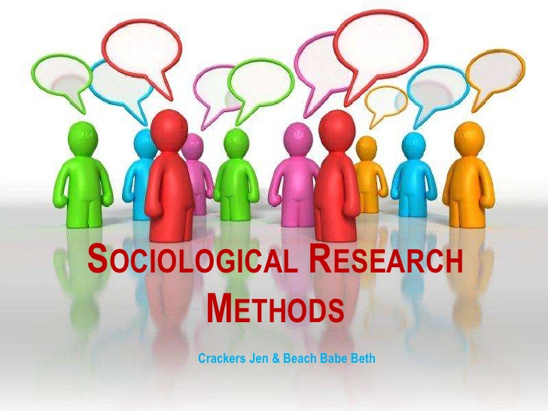](http://www.google.co.uk/url?sa=i&rct=j&q=&esrc=s&frm=1&source=images&cd=&cad=rja&uact=8&ved=0CAcQjRw&url=http://www.slideshare.net/bethanmartin/sociological-research-methods-12648268&ei=tyBbVYejI6fU7Aa444Mo&bvm=bv.93564037,d.ZGU&psig=AFQjCNHxhkL0RTP6F4Wzk-7enSwF2fh31g&ust=1432121886581340)

**WORKBOOK**

RESEARCH METHODS FOR A LEVEL PAPERS 1 AND 3

|  |  |  |
| --- | --- | --- |
| **Name:** | **Set:** | **Group:** |

**Contents**

**What the specification says** 4

**INTRODUCTION TO RESEARCH METHODS** 5

**WHAT IS SOCIOLOGICAL RESEARCH?** 5

**WHAT RESEARCH METHODS ARE THERE?** 6

**FACTORS INFLUENCING CHOICE OF METHOD: PET** 7

**SAMPLING** 17

**The sampling process** 18

**SAMPLING FRAME** 18

**SURVEYS AND QUESTIONNAIRES** 25

**INTERVIEWS** 29

**OBSERVATION** 38

**EXPERIMENTS** 49

**SECONDARY SOURCES** 57

**EXAM QUESTIONS** 63

**Style of questions** 63

10 mark**:** 63

**20 mark: methods in context (applying research methods to the study of education.** 64

**20 mark: theory and methods** 70

**EVALUATION OF DIFFERENT RESEARCH METHODS** 71

**PET - STATISTICS** 72

**PET - QUESTIONNAIRES** 73

**PET- STRUCTURED INTERVIEWS** 74

**PET- SEMI STRUCTURED INTERVIEWS** 75

**PET- UNSTRUCTURED INTERVIEWS** 76

**PET – GROUP INTERVIEWS/FOCUS GROUPS** 77

**PET - PARTICIPANT OBSERVATION** 78

**PET - NON PARTICIPANT/STRUCTURED OBSERVATION** 79

**PET - FIELD EXPERIMENTS** 80

**PET - QUALITATIVE SECONDARY DOCUMENTS** 81

# **What the specification says**

|  |
| --- |
| AQA Specification  Research Methods  Students must examine the following areas:   * quantitative and qualitative methods of research; research design * sources of data, including questionnaires, interviews, participant and non-participant observation, experiments, documents and official statistics * the distinction between primary and secondary data, and between quantitative and qualitative data * the relationship between positivism, interpretivism and sociological methods; the nature of ‘social facts’ * the theoretical, practical and ethical considerations influencing choice of topic, choice of method(s) and the conduct of research. * Students must examine the following areas: * Secondary sources of data: official statistics; different sources of official statistics * Considered the advantages and disadvantages of different sampling strategies * Sources of data, including questionnaires, interviews, participant and non-participant observation, experiments, documents and official statistics |

# **INTRODUCTION TO RESEARCH METHODS**

## **WHAT IS SOCIOLOGICAL RESEARCH?**

One of the main differences between sociology and "common-sense" is that sociology is based on carefully collected evidence. In order to be able to develop theories or explanations of the world, sociologists have to collect this evidence, which is often called data.

**What different types of data are there?**

Primary data is gathered "first hand" by the sociologist, perhaps by asking people questions or watching them behave. Secondary data is data which has been collected by somebody else and published or written down, for example government statistics or newspaper articles.

The form data takes may also differ. Some appears as numbers or statistics and is called quantitative data. Other data takes a written form and provides a more personal account of the social world. This is known as qualitative data.

The collection of data to answer questions about society and the way people behave is achieved by using research methods. Using pp. 120-121 *Sociology in Focus 2nd ed.*

|  |  |  |
| --- | --- | --- |
|  | **DEFINTION** | **EXAMPLE** |
| **PRIMARY DATA** |  |  |
| **SECONDARY DATA** |  |  |
| **QUANTITATIVE DATA** |  |  |
| **QUALITATIVE DATA** |  |  |

## **WHAT RESEARCH METHODS ARE THERE?**

The most common methods of sociological data collection are:

|  |  |
| --- | --- |
| **Questionnaires** | Simply lists of questions, which may be closed or open ended. The respondent (person answering) writes the answers themselves, a process known as self-completion. |
| **Interviews** | Questions asked and answers given verbally. |
| **Observation** | People's behaviour is watched. in participant observation the researcher, to some extent, joins in. |
| **The analysis of secondary data** | Examining already existing material such as official statistics or historical documents |
| **Experiments** | Are not typically used within sociology. They test a hypothesis and attempt to isolate and manipulate variables. |

Whether quantitative or qualitative data, or a combination of both, is collected will depend on the way the method is used by the sociologist, as the table below shows.

**Task 🖉**

Complete the following table using the answers listed below.

|  |  |  |
| --- | --- | --- |
|  | **Quantitative** | **Qualitative** |
| **Questionnaires** |  |  |
| **Interviews** |  |  |
| **Observation** |  |  |
| **Secondary data** |  |  |

1. Structured observation usually involves an "observation schedule so the observer can note the number of times certain events occur.
2. In structured interviews the interviewer asks closed questions which have a fixed number of possible answers.
3. The analysis of official statistics for example
4. Closed questions give the respondent a fixed number of choices.
5. Open questions leave respondents with space to write their answers.
6. The use of historical documents or novels for instance.
7. In unstructured or informal interviews questions are phrased in such a way as to encourage the respondent to talk at length.
8. In participant observation the observer aims to understand behaviour by joining in and feeling what it is like first-hand.

## **FACTORS INFLUENCING CHOICE OF METHOD: PET**

Given the wide range of methods available, sociologists need to select the right one for their research. Different methods and sources of data have different strengths and limitations in terms of **practica**l, **ethical** (moral) and **theoretical** issues.

**Task 🖉** Using your own knowledge, p.93 of the *AQA A Level Book One,* Webb, p.122-127of *Sociology in Focus 2 ed.* to help you and, complete the boxes below, summarising the different practical, ethical and theoretical issues which influence a choice of research method

|  |  |
| --- | --- |
| **Practical issues** | |
| Access to those being studied | Time and funding |
| Availability of data | Values and beliefs of the researcher |
| Values of society | Personal skills and characteristics of the researcher |

|  |  |
| --- | --- |
| **Ethical issues** | |
| Informed consent | Confidentiality/anonymity/privacy |
| Deception & covert research | Safety of the participants |
| Findings reported accurately and honestly | Vulnerable groups/sensitive information |
| **Theoretical issues** | |
| Sociologists’ choice of method and topic is also influenced by their methodological perspective – their view of what society is and how we should study it. Often sociologists have a theoretical approach to studying society which influences the method they choose. | |
| **POSITIVISM**  **Positivists** sees the process of studying society as a science, repeating research, generating statistics, numbers, trends, ratios and comparisons that are high in **RELIABILITY** and OBJECTIVITY. Durkheim, a positivist argued we can observe social facts- society is ‘out there’. These findings can then be turned into LAWS just like scientific ones and the researcher can remain VALUE FREE and objective. Therefore, society can be understood, predicted and controlled. This is a MACRO approach, which aims to use large samples to generalise to the target population.  **Key issues for Positivists:**  **Quantitative methods** - Positivists tend to use quantitative methods – the research focuses on measurement and the collection of numerical data (statistics and number crunching) that reflect their belief in a scientific approach. Also, by using scientific quantitative data the researcher can generate CAUSE and EFFECT relationships.  **Reliability** – the extent to which a test or procedure produces similar results under constant conditions or all occasions. Data is reliable when different researchers using the same method, or the same researcher using it at another time, obtain the same results.   * For example, if one person tests the temperature of water at boiling point, then another person does it a week later, you would expect the results to be the same i.e. reliable - as long as the data collection instrument (i.e. the thermometer) is trustworthy. * A survey using structured questionnaires tends to be reliable. The same results should be gained, regardless of who is asking the questions. This is particularly so with regard to simple structured questions (for example, a person’s age or gender).   **Representativeness / Generalisability**   * This is related to sampling technique (see later booklet). How far is the individual or group under study typical of the research population? * If they are typical, then what is true of them is also true of others. We can therefore *generalise* from this sample. * Researchers who use quantitative data can use complex statistical tools to enable them to see how representativeness their sample is. * Research based on in-depth qualitative methods must always be questioned in terms of representativeness because they tend to involve very few people. | **INTERPRETIVISM**  **Interpretivists**  argue that the study of society as a science is not possible as the things in it (**people**) are not identical and cannot be treated as the same. Therefore, a different approach is needed in order to gain a ‘true’ understanding; to discover an individual’s meanings, experiences and reasons for behaviour, an in-depth enquiry as to why the individual behaved as they did. This will produce more VALID findings. Interpretivists favour a MICRO approach, which prefers in-depth data from small scale research. The aim is to explore people’s lived experience in depth to understand them from their point of view.  **Key issues for Interpretivists:**  **Qualitative methods** – Interpretivists tend to use qualitative methods - the research focuses on interpreting meaning and feelings and is expressed in words rather than numbers.  **Validity** – the ability of the method to provide a true picture or mirror image of what is being studied.   * The real aim of sociological research should be to experience the social world of the people you are studying; to develop EMPATHY with them and put yourself in their ‘shoes’ (sometimes referred to as VERSTEHEN). * Qualitative methods (such as unstructured interviews) tend to produce valid data since the interviewer can spend time probing and questioning the respondent and really make them think about their answers. * Structured questionnaires tend to be low in validity because they are often a measure of what people think they ought to say and think, rather than what they actually do – social desirability. Also, people do not spend much time thinking about answers; the closed-ended nature of questions may restrict all possible answers / maybe ambiguous in meaning.   **Realism**  These researchers adopt a positivist and interpretivist approach by combining quantitative and qualitative methods. They use a mixed method approach to gain the advantages of both approaches, such as gaining data that is both reliable and valid. Increasingly sociologists are taking this approach because it allows them to triangulate their data to check for accuracy, and allow for a more holistic understanding of their respondents |

**Summarise these key terms below**

|  |  |
| --- | --- |
| Validity | Reliability |
| Representativeness | Generalisability |

**Task 🖉**

***Complete the missing words below from the list underneath.***

**Positivism**

These sociologists believe that social phenomena are as real as ____________ phenomena. This means that they should study what they can see (empirically) objectively, ______________, and count. Therefore, they claim society should be studied _________________avoiding any personal involvement. In turn, this use of ____________________ data can then generate statistics, numbers, __________, ratios and comparisons. Social facts can then be established.

**Interpretivism**

_________ phenomena are different to natural phenomena. People are active, conscious beings who act with intention and purpose. People have passions and ___________ and cannot therefore be studied the same way as _____________or atoms. Sociologists need to uncover _____________ :shared understandings and truthful detailed reasons as to why people might behave the way they do. ___________________ data is useful for giving the researcher a ‘feel’ for what something is like with descriptions and depth.

**Qualitative * measure * meanings * natural * trends * chemicals * social * emotions * quantitative * scientifically**

**The range of methods**

It may not be useful to think of research methods as falling into 2 completely separate compartments. It is better to think of them as being on a scale, as shown below:

Numbers involved

Many

Structured questionnarire

Structured inteviews

Unstructured interviews

Overt Observation

Participant observation

Few

Low High

Personal involvement of researcher

**Research methods video- ‘Understanding Sociology’** estream

1. Why is theory important to sociological research?
2. Outline the key features of positivism
3. What problems can be identified with positivism?
4. Outline the key features of interpretivism
5. Outline the key features of real

|  |
| --- |
| **Fitness for purpose** this means that researchers will select the method(s) most suitable for the collection of the data they require, and as long as the method fits what they need (the purpose) it really does not matter if it produces quantitative or qualitative data. The idea of mixed methods it that it enables the researcher to break free from the qualitative / quantitative divide, thus allowing greater flexibility. |
| The theoretical approach of the researcher will influence their choice of topic and how the research is conducted.  Consider the following scenarios:   |  |  |  | | --- | --- | --- | | Topic/issue | Positivists | Interpretivists | | Studying male underachievement |  |  | |  | Problems with this approach: | Problems with this approach: | | Victims of domestic violence |  |  | |  | Problems with this approach: | Problems with this approach: | | Studying division of housework between men and women |  |  | |  | Problems with this approach: | Problems with this approach: | |

**Stages of research-** taken from p.177 of *Sociology for AQA Volume 1*

|  |  |
| --- | --- |
| **Stage** | **Explanation / examples** |
| Choosing a topic- fitness for purpose for studying the group | Some topics lend themselves more to qualitative data collection methods, for example deviant groups (school truants, football hooligans) would probably not want to answer a questionnaire. A social survey is appropriate when the researcher wants to gather large amounts of quantitative data. |
| Formulating an aim or hypothesis or **research question** | **Hypothesis:** An idea you guess might be true, but which hasn’t yet been tested e.g. exposure to video games makes you more violent.  **Research question:** pose questions on areas that interest you e.g. why are boys more likely to fail in the education system? |
| Selecting the **method** | Will be influenced by the topic, practical, ethical and theoretical position of the researcher |
| **Operationalisation of** concept | A concept is an abstract idea or theory, like social class, which is difficult to define in only one way. In order to explore concepts in social research it is necessary to clearly define them so that they can be measured, this is what is meant by operationalisation. This is particularly important in quantitative methods where concepts are measured. For example, in terms of class, the concept could be operationalised by defining this issue based on household income. |
| *How would you operationalise educational achievement for example?* | |
| Identifying the **target population** to be surveyed | When conducting research, you need to decide on the group/people to be studied.  A target population includes the group/people to be studied. |
| Selecting the **sample** | It is not possible to study everyone in the target population for practical reasons, so a sample is selected. Positivists want large representative samples, whereas interpretivists favour samples that will provide in depth information on the topic. |
| **Accessing** the sample and **ethical** issues related to this group | Issues related to the nature of the sample e.g. studying students could be challenging because researchers would need to gain access to schools. Once access is achieved, researchers must adhere to ethical guidelines, such as informed consent |
| Carry out a **pilot study** | Carry out a practice of the method to assess any unforeseen theoretical or practical difficulties. Evaluate the results and make changes e.g. a questionnaire might be worded in a way that confuses people, leading to unreliable responses. |
| Carry out the research | Collect the data and record results |
| Analyse the results | Explain and interpret your results- what do they show you?  Positivits- will be looking for patterns and trends, and casual relationships between data.  Interpretivists- will be looking to explore the meaning behind people’s responses and select what is found to be most significant. |
| Prepare a report | Draw up conclusions and evaluate your research. What did you find? Did you fulfil your aims? What would you change for next time? |

**Mixed methods**

It is important that the distinction between quantitative and qualitative traditions is not over-stated. It may well aid our understanding of this topic to think in terms of a qualitative / quantitative divide, but the reality in terms of practical social research is the tendency to use a mixture of qualitative and quantitative techniques as part of a triangulation or methodological pluralism approach. The multiple or mixed methods approach has generally been used in two broad ways although the reasons for using each approach often overlap

1. **Methodological pluralism** – this is where the researcher employs more than one method of research in order to build up a fuller and more comprehensive picture of social life.
2. **Triangulation** – this refers to the use of multiple or mixed methods to cross-check and verify the reliability of a particular research tool and/or the validity of the data collected. E.g. using diaries to check the information collected in unstructured interviews. Triangulation could involve combining quantitative and qualitative methods in order to check on the accuracy of the data gathered by each method. For example, questionnaire responses might be checked by carrying out interviews with key respondents. Laud Humphrey’s study of the Tearoom Trade (1970) used questionnaires, unstructured interviews and participant observation to check the reliability and validity of his data.

**What strategies for research are there?**

Often sociologists will use a general approach, or strategy, within which a combination of methods will be chosen.

Some commonly used research strategies are:

**The social survey**

The aim of a survey is to make general statements about a particular population based on interviewing and/or giving questionnaires to a sample of that population. The data produced is usually quantitative.

**Ethnography**

This approach aims to understand the "way of life", or culture of a particular group in society. It is associated with a social action approach as it concentrates on understanding the group from their own point of view. It often involves observation of the group in question and typically produces qualitative data.

**Longitudinal Study**

Longitudinal studies follow the same group of respondents over a period of time. This allows attitudes, values and behaviour to be monitored and changes to be analysed and explained. Longitudinal studies try to avoid the pitfalls of more conventional “snapshot” studies.

**Case Study**

Sometimes the sociologist wishes to investigate a single example in depth, possibly a place of work, area or school. This approach is known as a case study.

**Triangulation**

All methods have their strengths and weaknesses. A questionnaire can be giver to a large sample of people, but it does not usually produce "in-depth" information for example. Triangulation involves a variety of methods being used so that the strengths of one make up for the limitations of another, and to get a more holistic understanding of those being studied.

**POSITIVISM & INTERPRETIVISM: A COMPARISON**

|  |  |  |
| --- | --- | --- |
|  | **POSITIVISM** | **INTERPRETIVISM** |
| **View of Society** | *Society acts as a constraint on individuals, it is therefore necessary to examine these social structural constraints, involving a macro or large scale approach* | *Individuals and groups play an active role in creating society it is therefore necessary to understand their individual meanings and motivations, involving a micro or small scale approach* |
| **The job of the sociologist is to ...** | *Look beyond what human beings think they do and observe actual behaviour* | *Uncover the meanings and motives behind behaviour* |
| **Data must be ...** | ***Reliable*** *- in the pursuit of “hard facts” reliability is essential. Sociologists should be able to replicate and verify existing studies.* | ***Valid*** *- it should be a “mirror image of reality. Statistics are not enough in uncovering underlying meanings.* |
| **Preferred Data** | ***Quantitative data****. Statistical data can be analysed and conclusions drawn. Generalisations can be made applicable to a wide range of social life, if sample is representative.* | ***Qualitative data****. Unless meanings are explored, statistics on their own can be meaningless or even misleading. Generalisations are less important than looking at reality in depth.* |
| **Preferred Methods** | *Social Surveys (questionnaires, structured interviews) experiments.* | *Observation, unstructured interviews, some kinds of experiments* |
| **Preferred secondary sources** | *Official statistics, surveys* | *Life documents* |

# **SAMPLING**

[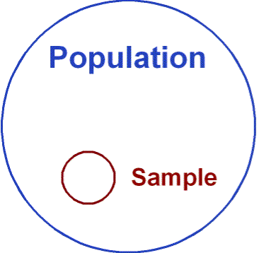](https://www.google.co.uk/url?sa=i&rct=j&q=&esrc=s&frm=1&source=images&cd=&cad=rja&uact=8&ved=0CAcQjRxqFQoTCKazm9Kmh8YCFUcJ2wodECsAVA&url=https://rmsbunkerblog.wordpress.com/2011/01/19/market-research-and-probabilistic-sampling-methods/&ei=ZVF5VebsLceS7AaQ1oCgBQ&bvm=bv.95277229,d.ZGU&psig=AFQjCNGqr7WZx48m9ktTuupez2Z5WlfpMA&ust=1434100371292313)[](http://www.google.co.uk/url?sa=i&rct=j&q=&esrc=s&frm=1&source=images&cd=&cad=rja&uact=8&ved=0CAcQjRxqFQoTCPuF2LCmh8YCFWma2wod5XkA6A&url=http://www.soapboxsample.com/what-we-do/sampling/&ei=H1F5Vbv6Gum07gbl84HADg&bvm=bv.95277229,d.ZGU&psig=AFQjCNGqr7WZx48m9ktTuupez2Z5WlfpMA&ust=1434100371292313)

**Aims**

This section is intended as a very quick guide to sampling techniques. It will revise some with which you will be familiar, and some which are a little more obscure

By the end of this module you should have

* Considered sampling strategies employed by sociologists and other researchers
* Considered the advantages and disadvantages of different sampling strategies
* Considered how sampling techniques may be more or less appropriate when combined with particular methods

**Key terms in sampling**

|  |
| --- |
| * Sample |
| * Sampling frame |
| * Universe |
| * Population |
| * Snowball sampling |
| * Opportunity sampling |
| * Random |
| * Quasi-random sampling |
| * Stratified Random Sampling |
| * Self-selected sample |
| * Practical reason |
| * Methodological reason |
| * Representativeness |
| * Reliability |
| * Validity |

## **The sampling process**

**(a) Using a sampling frame**

|  |  |  |
| --- | --- | --- |
|  | **UNIVERSE OR POPULATION** |  |
|  | The target group to be studied |  |
|  | **↓** |  |
|  | **SAMPLING FRAME** |  |
|  | A collection of names, a list, a roll, etc. which is in some sense representative of the target population |  |
|  | **↓** |  |
|  | **SAMPLE** |  |
|  | The group selected from the sampling frame to be studied by the researcher |  |

Representativeness will depend upon the relationship between these different levels, i.e., how closely related the frame is to the target population (e.g., if one were using a telephone book, would the absence of non-telephone users or users of alternative telephone systems be significant to the whole population, or might double counting occur where a household had more than one line or might it be significantly out of date?), and how closely related the sample is to the frame (this would be dependent primarily upon the technique used, the size of the sample and the accuracy of the process).

**(b)Not using a sampling frame**

e.g., Snowball sampling

Researcher

Here, representativeness will depend upon the willingness of respondents not only to respond themselves, but to facilitate other contacts for the researcher. This approach is far less systematic than (a) and may well introduce a range of hidden but potentially very influential biases.

**RANDOM SAMPLING**

Uses a sampling frame

May use computer generated tables or draw lots

“**Every item or person has as much chance of selection as every other”**

**QUASI-RANDOM OR SYSTEMATIC SAMPLING**

Uses a sampling frame sampling every nth entry in the frame e.g., takes every 5th or 10th entry on a list (so not truly random)

Often used in small scale studies because

**STRATIFIED RANDOM SAMPLING**

Uses a sampling frame

Divides the sampling frame into sub-sets to replicate characteristics within the survey population e.g.,

Often the most accurate form of sampling but may be difficult and time-consuming when applied to complex populations.

Thought to be the most appropriate for detailed sociological studies because

**CLUSTER OR MULTI-STAGE SAMPLING**

Uses a sampling frame

Uses a smaller geographical area to represent a larger geographical area

Often used in political opinion polls because

**QUOTA SAMPLING**

Uses no sampling frame

Attempts to select a certain number of people to fit certain categories

Often used by market researchers because

**SNOWBALL OR OPPORTUNITY SAMPLING**

Uses no sampling frame

Relies upon "networking" individuals through other individuals slowly accumulating a sample

Not representative but sometimes the only form of sampling available (e.g., studies of hidden deviance) because

**SELF-SELECTED SAMPLES**

Respondents select themselves choosing to participate in a particular study as **volunteers**.

Often used in psychological or other experiments where the active cooperation of respondents is required on ethical grounds.

Very likely to be unrepresentative because

*NB to describe a sample as self-selected is often felt to be a sufficient criticism in itself to disregard the findings of particular studies.*

**PURPOSIVE SAMPLING**

No sampling frame

Sampling which uses only relevant members of the population based on their knowledge or experience as determined by the researcher.

Unlikely to be representative of any wider population.

Similar to quota sampling but based on more complex range of variables rather than external appearance

**MULTI-PHASE SAMPLING**

Uses a series of sampling frames related to each other

May involve a variety of sampling techniques

Used in detailed case studies (such as *Barker’s “The Making of a Moonie”*) because

**ActivitIES**

**1. Using the list of topics below outline which of the types of sampling listed above, in your opinion, could be appropriate to each piece of research?**

|  |  |  |
| --- | --- | --- |
| Research topic | Type of sampling | Reasons |
| 1.Ph.D. research on men's experience of housework |  |  |
| 2.A journalist's account of a local biker gang |  |  |
| 3.Market research on customer satisfaction with South West Trains |  |  |
| 4.Content Analysis of a range of national newspapers for sexist bias |  |  |

**2. Why would interpretivists not be as interested in having representative samples?**

**Why would positivists think it is very important to have a representative sample?**

**3**. A lengthy questionnaire is sent out to a random sample of households in a given area asking detailed questions about the domestic relations of its respondents. The survey has a low response rate.

Suggest some reasons why people may not have responded to the questionnaire, why the researchers may have had doubts about some of the replies they did receive, and suggest ways in which the response rate might be improved.

# **SURVEYS AND QUESTIONNAIRES**



**SURVEYS**

Surveys are a means of collecting primary data from large numbers of people, and are most commonly carried out using questionnaires or structured interviews. In this booklet, we will be mainly focussing on questionnaires.

Because surveys mainly produce quantitative statistical data, combined with large samples, they are the method most favoured by positivists, such as by the so called ‘founding father’ of Sociology, Emile Durkheim (1858-1917).

However, it is important to note that many people use surveys other than sociologists – for instance, the government when it carries out the ten-yearly census, market researchers who want to test people’s attitudes to products, and election pollsters trying to find out how people vote in elections.

|  |
| --- |
| **QUESTIONS**   1. What types of topics/issues are suitable for surveys? 2. What types of topics/issues are less suitable for surveys? Why? |

**VIDEO: THE SEX SURVEY**

**National Survey of Sexual Attitudes and Lifestyles**

|  |  |  |  |  |
| --- | --- | --- | --- | --- |
| **Positivist** | **Interpretivist** | **Realist** | **Qualitative data** | **Quantitative data** |
|  |  |  |  |  |

|  |
| --- |
| **Reasons for the interest of the researchers on this topic (please stick to what is on the video!)** |
| **The methods used in the survey** |
| **The size of the sample (and the size of the original sampling frame)** |
| **The method of sampling used** |
| **Source of funding** |

**QUESTIONNAIRES**

As mentioned at the beginning of the booklet, most surveys involve the use of questionnaires. A questionnaire is a list of pre-set questions to which the respondents are asked to supply answers – either by filling in responses (a self-completion questionnaire) or by giving information to an interview, either face-to-face or over the telephone. When administered by an interviewer, these take the form of interviews.

Those using questionnaires see them as a comparatively cheap, efficient and fast method that allows for obtaining large amounts of quantitative data on relatively large samples of people.

In the next few pages of the booklet, we will examine some of the key issues to consider when designing questionnaires, the two types of questions used in questionnaires as well as the types of questionnaires.

**Questionnaire Design**

Great care is needed in designing a questionnaire. Because the idea is to present all respondents with the same questions and therefore obtain comparable data, questionnaires cannot be changed once a survey has begun. They should be kept as simple and clear as possible, otherwise those being interviewed or filling in the questionnaire will be unlikely to complete it.

A pilot survey is therefore important to clear up problems and avoid wasting time and money on a poorly designed questionnaire. Pilot studies are used to test questions, make sure their meaning is clear, and to ensure layout and sample are suitable for the intended sample.

|  |
| --- |
| **QUESTIONS**   1. Why is it important to phrase questions in ‘neutral terms? 2. Why should questions be phrased in clear, everyday language? 3. What types of questions should be avoided in questionnaires? |

**Types of Questions**

There are two main types of questions used in questionnaires: pre-coded or closed/structured questions and open-ended or open questions. Both types of question may be combined in the same questionnaire

**Closed Questions**

In closed questions, the range of responses is fixed by the researcher (pre-coded). The respondent usually has to select one answer from two or more given alternatives.

**Open Questions**

Open ended questions used in questionnaires are less structured than pre-coded questionnaires. An open question asks the respondent to answer a question in their own words. Although open-ended questionnaires will usually have a number of pre-set questions, there is no pre-set choice of answers.

**Types of Questionnaires**

**Postal/mail or online self-completion questionnaires**

This kind of questionnaire is either left with the respondent and picked up later, or sent through the post with a pre-paid addressed envelope for the reply, or posted on an internet site for people to reply to, or it may be sent and returned via email. The respondent will complete the questionnaire herself or himself (self-completion).

**Structured Interviews (see Booklet on Interviews)**

Questionnaires may also form the basis of interviews by social researchers, In a structured interview the interviewer reads out the questions either face-to-face or via the telephone. Structured interviews, then, are much like postal or self-completion questionnaires except they are carried out by an interviewer. The interviewer asks closed questions set in the same order each time, and does not probe beyond the basic answers received: a formal question-and-answer session.

# **INTERVIEWS**

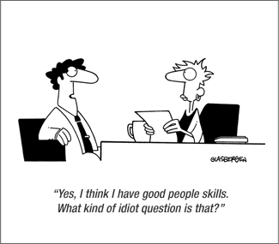

**INTERVIEWS**

Interviews are one of the most widely used methods of gathering data in sociology. There are a variety of different ways interviews can be conducted. In interviews the degree of structure of questions can vary:

1. The most **structured interview** or **formal interview** is the sort where the order and wording of the questions are predetermined and each respondent is asked exactly the same questions in exactly the same way from a tightly structured schedule, with the questions following the same order every time.

2. The **focused or semi-structured interview**, as its name suggests, is the sort where the questions are focused on particular topics but where the interviewer can choose the words he/she uses to ask them as well as the order in which they are asked. (Usually then the sort of interview schedule used here simply lists general areas of interest the interviewer is to get the respondent to talk about.)

3. The completely **unstructured** or **informal interview** involves the interviewer simply engaging the respondent in conversation, and then following up particular points of interest as they develop. It may be that no schedule at all is used. American sociologist Howard Becker describes this kind of interview well with the phrase ‘conversation with a purpose’.

In this booklet, we will focus on all three types of interviews, including their advantages/disadvantages as well as exemplary case studies. One key issue that affects all interviews relates to **interviewer bias** (see box below).

|  |
| --- |
| **Interviewer bias –** refers to the way answers in an interview may be influenced or distorted in some way by the presence or behaviour of the interviewer. Interviews involve face-to-face interaction between people, and the success of interviews often relies on the personal skills of the interviewer. The results of an interview will also partly depend on the way participants define the situation, and their perceptions of each other. For example, the interviewer’s personality, sex, age, ethnic identity, tone of voice, facial expressions and dress (e.g. suit or jeans) all impose a particular definition of the situation on the respondent, and this may influence the responses given. Status differences – for instance along the lines of ethnicity and age – between the respondent and the interviewer can lead to bias too. For example, and adult carrying out interviews with school students may not be given honest answers. The interviewer may give the impression, however unwittingly or unintentionally, of wanting to hear a certain answer.  In such circumstances, it is possible that the interviewees might adapt their responses to impress the interviewer by giving answers they think the interviewer wants to hear and would approve of, rather than giving their real opinions. This is perhaps unsurprising, as nearly everyone likes to obtain the approval of the person they are talking to.  **Overcoming interviewer bias?**  To overcome interviewer bias and try to ensure that interviews produce valid data, interviewers are trained to be **non-directive**. This means not to offer opinions, or show approval or disapproval of answers received. While it is important to establish **rapport** – a friendly and understanding relationship – it is equally important to remain sensible and business-like. Another way of minimizing interviewer bias is to try and match the social characteristics of the interviewer and the people being interviewed.  Unlike proponents of non-directive interviewing, Becker (1970) believes that a more aggressive style of interviewing is more likely to squeeze information out of respondents which may not otherwise have volunteered. This involves ‘playing dumb’, playing the devil’s advocate by taking positions on issues, or deliberately ‘provoking’ people in the hope of prompting the respondents to say more. A further way of overcoming interview bias is to avoid face-to-face interviews altogether, and resort to telephone interviews or even interviews via email. |
| **QUESTION**  When interviewing parents, what effect might age, gender or ethnic differences between the interviewer and interviewee have on the response rate and on the validity of the answers given? |

**STRUCTURED INTERVIEWS**

Use your textbook and any other sources to help fill in the following

|  |
| --- |
| **QUESTIONS**  1. Identify and explain what types of topics are suitable for using structured interviews.  2. What topics might be less suitable for using structured interviews? What method would you use instead? |

**Notes:**

**SEMI-STRUCTURED INTERVIEWS**

In a semi-structured interview, the interviewer is again present and has a clear list of issues to be addressed and questions to be answered. However, the questions can be asked in any order (i.e. they are flexible) and the interviewer has much greater control of proceedings than in a structured interview. In contrast to structured interviews, then, the interviewer has the freedom to ‘probe’. Respondents can be asked to clarify their answers to provide examples, and to develop what they have said.

You have been given two examples of semi-structured interviews- Hauari and Hollingworth’s study on fatherhood, which is on the next page.

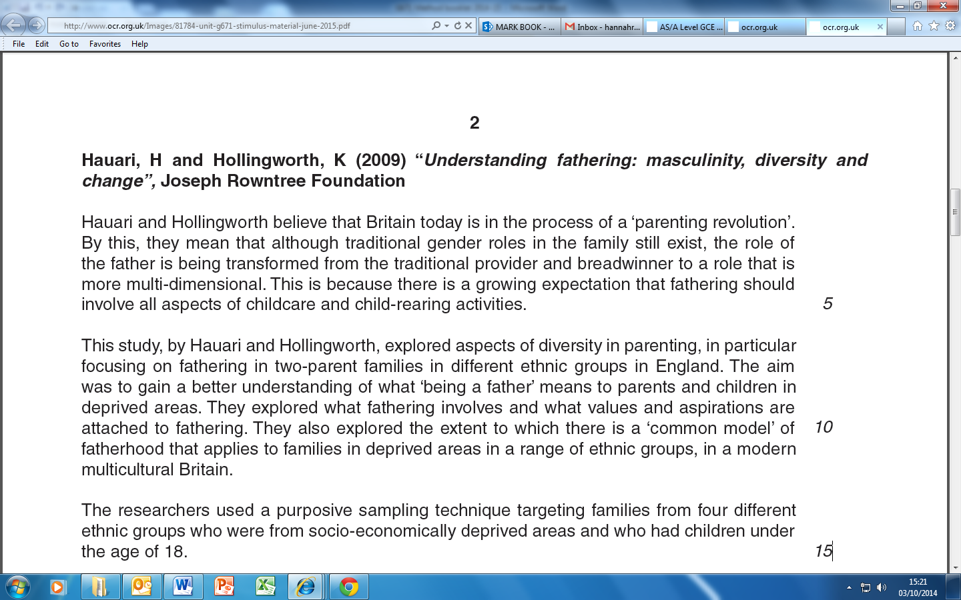

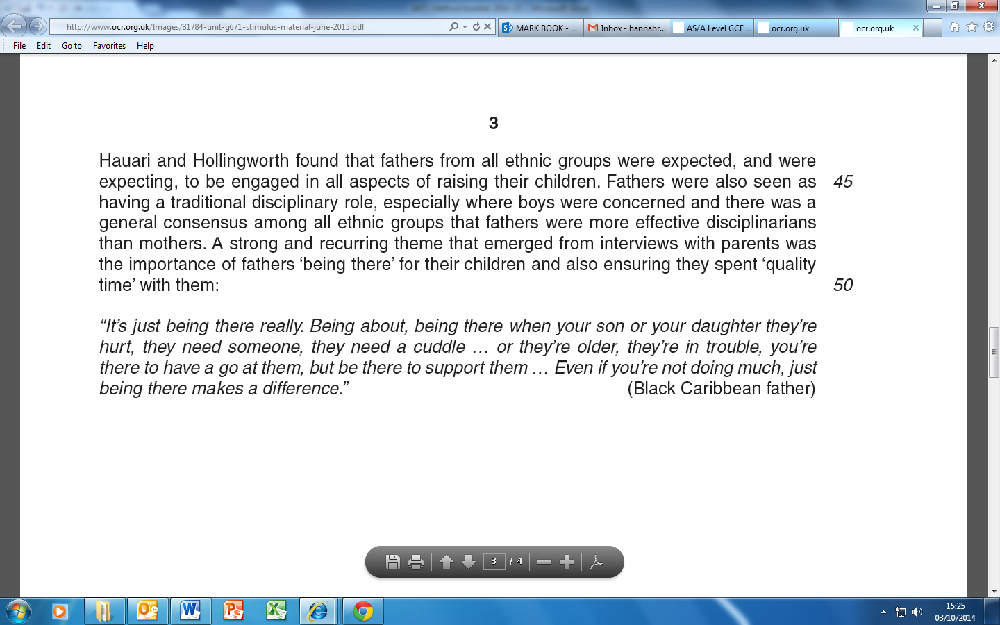

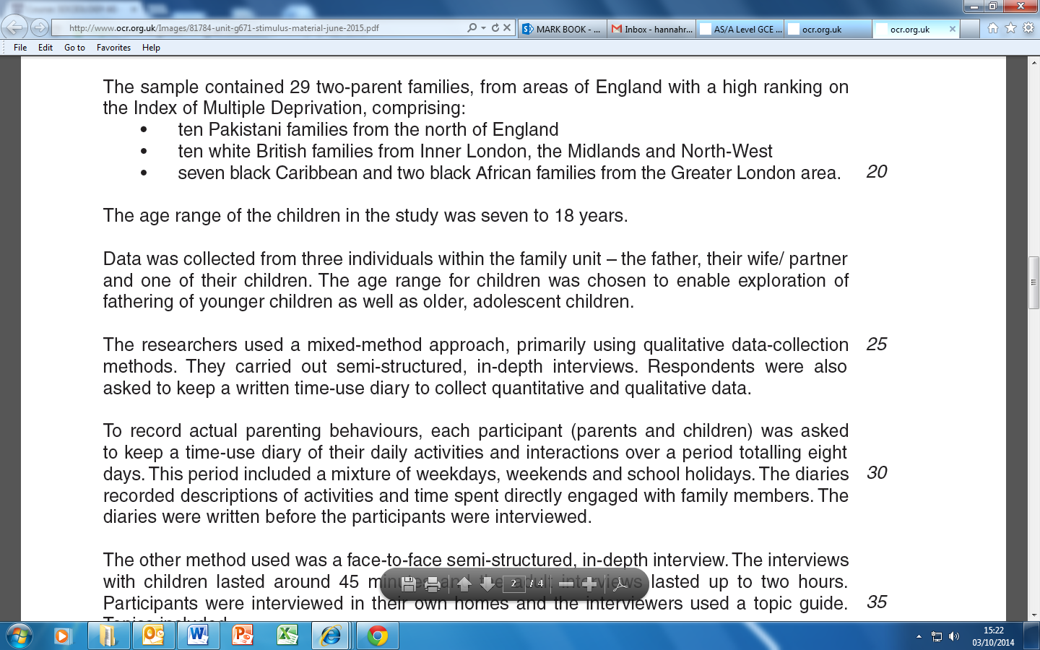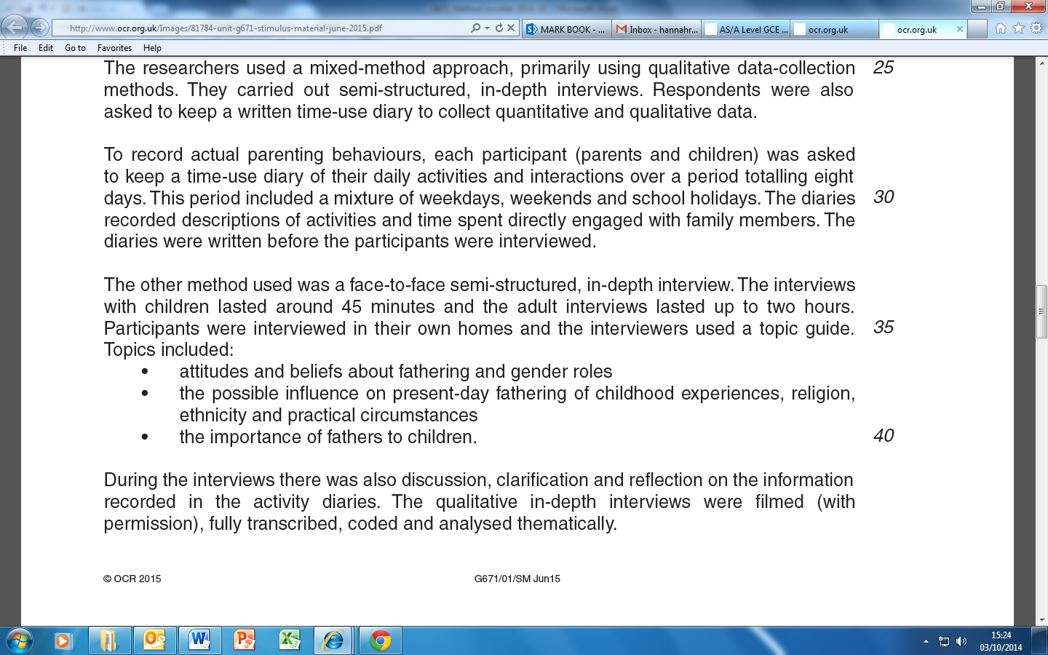

|  |
| --- |
| **QUESTIONS**   1. What is the advantage of using semi-structured interviews for studying fatherhood? 2. What kind of ethical issues can you identify with the method of semi-structured interviews? Can you think of alternative methods? |

**Notes:**

**UNSTRUCTURED INTERVIEWS**

An unstructured interview is like a guided conversation. The interviewer has topics in mind to cover (the **interview schedule**) but few, if any, pre-set questions. The interviewer will seek to put the respondent at ease, in a relaxed, informal situation, and will then ask open-ended questions which may trigger off discussions or further questions. The interviewer aims to obtain further depth or detail than is possible in a postal or other self-completion questionnaire or in a structured interview, and to draw out the respondent’s feelings and opinions. See the example of Dobash and Dobash at the end of the booklet.

Unstructured interviews may also be carried out with a group of people. This can help to trigger off discussion, encourage a dialogue to explore issues, and gain more in-depth qualitative information. These **group interviews** sometimes take the form of **focus groups**, when the group interview focuses on a particular topic, and people are free to talk to one another as well as the interviewer. In a group interview, the interviewer’s role is to question, whereas in a focus group the researcher’s role is to feed in ideas or questions for the participants to discuss and draw out their feelings, experiences, and opinions. The researcher also has to make sure the group remains focussed on the topic under discussion.

**Paul Willis (1977): *Learning to Labour***

**Activity:** Watch the video on Paul Willis discussing the methodology he used in his study of the growth of anti-school subcultures and then answer the following questions:

|  |
| --- |
| What is the purpose for Willis of sociological research? |
| Why did the 'lads' become the focus of Willis' research? How did he **select** them as a group? |
| Identify the different methods that Willis uses in his research |

|  |
| --- |
| What **types of** **data** does Willis produce with these methods? |
| In what ways does Willis see his research as **valid**? |
| Does he regard his study as **reliable**? Does he see reliability as important? |
| What prevents the sociological researcher **'going native'** for Willis? |
| Why is Willis dismissive of problems associated with the **'Hawthorne Effect'**? |

Willis also used focus groups as another interview technique. Define what this is below:

|  |  |
| --- | --- |
| Define focus group/group discussion interview | |
| Advantages of focus groups | Disadvantages of focus groups |
|  |  |

**Notes:**

# **OBSERVATION**

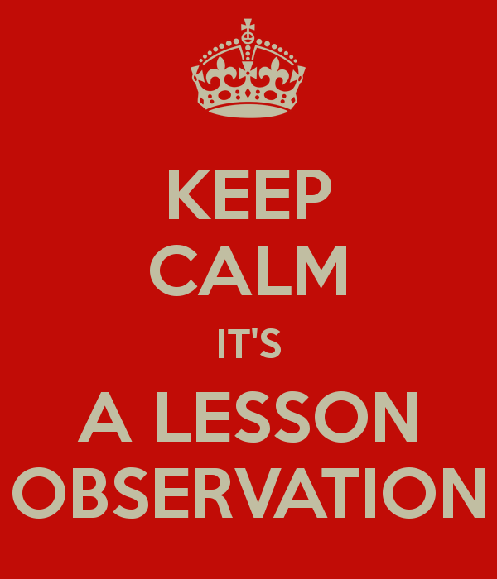

**OBSERVATION**

Perhaps the most obvious way to ‘do sociology’ is to watch people going about their everyday activities: We might observe people in exactly the same way that bird-watchers observe birds and then attempt to describe and explain their social behaviour. However, in some ways sociological observers face similar problems to bird-watchers. For example, if birds are aware of the presence of an observer they are likely to fly away and, similarly, people's behaviour can be affected if they are aware of being ‘watched’. Because of this the researcher usually has to join in, to some extent, with the group being studied.

Some sociologists in some situations may be able to conduct non-participant, or direct observation where they do not participate at all and are a ‘fly on the wall’. This may be possible at large events where many people are present so that the sociologist can easily blend in, or from behind a two-way mirror for example. Some sociologists, however, as you will see later, believe that we can only really understand human behaviour if we join in with it, thus discovering what it actually feels like to be that sort of person.

To wrap up this brief introduction, we can distinguish between two different types of observation**: Participant observation** and **non-participant observation**. In this booklet, we will mainly, but not exclusively, focus on participant observation. In particular, we will examine some useful examples where this method has been used, and explore the advantages and disadvantages that come with using this method.

**PARTICIPANT OBSERVATION**

This approach was first developed outside sociologyby anthropologists who study the variety of different societies and cultures in the world. In the early part of this century they began to live in the societies they were interested in. One of the most famous examples of this approach is Bronislaw Malinowski's research in the South Pacific Trobriand Islands where he lived during the First World War. Later in the 1920's and 1930's in America sociologists in Chicago borrowed this approach and applied it to their city. They studied the lives of different groups including tramps, members of criminal gangs and the rich.

In America in the 1950s and 1960s interactionism grew in importance as a dominant sociological perspective. Sociologists became increasingly interested in ‘getting inside the heads’ of their subjects. Participant observation gave researchers a method to view the world through the *eyes* of other people. Rather than testing hypotheses against evidence and searching for the causes of social events, the idea was that ***verstehen***(an understanding developed through empathy or close identification) and qualitative research are what sociology should be about.

For example, in his famous book, *Asylums*, Erving Goffman worked in a psychiatric hospital and carried out participant observation byparticipating in the lives of the patients and talking to them.

**The Stages of Participant Observation**

The stages of participant observation can be summed up in terms of *getting in*, *staying in*, and *getting out* of the group concerned. Let’s have a look at these issues before we examine a case study that illustrates the method of participant observation well.

**Getting In**

Joining a group raises several questions about the researcher’s role. The researcher may adopt an **overt role**, whereby he declares his true identity to the group and the fact that he or she is doing research. Alternatively, the researcher may choose to adopt a **covert role** (concealing his or her role as a researcher), or a cover story (partially declaring his or her role as a researcher, but concealing elements of it. James Patrick’s study A Glasgow Gang Observed (1973) offers an example of this. James Patrick was a teacher at an approved school in Scotland. He took up the invitation by Tim - a sixteen-year-old juvenile offender - to come and see for himself 'whit the score wis' in the 'Young team' (a Glasgow street gang of which Tim was leader).

Patrick, posing as Tim's friend from the approved school, took up this challenge. Having been briefed by Tim on the appropriate style of dress and considering himself aware of the local dialect and slang (an assumption which was to prove his first mistake), Patrick met and joined the gang.

To participate successfully, especially when adopting a covert role, the researcher would need to share some of the characteristics of the group, such as gender, age or ethnicity.

**Staying In**

The observer has to develop a role which will involve gaining the trust and cooperation of those observed, to enable continued participation in and observation of the group. Initially, this will involve learning, listening and getting a sense of what is going on. In Whyte’s study entitled *Street Corner Society* (1955), the main informant Doc plainly advised Whyte to ‘keep your eyes and ears open but keep your mouth shut’. Problems when staying in the group can arise when taking extensive notes, which might be seen as disruptive. Another question concerns how far you wish to immerse yourself within the group without either losing the trust of the group or your objectivity as a researcher (see box on ‘going native’). Staying in might also mean engaging in activities you disagree with. James Patrick, in his study on gangs in Glasgow, found the level of violence so abhorrent that he decided to stop his covert observation sooner than initially planned. In his study, Whyte did some ‘personating’ – illegally voting twice in an election – as this was common practice in the group he was studying.

**Getting Out**

Getting out of the group involves issues as such leaving the group without damaging relationships, becoming sufficiently detached to write an impartial and accurate account, and making sure members of the group cannot be identified. There may be possible reprisals against the researcher if criminal activities are involved. For instance, when Patrick’s study was published, he faced threats to his personal safety.

|  |
| --- |
| **‘Going Native’ –** The personal involvement which participant observation demands can reduce objectivity. An observer can identify so strongly with the group that the behaviour of its members is invariably seen in a positive light. In rare cases, this identification is carried to its extreme – observers ‘go native’, join the group and never return to their former lives |

**Types of Participant Observation: Overt and Covert Research**

**Overt Role**

|  |  |  |
| --- | --- | --- |
| Advantages | Disadvantages | Examples |
|  |  |  |

**Covert Role**

|  |  |  |
| --- | --- | --- |
| Advantages | Disadvantages | Examples |
|  |  |  |

**Sudhir Venkatesh: *Gang Leader for a Day* (2009)**

**Background –** In 1989 Sudhir Venkatesh, a graduate student at the University of Chicago, entered the Lake Park housing project armed only with a questionnaire and a desire to learn more about the lives of the people who lived in ‘The Projects’ (the general name given to Public Housing provision across the USA). He was almost immediately surrounded by a group of young black men he later came to understand belonged to the Black Kings – a well-organized gang that controlled a significant part of the drug trade in a territory dominated by the Robert Taylor Homes – one of the largest public housing projects in the world and home to a wide variety of some of the very poorest Chicago blacks.

During this initial encounter (and period of incarceration as a virtual prisoner of the gang), Venkatesh got to ask only one of his questions – ‘How does it feel to be black and poor?’ – before being forced by his ‘captors’ into the realization that to make sense of this question it was pointless to ask it; to understand what it was like ‘to be black and poor’ he had to experience what it was like to be both of these things – and to do this he needed access to the lives of the people in the Projects. He had, in other words, to live the lives they led (or as close to such an experience as it was possible for ‘an outsider’ to have).

To this end Venkatesh spent around 7 years in his study, producing a vivid description of the lives and relationships of the black residents, gang members and non-members alike, of Robert Taylor Homes. The study of a way of life of a group of people, which often involves an attempt to see the world from their point of view, is referred to as an **ethnography**.

Venkatesh revealed a complex mix of subculture (the Black Kings were a highly organized gang with a clear hierarchy, recruitment rituals, and socialization processes) and culture – the gang were embedded in the day-to-day life of the Projects. Although their primary purpose was to make money through selling drugs (mainly crack cocaine), they also performed a range of secondary functions within their territory – from the provision of protection for Project residents from other gangs, through the organization of social activities (such as Basketball games), to policing the Projects (involving things like the provision of shelter for ‘the homeless’).

**Activity:** Watch the video ‘Gang Leader for a Day’ (https://www.youtube.com/watch?v=yRq1AhFAN-4) and answer the following questions relating largely to practical, ethical and theoretical issues

|  |
| --- |
| 1. What was the context and aim of the research? 2. Why might the question ‘How does it feel to be black and poor?’ in his initial encounter have gotten Venkatesh into difficulties? What are the ethical issues with such a question? 3. How did Venkatesh solve the practical difficulty of gaining access? 4. At an early stage in the research JT seems to have used the idea that Venkatesh was “writing his life story” as a way of justifying Venkatesh’s presence in the Projects. Whether or not JT actually believed this is what Venkatesh was actually doing is not made clear, although Venkatesh does make passing reference to it at various points. Can you identity any ethical issues with this? 5. What is the advantage of spending seven years to study a group? What does it say about the validity of the data? 6. The individuals in the field were aware of Venkatesh’s status as a researcher. Explain how the known presence of the researcher might have an effect of the validity of the data. |

**Activity:** Using the following list, note at the side whether the point would be classified as a Practical Ethical or Theoretical issue (PET) and a + for it being a positive evaluation point and a X for a negative evaluation point

|  |  |  |
| --- | --- | --- |
| **Evaluation of observational methods** | **PET** | **+ or X** |
| Allows respondents to talk for themselves – does not impose a “researcher-led” structure on answers |  |  |
| May produce a more valid picture of social reality than some other techniques |  |  |
| Allows a fluidity in the research process that is not possible with most positivistic approaches |  |  |
| Much information is based on first-hand information (primary data) |  |  |
| Allows access to groups that other techniques could not |  |  |
| Within the group a range of possibilities can occur, e.g., “observer as participant” or “participant as observer” |  |  |
| Can be a useful source of hypotheses for further research |  |  |
| Can lead the researcher into problematic situations |  |  |
| Too much involvement can produce a subjective analysis (‘going native’) |  |  |
| Usually deals with small groups so generalisations are difficult to establish |  |  |
| Researcher’s presence may disturb the normal patterns of group interaction |  |  |
| Undercover (covert) participant observation can be considered ‘unethical’ and can threaten the project if found out |  |  |
| Difficult to record data – memory/selective issues |  |  |
| High level of researcher skills required |  |  |
| Comparisons are problematic due to lack of reliability |  |  |
| Time consuming |  |  |
| Access to restricted groups can be limited due to researcher’s characteristics – the attitudes of possible subjects |  |  |

**NON-PARTICIPANT OBSERVATION**

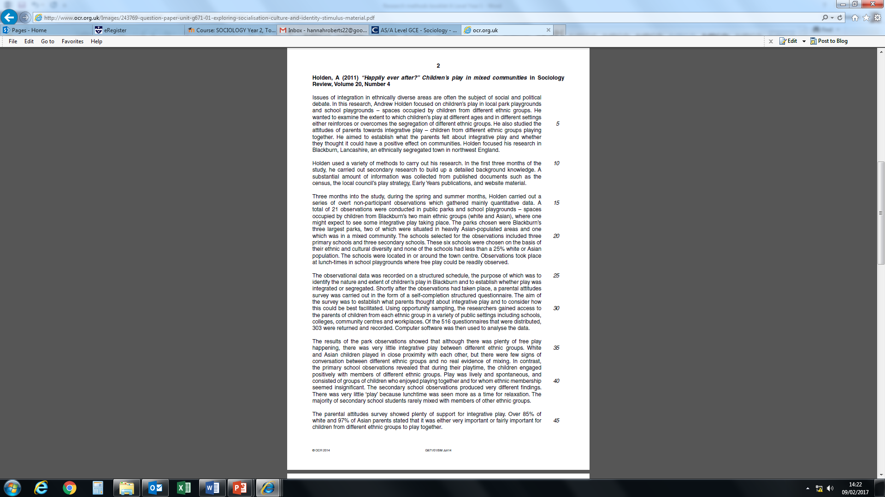In the case of non-participant observation, the researcher need not participate to observe people’s behaviour. A non-participant observer is like a birdwatcher in a hide, observing people without joining in. For example, a researcher may secretly observe children’s behaviour in a school playground from an upstairs room in the school. They may use a *behaviour schedule* – a checklist of activities which are noted when they occur. This is also called STRUCTURED OBSERVATION whereby particular behaviours or activities are recorded which allows for the observation data to be coded (counted using categories) to determine the number of times something happens.

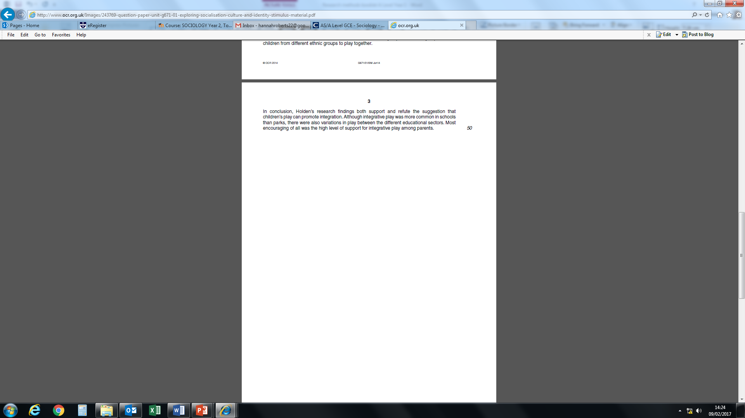

**What are the issues with this piece of research?**

**Activity:** Watch the video on street life (<https://www.youtube.com/watch?v=Y-s0pIHTac4>)

|  |
| --- |
| 1. Describe what is going on. 2. Why might non-participant observation be a useful approach for studying street life? 3. What theoretical and ethical issues might arise from this approach? |

|  |
| --- |
| **Case Study: ‘WHY KIDS KILL’ Dispatches- Glasgow shown on Channel 4 28.01.2008** |

The study wanted to find out the scale of violence in areas where gang violence was common. Dispatches have been asking kids about their experiences of the ‘teenage wars on our streets and possible solutions.’ It provides a good counterpoint to other studies on gang life explored in this booklet that use covert and overt participant observation (James Patrick’s ‘A Glasgow Gang Observed’ and Sudhir Venkatesh’s study ‘Gang Leader for a Day’).

|  |
| --- |
| Which methods are used by the investigators? |
| How many youths were included in the main body of the research? |
| What sorts of questions were asked? |

This research is not sociological in the ‘traditional’ sense; nonetheless, it helps us understand some of the practical, ethical and theoretical issues with **non-participant observation.**

The study contained **overt** **non-participant observation** with the use of filming the youths when questioned were asked

|  |
| --- |
| What data did this provide? |
| What were the benefits of using this method? |
| What problems could with using this method? |

The study also contained **covert non-participant observation** with the use of CCTV evidence

|  |
| --- |
| What data did this provide? |
| What were the benefits of using this method? |
| What problems could with using this method? |

# **EXPERIMENTS**

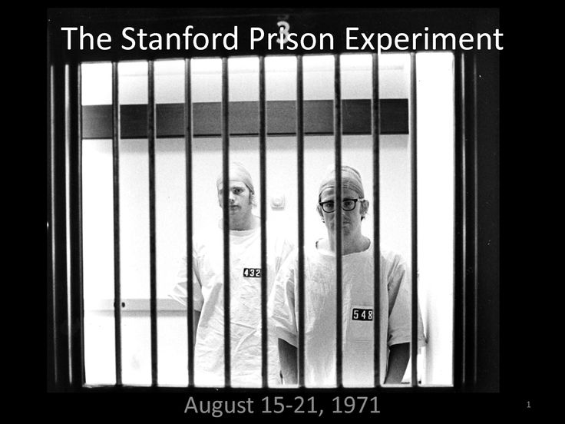

**EXPERIMENTS**

Experiments may be divided into two main types: **Laboratory experiments** (common in natural sciences**)** and **field experiments** (more common in Sociology but especially in Psychology). Let’s begin with laboratory experiments below.

**Laboratory Experiments**

The experiment is the main means of conducting research in the natural sciences. In natural sciences, experiments are used to test a **hypothesis** in laboratory conditions in which all **variables** or causes are under the control of the researcher. By manipulating variables and studying and measuring the results, the researcher tries to test a hypothesis by isolating the cause of some phenomenon under investigation (such as, why pigs get fat).

The researcher will take two groups that are alike in every way: one is the **control group** and the other is the **experimental group**. The researcher will then alter some factor (the independent variable) in the experimental group to see whether the variable being investigated (the dependent variable) changes, compared to in the **control group** (for example, alter heat in pigsties to see whether this affects pigs getting fat). If nothing changes in the **experimental group**, then that variable can be dismissed as a cause of the thing being investigated, and other variables can be tested. Through this experimental method, the researcher can eventually arrive at an explanation for the issue being investigated that has been tested against evidence, since any difference between the groups after the experiment can only be because of the experimental variable, as the two groups were otherwise identical before the experiment

Laboratory experiments in the natural sciences have a number of advantages:

* they enable scientists to test their hypotheses in controlled conditions.
* they make it easy to isolate and manipulate variables to determine the causes of events.
* they are repeatable (replicable) and therefore able to be checked by other researchers.
* they enable comparisons to be made with other similar experimental research.

**HOWEVER,** several problems exist when it comes to using the experimental method in Sociology. The key disadvantages are:

* in the social sciences, and sociology in particular, it is often difficult to isolate a single cause of a social issue like crime, or underachievement in school, and it is extremely difficult to isolate variables for testing. For example, crime and low achievement in school are the result of a range of causes.
* Experiments need to treat one group differently from another similar group and compare results. However, this poses ethical problems on sociologists, as it may have negative effects on the experimental group
* People may object to being experimented on, and if they are deceived and don’t realise they’re involved in an experiment – for example, to avoid the **Hawthorne Effect** – then the researcher will not have obtained the informed consent required in order to be acting ethically.

|  |
| --- |
| **The Hawthorne Effect –** Sociologists want to study people in their normal social context, but the laboratory and experimental conditions are artificial situations. People, unlike chemicals and many animals, can and do know what is going on in an experiment. The knowledge that an experiment is taking place, even if it is not fully understood, may mean people behave differently from their usual, everyday behaviour. They may deliberately sabotage the experiment, or ‘play up’ for the researcher. The very presence of the observer may become the principal independent variable in social scientific experiments. The classic example of this is known as the Hawthorne Effect. |

**EXAMPLE OF A LAB EXPERIMENT**

**The Stanley Milgram Experiment (1963) was created to explain some of the concentration camp-horrors of the World War 2, where Jews, Gypsies, homosexuals, Slavs and other enemies of the state were slaughtered by Nazis.**

**This article is a part of the guide:**

Many war-criminals claimed they were merely following orders and could not be held responsible for their actions, in the trials following the World War 2.

Were the Germans in fact evil and cold-hearted, or is this a group phenomenon which could happen to anyone, given the right conditions?

**Preparation of the Stanley Milgram Experiment**

The psychologist Stanley Milgram created an electric ‘shock generator’ with 30 switches. The switch was marked clearly in 15 volt increments, ranging from 15 to 450 volts.

He also placed labels indicating the shock level, such as ‘Moderate’ (75-120 Volts) and ‘Strong’ (135-180 Volts). The switches 375-420 Volts were marked ‘Danger: Severe Shock’ and the two highest levels 435-450, was marked ‘XXX’.

The ‘shock generator’ was in fact phony and would only produce sound when the switches were pressed.

40 subjects (males) were recruited via mail and a newspaper ad. They thought they were going to participate in an experiment about ‘memory and learning’.

In the test, each subject was informed clearly that their payment was for showing up, and they could keep the payment “no matter what happens after they arrive[d]”.

Next, the subject met an ‘experimenter’, the person leading the experiment, and another person told to be another subject. The other subject was in fact a confederate acting as a subject. He was a 47 year old male accountant.

The two subjects (the real subject and the con-subject) drew slips of paper to indicate who was going to be a ‘teacher’ and who was going to be a ‘learner’. The lottery was in fact a set-up, and the real subject would always get the role of ‘the teacher’.

The teacher saw that the learner was strapped to a chair and electrodes were attached. The subject was then seated in another room in front of the shock generator, unable to see the learner.

**Research Question**

The [Stanley Milgram Experiment](http://www.psychologytoday.com/articles/200203/the-man-who-shocked-the-world) aimed at getting an answer to the question:

“For how long will someone continue to give shocks to another person if they are told to do so, even if they thought they could be seriously hurt?” (the [dependent variable](https://explorable.com/dependent-variable))

Remember that they had met the other person, a likable stranger, and that they thought that it could very well be them who were in the learner-position receiving shocks.

**The Experiment**

The subject was instructed to teach word-pairs to the learner. When the learner made a mistake, the subject was instructed to punish the learner by giving him a shock, 15 volts higher for each mistake.

The learner never received the shocks, but pre-taped audio was triggered when a shock-switch was pressed.

If the experimenter, seated in the same room, was contacted, the experimenter would answer with predefined ‘prods’ (“Please continue”, “Please go on”, “The experiment requires that you go on”, “It is absolutely essential that you continue”, “You have no other choice, you must go on”), starting with the mild prods, and making it more authoritarian for each time the subject contacted the experimenter.

If the subject asked who was responsible if anything would happen to the learner, the experimenter answered “I am responsible”. This gave the subject a relief and many continued.

**Results**

During the Stanley Milgram Experiment, many subjects showed signs of tension. 3 subjects had “full-blown, uncontrollable seizures”.

Although most subjects were uncomfortable doing it, all 40 subjects obeyed up to 300 volts.

25 of the 40 subjects continued to complete to give shocks until the maximum level of 450 volts was reached.

**Conclusion - Obedience to Authority**

Before the Stanley Milgram Experiment, experts thought that about 1-3 % of the subjects would not stop giving shocks. They thought that you’d have to be pathological or a psychopath to do so.

Still, 65 % never stopped giving shocks. None stopped when the learner said he had heart-trouble. How could that be? We now believe that it has to do with our almost innate behavior that we should do as told, especially from authority persons.

**Ethical issues?**

**Using p.109-110 of the Webb textbook and your knowledge of the Milgram experiment outline the advantages and disadvantages of laboratory experiments below:**

|  |  |
| --- | --- |
| **Advantages** | **Disadvantages** |
|  |  |

**Field Experiments**

Field experiments are conducted in normal social situations, such as the classroom, the factory and the street corner. They are conducted in the real world under normal social conditions, but following similar procedures to the laboratory experiment. One advantage over laboratory experiments is the fact that field experiments are not ‘artificial’, which increases their validity. This is especially the case when the subjects (e.g. in a classroom) do not know that an experiment is taking place. Unlike laboratory experiments, however, they do not allow the researcher to control all the important variables, making them difficult to replicate.

Other disadvantages of field experiments are similar to laboratory experiments. These might involve the researcher misleading research participants, changing their behaviour through the Hawthorne effect or failing to gain their informed consent. The research might also have negative consequences for the participants.

Field experiments have been mainly carried out by interpretivists, who are interested in how meanings and labels, like ‘bright’ or ‘mentally ill’, get attached to people, and how others react to them. This is illustrated in the work of Rosenthal and Jacobson, which is examined below.

|  |
| --- |
| **Example – Rosenthal and Jacobson (1968). *Pygmalion in the Classroom*** |

**Activity**: Watch the video entitled ‘The Pygmalion Effect and the Power of Positive Expectations (<https://www.youtube.com/watch?v=hTghEXKNj7g>) and answer the following questions:

|  |
| --- |
| 1. What was the hypothesis of Rosenthal and Jacobson’s study? 2. How did the researchers go about with the study? 3. What was the outcome of the study? 4. What is the ‘pygmalion effect’? 5. What are the four factors in the classroom that contribute to the self-fulfilling prophecy? 6. What external factors/variables might you wish to take into account alongside teachers’ influence in creating student success/failure? 7. What may be some ethical issues relating to the study? |

**The Comparative method**

There is another experimental approach known as the comparative method where the approach is carried out only in the mind of the sociologist. It is a ‘thought’ experiment and does not involve actual people. Just like laboratory and field experiments its aim is to determine cause and effect. It works as follows:

1. Identify two groups of people who are very alike, but vary in one respect e.g. Durkheim in his study of suicide hypothesised (predicted) groups with higher levels of integration (Catholics) would have lower rates of suicide than Protestants who had lower levels of social integration.

2. Then compare the two groups and find differences. Durkheim’s hypothesis was supported by official statistics that found that Catholics had lower levels of suicide.

|  |  |
| --- | --- |
| Positives | Negatives |
| Avoids artificiality- does not use ‘real’ people who may change their behaviour because of the experiment. | Researcher has less control over variables- cannot determine whether other issues have caused the event. |
| No ethical issues because not dealing with people | Can be affected by the subjectivity of the researcher |
| Can study historical events |  |

# **SECONDARY SOURCES**

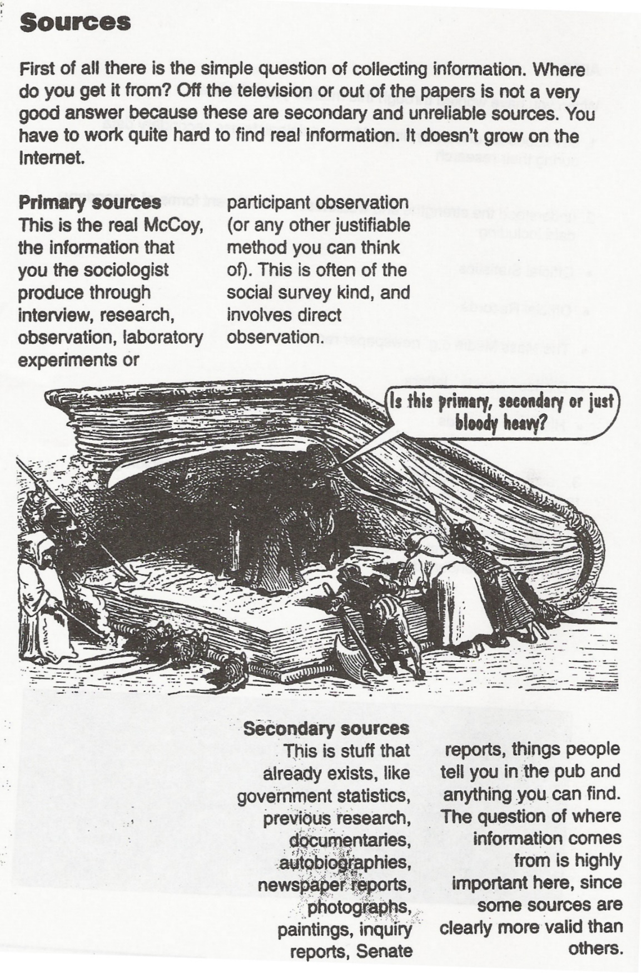

**SECONDARY SOURCES**

As established above, secondary data are those which already exist and are collected from secondary sources. Below is an overview of the main forms of secondary data. We will look at a selection of these throughout the booklet. We have already looked at one form: official statistics, in the earlier statistics booklet.

Secondary data can take either **quantitative** (statistical) or **qualitative** (non-statistical) forms. We can therefore distinguish between different types of documents. Some of these documents (personal/life documents) will be examined in depth in this booklet.

**Quantitative Secondary Sources (other than statistics)**

**Content Analysis**

As the name suggests, Content Analysis is used by sociologists to systematically investigate the content of documents. It explores the content of various media (books, magazines, TV, film etc.) in order to discover how particular issues are presented. Although such documents are usually qualitative, content analysis allows the sociologist to produce quantitative data from these sources. At its most basic, content analysis is a **statistical** exercise that involves categorising some aspect or quality of people’s behaviour and counting the number of times such behaviour appears (a simple content analysis might involve counting the number of minutes men and women appear on screen in a programme such as ‘Eastenders’). In this way, content analysis helps us to build-up a picture of the patterns of behaviour that underlie (and are usually hidden from view) the social interaction portrayed in the media.

It explores the content of secondary data (data which already exists) to create primary data.

As a technique it involves the researcher working out some kind of **CODING SCHEME** (or SCHEMA), that is the group of criteria by which characters are coded for belonging to a particular category.

A **content analysis** of a **television programme** such as Eastenders might involve two basic **categories** (**men** and **women**).

A very **simple form of content analysis** might simply involve **counting** the number of minutes men and women appear on screen.

A **more-complex form** might involve the use of **categories** like:

1. Where is each character most-often seen? (for example, in the pub as a customer or an employee; in their own home and so forth).
2. What does each character mainly do? (for example, are they always pictured at work or at home and so forth).

|  |  |
| --- | --- |
| **STRENGTHS** | **WEAKNESSES** |
|  |  |

**Qualitative Secondary Sources**

Qualitative secondary sources include newspaper, radio and TV reports, websites, novels, literature, art, autobiographies, letters, diaries, parish registers, historical documents, previous sociological studies, school records, social work files, police records, minutes of meetings as well as some official government reports. As John Scott (1980) argues, when it comes to assessing documentary sources, the general principles are the same as those for any other type of sociological evidence. He puts forward for criteria for evaluating documents (Webb textbook p.153-154): authenticity, credibility, representativeness and meaning.

A newer form of personal document can be seen to be the massive amount of information now placed on social media sites, such as Facebook, which have become repositories for information about our lives.

**Personal/life documents** – usually refer to private documents for a person’s own use, which record part of a person’s life. Imagine all the pieces of paper and documents that you have created during your life so for letters, diaries, stories, drawings, photographs, as well as all the material you have produced during your education. If these were discovered of some point for in the future they could provide ‘clues’ as to the time, place and society you lived in: its technology, education system and values for example, as well giving an idea of the sort of person you were. These are the sort of materials referred to as **personal** or **life documents**, and which can be used by sociologists as secondary data. The use of life documents has a long history in Sociology and was popularised by Thomas and Znaniecki in their study *The Polish Peasant in Europe and America* (1919). The researchers made use of 764 letters, a lengthy statement by one Polish peasant about his life, reports from social work agencies, court reports, and articles from Polish newspapers. From such sources they tried to understand and explain the experience of migration for the hundreds of thousands of Polish people who moved to America in the early years of the twentieth century. We will be looking at a more recent example of life documents towards the end of the booklet.

**Public documents** – they refer to those documents that are produced for public knowledge, and include a range of material like all manner of reports and statistics from government, council, charities, voluntary organisations, businesses and the media. *The Report of the Hillsborough Independent Panel* (2012), ordered by the House of Commons to investigate the circumstances surrounding the stadium disaster in Sheffield in 1989, is one recent example of a public document and easily accessible to the public. Another example of a public documents is the Black Report (1980), an enquiry into inequalities in health.

**Historical documents** – In a sense, all documents are historical, but conventionally we are referring to documents which relate to, or were written by, people who are dead. For studying the past, historical documents are often the major and sometimes the only source of information. Max Weber’s classic study *The Protestant Work Ethic and the Spirit of Capitalism* (1905) could not have been written without a range of historical documents. For example, he illustrates the spirit of capitalism with quotes from two books by Benjamin Franklin and written in the mid-eighteenth century. Other examples of historical documents are Phillipe Ariès, who used child-rearing manuals and paintings in his study on the rise of the modern notion of childhood (1962).

**Activity**

Using either the facebook page of a friend (who has given you consent to look at it) or the page of a celebrity or public group, apply John Scott’s criteria for evaluating documents to it and make some notes below:

**Authenticity:** is the page what it claims to be? Is it free from errors?

**Credibility:** is the page believable? Is the information true or is there information missing?

**Representativeness:** is the evidence typical? Could you use it to apply to similar people?

**Meaning:** Do you need special skills to interpret? Would it be possible to interpret it differently by different people

**Other types of secondary data: Photo diaries**

**Case Study: Archer, L., Hollingworth, S. and Halsall, A. (2007) 'University's not for Me - I'm a Nike Person': Urban, Working-Class Young People's Negotiations of 'Style', Identity and Educational Engagement, *Sociology,* 41, 2: 219-237**

Despite the government's wish to increase the numbers of working class young people entering Higher Education, the numbers of working class students currently going to university is low. Many leave education for good at 16. This research, which is part of a larger study on young, urban, working-class people, considers ways in which members of the social group invests in a style and identity which help to shape their view that 'university's not for me .. .'. The aim of the study was to explore the identities and aspirations of young people in London schools, who had been identified by teachers as 'at risk' of dropping out of education or 'unlikely to progress into post-16 education'. Archer et al argue that the identity taken up and acted out by urban working class youth is one based on knowing they are looked down on by their middle class peers, by the school system and by wider society. They argue that urban, working-class youth actively negotiate a position of social disadvantage which is based on a certain style: ' ... I'm a Nike person .. .'. However, this adopted style merely reinforces the reality of their marginalised and disadvantaged social status and results in a lot of conflict with teachers and the school system. For example, in a discussion about wearing trainers in school, one girl commented:

*"It's just shoes, I don't understand the rule Shoes don't affect my learning* " (Jordan, white working class girl).

Archer et al also argue that holding the view that 'university's not for me' means that these young people are less likely to be successful in education. The researchers also argue that working class urban youths' style differs from that of middle class youth and is one of the contributory factors in relation to the reproduction of educational inequalities.

The research took place over two years in six London schools. The schools were spread out across the city: two in the North, one in the East, one in central London and two in the West. They wanted to include a range of schools from different areas and with a diversity of pupils which were selected on the basis of data on pupil achievement from the Department for Education. All of the selected schools had a high proportion of underachieving pupils and were from disadvantaged areas. The access was obtained by initially contacting head-teachers who then acted as gatekeepers to the Year 10 and 11 form tutors and who also put the researchers in touch with some support staff. Pupils who were 'at risk' of dropping out of school were identified by the schools and the research team then wrote to their parents/guardians as well as the pupils themselves to gain permission for the interviews. Following this initial contact all of the pupils who agreed to take part were included in the study. The data was collected from interviews with fifty-three pupils from Years 10 and 11, discussion (focus) groups, photographic diaries and semi­structured interviews with teachers. Most of the fifty-three young people, whose age range was 14-16 years old, were interviewed four times. Some of the sample group left the study as a result of moving away or changing their contact details. The sample was comprised of twenty three girls and thirty boys. In relation to ethnicity the breakdown was thirty-six white UK, one Black African/Caribbean; six mixed ethnicity; four Asian; three Middle Eastern and three White other. The young people all lived in socially disadvantaged areas where there was high poverty, crime and drugs. They attended schools which were undersubscribed and considered less attractive than other schools in the area. Many of the interviewees had experienced repeated failure from the constant testing (SATS) they had endured during their school careers and described themselves as 'stupid' or 'not exactly a star student'.

In addition to the semi-structured interviews, eight pupils were asked to keep photographic diaries (they were invited to take photographs of anything that was either meaningful to them, reflected their identities or their daily lives), and a further 36 pupils took part in discussion groups - five pupils in each. The interviews varied in length from half an hour to one and a half hours. This enabled Archer et al to collect data that was, in the main, qualitative. The interviews were conducted on the school premises although a few took place in local cafes or other places identified by the pupils. These were usually when a pupil had left school or were frequently absent. Some interviews took place in Pupil Referral Units (PRUs) when pupils were moved into them by the schools over the two years.

In relation to ethics, parents of the pupils involved were asked for consent since the pupils were under 16 years old. The pupils' identities were anonymised by the use of pseudonyms which the pupils chose themselves. All of the interviews and discussion groups were audio recorded and a professional transcriber was employed to type them up.

Archer et al found that the style of the urban young working-class youth was linked to their class identity. A style which gave them a sense of self-worth and value and which enabled them to resist the worthlessness they might otherwise experience from attending 'crap' schools in 'rubbish areas'. They saw the style as 'cool' which was partly related to its association with black masculinity which was distinct from that of the middle class and symbolised 'hardness' and 'street cred'.

*"You wouldn't really expect [upper class] people to come out in Nike tracksuits and stuff, we expect them to have that Gucci designer stuff. But people like* us ... *we're Nike"* (Sean, Year 10 male).

|  |
| --- |
| **QUESTIONS**   1. Explain why photographic diaries can be a useful method for researching identities and aspirations of young people   2. Why would a Positivist be sceptical about using photographic diaries as sources of data? |