Godalming College
Booklet checked by
Grade: U/S 1 2 3
Comments:

Sociology and Anthropology Department

Exam skills
AS to A Level



Supplementary Workbook: Exam skills: As to A Level
Name | Set | Group

How the AS Level and A Level differ:
Paper 1: Education with Methods in Context | Paper 2: Research Methods and Topics in Sociology  (Families and Households)
Assessed:  - 1 hour 30 minutes written exam  - 60 marks  - 50% of AS Level | Assessed:  - 1 hour 30 minutes written exam  - 60 marks  - 50% of AS Level
Questions:  - Education: short answer and extended writing (40 marks)  - Methods in Context: extended writing (20 marks) | Questions:  - Section A (Research Methods): short answer and extended writing. (20 marks)  - Section B (Families and Households): Short answer and extended writing. (40 marks)

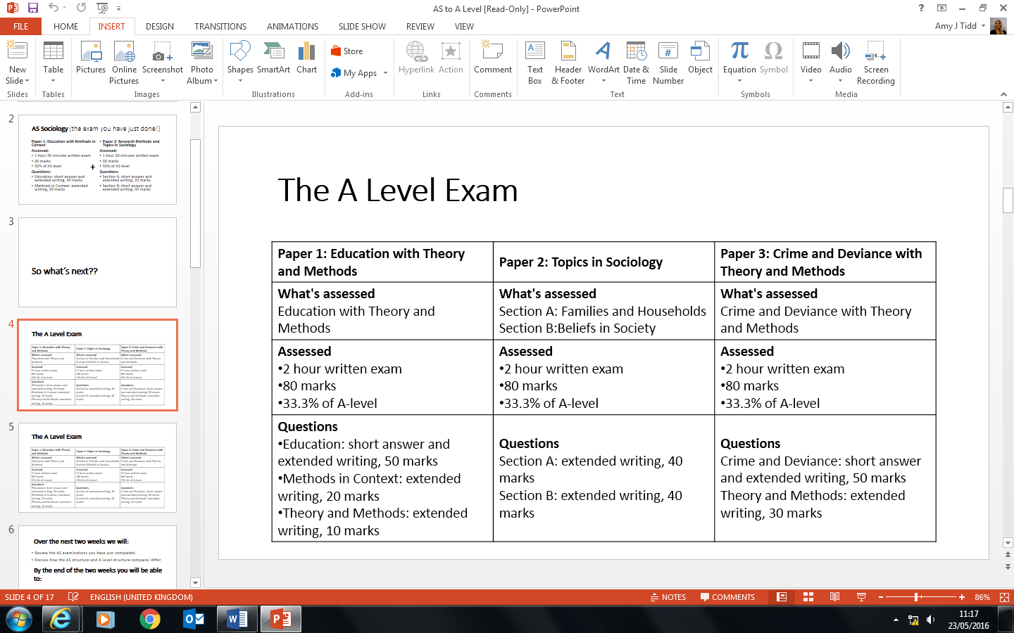
Over the next two weeks we will:
- Review the AS examinations you have just completed.
- Discuss how the AS structure and A Level structure compare/ differ
By the end of the two weeks you will have:
- Learnt the differences between the AS examination you have just completed and the A Level examinations you will be studying for next year.
- Continued revising and consolidating knowledge on Sociology of Education and Sociology of families and households in preparation for A Level.
- Attempted several A Level examination questions Sociology of Education and Sociology of families and households.
- Completed an A Level Sociology of families and households mock (page 19 of this workbook) using the examinations skills you have learnt throughout this workbook.
Paper 1 exam structure at A Level (Education with Theory and Methods)
Education:
Question 1: Outline two … (4)
Question 2: Outline three … (6)
Question 3: Applying material from Item A, analyse two reasons … (10)
Question 4: Applying material from Item B and your knowledge, evaluate the view that … (30)
Methods in context:
Question 5: Applying material from Item C and your knowledge of research methods, evaluate the strengths and limitations of using (a method) to investigate (a topic relating to education). (20)
Theory and Methods:
Question 6: Outline and explain two arguments … (10)

Paper 2 exam structure at A Level - Topics in Sociology (Families and Households/ Beliefs in Society)
Families and Households:
Question 1: Outline and explain two ways … (10)
Question 2: Applying material from Item A, analyse two … (10)
Question 3: Applying material from Item B and your knowledge, evaluate the view that … (20)
Beliefs in Society:
Question 1: Outline and explain two ways … (10)
Question 2: Applying material from Item A, analyse two … (10)
Question 3: Applying material from Item B and your knowledge, evaluate the view that … (20)

The structure of Paper 3 (Crime and Deviance with Theory and Methods) will be outlined in the Introduction to Crime and Deviance workbook that you will receive before the summer holidays

Education (with theory and methods)
Paper 1: Education (with theory and methods)
4 and 6 mark questions

The structure of these questions and the command words used are not too dissimilar to the AS paper that you have just sat.

You should tackle these questions using the ‘PEE’ technique:

- Point – clearly state the point
‘One way/ reason is...’
- Explain - develop the point

- Evidence – try to link into a contemporary example and ideally sociological study/ policy to illustrate the point further.

Question 1: Outline two processes within schools that may lead to working-class pupils achieving.
(4 marks)

________________________________________________________________________________________________________________________________________________________________________________________________________________________________________________________________________________________________________________________________________________________________________________________________________________________________________________________________________________________________________________________________________________________________________________________________________________________________________________________________________________________________________________________

Question 2: Outline three ways in which government educational policies have attempted to reduce inequality in achievement between social classes. (6 marks)

____________________________________________________________________________________________________________________________________________________________________________________________________________________________________________________________________________________________________________________________________________________________
________________________________________________________________________________________________________________________________________________________________________________________________________________________________________________________________________________________________________________________________________________________________________________________________________________________________________________________________________________________________________________________________________________________________________________________________________________________________________________________________________________________________________________________
Extra Space: ____________________________________________________________________________________________________________________________________________________________________________________________________________________________________________________________________________________________________________________________________________________________
Paper 1: Education (with theory and methods)
10 mark (education) questions

This is an example of an A Level 10 mark education question:

Item A
Since the 1980s there has been a growing gender gap in achievement. In almost all subjects at GCSE level females have consistently outperformed males. The impact of feminism as widely been acknowledged as a key factor in the improved achievement of girls. However, despite gender difference in attitude and application, the educational performance of boys has also improved. While women are now more likely than men to go to university, a higher proportion of men get a first class degree.

Question 3: Applying material from Item A, analyse two reasons for gender differences in achievement.
(10 Mark)

What is different between the wording/ structure of the question above and a 10 mark AS level question?

Select two reasons from the list below (all of which are either explicitly or implicitly stated within the Item) and then attempt to write an answer the 10 mark question:

- Impact of feminism
- Gender socialisation in the family
- Biological differences between males and females

- Teacher Labelling
- Differences in male/ female aspirations
- Introduction of coursework (National Curriculum)

____________________________________________________________________________________________________________________________________________________________________________________________________________________________________________________________________________________________________________________________________________________________
________________________________________________________________________________________________________________________________________________________________________________________________________________________________________________________________________________________________________________________________________________________________________________________________________________________________________________________________________________________________________________________________________________________________________________________________________________________________________________________________________________________________________________________
____________________________________________________________________________________________________________________________________________________________________________________________________________________________________________________________________________________________________________________________________________________________
_____________________________________________________________________________________________________________________________________________________________________________________________________________________________________________________________________________________________________________________________________________________________________________________________________________________________________________________________________________________________________________________________________________________________________________________________________________________________________________________________________________________________________________________________________________________________________________________________________________________________________________________________________________________________________________________________________________________________________________________________
Extra Space

____________________________________________________________________________________________________________________________________________________________________________________________________________________________________________________________________________________________________________________________________________________________
______________________________________________________________________________________________________________________________________________________________________________________________________________________________________________________________________________________________________________________________________________________________________________________________________________________________________________________________________________________________________________________________________________________________________________________________________________________________________________________________________________________________________________________________________________________________________________________________________________________________________________________________________________________________________
Paper 1: Education (with theory and methods)
30 mark question

The 30 mark essay is an education essay. It requires you to adopt a similar approach/ structure to the 20 mark questions you completed in the AS Level paper that you have just completed. This question requires you to use an Item.

Proposed essay structure:

Introduction:
- ‘As the Item states...’
- Outline the debate – view in the question VS opposing view.

Main Body:
- 3 paragraphs on the view in the question (including AO2 & AO3 )
- 2 paragraph on opposing view
- 1 paragraph on other possible views/ arguments.

Conclusion:
- Discuss main strengths and weaknesses of the arguments
- Say something new

Example 30 mark education question and answer:

Read Item B and answer the question that follows:

Item B
According to figures from the DfE, pupils from Chinese and Indian backgrounds consistently perform better than white, Pakistani, Bangladeshi and black pupils at all stages of education. There are also important gender differences between ethnic groups in other areas within education. For example, permanent exclusion rates are usually highest for black Caribbean boys and lowest for Bangladeshi girls.

Some sociologists argue that such differences can be explained by factors that occur in school such as teacher racism and bias in the school curriculum. However, other sociologists argue that factors outside school are more important.

Applying material from Item B and your own knowledge evaluate the view that ethnic differences in educational achievement are primarily the result of factors inside school. (30 marks)

Activity:
Read the exemplar answer on the next page. Using different colours highlight:
- Every time the student refers to the item
- Mention of key concepts
- Mention of studies.

Alongside the item place:
- A ‘+’ every time the content discusses the view in the question
- A ‘-‘ every time the content evaluates/ opposes the view in the question.

As Item B states, certain groups such as black pupils and some Asians perform relatively poorly in education. The reasons for this are complex as demonstrated by the fact that some Asian groups, namely Indian, perform better than white students. Interactionists would argue that the reason why certain ethnic groups underachieve is down to internal factors such as negative teacher labelling and pupils’ responses to this. However, functionalists would focus on external factors such as cultural deprivation when looking at the cause of differential ethnic achievement. They would argue that positive parental support and values are more important than any issues that occur in school.

In terms of racist labelling, Wright (1992) found that Asian students were often the victim of negative treatment from teachers. Teacher assumed they would have a poor grasp of English and would tend to misspell and mispronounce names. This would lower their self-esteem and cause them to underachieve. Gillborn and Youdell (2000) found that teachers already has ‘racialised expectations’ towards black students and would see their behaviour as a threat. As a result black students felt they were being picked on and would underachieve. It could be argued that the reason why black Caribbean pupils are more likely to be excluded , as referred to in item B is because of these ‘racialised expectations’. If teachers treated them unfairly and see them as a ‘threat’ they would be more likely to be excluded from school and therefore underachieve as a result. However functionalists would argue that the more likely reason for this statistic is that black students are often culturally deprived due to inadequate socialisation. For example, values such as immediate gratification are passed on where black parents would encourage their children to leave school as soon as possible and not teach the value of education. Similarly, New Right thinker Murray would argue that black pupils are more likely to be part of an underclass with female-headed families and the resulting lack of male role model. However, interactionists such as Keddie would reject the cultural deprivation approach as ‘victim blaming’ and would argue that internal school-based factors such as streaming are more important.

Even if negatively labelled by teachers, ethnic minority students can still achieve. As Fuller’s study on black girls illustrates, students who want to succeed can reject teacher labels and get together to form a pro-education subculture. However, Mirza’s study shows that attempts to do this and reject help from teachers they see as racist may not be successful for some black female students. Sewell (1998) found that black boys fell into four types of response to the racist stereotype that they felt teachers had of them as being ‘trouble’. While the ‘rebels’ rejected goals and rules of the school and were likely to underachieve, they were only the minority. The largest group were the ‘conformists’ who accepted school and goals and wanted to achieve despite this labelling. While Sewell’s study may be out of date, it has strength of illustrating how pupils can respond to labelling in different ways. He also accepts that factors outside of school such as a lack of a male role model and the media can influence the achievement of black boys.

Marxists and Weberians, however, would argue that by focusing on internal factors interactionists are ignoring material factors and the impact of racism in wider society. It can be argued that some ethnic minorities such as Bangladeshi and Pakistani suffer from material deprivation due to racial discrimination in the labour market. This means that due to low family income they may lack access to materials such as educational equipment and a quiet place to study and so as a result may underachieve. Noon’s study provides evidence that there is racial discrimination in areas such as employment which may have a knock on effect on educational achievement. If students from an ethnic minority background feel that employers are racist this may act as a disincentive to work hard to get qualifications in school. This may be more of an important factor on where they achieve than any negative labelling by teachers who are unlikely to be overtly racist in school through fear of losing their job.

Rather than the negative labelling of individual teachers, another internal factor that may influence ethnic minorities’ achievement is that schools as a whole are institutionally racist. It has been argued by Coard that UK schools are ethnocentric, meaning that education favours British white culture and therefore giving priority to white pupils who are therefore more likely to achieve. An ethnocentric curriculum may produce underachievement for groups such as black students in subjects like history. For example, if the image of black people is portrayed negatively in lessons on slavery then this may damage black students’ self-esteem and can lead to failure in a subject like history. However, the ethnocentric curriculum cannot be the only cause of the ethnic gap in underachievement as Chinese pupils achieve highest despite the curriculum being biased against their culture. Sociologists who look at external factors would argue that the high achievement of Chinese pupils is more due to the importance that is placed on getting a good education at home by so-called ‘tiger mums’.

Government policies that have introduced greater selections by schools, such as parentocracy, have led to another internal factor which is likely to disadvantage students from ethnic minority backgrounds. Evidence suggests that schools can be racist in their admissions policies such as using primary school reports to avoid selecting certain ethnic groups. It also may be more difficult for parents from some ethnic backgrounds to get their child into a ‘good’ school as they may lack the cultural capital required such as knowledge of admissions procedures. This may apply to students whose parents do not have English as a first language. While Marxist –influenced sociologists would argue that the selection system is biased towards white, middle class parents, functionalists argue that the system offers equal opportunities. They would argue that if ethnic minority parents miss out on their choice of school it is more likely to be caused nu cultural deprivation as they are probably not doing enough to get their child into a good school.

Perhaps the main reason why there is an ethnic gap in achievement is due to the internal factor of teacher labelling. However this may not be applicable to all ethnic groups, such as Chinese and Indians, who outperform white students.
Paper 1: Education (with theory and methods)
20 mark (methods in context) question

The typical structure of the 20 mark method is context question is:
Applying material from Item C and your knowledge of research methods, evaluate the strengths and limitations of using (a method) to investigate (a topic in education)

THIS QUESTION IS STRUCTURED AND MARKED EXACTLY THE SAME AS THE AS LEVEL PAPER.

Example of a question (taken from the AS Sociology Examination paper 2016):

ITEM C:

Applying material from Item C and your knowledge of research methods, evaluate the strengths and limitations of using group interviews to investigate the causes of educational underachievement amongst boys.

After the group activity write a quick summary of the main elements you need to include in a methods in context question:

Paper 1: Education (with theory and methods)
10 mark (theory and methods) question

This 10 mark question could be on either method OR theory based.

Method:
Outline and explain two advantages of using (a method) in sociological research

OR

Theory:
Outline and explain two arguments against the view that sociology can be value free.

Activity:

In pairs type up your answer your allocated 10 mark (research method based) question.

Outline and explain two advantages of using (a method below) in sociological research

- Official statistics
- Non-official statistics
- Field Experiments
- Semi-structured
- Unstructured
- Group Interviews
- Questionnaires
- Covert Observation
- Overt Observation
- Participant Observation
- Non-Participant Observation

Note: You will cover more content on theory and method in your A Level year (alongside the Crime and Deviance module) to enhance your knowledge of methods and also to cover the questions that are theory based.

Families and Households
Paper 2: Topics in Sociology (Families and Households/ Beliefs in Society)
Families and Households
10 mark question

The first 10 mark question in the Families and Household/ Beliefs in Society paper will always be worded as:

Outline and explain two … (10)

Not only are these questions worded exactly the same as your AS 10 mark questions in both Paper 1 and Paper 2, using the same command words ‘outline and explain’, the way they are marked has not differed either, with the weighting as follows:

AO1 | 5 | AO2 | 3 | AO3 | 2

They will require you to outline and explain two factors, features, reasons, causes, effects, functions, ways, problems, advantages, disadvantages, criticisms or other issues.

Guidance for answering these questions:
- Spend approximately 15 minutes on this question type.
- Divide your time equally between each reason.
- Write two clear paragraphs.
- Do not waste time writing an introduction.
- Very clearly at the beginning of each paragraph state your reason.
- Describe each reason in detail. Develop a chain of reasoning (see page 248 of AQA A Level Sociology Book One, Webb et al) to ensure significant depth.
- Ensure you use concepts throughout, as well as apply relevant supporting sociological studies as evidence.

Some example questions:

Outline and explain two reasons for the increase in divorce rates since the 1960s.

Outline and explain two reasons why the position of children in the United Kingdom may be changing.

Outline and explain two ways in which changes in the law have affected women’s family roles over the past 60 years.

Outline and explain two ways in which changes to gender roles have affected diversity of family structures.

Paper 2: Topics in Sociology (Families and Households/ Beliefs in Society)
Families and Households
10 mark question (using the item)

The second question on Paper 2: Topics in Sociology Families and Household/ Beliefs in Society will always be structure as:

Applying material from Item A, analyse two …

This is exactly the same format and marked exactly the same as the 10 mark questions in Paper 1 (Education) and Paper 3 (Crime and Deviance) so you need to be fully familiar with the structure and the requirements of this type of question. (See page 7 of this workbook for extra advice)

Guidance for answering these questions:
- Spend approximately 15 minutes on this question.
- This question will require you to use the Item.
- These questions will ask you to analyse two points, BUT you must apply the item to both the two points you make within your answer.
- The points may be explicitly or implicitly within the item. Don’t assume they’re obvious. You will need to seek them out and fully explain/ apply the item to show your analysis/ reasoning.

Sample question:

Read Item A below and answer the question that follows:

Item A
Almost a third of households in the UK, 7 million in total, are now one-person households. However, people living alone do not form a group sharing the same characteristics. For example, there are more women than men in this group, except in the 35-49 age group, and whites are more likely than Asians or British Asians to live alone.

Applying material from Item A, analyse two reasons for the increase in one-person households

Activity:
In pairs brainstorm reasons for the increase in one-person households:

Reasons for the increase in one-person households
Considering the question above pick two reasons from your brainstorm on page 16 to attempt the question. Remember somewhere within each point you must apply Item A.

Reason 1 | Reason 2
Detail (chain of reasoning)  What concepts/ studies/ theories could you link to? | Detail (chain of reasoning)  What concepts/ studies/ theories could you link to?
How would you apply Item A within your response? | How would you apply Item A within your response?
Paper 2: Topics in Sociology (Families and Households/ Beliefs in Society)
Families and Households
20 mark essay question (using the item)

The 20 mark question in Paper 2 is an essay style question, asking you to evaluate something, such as an explanation or view. These questions will always require you to use the item and will be structured like this:

Applying material from Item B and your knowledge, evaluate the view that …
NOTE: these questions worded exactly the same as your AS 20 mark questions in Paper 2, and the way they are marked has not differed either, with the weighting as follows:

AO1 | 8 | AO2 | 6 | AO3 | 6

In this question, as well as showing knowledge and understanding of relevant theories, methods, concepts and studies (AO1) you will also need to show the AO2 skills of Application (by using the Item thoroughly) and AO3 skills of Analysis and Evaluation.

Example question:

Read Item B below and answer the question that follows.

Item B
Some sociologists claim that the small, home centred nuclear family is ideal for socialising children into the norms and values of society and provides a stable background for both children and their parents, Some politicians go further and argue that the increasing breakdown of family units is at least partly responsible for such social ills as delinquency and other forms of anti-social behaviour, together with rising rates of depression.

Applying material from Item B and your own knowledge, evaluate the view that the traditional nuclear family best serves the interest of its members and of society as a whole.

Activity:
- Cut out all of the sections of the essay and then put them in order to formulate an essay that flows. Check that the order is correct before gluing it onto page 18.
- Using the generic mark scheme attempt to mark this essay out of 20.

