**10 mark questions on trends, demographics and diversity**

It is very likely that you will get a question from this topic in the exam.

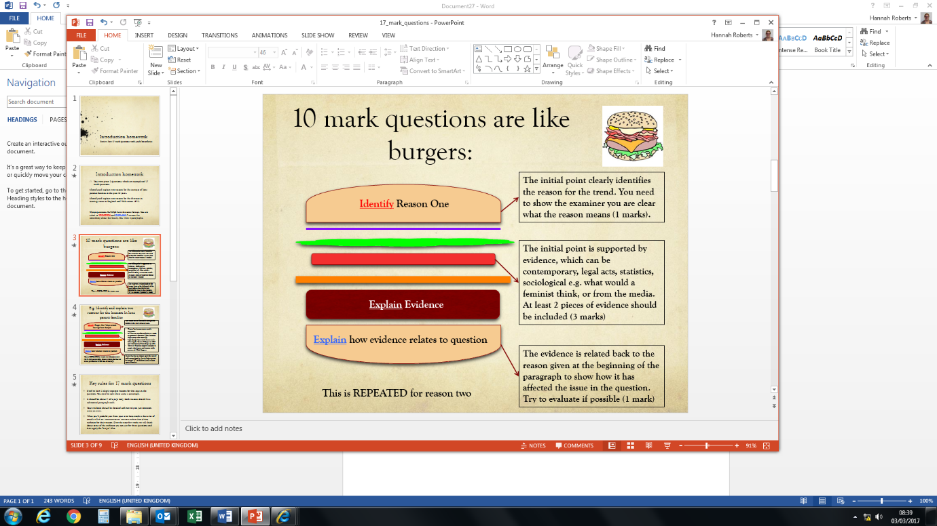

STUDIES AND THEORIES REALLY HELP GET GOOD MARKS ON THESE QUESTIONS

Possible examples:

1. Outline and explain two reasons for the growth in single person households in the contemporary UK. [10]
2. Outline and explain two reasons for the decrease in family size over the past 30 years. [10]
3. Outline and explain two reasons for the increase in cohabitation in the contemporary UK. [10]
4. Outline and explain two ways in which an ageing population affects family life. [10]
5. Outline and explain two reasons for the decline in the marriage rate in the UK. [10]
6. Outline and explain two reasons for the increase in one parent families in the contemporary UK. [10]
7. Outline and explain two reasons for the increase in the divorce rate in the last 40 years. [10]
8. Outline and explain two types of family diversity in the contemporary UK. [10]
9. Outline and explain two ways families may differ based on ethnic differences [10]
10. Outline and explain two ways migration has had an impact on families in the UK [10]
11. Outline and explain two reasons for the growth of LATS (living apart together) [10]
12. Outline and explain two reasons for the increase in same sex couples with children [10]
13. Outline and explain two reasons for the decline in birth rate [10]
14. Outline and explain two reasons why women are choosing to have children later [10]
15. Outline and explain two reasons why more young people are living with their parents for longer [10]
16. Outline and explain two reasons for the decline in infant mortality rates [10]