
GCSE Mathematics
Practice Tests: Set 3
Paper 3H (Calculator)
Time: 1 hour 30 minutes
You should have: Ruler graduated in centimetres and millimetres, protractor, pair of compasses, pen, HB pencil, eraser, calculator.

Instructions
- Use black ink or ball-point pen.
- Fill in the boxes at the top of this page with your name,
centre number and candidate number.
- Answer all questions.
- Answer the questions in the spaces provided
– there may be more space than you need.
- Calculators may be used.
- Diagrams are NOT accurately drawn, unless otherwise indicated.
- You must show all your working out.

Information
- The total mark for this paper is 80
- The marks for each question are shown in brackets
– use this as a guide as to how much time to spend on each question.

Advice
- Read each question carefully before you start to answer it.
- Keep an eye on the time.
- Try to answer every question.
- Check your answers if you have time at the end.

Answer ALL questions.
Write your answers in the spaces provided.
You must write down all the stages in your working.

1. –2 < n ≤ 3
n is an integer.
(a) Write down all the possible values of n.

................................
(2)

x is a number.
Another number is 9 greater than x.
Both numbers are whole numbers.
The total of the two numbers is less than 60
(b) Find the greatest possible value of x.

................................
(3)
(Total 5 marks)
___________________________________________________________________________
2

Use ruler and compasses to construct the perpendicular bisector of the line AB.
You must show all your construction lines.

(Total 2 marks)
__________________________________________________________________________
3. Alex and Ben go to a cafe with some friends.

Alex buys 4 cups of coffee and 3 cups of tea.
He pays a total of £6.95

Ben buys 5 cups of coffee and 2 cups of tea.
He pays a total of £7.20

Work out the cost of each cup of coffee and the cost of each cup of tea.

Cup of coffee ................................

Cup of tea ................................
(Total 5 mark)
___________________________________________________________________________
4. Beth has 600 counters.
$\frac{3}{5}$ of the counters are yellow.
25% of the counters are red.
The rest of the counters are green.

Beth is given some more red counters.
Now the ratio of the number of green counters to the number of red counters is 1 : 2
How many red counters was Beth given?

................................
(Total 4 mark)
___________________________________________________________________________

5. Work out (9.5 × 109) ÷ (3.8 × 103)
Give your answer in standard form.

................................
(Total 2 marks)
___________________________________________________________________________
6.

Work out the value of x.
Give your answer correct to 3 significant figures.

x = ................................
(Total 3 marks)
___________________________________________________________________________
7. (a) A = {p, r, a, g, u, e}
B = {p, a, r, i, s}
C = {b, u, d, a, p, e, s, t}

List the members of the set

(i)

................................................................
(ii)

................................................................
(2)
(b) D = {r, o, m, e}
E = {l, i, s, b, o, n}
F = {b, e, r, l, i, n}

Put one of the letters D, E or F in the box below to make the statement correct.

Explain your answer.

...............................................................................................................................................
(1)
(Total 3 marks)
___________________________________________________________________________
8. Here is a formula used to work out the speed, v mph, of a car making an emergency stop.
$$v=\sqrt{\text{21}d}$$
d feet is the length of the mark the car’s tyres make on the road when making an emergency stop.
A car makes an emergency stop.
The car’s tyres make a mark 90 feet long.
(a) Work out the speed of the car.
Give your answer correct to the nearest whole number.

................................ mph
(2)
A car made an emergency stop.
The car’s speed was 50 mph.
(b) Work out the length of the mark on the road.
Give your answer correct to the nearest whole number.

................................ feet
(3)
(Total 5 marks)
___________________________________________________________________________
9. The diagram shows a large tin of pet food in the shape of a cylinder.

The large tin has a radius of 6.5 cm and a height of 11.5 cm.

A pet food company wants to make a new size of tin.

The new tin will have a radius of 5.8 cm.
It will have the same volume as the large tin.

Calculate the height of the new tin.
Give your answer correct to one decimal place.

.......................................... cm
(Total 3 marks)
___________________________________________________________________________
10. Simon wants to raise money for charity.
He designs a game for people to play.

Simon uses two fair 5-sided spinners for the game.
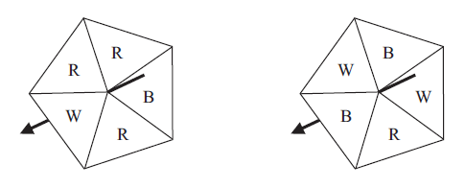

People spin each spinner once.
A person wins the game when both spinners land on the same letter.

People pay 40p for each game they play. The prize for a win is £1.

Work out if Simon is likely to raise any money for charity with his game.

(Total 5 marks)
___________________________________________________________________________
11. The value of a motor bike depreciates by 20% each year.

Brian says,

“After two years, the value of the motor bike will have reduced by 40%”.

He is wrong.

Explain why.

(Total 3 marks)
__________________________________________________________________________
12. The diagram shows a regular pentagon ABCDE.

The pentagon is divided into 5 isosceles triangles.
OA = OB = OC = OD = OE = 6 m

Work out the area of the pentagon.
Give your answer correct to 1 decimal place.

.............................................. m²
(Total 4 marks)
___________________________________________________________________________
13. The points A(6, 1) and B(−2, 5) are on the line with equation y = −x + 4
M is the midpoint of AB.
Find an equation of the line through M that is perpendicular to y = −x + 4

......................................................................
(Total 4 marks)
___________________________________________________________________________
14. In the winter a farmer feeds his cows with hay each day.

The number of days, d, the hay will last is inversely proportional to the number of cows, c, the farmer has.

The farmer has enough hay to feed 280 cows for 25 days.

(a) Find a formula for d in terms of c.

................................
(2)

The farmer has 350 cows.

(b) How many days will the farmer be able to feed all his cows with hay?

................................ days
(2)
(Total 4 marks)
___________________________________________________________________________
15. Hot drinks are served at a temperature of 70 °C.

The graph shows the temperature of a hot drink as it cools in a china mug from the time it is served.
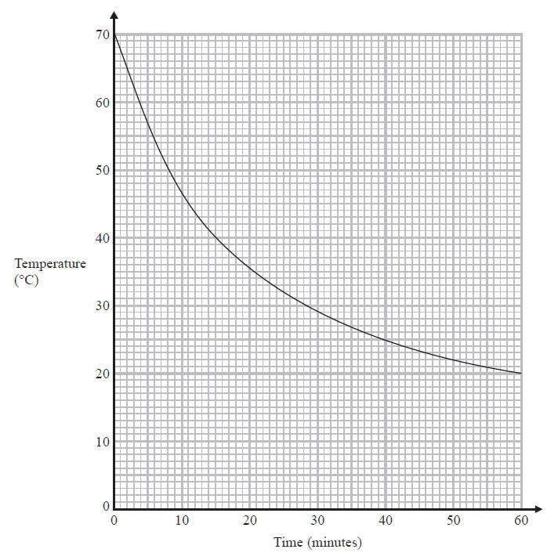
Work out the rate of cooling of the drink at time 20 minutes.

................................ °C per minute
(Total 3 marks)
___________________________________________________________________________
16. Adele grew 30 cabbages.

She gave fertiliser to 15 of the cabbages.
She did not gave fertiliser to the other 15 cabbages.

Here are the final weights, in kilograms, of the 15 cabbages Adele gave fertiliser to.

1.5 | 1.5 | 1.6 | 1.6 | 1.6 | 1.7 | 1.8 | 1.8
2.0 | 2.0 | 2.0 | 2.0 | 2.2 | 2.5 | 2.6

Here is some information about the final weights, in kilograms, of the 15 cabbages Adele did not give fertiliser to.

Smallest | 1.0
Largest | 2.1
Median | 1.4
Lower quartile | 1.2
Upper quartile | 1.6

Compare the two distributions of weights.

(Total 2 marks)
___________________________________________________________________________
17. A field is in the shape of a rectangle.
The width of the field is 28 metres, measured to the nearest metre.

(a) Work out the upper bound of the width of the field.

......................... metres
(1)

The length of the field is 145 metres, measured to the nearest 5 metres.

(b) Work out the upper bound for the perimeter of the field.

......................... metres
(3)
(Total 4 marks)
___________________________________________________________________________

18. The tables show some information about the population of the United Kingdom (UK) in 2003 and in 2008.

2003
 | Area (km²) | Number of people per km²
England | 130 281 | 383
Northern Ireland | 13 576 | 125
Scotland | 77 925 | 65
Wales | 20 732 | 142

2008
 | Percentage of total UK population
England | 84%
Northern Ireland | 4%
Scotland | 9%
Wales | 3%

In 2008, the total population of the UK was 61 million.
The population of England increased between 2003 and 2008 Work out this increase.
Give your answer correct to 2 significant figures.

..................................
(Total 5 marks)
___________________________________________________________________________
19. Here is a triangle ABC.

AC = 90 m.
BC = 60 m.
Angle ACB = 130°.

Calculate the perimeter of the triangle.
Give your answer correct to one decimal place.

................................. m
(Total 4 marks)
___________________________________________________________________________
20. The histogram shows information about the areas of some farms.

90 of the farms have an area of 10 hectares or less.

60% of the farms with an area of 100 hectares or less are arable farms.
of the farms with an area of more than 100 hectares are arable farms.
Work out an estimate for the total number of arable farms.

..............................................
(Total 5 marks)
___________________________________________________________________________
21. Solve $\frac{5(2x+1)^{2}}{4x+5}$ = 5x – 1

..................................
(Total 5 marks)
___________________________________________________________________________

TOTAL FOR PAPER IS 80 MARKS

BLANK PAGE

