**Timeline for *Identities* in works of Art & Architecture**

**Augustus of Prima Porta, Roman, c. AD14, marble, 2.03m high**

**Frida Kahlo   
‘Self Portrait on the border of Mexico and the USA’, Mexican, 1932**

**Sinan ‘Suleymaniye Mosque’, Istanbul,   
1550-58**

**Jan van Eyck   
‘The Arnolfini Portrait’ 1434, Flemish**

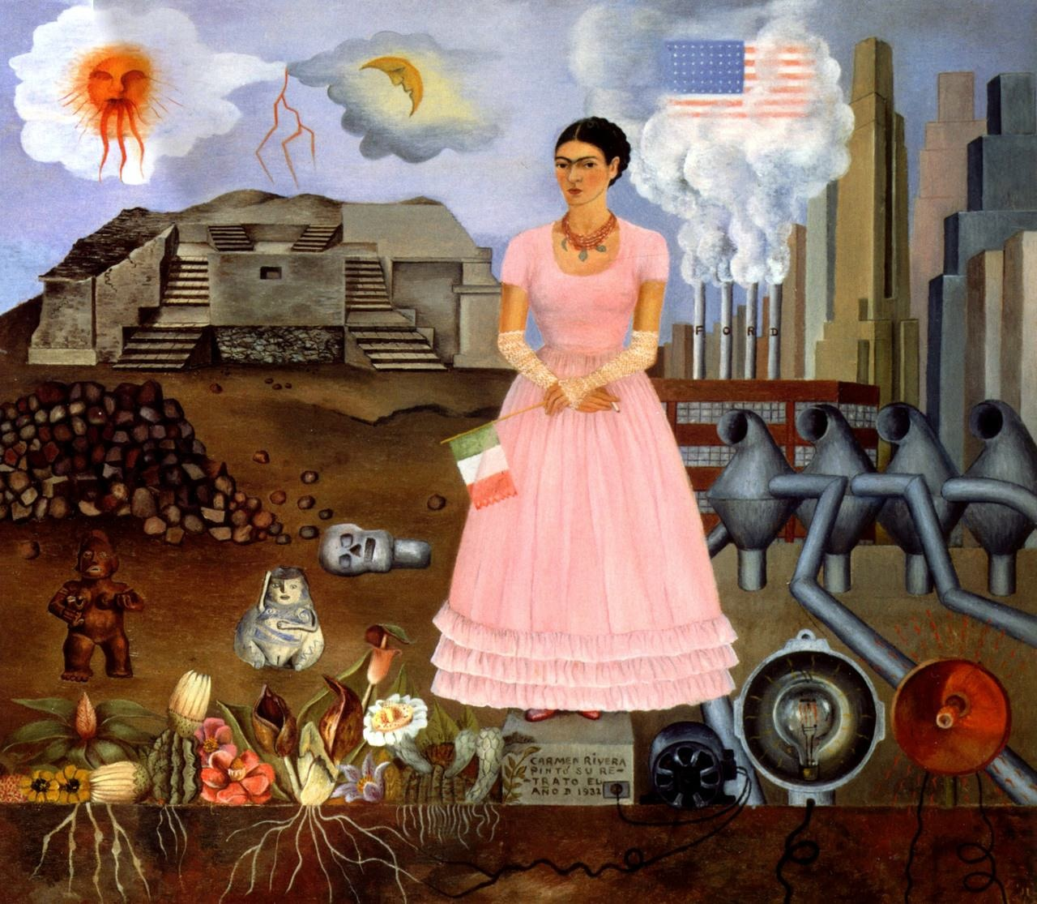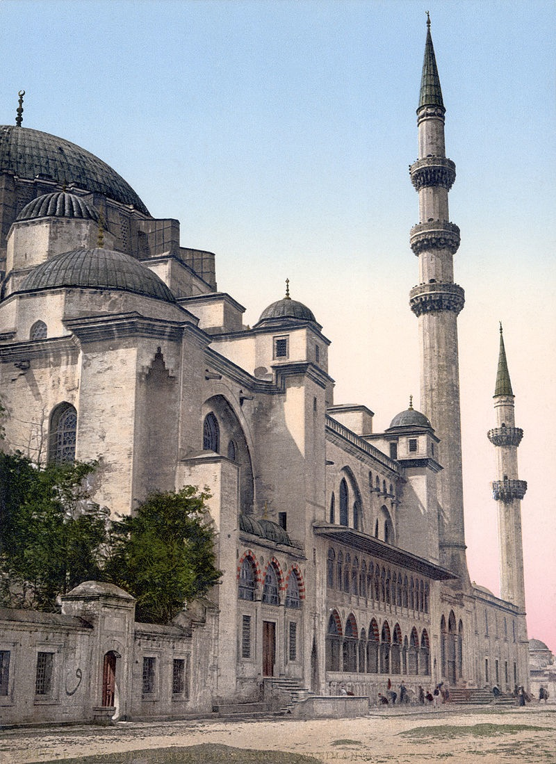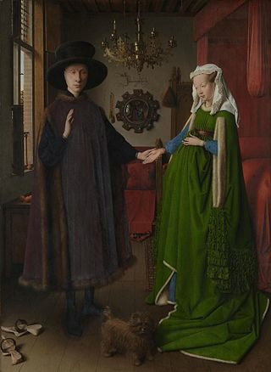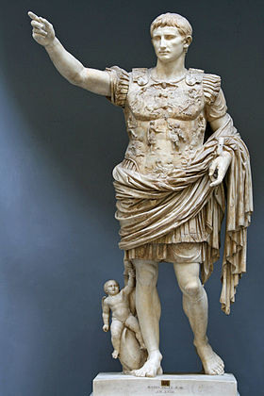

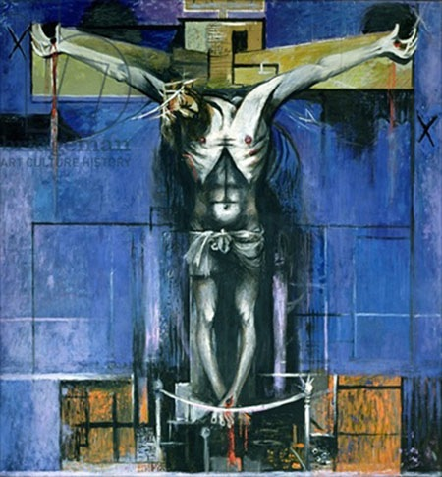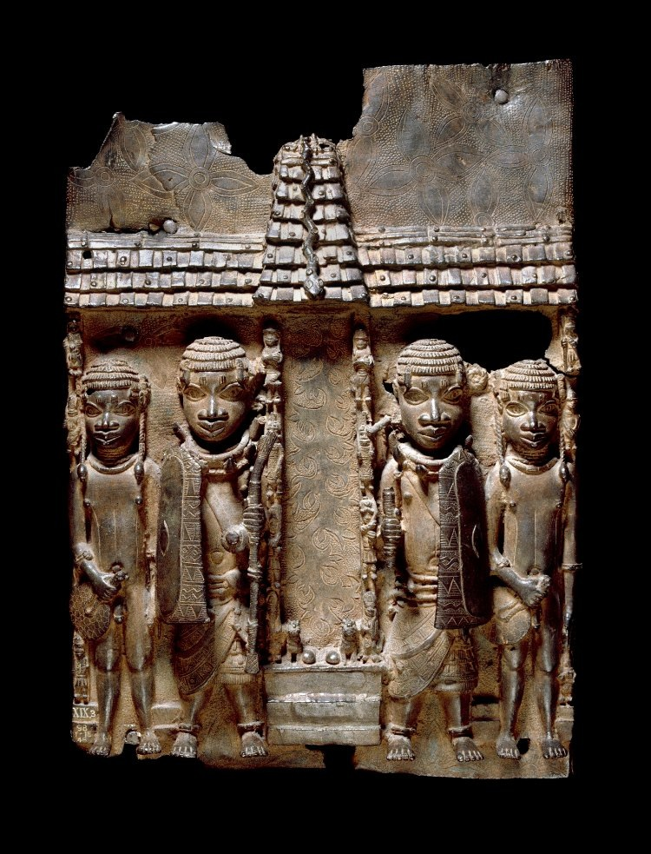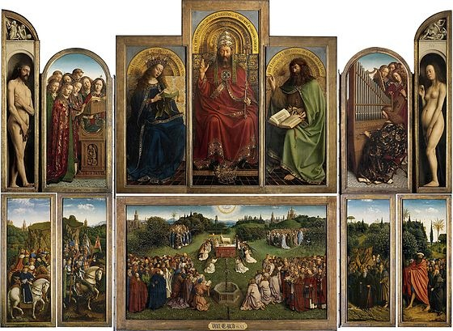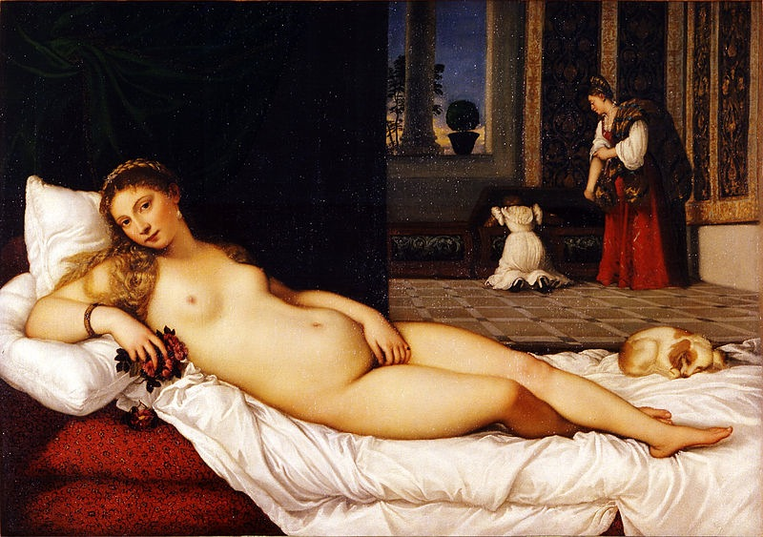

**‘Group of four figures in front of the Royal Palace. Benin, 16th-17th century**

**Graham Sutherland   
‘Crucifixion’, British 1946**

**Jan van Eyck ‘The Ghent Altarpiece’, Flemish, 1430,**

**Titian ‘Venus of Urbino’ Italian Renaissance, 1538**