Give a definition for the terms and phrases below

|  |  |  |
| --- | --- | --- |
| Equestrian portrait | Ad locutio | Idealised |
| Propaganda | First consul | Diplomacy |

**Contextual background:**

In the spring of 1800 Napoleon led the Reserve Army across the Alps through the [Great St. Bernard Pass](http://en.wikipedia.org/wiki/Great_St_Bernard_Pass). The Reserve Army fought a battle at [Montebello](http://en.wikipedia.org/wiki/Battle_of_Montebello_(1800)) on 9 June before eventually securing a decisive victory at the [Battle of Marengo](http://en.wikipedia.org/wiki/Battle_of_Marengo_(1800)). The painting was created in remembrance of the war and Napoleon’s win.

Napoleon was then known as a [First Consul](http://en.wikipedia.org/wiki/First_Consul). The French ambassador to Spain, [Charles-Jean-Marie Alquier](http://en.wikipedia.org/w/index.php?title=Charles-Jean-Marie_Alquier&action=edit&redlink=1), was to hang the portrait in the [Royal Palace of Madrid](http://en.wikipedia.org/wiki/Royal_Palace_of_Madrid) as a token of the new relationship between the two countries. David was eager to undertake the commission.

The commission specified a portrait of Napoleon standing in the uniform of the [First Consul](http://en.wikipedia.org/wiki/First_Consul). The Spanish ambassador informed Napoleon and asked him how he would like to be represented. Napoleon initially requested to be shown reviewing the troops but eventually decided on a scene showing him crossing the Alps.

Napoleon asked David to portray him "calm, mounted on a fiery steed". However, in reality the crossing had been made with Napoleon being led across the mountains, mounted on a mule, by a guide. It is likely that he suggested the addition of the names of the other great generals who had led their forces across the Alps.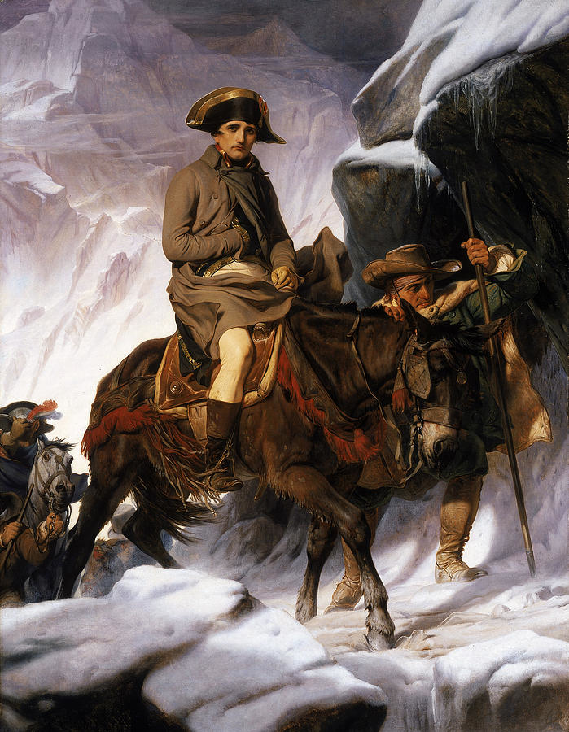The commission of David’s painting of *Napoleon Crossing the Alps* might be seen to be an obvious attempt by the Spanish government to remain on friendly terms with Napoleon and France.

Artist: Paul Delaroche

Title: *Bonaparte Crossing the Alps*  
Size: 289 cm × 222 cm

Material: Oil on canvas.

Date: Completed 1850

**The French history painter Paul Delaroche created his own interpretation of the event almost fifty years after David’s painting.**

Q: How do these two works differ in terms of the depiction of the actual event?

Q: David’s painting was created with direct input from Napoleon whereas Delaroche’s version was for an English collector of Napoleonic memorabilia and artefacts and completed almost thirty years after Napoleon’s death. How did these factors influence or effect the resultant portraits?

Q: What might Spain have to fear?

Q: How did the relationship between France and Spain eventually develop in the following years?

Q: Napoleon requested a further four copies of this portrait. What does this indicate?

**About the artist:**

Jacques Louis David was a leading painter in the Neoclassical style though he initially trained under Rococo painters. Winning the prestigious Prix de Rome in 1774 allowed him to study art in Rome for three to five years and his work became more informed by classical antiquity. He excelled at depictions of historical events which were attuned to or hinted at current political and social events. Despite receiving support and commissions from the aristocracy David supported the French Revolution and desired to see an end to the monarchy. He voted for the execution of both Louis XVI and the queen Marie Antoinette.

David’s paintings during the Revolution carried themes relating to civic duty and putting one’s own political beliefs before personal fortune or happiness. He was close friends with Robespierre, an influential figure during the Revolution and the Reign of Terror. David was imprisoned after Robespierre’s own execution on the guillotine but after his release would support Napoleon under his regime.

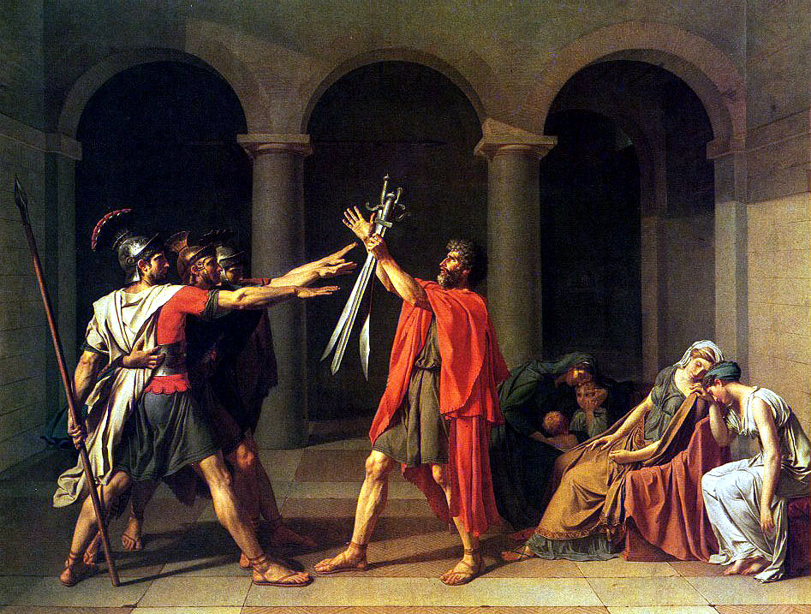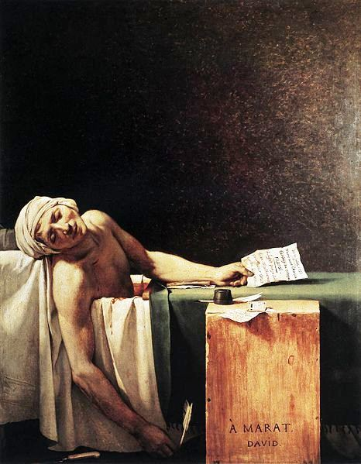

Title: *The Oath of the Horatii*  
Size: 329.8 cm × 424.8 cm

Material: Oil on canvas.

Date: 1784

Title: *The Death of Marat*  
Size: 165 cm × 128 cm

Material: Oil on canvas.

Date: 1793

**Style:**

Neoclassicism is the name given to Western [movements](http://en.wikipedia.org/wiki/Cultural_movement) in the [decorative](http://en.wikipedia.org/wiki/Decorative_art) and [visual arts](http://en.wikipedia.org/wiki/Visual_art) and [architecture](http://en.wikipedia.org/wiki/Architecture) that draw inspiration from the "classical" art and culture of [Ancient Greece](http://en.wikipedia.org/wiki/Ancient_Greece) or [Ancient Rome](http://en.wikipedia.org/wiki/Ancient_Rome). The main Neoclassical movement coincided with the 18th century [Age of Enlightenment](http://en.wikipedia.org/wiki/Age_of_Enlightenment). Neoclassicism is a revival of the styles and spirit of classic antiquity inspired directly from the classical period and was initially a reaction against the excesses of the preceding [Rococo](http://en.wikipedia.org/wiki/Rococo) style. The writings of [Johann Joachim Winckelmann](http://en.wikipedia.org/wiki/Johann_Joachim_Winckelmann) were important in shaping this movement in both architecture and the visual arts. His books were the first to distinguish sharply between Ancient Greek and Roman art, and define periods within Greek art. Winckelmann believed that art should aim at "noble simplicity and calm grandeur” and praised the idealism of Greek art, in which he said we find: "not only nature at its most beautiful but also something beyond nature, namely certain ideal forms of its beauty."

Simplicity, Symmetry, Order, Idealism, Beauty

Winckelmann believed that art should aim at "noble simplicity and calm grandeur",

Rococo frivolity and Baroque movement had been stripped away

Neo-classicists, such as Jacques-Louis David preferred the well-delineated form—clear drawing and modelling (shading). Drawing was considered more important than painting. The Neo-classical surface had to look perfectly smooth—no evidence of brush-strokes should be discernible to the naked eye.

Neo-classicism is characterised by: clarity of form; sober colours; shallow space; strong horizontal and verticals that render that subject matter timeless, instead of temporal as in the dynamic Baroque works; and, Classical subject matter—or classicising contemporary subject matter.

Q: How does ‘*Napoleon Crossing the Alps’* fulfil the criteria of being a neoclassical work of art?

Read the following link on this painting.

<https://smarthistory.org/jacques-louis-david-napoleon-crossing-the-alps/>