**Themes in Art & Architecture: War**

Artist: Jacques Louis David

Title: ‘*Napoleon Crossing the Alps’*Scope of work: Leaders in 2D or 3D

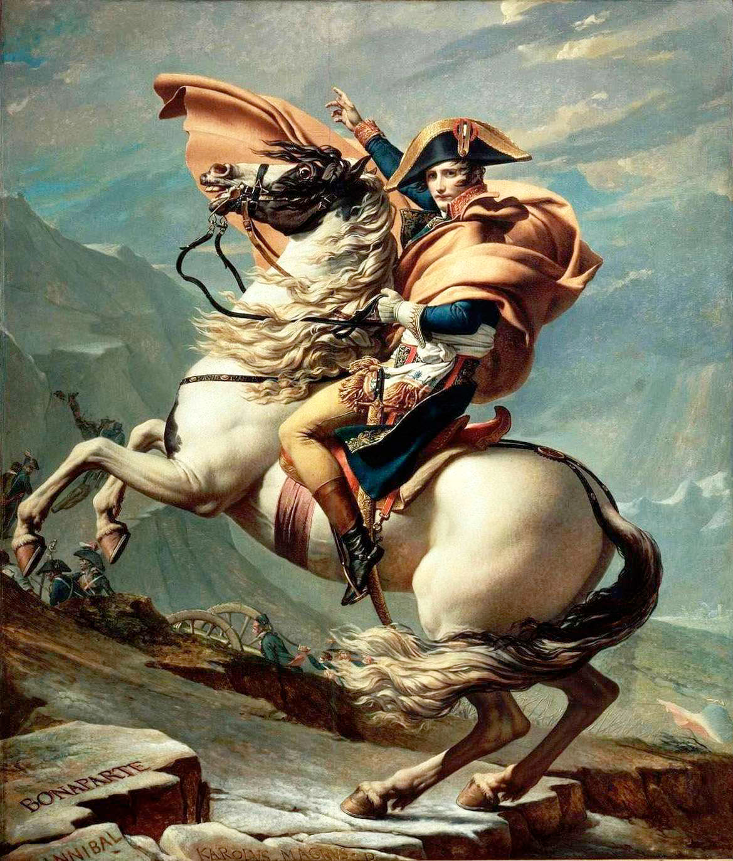

**Key Facts**  
Size: 2.6 m x 2.21 m

Material: Oil on canvas.

Date: 1801

Location: Château de Malmaison

**Art Historical Terms and Concepts**

**Subject matter**: Napoleon sits astride a rearing ‘fiery steed’ and faces the viewer in a calm yet assertive manner. In the background we see his troops wheel cannons across the Alps as Napoleon gestures them onwards to military success. Their aim is to defeat Austrian troops and gain control of Italy. This seemingly impossible feat was achieved through determination, fearlessness and wily strategies on behalf of Napoleon. This painting was completed a year after the event it documents.

**Colour:** Look carefully at the colour scheme of this work. What colours appear dominant here that we have also seen in other works in the War Theme?

**Composition:** Analyse the composition of the painting.

**Figure handing:** Discuss the depiction of Napoleon’s figure. Look at pose, gesture, costume, facial expression, styling.

**Form:** How would you describe the form of this work?

**Space & Depth:** How has David suggested spatial depth within this image?

Context: Napoleon Bonaparte

Born in 1769 into a Corsican family of minor nobility, by the age of 30 in 1799, Napoleon Bonaparte had taken supreme control of France. This was initially achieved through his climbing the military ranks during the years of the French Revolution which had broken out in 1789. By the age of 24 he had been made a general.

Napoleon led numerous successful military campaigns on behalf of The Directory. This was the government set in place during the final years of the French Revolution. In 1799 however, buoyed by public popularity and confidence in his military successes Napoleon staged a coup to overthrow The Directory. He declared himself First Consul of the Republic of France.

Napoleon and his troops crossed the Alps in the spring of 1800. He did so with the intention of defeating Austrian troops who threatened his hold on Italy. Napoleon had been involved in a number of battles with Austria in the preceding decade over gaining control of occupied territories in Italy. Austrian troops were involved in a war in Genoa and by taking the long and arduous trans-Alps route Napoleon hoped to take the Austrians by surprise. Napoleon and his troops spend five days crossing the Alps via the Great St Bernard Pass. A decisive battle was eventually fought between French and Austrian troops at Marnego with the French becoming victorious.

Countries neighbouring France became nervous of Napoleon’s increasing power. To maintain a friendly relationship between Spain and France, King Charles IV of Spain suggested the leaders of both countries exchanged expensive gifts. This painting was commissioned to flatter Napoleon’s ego and placate any potential hostilities. The painting was to hang alongside portraits of other great leaders, generals and monarchs albeit these were Spanish individuals.

The painter David was the pre-eminent artist in France at this period and was commissioned to produce the portrait. The portrait took just four months to complete and Napoleon was so pleased with the results that a further four copies were made.

Napoleon claimed to be too busy to sit for the portrait but did stipulate that he was to be depicted as ‘calm but on a fiery steed’.

**Context recap:**

1: Who was Napoleon?

2: When did he become Emperor?

3: What happened at the Battle of Marengo?

4: Whose names are ‘engraved’ in the rocks in the foreground of the painting?

5: Why is this association important?

6: Describe the setting of the work.

7: What genre is this work?

8: Research other equestrian portraits by Titian, Velazquez and Van Dyck as well as sculptural versions of Marcus Aurelius. What do they have in common with this version by David?

**Patronage:**

1: Who asked for this painting to be completed?

2: Why?

3: Where was it going to be hung?

4: Why did the patron go to David?

5: Who was the intermediary?

6: How do we know that Napoleon liked the painting?

7: Which elements do you think were controlled by the patron?

8: And which by the artist?

9: Would you consider this a work of public or private patronage? Explain your reasoning.

**Other questions to be considered:**

1: What kind of values does this portrait reinforce?

2: What kind of a man is Napoleon shown to be here?

3: How effective was this painting as a piece of political propaganda?

4: How did Napoleon actually cross the Alps?

5: How and why do you think the artist has ‘managed’ this representation?

6: List the aims of Neo-Classical art.

7: What were the main influences on the Neo-Classical style?

8: How is the Neo-Classical style evident in this portrait?

**Links:**

**Essay on the painting**

<https://smarthistory.org/jacques-louis-david-napoleon-crossing-the-alps/>

**Short video on Napoleon**

<https://www.youtube.com/watch?v=tfHnwqtJT9U>