**Themes in Art & Architecture: War**

**Artist: Pablo Picasso (1881-1973)**

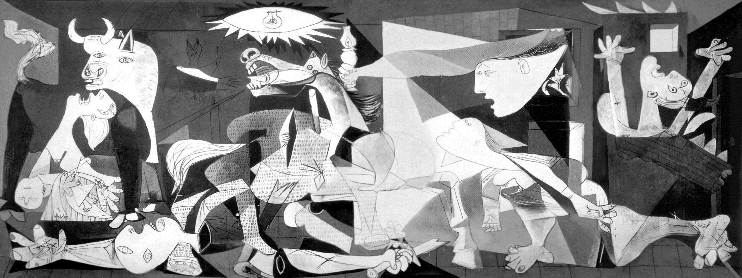**Title: ‘*Guernica’***

**Key Facts**  
Size: **3.49m x 7.76m**

Material: **Oil on canvas.**

Date: **1937.**

Location: **Museo Reina Sofia, Madrid.**

Patron: **Spanish Republican Government.**

**Art Historical Terms and Concepts**  
**Subject matter**: Chaos ensues as people and animals seek shelter in a building in the Spanish town of Guernica which was bombed by German aircraft during an aerial attack. Set in the early years of the Spanish Civil War, the victims were predominantly civilians and the atrocity cause a major international outcry. The victims react in a variety of ways. A screaming woman throws her head backwards, her mouth omitting a wail of grief. In her arms lies the source of this distress, her dead child. Above her we see a bull, symbolic of Spain, its people now under attack. On the opposite side a head looks through a window and into this scene. The figure holds up a lamp revealing to us the brutality of the attack, the look of astonishment on the face suggests incomprehension and bewilderment at such an act of barbarity.  
  
**Colour:** Analyse Picasso’s use of colour. What artistic choices has he made in his colour palette.

**Composition:** Analyse the composition of this painting. Is there a focal point? What words would you use to describe the composition and does it suit the theme/subject matter of the painting? Explain.

**Figure handing:** How have figures and animals been depicted? What words would you use to describe the representation of the figures? Discuss Picasso’s rendering of the figures.

**Line:** Discuss/analyse Picasso’s use of line in this painting.

|  |  |  |
| --- | --- | --- |
| **Give a definition for the following terms/phrases** | Monochromatic | Fragmented |
|  | Elongated | Reportage |
|  | Frieze | Simplified |

**The event and its reporting:**  
On 26 April 1937, the Luftwaffe, on the orders of Adolf Hitler who was sympathetic to the cause of **Fascist** dictator Franco, bombed Guernica. This town in the Basque region of Spain was considered a hotbed for **Spanish Republican** activities and was the centre for their communications. The Republicans were left-leaning and democratic, they opposed the **Nationalists**, led by General Franco.

‘*Guernica, the most ancient town of the* ***Basques*** *and the centre of their cultural tradition, was  
completely destroyed yesterday afternoon by insurgent air raiders. The bombardment of this open town far behind the lines occupied precisely three hours and a quarter, during which a powerful fleet of aeroplanes consisting of three types of German types, Junkers and Heinkel bombers, did not cease unloading on the town bombs weighing from 1,000 lbs. downwards and, it is calculated, more than 3,000 two-pounder aluminium incendiary projectiles. The fighters, meanwhile, plunged low from above the centre of the town to machine gun those of the civilian population who had taken refuge in the fields’*

**-eyewitness account from a journalist for The Times.**

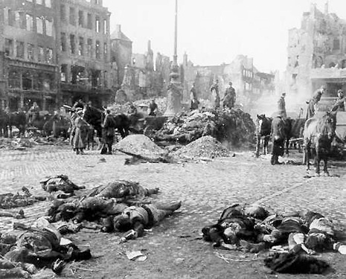

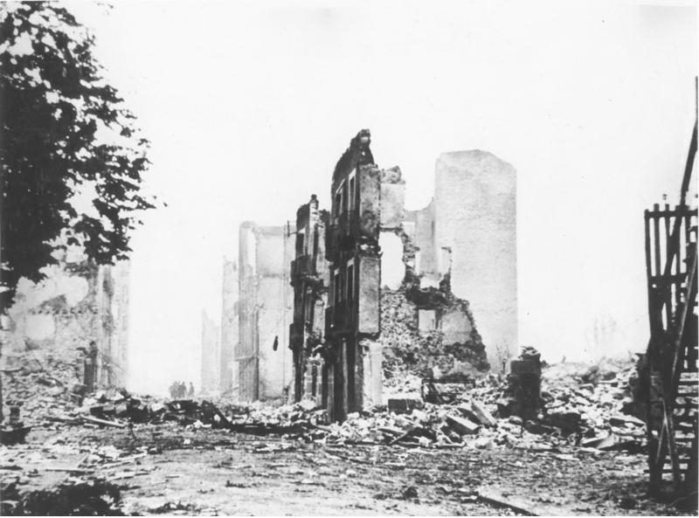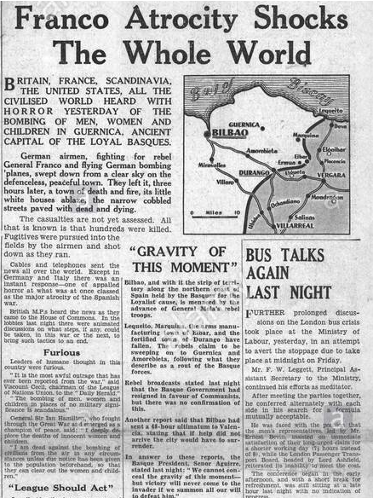

Explain the following definitions:

|  |  |
| --- | --- |
| **Fascist** | **Atrocity** |
| **Spanish Republicans** | **Civilians** |
| **Spanish Nationalists** | **Luftwaffe** |
| **Basque region** | **Civil war** |

**The commission:**

Picasso was already working on a mural commission for the Spanish Republican Government for the Spanish pavilion at the 1937 World Fair in Paris. Due to the huge public outcry over the atrocity and having read eyewitness reports Picasso changed his initial plan for the commission and instead focused on the fate of Guernica and began work on May 1st 1937. Picasso rarely took on public commissions as he wanted total control over his own work and the finished product. Picasso was living in Paris but felt compelled to create a work which illustrated his sympathies for his home country.

Picasso’s lover, the artist Dora Maar, famously documented Picasso working on the painting in a series of photographs which showed the various stages the work went through.

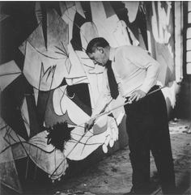

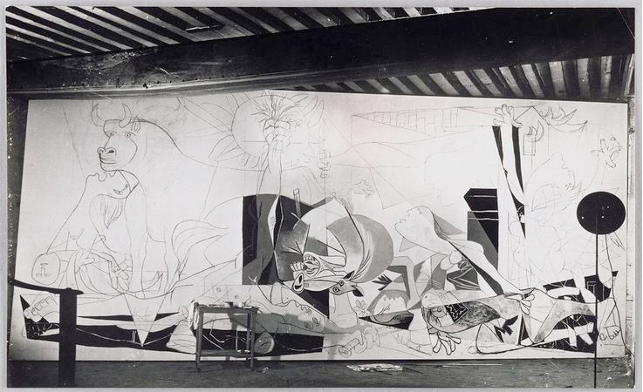

Q: How does Picasso’s working method inform the artistic decisions he made when creating this painting?  
  
  
Q: Why might the Spanish Republican Government approve the subject matter of this commission?  
  
  
Q: What was the outcome of the Spanish Civil War?

Q: How effective is this image in terms of a criticism of war? Does Picasso support a specific ‘side’ in this event?   
  
  
  
Q: List all the emblems, symbols and motifs you can identify which relate to; loss, anguish, war, defeat, death, destruction, hope.

*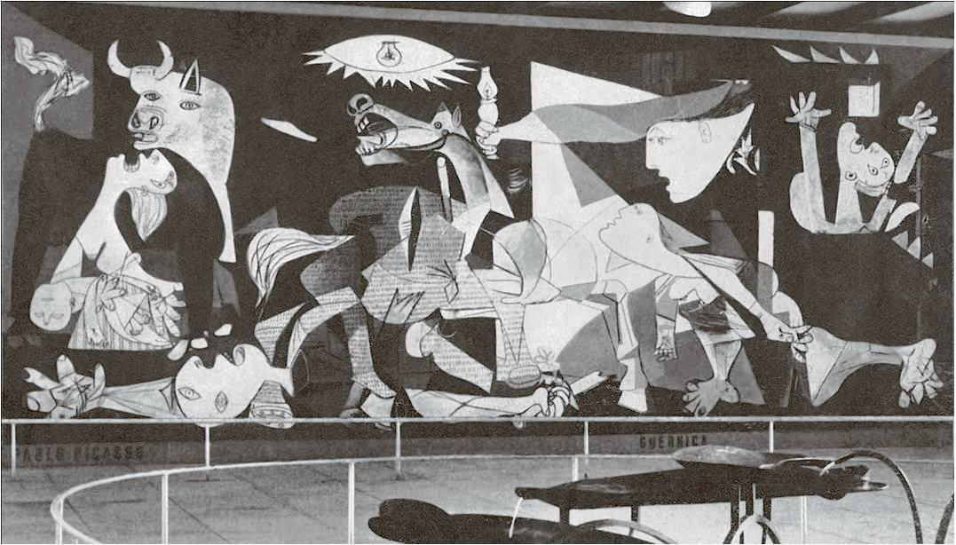Guernica* in situ in the Spanish Pavilion at the World Fair, Paris, 1937

**T J Clark** Extract taken from *Picasso and Truth: from Cubism to Guernica. Lecture 6 – Mural. P248-250*

Picasso himself rarely talked about pictures he had done, nor should we expect him to. He made a few offhand remarks about *Guernica* in retrospect, one or two of which I have already quoted. He tried – but of course failed – to head off the iconographers, and insisted that a bull is a bull. (I shall follow his lead in this.) But there is one moment, I feel, in which he says something worth thinking about. Two moments, actually: both Malraux and Gilot report essentially the same conversation. It has to do not directly with *Guernica*, but with Goya’s *Third of May 1808.* Naturally in talking about the one he knew he was talking about the other. Malraux reports the exchange as specifically happening in 1937, just before *Guernica* went off to the Spanish pavilion. Probably an artefact, this dating, but the connection is clear. The dark sky in the *Third of May,* says Picasso,

is not a sky, it is just blackness. The light takes two forms. One of which we do not understand. It bathes everything, like moonlight: the sierra, the bell-tower, the firing squad, which ought to be lit only from behind. But it is much brighter than the moon. It isn’t the color of moonlight. And then there is the enormous lantern on the ground, in the center. That lantern, what does it illuminate? The fellow with upraised arms, the martyr. You look carefully: its light falls only on him. The lantern is Death. Why? We don’t know. Nor did Goya. But Goya, he knew it had to be like that.

Compare Malraux with Gilot. Goya in the *Third of May,* she remembers Picasso saying (for some reason this passage occurs only in her book’s French edition),

truly places us in “the time of death.” All the elements in the picture are chosen and placed in a hierarchy, deriving from that enormous square lantern, placed on the ground in the center of the canvas like the light of eternity.

One may well distrust the detail here. “Phare d’éternité” sounds more Gilot than Picasso. But I am interested in what the two reminiscences share: the idea that the task of this kind of history painting turns on its *placing* the viewer in a time of death, and that the way to this placement lies in a kind of light. I would go further. The light that makes Death appear in a painting is not a general illumination – not the weird everywhereness of Goya’s more-than-moonlight – but light placed on the ground, given a shape and a size. The lamp in *Third of May* is enormous (the word occurs in both memoirs), and it is square. My intuition is that it is the specific crude objectivity given to light that Picasso most admires. “The lantern is Death. Why? We don’t know.” Maybe because its unlovely geometry anchors, but also contradicts, the heavy flow of embodiment all round it. It stands apart from the agony. It is a house – an abstraction of shelter – a tomb.

Incidentally, this is not the only time that Picasso talks about the idea of death being crystallized in an object. Remember the question to Malraux: “When I paint a woman in an armchair, the armchair, it’s old age and death, isn’t it?” Not that the “*x* and *y*” in this case (the single figure, the ominous piece of furniture) gets us close to what happens in *Guernica.* Critics who go on looking for death specifically in the lamp-bulb sun or the bull’s head or the fallen warrior are trying to turn the picture into an easel painting: they are forgetting the impact – the overload of stimuli – that comes from *Guernica’*s actual size. Death is not localized in *Guernica*: it is everywhere and nowhere: that is the picture’s main point. Everywhere and nowhere, but manifest – materialized – as a kind of illumination. Which exactly does not mean appearing as ambience or effulgence (a new moonlight): the flash of a bomb-blast is the hardest, most finite thing imaginable. It is specific as the twist of tungsten in a sixty-watt bulb. That is what had to be learnt from Goya.

**Guernica on tour and its recent history:**

From 1938 the painting toured extensively throughout Europe including a showing at the Whitechapel Gallery in London. The work was then shown in a number of States in the U.S. By this time Franco was victorious and the work was used to raise aid for Spanish refugees displaced by Franco and his regime.

Picasso was adamant that the work should not be shown in Spain while Franco was in power. The artist died in 1973 and Franco two years later. The painting was finally returned to Spain in 1981, a century after the birth of Picasso.

A tapestry version of the work was produced in 1955 and displayed at the United Nations Buildings in NYC from 1985. The image is seen as a symbol warning against the destruction effects of war on humanity and civilisation.

In 2003, then Secretary of State, 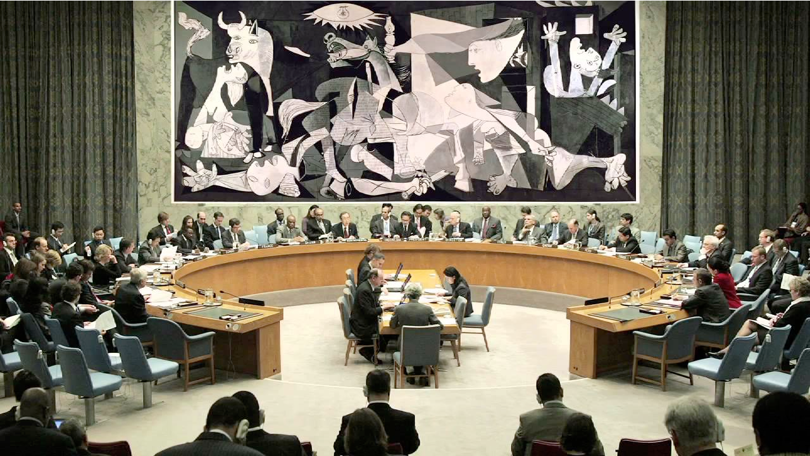Colin Powell gave a press conference at the United Nations presenting a case for why the United States should go to war against Iraq. The tapestry of Guernica hanging behind Powell was covered by a blue curtain. Many critics and observers speculated this was a deliberate decision to conceal an image of violence at a time when Western powers were seeking justifications for going to war against the Middle East.

Guernica tapestry in the United Nations

Further reading and links:

<https://www.khanacademy.org/humanities/art-1010/early-abstraction/cubism/a/picasso-guernica>

<http://www.museoreinasofia.es/en/collection/artwork/guernica>

<http://www.pbs.org/treasuresoftheworld/a_nav/guernica_nav/main_guerfrm.html>

[https://socialistworker.co.uk/art/10989/Guernica:%20shock%20and%20awe%20in%20paint](https://socialistworker.co.uk/art/10989/Guernica:%2520shock%2520and%2520awe%2520in%2520paint)

Andrew Graham Dixon, ’Art, the Definitive Guide’, p424-425

Q: Delacroix was an eyewitness to the events of July 1830. Picasso by comparison found out about the bombing of Guernica through newspapers, news reels and photography.

Does an artist have to be a witness to events to give an accurate or honest portrayal of what occurred?

Is *‘Liberty Leading the People’* a more successful depiction of war than ‘*Guernica’*? Or vice versa?   
  
What is the fundamental message conveyed in ‘*Liberty Leading the People*’?And in ‘*Guernica’*?