**Themes in Art & Architecture: War**

Artist: Renato Bertelli (1900-1974)

Title: ‘*Continuous Profile (Head of Mussolini)’*Scope of work: Leaders in 2D or 3D

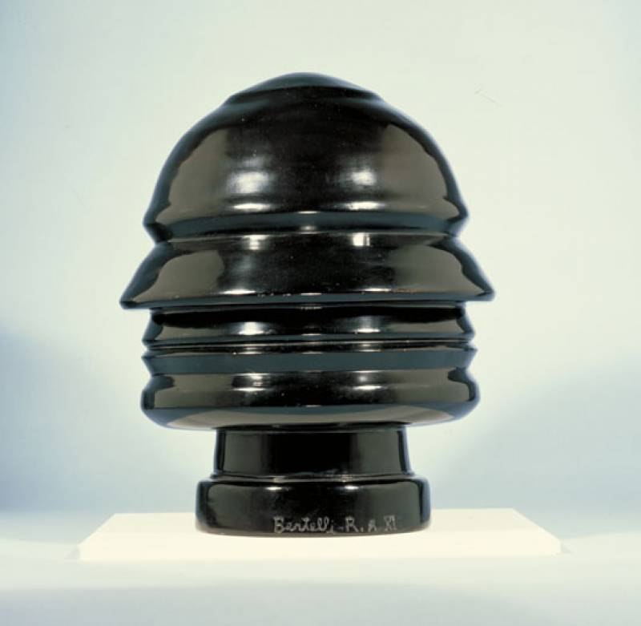

**Key Facts**  
Size: 34cm × 28cm

Material: Terracotta.

Date: 1933**.**

Location: Imperial War Museum, London

**Art Historical Terms and Concepts**  
**Subject matter**: One of many portraits created during the lifetime of Il Duce (The Leader), Benito Mussolini, this work shows Mussolini’s profile continued in a 360 degree rotation. The Fascist leader appears to be wearing a military helmet and constantly surveying his surroundings whilst simultaneously avoiding our gaze. Completed a decade after he seized power Mussolini was very aware of the power of art as a tool for propaganda.

**Colour:** Is there any significance to the artist’s use of colour in this sculpture? What associations can be made from his decision?

**Composition:** Analyse the composition of the sculpture.

**Figure handing:** Discuss the depiction of Mussolini.

**Form:** How would you describe the form of this work?

**Materials:** What associations can be made from the artist’s choice of material?

**Contextual background:**

From BBC History

Mussolini was the founder of Fascism and leader of Italy from 1922 to 1943. He allied Italy with Nazi Germany and Japan in World War Two.

Benito Amilcare Andrea Mussolini was born on 29 July 1883 in Predappio in northern central Italy. His father was a blacksmith. Employment prospects in the area were poor so in 1902 Mussolini moved to Switzerland, where he became involved in socialist politics. He returned to Italy in 1904, and worked as a journalist in the socialist press, but his support for Italy's entry into World War One led to his break with socialism. He was drafted into the Italian army in September 1915.

In March 1919, Mussolini formed the Fascist Party, galvanising the support of many unemployed war veterans. He organised them into armed squads known as Black Shirts, who terrorised their political opponents. In 1921, the Fascist Party was invited to join the coalition government.

By October 1922, Italy seemed to be slipping into political chaos. The Black Shirts marched on Rome and Mussolini presented himself as the only man capable of restoring order. King Victor Emmanuel invited Mussolini to form a government. Mussolini gradually dismantled the institutions of democratic government and in 1925 made himself dictator, taking the title 'Il Duce'. He set about attempting to re-establish Italy as a great European power. The regime was held together by strong state control and Mussolini's cult of personality.

In 1935, Mussolini invaded Abyssinia (now Ethiopia) and incorporated it into his new Italian Empire. He provided military support to Franco in the Spanish Civil War. Increasing co-operation with Nazi Germany culminated in the 1939 Pact of Steel. Influenced by Hitler, Mussolini began to introduce anti-Jewish legislation in Italy. His declaration of war on Britain and France in June 1940 exposed Italian military weakness and was followed by a series of defeats in North and East Africa and the Balkans.

In July 1943, Allied troops landed in Sicily. Mussolini was overthrown and imprisoned by his former colleagues in the Fascist government. In September, Italy signed an armistice with the Allies. The German army began the occupation of Italy and Mussolini was rescued by German commandos. He was installed as the leader of a new government, but had little power. As the Allies advanced northwards through Italy, Mussolini fled towards Switzerland. He was captured by Italian partisans and shot on 28 April 1945.

<http://www.bbc.co.uk/history/historic_figures/mussolini_benito.shtml>

Q: What does the term ‘cult of personality’ mean?

Q: Why might Mussolini have used art as a means to promote himself?

Q: What does the representation of Mussolini as shown in the sculpture above tell us about him as an individual?

Q: How does this portrait differ from portraits of leaders of the period? See below.

Ramsay MacDonald, PM Great Britain Franklin D. Roosevelt, U.S President Joseph Stalin, Premier of the Soviet Union

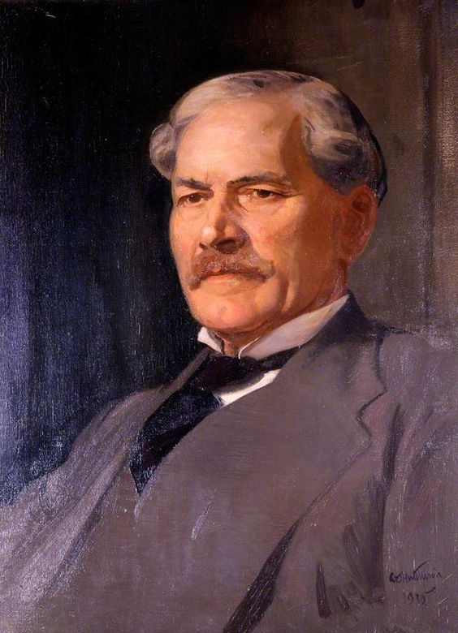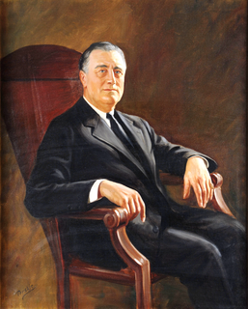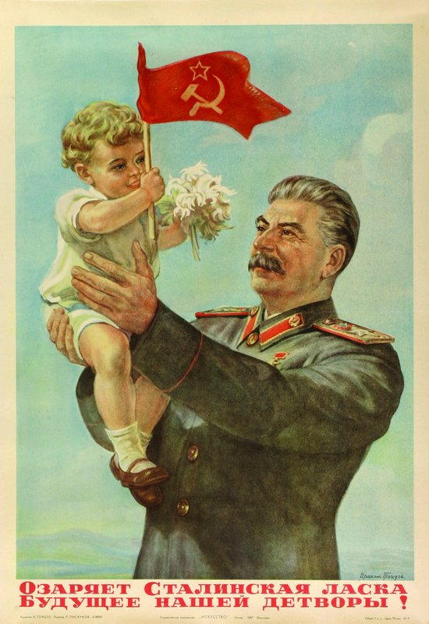

Q: When considering the ‘*Continuous Profile (Head of Mussolini)’,* how significant is the importance of a likeness or similarity between the subject and the work of art?

**Italian Futurism:**

**From the Guggenheim Gallery, New York.**

[**http://exhibitions.guggenheim.org/futurism/**](http://exhibitions.guggenheim.org/futurism/)

Italian Futurism was officially launched in 1909 when Filippo Tommaso Marinetti, an Italian intellectual, published his “Founding and Manifesto of Futurism” in the French newspaper *Le Figaro*. Marinetti’s continuous leadership ensured the movement’s cohesion for three and half decades, until his death in 1944.

To be a Futurist in the Italy of the early 20th century was to be modern, young, and insurgent. Inspired by the markers of modernity—the industrial city, machines, speed, and flight—Futurism’s adherents exalted the new and the disruptive. They sought to revitalize what they determined to be a static, decaying culture and an impotent nation that looked to the past for its identity.

Futurism began as a literary avant-garde, and the printed word was vital for this group. Manifestos, words-in-freedom poems, novels, and journals were intrinsic to the dissemination of their ideas. But the Futurists quickly embraced the visual and performing arts, politics, and even advertising. Futurist artists experimented with the fragmentation of form, the collapsing of time and space, the depiction of dynamic motion, and dizzying perspectives. Their style evolved from fractured elements in the 1910s to a mechanical language in the ’20s, and then to aerial imagery in the ’30s. No vanguard exists in a void—all are touched by their historical context. The Futurists’ celebration of war as a means to remake Italy and their support of Italy’s entrance into World War I also constitute part of the movement’s narrative, as does the later, complicated relationship between Futurism and Italian fascism.

Futurism was punctuated by paradoxes: while predominantly antifeminine, it had active female participants; while calling for a breakdown between “high” and “low” culture, it valued painting above other forms of expression; while glorifying the machine, it shied away from the mechanized medium of film. By 1929, the artists who had denounced traditional institutions saw their leader, Marinetti, become a member of the Academy of Italy. And many of the revolutionary Futurists complied in some way with the Fascist regime. Through a comprehensive examination of Italian Futurism’s full history, the exhibition offers an opportunity to reassess one of the most contentious of modernist movements.

Q: How does ‘*Continuous Profile (Head of Mussolini)’* fulfil the criteria of being a Futurist work of art?

Q: Is ‘*Continuous Profile (Head of Mussolini)’* a successful representation of what you know about the character of Mussolini?

Watch this video on Mussolini and his rise to power:

<https://www.youtube.com/watch?v=LpAVqiDVlw4>

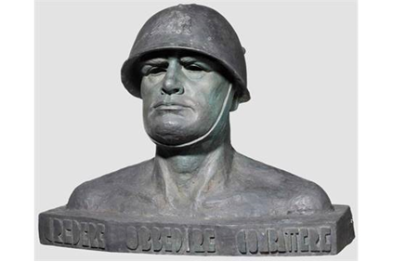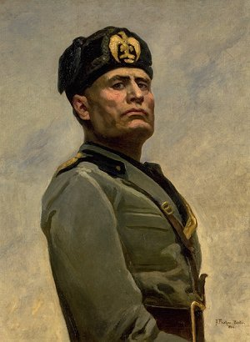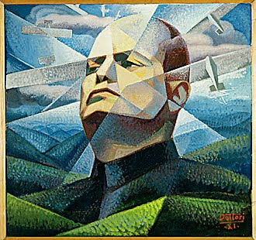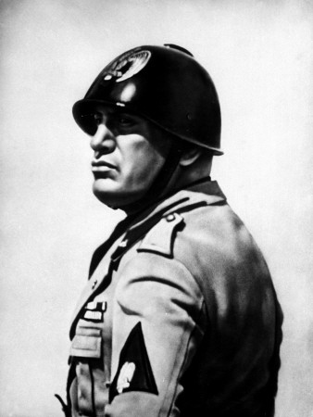Other representations of Mussolini