**Induction work for Politics Students: September 2017**

**Task 1**

**Brexit**

Go to <https://www.theguardian.com/politics/2017/aug/28/divorce-bill-remains-sticking-point-brexit-negotiations-resume> and answer the following questions



1) Who is the Brexit secretary? Which party does he belong to?

2) What are Brussels (meaning the European Union) infuriated with the UK’s negotiators about?

3) In what way do they EU and the UK disagree on the order that negotiations should take?

4) What was the big change in Labour policy recently, mentioned in the article?

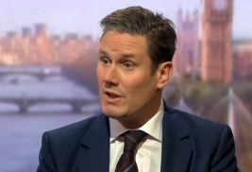

Keir Starmer, shadow secretary of state for Brexit

**The 2017 election**

Go to <http://www.bbc.co.uk/news/election-2017-40219030> and answer the following questions

1) How many seats did May and the Conservatives need in order to secure a majority? Who has this resulted in them forming a deal with in order to rule?

2) What is the name of the type of deal that the Tories have made with the DUP?

3) What are some of the policies that the DUP officially stands for?

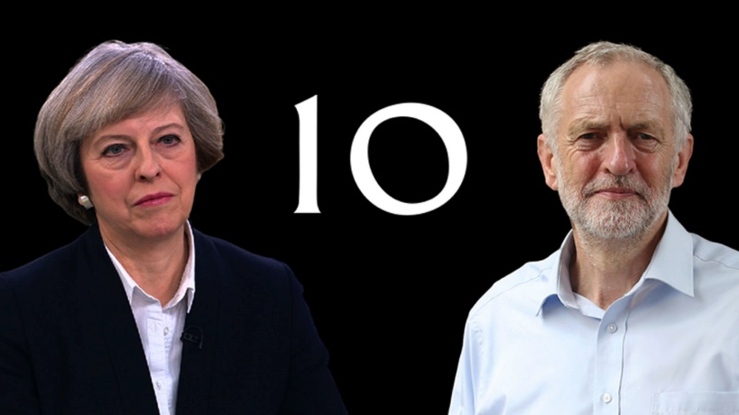

4) How many seats did Labour pick up in the election?

**Parliament’s summer break**

Go to <http://www.parliament.uk/about/faqs/house-of-commons-faqs/business-faq-page/recess-dates/> and answer the following questions

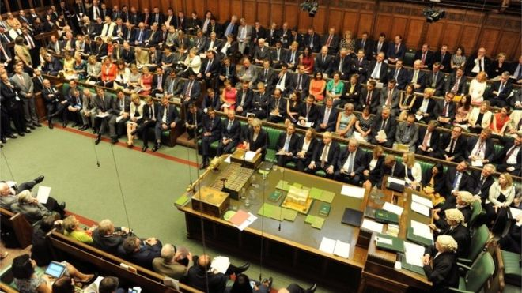1) When did the House of Commons break up for their summer recess?

2) When do they return?

3) Do you think they deserve this long of a break?

**Task 2**

|  |  |
| --- | --- |
| **POLITICAL CONCEPTS MATCHING EXERCISE** |  |
| Possible answers are: *MP, Conservatives, constitution, left wing, capitalism, Coalition, A body that represents workers, Liberal Democrats, Parliament, Cabinet, the Greens, minister, democracy, right wing, Labour, government, ideology, sovereignty, socialism, the State, Constituency.* |  |
| 1. Which party traditionally favoured trade unions. |  |
| 1. What is a trade union? |  |
| 1. The smaller party in the coalition. |  |
| 1. The party which stands for free enterprise and traditional values. |  |
| 1. The legislature (supreme law making body). |  |
| 1. The group of senior politicians who decide policy and rule the country. |  |
| 1. The institution at the centre of the above which meets once a week to advise the Prime Minister on policy. |  |
| 1. A politician who runs all or part of a government department like the Department of Education. |  |
| 1. A member of the legislature. |  |
| 1. The area represented by a member of the legislature. |  |
| 1. Which party is currently seeking a new leader? |  |
| 1. Someone is called this if they believe in a more equal society and a more liberal approach to issues like immigration. |  |
| 1. The economic system based on private ownership and free enterprise with minimum state interference. |  |
| 1. The economic system in which the government intervenes to make society more equal. |  |
| 1. A system or document which defines the relationship between government institutions and between them and the individual citizen. |  |
| 1. Supreme political authority and a country’s right to determine its own affairs. |  |
| 1. A set of political ideas like conservatism or liberalism. |  |
| 1. The political system in which the government is elected by and accountable to the people. |  |
| 1. The area controlled by a national government; also the word for government authority as opposed to privately owned businesses or individual citizens. |  |
| 1. When two or more parties combine to govern |  |

**Task 3 – Get involved with social media!**

Politics is a fast-moving, dynamic subject which lends itself really well to social media.

i) The department runs a facebook site where you can discuss current affairs with other politics students at college. If you are on facebook please apply to join (‘Godalming College Politics Forum’) and we’ll let you in!

|  |
| --- |
| When you apply to join the forum you are deemed to have agreed to these guidelines:   * Please do:   + Maintain the terms and conditions of your Student Contract when using the Godalming College Politics Forum, specifically: *To behave in a courteous, considerate and responsible manner at all times respecting the needs and rights of others whether staff or students at the college or members of the local community****.*** In this instance the community also includes the online community.   + be accurate, fair and transparent when creating or altering online sources of information. * Please don’t:   + engage in activities involving this Forum which might bring Godalming College into disrepute.   + represent your personal views as those of Godalming College on this site.   + discuss personal information about students or staff at Godalming College on this site.   + use this Forum in any way to attack, insult, abuse or defame students, their family members, colleagues, other professionals, other organisations or Godalming College.   **If you contravene any of these principles you risk being removed from the Forum and referred to your Senior Tutor.** |

**ii) Try following some politics on t**witter. Sign up to at least five. Here are some suggestions:

|  |  |  |
| --- | --- | --- |
| **News organisations** | **Political Commentators** | **MPs** |
| @BBCNews  @guardiannews  @Telegraph  @independent  @TheEconomist | @bbcnickrobinson  @jonsnowC4  @owenjones84  @frasernelson  @paulmasonnews | @stellacreasy  @David_Cameron  @nigel_farage  @drwollostanmp  @DouglasCarswell  @DavidLammy  @NadineDorriesMP  @jreedmp |

**Task 4 – Keeping up with the press!**

Read *one* of these newspapers for 10 minutes each day (or use their website):

The Times

The Guardian

The Independent

The Telegraph

Have a look at *one* of these magazines (or their website) and read a couple of the articles:

The Spectator The Economist Prospect

The New Statesman Time