Booklet checked by 
Grade:             U/S     1     2     3
Comments:


**Democracy   
and participation**

**What do I need to know?**

* Current systems of representative democracy and direct democracy
* The expansion of the franchise and debates over suffrage
* The role of pressure groups in politics and other influences
* The development of political rights in the UK

**Key Vocab**

|  |  |  |
| --- | --- | --- |
| Legitimacy | Accountability | Promotional group |
| Direct democracy | Civil liberties | Group politics |
| Representative democracy | Civil society | Pluralism |
| Pluralist democracy | Common law | Hyperpluralism |
| Democratic deficit | Decentralisation | Limited government |
| Participation crisis | e-democracy | Redress of greivances |
| Franchise | Electoral mandate | Manifesto |
| Think tanks | Elitism | Sectional group |
| Lobbyists | Formal equality | Suffrage |

**Possible exam questions**

1. Describe the main features of representative democracy (10)
2. Describe any three measures that have been proposed to increase political participation in the UK (10)
3. Using the source, explain the distinctions between parties and pressure groups and why the distinctions are becoming blurred. *In your response you must use knowledge and understanding that are only in the source.* (10)  
   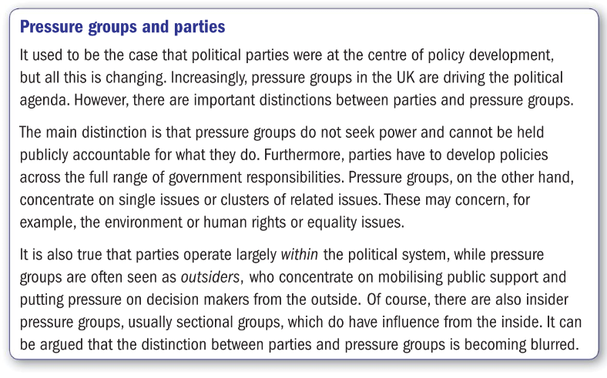
4. ‘The UK Parliament is no longer a truly representative body.’ How far do you agree with this statement? *In your answer you must refer to at least two views of representation and consider this view and the alternative to this view in a balanced way.* (30)
5. ‘The UK is suffering from a democratic deficit.’ How far do you agree with this statement? *In your answer you must refer to at least two elements of democracy and consider this view and the alternative to this view in a balanced way.* (30)

**What is democracy and where does it come from?**

|  |
| --- |
| When you hear the term ‘democracy’ what do you think of first, and why? |

Task: Our concept of what democracy actually is has been evolving over centuries in the UK. Now imagine that you had to set up a society from scratch. What principles would be crucial to you? Read this article from the Daily Mail (summer 2011) and consider the questions below.

|  |
| --- |
| **Green Float: The futuristic concept that sees humans live in giant skyscrapers on floating water lilies in the middle of the Pacific**  Humans in the future could live in mini floating cities that drift across the Pacific as if on giant water lilies.  Description: The majority of people on the cells would live in huge towers 1km high surrounded by lush green fieldsThe startling new concept has been dreamed up by Japanese technology firm Shimizu and is designed to be a way of harnessing green technologies and creating carbon-neutral cities.  The Green Float concept involves a number of cells, each one kilometer wide, that house between 10,000 and 50,000 people.  The majority of people on the cells would live in huge towers 1km high surrounded by lush green fields  Each individual cell would be free to float on the Pacific Ocean near the equator but could also be joined together with other cells to form larger towns and even cities.  A group or modules, a collection of cells, would become a country in its own right.  Description: The floating cellsMost people in this brave new world would live in a 1 kilometre-high ‘City in the Sky’ at the centre of each cell. More people would live in residential areas around the edge of the cell.  The central towers would be surrounded by grassland and forests and be self-sufficient in terms of food, while livestock and other farming would take place in 'plains' also surrounding the tower - all built on a lattice of 7,000-tonne honeycomb pontoons.  The towers would be built from super-light alloys with the metal deriving from magnesium in seawater.  The imaginative plan is designed to create a future carbon-neutral society and the Shimizu developers claim that living on cells in this way would cut carbon emissions by 40 per cent.  The floating cells, each with a City in the Sky structure at its centre, can join together to form larger modules  Description: The City in the Sky skscrapers are designed to be carbon negative  The City in the Sky skscrapers are designed to be carbon negative with extensive environmental technologies and recycling facilities built in  The cells would create zero waste and recycle every product and covert waste into energy using new green technologies. Islands of waste would drift around the ocean and could be ‘harvested’ to provide energy  The location of the islands is key to their success too, the designers claim.  Each group of cells would be near the equator where the climate is at its most stable and a range of technologies would be used to protect the floating cities from tidal waves and extreme weather.  To protect the inhabitants from large waves, strong elastic membranes would be attached to the lagoons around the outer edge of the cells, with the shallows above the membranes standing 30 feet above sea level.  Shimizu scientists calculate that the water pressure difference between the lagoons and the ocean would limit the movement of the membranes and buffer the force of the open sea waves.  Seawalls as high as 100 feet could also be constructed. And tsunamis in the open sea are far less dangerous than those that hit coastal areas, the designers say.  [Description: A country consisting of one million people would be formed after modules joined together one by one](http://i.dailymail.co.uk/i/pix/2010/11/11/article-1328680-0C000C57000005DC-909_634x254_popup.jpg)  A country consisting of one million people would be formed after modules joined together one by one  Lightning rods would be fitted around the circumference of the towers and mesh lightning conductors will be placed on the exterior walls to protect against lightning strikes.  Shimizu wants to develop the first cells by 2025 and is concentrating on developing the technologies to make it happen. The concept was displayed at a recent Japanese university conference.  This is the not the first outlandish idea that Shimizu has come up with. The firm also proposes encircling the moon in a belt of solar collectors that would collect solar energy and transmit it to |

**How to organise your futuristic society?!**

**Task*: Imagine that you and your group are drifting around on your new island society with its 50,000 inhabitants. We are not interested in what the island will look like but how it will be organised! Answer these questions:***

1. **How will your island be governed?**
2. **How will you choose a government?**
3. **If you are voting for a government:**

* **How often will you have elections?**
* **Will all citizens have equal votes?**
* **Who will be allowed to vote?**
* **Can prisoners vote?**
* **At what age will citizens get the vote?**
* **Can the right to vote ever be taken away?**
* **How will elections actually be conducted?**
* **How many legislative chambers will you have?**

1. **What will your policy be towards immigrants from other islands? Will they be allowed to work on your island and vote? How will you control immigration?**
2. **The article mentions that cities might join together. How will you make the decision to join with other island cities?**
3. **Who will get to write the constitution of your new island society? How might this be amended?**

**Define democracy -** please write in your own words and so that you understand clearly. If you just copy from the textbook it won’t mean as much to you later when you come to revise.

**Watch “Brexit Britain: The inside story of how the Leave campaign won” (**[**https://youtu.be/kqSGgXb9Ngg**](https://youtu.be/kqSGgXb9Ngg)**) on Youtube:**

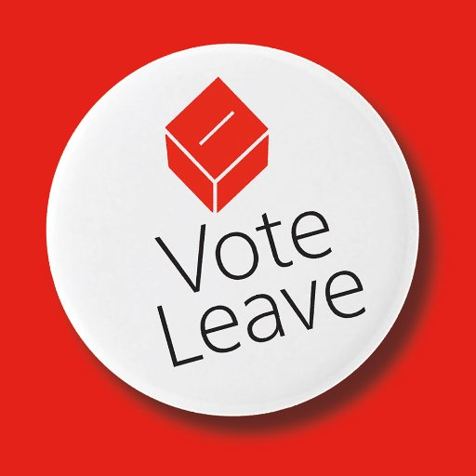

1. Why was it thought it would be third time lucky for David Cameron?
2. What was the ‘genius’ message that the Leave campaign came up with?
3. What did Barack Obama warn?
4. What was the famous claim about how much the UK sends to the EU each week?
5. What did the official figures over migration show?
6. What was Nigel Farage (sort of) sorry for?
7. Why was the lack of involvement by Jeremy Corbyn important?

How is the Brexit vote an example of democracy?

Referendums are an example of direct democracy, whilst general elections are examples of representative democracy.

**Define direct democracy**

**Some issues with Direct Democracy!**

**What would you vote in response to these referendum questions? Or do you have any problems with them?** Explain any problems you have with each question below it.

1. *What colour should this classroom be painted?*
2. *Should responsibility within the school governing body for exam results be handled by a committee or the academic governor?*
3. *Should teachers’ pay at Godalming be increased?*
4. *Should the College reform the undemocratic Student Union?*
5. *The teachers at Godalming have decided students want more freedom to choose when to study. Therefore should class attendance be only voluntary?*

**You can see that there are issues with the most democratic system ‘direct democracy’.**

*NB – we will look at direct democracy in more detail when we consider referenda in the elections topic*

**Define representative democracy**

Use the pages in the textbook to create a spider diagram below on the forms of representative democracy.

|  |  |
| --- | --- |
| Advantages of Direct Democracy | Advantages of Representative Democracy |
|  |  |
|  |  |
|  |  |
|  |  |

Should we use more direct democracy in the UK? Write down your own view below.

**How democratic is the UK?**

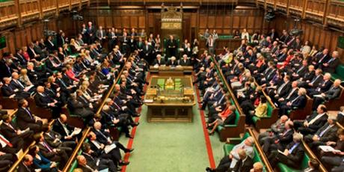Although the UK is undoubtedly a democracy, there have been questions raised over the extent to which this is the case.

**A Democratic Audit of the UK!**

**Task:** Use the internet to research the following questions.

1) What is the percentage of women MPs in the House of Commons? What are the figures for the Scottish Parliament?

2) What was the turnout at the 2017 General Election?

3) What was the turnout amongst the 18-24 age group?

4) What was the turnout amongst the 65+ age group?

5) Which are the only two countries in the developed world (the OECD) to have a wholly unelected Second Chamber?

6) Where does the UK rank in the world for levels of press freedom?

7) Find 5 examples of previous jobs MPs have held before they entered parliament.

8) What was the combined membership of the 2 main political parties in 2017? What was it in 2000? What was it in 1950?

What would you consider to be the key features of a democracy?



Prepare for a debate on the extent to which the UK is democratic.

|  |  |
| --- | --- |
| Positives of the UK democratic system | Negatives of the UK democratic system |
|  |  |
|  |  |
|  |  |
|  |  |

**The ‘Participation Crisis’ and Enhancing Democracy in the UK**

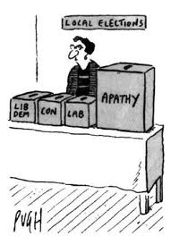Perhaps the main concern about democracy in the UK stems from evidence of growing political apathy. Some have seen this as nothing less than a ‘participation crisis’. How can democracy be healthy when, despite opportunities for participation, more and more citizens seem to be uninterested or unwilling to engage in political life? This has been most evident in the declining rates of voter turnout and falling levels of party membership

**The Participation Crisis**

**Voter turnout**

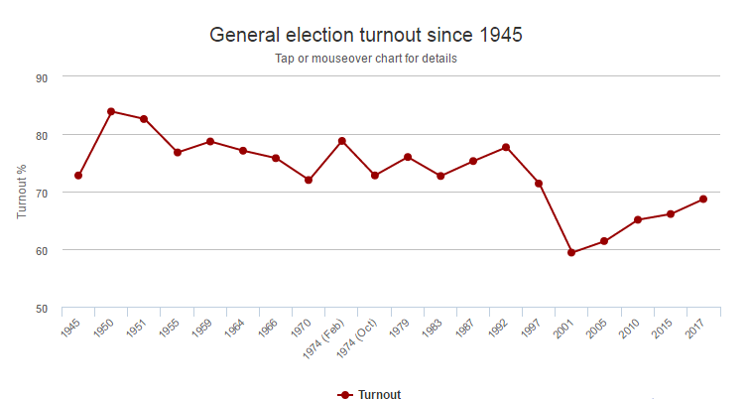

Turnout went through a period of dramatic reduction during the late 1990s and the 2000s. Whilst it has recovered in the last few elections, it is still not at the point it was during the majority of the 20th Century.

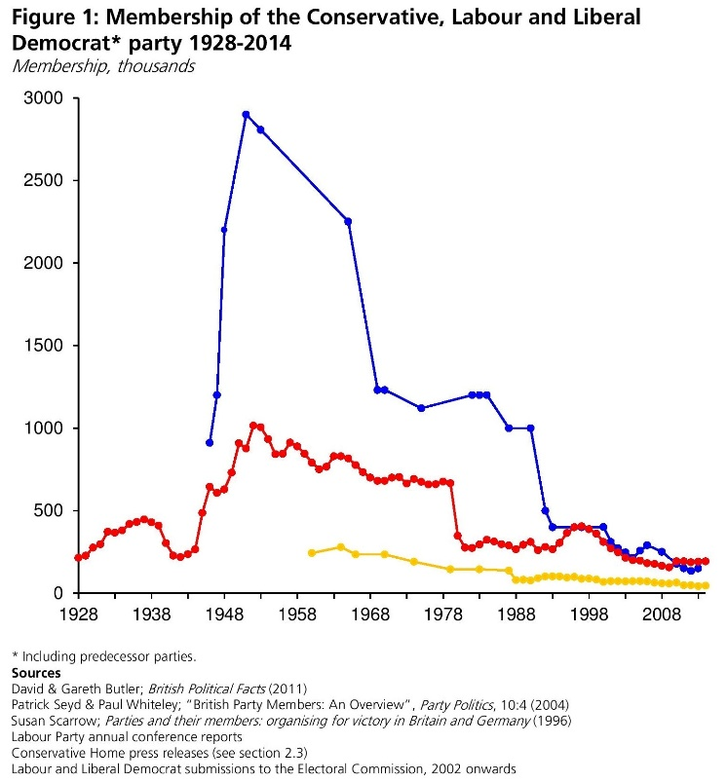**Party membership**

In a similar manner to voter turnout, party membership has steadily decreased from highs during the 1950s, until the current situation. The Labour party, as well as the minor parties, have received a small reversal to this in the last couple of years, but not to a great extent.

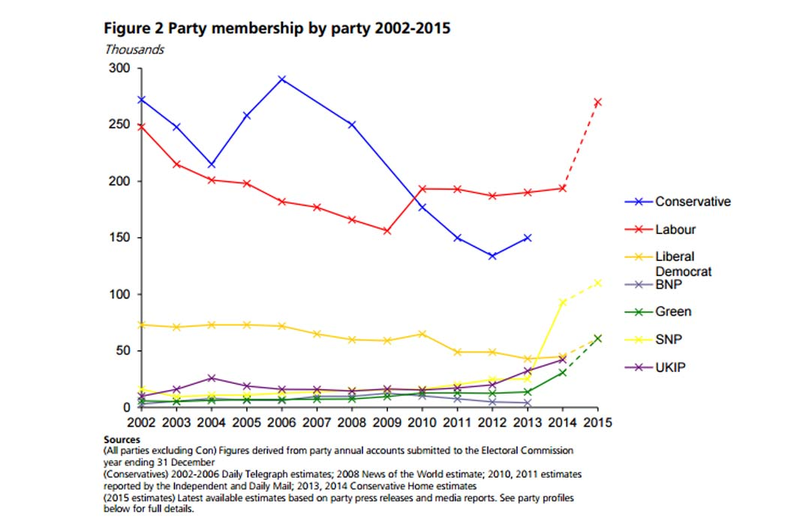

However, **the idea of a ‘participation crisis’ in UK politics has also been criticised**. The problem may not so much be a decline in the overall level of political participation but, rather, that there has been a shift from one kind of participation to another. In particular, as disillusionment and cynicism with party politics have grown, there has been an upsurge of interest in pressure group politics and protest movements. This, combined with the recent surge in support from the youth towards Corbyn’s Labour has led to some suggesting that the participation crisis was overstated by some analysists.

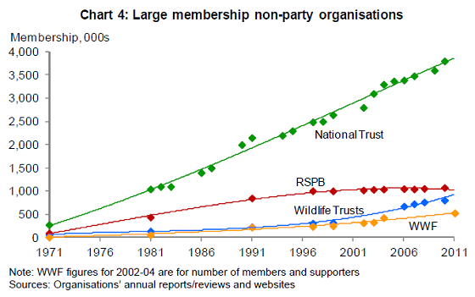

Write your own ‘mini-judgement’ on whether or not there is a participation crisis in the UK?

**Suffrage**

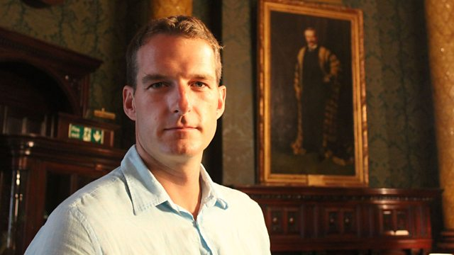

Watch ‘Dan Snow on Democracy’ on Youtube (<https://youtu.be/4MH89RzS39g>)

Who could vote first?

What **percentage** of people AND **type** of people could vote in…

* Great reform  
  act 1832
* Second reform  
  act 1867
* Representation  
  of the People  
  act 1884
* Representation   
  of the People   
  act 1918
* Representation   
  of the People   
  act (Equal  
  Franchise)  
  1928
* Representation   
  of the People  
  act 1969

Who actually votes? What was the TURNOUT in……

1951

1992

2001

Why is this a problem?

**Extension video:**

**Big ideas that Changed the World: Democracy, (**Parts 1 and 2)

[**https://www.youtube.com/watch?v=IVP2-zsKYcI**](https://www.youtube.com/watch?v=IVP2-zsKYcI)

***Tony Benn was left wing and this video looks at the development of Democracy from the viewpoint of ordinary people rather than ‘top down’ from the monarchy.***

What does the word democracy mean?

How did the **Ancient Greeks** use democracy?

Who did it include and not include?

When did **English democracy** begin?

What was **Magna Carta (1215)** about?

What does **Magna Carta** not refer to?

1st turning point: **The Peasants Revolt**. What happened and what is it remembered for?

1295: The First Parliament was summoned by the King. But the common people still had no say.

1649: The Civil War (English Revolution). Cromwell defeats the King, Charles I who is executed in 1949. The monarchy was restored in ________.

**Tom Payne**. What happened to his book, The Rights of Man?

What did he say?

Who were the **Tolpuddle Martyrs** (1833)?

What happened?

1832 – How many had the vote and who were they?

Who were the **Chartists** and what did they do?

Were they successful?

Who were the **Suffragettes**? What were their tactics?

When were women given the vote? When did it become equal with men?

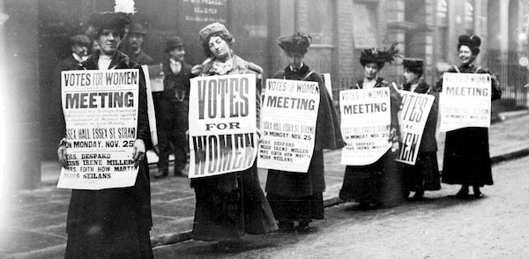

**Further reforms to suffrage**

Which of the following do you think would be a good idea in the UK? Explain your answers.



**Votes at 16?**

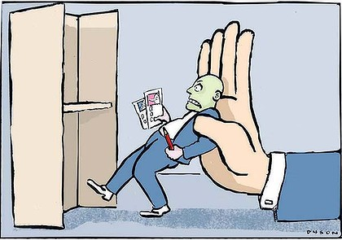

**Compulsory voting?**

**Digital voting?**

**Pressure Groups**

Pressure Groups form a fundamental part of politics. Watch the video extract on Amnesty International and also study the various pressure group leaflets provided. What are the various pressure groups trying to do?

|  |
| --- |
| **Define a Pressure Group**  Aims: |

**Task:** Watch the video extract on Amnesty International and other pressure groups. What are the various pressure groups trying to do?

**Types of Pressure Group**

Pressure Groups can be classified into a number of different types – *Sectional* and *Cause* Groups, *Insider* and *Outsider* Groups.

|  |
| --- |
| **Sectional Groups**  **Sectional Groups** (sometimes also called *‘interest’* or *‘functional’* groups are groups that **represent a particular section of society**: workers, employers, consumers, an ethnic or religious group and so on.  Sectional Groups have the following features:   * They are concerned to **protect or advance the interests of their members.** * **Membership is limited** to people in a particular occupation, career or economic position. * **Members are motivated by self-interest**.   **Examples**  Trade Unions, business corporations and professional bodies are the prime examples of this type of group. Specific examples include the BMA (*British Medical Association*), the NUT (*National Union of Teachers*) and so-called ‘umbrella’ groups such as the CBI (*Confederation of British Industry*)  http://img.thesun.co.uk/multimedia/archive/00475/Teachers_Strike3_38_475320a.jpg |

|  |
| --- |
| **Promotional Groups**  Promotional Group (sometimes called ‘cause’ or ‘issue’ groups) are groups that are based on shared attitudes or values, rather than the common interests of its members. The causes they seek to advance are many and various. They range from charity activities, poverty reduction, education and environment to human rights, international development and peace.  http://egfl.net/Teaching/media/shelter.jpgPromotional Groups have the following features:   * They seek to advance particular ideals or principles * Membership is open to all * Members are motivated by moral or altruistic concerns (they seek to benefit society as a whole).   **Examples**  Specific examples of cause groups include Friends of the Earth, Amnesty International, Shelter, the RSPB and the Electoral Reform Society. |

|  |
| --- |
| **Insider Groups**  Insider groups are PGs that have particularly close links with the government, at all levels. They have influence over policy, both at a formation and implementation level. The main ways they operate include:   * They are involved in the early stages of law making and policy * They tend to employ professional lobbyists who try to influence governmental opinion * Some groups may even have positions on special governmental committees on policies – such as the NFU (National Farmers Union) over agricultural policy.   Image resultExamples of insider PGs include organisations such as the NFU, the CBI (Confederation of British Industry) and the IOD (Institute of Directors). |

|  |
| --- |
| **Outsider Groups**  Outsider groups are PGs that do not enjoy a special position within governing circles. This could be a government decision, or one by the pressure group themselves (Greenpeace, for example). Outsider groups are normally:   * Promotional groups. Sectional groups tend to have a clear membership and are therefore more useful to governments. * Have alternative methods, such as public campaigning and use of the media. This can often develop in to less responsible or possibly even illegal actions, such as publicity ‘stunts’. * Their focus tends to be on getting public opinion on their side, rather than directly focused on the government.   Image result for greenpeaceExamples of outsider PGs include organisations such as Greenpeace, Fathers for Justice or Amnesty International. |

|  |
| --- |
| **Test Yourself**  Define these PGs as Insider / Outsider, Sectional / Promotional……  **Amnesty Mencap Greenpeace**  **Fathers4Justice Animal Liberation Front ASH**  **TUC National Trust Plane Stupid No2ID**    **ProTEST RSPB CBI Child Poverty Action Group**  **Occupy Frack Off NUS** |

**Case Study of a Pressure Group in Action (i). ‘Hugh Grant: Taking on the Tabloids’**

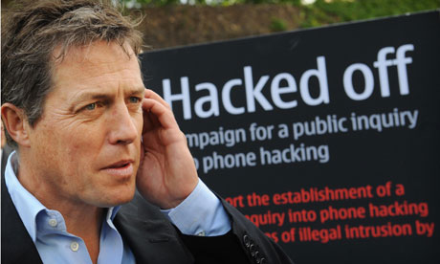1. How did Hugh Grant become associated with Hacked Off and what were he and they campaigning for?

|  |
| --- |
| 2. Name the various methods that Hugh used to try to influence the government to change the law on press regulation. |

|  |
| --- |
| 3. Name the various methods used by opponents of press regulation to make their case |

|  |
| --- |
| 4. Why did Hugh have his work cut out?! *Where is the money? Who has the insider influence?* |

**Further discussion points:**

*What distinguishes Hacked Off as an ‘outsider’ pressure group? Is this actually true? Why might they prefer to define themselves as an outsider group?*

*How successful, in your view, was Hacked Off in achieving its aims?*

*What do you think they would need to have done to become more successful?*

*What contribution, if any, do you think ‘Hacked Off’ is making to our democracy?*

*Research what has happened in the time since this film was made? What do you think?*

**Case Study of a Pressure Group in Action (i). BMA (British Medical Association) Junior Doctors’ Strikes 2016**

Article from the Guardian, 1st September 2016. “What you need to know about the junior doctors’ strike’

## ****When will the five-day strikes happen?****

The BMA announced that junior doctors will strike from 12 to 16 September, in a significant escalation in their dispute with the government over a proposed new contract. The walkout will occur between 8am and 5pm on those days, so technically it is not five-day strike but a strike on five consecutive days. There are also walkouts proposed for 5, 6, 7, 10 and 11 October, 14-18 November and 5-9 December.

## ****What impact will the strikes have?****

Jeremy Hunt, the health secretary, says if they go ahead these will be the [worst doctors’ strikes in NHS history](https://www.theguardian.com/society/2016/sep/01/jeremy-hunt-five-day-doctors-strike-worst-in-nhs-history). He claimed that up to 100,000 operations and up to 1 million appointments could be cancelled. In the last strike over two days in April 100,000 operations and outpatient appointments were cancelled.

## ****How has the industrial action been ramped up?****

There have been six walkouts already this year, but until now none have lasted more than two days. In the first four strikes, junior doctors continued to provide cover in settings that provide life or death care, such as A&E, intensive care, maternity services, acute medicine and emergency surgery. But in two strikes in April doctors walked out from emergency departments for the first time in NHS history. This latest round of action will also include emergency departments. As well as the extra length of planned action, the short notice on the dates also ramps up the dispute and will limit [NHS](https://www.theguardian.com/society/nhs) contingency plans.

## ****Why are they striking?****

At the centre of dispute is a new contract that Hunt intends to impose on junior doctors – all those below the level of consultant – in a phased introduction schedule to start this autumn. On-and-off talks over more than three years have failed to produce final agreement on the terms and conditions that has the crucial backing of BMA members.

## ****Didn’t the two sides reach agreement earlier this?****

Yes**.**A compromise deal, said to be the government’s final offer, was backed by the then chair of the junior doctors’ committee, Dr Johann Malawana, in May. But he resigned in July after BMA members voted against the agreement by 58% to 42%. Malawana’s replacement, Dr Ellen McCourt, now says junior doctors have no choice but to strike, because Hunt has refused to engage in meaningful negotiations.  
  
**What does Hunt say?**

He claims he is open to talks, but that he has an election mandate to force through the new contract, because of the Conservatives’ manifesto pledge to introduce a seven-day NHS.

## ****What are the sticking points?****

Hunt claims there are only two issues to be resolved: Saturday pay and automatic pay rises for part-time workers. He says the new contract offers reasonable deals on both. Junior doctors say that what is being offered is unreasonable. They remained concerned about the impact on those working less than full time, a majority of whom are women, and the impact on junior doctors working the most weekend. The BMA says the contract fuels a workforce crisis, and fails to treat all doctors fairly.

## ****Is the BMA split on five-day strikes?****

Yes. Dr Mark Porter, chair of the BMA council, admitted the decision to strike came after “long and difficult debates” and did not dispute a claim that the council backed the action by only 16 votes to 12.

## ****Is there any hope of the dispute being resolved?****

Not at the moment. The government shows no sign of backing down on its determination to force through the contract. It will take 18 months before all 45,000 trainee medics are on the contract. The BMA says it will only call off the strikes if the imposition of the new contract is halted. Until now the doctors have enjoyed public backing in their fight with the government, but they could risk squandering that support and angering patients by escalating the dispute. For his part, Hunt is hoping to exploit divisions in the BMA over the wisdom of strike action, to force the junior doctors to back down.

***Answer the following questions based on the above article:***

How many operations were going to be cancelled as a result of the strikes?

What reasons do the BMA give for going on strike?

Why did it seem unlikely that the dispute would be resolved swiftly?

Do you think the BMA are an insider or outsider PG? What kind of tactics are they using?

Compare the BMA to Hacked Off. How would you say they are similar in their aims and methods? How are they dissimilar?

**Task: Pick two of your pressure groups you find interesting and research them below.**

**Hints:** *If you are short for ideas try any of the following: Amnesty International, Occupy, Oxfam, Fathers for Justice, Stonewall….*

**Name of Group:**

**Main Aim(s)**

**Classification (insider/outsider, sectional/promotional)**

**Strategies/methods used to achieve aims**

**Name of Group:**

**Main Aim(s)**

**Classification (insider/outsider, sectional/promotional)**

**Strategies/methods used to achieve aims**

**PG Methods**

|  |  |  |
| --- | --- | --- |
| **Method Used** | **Explanation** | **Specific example of this method** |
| **Lobbying Parliament**  And access points in general |  |  |
| **Public campaigning** |  |  |
| **Working with political parties and MPs** |  |  |
| **Media campaigns** |  |  |
| **Use of illegal methods and civil disobedience** |  |  |
| **Use of courts** |  |  |

**Why are some PG more successful than others?**

Prepare for a balloon debate on the key reasons for a PG success or failure.

* Size
* Finance
* Insider status
* Public support
* Opposition

You need to prepare an argument for your assigned factor, stating why it is the most important.

Once you have finished the debate with your class, complete the pie chart below. Give a larger section of the pie to the factors that you think are most important.

Finally, write a conclusion to the question: “To what extent is size the most important factor for determining a Pressure Groups success?”

**Are PGs good for democracy?**

Pressure groups are groups of like-minded individuals who come together on the basis of shared interests or a commonly held cause in order to put pressure on policymakers at Westminster and beyond. A democracy is a system where the people have power rather than, say, an unelected elite or institutions which cannot be held to account. There are strong arguments that, whilst seemingly being the essence of a so-called ‘pluralist democracy,’ pressure groups can actually sometimes embody rather undemocratic features and can even pose a threat to our democratic system of government. 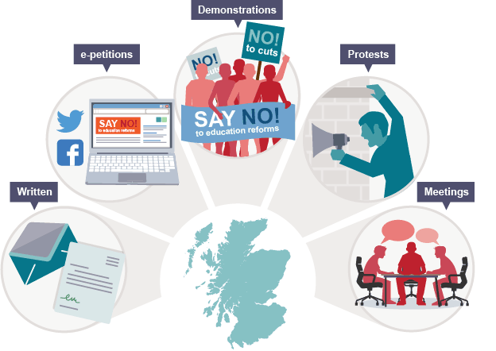

Complete the below table, using the textbook.

|  |  |
| --- | --- |
| Ways in which PGs enhance democracy | Ways in which they may threaten democracy |
|  |  |
|  |  |
|  |  |
|  |  |
|  |  |

Now rate the arguments in order of how strong they are. Give each argument a score out of 10. Overall, which side is stronger?

**Other types of external influence on the government**

There are a range of other influences on governmental policy, besides pressure groups. Organisations such as ‘think tanks’, as well as lobbyists and even celebrities all try to influence policy. In some situations these organisations have been set up by the government in order to look in to a certain issue and advise accordingly.

Using the textbook, add detail to the spider diagram below. Include:

* An explanation of each
* Examples of them in action (for think tanks, include at least two different types)

**Evolution of Rights within the UK**

Write down a definition of human rights and civil liberties below:

**Define human rights:**

**Define civil liberties:**

Read the amended extract below from the Equality and Human Rights Commission, detailing the history of the human rights in the UK:

## Image result for rights in the ukMagna Carta 1215

This English Charter acknowledged for the first time that subjects of the crown had legal rights and that laws could apply to kings and queens too. The Magna Carta was also the first step in giving us the right to a trial by a jury of our peers.

## Habeas Corpus Act 1679

Another crucial step towards the right to a fair trial, this law protected and extended the right of a detained person to go before a judge to determine whether the detention was legal.

## English Bill of Rights 1689

The Bill was a landmark moment in the political history of Britain because it limited the powers of the monarch and set out the rights of Parliament. It included the freedom to petition the monarch (a step towards political protest rights); the freedom from cruel and unusual punishments (the forerunner to the ban on torture contained in our Human Rights Act) and the freedom from being fined without trial.

## Sex Discrimination Act 1975

The Act made gender-based discrimination illegal in the areas of employment, education and the provision of goods, facilities and services.

## Race Relations Act 1976

The Act enshrined many of the laws on race discrimination that we take for granted today. It made race discrimination unlawful in employment, training, housing, education and the provision of goods, facilities and services.

## Disability Discrimination Act 1995

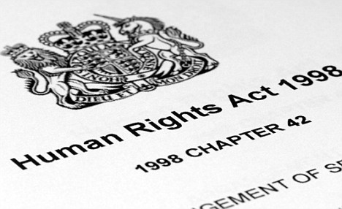This Act represented the first far-reaching anti-discrimination legislation for disabled people. It covered key areas of life such as employment and training, education, goods, facilities and services, premises and transport.

## Human Rights Act 1998

In force since October 2000, the Act incorporated into domestic law the rights and liberties enshrined in the European Convention on Human Rights. People in the UK no longer had to take complaints about human rights breaches to the European Court in Strasbourg – British courts could now hear these cases.

## The Freedom of Information Act 2000

The FOI allows campaigners and the public to access government information. If the release of the information does not ‘risk public safety’, then the government has to allow access to it. This in turn has helped to improve health services, the police, the civil service and education, by shedding light on their activities and helping to promote reform.

## The Equality Act 2010

The Equality Act brought together over 116 separate pieces of legislation into one single Act - a new, streamlined legal framework to protect the rights of individuals and advance equality of opportunity for all.

**Which of the above do you think was most important? Why?**



**Protection of rights in the UK**

Pressure groups play a key role in the protection of rights in the UK. We’ve looked at the different methods used by PGs already. We will be researching two human rights pressure groups.

|  |  |  |
| --- | --- | --- |
|  | Aims | Examples of them in action |
| Amnesty International |  |  |
| Liberty |  |  |

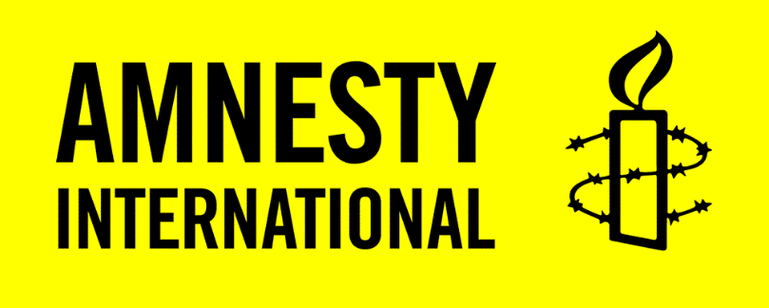

**How well are rights protected in the UK?**

Despite progression of rights in the UK in recent years, there are still some claims that citizens’ rights are not as secure as they could be. Due, in part, to the nature of the UK’s uncodified constitution, there are issues over the extent to which rights and freedoms are entrenched.

|  |  |  |
| --- | --- | --- |
| Strengths of UK rights | Weaknesses of UK rights | Overall? How strong are rights protected? |
| Strong traditions – in particular common law | Can be overturned by parliamentary statue, also not always clear |  |
| UK is signed up to European Convention on Human Rights (ECHR) | Parliament is still sovereign and can ignore the ECHR – could even repeal the HRA (Human Rights Act) |  |
| The judiciary is independent and separate from Parliament and politics. | The rise in terrorism, both in the UK and abroad, has resulted in the government cutting back on some of the rights of citizens |  |

**Individual versus collective rights**

As well as impacting on the clash between state power and rights, the rise in terrorism has once again highlighted the clash between individual and collective rights. There has been a long-standing dispute between the rights of the community as a whole and how that impacts on the individuals own civil liberties.

Which of the below do you think are more important?

Rights to not be offended (often on religious grounds)



Freedom of expression

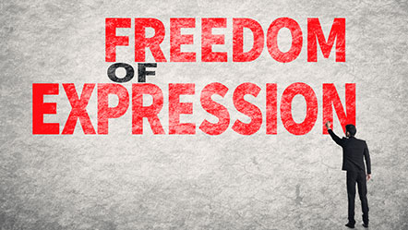



Why?

Right to privacy 

The right of the community to be protected from terrorism by security services that may need to listen in to private communications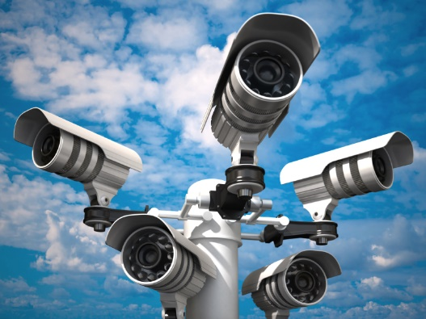



Why?



Right of public figures to keep their private lives private

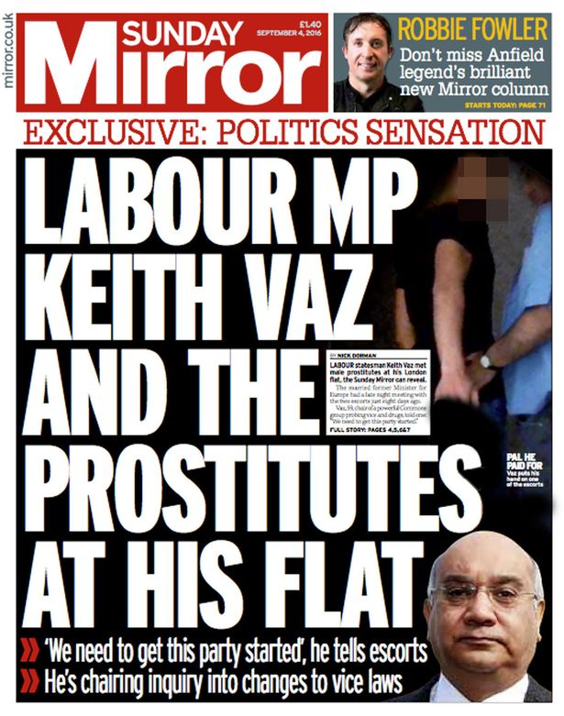

Right to press freedom

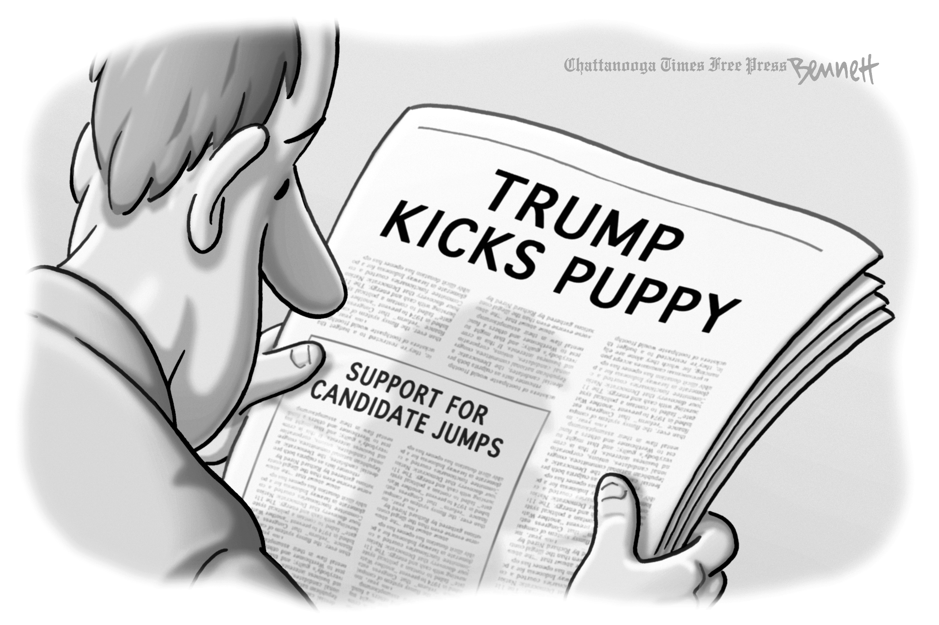

Why?



Right to demonstrate in public places

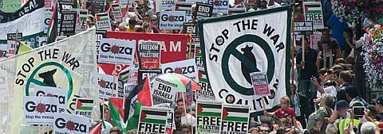

Right of community to own freedom of movement (and not being disrupted by protests)

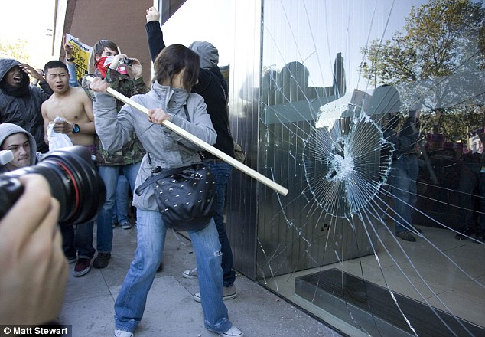

Why?



Right to strike

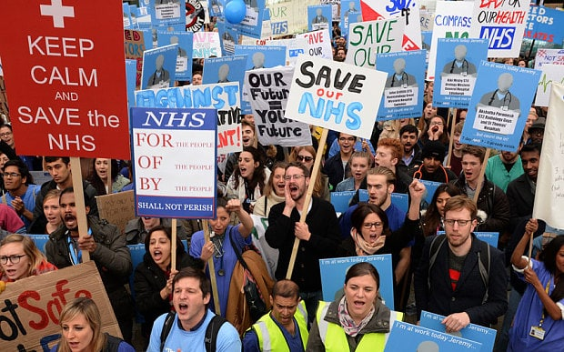

Right of community to expect good service from public servants

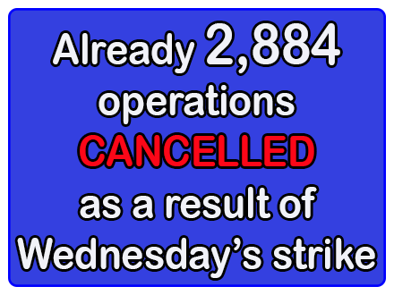

Why?

**What do you think overall? Do the rights of the individual outweigh that of society as a whole?**

**Vocabulary**

|  |  |
| --- | --- |
| **Vocab** | **Definition** |
| Accountability |  |
| Civil liberties |  |
| Civil society |  |
| Common law |  |
| Decentralisation |  |
| Democratic deficit |  |
| Direct democracy |  |
| e-democracy |  |
| Electoral mandate |  |
| Elitism |  |
| Formal equality |  |
| Franchise |  |
| Group politics |  |
| Hyperpluralism |  |
| Legitimacy |  |
| Limited government |  |
| Lobbyists |  |
| Manifesto |  |
| Participation crisis |  |
| Pluralism |  |
| Pluralist democracy |  |
| Promotional group |  |
| Redress of grievances |  |
| Representative democracy |  |
| Sectional group |  |
| Suffrage |  |
| Think tanks |  |