**Themes in Art & Architecture: War**

Artist: Unknown

Title: ‘*Kneeling Archer from the Terracotta Army’*Scope of work: Participants in 2D or 3D

**Key Facts**  
Size: Lifesize

Material: Terracotta.

Date: c210BC

Location: Museum of the Terracotta Warriors of Qin Shihuang, Xi'an, PRC

**Art Historical Terms and Concepts**  
**Subject matter**: A male archer kneels and looks alert and focused towards some unseen foe. His left hand reaches to grab what would have been a bronze crossbow. This archer has spent over two thousand years keeping vigil along with an army of soldiers, horses and chariots, at the tomb of Qin Shi Huang, the First Emperor of China. His role is to protect the Emperor in the afterlife as he had done during the Emperor’s lifetime.

**Colour:** Research how these figures were originally painted. What was the intended effect of the figures in a coloured condition?

**Composition:** Analyse the composition of the sculpture.

**Figure handing:** Discuss the depiction of archer’s figure. Look at pose, gesture, costume, facial expression, styling.

**Form:** How would you describe the form of this work?

**Materials:** What associations can be made from the artist’s choice of material?

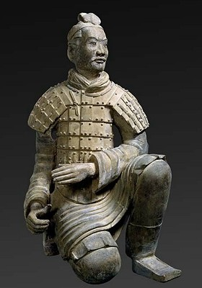

Context: Emperor Qin's Tomb

*The Terra-Cotta Army protects the tomb of China's first emperor*

**National Geographic**

Workers digging a well outside the city of Xi'an, China, in 1974 struck upon one of the [greatest archaeological discoveries in the world](http://news.nationalgeographic.com/2016/10/china-first-emperor-terra-cotta-warriors-tomb/): a life-size clay soldier poised for battle.

The diggers notified Chinese authorities, who dispatched government archaeologists to the site. They found not one, but thousands of clay soldiers, each with unique facial expressions and positioned according to rank. And though largely grey today, patches of paint hint at once brightly coloured clothes. Further excavations have revealed swords, arrow tips, and other weapons, many in pristine condition.

The soldiers are in trench-like, underground corridors. In some of the corridors, clay horses are aligned four abreast; behind them are wooden chariots. The terra-cotta army, as it is known, is part of an elaborate mausoleum created to accompany the first emperor of China into the afterlife, according to archaeologists.

Ying Zheng took the throne in 246 B.C. at the age of 13. By 221 B.C. he had unified a collection of warring kingdoms and took the name of Qin Shi Huang Di- the First Emperor of Qin. During his rule, Qin standardized coins, weights, and measures; interlinked the states with canals and roads; and is credited for building the first version of the Great Wall. According to writings of court historian Siam Qian during the following Han dynasty, Qin ordered the mausoleum's construction shortly after taking the throne. More than 700,000 laborers worked on the project, which was halted in 209 B.C. amid uprisings a year after Qin's death.

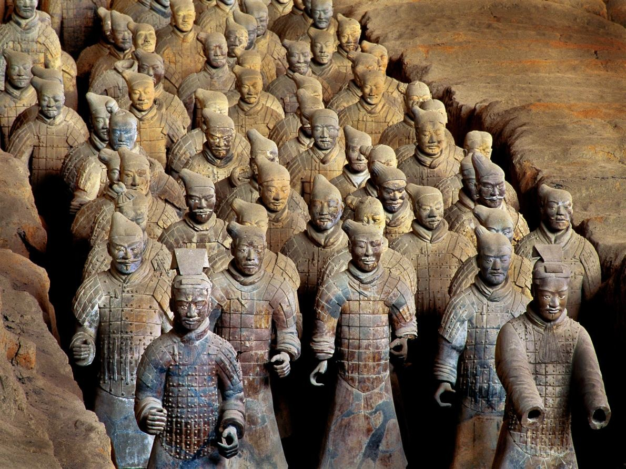To date, four pits have been partially excavated. Three are filled with the terra-cotta soldiers, horse-drawn chariots, and weapons. The fourth pit is empty, a testament to the original unfinished construction. Archaeologists estimate the pits may contain as many as 8,000 figures, but the total may never be known.

Q: What does the article above reveal to us about Emperor Qin Shi Huang Di?

Q: Why might the Emperor require military protection in the afterlife?

**From the Unesco website:**

The army of statues bears unique testimony to the military organization in China at the time of the Warring Kingdoms (475-221 BCE) and that of the short-lived Empire of a Thousand Generations (221-210 BCE). The direct testimony of the objects found *in situ* (lances, swords, axes, halberds, bows, arrows, etc.) is evident. The documentary value of a group of hyper realistic sculptures where no detail has been neglected - from the uniforms of the warriors, their arms, to even the horses' halters - is enormous. Furthermore, the information to be gleaned from the statues concerning the craft and techniques of potters and bronze-workers is immeasurable.

<http://whc.unesco.org/en/list/441>

[https://www.youtube.com/watch?v=W73GLWEJuQA#t=116](https://www.youtube.com/watch?v=W73GLWEJuQA%23t=116)

[https://www.youtube.com/watch?v=Zuugb3qq0Zg#t=42](https://www.youtube.com/watch?v=Zuugb3qq0Zg%23t=42)