Subsidies that breed poverty By Nick Mathiason and Heather Stewart in The Observer, Sunday 19 June 2005

Africa is dumped on and locked out. It can't trade its way out of its malaise because rich countries protect powerful interests

Some Facts about COFFEE  - 2.25 billion cups consumed every day  - 90% grown in developing countries but majority consumed and manufactured in developed countries. Brazil is the biggest exporter of green coffee beans  - Green coffee beans are the beans straight from the tree. They are an important commodity which is globally traded every day  - Roasted coffee beans have gone through a production process and are then either ground down, packaged and sold to retailers. | Definitions  - Tariffs - taxes on imports to prevent national consumers buying foreign imports and to therefore force them to buy from national/local firms)  - Tariff Escalation - escalating tariffs on manufactured products but allowing primary products to be imported. | For 1lb bag of coffee, the following firms receive:  - PRIMARY: Farmers (green coffee beans) = $1.41  - SECONDARY: Roasting the coffee beans, grinding them down and packaging = $26  - TERTIARY: Selling the coffee (via supermarkets or coffee houses – Starbucks etc) = $214

Tariff Escalation  From her smallholding in southern Rwanda, Beneconcille Murekezi produces enough green coffee beans to ensure her three children get to school each day. That is some achievement, as Rwanda tentatively recovers from genocide 10 years ago. As a member of a cooperative which sells coffee beans to a UK firm, Union Coffee Roasters, Murekezi, 38, is in a perilous position. In fact, she is in a poverty trap. There is a ceiling through which real improvements to her life and community cannot break through.  Murekezi and thousands of her co-operative colleagues would like to process all the beans rejected by Union Coffee Roasters to produce their own roasted coffee and add value. Micro bank loans would enable the co-op to invest in new machinery. But under arcane world trade rules known as tariff escalation, Murekezi's co-operative cannot 'add value' to their beans without incurring financial penalties from exporting to the EU that would make the whole project unviable.  Instead it is giant food companies such as Nestlé that have the right to roast African and South American beans in Europe, which is where the value added is. This poverty trap really hurts especially as coffee prices on world commodity markets have plummeted. Murekezi's 300 coffee trees, which produce the cherry-like fruit in which the beans are found, would have been worth $500 five years ago: today it's $300. This puts Rwanda in a nightmare situation. Nearly a third of its exports are in coffee, a depreciating commodity as there is too much world supply. | 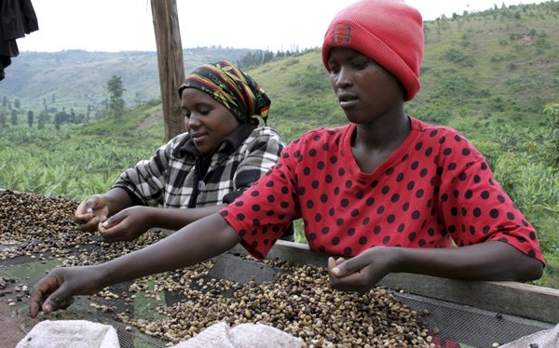  Beneconcille Murekezi: 'I would like to build extra rooms in my house. It would be nice to be able to use our work as a way to make ourselves more comfortable,' Murekezi says from her mud hut. 'But there is no way out.'
Tariff escalation holds back export-led growth and greater diversification in developing countries. Tariff escalation prevails in a large number of agricultural commodity chains in both developed and developing countries. It is more pronounced in commodity sectors such as meat, sugar, fruit, coffee, cocoa, and hides and skins, most of which are of export interest to many of the poor developing countries,' says Nasredin Elamin, an economist at the UN's Food and Agriculture Organisation.

Subsisdies and Dumping

Two main problems  - UNEQUAL PLAYING FIELD: Developing countries cannot compete with the subsidised prices on top of the fact that the US and EU have greater productivity due to Economies of Scale and Specialisation. Equally, ‘developing countries’ do not have the fiscal power to subsidise their own farmers.  - DUMPING: The EU and US produce too much as they are incentivised to do so with the subsidies (shift to the right in the supply curve for agricultural markets). What do these countries do with the surplus? Give them for free to the ‘starving Africans’! Problems? Well, what happens to the domestic agricultural markets in African countries if there is a sudden increase in essentially free imports? Collapse! And a dependency on the EU and US for food. | - Subsidies: Free grants given to businesses (in this case farms and farmers) by EU and US Governments. Means the cost of producing food for these farms is reduced which leads to lower prices for EU and US produced food.

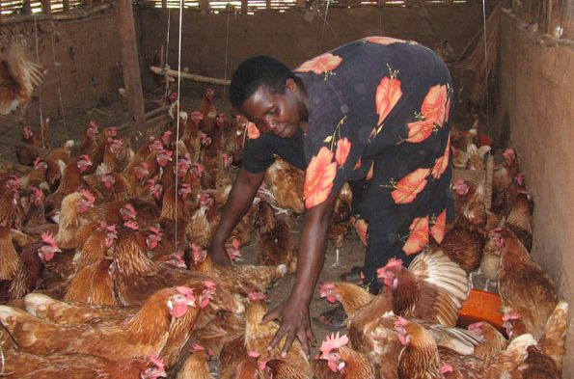 | The sheer weight and range of subsidies affects every facet of agricultural life in the developing world. Chicken farmers in Ghana are being forced out of business because they cannot compete with frozen chicken imports subsidised by European taxpayers. Trade campaigners call this 'dumping': EU subsidies allow farmers to sell goods at below-cost prices and make a profit; and when there is over-production in rich countries, the surplus gets sold into poor countries such as Ghana. Poultry farming is not directly subsidised under the CAP, but wheat production is, and paying for grain to feed chickens is a major cost. Ghana imported 36,000 tonnes of chicken in 2003, much of it from Europe.  Ghana is one of the 18 countries which will immediately benefit from the $55bn debt forgiveness package agreed by G8 finance ministers. But by refusing to give up the CAP, campaigners say Europe is giving with one hand, taking with the other. And Ghana's chicken farmers are not alone. The Dominican Republic was the fifth largest market for CAP-subsidised European milk exports last year; Indonesian rice-producers find it impossible to compete with cut-price US rice; and India imports sugar from Europe, where farmers in the Paris basin, and even in Finland, are subsidised to grow it. These three examples were singled out by Oxfam in a report about agricultural dumping which it published last week. Ghana's chicken farmers won the support of parliament for a measure which would have raised import taxes to protect the industry; but according to a report by Christian Aid earlier this year, the International Monetary Fund and World Bank warned the government against implementing the proposal. And since the World Bank and IMF are the gatekeepers for debt forgiveness, the government complied.

Most campaigners believe that trade barriers in both rich and poor countries will eventually have to come down, increasing the flow of global trade and bringing huge benefits to rich and poor. But while Europe and the US are still subsidising their farmers, Oxfam, Christian Aid and other groups believe African countries should be able to shelter their much less developed industries. 'You need to have aid and debt flows as well; there has been a sustained agricultural crisis in much of the developed world for the last 20 years: internal markets have collapsed,' says Matt Griffith, trade policy analyst at Cafod.

The inability to trade their way out of poverty means aid from rich countries fails to build sustainable long-term growth, believes CBI director-general Digby Jones. 'Without scrapping the CAP, all that will happen is that Swiss bank accounts will get fatter. Of course, Africa needs more money, but if it's not linked to ending agricultural subsidies in Europe, and in particular France, then it's blatant hypocrisy. The way to build asting sustainable economic growth, healthcare, roads and education is for Europe to end the CAP. Stopping trade distorting subsidies will allow African products to be exported and stop European goods being sold more cheaply in Africa.'

If the G8 leaders are serious about transforming the fate of Africa, they will have to exert true statesmanlike pressure to keep in check powerful agribusiness lobbies and end not just the CAP but similar subsidies in America. In the coming months, as the date draws closer to crucial trade talks in Hong Kong, we will know whether they have it in them.

