**Economic Integration and TRADE BLOCS**

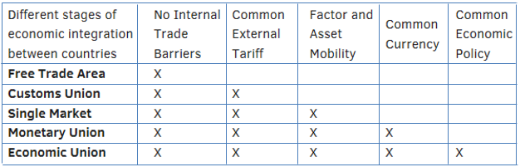

**The Two Main World Trading Blocs**

**1. NAFTA: a Free Trade Area**

The North American Free Trade Agreement (NAFTA) is a regional agreement, formed in 1993, between the Government of Canada, the Government of the United Mexican States and the Government of the United States of America to implement a **free trade area**.

These three countries have agreed to abolish tariffs between themselves in the hope that increased trade and co-operation will follow. Tariffs were to be phased out between the countries overtime with tariffs between USA/Canada and Mexico to be phased out by 2009. NAFTA members hope with a market similar in size to the EU it will be able to rival the EU’s economic power.

NAFTA is not a common market. Unlike the EU it does not seek to harmonise laws and regulations. Member countries are permitted total legal independence but must treat all firms from every member country equally.

**2. EU: from a Customs Union to a Single Market**

The EU (or the EEC as it was first known) was formed in 1958 with six original members: France, West Germany, Luxemburg, Netherlands and Belgium. Over time it has been enlarged with its membership to include Eastern Europe (most recently Croatia in 2013).

In 1968 all internal tariffs between members had been abolished and a **common external tariff (CET)** was put in place; the EU became a **customs union.** However, the EU had ever grander plans – wishing to become a **single market** as well as a customs union. The EU has many shared economic policies:

* **The Common Agricultural Policy (CAP)**
* **Regional Policy:** providing grants and support to depressed regions of the EU
* **Monopoly and Restrictive Practice Policy:** common competition policy
* **Harmonisation of Taxes:** VAT is the standard form of indirect tax in the EU, but there are still variations
* **Social Policy & Common Laws:** e.g. employment & health/safety
* **Economic Monetary Union:** for 19 members of the Eurozone

**WTO and Trading Blocs**

The WTO will be in favour of trading blocs in part because they have free trade within them and therefore countries joining increases trade within the bloc. However, they still have protectionism on the outside which conflicts with the WTO’s principles or aim of increased free trade.

Due to the size of trading blocs (e.g. EU and NAFTA) and the protectionism in place between these blocs there can be many disputes. Therefore the WTO will need to settle disputes between trading blocs and between trading blocs and individual countries.