ISI CASE STUDY: Have all developed nations had Import Substitution Industrialisation?

The Case of the USA and its Development
The southern states of America processed raw cotton to sell to the manufacturers of the UK. In the meantime, the Northern states of the US were developing their own industry to compete with the UK. The UK’s manufacturing base was well established thanks to the country being a pioneer of the ‘Industrial Revolution’. Industries in the US to begin with were only small and struggled to compete with the larger more established British manufacturers. Therefore, the US Government implemented a strategy of import substitution industrialization to prevent British competition from destroying their ‘infant industries’. Taxes from the tariffs but more importantly the growing industry created by ISI, led to the development of the US Railways; arguably one of the main reasons why US economic development was so fast and why by the end of World War II, the USA was the biggest economy in the World.

Between the Civil War and the Second World War, the USA was literally the most heavily protected economy in the world. In this context, it is important to note that the American Civil War was fought on the issue of tariff as much as, if not more, on the issue of slavery. In protecting their industries, the US was going against the advice of such prominent economists as Adam Smith who advocated specialization and free trade. However, the Americans knew exactly what the game was. They knew that Britain reached the top through protection and subsidies and therefore they needed to do the same if they were going to develop. In fact Ulysses Grant the famous civil war general (and later president) poured scorn on the UK’s attempt to remove protection from its borders. He famously said: “Within 200 years, when America has gotten out of protection all that it can offer, it too will adopt free trade”. Ironically, when his country later reached the top after the Second World War, it too started “kicking away the ladder” by preaching and forcing free trade to the less developed countries through the World Trade Organisation.

Chang’s Theory  Ha-Joon Chang is a leading economist specialising in development economics; he is a Professor in the Political Economy of Development at the University of Cambridge. In his book ‘Kicking Away the Ladder’, Chang argued that all major developed countries used import substitution economic policies in order to get rich and then tried to forbid poorer countries to copy them. The World Trade Organization, World Bank and International Monetary Fund come in for strong criticism from Chang for "ladder-kicking" of this type, which, he argues, are the fundamental obstacle to poverty alleviation in the developing world. The UK and the USA may be the more dramatic examples, but almost all the rest of the developed world today used tariffs, subsidies and other means to promote their industries in the earlier stages of their development. Cases like Germany, Japan, and Korea are well known in this respect. But even Sweden, which later came to represent the “small open economy” to many economists had also strategically used tariffs, subsidies, cartels, and state support for R&D to develop key industries, especially textile, steel, and engineering.  There were some exceptions like the Netherlands and Switzerland that have maintained free trade since the late 18th century. However, these were countries that were already on the frontier of technological development by the 18th centuries and therefore did not need much protection. Also, it should be noted that the Netherlands deployed an impressive range of interventionist measures up till the 17th century in order to build up its maritime and commercial supremacy. One important conclusion that emerges from the history of institutional development is that it took the developed countries a long time to develop institutions in their earlier days of development. Institutions typically took decades, and sometimes generations, to develop. Just to give one example, the need for central banking was perceived at least in some circles from at least the 17th century, but the first “real” central bank, the Bank of England, was instituted only in 1844, some two centuries later. | Criticisms of Chang’s Theory  Import substitution is no magic bullet. Other elements are key to the development of a country – education and technology advances being two big examples. Economists are undecided on the ‘cause and effect’ of economic growth. To say it is solely ISI is not proven empirically. There are also problems with trying to predict what ‘makes an Economy grow’ as there can be several different factors…it is not a one size fits all. Bill Easterly, another famous economist therefore accuses Chang of just fiddling the data to prove his point.  More recent examples such as Zambia (see above) or the case of Tanzania. From the 1960s through the 1980s, output per factory worker was steeply declining despite huge state investments in manufacturing. The Morogoro shoe factory, established in Tanzania during this time, was supposed to become a major exporter but never produced more than 4 percent of capacity and then went out of business.  Is it fair to expect instant results from Import Substitution Industrialisation? The UK and USA’s development were gradual processes over one hundred years; both the African cases were around 20 year experiments. But the pursuit of instant solutions to try and combat poverty during this time…

QUESTION TO ANSWER:
- Do you agree with Chang’s Theory or not? Justify your answer
ISI CASE STUDY 1: Zambia’s ‘Socialist Experiment’ and ISI – 1964 to 1984

Introduction
Zambia was made independent in 1964 from British rule and under Kenneth Kaunda, the new Zambian President, started to move in a ‘socialist’ direction. Large state run Governmental firms were set up called “Parastatals” which would provide industries such as copper mining, textiles and Cotton production. Kaunda, an admirer of the communist party in China fostered links with the country; partly this led to increased Chinese co-operation with the building of a railway called TAZARA in 1970, which connected Zambia via trade links through Tanzania and to the coast of East Africa.  Kaunda also employed ‘one party rule’ or a ‘one party democracy’ where other political parties were banned and the president of Zambia was elected every five years from within the party at the general conference. This gave Kaunda considerable power to implement his economic and social policy but raised questions about how democratic this process was.  1964-1974: The Golden Decade  The ‘socialist’ policy was able to build up a relatively diversified industrial sector with a mix of goods. The prominent sectors were food, beverages and tobacco; textiles and leather; chemicals and chemical products, and basic metals and metal products. However, and typical of the manufacturing sector at the time, very little was produced for exports. During the time of a thriving domestic market, the textile and clothing industry boasted a record of over 140 companies, employing over 25,000 Zambians in the 1980s. | 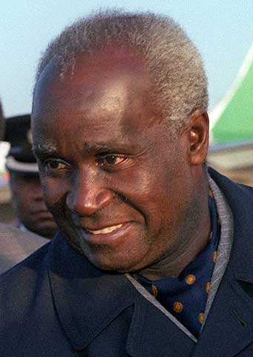  Kenneth Kaunda – Zambian President 1964 to 1991
Zambia’s textiles and clothing industry are a good example. They received substantial government support through an incentive system that favoured the entire manufacturing sector in Zambia, not just textiles. This incentive system was a form of import substitution industrialization. It was determined by a combination of tariffs (taxes) on imports, quotas on imports and exchange rate management by the Government to make imports more expensive. The ultimate result was to shelter the textile and clothing industry from external competition and Zambians would just buy from their own domestic industries. It also reduced the role of the free ‘capitalist’ market and increased state involvement (a socialist direction). The main Government run textile producers in Zambia were called ‘Parastatals’ and they were protected by high tariffs and mostly dependent on state financing as they were considered infant industries.

Because of support from the state, Zambia’s textiles and clothing industry grew considerably between 1964 and the 1980s. As the World Bank (1984) reports, Zambia’s textiles, wearing apparel and leather contribution to total manufacturing value-added rose from 10.1 percent in 1964 to 18.4 percent in 1980. During this time, the textile and clothing industry boasted a record of over 140 companies, employing over 25,000 Zambians in the 1980s.
Economic growth of the economy was very good and employment levels rose considerably. Zambia seemed to be living up to its promise as one of the potentially richest countries in Africa.

1974-1984: The Wheels start to fall off?
Unfortunately, the ‘socialist’ policy proved costly for Zambia. In 1975, copper prices fell simultaneously as oil prices shot up. Government revenue declined significantly and the textiles and clothing industry started to experience under use of capacity (not all of its production. This was partly due to the nature of the investment in the industry and the scarcity of extra money (from foreign trade) for imported inputs and spare parts. Over the next ten years, production and growth stalled, as Zambia was forced to take out more and more ‘hard loans’ from international banks.

Eventually in 1984, the IMF intervened and ‘bailed out’ Zambia by replacing all of its ‘hard loans’ with ‘soft loans’. Alongside these new loans however, conditions were attached: ‘Structural Adjustment Policies’. These consisted of moving away from the ‘socialist experiment’ to a more ‘capitalist outlook’ by privatising state run companies, opening trade barriers and drastically reducing Government spending further. This first phase of debt relief from 1984 to 1997 was arguably an unmitigated disaster with falling GDP per capita and life expectancy coupled with a sharp rise in HIV and deaths from other diseases.

Parastatals were also accused of being inefficient. Without competition or worries about profit, these large firms arguably started to fall into disrepair and there was little innovation or new technology to sustain economic growth.

QUESTIONS TO ANSWER:
- What were the advantages and disadvantages of the ‘socialist experiment’ in promoting development in Zambia?
- Was the debt crisis caused by copper price meltdown on the world markets OR due to expensive subsidies by the Zambian Government in your view?

ISI CASE STUDY 2: China, Chairman Mao and ‘Extreme’ ISI 1949 to 1978

Key events:
- Chinese Civil War and the rise of Chairman Mao - After the Chinese civil war, Chairman Mao Zedong launched a communist vision of China with extensive land reforms to redistribute on a more equal scale with the persecution of landlords and merchants. The period between 1949 and 1956 was recognized as the golden period of Chinese industrialization, as the country established its primary industries including steel, automobile, textile, chemical, and defense. The GDP grew at the rate of over 20% per year!  - Great Leap Forward 1958 and the Great Famine - Because of over-optimism, Mao made his first huge mistake by summoning his nation to speed up industrialization. This was the “Great Leap”, which resulted in the significant economic recession in 1958 and 1959 and also the disaster in early 1960s.To continue the industrialisation, Mao insisted that former agricultural labourers would start to smelt iron. Such small-scale industry however was very inefficient and the focus on industry meant agriculture suffered. 30 million people died from 1958 to 1961 due to famine; one of the worst famines ever known.  - Cultural Revolution 1966 - An attempt by Mao to remove ‘capitalist, cultural and traditional elements from Chinese society and for everyone to adopt a ‘Mao orthodoxy’. Millions of people faced torture, humiliation, death and displacement not to mention the destruction of rare historical artifacts.  - Period of adjustment (76-78) – After the death of Mao, political uncertainty with the struggle to power with the ‘gang of four’. Political resolution occurred with the arrival of Deng Xiangpao who started to revolutionize the old ‘socialist’ mantra to some extent  Protectionist China 1949 to 1978: ‘Extreme’ Import Substitution Industrialisation  From 1949 – 1978, China, for the first time, systematically built its industrial base and transformed itself from an agricultural economy to an industrial one. In China ISI was the key part of central planning system copied from the Soviet model (USSR – now known as Russia), which makes normal ISI measures all become extreme. Instead of infant industry protection for some industries, it protects all industries – tariffs are placed on all imports. Thus, the extreme ISI aims at achieving the goal of rapid industrial growth by kick starting all domestic resources rather than relying on foreign assistance. This means China during this period had international isolation – nobody or thing came in or out of China. | 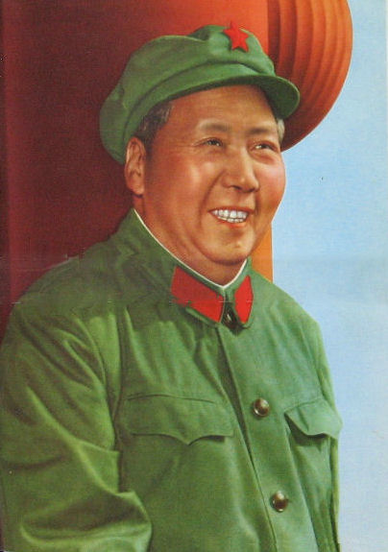  Chairman Mao

Another reason why it was ‘extreme’ ISI concerns how it was financed by the Government. In the Soviet model, the nationalization of all industries and banks made sure that the government could re- invest all possible resources into industrial development. Therefore a total command or socialist economy produced goods in the economy as opposed to an economy that had some capitalist elements to it.

Although the extreme ISI created an industrial foundation for China’s modernization, it alone clearly had its limitations. First, China seriously lacked modern technology and equipment, as they were unable to import foreign goods. Taiwan’s ISI in the 1950s was supported by the US with relatively advanced technology and equipment, while China’s extreme ISI was founded on domestic resources. Therefore even if China had wanted to buy foreign technology, ISI prevented external finance being raised (no exports either). This technology and other goods were so urgently needed by China to develop further but it had to rely on its domestic production. Second, in order to mobilize all available resources the extreme ISI had to suppress domestic consumption (spending) and forced people to save, which in the long run damaged people’s incentive to work (what was the point?). All of this was worsened by political turmoil during the Cultural Revolution between 1966 and 1976.

QUESTIONS TO ANSWER:
- What were the advantages and disadvantages of the extreme ISI that China adopted during this period?
- How much were the problems China faced due to the adoption of ISI OR Chairman Mao’s policies in your view?

