**EUROPEAN UNION OVERVIEW**

* **The Commission** – based in Brussels. One Commissioner from each country – ours is Sir Julian King. The President is Jean-Claude Juncker (Belgium). This post is a 5 year elected position. The European Commission make policy and pass new laws for the EU.

 

**Jean-Claude Juncker & Sir Julian King.**

* **The Parliament** – based in Brussels and in Strasbourg. MEPs (Members of the European Parliament) represent their country by sitting with other MEPs with the same political affiliation. There are 751 MEPs in total, from which 73 are from the UK. The number of seats a member state has is in proportion to their percentage of EU population. The European Parliament meet up several times a year to discuss the impact of new laws and policies. They appoint the Commission and also approve the annual budget.

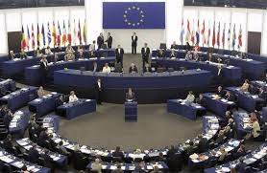

* **The European Court of Justice** – based in Luxembourg. One Judge is appointed from each country. Their responsibility is to interpret and enforce EU law which takes precedence over the domestic laws in member countries. In most cases, member states have to accept the EU ruling. However, on issues of national security and defence, the domestic governments have the first decision, and the European Court of Justice accepts it is subsidiary.

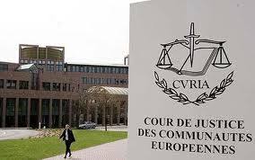

* **The European Central Bank** – based in Frankfurt. Mario Draghi (Italy) is the President of the ECB. It administers the Monetary Policy for the Euro Zone – sets interest rate for the Euro Zone and is charged with keeping inflation in the Zone to below 2% whilst keeping it as close to 2% as it can.

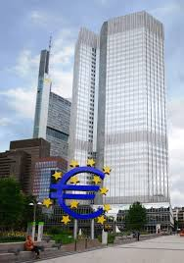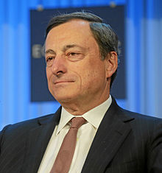

**Mario Draghi.**

* **The European Council** – this is essentially the name given to European Summits, the meetings of Heads of Countries. As well as being important for keeping up to date with World Affairs, these meetings help to form policy and development for the EU. Until recently, the meetings were chaired by the Leaders in rotation by country every 6 months. This group now chooses a President for a two and a half year period. Donald Tusk (Poland) is President.

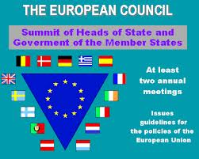



**Donald Tusk, President of the European Council.**

* **The European Council of Ministers** – sounds similar to above – and indeed has a similar purpose. The membership of this group is determined by the topic under discussion suggested as being important. For instance, there may be a need to discuss taxes – and the Chancellor would be the Minister to go – or it may be policing and security, so the Home Secretary represents…..

**The European Union Tri – Partite Separation of Powers**

|  |  |  |
| --- | --- | --- |
| **The Commission**  One from each country – policy makers  Brussels | **The Parliament**  Number of MEPs from each country based on population  Brussels and Strasbourg | **The Court of Justice**  Representatives from each country  Luxembourg |

