Overview of market structure |  | Which market structure and WHY
BANKING INDUSTRY (UK NATIONALLY)  - Retail banking is of fundamental importance to consumers and businesses and to the UK economy as a whole. There are around 70 million active PCAs (personal current accounts) in the UK and PCAs generated revenues of approximately £8.7 billion in 2014. 97% of adults have a PCA and 5.6 million PCAs were opened in the UK in 2015.  - There has been new entry into retail banking in recent years. Aldermore entered in 2009 providing SME lending. Metro was the first new high street bank in more than 100 years when it received its banking licence in March 2010 and offers both PCAs and SME (small and medium enterprise or businesses) banking including BCAs (business current accounts). Several other new entrants in PCAs have their roots in ancillary financial or retail services such as Tesco Bank (which entered in 2014), the Post Office (which entered in 2013/14), Virgin Money (which entered in 2014), and Marks & Spencer Bank (M&S Bank, part of HSBCG) (which entered in 2012). Santander entered the UK PCA and SME banking markets through its acquisition of Abbey National plc in 2004, followed by its acquisitions of Bradford & Bingley Building Society in 2008 and Alliance & Leicester Building Society in 2009.  - There are also a number of banks that have recently been authorised or are in the process of being authorised including Atom Bank (Atom) (authorised in June 2015, digital PCA and SME), Starling Bank (digital PCA), CivilisedBank (SME) and OakNorth (authorised in March 2015 SME banking but not BCAs). In addition to traditional bank lending, alternative finance has been growing rapidly in recent years.  - Despite these new entrants, the UK banking sector is dominated by a four very large banking groups, including the Lloyds Group, Barclays, the Royal Bank of Scotland (RBS), and HSBC. In response to the financial crisis, the UK banking sector went through a process of consolidation. In January 2009 the Halifax Bank of Scotland (HBOS) merged with Lloyds TBS to create the single biggest banking group, the Lloyds Group. By 2015 the market share of Lloyds Group in terms of personal current accounts had risen to 27% of the total market. Between them, the big four hold 77% of personal accounts and 85% of business accounts. Following the financial crisis the banking industry actually increased its level of concentration. The banking H-H Index rose from 1401 in 2007 to 1736 in 2010 (an index score of 2000 is regarded as highly concentrated.)  - As with US and EU banks, UK banks are now subject to much tighter regulation. Regulators must balance the need for financial stability and for ensuring that banks can pass any stress test they are faced with, as well as ensure that financial markets remain competitive. In the UK, the Financial Conduct Authority (FCA) is responsible for ensuring that financial markets work fairly. Banking has been subject to several competition reviews over the last 10 years, with most concluding that the market is excessively concentrated, with considerable barriers to entry. In 2014 the CMA launched the latest investigation into the personal current account (PCA) customers and to small and medium-sized enterprises (SMEs). | 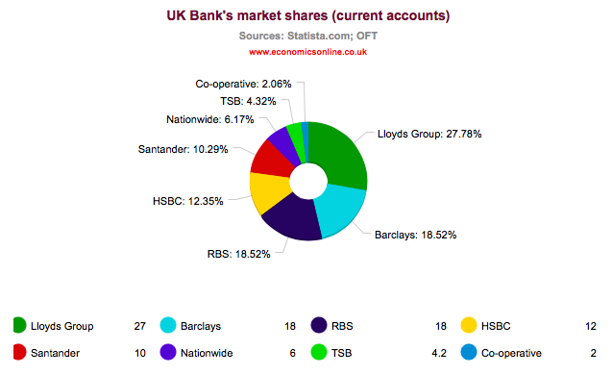
FOOD AND GROCERY INDUSTRY (UK NATIONALLY)  - THE PAST: BEFORE SUPERMARKETS: 1800’s-1950’s: Shop assistants serving customers (no self service). Tesco’s, Sainsbury’s and Asda all become PLC’s  - GROWTH OF THE SUPERMARKETS: 1950’s-1990’s: Supermarkets grow and become more popular. By 2000, supermarkets rake in a staggering £7 out of every £10 spent on the high street. The ‘big four’ control the majority of the grocery market. 1999: Traditional bakers, grocers, butchers etc. go out of business. Supermarket revolution accused of destroying the ‘traditional British High Street. Also accusations of Supermarkets having monopsony power and forcing prices down for suppliers. Tesco rises to the top of the pile with the most market share, overtaking Sainsbury’s in 1996 thanks to their loyalty club card which revolutionized the way supermarkets recorded information from their customers.  - SUPERMARKET DOMINANCE: 2000: Supermarkets first investigated by the OFT – findings were that prices had dropped since the 1980’s by 9.4% but were still 12-16% higher than in Europe. Also evidence of ‘predatory’ and ‘limit pricing’ was discovered and some examples where supermarkets were raising prices in certain goods where there was no competition. Led to a non-voluntary code of conduct in 2000. 2006: Criticism of supermarkets continues with a lack of progress since the CC ruling in 1999 and the code of conduct. However supermarkets praised for getting a good deal for it’s consumers (Competition Commission). Tesco’s manage to increase their market share by employing lawyers to argue that their merger/takeover with a local convenience retailer was not the same as taking over a supermarket as a local convenience store and a supermarket were totally different things! Were Tesco’s able to break the loopholes of Government regulation? 2007: The Office of Fair Trading (OFT) has said that the UK's four biggest supermarkets, Asda, Tesco, Morrisons and Sainsbury's, colluded with dairies to keep the price of milk and other dairy goods artificially high between 2002 and 2003. The watchdog says that consumers ended up paying £270m over the odds for milk, cheese and butter as a result of the price-fixing deal. The supermarkets were subsequently fined £50 million pounds in 2011. 2010: OFT investigate Tesco’s alleged ‘land grab’ of property around the UK – are they destroying possible competition by exploiting planning laws? Accusations of ‘regulatory capture’ with the OFT being renamed ‘The Office that Favours Tesco’ and accusations that Tesco’s are becoming too powerful with so called ‘Tesco Towns’ and a new economic term: ‘Tescopoly’  - Post 2010: Decline of Supermarkets: The UK grocery market has become increasingly competitive in the past seven years. Certainly the growing strength of discount giants like Aldi and Lidl have really shaken up the market and diluted the cosy oligopoly previous enjoyed by the likes of Tesco and Sainsbury. Tesco’s in particular suffered a decline post 2010 from which it is only just recovering in 2017. To further add interest, Pound shops are also gaining market share and nibbling away at the margins of the big supermarkets. For consumers it is largely good news with lower prices, lower profit margins and a raft of incentives from supermarkets trying to hold onto market share. | 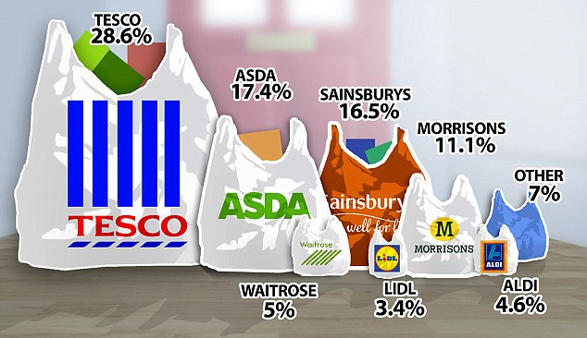
ENERGY INDUSTRY (UK NATIONALLY)  - In the early 1960s, coal provided 81% of UK energy needs By 2010, this had fallen to 30%. At peak times in cold winters, coal use can increase to 40% of the UK’s electricity production. Despite a revival in coal production in the last year. A third of our current coal power stations are expected to close by 2016 so that they meet EU air quality legislation.  - Supplying energy to homes across the UK involves three key elements: making electricity through generation transporting gas and electricity and selling it to the customer (retail). Energy companies can work in any of these different areas, and some operate in all of three of them The electricity and gas markets in the UK are privatised. This means that private companies make sure we have the energy that we need. It also means that customers can choose which companies supply their energy.  - Six suppliers - SSE, Scottish Power, Centrica, RWE npower, E.ON and EDF Energy - control 96 percent of the UK electricity generation market. In June 2014, the Competition and Markets Authority (CMA) announced that it was launching a full investigation into the supply of energy in Great Britain. Over recent years there has been almost continuous media debate about the soaring price of electricity and gas in the UK and it has become clear that there are many areas of concern about how the market is functioning.  - In 2017, Five of the big six energy suppliers – EDF, E.ON, Npower, SSE and Scottishpower – have increased their prices, blaming rising wholesale costs and other factors includiong the need to reinvest into worsening infrastructure. However one small supplier said, however, that it could not understand how suppliers could justify raising prices, especially twice in the case of EDF. | 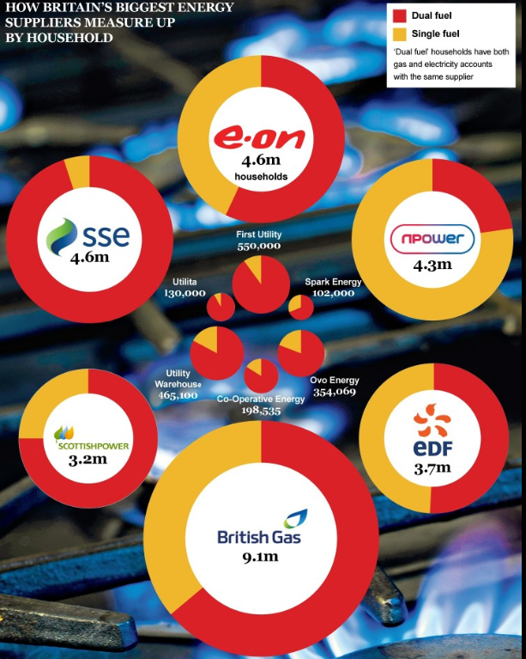

Overview of market structure |  | Which market structure and WHY
TRANSPORT INDUSTRY (NAMELY THE TRAIN SERVICE BETWEEN PORTSMOUTH AND LONDON WATERLOO)  - South Western Railway (SWR) is an English train operating company owned by FirstGroup (70%) and MTR Corporation (30%) that operates the South Western franchise. It operates commuter services from its Central London terminus at London Waterloo to South West London. It provides outer suburban and regional services in the counties of Surrey, Hampshire and Dorset, as well as regional services in Devon, Somerset, Berkshire and Wiltshire. SWR was awarded the South Western franchise in March 2017 and took over from South West Trains on 20 August 2017.  - The train company has invested money into new rolling stock after 1996 with privatization of the railways. However more recently it has been associated with increasing rail prices for commuters between Godalming and London Waterloo. In 2015, a season ticket cost over £4000 and rail prices have increased year on year. | 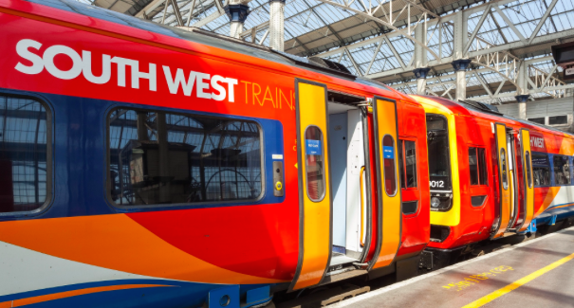
RESTAURANT INDUSTRY (UK NATIONALLY AND GODALMING HIGH STREET)  - The UK eating out market is worth over £40 billion, and while consumers continue to engage and enjoy the food industry across several channels, and brand power continues to hold its strength at the more expensive end of the market, the casual dining sector still find their target markets to be cost conscious and savvy about pursuing the best value without compromising on quality with competition from the dining packages offered by supermarkets.  - Clearly chain restaurants such as MacDonalds are dominant because of their brand presence who also benefit from economies of scale but there are also independent restaurants in most towns and cities. in most areas there are many firms, each is different, and entry and exit are very easy. Each restaurant has many close substitutes—these may include other restaurants, fast-food outlets, and the deli and frozen-food sections at local supermarkets.  - Restaurant growth continued to outstrip pubs in March 2014, with overall sales up 6.6 per cent year-on-year compared with 3.7 per cent for pubs, according to the Coffer Peach Business Tracker, which uses data from 30 leading restaurant and pub groups. However by Dec 2016/Jan 2017, thousands of UK restaurants could be at risk of going out of business as the sharp fall in the value of the pound since the Brexit vote raises costs for imported food and threatens to squeeze consumer spending. Over 5,500 restaurants companies could go bust within the next three years, due to inflationary pressures and stagnating disposable incomes, according to a new research by accountancy firm Moore Stephens. | 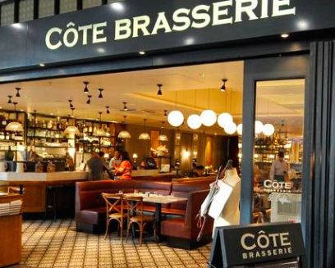
RETAIL INDUSTRY (MOROCAN SOUK)  - In the villages and towns that make up beautiful Morocco, you can find souks and outdoor markets displaying some of the finest Moroccan crafts and threadworks available. In the smaller countryside villages and towns, the same souks and markets display their offerings on a weekly basis.  - Souqs are traditionally divided into specialized sections dealing in specific types of product, in the case of permanent souqs each usually housed in a few narrow streets and named after the product it specializes in such as the gold souq, the fabric souq, the spice souq, the leather souq, the copy souq (for books), etc. This promotes competition among sellers and helps buyers easily compare prices.  - At the same time the whole assembly is collectively called a souq. Some of the prominent examples are Souq Al-Melh in Sana'a, Manama Souq in Bahrain, Bizouriyya Souq in Damascus, Saray Souq in Baghdad, Khan Al-Zeit in Jerusalem, and Zanqat Al-Niswaan in Alexandria.  - Though each neighbourhood within the city would have a local Souq selling food and other essentials, the main souq was one of the central structures of a large city, selling durable goods, luxuries and providing services such as money exchange.Workshops where goods for sale are produced (in the case of a merchant selling locally-made products) are typically located away from the souq itself. The souq was a level of municipal administration. | 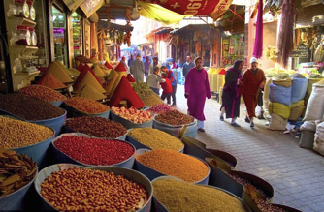
RETAIL INDUSTRY (HAIR AND BEAUTY – UK NATIONALLY AND GODALMING HIGH STREET)  - The annual turnover of this sector nationally is £6.2 billion and employs roughly 250,000 people in the UK. Take a look on the average British high street now, and chances are you will be faced with an impressive choice of places to get a hair cut, manicure or wet shave. Godalming is no exception with around 15 different hairdressing salons. According to the Royal Mail’s Address Management Unit, more beauty and grooming salons opened on UK high streets in 2015 than any other type of independent business, with a net increase of 626 salons, the equivalent of 10%. The increase in men’s grooming has been cited as one of the biggest drivers of growth in this industry as well as an increased demand for nail care. These types of treatments are no longer seen as a luxury good but are now normal goods and so their income elasticity of demand has fallen. For many, being well groomed has become a necessity.  - However there are now signs of saturation in the market with too many entrants coming into the market. Staying competitive in the industry is becoming increasingly hard with businesses having to offer compete using methods other than price.  - There are no national chains of hairdressers that dominate the market necessarily and benefit from economies of scale and therefore are in an advantageous position. There are chains such as ‘Toni and Guy’ who probably come closest with their franchise of over 495 stores in the UK but they do not dominate the market nationally due to the large number of small independent businesses competing on a local basis. | 