**Music Technology**

**Advanced Subsidiary**

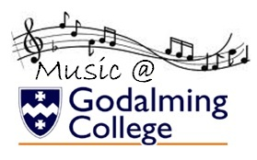

**Component 1: Recording**

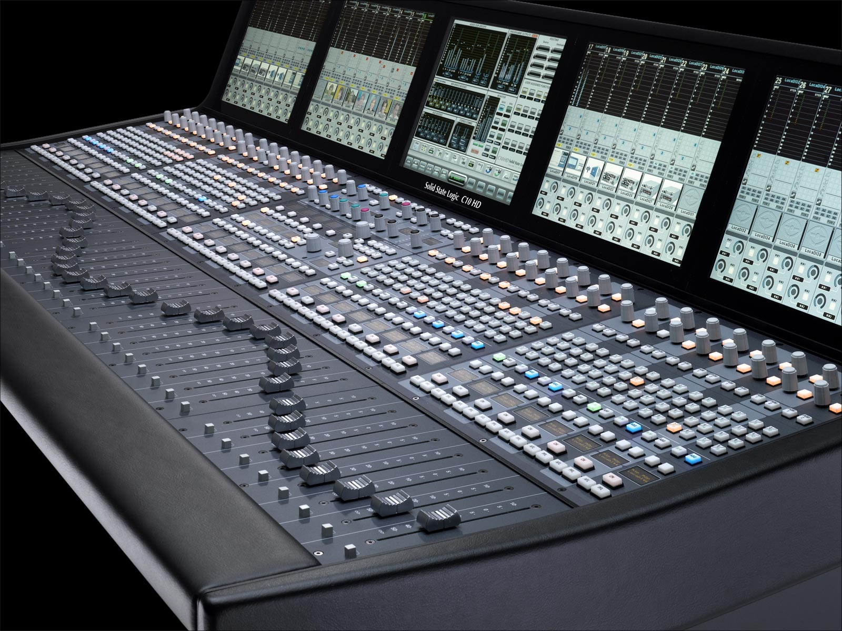

STUDENT WORKBOOK

Name\_\_\_\_\_\_\_\_\_\_\_\_\_\_\_\_\_\_\_\_\_\_\_\_\_\_\_\_\_\_\_\_\_\_

**Recording Task**

Produce a stereo mix of one song by one artist from the list of 10 that meets the instrumental requirements listed below. Your choice of song must be taken from a commercial studio recording on which the artist is credited.

Your Recording must demonstrate competencies in capture of sound and use of EQ, dynamic processing, effects, stereo, balance and blend. Your Recording must last between 2 and 2½ minutes. Your Recording must meet the following instrumentation requirements:

|  |  |
| --- | --- |
| **Instrumentation requirements** | |
| **Compulsory audio instruments**  You must record all the instruments in this list.  The total playing time for each must be no less than 1 ½ minutes. | **Additional audio instruments**  You must record at least two different instruments from this list.  The total playing time for each must be no less than 45 seconds. |
| Acoustic guitar  Bass guitar or double bass  Lead vocal | Acoustic melody instrument  Electric guitar  Keyboard  Backing vocal |
| Additional instances of any of the instruments listed above may be used in the Recording, if appropriate to the instrumentation of the chosen song, e.g. additional guitar and/or keyboard parts.  Drum kit and additional unpitched percussion instruments (including electronic percussion) must not be included in the Recording. These will mask the other instruments and as a result, full credit will not be awarded.  You may capture keyboard instruments using microphones, DI, or plug-in virtual instruments. It is not acceptable to use plug-in virtual instruments to replace any of the non-keyboard instruments; this includes any virtual instrument player software. | |

|  |  |
| --- | --- |
| **List of 10 Artists 2017/18**  **You must choose one song from one artist in the following list** | |
| Adele  Jimmy Cliff  The Cure  Sammy Davis Jr  Billy Joel  The Kinks  John Legend  Laura Marling  Pearl Jam  Dionne Warwick | psc:Desktop:MI0001338619.jpgpsc:Desktop:1469549207912b88a840fceaf4c2702a34bfc5b83b.jpgpsc:Desktop:laura-marling2.jpgpsc:Desktop:dailyshow-2.jpgpsc:Desktop:0025008,bbc-sessions-1964-1977.jpgMacintosh HD:Users:psc:Downloads:56583_1.jpgpsc:Desktop:image.jpgpsc:Desktop:7ca743e822b80133971ccf5c70fcbd77a4f4f508.jpegpsc:Desktop:MI0002506865.jpgpsc:Desktop:adele-25-packshot.jpg |

You must:

• ensure the Recording is free from distortion and noise

• use contemporary production techniques for stereo

• use EQ that reflects contemporary standards of clarity.

You may use any of the following techniques as appropriate:

• drop-ins/overdubs

 • double tracking

• compiling complete performances from several takes

• sequencing of virtual instruments or live recording to capture keyboards

• editing of timing or pitch.

In order to meet the specification requirements you may:

1. replicate the instrumentation as performed on the original stimulus or adapt the  performances to suit your chosen instruments
2. adapt the song to fade or finish after 2 and before 2½ minutes.

You must not use looping techniques to construct tracks from short sections of audio or MIDI. However, it is acceptable to correct occasional performance mistakes using short sections of audio from elsewhere in the song.  You must be in sole charge of the recording process from capture of audio to mixdown. Sharing of audio files between candidates is not permitted.

**You must submit your Recording digitally in the format detailed in the administrative support guide, found on the Pearson website.**  **Course Overview**

|  |  |
| --- | --- |
| 1 | Introduction to Component 1 |
| 2 | Fundamentals of Sound |
| 3 | Microphones |
| 4 | Studio Induction |
| 5 | Recording Vocals and Acoustic Guitar |
| **6** | **Practical Assessment: Guitar and Vocal recording 20th October** |
| **7** | Recording Bass( Mic and DI) |
| **8** | Recording Electric Guitar |
| **9** | Mixing Basics: Balance and Pan |
| **10** | Mixing Basics: EQ |
| **11** | Mixing Basics: Dynamic Processing |
| **12** | Mixing Basics: FX Processing |
| **13** | **Assessment: Elec Guitar and Bass( and any additional instruments) recording 14th December** |
| **14** | Exploring the mark scheme |
| **15** | **COMPONENT 1: RECORDING SESSIONS week starting January 8th** |
| **16** | Mixing workshops-Getting your project mix ready |
| **17** | Mixing workshops-Balance and Blend |
| **18** | Mixing workshops-Effective use of processing |
| **19** | **Assessment: Rough Mix 9th Feb** |
| **20** | Exploring mark scheme and feedback |
| **21** | Mastering Workshop |
| **22** | Coursework workshops/tutorials |
| **23** | Logbook |
| **24** | **COMPONENT 1 FINAL MIX 2nd March** |

**Task 1: Guitar and Vocal Recording  *Deadline: 20th October 2017***

Title of piece recorded, with details of composer/original band or artist:

................................................................................................................................................................................................................................................

Complete the following information about the equipment that you used when

working on your recording:

1. Microphones

................................................................................................................................................................................................................................................

...............................................................................................................................................................................................................................................

................................................................................................................................................................................................................................................

1. Mixing desk and/or audio interface

................................................................................................................................................................................................................................................

1. Multi-track hard disk recorder or software

...............................................................................................................................................................................................................................................

1. Effects and dynamic processors (hardware or software)

................................................................................................................................................................................................................................................

................................................................................................................................................................................................................................................

................................................................................................................................................................................................................................................

1. Monitoring equipment

................................................................................................................................................................................................................................................

1. Other equipment (e.g. DI box, pre amps)

................................................................................................................................................................................................................................................

................................................................................................................................................................................................................................................

Using the space below, and continuing on a separate page if necessary, draw and label diagrams to show how you arranged the microphones you used. You may attach photographs if you prefer

Complete the table below to show the instruments you have recorded and the microphone type, DI, or other capture method used.

| **Compulsory audio instruments** | Capture method |
| --- | --- |
| Example:  Electric guitar | Checked that the guitar was tuned and the jack lead was working. Used a Shure SM57 dynamic microphone and positioned in front of the amplifier, slightly off center from the speaker cone. |
| Acoustic Guitar |  |
| Lead Vocal |  |
| **Additional audio instruments** | **Capture method** |
| **NO ADDITIONAL INSTRUMENTS REQUIRED FOR THIS TASK** | |
|  |  |
|  |  |

Complete the track sheet below to illustrate your mix and processing decisions.

|  |  |  |  |  |  |  |
| --- | --- | --- | --- | --- | --- | --- |
| **Output** |  |  |  |  |  |  |
| **Bus 2** |  |  |  |  |  |  |
| **Bus 1** |  |  |  |  |  |  |
| **Track 3** |  |  |  |  |  |  |
| **Track 2** |  |  |  |  |  |  |
| **Track 1** |  |  |  |  |  |  |
|  | Instrument/ Voice | EQ | FX | Dynamic Processing | Panning(L-R) | Level |

|  |  |
| --- | --- |
| **Task 1** | Recording Guitar and Vocal |

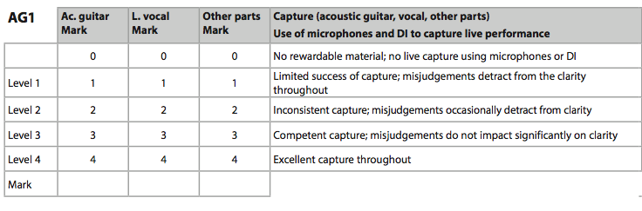

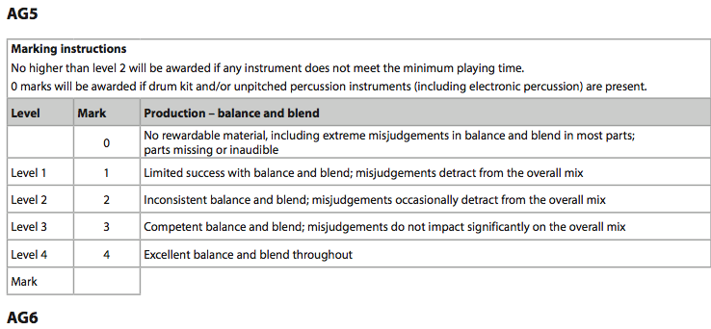

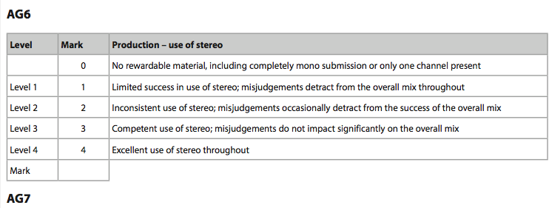

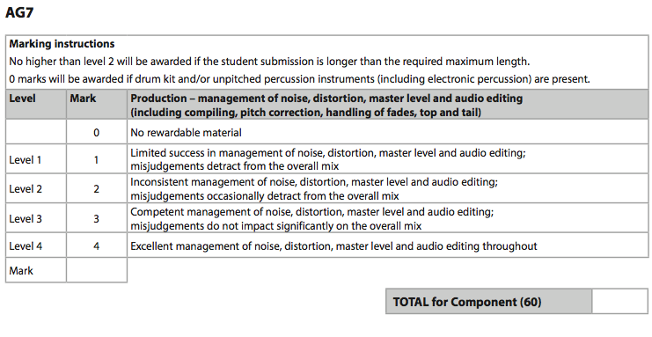

**Total for task (20)**

**Task 2: Electric guitar and Bass Deadline: 14th December 2017**

Title of piece recorded, with details of composer/original band or artist:

................................................................................................................................................................................................................................................

Complete the following information about the equipment that you used when

working on your recording:

1. Microphones

................................................................................................................................................................................................................................................

...............................................................................................................................................................................................................................................

................................................................................................................................................................................................................................................

1. Mixing desk and/or audio interface

................................................................................................................................................................................................................................................

1. Multi-track hard disk recorder or software

...............................................................................................................................................................................................................................................

1. Effects and dynamic processors (hardware or software)

................................................................................................................................................................................................................................................

................................................................................................................................................................................................................................................

................................................................................................................................................................................................................................................

1. Monitoring equipment

................................................................................................................................................................................................................................................

1. Other equipment (e.g. DI box, pre amps)

................................................................................................................................................................................................................................................

................................................................................................................................................................................................................................................

Using the space below, and continuing on a separate page if necessary, draw and label diagrams to show how you arranged the microphones you used. You may attach photographs if you prefer

Complete the table below to show the instruments you have recorded and the microphone type, DI, or other capture method used.

| **Compulsory audio instruments** | Capture method |
| --- | --- |
| Acoustic Guitar |  |
| Lead Vocal |  |
| Bass or Double Bass |  |
| **Additional audio instruments** | **Capture method** |
| Acoustic  melody instrument |  |
| Backing vocal |  |
| Electric guitar |  |

Complete the track sheet below showing the settings used for mixdown

|  |  |  |  |  |  |  |
| --- | --- | --- | --- | --- | --- | --- |
| **Track 6** |  |  |  |  |  |  |
| **Track 5** |  |  |  |  |  |  |
| **Track 4** |  |  |  |  |  |  |
| **Track 3** |  |  |  |  |  |  |
| **Track 2** |  |  |  |  |  |  |
| **Track 1** |  |  |  |  |  |  |
|  | Instrument/ Voice | EQ | FX | Dynamic Processing | Panning(L-R) | Level |

|  |  |  |  |  |  |  |
| --- | --- | --- | --- | --- | --- | --- |
| **Output** |  |  |  |  |  |  |
| **Bus 3** |  |  |  |  |  |  |
| **Bus 2** |  |  |  |  |  |  |
| **Bus 1** |  |  |  |  |  |  |
| **Track 8** |  |  |  |  |  |  |
| **Track 7** |  |  |  |  |  |  |
|  | Instrument/ Voice | EQ | FX | Dynamic Processing | Panning(L-R) | Level |

|  |  |
| --- | --- |
| **Task 2** | Recording Drums and Bass |

****

**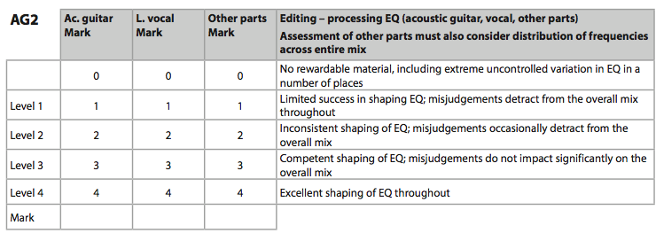**

**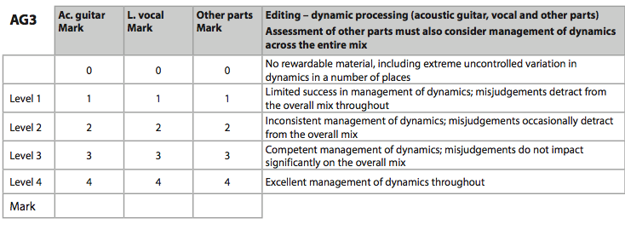**

**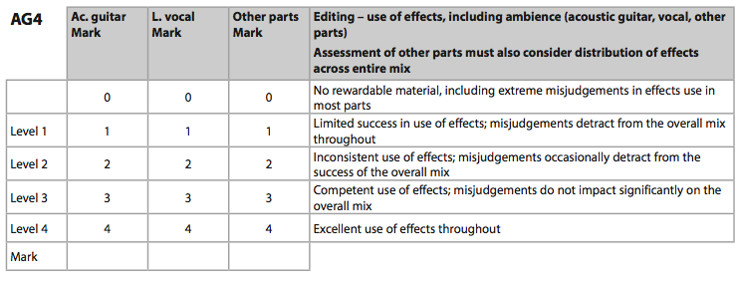**

****

****

****

**COURSE WORK *Tracking Deadline: 15/01/2018 Mix Deadline: 09/02/2017***

Complete the table below to show the instruments you have recorded and the microphone type, DI, or other capture method used.

| **Compulsory audio instruments** | Capture method |
| --- | --- |
| Acoustic Guitar |  |
| Lead Vocal |  |
| Bass or Double Bass |  |
| **Additional audio instruments** | **Capture method** |
| Acoustic  melody instrument |  |
| Backing vocal |  |
| Electric guitar |  |
| **Other instruments** | **Capture method** |
|  |  |
|  |  |
|  |  |

Complete the arrange window to show how you have met the total playing time requirements for each instrument you have recorded.

2.30

2.00

1.30

1.00

0.30

0.00

|  |  |  |  |  |  |
| --- | --- | --- | --- | --- | --- |
| **Ac. Guitar** |  |  |  |  |  |
| **Lead Vocal** |  |  |  |  |  |
| **Bass** |  |  |  |  |  |
| **Ac. Melody** |  |  |  |  |  |
| **B.Vocal** |  |  |  |  |  |
| **Keyboard** |  |  |  |  |  |
| **El.Guitar** |  |  |  |  |  |
|  |  |  |  |  |  |
|  |  |  |  |  |  |
|  |  |  |  |  |  |

Using the space below, and continuing on a separate page if necessary, draw and label diagrams to show how you arranged the microphones you used. You may attach photographs if you prefer

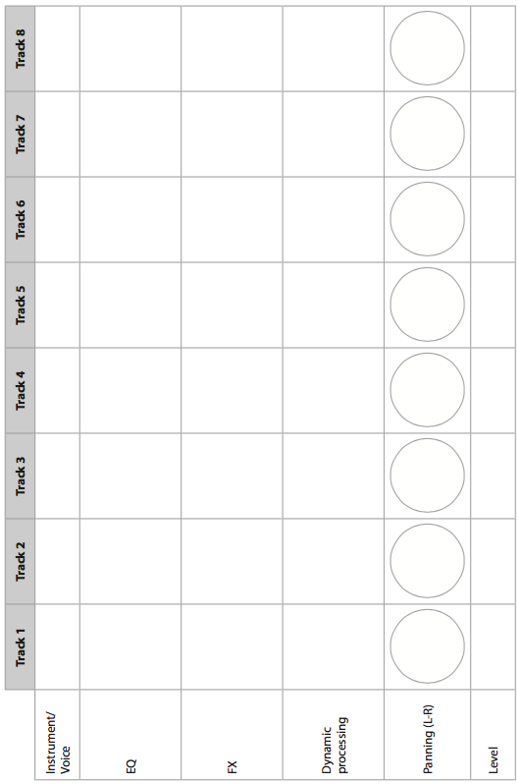Complete the track sheet below to illustrate your mix and processing decisions.

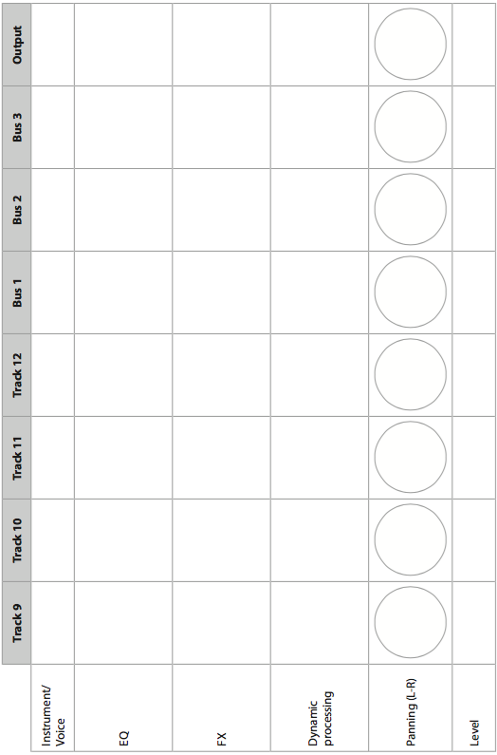

|  |
| --- |
| Course Work |

****

****

****

****

****

****

****

LOG SHEET: RESEARCH AND PREPARATION

|  |  |  |  |  |
| --- | --- | --- | --- | --- |
| DATE | TIME IN | TIME OUT | DESCRIPTION | TOTAL TIME |
|  |  |  |  |  |
|  |  |  |  |  |
|  |  |  |  |  |
|  |  |  |  |  |
|  |  |  |  |  |
|  |  |  |  |  |
|  |  |  |  |  |
|  |  |  |  |  |
|  |  |  |  |  |
|  |  |  |  |  |
|  |  |  |  |  |
|  |  |  |  |  |
|  |  |  |  |  |
|  |  |  |  |  |
|  |  |  |  |  |
|  |  |  |  |  |
|  |  |  |  |  |
|  |  |  |  |  |
|  |  |  |  |  |
|  |  |  |  |  |
|  |  |  |  |  |
|  |  |  |  |  |
|  |  |  |  |  |
|  |  |  |  |  |
|  |  |  |  |  |
|  |  |  |  |  |
|  |  |  |  |  |
|  |  |  |  |  |
|  |  |  |  |  |
|  |  |  |  |  |
|  |  |  |  |  |
|  |  |  |  |  |
|  |  |  |  |  |
|  |  |  |  |  |
|  |  |  |  |  |
|  |  |  |  |  |
|  |  |  |  |  |
|  |  |  |  |  |
|  |  |  |  |  |
|  |  |  |  |  |
|  |  |  |  |  |
|  |  |  |  |  |
|  |  |  |  |  |
|  |  |  |  |  |
|  |  |  |  |  |

LOG SHEET: COURSE WORK( MAX. 20hrs)

|  |  |  |  |  |
| --- | --- | --- | --- | --- |
| DATE | TIME IN | TIME OUT | DESCRIPTION | TOTAL TIME |
|  |  |  |  |  |
|  |  |  |  |  |
|  |  |  |  |  |
|  |  |  |  |  |
|  |  |  |  |  |
|  |  |  |  |  |
|  |  |  |  |  |
|  |  |  |  |  |
|  |  |  |  |  |
|  |  |  |  |  |
|  |  |  |  |  |
|  |  |  |  |  |
|  |  |  |  |  |
|  |  |  |  |  |
|  |  |  |  |  |
|  |  |  |  |  |
|  |  |  |  |  |
|  |  |  |  |  |
|  |  |  |  |  |
|  |  |  |  |  |
|  |  |  |  |  |
|  |  |  |  |  |
|  |  |  |  |  |
|  |  |  |  |  |
|  |  |  |  |  |
|  |  |  |  |  |
|  |  |  |  |  |
|  |  |  |  |  |
|  |  |  |  |  |
|  |  |  |  |  |
|  |  |  |  |  |
|  |  |  |  |  |
|  |  |  |  |  |
|  |  |  |  |  |
|  |  |  |  |  |
|  |  |  |  |  |
|  |  |  |  |  |
|  |  |  |  |  |
|  |  |  |  |  |
|  |  |  |  |  |
|  |  |  |  |  |
|  |  |  |  |  |
|  |  |  |  |  |
|  |  |  |  |  |
|  |  |  |  |  |

**JARGON BUSTING GLOSSARY**

**AC:** Alternating Current.   
**A/D [A-D] CONVERTER:** Circuit for converting analogue waveforms into a series of equally spaced numerical values represented by binary numbers. The more 'bits' a converter has, the greater the resolution of the sampling process.   
**ACTIVE:** Describes a circuit containing transistors, ICs, tubes and other devices,that require power to operate and are capable of amplification.  
**ADAT:** The term 'ADAT' is best known today as a widely used eight-channel optical digital audio interface — and a contraction of 'ADAT **Lightpipe**'. It was developed by Alesis as a bespoke interface for the company's digital eight-track tape machines in the early 1990s — hence the name ADAT (Alesis Digital Audio Tape). Those machines are long obsolete, but the interface has survived.  
The interface transfers up to eight channels of 24-bit digital audio at base sample rates (44.1 or 48kHz) via a single fibre-optic cable. This 'lightpipe' is physically identical to that used for the TOSlink optical S/PDIF stereo interface found on many digital consumer hi-fi devices, but while the fibre itself can be used interchangeably for either format, the S/PDIF and ADAT interfaces are not compatible in any other way.  
The interface incorporates embedded word- and bit-clocks, and padding zeros are introduced automatically if digital wordlengths lower than 24 bits are being transmitted.  
Although not supported by all ADAT Lightpipe interfaces, an increasing number of devices do support the **S/MUX** (Sample Multiplexing) protocol (licensed from Sonorus) which allows higher sample rates to be employed at the cost of fewer channels of audio. The S/MUX2 format operates at double sample rates (88.2 and 96kHz) but carries only four channels, while S/MUX4 operates at quad rates (176.4 and 192kHz) but with only two channels.   
S/MUX uses a clever technique that divides the high sample rate data across the nominal channels in such a way that accidental level changes or dithering applied identically to each channel in the data stream do not destroy the wanted demultiplexed signal.  
**ADDITIVE SYNTHESIS:** A system for generating waveforms or sounds by combining basic waveforms or sampled sounds prior to further processing with filters and envelope shapers.   
**ADSR:** Envelope generator with Attack, Sustain, Decay and Release parameters. This is a simple type of envelope generator and was first used on early analogue synthesizers. This form of envelope generator continues to be popular on modern instruments. See [Decay](http://www.soundonsound.com/information/Glossary.php#Decay) for more details.   
**ACTIVE SENSING:** A system used to verify that a MIDI connection is working, that involves the sending device sending frequent short messages to the receiving device to reassure it that all is well. If these active sensing messages stop for any reason,the receiving device will recognise a fault condition and switch off all notes. Not all MIDI devices support active sensing.   
**AES:** Acronym for Audio Engineering Society, one of the industry's professional audio associations. [www.aes.org](http://www.aes.org)  
**AES 3:** A two-channel interface used to pass digital audio between equipment. Originally developed by the Audio Engineering Society and the European Broadcasting Union, it is often known as the AES-EBU interface. The AES standards documentation list it as 'AES 3', and it is normally connected using 3-pin XLRs. It carries two digital audio channels plus embedded clocking data on a balanced cable of a nominal 110 Ohm impedance, with up to 24 bits per sample and sample rates up to 384kHz. The datastream is structured identically to S/PDIF, although some of the Channel status codes are used differently. An extension to the AES 3 standard is AES 3-id, which describes an unbalanced version of the interface using BNC connectors and 75 Ohm video cables.   
**AFL:** After Fade listen; a system used within mixing consoles to allow specific signals to be monitored at the level set by their fader of level control knob. Aux sends are generally monitored AFL rather than PFL (see [PFL](http://www.soundonsound.com/information/Glossary.php#PFL)).   
**AFTERTOUCH:** A means of generating a control signal based on how much pressure is applied to the keys of a MIDI keyboard. Most instruments that support this do not have independent pressure sensing for all keys, but rather detect the overall pressure by means of a sensing strip running beneath the keys. Aftertouch may be used to control such functions as vibrato depth, filter brightness, loudness and so on.   
**ALGORITHM:** A computer program designed to perform a specific task. In the context of effects units, algorithms usually describe a software building block designed to create a specific effect or combination of effects.   
**ALIASING:** When an analogue signal is sampled for conversion into a digital data stream, the sampling frequency must be at least twice that of the highest frequency component of the input signal. If this rule is disobeyed, the sampling process becomes ambiguous as there are insufficient points to define each cycle of the waveform, resulting in enharmonic frequencies being added to the audible signal.   
**AMBIENCE:** The result of sound reflections in a confined space being added to the original sound. Ambience may also be created electronically by some digital reverb units. The main difference between ambience and reverberation is that ambience doesn't have the characteristic long delay time of reverberation - the reflections mainly give the sound a sense of space.   
**AMP:** (Ampere) Unit of electrical current.   
**AMPLIFIER:** Device that increases the level of an electrical signal.   
**AMPLITUDE:** Another word for level. Can refer to sound levels or electrical signal levels.   
**ANALOGUE:** Circuitry that uses a continually changing voltage or current to represent a signal. The origin of the term is that the electrical signal can be thought of as being 'analogous' to the original signal.   
**ANALOGUE SYNTHESIS:** A system for synthesizing sounds by means of analogue circuitry, usually by filtering simple repeating waveforms. ATTENUATE: To make lower in level.   
**ANTI-ALIASING FILTER:** Filter used to limit the frequency range of an analogue signal prior to A/D conversion so that the maximum frequency does not exceed half the sampling rate.   
**APPLICATION:** Alternative term for computer program.   
**ARPEGGIATOR:** Device (or software), that allows a MIDI instrument to sequence around any notes currently being played. Most arpeggiators also allows the sound to be sequenced over several octaves, so that holding down a simple chord can result in an impressive repeating sequence of notes.   
**ASCII:** American Standard Code for Information Interchange. A standard code for representing computer keyboard characters by binary data.   
**ATTACK:** The time taken for a sound to achieve maximum amplitude. Drums have a fast attack, whereas bowed strings have a slow attack. In compressors and gates, the attack time equates to how quickly the processor can change its gain.   
**AUDIO FREQUENCY:** Signals in the human audio range:nominally 20Hz to 20kHz.   
**AUTOLOCATOR:** Feature of a tape machine or other recording device that enables specific locations to be stored, then at some later time, these locations within the recording may be recalled. For example, you may store the start of a verse as a locate point so that you can get the tape machine to wind back the start of the verse after you've recorded an overdub.   
**AUX:** Control on a mixing console designed to route a proportion of the channel signal to the effects or cue mix outputs (Aux Send).   
**AUX SEND:** Physical output from a mixer Aux Send buss.   
**AUX RETURN:** Mixer inputs used to add effects to the mix.   
**AZIMUTH:** Alignment coordinate of a tape head which references the head gap to the true vertical relative to the tape path.

**BACKUP:** A safety copy of software or other digital data.   
**BAND PASS FILTER (BPF):** Filter that removes or attenuates frequencies above and below the frequency at which it is set. Frequencies within the band are emphasised. Bandpass filters are often used in synthesizers as tone shaping elements.   
**BALANCE:** This word has several meanings in recording. It may refer to the relative levels of the left and right channels of a stereo recording, or it may be used to describe the relative levels of the various instruments and voices within a mix.   
**BALANCED WIRING:** Wiring system which uses two out-of-phase conductors and a common screen to reduce the effect of interference. For balancing to be effective, both the sending and receiving device must have balanced output and input stages respectively.   
**BANDPASS:** A filter that passes frequencies only between specific upper and lower limits.   
**BANDWIDTH:** A means of specifying the range of frequencies passed by an electronic circuit such as an amplifier, mixer or filter. The frequency range is usually measured at the points where the level drops by 3dB relative to the maximum.   
**BETA VERSION:** Software which is not fully tested and may include bugs.   
**BIAS:** High frequency signal used in analogue recording to improve the accuracy of the recorded signal and to drive the erase head. Bias is generated by a bias oscillator.   
**BINARY:** Counting system based on only two states - 1s and 0s.   
**BIOS:** Part of a computer operating system held on ROM rather than on disk. This handles basic routines such as accessing the disk drive.   
**BIT:** Binary digit, which may either be 1 or 0.   
**BOOST/CUT CONTROL:** A single control which allows the range of frequencies passing through a filter to be either amplified or attenuated. The centre position is usually the 'flat' or 'no effect' position.   
**BOUNCING:** The process of mixing two or more recorded tracks together and re-recording these onto another track.   
**BPM:** Beats Per Minute.   
**BREATH CONTROLLER:** Device that converts breath pressure into MIDI controller data.   
**BUFFER:** Circuit designed to isolate the output of a source device from loading effects due to the input impedance of the destination device.   
**BUFFER MEMORY:** Temporary RAM memory used in some computer operations, sometimes to prevent a break in the data stream when the computer is interrupted to perform another task.   
**BUG:** Slang term for software fault or equipment design problem.   
**BUSS:** A common electrical signal path along which signals may travel. In a mixer, there are several busses carrying the stereo mix, the groups, the PFL signal, the aux sends and so on. Power supplies are also fed along busses.   
**BYTE:** A piece of digital data comprising eight bits.

**CARDIOID:** Meaning heart shaped, describes the polar response of a unidirectional microphone.   
**CD-R:** A recordable type of Compact Disc that can only be recorded once - it cannot be erased and reused.   
**CD-R BURNER:** A device capable of recording data onto blank CD-R discs.   
**CV:** Control Voltage used to control the pitch of an oscillator or filter frequency in an analogue synthesizer. Most analogue synthesizers follow a one volt per octave convention, though there are exceptions. To use a pre-MIDI analogue synthesizer under MIDI control, a MIDI to CV converter is required.   
**CAPACITANCE:** Property of an electrical component able to store electrostatic charge.   
**CAPACITOR:** Electrical component exhibiting capacitance. Capacitor microphones are often abbreviated to capacitors. **CAPACITOR MICROPHONE:** Microphone that operates on the principle of measuring the change in electrical charge across a capacitor where one of the electrodes is a thin conductive membrane that flexes in response to sound pressure.   
**CHANNEL:** A single strip of controls in a mixing console relating to either a single input or a pair of main/monitor inputs.   
**CHANNEL:** In the context of MIDI, Channel refers to one of 16 possible data channel over which MIDI data may be sent. The organisation of data by channels means that up to 16 different MIDI instruments or parts may be addressed using a single cable.   
**CHANNEL:** In the context of mixing consoles, a channel is a single strip of controls relating to one input.   
**CHASE:** Term describing the process whereby a slave device attempts to synchronise itself with a master device. In the context of a MIDI sequence, Chase may also involve chasing events - looking back to earlier positions in the song to see if there are any program change or other events that need to be acted upon.   
**CHIP:** Integrated circuit.   
**CHORD:** Three or more different musical notes played at the same time.   
**CHORUS:** Effect created by doubling a signal and adding delay and pitch modulation.   
**CHROMATIC:** A scale of pitches rising in semitone steps.   
**CLICK TRACK:** Metronome pulse which assists musicians in playing in time.   
**CLIPPING:** Severe form of distortion which occurs when a signal attempts to exceed the maximum level which a piece of equipment can handle.   
**CLONE:** Exact duplicate. Often refers to digital copies of digital tapes.   
**COMMON MODE REJECTION:** A measure of how well a balanced circuit rejects a signal that is common to both inputs.   
**COMPANDER:** Encode decode device that compresses a signal while encoding it, then expands it when decoding it.   
**COMPRESSOR:** Device designed to reduce the dynamic range of audio signals by reducing the level of high signals or by increasing the level of low signals.   
**COMPUTER:** A device for the storing and processing of digital data.   
**CONDUCTOR:** Material that provides a low resistance path for electrical current.   
**CONSOLE:** Alternative term for mixer.   
**CONTACT ENHANCER:** Compound designed to increase the electrical conductivity of electrical contacts such as plugs, sockets and edge connectors.   
**CONTINUOUS CONTROLLER:** Type of MIDI message used to translate continuous change, such as from a pedal, wheel or breath control device.   
**COPY PROTECTION:** Method used by software manufacturers to prevent unauthorised copying.   
**CRASH:** Slang term relating to malfunction of computer program.   
**CUT AND PASTE EDITING:** The ability to copy or move sections of a recording to new locations.   
**CUTOFF FREQUENCY:** The frequency above or below which attenuation begins in a filter circuit.   
**CYCLE:** One complete vibration of a sound source or its electrical equivalent. One cycle per second is expressed as 1Hertz (Hz).   
**CV:** Control voltage used in analogue synthesizers, to control oscillator or filter frequency.

**DAISY CHAIN:** Term used to describe serial electrical connection between devices or modules.   
**DAMPING:** In the context of reverberation, damping refers to the rate at which the reverberant energy is absorbed by the various surfaces in the environment.   
**DAT:** Digital Audio Tape. The commonly used DAT machines are more correctly known as R-DAT because they use a rotating head similar to a video recorder. Digital recorders using fixed or stationary heads (such as DCC) are known as S-DAT machines.   
**DATA:** Information stored and used by a computer.   
**DATA COMPRESSION:** A system used to reduce the amount of data needed to represent an audio signal, usually by discarding audio information that is being masked by more prominent sounds.   
**DAW (Digital Audio Workstation):** A term first used in the 1980s to describe early "tapeless" recording/sampling machines like the Fairlight and Synclavier. Nowadays, DAW is more commonly used to describe Audio+MIDI "virtual studio" software programs such as Cubase, Logic Pro, Digital Performer, Sonar and such-like.   
**dB:** deciBel. Unit used to express the relative levels of two electrical voltages, powers or sounds.   
**dBm:** Variation on dB referenced to 0dB = 1mW into 600 Ohms.   
**dBv:** Variation on dB referenced to 0dB = 0.775 volts.   
**dBV:** Variation on dB referenced to 0dB = 1 volt.   
**dB/Octave:** A means of measuring the slope of a filter. The more dBs per octave, the sharper the filter slope.   
**DATA COMPRESSION:** A system for reducing the amount of data stored by a digital system. Most audio data compression systems are so-called lossy systems as some of the original signal is discarded based on psychoacoustic principles designed to ensure that only components which cannot be heard are lost.   
**DC:** Direct Current.   
**DCC:** Stationary head digital recorder format developed by Philips. Uses a data compression system to reduce the amount of data that needs to be stored.   
**dbx:** A commercial encode/decode tape noise reduction system that compresses the signal during recording and expands it by an identical amount on playback.   
**DCO:** Digitally Controlled Oscillator.   
**DDL:** Digital Delay Line.   
**DE-ESSER:** Device for reducing the effect of sibilance in vocal signals.   
**DEOXIDISING COMPOUND:** Substance formulated to remove oxides from electrical contacts.   
**DECAY:** The progressive reduction in amplitude of a sound or electrical signal over time. In the context of an ADSR envelope shaper, the Decay phase starts as soon as the Attack phase has reached its maximum level. In the Decay phase, the signal level drops until it reaches the Sustain level set by the user. The signal then remains at this level until the key is released, at which point the Release phase is entered.   
**DEFRAGMENT:** The process of rearranging the files on a hard disk so that all the files are as contiguous as possible, and that the remaining free space is also contiguous.   
**DETENT:** Physical click stop in the centre of a control such as a pan or EQ cut/boost knob.   
**DI:** Short for Direct Inject, where a signal is plugged directly into an audio chain without the aid of a microphone.   
**DI BOX:** Device for matching the signal level impedance of a source to a tape machine or mixer input.   
**DIGITAL:** Electronic system which represents data and signals in the form of codes comprising 1s and 0s.   
**DIGITAL DELAY:** Digital processor for generating delay and echo effects.   
**DIGITAL REVERB:** Digital processor for simulating reverberation.   
**DIN CONNECTOR:** Consumer multipin signal connection format, also used for MIDI cabling. Various pin configurations are available.   
**DIRECT COUPLING:** A means of connecting two electrical circuits so that both AC and DC signals may be passed between them.   
**DITHER:** A system of adding low level noise to a digitized audio signal in such a way as to extend to the low level resolution at the expense of a slight deterioration in noise performance.   
**DISC:** Used to describe vinyl discs, CDs and MiniDiscs.   
**DISK:** Abbreviation of Diskette, but now used to describe computer floppy, hard and removable disks.   
**DMA:** Direct Memory Access:Part of a computer operating system that allows peripheral devices to communicate directly with the computer memory without going via the central processor or CPU.   
**DOLBY:** An encode/decode tape noise reduction system that amplifies low level, high frequency signals during recording, then reverses this process during playback. There are several different Dolby systems in use: types B, C and S for domestic and semi-professional machines, and types A and SR for professional machines. Recordings made using one of these systems must also be replayed via the same system.   
**DOS:** Disk Operating System. Part of the operating system of PC and PC compatible computers   
**DSP:** Digital Signal Processor. A powerful microchip used to process digital signals.   
**DRIVER:** Piece of software that handles communications between the main program and a hardware peripheral, such as a soundcard, printer or scanner.   
**DRUM PAD:** Synthetic playing surface which produces electronic trigger signals in response to being hit with drum sticks.   
**DRY:** A signal that has had no effects added.   
**DUBBING:** Adding further material to an existing recording. Also known as overdubbing.   
**DUCKING:** A system for controlling the level of one audio signal with another. For example, background music can be made to 'duck' whenever there's a voice over.   
**DUMP:** To transfer digital data from one device to another. A Sysex dump is a means of transmitting information about a particular instrument or module over MIDI, and may be used to store sound patches, parameter settings and so on.   
**DYNAMIC MICROPHONE:** A type of microphone that works on the electric generator principle, where a diaphragm moves a coil of wire within a magnetic field.   
**DYNAMIC RANGE:** The range in dB between the highest signal that can be handled by a piece of equipment and the level at which small signals disappear into the noise floor.   
**DYNAMICS:** Way of describing the relative levels within a piece of music.

**EARLY REFLECTIONS:** The first sound reflections from walls, floors and ceilings following a sound created in an acoustically reflective environment.   
**EFFECT:** Device for treating an audio signal in order to change it in some creative way. Effects often involve the use of delay circuits, and include such treatments as reverb and echo.   
**EFFECTS LOOP:** Connection system that allows an external signal processor to be connected into the audio chain.   
**EFFECTS RETURN:** Additional mixer input designed to accommodate the output from an effects unit.   
**ELECTRET MICROPHONE:** Type of capacitor microphone utilising a permanently charged capsule.   
**ENCODE/DECODE:** A system that requires a signal to be processed prior to recording, then that process reversed during playback.   
**ENHANCER:** A device designed to brighten audio material using techniques such as dynamic equalisation, phase shifting and harmonic generation.   
**ENVELOPE:** The way in which the level of a sound or signal varies over time.   
**ENVELOPE GENERATOR:** A circuit capable of generating a control signal which represents the envelope of the sound you want to recreate. This may then be used to control the level of an oscillator or other sound source, though envelopes may also be used to control filter or modulation settings. The most common example is the ADSR generator.   
**EQUALISER:** Device for selectively cutting or boosting selected parts of the audio spectrum.   
**ERASE:** To remove recorded material from an analogue tape, or to remove digital data from any form of storage media.   
**EVENT:** In MIDI terms, an event is a single unit of MIDI data, such as a note being turned on or off, a piece of controller information, a program change, and so on.   
**EXCITER:** An enhancer that works by synthesizing new high frequency harmonics.   
**EXPANDER:** A devise designed to decrease the level of low level signals and increase the level of high level signals, thus increasing the dynamic range of the signal.   
**EXPANDER MODULE:** Synthesizer with no keyboard, often rack mountable or in some other compact format.

**FADER:** Sliding potentiometer control used in mixers and other processors.   
**FERRIC:** Type of magnetic tape coating that uses iron oxide.   
**FET:** Field Effect Transistor.   
**FIGURE-OF-EIGHT:** Describes the polar response of a microphone that is equally sensitive both front and rear, yet rejects sounds coming from the sides.   
**FILE:** A meaningful list of data stored in digital form. A Standard MIDI File is a specific type of file designed to allow sequence information to be interchanged between different types of sequencer.   
**FILTER:** An electronic circuit designed to emphasize or attenuate a specific range of frequencies.   
**FLANGING:** Modulated delay effect using feedback to create a dramatic, sweeping sound.   
**FLOPPY DISK:** Computer disk that uses a flexible magnetic medium encased in a protective plastic sleeve. The maximum capacity of a standard High Density disk is 1.44Mbytes. Earlier Double Density disks hold only around half the amount of data.   
**FLUTTER ECHO:** Resonant echo that occurs when sound reflects back and forth between two parallel, reflective surfaces.   
**FOLDBACK:** System for feeding one or more separate mixes to the performers for use while recording and overdubbing. Also known as a Cue mix.   
**FORMANT:** Frequency component or resonance of an instrument or voice sound that doesn't change with the pitch of the note being played or sung. For example, the body resonance of an acoustic guitar remains constant, regardless of the note being played.   
**FORMAT:** Procedure required to ready a computer disk for use. Formatting organises the disk's surface into a series of electronic pigeon holes into which data can be stored. Different computers often use different formatting systems.   
**FRAGMENTATION:** The process by which the available space on a disk drive gets split up into small sections due to the storing and erasing of files. See [Defragmentation](http://www.soundonsound.com/information/Glossary.php#Defragment).   
**FREQUENCY:** Indication of how many cycles of a repetitive waveform occur in 1 second. A waveform which has a repetition cycle of once per second has a frequency of 1Hz (pronounced Hertz).   
**FREQUENCY RESPONSE:** A measurement of the frequency range that can be handled by a specific piece of electrical equipment or loudspeaker.   
**FSK:** Frequency Shift Keying. A method of recording a sync clock signal onto tape by representing it as two alternating tones.   
**FUNDAMENTAL:** Any sound comprises a fundamental or basic frequency plus harmonics and partials at a higher frequency.   
**FX:** Effects.

**GAIN:** The amount by which a circuit amplifies a signal.   
**GATE:** An electrical signal that is generated whenever a key is depressed on an electronic keyboard. This is used to trigger envelope generators and other events that need to be synchronised to key action.   
**GATE:** An electronic device designed to mute low level signals so as to improve noise performance during pauses in the wanted material.   
**GENERAL MIDI:** An addition to the basic MIDI spec to assure a minimum level of compatibility when playing back GM format song files. The specification covers type and program number of sounds, minimum levels of polyphony and multitimbrality, response to controller information and so on.   
**GLITCH:** Describes an unwanted short term corruption of a signal, or the unexplained, short term malfunction of a piece of equipment. For example, an inexplicable click on a DAT tape would be termed a glitch.   
**GM RESET:** A universal sysex command which activates the General MIDI mode on a GM instrument. The same command also sets all controllers to their default values and switches off any notes still playing by means of an All Notes Off message.   
**GRAPHIC EQUALISER:** An equaliser whereby several narrow segments of the audio spectrum are controlled by individual cur/boost faders. The name comes about because the fader positions provide a graphic representation of the EQ curve.   
**GROUND:** Electrical earth or 0 Volts. In mains wiring, the ground cable is physically connected to the ground via a long conductive metal spike.   
**GROUND LOOP:** Wiring problem where multiple ground connections are causing audible mains hum to be picked up. Also known as earth loops.   
**GROUP:** A collection of signals within a mixer that are mixed, then routed through a separate fader to provide overall control. In a multitrack mixer, several groups are provided to feed the various recorder track inputs.   
**GROUND LOOP:** A condition likely to lead to the circulation of currents in the ground wiring of an audio system. When these currents are induced by the alternating mains supply, hum results.   
**GS:** Roland's own extension to the General MIDI protocol.

**HARD DISK:** High capacity computer storage device based on a rotating rigid disk with a magnetic coating onto which data may be recorded.   
**HARMONIC:** High frequency component of a complex waveform.   
**HARMONIC DISTORTION:** The addition of harmonics that were not present in the original signal.   
**HEAD:** The part of a tape machine or disk drive that reads and/or writes data to and from the storage media.   
**HEADROOM:** The safety margin in dBs between the highest peak signal being passed by a piece of equipment and the absolute maximum level the equipment can handle.   
**HIGH PASS FILTER (HPF):** A filter which attenuates frequencies below its cutoff frequency.   
**HISS:** Noise caused by random electrical fluctuations.   
**HUM:** Signal contamination caused by the addition of low frequencies, usually related to the mains power frequency.   
**Hz:** Short for Hertz, the unit of frequency.

**IC:** Integrated Circuit.   
**IMPEDANCE:** Can be visualised as the 'AC resistance' of a circuit which contains both resistive and reactive components.   
**INDUCTOR:** Reactive component that presents an increasing impedance with frequency.   
**INITIALISE:** To automatically restore a piece of equipment to its factory default settings.   
**INSERT POINT:** A connector that allows an external processor to be patched into a signal path so that the signal now flows through the external processor.   
**INSULATOR:** Material that does not conduct electricity.   
**INTERFACE:** A device that acts as an intermediary to two or more other pieces of equipment. For example, a MIDI interface enables a computer to communicate with MIDI instruments and keyboards.   
**INTERMITTENT:** Usually describes a fault that only appears occasionally.   
**INTERMODULATION DISTORTION:** A form of distortion that introduces frequencies not present in the original signal. These are invariably based on the sum and difference products of the original frequencies.   
**I/O:** The part of a system that handles inputs and outputs, usually in the digital domain.   
**IPS:** Inches Per Second. Used to describe tape speed.   
**IRQ:** Interrupt Request. Part of the operating system of a computer that allows a connected device to request attention from the processor in order to transfer data to it or from it.   
**ISOPROPYL ALCOHOL:** Type of alcohol commonly used for cleaning and de-greasing tape machine heads and guides.

**JACK:** Commonly used audio connector. May be mono or stereo.   
**JARGON:** Specialised words associated with a specialist subject.

**k:** Abbreviation for 1000 (kilo). Used as a prefix to other values to indicate magnitude.   
**kHz:** 1000Hz   
**kOhm:** 1000 ohms

**LED:** Light Emitting Diode. A form of solid state lamp.   
**LCD:** Liquid Crystal Display.   
**LFO:** Low Frequency Oscillator, often found in synths or effects using modulation.   
**LSB:** Least Significant Byte. If a piece of data has to be conveyed as two bytes, one byte represents high value numbers and the other low value numbers, much in the same way as tens and units function in the decimal system. The high value, or most significant part of the message is called the Most Significant Byte or MSB.   
**LIGHTPIPE:** See [ADAT Lightpipe](http://www.soundonsound.com/information/Glossary.php#Lightpipe).  
**LIMITER:** Device that controls the gain of a signal so as to prevent it from ever exceeding a preset level. A limiter is essentially a fast acting compressor with an infinite compression ratio.   
**LINEAR:** A device where the output is a direct multiple of the input.   
**LINE LEVEL:** A nominal signal level which is around -10dBV for semi-pro equipment and +4dBu for professional equipment.   
**LOAD:** Electrical circuit that draws power from another circuit or power supply. Also describes reading data into a computer.   
**LOCAL ON/OFF:** A function to allow the keyboard and sound generating section of a keyboard synthesizer to be used independently of each other.   
**LOGIC:** Type of electronic circuitry used for processing binary signals comprising two discrete voltage levels.   
**LOOP:** Circuit where the output is connected back to the input.   
**LOW FREQUENCY OSCILLATOR (LFO):** An oscillator used as a modulation source, usually below 20Hz. The most common LFO waveshape is the sine wave, though there is often a choice of sine, square, triangular and sawtooth waveforms.   
**LOW PASS FILTER (LPF):** A filter which attenuates frequencies above its cutoff frequency.

**mA:** milliamp or one thousandth of an amp. See [Amp](http://www.soundonsound.com/information/Glossary.php#Ampere).  
**MB:** Megabyte. 1,000,000 (one million) bytes of data**.  
MEG:** Abbreviation for 1,000,000.   
**MDM:** Modular Digital Multitrack; a digital recorder that can be used in multiples to provide a greater number of synchronized tracks than a single machine.   
**MACHINE HEAD:** Another way of describing the tuning machines of a guitar.   
**MEMORY:** Computer's RAM memory used to store programs and data. This data is lost when the computer is switched off and so must be stored to disk or other suitable media.   
**MENU:** List of choices presented by a computer program or a device with a display window.   
**MIC LEVEL:** The low level signal generated by a microphone. This must be amplified many times to increase it to line level.   
**MICROPROCESSOR:** Specialised microchip at the heart of a computer. It is here that instructions are read and acted upon.   
**MIDI:** Musical Instrument Digital Interface.   
**MIDI ANALYSER:** Device that gives a visual readout of MIDI activity when connected between two pieces of MIDI equipment.   
**MTC:** MIDI Time Code; a MIDI sync implementation based on SMPTE time code.   
**MIDI BANK CHANGE:** A type of controller message used to select alternate banks of MIDI Programs where access to more than 128 programs is required.   
**MIDI CONTROLLER:** A term used to describe the physical interface by means of which the musician plays the MIDI synthesizer or other sound generator. Examples of controllers are keyboards, drum pads, wind synths and so on.   
**MIDI CONTROL CHANGE:** Also knows as MIDI Controllers or Controller Data, these messages convey positional information relating to performance controls such as wheels, pedals, switches and other devices. This information can be used to control functions such as vibrato depth, brightness, portamento, effects levels, and many other parameters.   
**(STANDARD) MIDI FILE:** A standard file format for storing song data recorded on a MIDI sequencer in such as way as to allow it to be read by other makes or model of MIDI sequencer.   
**MIDI IMPLEMENTATION CHART:** A chart, usually found in MIDI product manuals, which provides information as to which MIDI features are supported. Supported features are marked with a 0 while unsupported feature are marked with a X. Additional information may be provided, such as the exact form of the Bank Change message.   
**MIDI MERGE:** A device or sequencer function that enables two or more streams of MIDI data to be combined.   
**MIDI MODULE:** Sound generating device with no integral keyboard.   
**MULTITIMBRAL MODULE:** MIDI Sound Source capable of producing several different sounds at the same time and controlled on different MIDI channels.   
**MIDI MODE:** MIDI information can be interpreted by the receiving MIDI instrument in a number of ways, the most common being polyphonically on a single MIDI channel (Poly-Omni Off mode). Omni mode enables a MIDI Instrument to play all incoming data regardless of channel.   
**MIDI NOTE NUMBER:** Every key on a MIDI keyboard has its own note number ranging from 0 to 127, where 60 represents middle C. Some systems use C3 as middle C while others use C4.   
**MIDI NOTE ON:** MIDI message sent when note is played (key pressed).   
**MIDI NOTE OFF:** Message sent when key is released.   
**MIDI OUT:** The MIDI connector used to send data from a master device to the MIDI In of a connected slave device.   
**MIDI PORT:** The MIDI connections of a MIDI compatible device. A Multiport, in the context of a MIDI Interface, is a device with multiple MIDI output sockets, each capable of carrying data relating to a different set of 16 MIDI channels. Multiports are the only means of exceeding the limitations imposed by 16 MIDI channels.   
**MIDI PROGRAM CHANGE:** Type of MIDI message used to change sound patches on a remote module or the effects patch on a MIDI effects unit.   
**MIDI SPLITTER:** Alternative term for MIDI Thru box.   
**MIDI THRU BOX:** Device which splits the MIDI Out signal of a master instrument or sequencer to avoid daisy chaining. Powered circuitry is used to 'buffer' the outputs so as to prevent problems when many pieces of equipment are driven from a single MIDI output.   
**MIDI IN:** The socket used to receive information from a master controller or from the MIDI Thru socket of a slave unit.   
**MIDI OUT:** The socket on a master controller or sequencer used to send MIDI information to the slave units.   
**MIDI SYNC:** A description of the synchronisation systems available to MIDI users - MIDI Clock and MIDI Time Code.   
**MIDI THRU:** The socket on a slave unit used to feed the MIDI In socket of the next unit in line.   
**MIXER:** Device for combining two or more audio signals.   
**MONITOR:** A reference loudspeaker used for mixing.   
**MONITOR:** The action of listening to a mix or a specific audio signal.   
**MONITOR:** VDU display for a computer.   
**MONOPHONIC:** One note at a time.   
**MOTHERBOARD:** The main circuit board within a computer into which all the other components plug or connect.   
**MULTI-SAMPLE:** The creation of several samples, each covering a limited musical range, the idea being to produce a more natural range of sounds across the range of the instrument being sampled. For example, a piano may need to be sampled every two or three semitones in order to sound convincing.   
**MULTI-TIMBRAL:** A synthesizer, sampler or module that can play several parts at the same time, each under the control of a different MIDI channel.   
**MULTITRACK:** A recording device capable of recording several 'parallel' parts or tracks which may then be mixed or re-recorded independently.

**NEAR FIELD:** Some people prefer the term 'close field', to describe a loudspeaker system designed to be used close to the listener. The advantage is that the listener hears more of the direct sound from the speakers and less of the reflected sound from the room.   
**NOISE REDUCTION:** System for reducing analogue tape noise or for reducing the level of hiss present in a recording.   
**NOISE SHAPING:** A system for creating digital dither such that any added noise is shifted into those parts of the audio spectrum where the human ear is least sensitive.   
**NON REGISTERED PARAMETER NUMBER:** An addition to the basic MIDI spec that allows Controllers 98 and 99 to be used to control non-standard parameters relating to particular models of synthesizer. This is an alternative to using System Exclusive data to achieve the same ends, though NRPNs tend to be used mainly by Yamaha and Roland instruments.   
**NON-LINEAR RECORDING:** Describes digital recording systems that allow any parts of the recording to be played back in any order with no gaps. Conventional tape is referred to as linear, because the material can only play back in the order in which it was recorded.   
**NORMALISE:** A socket is said to be normalised when it is wired such that the original signal path is maintained unless a plug is inserted into the socket. The most common examples of normalised connectors are the insert points on a mixing console.   
**NYQUIST THEOREM:** The rule which states that a digital sampling system must have a sample rate at least twice as high as that of the highest frequency being sampled in order to avoid aliasing. Because anti-aliasing filters aren't perfect, the sampling frequency has usually to be made more than twice that of the maximum input frequency.   
**NUT:** Slotted plastic or bone component at the headstock end of a guitar neck used to guide the strings over the fingerboard, and to space the strings above the frets. (Alt: all members of SOS staff :-)

**OCTAVE:** When a frequency or pitch is transposed up by one octave, its frequency is doubled.   
**OFF-LINE:** Process carried out while a recording is not playing. For example, some computer-based processes have to be carried out off-line as the computer isn't fast enough to carry out the process in real time.   
**OHM:** Unit of electrical resistance.   
**OMNI:** Meaning all, refers to a microphone that is equally sensitive in all directions, or to the MIDI mode where data on all channels is recognised.   
**OPEN CIRCUIT:** A break in an electrical circuit that prevents current from flowing.   
**OPEN REEL:** A tape machine where the tape is wound on spools rather than sealed in a cassette.   
**OPERATING SYSTEM:** The basic software that enables a computer to load and run other programs.   
**OPTO ELECTRONIC DEVICE:** A device where some electrical parameter changes in response to a variation in light intensity. Variable photoresistors are sometimes used as gain control elements in compressors where the side-chain signal modulates the light intensity.   
**OSCILLATOR:** Circuit designed to generate a periodic electrical waveform.   
**OVERDUB:** To add another part to a multitrack recording or to replace one of the existing parts.   
**OVERLOAD:** To exceed the operating capacity of an electronic or electrical circuit.

**PAD:** Resistive circuit for reducing signal level.   
**PAN POT:** Control enabling the user of a mixer to move the signal to any point in the stereo soundstage by varying the relative levels fed to the left and right stereo outputs.   
**PARALLEL:** A means of connecting two or more circuits together so that their inputs are connected together, and their outputs are all connected together.   
**PARAMETER:** A variable value that affects some aspect of a device's performance.   
**PARAMETRIC EQ:** An equaliser with separate controls for frequency, bandwidth and cut/boost.   
**PASSIVE:** A circuit with no active elements.   
**PATCH:** Alternative term for Program, referring to a single programmed sound within a synthesizer that can be called up using Program Change commands. MIDI effects units and samplers also have patches.   
**PATCH BAY:** A system of panel-mounted connectors used to bring inputs and outputs to a central point from where they can be routed using plug-in patch cords.   
**PATCH CORD:** Short cable used with patch bays.   
**PEAK:** Maximum instantaneous level of a signal.   
**PHASE:** The timing difference between two electrical waveforms expressed in degrees where 360 degrees corresponds to a delay of exactly one cycle.   
**PHASER:** Effect which combines a signal with a phase shifted version of itself to produce creative filtering effects. Most phasers are controlled by means of an LFO.   
**PEAK:** The highest signal level in any section of programme material.   
**PFL:** Pre Fade Listen; a system used within a mixing console to allow the operator to listen in on a selected signal, regardless of the position of the fader controlling that signal.   
**PPM:** Peak Programme Meter; a meter designed to register signal peaks rather than the average level.   
**PHANTOM POWER:** 48V DC supply for capacitor microphones, transmitted along the signal cores of a balanced mic cable.   
**PHASE:** The timing difference between two electrical waveforms expressed in degrees where 360 degrees corresponds to a delay of exactly one cycle.   
**PHASER:** Effect which combines a signal with a phase shifted version of itself to produce creative filtering effects. Most phasers are controlled by means of an LFO.   
**PHONO PLUG:** Hi-Fi connector developed by RCA and used extensively on semi-pro, unbalanced recording equipment.   
**PICKUP:** The part of a guitar that converts the string vibrations to electrical signals.   
**PITCH:** Musical interpretation of an audio frequency.   
**PITCH BEND:** A special control message specifically designed to produce a change in pitch in response to the movement of a pitch bend wheel or lever. Pitch bend data can be recorded and edited, just like any other MIDI controller data, even though it isn't part of the Controller message group.   
**PITCH SHIFTER:** Device for changing the pitch of an audio signal without changing it's duration.   
**POLYPHONY:** The ability of an instrument to play two or more notes simultaneously. An instrument which can only play one note at a time is described as monophonic.   
**POLY MODE:** The most common MIDI mode that allows and instrument to respond to multiple simultaneous notes transmitted on a single MIDI channel.   
**PORT:** Connection for the input or output of data.   
**PORTAMENTO:** A gliding effect that allows a sound to change pitch at a gradual rate, rather than abruptly, when a new key is pressed or MIDI note sent.   
**POST PRODUCTION:** Work done to a stereo recording after mixing is complete.   
**POWER SUPPLY:** A unit designed to convert mains electricity to the voltages necessary to power an electronic circuit or device.   
**POST-FADE:** Aux signal taken from after the channel fader so that the aux send level follows any channel fader changes. Normally used for feeding effects devices.   
**PPQN:** Pulsed Per Quarter Note. Used in the context of MIDI Clock derived sync signals.   
**PRE-EMPHASIS:** A system for applying high frequency boost to a sound before processing so as to reduce the effect of noise. A corresponding de-emphasis process is required on playback so as to restore the original signal, and to attenuate any high frequency noise contributed by the recording process.   
**PRE-FADE:** Aux signal taken from before the channel fader so that the channel fader has no effect on the aux send level. Normally used for creating Foldback or Cue mixes.   
**PRESET:** Effects unit or synth patch that cannot be altered by the user.   
**PRESSURE:** Alternative term for Aftertouch.   
**PRINT THROUGH:** The undesirable process that causes some magnetic information from a recorded analogue tape to become imprinted onto an adjacent layer. This can produce low level pre or post echoes.   
**PROCESSOR:** Device designed to treat an audio signal by changing its dynamics or frequency content. Examples of processors include compressors, gates and equalisers.   
**PROGRAM CHANGE:** MIDI message designed to change instrument or effects unit patches.   
**PULSE WAVE:** Similar to a square wave but non-symmetrical. Pulse waves sound brighter and thinner than square waves, making them useful in the synthesis of reed instruments. The timbre changes according to the mark/space ratio of the waveform.   
**PULSE WIDTH MODULATION:** A means of modulating the duty cycle (mark/space ratio) of a pulse wave. This changes the timbre of the basic tone; LFO modulation of pulse width can be used to produce a pseudo-chorus effect.   
**PUNCH IN:** The action of placing an already recorded track into record at the correct time during playback, so that the existing material may be extended or replaced.   
**PUNCH OUT:** The action of switching a tape machine (or other recording device), out of record after executing a punch-in. With most multitrack machines, both punching in and punching out can be accomplished without stopping the tape.   
**PQ CODING:** Process for adding Pause, Cue and other subcode information to a digital master tape in preparation for CD manufacture.   
**PZM:** Pressure Zone Microphone. A type of boundary microphone. Designed to reject out-of-phase sounds reflected from surfaces within the recording environment.

**Q:** A measure of the resonant properties of a filter. The higher the Q, the more resonant the filter and the narrower the range of frequencies that are allowed to pass. This will be explained in more detail when we talk about filters later in the series.   
**QUANTIZE:** A means of moving notes recorded in a MIDI sequencer so that they line up with user defined subdivisions of a musical bar, for example, 16s. The facility may be used to correct timing errors, but over-quantization can remove the human feel from a performance.

**RAM:** Abbreviation for Random Access Memory. This is a type of memory used by computers for the temporary storage of programs and data, and all data is lost when the power is turned off. For that reason, work needs to be saved to disk if it is not to be lost.   
**R-DAT:** Digital tape machine using a rotating head system.   
**REAL TIME:** An audio process that can be carried out as the signal is being recorded or played back. The opposite is off-line, where the signal is processed in non-real time.   
**RELEASE:** The time taken for a level or gain to return to normal. Often used to describe the rate at which a synthesized sound reduces in level after a key has been released.   
**RESISTANCE:** Opposition to the flow of electrical current. Measured in Ohms.   
**RESOLUTION:** The accuracy with which an analogue signal is represented by a digitising system. The more bits are used, the more accurately the amplitude of each sample can be measured, but there are other elements of converter design that also affect accuracy. High conversion accuracy is known as high resolution.   
**RESONANCE:** Same as [Q](http://www.soundonsound.com/information/Glossary.php#Q).   
**REVERB:** Acoustic ambience created by multiple reflections in a confined space.   
**RF:** Radio Frequency.   
**RF Interference:** Interference significantly above the range of human hearing.   
**RIBBON MICROPHONE:** A microphone where the sound capturing element is a thin metal ribbon suspended in a magnetic filed. When sound causes the ribbon to vibrate, a small electrical current is generated within the ribbon.   
**ROLL-OFF:** The rate at which a filter attenuates a signal once it has passed the filter cut-off point.   
**ROM:** Abbreviation for Read Only Memory. This is a permanent or non-volatile type of memory containing data that can't be changed. Operating systems are often stored on ROM as the memory remains intact when the power is removed.   
**E-PROM:** (Erasable Programmable Read Only Memory) Similar to ROM, but the information on the chip can be erased and replaced using special equipment.   
**RELEASE:** The rate at which a signal amplitude decays once a key has been released.   
**RESONANCE:** The characteristic of a filter that allows it to selectively pass a narrow range of frequencies. See [Q](http://www.soundonsound.com/information/Glossary.php#Q).   
**RING MODULATOR:** A device that accepts and processes two input signals in a particular way. The output signal does not contain any of the original input signal but instead comprises new frequencies based on the sum and difference of the input signals' frequency components. Ring Modulators will be covered in depth later in the series. The best known application of Ring Modulation is the creation of Dalek voices but it may also be used to create dramatic instrumental textures. Depending on the relationships between the input signals, the results may either be musical or extremely dissonant - for example, ring modulation can be used to create bell-like tones. (The term 'Ring' is used because the original circuit which produced the effect used a ring of diodes.)   
**RMS:** (Root Mean Square) A method of specifying the behaviour of a piece of electrical equipment under continuous sine wave testing conditions.

**SAFETY COPY:** Copy or clone of an original tape for use in case of loss or damage to the original.   
**SAMPLE:** The process carried out by an A/D converter where the instantaneous amplitude of a signal is measured many times per second (44.1kHz in the case of CD).   
**SAMPLE:** A digitised sound used as a musical sound source in a sampler or additive synthesizer.   
**SAMPLE RATE:** The number of time an A/D converter samples the incoming waveform each second.   
**SAMPLE AND HOLD:** Usually refers to a feature whereby random values are generated at regular intervals and then used to control another function such as pitch or filter frequency. Sample and hold circuits were also used in old analogue synthesizers to 'remember' the note being played after a key had been released.   
**SCSI:** (Pronounced SKUZZY) Abbreviation for Small Computer Systems Interface. An interfacing system for using hard drives, scanners, CD-ROM drives and similar peripherals with a computer. Each SCSI device has its own ID number and no two SCSI devices in the same chain must be set to the same number. The last SCSI device in the chain should be terminated, either via an internal terminator, where provided or via a plug-in terminator fitted to a free SCSI socket.   
**SESSION TAPE:** The original tape made during a recording session.   
**SEQUENCER:** Device for recording and replaying MIDI data, usually in a multitrack format, allowing complex compositions to be built up a part at a time.   
**SHORT CIRCUIT:** A low resistance path that allows electrical current to flow. The term is usually used to describe a current path that exists through a fault condition.   
**SIBILANCE:** High frequency whistling or lisping sound that affects vocal recordings, due either to poor mic technique or excessive equalisation.   
**SIDE-CHAIN:** A part of the circuit that splits off a proportion of the main signal to be processed in some way. Compressors use the side-chain signal to derive their control signals.   
**SIGNAL:** Electrical representation of input such as sound.   
**SIGNAL CHAIN:** Route taken by a signal from the input to a system to the output.   
**SIGNAL-TO-NOISE RATIO:** The ratio of maximum signal level to the residual noise, expressed in dBs.   
**SINE WAVE:** The waveform of a pure tone with no harmonics.   
**SINGLE ENDED NOISE REDUCTION:** A device for removing or attenuating the noise component of a signal, but that doesn't require previous coding, as in the case of Dolby or dbx.   
**SLATE (SLATING):** The term 'slate' comes from the silent film practice of writing the scene, take and shot numbers with chalk on a slate and holding it up in front of the camera before the action starts, so that the film editor can identify the material. A role now replaced by the 'clapper-board' which adds an audio synchronisation marking facility as well.  
In an audio context, a slate is a verbal identification recorded just before each take to help identify it subsequently. This is normally achieved by using the talkback microphone specially routed to the main, group and/or direct outputs. In the days of analogue tape recording the slate function often mixed a low frequency tone in with the microphone signal to help make locating the start of each take much easier when fast- winding the tape against the playback head. Each slate ident would be heard as a short, steady mid-frequency tone.  
**SLAVE:** A device under the control of a master device.   
**SMPTE:** Time code developed for the film industry but now extensively used in music and recording. SMPTE is a real-time code and is related to hours, minutes, seconds and film or video frames rather than to musical tempo.   
**S/MUX / S/MUX2:** Sample Multiplexing. See [ADAT](http://www.soundonsound.com/information/Glossary.php#SMUX) for more details.  
**SOUND ON SOUND:** Early recording technique pioneered by Les Paul and others to allow pseudo-multitracking. Also, the world's best music recording technology magazine (see [ukdigital.soundonsound.com](http://ukdigital.soundonsound.com)  
**S/PDIF** — acronym for "Sony/Philips Digital Inter Face". *[ Also sometimes referred to by its common "standards" title of IEC958 (type-2). It also conforms with the EIAJ standard of CP-340 (type-2), now renumbered to CP-1201 ]*.  
The S/PDIF digital data format is very similar to the professional AES-EBU standard although it uses different electrical characteristics. The system normally carries 16 or 20-bit data, although it can accommodate 24-bits of audio data per channel. Extra information can also be carried along side the audio such as track start flags, source identification information, and timing data.   
The electrical interface is unbalanced and normally employs phono connectors. The source impedance of 75 Ohms and high signal frequencies (0.1 to 6MHz) require good quality 75-Ohm co-axial (RF) cable to operate reliably. Also, as the source amplitude of the data signal is only 0.5V peak-to-peak this restricts the transmission distance to short cable runs of up to about 10 metres.   
An optical version of the interface is also available known as "**TOSLink**" which transmits the same data signals as the electrical IEC958. This is achieved with an LED transmitter and an opto-sensor as the receiver. High quality optical interfaces offer several advantages in terms of galvanic isolation and freedom from electro-magnetic interference, but cheap fibre-optic cables suffer from restricted bandwidths and high dispersion which result in severe timing instability and data errors.  
**SPL:** Sound Pressure Level measured in dBs.   
**SPP:** Song Position Pointer (MIDI).   
**STANDARD MIDI FILE:** A standard file format that allows MIDI files to be transferred between different sequencers and MIDI file players.   
**STEMS:** When mixing complex audio material it is often useful to divide the tracks into related sections and mix those sections separately before combining the whole. In mixing film soundtracks, the material would often be grouped as a dialogue stem, a music stem, an effects stem and so on. Each stem might be mono, stereo or multichannel, as appropriate to the situation. In music mixing, stems might be used for the rhythm section, backline instruments, frontline instruments, backing vocals, lead vocals and effects — or any other combination that suited the particular project.   
**STEP TIME:** A system for programming a sequencer in non-real time.   
**STEREO:** two-channel system feeding left and right loudspeakers.   
**STICKY SHED SYNDROME:** A problem affecting some brands of analogue tape after a long time in storage. A breakdown of the binder causes the oxide to shed, and the tape tends to adhere to the tape heads and guides when played. A short term cure can be affected by baking the affected tape for several hours at 50 degrees C.   
**STRIPE:** To record time code onto one track of a multitrack tape machine.   
**SQUARE WAVE:** A symmetrical rectangular waveform. Square waves contain a series of odd harmonics.   
**SAWTOOTH WAVE:** So called because it resembles the teeth of a saw, this waveform contains both odd and even harmonics.   
**SUB BASS:** Frequencies below the range of typical monitor loudspeakers. Some define sub-bass as frequencies that can be felt rather than heard.   
**SUBCODE:** Hidden data within the CD and DAT format that includes such information as the absolute time location, number of tracks, total running time and so on.   
**SUBTRACTIVE SYNTHESIS:** The process of creating a new sound by filtering and shaping a raw, harmonically complex waveform.   
**SURGE:** Sudden increase in mains voltage.   
**SUSTAIN:** Part of the ADSR envelope which determines the level to which the sound will settle if a key is held down. Once the key is released, the sound decays at a rate set by the Release parameter. Also refers to a guitar's ability to hold notes which decay very slowly.   
**SWEET SPOT:** The optimum position for a microphone, or for a listener relative to monitor loudspeakers.   
**SWITCHING POWER SUPPLY:** A type of power supply that uses a high frequency oscillator prior to the transformer so that a smaller, lighter transformer may be used. These power supplies are commonly used in computers and some synthesizer modules.   
**SYNC:** A system for making two or more pieces of equipment run in synchronism with each other.   
**SYNTHESIZER:** Electronic musical instrument designed to create a wide range of sounds, both imitative and abstract.

**TAPE HEAD:** The part of a tape machine that transfers magnetic energy to the tape during recording, or reads it during playback.   
**TEMPO:** The rate of the 'beat' of a piece of music measured in beats per minute.   
**TEST TONE:** steady, fixed level tone recorded onto a multitrack or stereo recording to act as a reference when matching levels.   
**THD:** Total Harmonic Distortion.   
**THRU:** MIDI connector which passes on the signal received at the MIDI in socket.   
**TIMBRE:** The tonal 'colour' of a sound.   
**TOSLINK:** See "S/PDIF".   
**TRACK:** The term dates back to multitrack tape where the tracks are physical stripes of recorded material, located side by side along the length of the tape.   
**TRACKING:** The system whereby one device follows another. Tracking is often discussed in the context of MIDI guitar synthesizers or controllers where the MIDI output attempts to track the pitch of the guitar strings.   
**TRANSIENTS:** An element of a sound where the spectral content changes abruptly. Most natural sounds start with a transient element before settling into something more steady-state, and it is often that transient element that provides most of the recognisable character of the sound source.   
**TRANSPARENCY:** Subjective term used to describe audio quality where the high frequency detail is clear and individual sounds are easy to identify and separate.   
**TREMOLO:** Modulation of the amplitude of a sound using an LFO.   
**TRANSDUCER:** A device for converting one form of energy to another. A microphone is a good example of a transducer as it converts mechanical energy to electrical energy.   
**TRANSPOSE:** To shift a musical signal by a fixed number of semitones.   
**TRIANGLE WAVE:** Symmetrical triangular shaped wave containing odd harmonics only, but with a lower harmonic content than the square wave.   
**TRS JACK:** Stereo type jack with Tip, Ring and Sleeve connections.   
**TRUSS ROD:** A metal bar within a guitar neck which is tensioned so as to counteract the tendency for the neck to bend under the tension of the strings.

**UNBALANCED:** A 2-wire electrical signal connection where the inner or hot or +ve (positive) conductor is usually surrounded by the cold or -ve (negative) conductor, which forms a screen against electrical interference.   
**UNISON:** To play the same melody using two or more different instruments or voices.   
**USB:** (Universal Serial Buss) A high-speed serial communications protocol which allows (theoretically) up to 127 hot-swappable peripherals to be connected in daisy-chain fashion. USB devices can be unplugged/plugged in without having to reboot your computer. Popular on modern PCs and associated computer peripherals (printers, scanners etc) but also adopted by Apple on their iMac and blue G3 machines onwards.

**VALVE:** Vacuum tube amplification component, also known as a tube.   
**VELOCITY:** The rate at which a key is depressed. This may be used to control loudness (to simulate the response of instruments such as pianos) or other parameters on later synthesizers.   
**VOCODER:** Signal processor that imposes a changing spectral filter on a sound based on the frequency characteristics of a second sound. By taking the spectral content of a human voice and imposing it on a musical instrument, talking instrument effects can be created.   
**VOICE:** The capacity of a synthesizer to play a single musical note. An instrument capable of playing 16 simultaneous notes is said to be a 16-voice instrument.   
**VIBRATO:** Pitch modulation using an [LFO](http://www.soundonsound.com/information/Glossary.php#LFO) to modulate a VCO.   
**VU Meter:** Meter designed to interpret signal levels in roughly the same way as the human ear, which responds more closely to the average levels of sounds rather than to the peak levels.

**WAH PEDAL:** Guitar effects device where a bandpass filter is varied in frequency by means of a pedal control.   
**WATT:** Unit of electrical power.   
**WARMTH:** Subjective term used to describe sound where the bass and low mid frequencies have depth and where the high frequencies are smooth sounding rather than being aggressive or fatiguing. Warm sounding tube equipment may also exhibit some of the aspects of compression.   
**WAVEFORM:** A graphic representation of the way in which a sound wave or electrical wave varies with time.   
**WHITE NOISE:** A random signal with an energy distribution that produces the same amount of noise power per Hz.   
**WORD CLOCK:** The precise and accurate timing of digital audio samples is critical to the correct operation of interconnected digital audio equipment. The 'metronome' that governs sample timing is called the *Word Clock* (sometimes conjoined to 'Wordclock', or abbreviated to 'Wclk'). However, word clock does more than merely beat time; it also identifies the start and end of each digital word or sample, and which samples belong to the left or right channels. Digital interfaces such as the AES-EBU and S/PDIF embody clock signals within the data stream, but it is often necessary to convey a discrete word clock between equipment as a square wave signal running at the sampling rate. Dedicated word clock inputs and outputs on digital equipment generally use BNC connectors (the kind of terminals commonly used for video).  
**WRITE:** To save data to a digital storage medium, such as a hard drive.

**XG:** Yamaha's alternative to Roland's GS system for enhancing the General MIDI protocol so as to provide additional banks of patches and further editing facilities.   
**XLR:** Type of connector commonly used to carry balanced audio signals including the feeds from microphones.

**Y-Lead:** Lead split so that one source can feed two destinations. Y leads may also be used in console insert points in which case a stereo jack plug at one end of the lead id split into two monos at the other.

**ZENITH:** Parameter of tape head alignment relating to whether or not the head is perpendicular to the tape path, and aligned so as to be in the same plane.   
**ZERO CROSSING POINT:** The point at which a signal waveform crosses from being positive to negative or vice versa.   
**ZIPPER NOISE:** Audible steps that occur when a parameter is being varied in a digital audio processor.