Student Name: Deadline: 15th September 2017
Please research the following microphones and complete the specifications table.
Extended Question: Explain how microphones work and discuss the differences between a dynamic and condenser microphone.
Microphone | Transducer Type | Polar Pattern | Frequency Response
Example:  Shure SM58  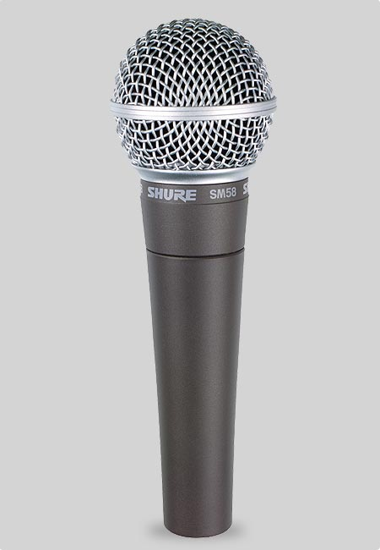 | Dynamic | Cardioid  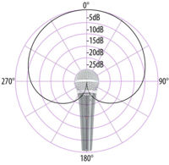 | 50Hz-15kHz  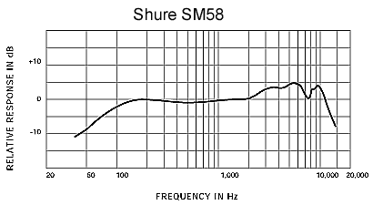
AKG C414
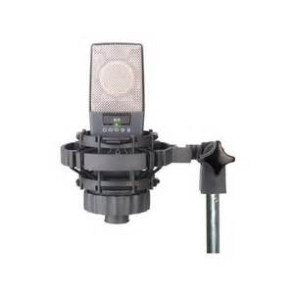
AKG D112
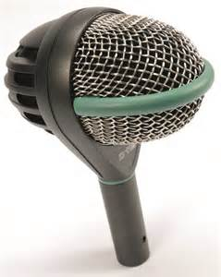
AKG C1000S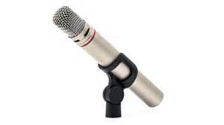
Neumann TLM 102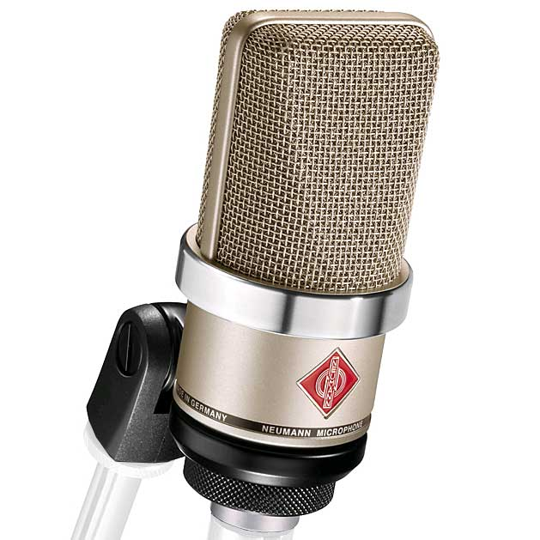
Shure SM57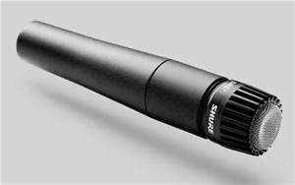
Rode NT2-A 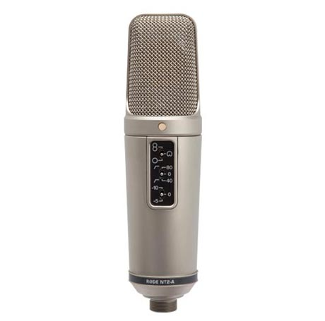
Rode NT5
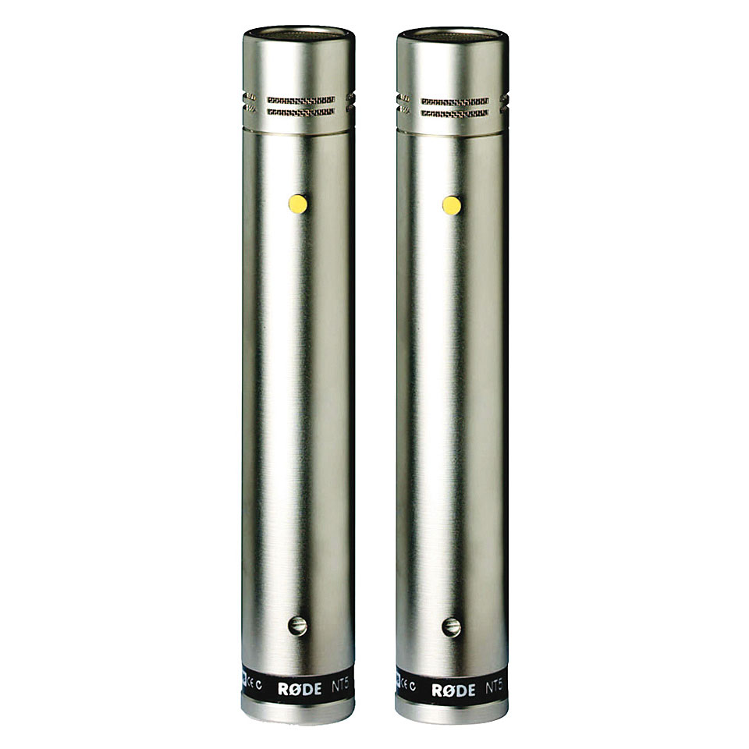
Microphone | Transducer Type | Polar Pattern | Frequency Response
Example:  Shure SM58 | Dynamic | Cardioid | 50Hz-15kHz
AKG C414 | Condenser | Multiple | 20Hz-20kHz
AKG D112 | Dynamic | Cardioid | 20-17kHz
AKG C1000S | Condenser | Cardioid | 50Hz-20kHz
AKG SolidTube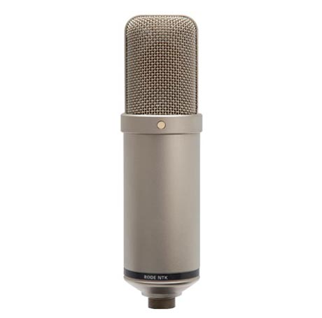 | Condenser | Cardioid | 20Hz-20kHz
Shure SM57 | Dynamic | Cardioid | 40Hz-15kHz
Rode NT2-A | Condenser | Multiple | 20Hz-20kHz
Rode M3  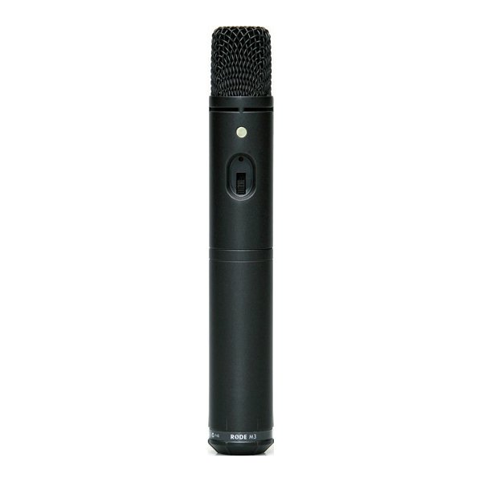 | Condenser | Cardioid | 40Hz-20kHz

Complete the table of stereo microphone techniques

Technique | Description
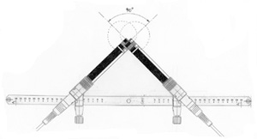
XY coincident pair
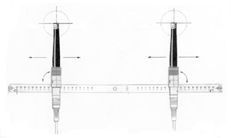
AB spaced pair
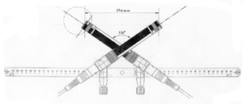
ORTF near concident pair
Blumlein stereo
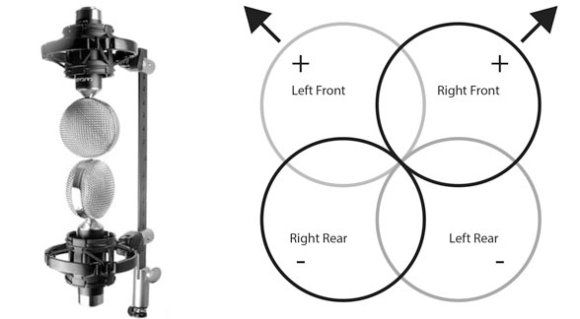
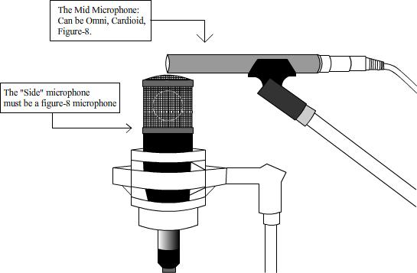
MS-Mid Side stereo

BONUS question: Explain the difference between ambient and close microphone techniques.

