**Film Studies yr1** Sound

*Watch the relevant attached clips (you may need to watch some of the clips more than once) and answer the subsequent questions.*

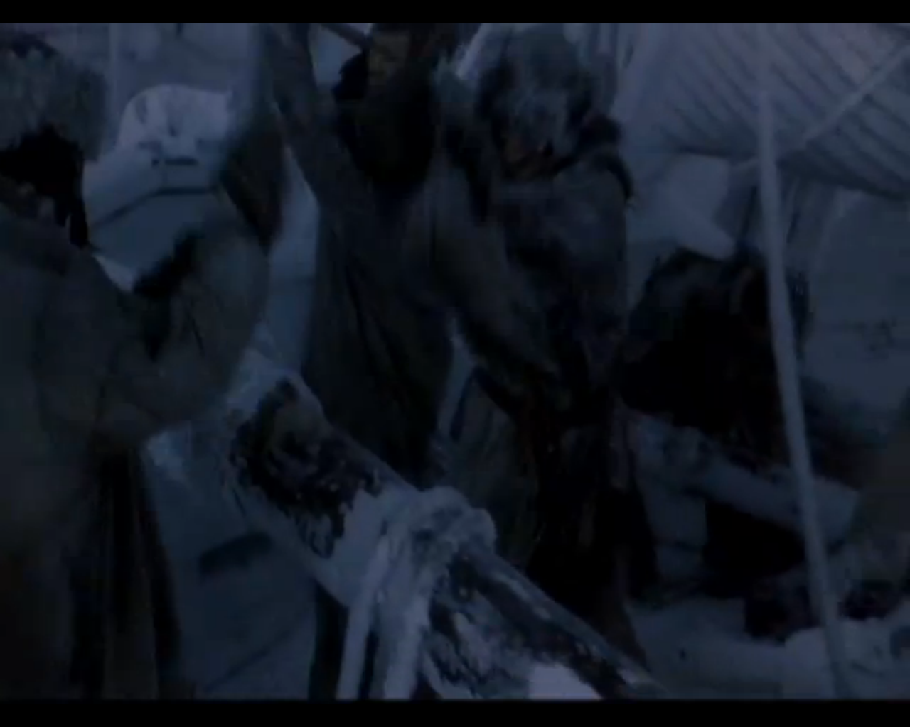

1. *Mary Shelly’s Frankenstein* (Kenneth Branagh, 1994) – eStream no. 2576, chapter title ‘sound task’.

Identify and list the **diegetic** and **non-diegetic** sounds in this clip.

………………………………………………………………………………………………………………………….

………………………………………………………………………………………………………………………….

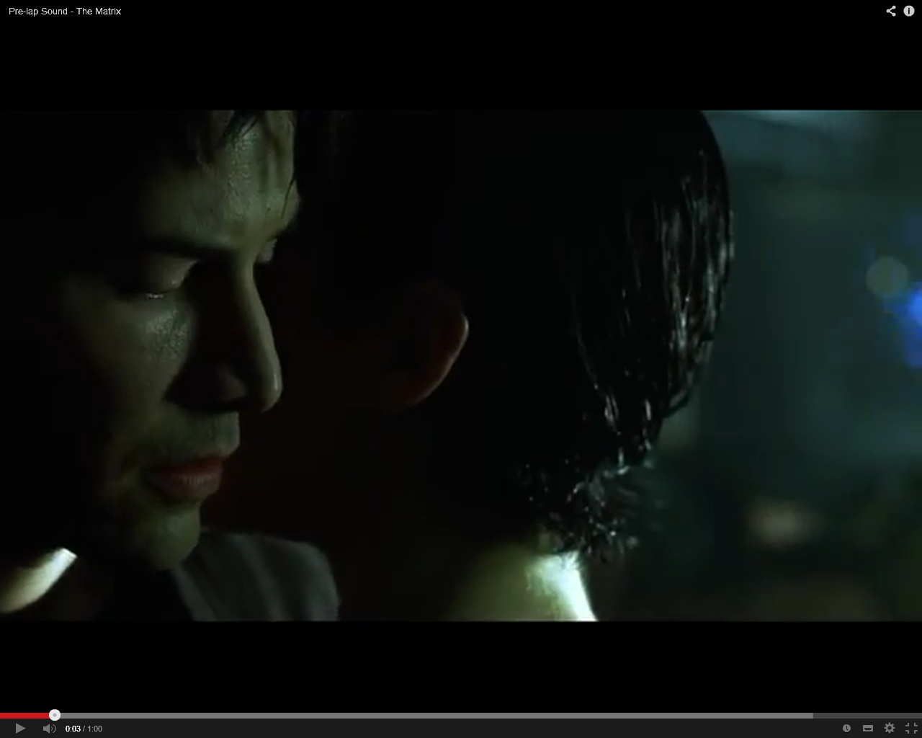

2. *The Matrix* ([Lilly Wachowski](http://www.imdb.com/name/nm0905152/?ref_=tt_ov_wr) & [Lana Wachowski](http://www.imdb.com/name/nm0905154/?ref_=tt_ov_wr), 1999) YouTube clip <http://www.youtube.com/watch?v=zJZ-gPQ0ew8>

Identify the Sound Bridge in this clip. What is it’s purpose? How do it work to connect the two shots, the two scenes?

………………………………………………………………………………………………………………………….

………………………………………………………………………………………………………………………….

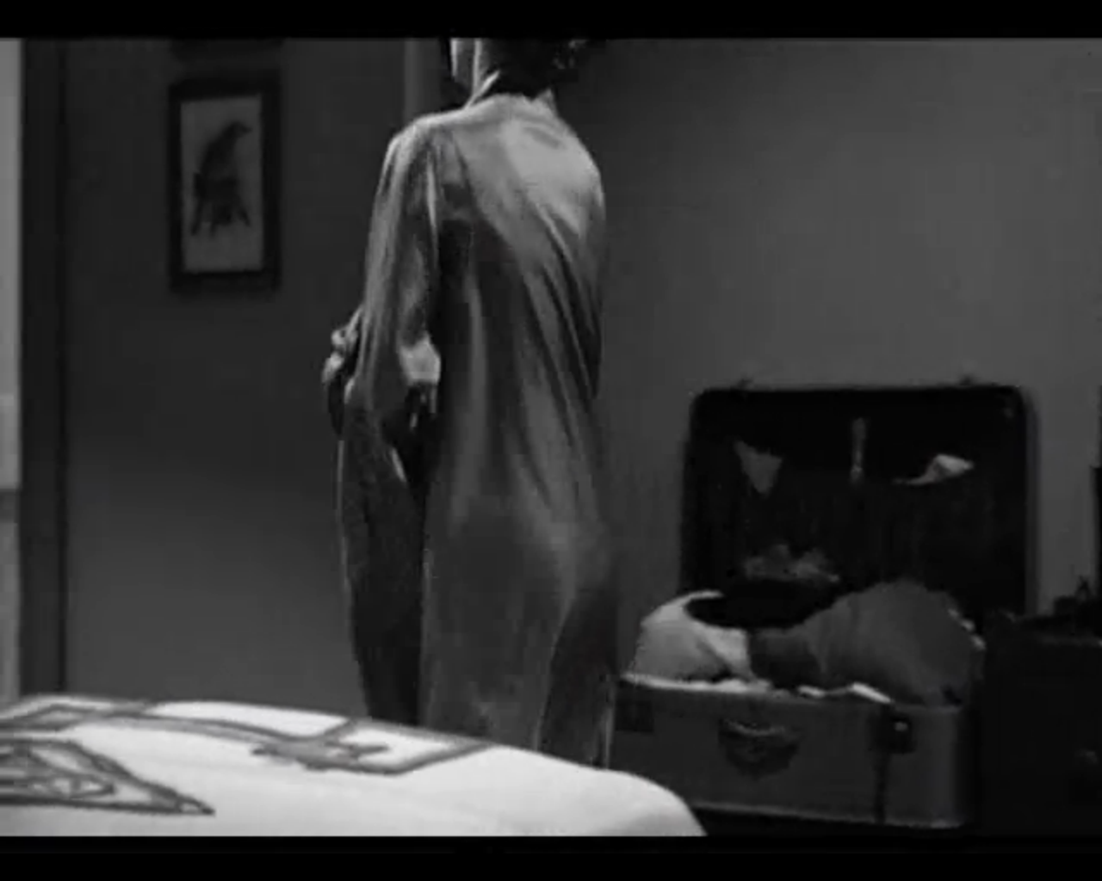

3. *Psycho* (Alfred Hitchcock, 1960) eStream no. 13, chapter title ‘shower scene’.

Describe the music in this scene (the instruments used, chords, tone, mood etc.)? Is it parallel or contrapuntal to the on screen action? Explain your answers.

………………………………………………………………………………………………………………………….

………………………………………………………………………………………………………………………….

………………………………………………………………………………………………………………………….

………………………………………………………………………………………………………………………….

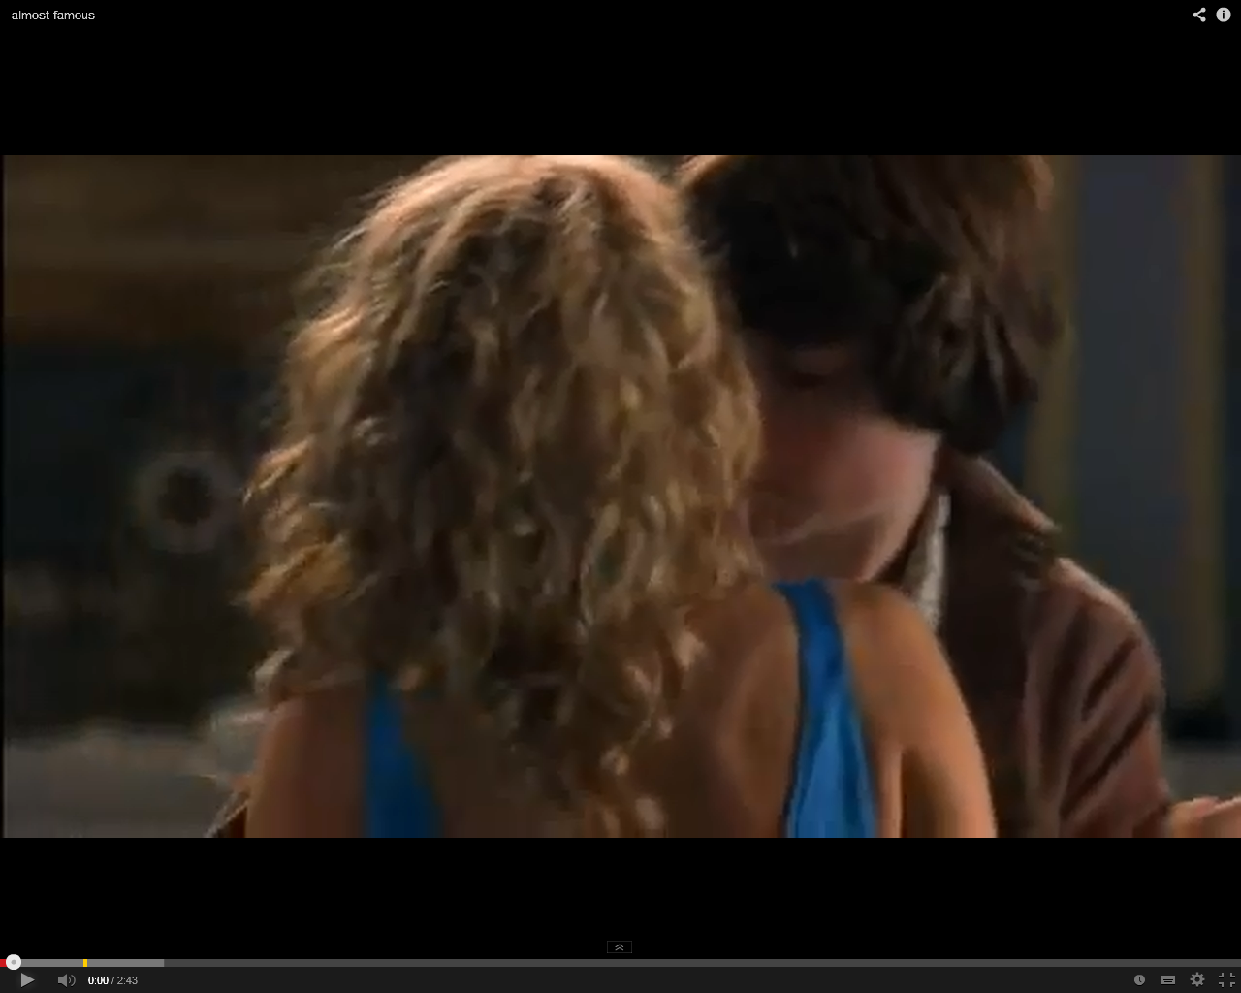

4. *Almost Famous* (Cameron Crowe, 2000) YouTube clip

[Almost Famous (2000) - Love & Departure - YouTube](https://www.youtube.com/watch?v=AhGtgL1LWCk)

Describe the use of music in this scene (towards the end of the clip)? Is it parallel or contrapuntal? Explain your answer.

………………………………………………………………………………………………………………………….

………………………………………………………………………………………………………………………….

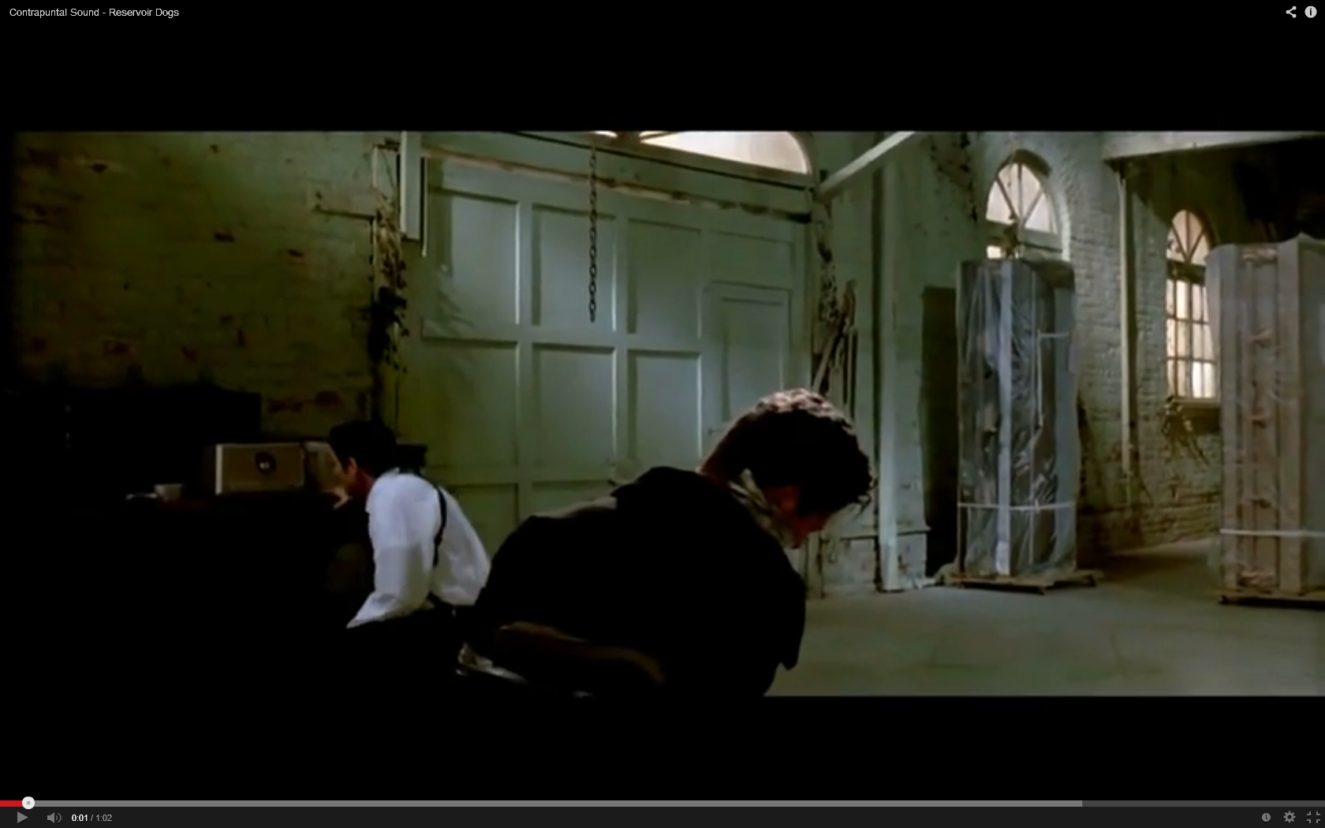

5. *Reservoir Dogs* (Quentin Tarantino, 1992) YouTube clip <http://www.youtube.com/watch?v=P0EXHvbsnJ8>

Describe the use of music in this scene? Is it parallel or contrapuntal? How does it differ from the above clip?

………………………………………………………………………………………………………………………….

………………………………………………………………………………………………………………………….

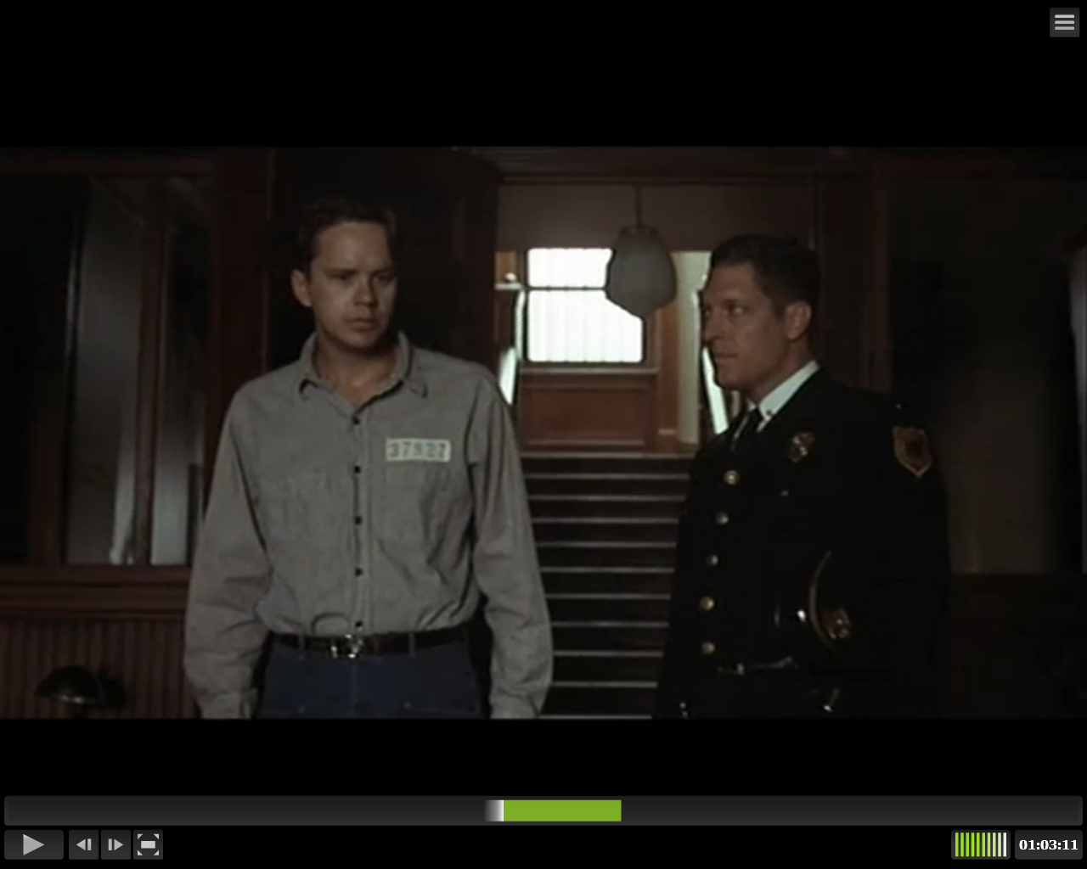

6. *The Shawshank Redemption* (Frank Darabont, 1994) eStream no.10387, chapter title ‘Sound task’.

Describe the main piece of music in this scene. Is it diegetic or non-diegetic? What effect (or affect) does the piece of music have on the characters (the prison inmates) and us the audience?

………………………………………………………………………………………………………………………….………………………………………………………………………………………………………………………….

………………………………………………………………………………………………………………………….

………………………………………………………………………………………………………………………….

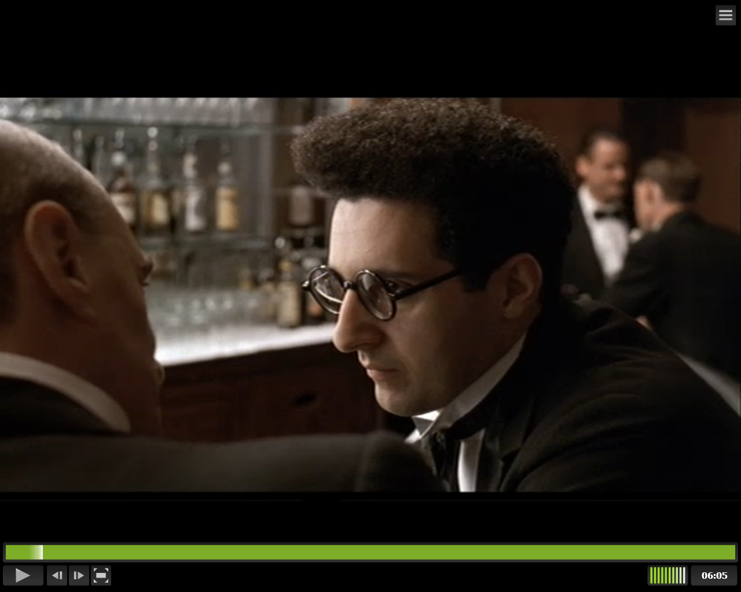

7. *Barton Fink* (Joel Coen, 1991) eStream no.10384, chapter titles ‘Sound task’ and ‘Sound task 2’.

Describe the use of sound effects in the 2 sequences / chapters in the above film? Are they natural or exaggerated? As an audience member, how are we encouraged to read the 2 sequences?

………………………………………………………………………………………………………………………….

………………………………………………………………………………………………………………………….

………………………………………………………………………………………………………………………….

………………………………………………………………………………………………………………………….

………………………………………………………………………………………………………………………….

………………………………………………………………………………………………………………………….

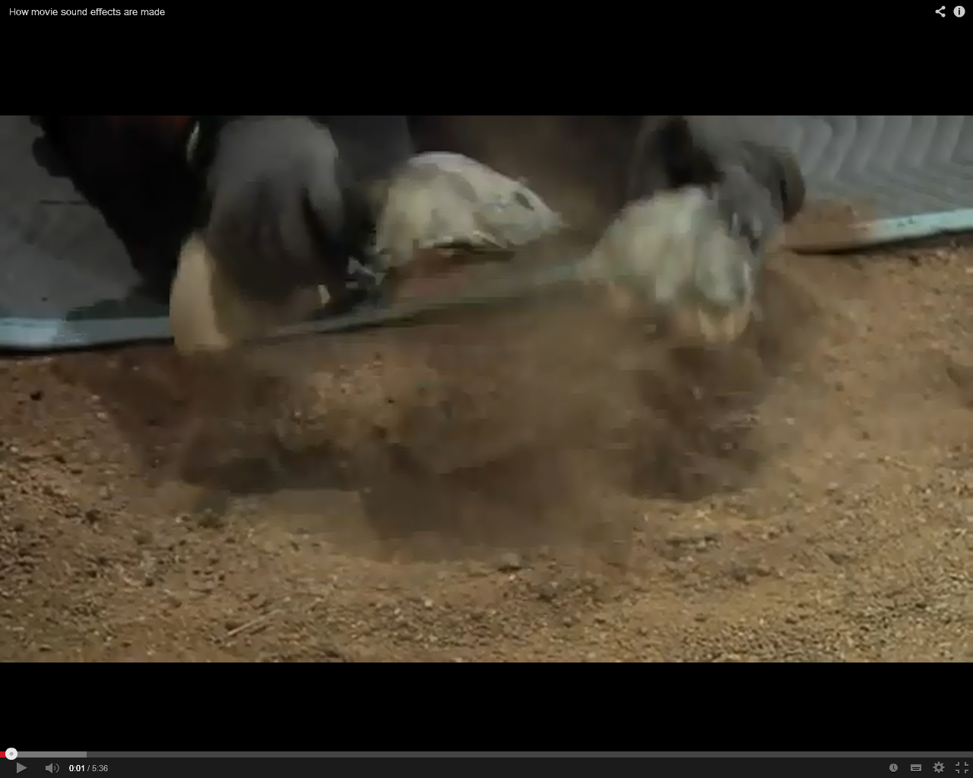

8. Now watch the short documentary clip on Foley artist Gary Hecker, to see how diegetic sounds are created.

<https://www.youtube.com/watch?v=Gqs1KO_HKWY>