Format | Conventions – what are the typical features of the format? | Functions – how is it done? | Purpose – why is it done this way?
SOAP OPERA (narrative)
SITUATION COMEDIES
(narrative)

CHAT SHOW
(non-narrative)

LIVE EVENT  (non-narrative)  Olympic Opening Ceremony  2012 | Live shows are complicated events which require precise planning.  Often rely upon ‘spectacle’ that looks good in the crowd and at home on television.  Live sports events – cameras closely follow the action.  Live concerts (e.g. – the Proms) – cameras provide multiple views of the event from different angles.  Cutting between event and audience reaction  Important to maintain audience interest to make event seem intimate  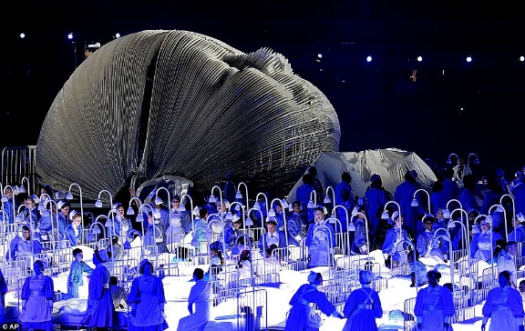 | The entire event is planned in detail with a pre-visualisation / computer generated programme, overseen by the creative director.  Some sequences are heavily storyboarded.  Danny Boyle was chosen as director for project, as it was his personal vision. Hamish Hamilton was directing team from the gallery; division of labour.  Camera placement is crucial to achieving interesting and innovative shots.  The whole event was rehearsed and shot on a number of domestic cameras within the location, well in advance of the event.  The above sequences were then edited together with Boyle as part of the edit team.  Camera scripts were drafted for camera operators.  Range of camera were employed on the day – interesting angles (helicopters, Go-pros etc.).  Behind the production – 2X vision galleries / 2X central operation rooms / 2X sound galleries | This helps the crew understand the vision of the director and makes it easier to work as a team to unlock his vision.  This is a useful method for allowing the team to understand complex sequences and their role in helping create them.  Removes creative decisions from Hamilton, allowing Boyle’s vision to be the over-riding one.  The event is large and lasts a long time (approx. 3 hours) – needs to be stimulating for viewers at home.  Planning experience for the team and Hamish (locations director).  Creates an understanding between director and creative team.  The sheer scale of the event needed structure and each operator needs to know what / where / when they are needed.  Maintains the size and spectacle of the event.  Provides seamless back-up in case of things going wrong. This also double the team needed for the event.

Links that may help with your research –
Behind the scenes – Eastenders (Mick and Linda’s wedding)
Eastenders – Queen Vic on fire
Behind the Scenes of the Big Bang Theory
Live recording of Big Bang Theory
Friends – Behind the scenes

