GRAPHIC DESIGN Paul Klee

Aim: To study the artist’s style and technique to help you further explore the use of surface pattern, mark making and typography.
Deadline: WEEK 2 homework set on FRIDAY 22/9/17. Due lesson FRIDAY 29/9/17
Task: Produce 2x A4 spread covering the work of the PAUL KLEE (see EXAMPLE OF HOMEWORK below).
After your Jasper Johns homework, please leave two pages and then present your Paul Klee homework across the next two pages.

- SIDE TAB/FLAP - Research work by the artist PAUL KLEE
Create a side tab/flap, which will include written research (150-200 words), biography about Jasper Johns (+ analysis of his artwork) + selection of artworks by Paul Klee. You have been provided with a piece of cartridge paper (dimensions 10cm x 18cm portrait) – you can use this piece of paper for your side tab.

- LEFT PAGE – Create a copy of an artwork by Paul Klee using a mixed media approach e.g. paints, inks, pencils, collage, patterns and mark making etc. You must do this on the 1x A4 cartridge paper, which has been provided for you. This piece of paper has been trimmed slightly so that it will fit neatly on the page. Trim down if necessary.
Here is a link https://www.dropbox.com/sh/klx00uhr11emvmx/AAAhsNn89AA_q1z6dXwa_Qzwa?dl=0 to a Dropbox folder containing a selection of Paul Klee artworks. You must choose one artwork from this selection to do your copy. Paper print outs of these copies have also been provided for you.
The copy must fill the page as best as can be. I would like you to also create a palette using the fabriano strip of paper (dimensions 27cm x 5cm landscape), include any colours, textures and patterns used in your Paul Klee copy.

Include annotations.

3. RIGHT page.
You are produce 3x pieces. Include annotations.

You have been provided with two small cartridge paper squares (dimensions: 8cm x 8cm) + one medium size fabriano square paper (19.5cm x 19.5cm).

Look at example of homework at end of document.

On the first small cartridge square.
3a: Use black quink ink or black Indian + a drawing nib. Use skills learnt in class. Use the nib and ink to draw a grid (6 across, 6 down). Do not use a ruler.
3b: Start from top left, use nib and ink to draw the letters of your name, one letter in each square. Each letter must fill the square. Do not draw any lines on the grid.

E.g
A looks like
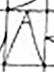
E and H both would look like
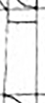
M like
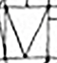

Look at Paul Klee’s example
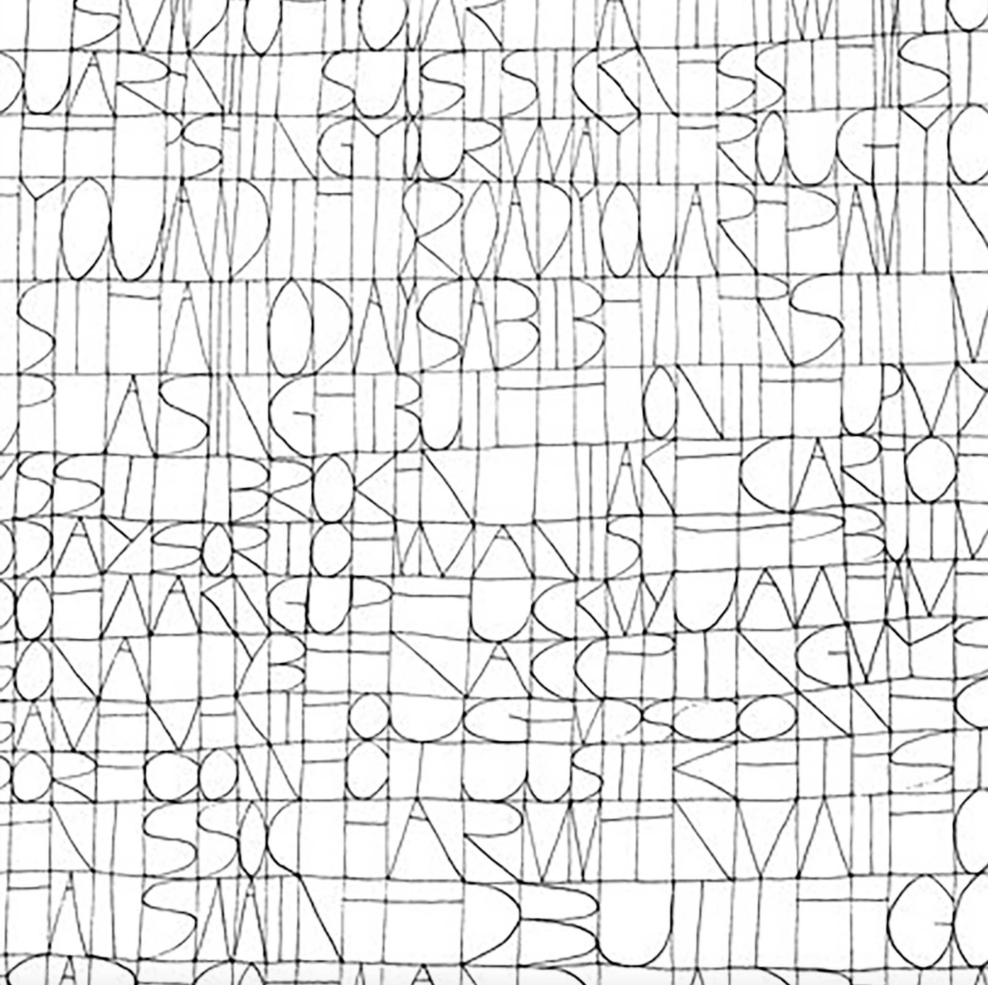

Draw all letters from your full name, repeat name if need be to fill the whole grid.

3c: On the second small square cartridge square. Repeat process of step 3a, but this time draw a grid 5 across, 5 down.

3d: Select colours, which work in harmony with one another (next to each other on the colour wheel) or contrasting colours (opposite colours on the colour wheel).

3e: Use inks, paints, paint pens etc.
Fill in the shapes as shown in the example. Avoid using the exact same colour in two shapes side by side.

3f: On the fabriano paper -

Use your second small cartridge artwork as reference to draw from. You are to select an area from your design 4 squares across, 4 down. Enlarge the scale of your selection and recreate the design in the fabriano square without drawing the lines. Only concentrate on the shapes/fills.

Use the same or a different palette of colours. As well as a selection of patterns of your choosing. Look at my example. I have used a range of mediums (paints, pens, pencils, inks, patterns, white negative space). And then create another palette on the fabriano paper (dimensions 3cm x 19.5cm), include colours, patterns, textures that you have used on RIGHT PAGE.

Below are examples to help you with your homework. (go to next page)

Examples of Paul Klee homework LEFT PAGE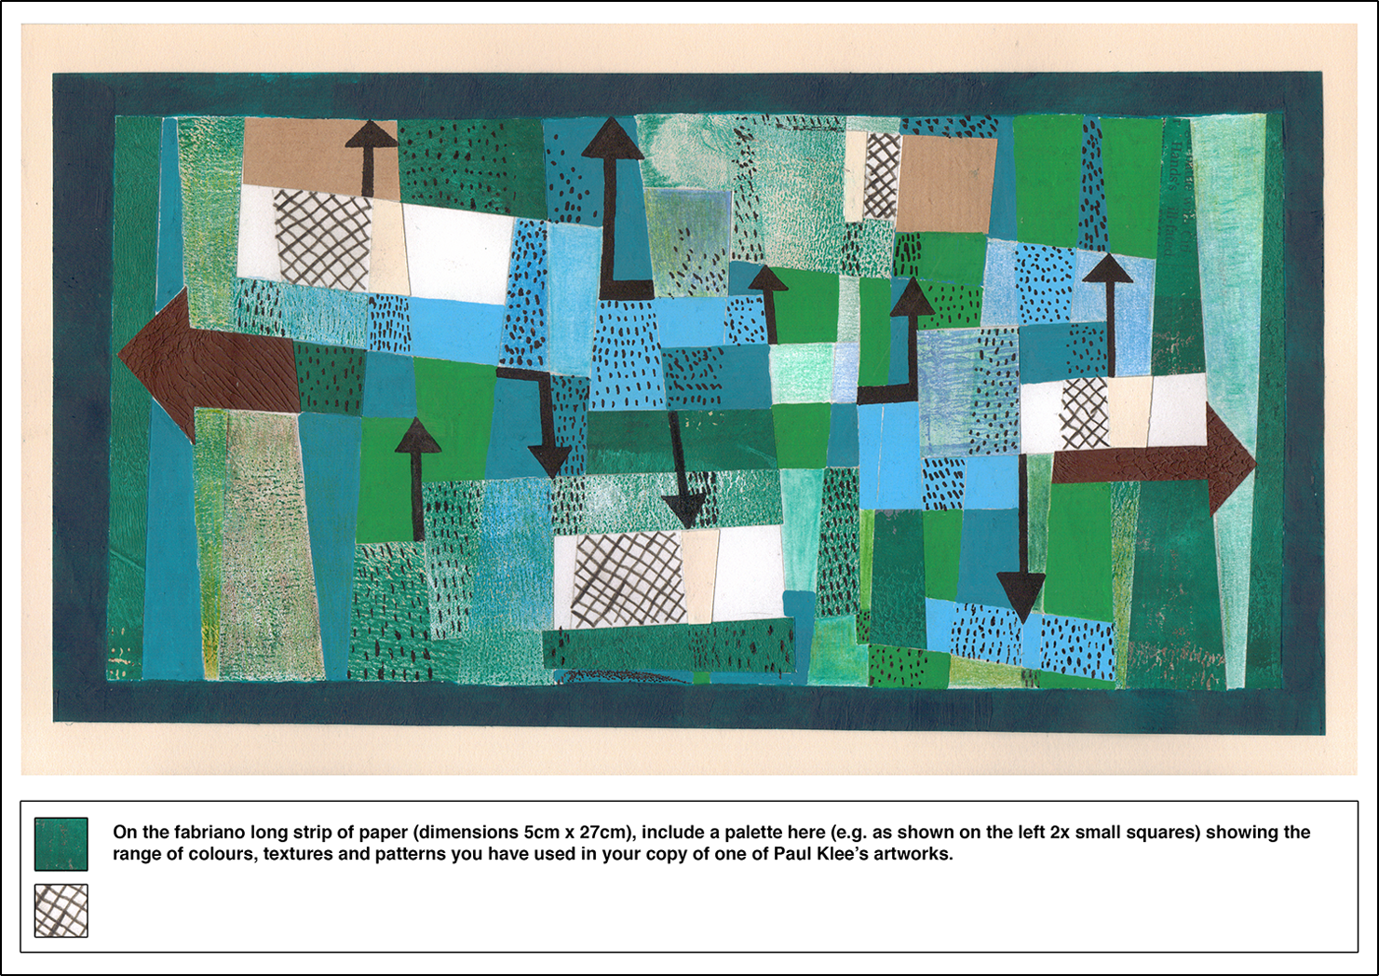
Examples of Paul Klee homework RIGHT PAGE 