Example:  Shure SM58  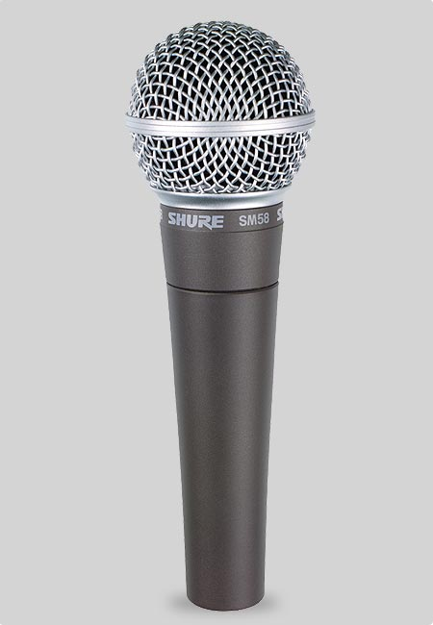 | Dynamic | Cardioid | 50Hz-15kHz  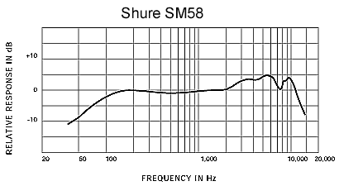
AKG C414  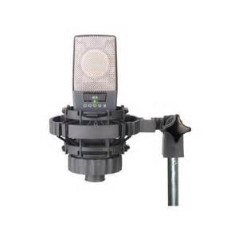 | Condenser | Multiple | 20Hz-20kHz  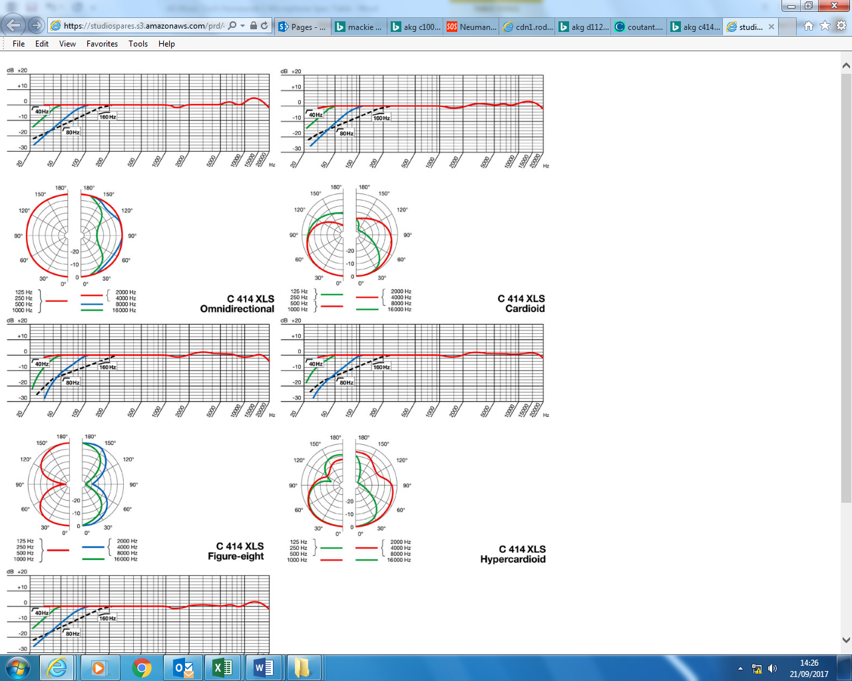
AKG D112  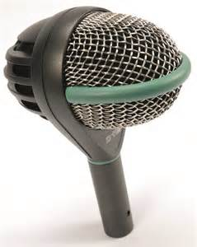 | Dynamic | Cardioid | 20-17kHz  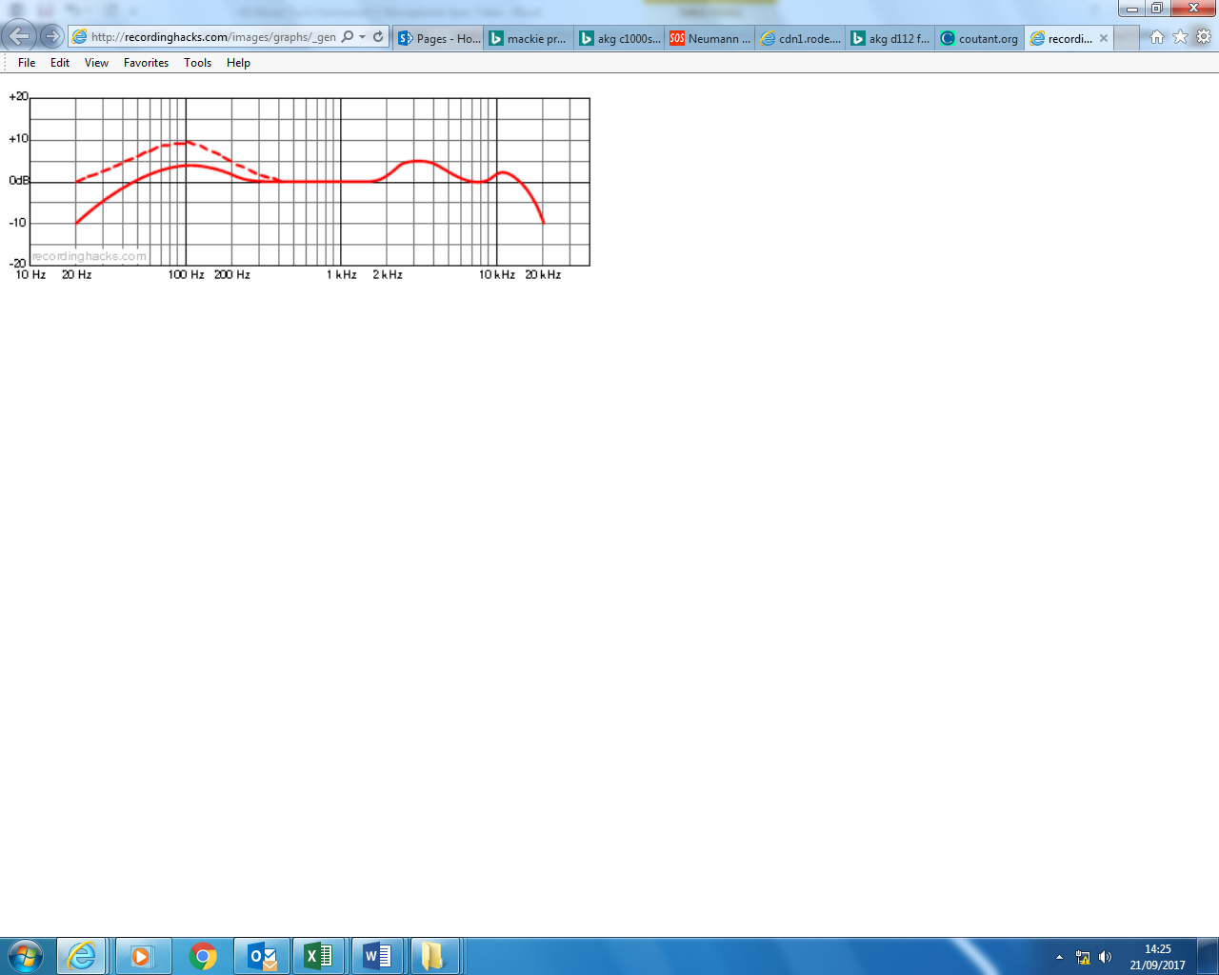
AKG C1000S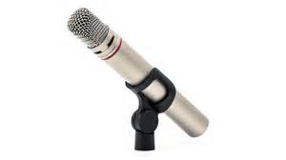 | Condenser | Cardioid | 50Hz-20kHz  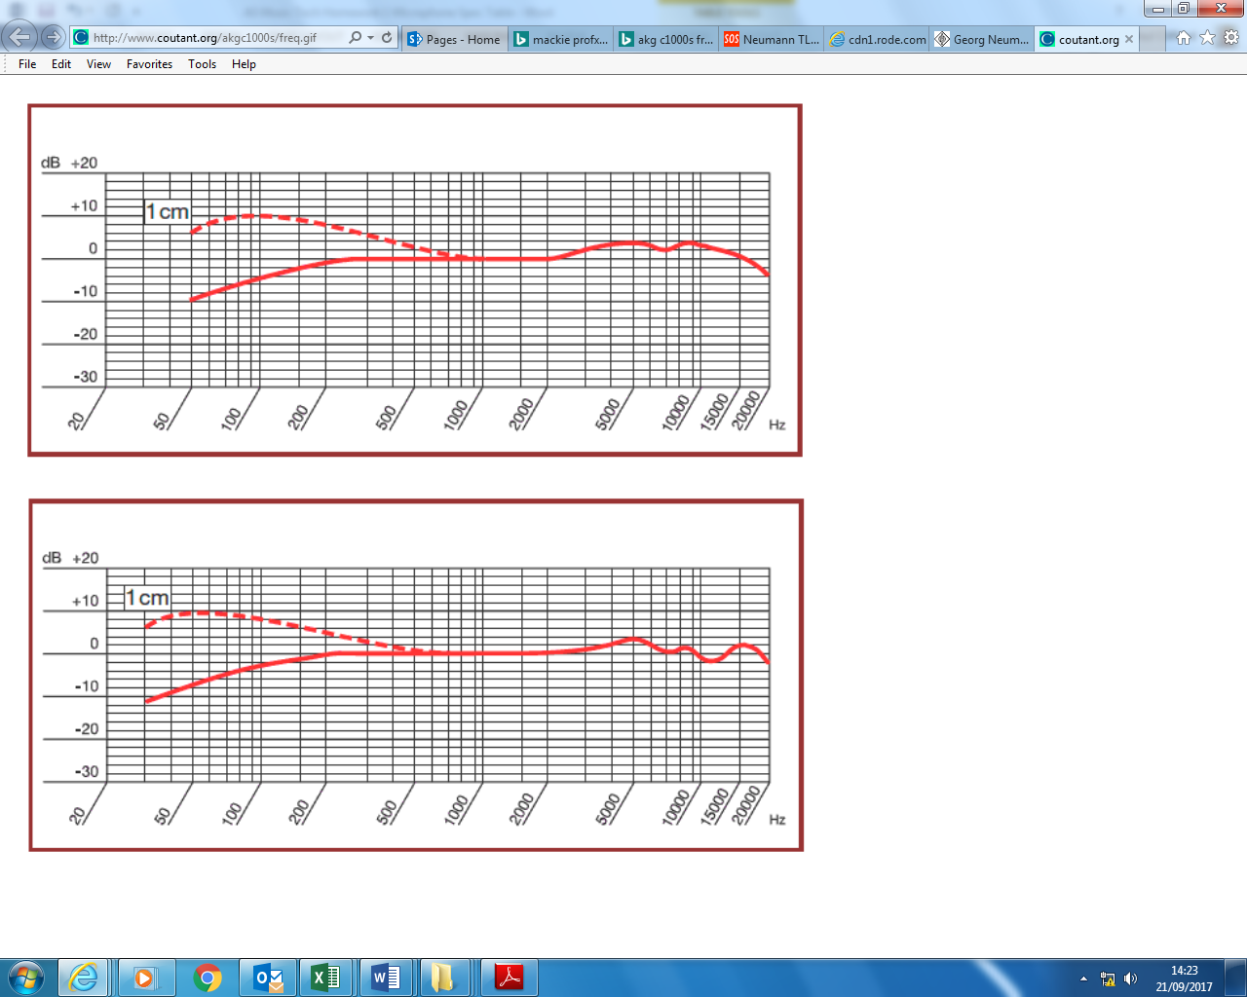
Neumann TLM 102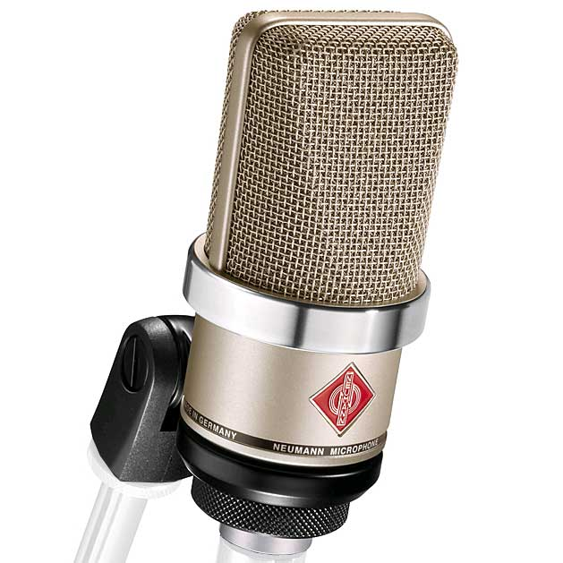 | Condenser | Cardioid | 20Hz-20kHz  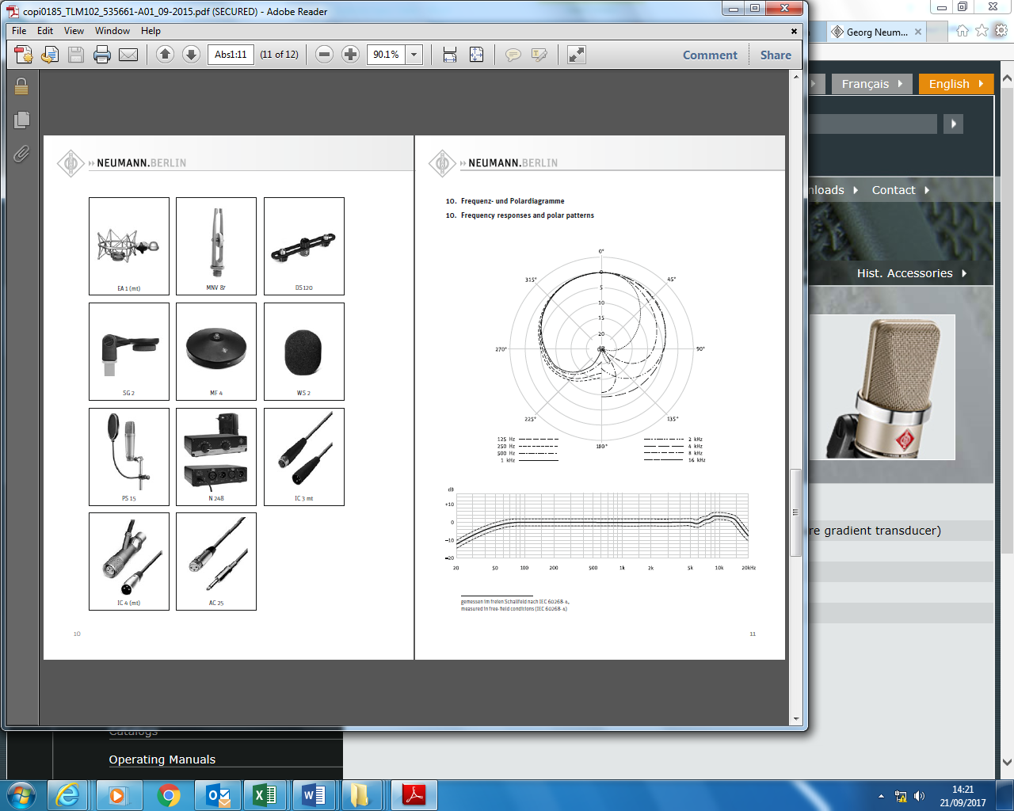
Shure SM57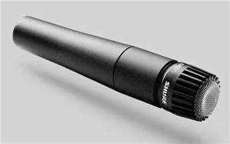 | Dynamic | Cardioid | 40Hz-15kHz  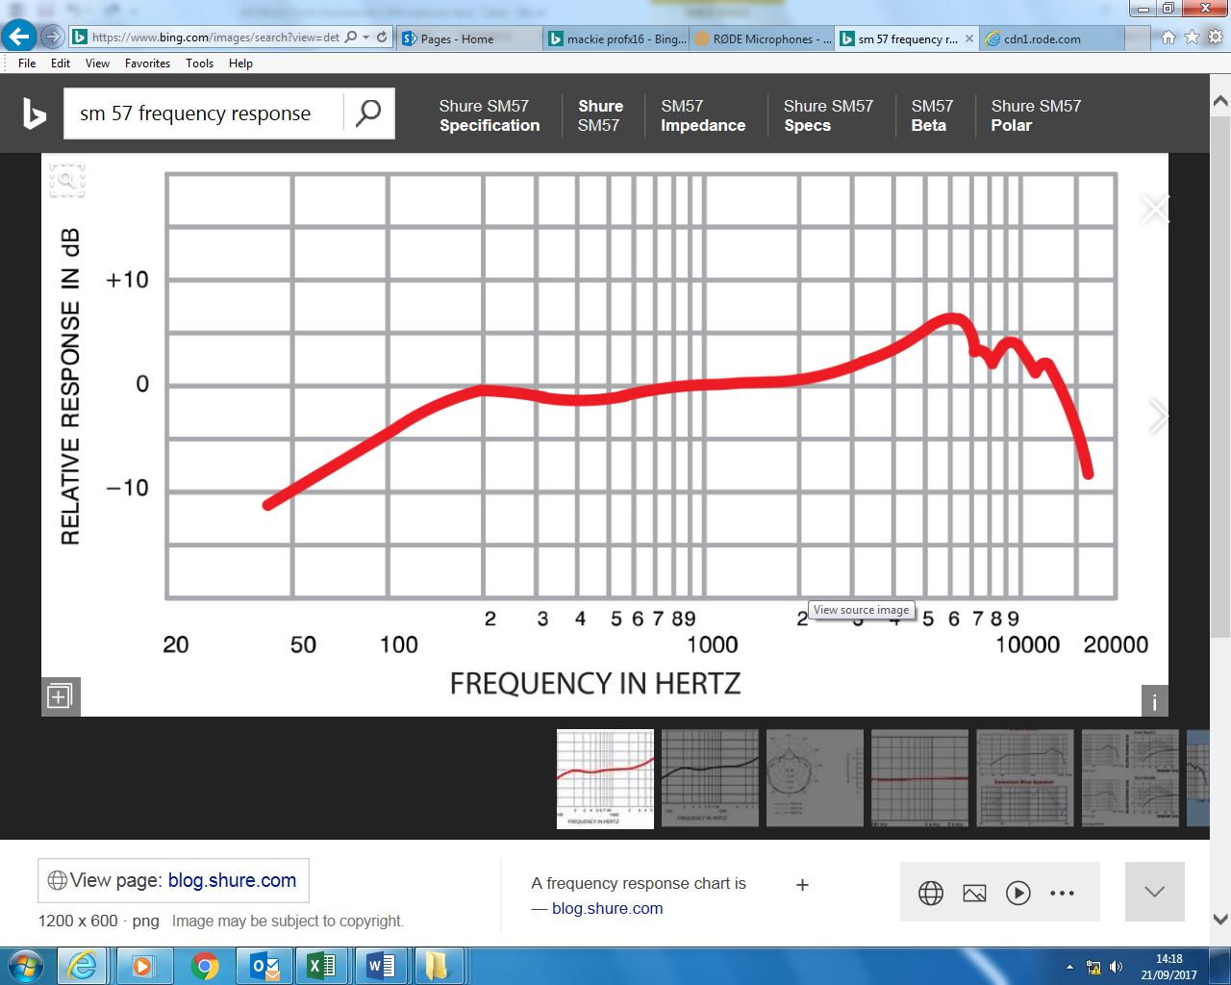
Rode NT2-A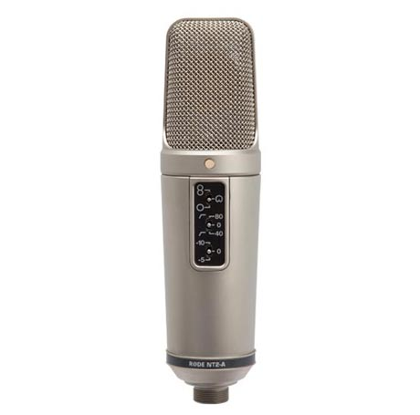 | Condenser | Multiple | 20Hz-20kHz  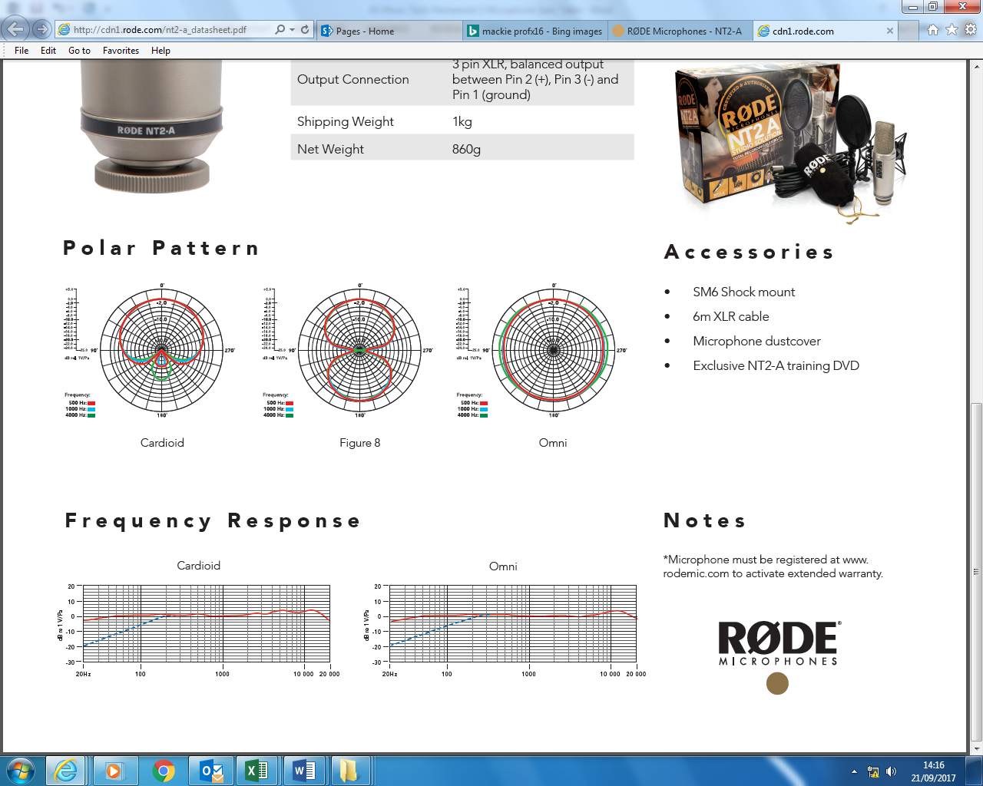
Rode NT5  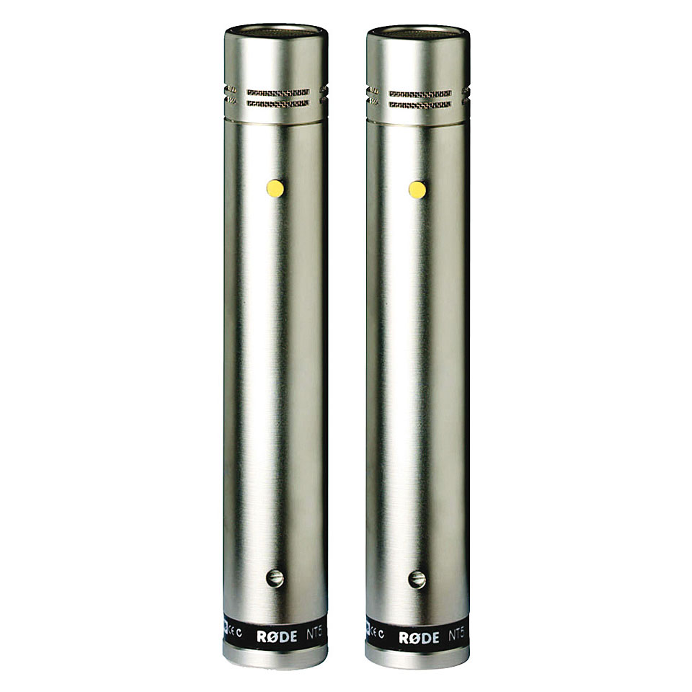 | Condenser | Cardioid | 20Hz-20kHz  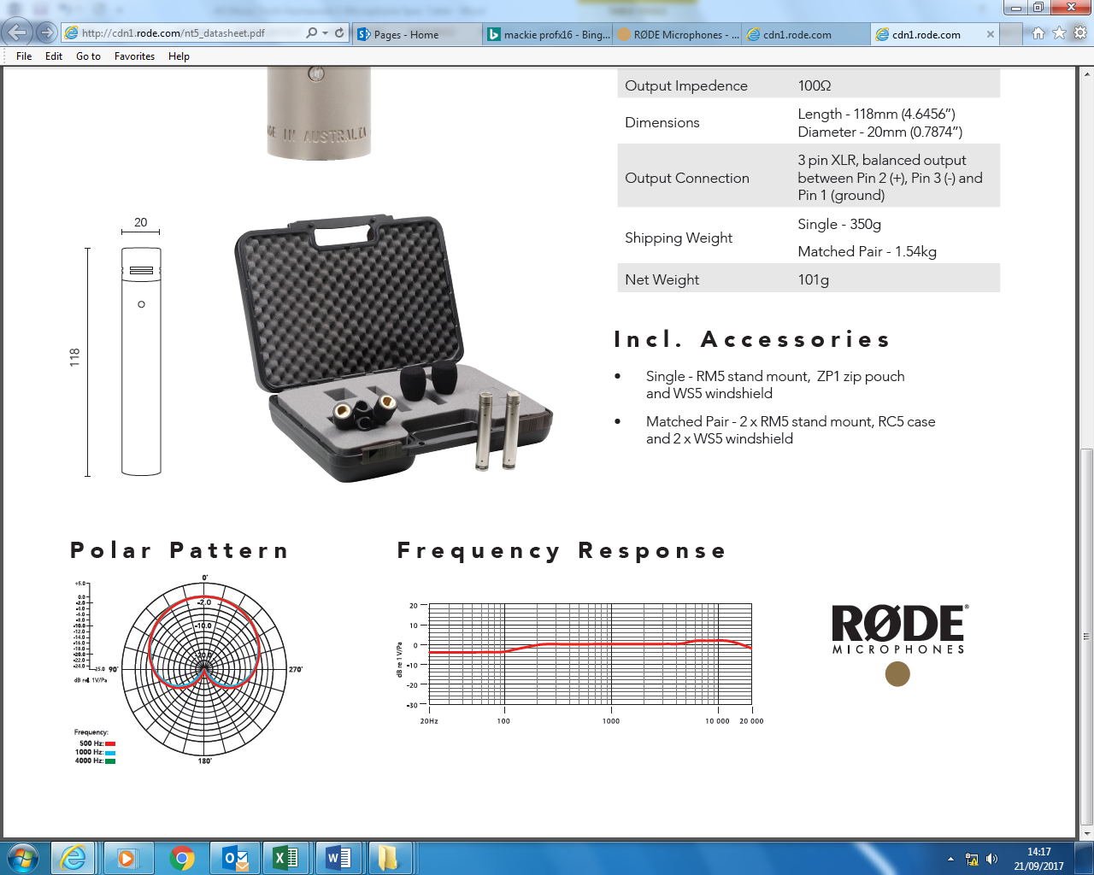

Description of a microphone
A microphone is a transducer (1) that converts sound energy into electrical energy (1). The sensitive transducer element of a microphones called its element or capsule (1). The signal needs a pre-amp (1) to convert it to a workable (line) level/impedance (1).
Any discussion of polar response, e.g. omni / cardioids. Credit accurate
diagrams. Max 1.
Dynamic microphone
Dynamic microphones are sometimes called moving coil microphones (1).
Dynamic microphones function in the same way as a loud speaker, only reversed (1).
A movable coil (1) which is positioned in a magnetic field (1) is attached to the diaphragm (1). When sound enters the microphone the membrane / diaphragm vibrates (1). Consequently, the coil moves in the magnetic field and a varying (1) electrical current is induced (1) in the coil, in line with the rising/falling air pressure (1). This process is called electromagnetic induction (1).

Benefits of dynamic microphones
Generally inexpensive (1) Robust (1)
Can withstand high SPL (allow volume) (1)
Resistant to moisture (1)
Lack of sensitivity reduces feedback (1)
Good for live use (1)
Does not require (phantom) power (1).
Limited HF response makes them suitable for bass instruments (1)
Slow transient response introduces a form of acoustic compression (1)

Condenser microphone
The diaphragm (1) (don’t award diaphragm buzzword twice if mentioned
for dynamic microphone) forms one (1) plate (1) of a capacitor (1).
When the diaphragm vibrates, the distance of the plates changes (1)
thus changing the capacitance (1). From this a varying voltage (1) is
produced.
Phantom power (1) 48V (1) is required to charge the capacitor (1).
Some condenser microphones can be powered by a battery (1).
Polar response / pick-up pattern switch (1) that selects between
different / combinations of capsules (1). Some microphones have
interchangeable capsules (1).
Power switch (1).
Pad switch (1) usually -10 dB (1)
6MT04_01
1106
High pass filter (1) to eliminate rumble/low frequencies (1)
Usually has cradle/shock mount (1)

Benefits of condenser microphones
Sensitive / pick up quiet sounds (1)
Flat frequency response (1)
Good high frequency response / wide frequency range / brighter than
dynamics (1)
Good signal to noise ratio / low noise / wide dynamic range (1)
Fast transient response (1)

