**AS Film Studies**

Sound - ANSWERS

*Watch the relevant attached clips (you will need to watch most of the clips more than once) and answer the subsequent questions.*

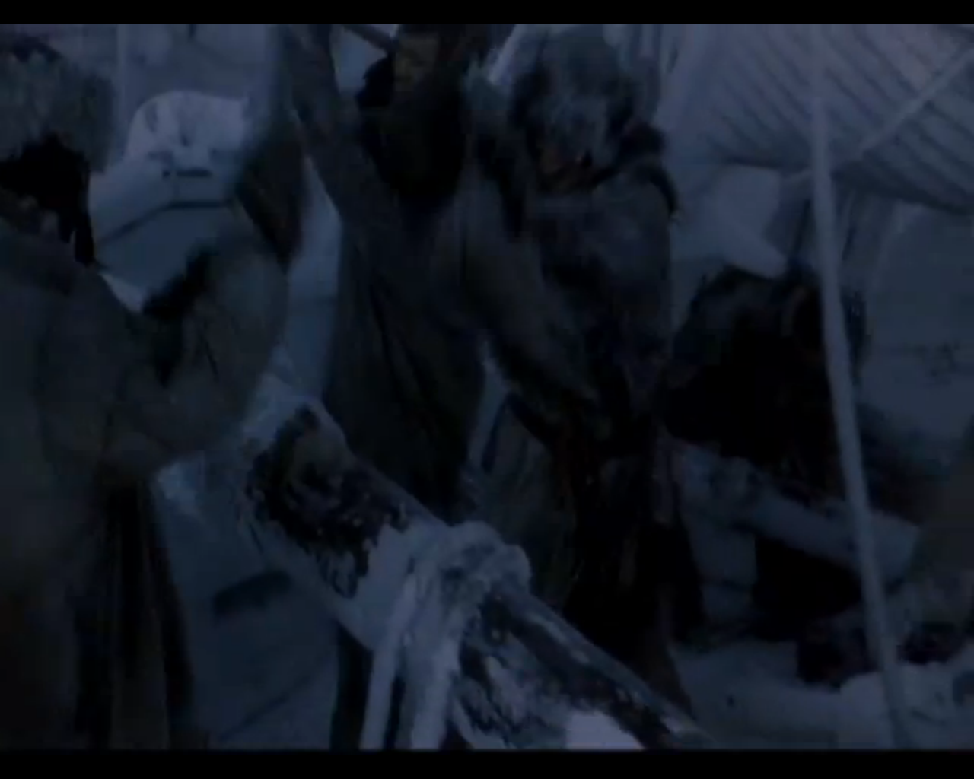

1. *Mary Shelly’s Frankenstein* (Kenneth Branagh, 1994) – eStream no. 2576, chapter title ‘sound task’.

Identify and list the **diegetic** and **non-diegetic** sounds in this clip.

Non-diegetic- Music score throughout and sound blast / jump scare at the end of clip. Diegetic- everything else. Atmosphere sounds, dialogue, wood chopping, dogs howling etc.

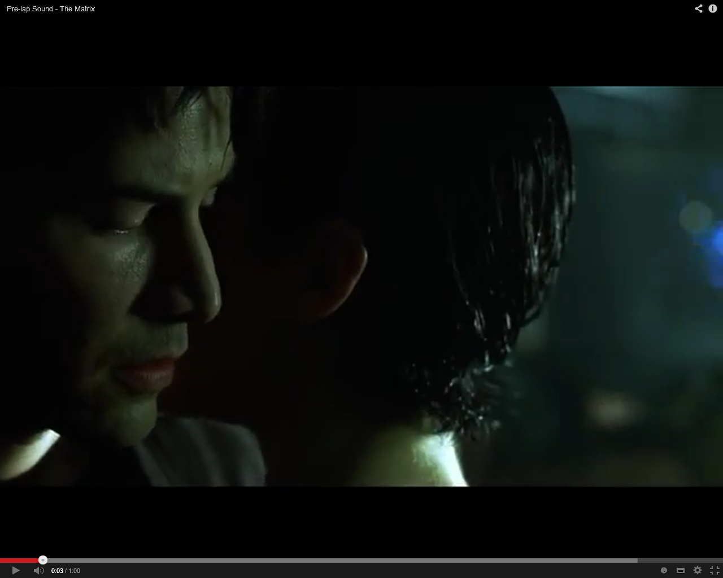

2. *The Matrix* ([Andy Wachowski](http://www.imdb.com/name/nm0905152/?ref_=tt_ov_wr) & [Lana Wachowski](http://www.imdb.com/name/nm0905154/?ref_=tt_ov_wr), 1999) YouTube clip <http://www.youtube.com/watch?v=zJZ-gPQ0ew8>

Identify the **two** Sound Bridges in this clip. What is their purpose? How do they work to connect the two shots, the two scenes?

The most obvious sound bridge is the alarm sound which bridges the two separate scenes together- was what happened the night before a dream? The diegetic music track playing in the background of the club, also bridges the cuts within the scene.

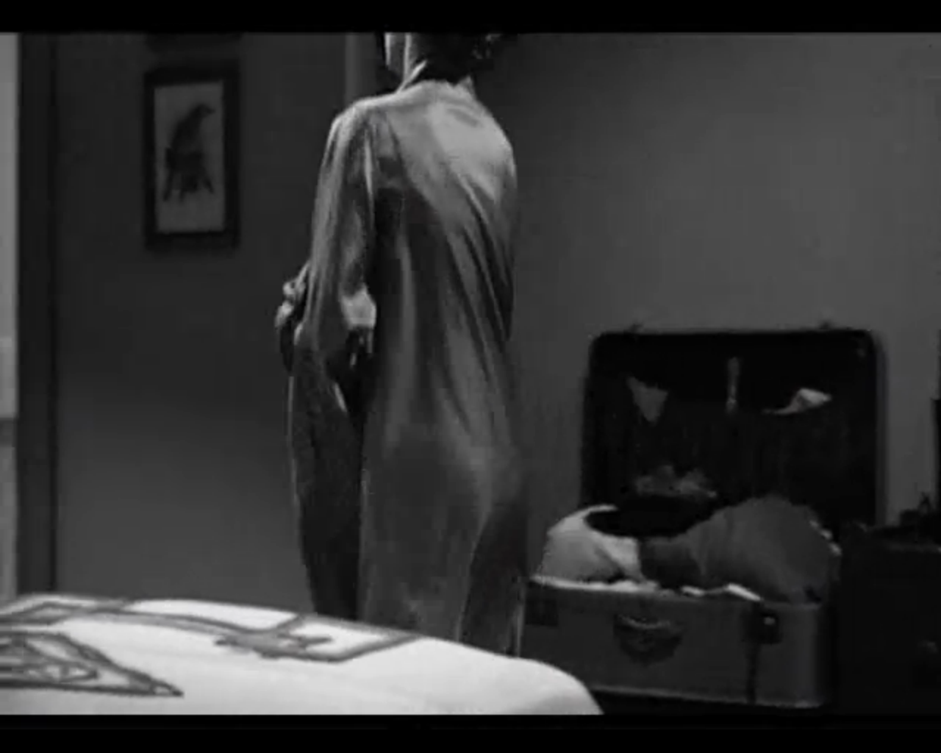

3. *Psycho* (Alfred Hitchcock, 1960) eStream no. 13, chapter title ‘shower scene’.

Describe the music in this scene (the instruments used, chords, tone, mood etc.)? Is it parallel or contrapuntal to the on screen action? Explain your answers.

Bernard Herrmann’s famous iconic score mirrors the action onscreen (parallel sound). The music is a haunting cacophony, which has been described as both sounding like a woman screaming and finger nails down a blackboard. The timing of the piece seems to match the stabbing motion too.

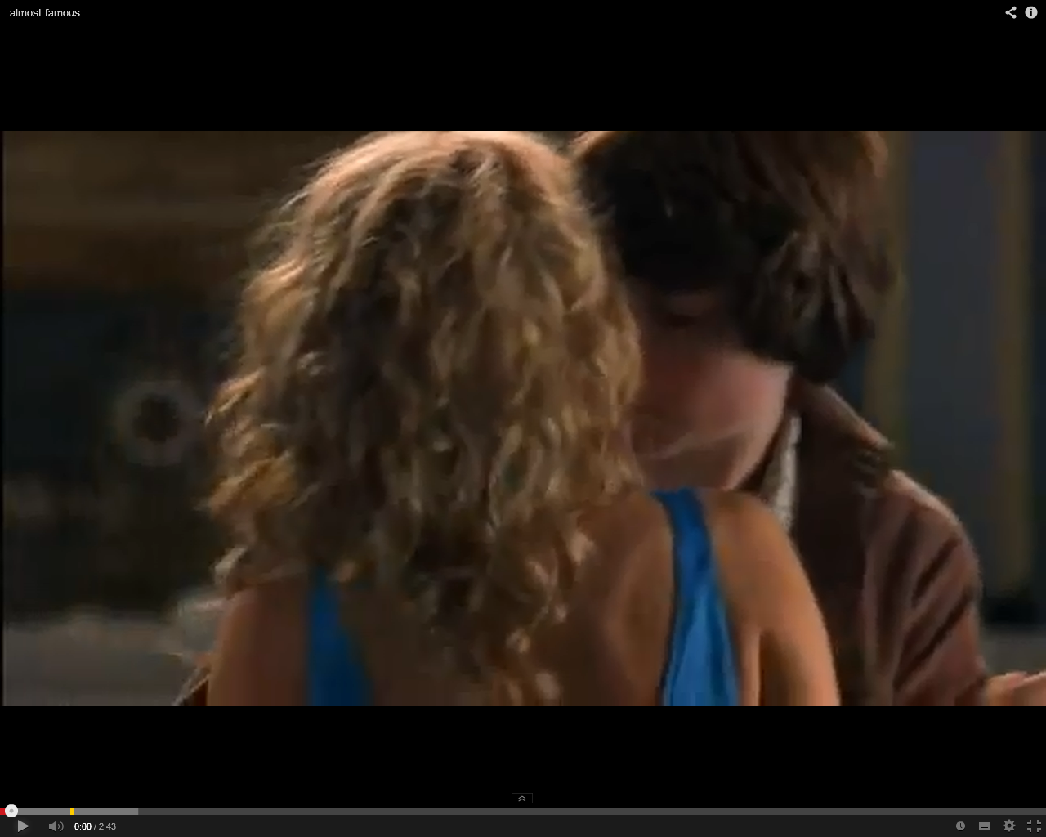

4. *Almost Famous* (Cameron Crowe, 2000) YouTube clip

<http://www.youtube.com/watch?v=ObdOyhv6cZ0&feature=player_embedded>

Describe the use of music in this scene (towards the end of the clip)? Is it parallel or contrapuntal? Explain your answer.

Contrapuntal. The Stevie Wonder tune is an iconic love song. It plays while the love interest is having her stomach pumped. Although, it could be argued that maybe it *is* an appropriate song- the film is about unrequited love, and despite the fact she is having her stomach pumped, the protagonist *still* desires her.

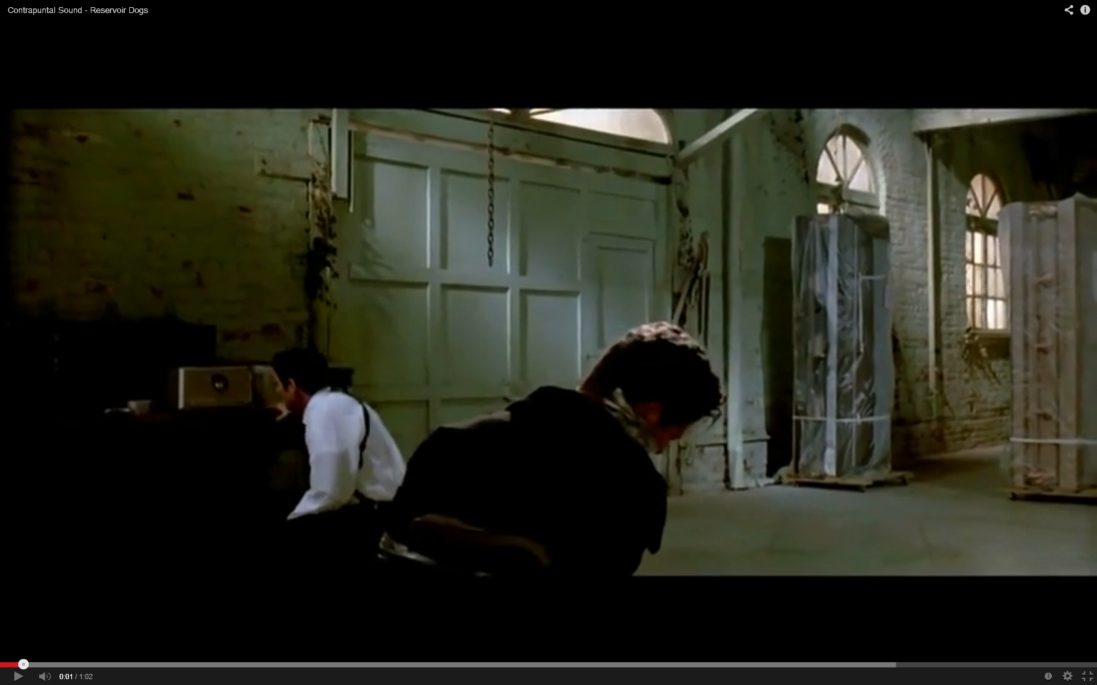

5. *Reservoir Dogs* (Quentin Tarantino, 1992) YouTube clip <http://www.youtube.com/watch?v=P0EXHvbsnJ8>

Describe the use of music in this scene? Is it parallel or contrapuntal? How does it differ from the above clip?

A famous example of contrapuntal sound. The upbeat, breezy pop song adds an additional psychotic element to the torture scene. It differs from the above as the source is a radio, making it diegetic.

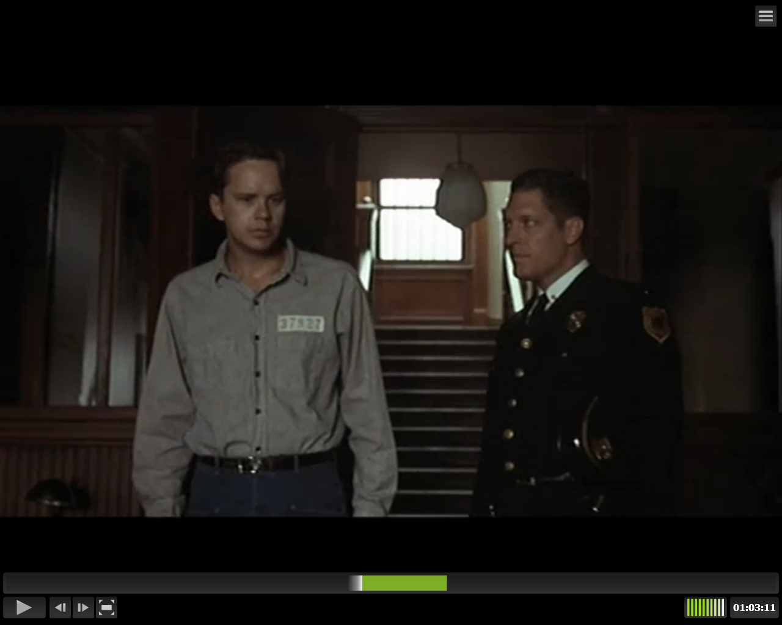

6. *The Shawshank Redemption* (Frank Darabont, 1994) eStream no.10387, chapter title ‘Sound task’.

Describe the main piece of music in this scene. Is it diegetic or non-diegetic? What effect (or affect) does the piece of music have on the characters (the prison inmates) and us the audience?

A beautiful scene in a popular film. The classical music seems to switch between diegetic and non-diegetic. ‘Moving’ both characters and audience members. As the voice over suggests the beautiful, stirring melody transcends the prison walls and for a moment each prison inmate feels ‘free’.

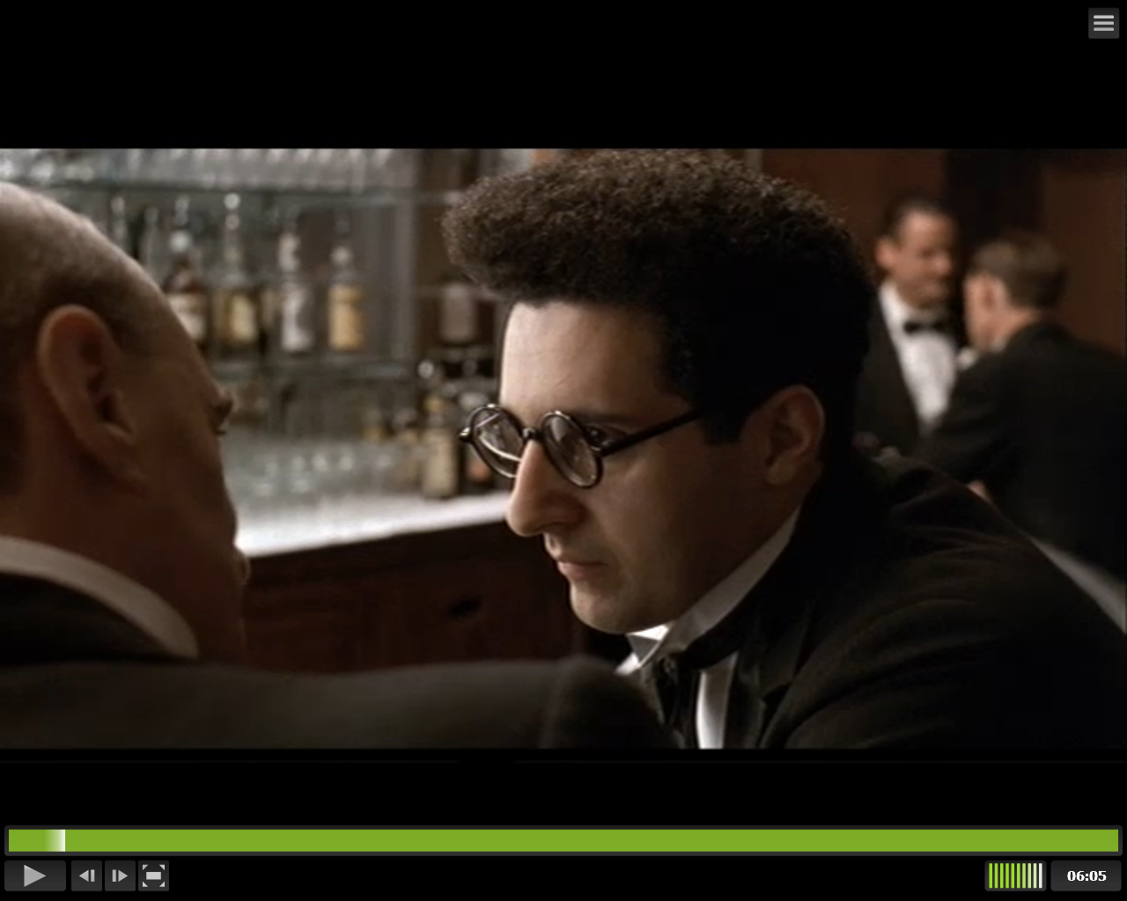

7. *Barton Fink* (Joel Coen, 1991) eStream no.10384, chapter titles ‘Sound task’ and ‘Sound task 2’.

Describe the use of sound effects in the 2 sequences / chapters in the above film? Are they natural or exaggerated? As an audience member, how are we encouraged to read the 2 sequences?

To fully appreciate these two scenes you need a little context about Barton Fink as a character. He is uptight and anxious. He is a play write, being forced to go to Hollywood and write a screenplay for a wrestling movie. Firstly we get a great sound bridge of waves crashing against a rock, symbolic of his acceptance / reluctance to take the job. All the sounds at the hotel are exaggerated to show his heighted mental state- the bell, the windy corridor, the springs on the bed etc.