Job Description | Roles and Responsibilities | Works with… | Example
Camera Operator  Camera Operator is a senior role within camera departments. | Ensures that cameras and associated equipment are rigged and ready for the required shots to be taken.  They must be able to multi-task, and to watch, listen and think on their feet while carrying out complex technical tasks.  May carry out simple camera fault diagnosis.  On most productions, a team of Camera Operators is led by a Camera Supervisor or Senior Camera Person. This senior role is responsible for overseeing the work of the Camera Operators and any Camera Assistants working on the studio floor or Outside Broadcast (OB) location.  Programmes shot by multiple cameras are usually broadcast live, or recorded ‘as live’, and a Camera Operator’s work can be very intensive, stressful and exhilarating. | Supervises the camera assistants – cameras are heavy to move!  Provide instructions for actors, allowing them to hit their marks, be in the right position etc.  Receives key direction from the Director who is based in a gallery; how to frame shots, movements, composition.  Led by a Camera Supervisor or senior camera person. | Eastenders (Soap Opera)  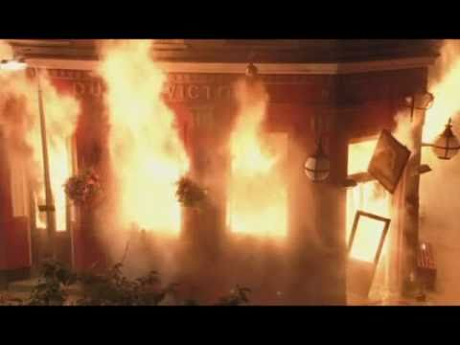  In this complex external sequence in which the Queen Vic is accidently set on fire, the camera operator must ensure that he/she communicates clearly with both the director (who is on set), the actors and the pyrotechnics crew.  It is essential that the framing, composition and movement is correctly carried out to ensure a realistic looking scene, but also because it is an on-off event that cannot be recreated quickly. Deadlines are tight on soap operas (Eastenders is on three times per week), so destroying a set requires careful planning. It is also a dangerous and high pressured situation.  A senior Camera Supervisor will be in control of the overall direction of the scene and safety of the camera crew.
Floor Manager
Presenter
Director
Production Assistant
VT Operator
Sound Supervisor
Vision Mixer

