

NAME:

**Ancient History**

**Period Study: Relations Between Greek States and Between Greek and Non-Greek States, 492-404 BC**

**TOPIC 2:**

**Greece in Conflict**

**479-446 BC**

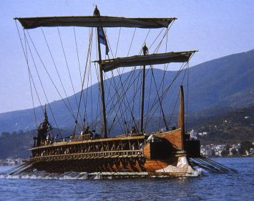

***Aims of this Booklet:***

* Identify the impact of the Persian Wars on Hellas
* Assess the reasons for the growth in Athenian power after 479
* Evaluate the strengths of Athenian and Spartan relations
* Examine the First Peloponnesian War – causes, events, outcome
* Identify the main sources from this period and understand their context

**Suggested Reading**

**History Today Articles (go to** [www.historytoday.com](http://www.historytoday.com) **username= Godalming; password= history)**

# Thucydides: the Compassionate Scientist

By [P.A. Brunt](http://www.historytoday.com/author/pa-brunt)

Published in [History Today](http://www.historytoday.com/archive/history-today/latest) [Volume 7 Issue 12 December 1957](http://www.historytoday.com/archive/history-today/volume-7-issue-12-december-1957)

# Thucydides, Chance and the Dilemma of Imperialism

By [Irene Brown](http://www.historytoday.com/author/irene-brown)

Published in [History Today](http://www.historytoday.com/archive/history-today/latest) [Volume 31 Issue 3 March 1981](http://www.historytoday.com/archive/history-today/volume-31-issue-3-march-1981)

# Architects of the Athenian Empire, Part I: Themistocles

By [Stephen Usher](http://www.historytoday.com/author/stephen-usher)

Published in [History Today](http://www.historytoday.com/archive/history-today/latest) [Volume 17 Issue 5 May 1967](http://www.historytoday.com/archive/history-today/volume-17-issue-5-may-1967)

# Architects of the Athenian Empire, Part II: Pericles

By [Stephen Usher](http://www.historytoday.com/author/stephen-usher)

Published in [History Today](http://www.historytoday.com/archive/history-today/latest) [Volume 17 Issue 6 June 1967](http://www.historytoday.com/archive/history-today/volume-17-issue-6-june-1967)

**Textbooks**

* C. Cottam, D. Hodgkinson *et al*, *OCR Ancient History, Component 1: Greece*, Bloomsbury, 2017

**Books in the ILC**

* J. T. Roberts, *The Plague of War: Athens, Sparta and the struggle for Ancient Greece,* Oxford, 2017
* J. Ober, *The Rise and fall of Classical Greece*, Princeton, 2016
* R. Garland, *Ancient Greece: everyday life in the birthplace of western civilisation,* New York, 2013
* R. L. Fox, The Classical World, Penguin, 2006
* P. Cartledge, *Ancient Greece: A very Short Introduction*, Oxford, 2011
* J. Boardman, *The Oxford History of Greece & the Hellenistic World*, Oxford, 1986

**eBooks on** [**www.dawsonera.co.uk**](http://www.dawsonera.co.uk)

* G. Cawkwell, *The Greek Wars: The Failure of Persia*, Oxford, 2005
* P. Rhodes, *A History of the Classical Greek World 478-323 BC*, Wiley-Blackwell, 2009
* P. Cartledge, *After Thermopylae,* Oxford, 2013
* Powell, *Athens and Sparta,* Routledge, 2016
* P. De Souza, *The Greek and Persian Wars 499-386 BC*

**Useful Websites**

* <https://www.bloomsbury.com/cw/ocr-as-and-a-level-ancient-history/?pid=330294> (A companion website for the OCR Ancient History textbook – good selection of wider reading and revision quizzes)
* <http://www.ancient.eu/>
* <http://ancient-greece.org/index.html>
* <http://www.livius.org/>
* [www.ocr.org.uk](http://www.ocr.org.uk)

 **Podcasts**

Sparta **-** <http://www.bbc.co.uk/programmes/b00nvz72>

The Battle of Themopylae - <http://www.bbc.co.uk/programmes/p004y278>

The Battle of Salamis - <http://www.bbc.co.uk/programmes/b08j99jl>

Thucydides - <http://www.bbc.co.uk/programmes/b050bcf1>



*For help in accessing the ebook catalogue on dawsonera, go to the ILC’s page on Godalming Online and read their guide to accessing ebooks.*

*Ebooks can be read using your college log on details whilst in college or at home.*

**ANCIENT HISTORY LUNCHTIME SUPPORT**

**If you need any help in Ancient History going over content, completing homework, attempting assessed questions or preparing for exams, there will be a lunchtime support session each Wednesday between 1 and 2 pm in room 211.**

**Primary Sources**

Herodotus’ account of the Persian Wars ends largely in 479 BC and there is not one single source that covers the period that follows (and certainly not in the detail that Herodotus had done). Instead our evidence of this period comes from sections of different sources:

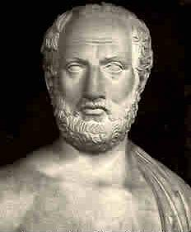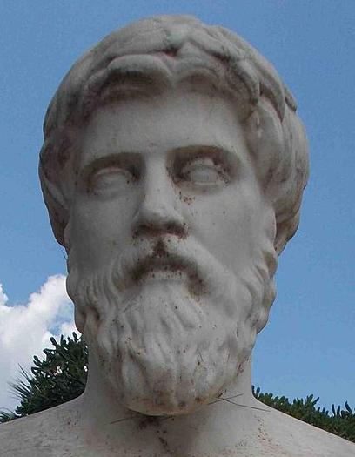

**Primary Source – Author**

**Thucydides**

* Born around 460 BC and died around 404 BC
* Wrote *The History of the Peloponnesian War* – a detailed year-by-year account of the conflict between Athens and Sparta
* Thucydides lived through the entire conflict and served as an Athenian general in 424
* Claimed to base his work on research and investigation. Wrote during a period of Greek rationalism that sought to give scientific explanations for events
* Moved away from Herodotus’ style of writing which included the Gods and myths
* Accounts , however, are one-sided and the role of Persia in the conflict is largely ignored

**Primary Source – Author**

**Plutarch**

* Born in the town of Chaeronea in Boeotia (mainland Greece)
* Born sometime before AD 50 and died around 120
* Wrote a work called *Parallel Lives* which was a series of biographies comparing famous Greeks with famous Romans
* Used a wide variety of earlier sources to create his work. Also came from a well-educated background
* Plutarch himself stated that he was a biographer not a historian

**Primary Source – Author**

**Diodorus Siculus**

* A Greek historian writing in the first-century BC (by this time Greece was part of the Roman Empire)
* Also known as Diodorus ‘the Sicilian’
* He wrote a work called *Universal History* – a huge work which attempted to write down known history of the known world up to 60 BC
* Based much of his work on the evidence of an earlier writer called Ephorus. Ephorus, however, was trained in rhetoric and therefore tried to make events as dramatic and exciting as possible

**The Impact of the Persian Wars**

***STARTER***

Before looking at the consequences of the Persian Wars in detail, consider the following with the person next to you:

**Discussion Point One**

***Who was in a stronger poisition at the end of the Persian Wars?***

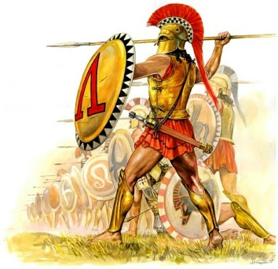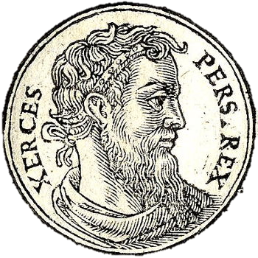

**Discussion Point Three**

***What should the Hellenic league do following their victory in 479?***

**Discussion Point TWO**

***How would you expect Xerxes and the Persians to react after 479?***

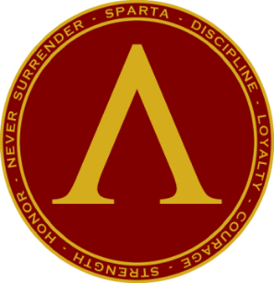

**SPARTA**

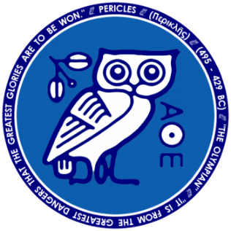

**ATHENS**

**The Impact of the Persian Wars**

With the Greek victories at Plataea and Myclae in 479 BC, the immediate Persian threat ended. However, there was no guarantee that the Persians would not regather their strength and attack again, as they had done after their first defeat at Marathon in 490.

The Greeks therefore had to find more permanent ways of defending *Hellas* from future invasion.

***Recap:***Can you remember what two suggestions were put forward during the Hellenic League’s meeting at Samos in 479 about how best to defend against future Persian attack?

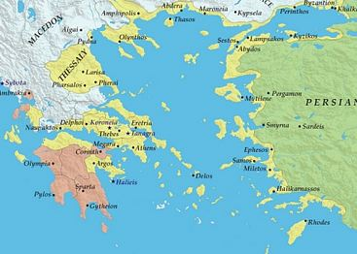As the Greeks continued to attack and chase the Persians after 479, two powerful leagues would develop and growing division between the Greeks would become clear.

These leagues were the **Peloponnesian League**, which had existed as far back as the 550s and was dominated by Sparta, and the newly formed **Delian League** under the leadership of Athens.The period between 479 and 460 saw tensions between the two Leagues grow dramatically and by 460 the two sides would be at war, known as **the First Peloponnesian War** (460-446), and Athens and Sparta would fight directly in battle for the first time in 457.

***Looking at the two sides shown on the map, which do you think held the advantage in 460?***

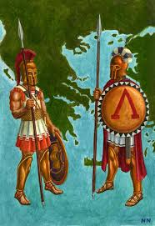

**The Peloponnesian League**

As you have already seen, the Peloponnesian League had existed as far back as the 550s BC and had been the basis of the Hellenic League during the Persian Wars. The Peloponnesian League was formed of city-states mainly from the Peloponnese, although there were other important members including Megara and the island of Aegina. The League was based on the following points:

1. If any member was attacked by someone outside the League, the other members would come to its defence
2. Decision-making was shared: the Spartan assembly and a congress of all the other allied states had to agree for the League to take action
3. When the League went to war, the Spartans would organise and lead the army

During the second Persian invasion, the Peloponnesian League had cooperated with other cities such as Athens but once the Persian threat had gone, cracks in this cooperation soon began to appear. In particular, Sparta and other member of the League became increasingly worried about the rapid growth in Athenian power as it created the new Delian League and gained money and ships in the process.

Spartan anxiety became more intense as the Athenians quickly built strong walls around their city between 479 and 478 BC.

**Prescribed Source – Thucydides 1.90-92 (p. 88-90)**

When the Spartans heard of what was going on they sent an embassy to Athens. This was partly because they themselves did not like the idea of Athens or any other city being fortified, but chiefly because they were urged on by their allies, who were alarmed both by the sudden growth of Athenian sea-power and by the daring the Athenians had shown in the war against the Persians. The Spartans proposed that not only should Athens refrain from building her own fortifications, but that she should join them in pulling down all the fortifications which still existed in cities outside the Peloponnese. In making this suggestion to the Athenians they concealed their real meaning and their real fears; the idea was, they said, that if there was another Persian invasion, the Persians would have no strong base from which to operate, such as they had in Thebes; and that the Peloponnese was capable of serving the needs of everyone, both as a place of refuge and as a place from which to attack.

After this speech from the Spartans, the Athenians, on the advice of Themistocles, immediately sent them away with the reply that they would send an embassy to discuss the points that had been raised. Themistocles then proposed that they should send him to Sparta at once, but should not for the time being send the other delegates elected to go with him; instead they should wait until they had built their fortifications high enough to be able to be defended. Meanwhile the whole population of the city was to work at building the walls; no private house or public building which might be of any use to the work was to be spared, but must in every case be demolished.

So Themistocles set off, leaving these instructions behind him and indicating that he himself would arrange everything else that needed arranging in Sparta. When he arrived there he did not approach the Spartan government, but kept on putting things off on various excuses. If anyone in authority asked him why he did not come before the Assembly, he replied that he was waiting for his colleagues, that they had not been able to leave Athens because of urgent business, but that he expected them to come soon and was surprised that they had not arrived already. The Spartans believed what Themistocles said because of the respect in which they held him; but as other people kept on arriving, all positively asserting that the fortifications were being built and had already reached a certain height, they did not see how they could reject such information. Themistocles, realizing this, told them that instead of being led astray by rumours they ought to send some reliable people of their own who could go and see for themselves and come back with a correct report. This the Spartans did, and Themistocles sent secretly to Athens, telling the Athenians to keep the Spartan envoys there, to avoid, if possible, putting them under open constraint but not to let them go until he and his colleagues had got back. For his fellow delegates – Abronichus, the son of Lysicles, and Aristides, the son of Lysimachus – had now arrived, and had told him that the fortifications were now sufficiently advanced. Themistocles therefore was afraid that the Spartans might now refuse to let them go, once they received accurate information about what had happened.

The Athenians followed this instruction and detained the Spartan delegates. Themistocles approached the Spartan authorities and at last spoke to them openly. He said that Athens was now fortified, and fortified sufficiently well to be able to protect her people: that if the Spartans or their allies wanted to send embassies to Athens on any subject, they should in future go there prepared to recognize that the Athenians were capable of making up their own minds both about their own interests and about the interest of the rest of Hellas. He pointed out that when the Athenians decided to abandon their city and take to their ships; it was not in consultation with Sparta that they were adopting that daring resolution, and that whenever they had joined in counsel with the Spartans it was clear that no one else had offered better advice. And now they thought it better that their city should be fortified; it was better for their own citizens and also would be an advantage to the whole alliance; for it was only on the basis of equal strength that equal and fair discussions on the common interest could be held. This meant that no city in the alliance should be fortified or else that wat the Athenians had done should be approved.

After listening to this, the Spartans showed no open signs of displeasure towards Athens. The fact was that their original embassy to the Athenian people had not stated any intention to prevent the action but had only appeared to offer advice. Also this was a time when Sparta was particularly friendly to Athens, because of the courage displayed by Athens against the Persians. All the same the Spartans had not got their way and secretly they felt aggrieved because of it. The delegates from both states returned home without making any complaints.

1. Why were the Athenians determined to build walls around their city?
2. What does the account of the building of Athens’ wall reveal about their relationship with Sparta?
3. What is the tone/style of Themistocles’ final speech to the Spartans and why is this?

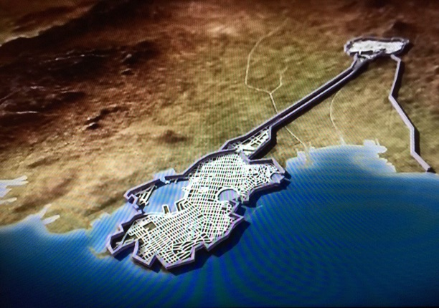Archaeological remains support the idea that Athens’ walls were built quickly and in addition to the walls around the city, Themistocles had also created a plan before the first Persian invasion to build a wall around Athens’ port **Piraeus** and a set of walls connecting it to the city. These fortifications would be known as the **Long Walls** and are a good example of Athens’ growing confidence and power, along with its suspicions of other Greeks. The construction of the Long Walls would be finished in 457 BC.

**Prescribed Source – Thucydides 1.107 (p. 97-98)**

At about this time the Athenians began to build their two long walls down to the sea, one to Phalerum and one to Piraeus. And at the same time the Phocians started a campaign against Doris, the original homeland of the Spartans, containing the towns of Boeum, Cytinium, and Erineum. When they had captured one of these places the Spartans came to the assistance of the Dorians with a force of 1,500 hoplites of their own and 10,000 of their allies. This force was commanded by Nicomedes, the son of Cleombrotus, acting as deputy for the Spartan king Pleistoanax, who was still under age. The Spartans compelled the Phocians to come to terms and to give back the town which they had taken. They then began to think of their return journey. If they went by sea across the Gulf of Crisa, the Athenians would be able to sail up with their fleet and stop them; nor did the route across Geraneia appear to be a safe one, since the Athenians held Megara and Pegae. The passes over Geraneai are difficult ones and were always guarded by the Athenians; moreover, on this occasion the Spartans had information that the Athenians had every intention of preventing them from taking this route. It seemed best, therefore, to stay in Boeotia and wait and see what the safest line of march would be. In this course they were also influenced by the fact that there was a party in Athens who were secretly negotiating with them in hope of putting an end to democratic government and preventing the building of the Long Walls.

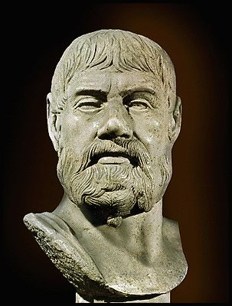**The Delian League**

The Delian League started life between 478 and 477 BC as an alliance between Athens a number of city-states and islands around the Aegean. Its aim was to defend against a future Persian invasion (defensive) and to drive the Persians out of the Greek city-states in Asia Minor (offensive). Originally the Hellenic League had organised the effort to drive out the Persians under the command of the Spartan commander **Pausanias**.

Pausanias achieved a number of victories including the capture of Cyprus and the city of Byzantium from the Persians in 478. However, the sources depict Pausanias as an arrogant commander who would later even try to establish himself as a dictator in Byzantium. The other Greek forces under Pausanias command plotted to remove him and give command of the Greek forces in the Aegean to Athens instead.

Two Athenian figures would emerge to take over command and build the new Delian League. The first, **Aristeides** was known as ‘The Just’, whilst the second, **Cimon**, was the son of Miltiades (Athenian commander at Marathon) and would lead the Delian military forces in its early years.

**Prescribed Source - Plutarch, *Aristeides* 23 (No. 10)**

When Aristeides was sent out along with Kimon as general for the war, he saw Pausanias and the other Spartiate [=Spartan citizen] commanders proving harsh and tiresome for the allies. He himself mingled with them in a kindly and considerate way and made sure Kimon was accommodating and even-handed to all the contingents. In this way he took over the leadership without the Spartans noticing, not by force of infantry, navy or cavalry but by kindness and diplomacy.

Pausanias’ greed and harshness were particularly important in making the Athenians desirable, the Athenians being agreeable to the Greeks because Aristeides was fair and Kimon noble. Pausanias always met the allied commanders with a short temper and rough treatment, and he punished the troops with beatings and making them stand holding an iron anchor all day.

No one was allowed to fetch bedding or fodder or approach a spring to get water before the Spartans did, servants with whips driving away anyone who tried. When Aristeides once tried to make known the complaints on their behalf, Pausanias scowled, said he had no time, and did not hear him out.

As a result of this the various Greek naval and military commanders, and particularly he Khians, Samians and Lesbians, went along to Aristeides and tried to persuade him to accept the leadership and to take command of the allies who had long wanted to be rid of the Spartiates and to transfer their allegiance to the Athenians.

Aristeides replied that he saw that their arguments were compelling and fair, but that he needed a pledge in the form of an action which, once taken, would not allow the troops to transfer their allegiance back again. AS a result, the friends of Ouliades the Samian and Antagoras the Khian, who had hatched the plot at Byzantion, launched an attack on Pausanias’ trireme when it was sailing out in the middle of the fleet.

When Pausanias saw this, he rose up and angrily threatened that in a short time he would show that they had not attacked his ship but their own homelands. They told him to go away and think himself lucky to have had a share of their glory at Plataia; for they thought that it was because the Greeks still felt embarrassed over that they had never exacted proper justice form him. Finally they revolted and went over to the Athenians.

It was here that Sparta’s wisdom revealed itself as remarkable. For when they became conscious that their commanders were being corrupted by the amount of power they were exercising, they willingly gave up the leadership and stopped sending generals to the war; they chose to have citizens who were self-controlled and continued to behave according to traditional values rather than to rule the whole of Greece.

1. What type of behaviour was Pausanias accused of? (Try to find at least three points)
2. Which states were particularly important in removing Pausanias as commander?
3. What does Plutarch claim in the final section of this source and how convincing do you find this?

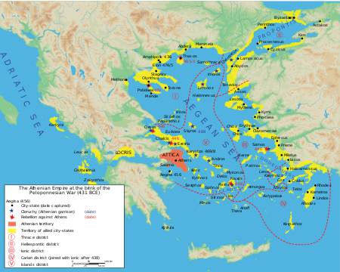

Following Pausanias’ removal as commander, Aristeides and Cimon went on to found a new alliance with Athens at the centre of it. This new league met for the first time in 477 on the island of **Delos** – a sacred island that was meant to be the birth place of Apollo and Artemis, and was also central to most of the member states. At the time this new alliance did not have a particular name but has since be called the **Delian League** by historians after the location of its first meeting.

The League was primarily a naval alliance and a system was devised for collecting either ships or money from the member states. Larger members, it was intended, would contribute more and smaller states less. The money collected was kept in a central treasury on the island of Delos. It is not entirely clear how decisions were originally made in the League but the members either had one vote each, or the Athens held one vote and all the other states held another (this was how the Peloponnesian League was run).

**Prescribed Source - Diodorus 11.46-47 (No. 19)**

Aristeides’ conduct as General was compared [to the notorious behaviour of Pausanias] among the allies, and because of the way he got on with his subordinates and his other virtues, he made them all incline, as it were with one accord, towards the Athenians. So they no longer took any notice of leaders sent from Sparta, but as a result of their admiration for Aristeides they enthusiastically submitted to him in every matter, and so enabled him to take over the supreme command by sea without having to face any danger. Immediately, therefore, Aristeides advised all the allies, who were holding a general meeting, to choose Delos as their common Treasury, to deposit there all the money they collected, and to impose a levy on all the cities according to their means for the war which they suspected would come from Persia. The total collected as a result was 506 talents. Aristeides was put in charge of the tribute assessment, and he shared out the amount so precisely and fairly that all the cities were well pleased. Since he seemed to have accomplished something impossible, Aristeides got the greatest reputation for justice, and because he was so excessively just he was known as ‘Aristeides the Just’.

***How similar is the portrayal of Aristeides in the ancient sources?***

**Prescribed Source - Plutarch, *Aristeides* 24.1–5 (No. 20)**

Even while the Spartans were leading them, the Greeks made contributions towards the war. Wanting the burden on each city to be moderate, they asked the Athenians for Aristeides’ help, and instructed him to consider the land and income of each city and to fix the contributions according to the resources of each. When he acquired such powers and Greece had, in a way, put all her affairs in his sole charge, he went out to the job poor and returned poorer, and he assessed the contributions not only justly but in a way that was kind and fitting for everyone. As the men of old praised the age of Kronos [as the Golden Age], so the allies of the Athenians sang the praises of Aristeides’ assessment as a stroke of good fortune for Greece, and particularly when not long afterwards tribute was doubled and then tripled. To explain, Aristeides’ assessment was 460 talents; Perikles added practically a third to this, for Thucydides says that at the beginning of the [Peloponnesian] war 600 talents were coming into the Athenians from their allies; after Perikles’ death, the demagogues [popular political leaders] increased it little by little until they had brought the total to 1,300 talents. They did this not so much because of the length and fortunes of war, but because they enticed the people into distributions of money, payments for public shows [*theorika*] and constructing cult statues and temples.

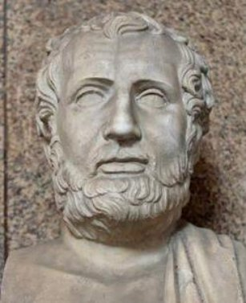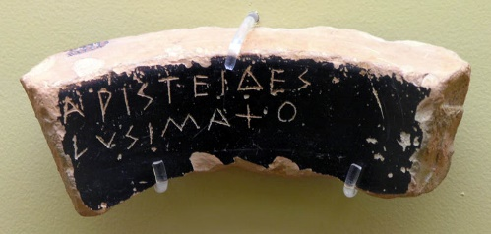

**Prescribed Source – Thucydides 1.96 (p.92)**

So Athens took over the leadership, and the allies, because of their dislike of Pausanias, were glad to see her do so. Next the Athenians assessed the various contributions to be made for the war against Persia, and decided which states should furnish money and which states should send ships – the object being to compensate themselves for their losses by ravaging the territory of the King of Persia. At this time the officials known as ‘Hellenic Treasurers’ were first appointed by the Athenians. These officials received the tribute, which was the name given to the contributions in money. The original sum fixed for the tribute was 460 talents. The treasury of the league was at Delos, and representative meetings were held in the temple there.

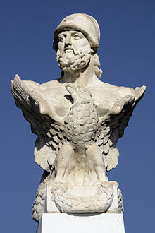

**Prescribed Source – Thucydides, 1.99-100 (p. 99-100)**

The chief reasons for these revolts were failures to produce the right amount of tribute or the right number of ships, and sometimes a refusal to produce any ships at all. For the Athenians insisted on obligations being exactly met., and made themselves unpopular by bringing the severest pressure to bear on allies who were not used to make sacrifices and did not want to make them. In other ways, too, the Athenians as rulers were no longer popular as they used to be: they bore more than their fair shar of the actual fighting, but this made it all the easier for them to force back into the alliance any state that wanted to leave it. For this position it was the allies themselves who were to blame. Because of this reluctance of theirs to face military service, most of them, to avoid serving abroad, had assessments made by which, instead of producing ships, they were to pay a corresponding sum of money. The result was that the Athenian navy grew strong at their expense, and when they revolted they always found themselves inadequately armed and inexperienced in war. Next came the battles of the river Eurymedon in Pamphylia, fought on land and on sea by the Athenians and their allies against the Persians. In both battles, the Athenians won the victory on the same ay under the command of Cimon, the son of Miltiades, and they captured or destroyed the entire Phoenician fleet of 200 triremes.

***How similar is the portrayal of Cimon in the ancient sources?***

**Prescribed Source - Plutarch, *Cimon* 11–12.4 (No. 33);**

The Allies continued paying tribute but failed to provide men and ships according to their assessment, and were already refusing to go on campaign and did not man ships or send men, on the grounds that there was no need for warfare and that they wanted to live quietly and farm, since the barbarians had been removed and were not causing trouble. The other Athenian generals applied compulsion to make them do this, put those who failed on trial and by their punishments made Athenian rule grievous and hard to bear. But when Kimon was general he went in the opposite direction, and did not apply force to any Greek; he accepted money from those who were not willing to campaign, and empty ships, and he let them be enticed by leisure and spend their time on their own affairs, turning themselves from warriors into money-makers and farmers not fit for war through luxury and folly. He put many Athenians on the ships in turn and made them labour on the campaigns, and in short time used the money and pay from the allies to make the Athenians masters of those who paid. As a result of their own shyness of warfare, the allies became accustomed to fearing and flattering the men who were maintained and trained, and were always sailing and handling arms; they failed to realise that they were turning themselves into subjects and slaves.

No one did more to humble the great King and abase his pride than Kimon. He did not let him go when he departed from Greece, but following hard on the Persians’ heels and not letting them pause for breath, as it were, he ravaged and destroyed some of their territories and made others revolt and come over to the Greeks, so that he completely cleared Asia of Persian arms from Ionia to Pamphylia. When he learned that the King’s generals were lying in wait in Pamphylia with a large army and many ships, he set out from Knidos and the Triopion peninsula with 300 ships, with the intention of inducing such fear as to make the sea this side of the Khelidonian islands an area they would not sail into or trespass upon. These ships had been made by Themistokles to be very swift and manoeuvrable, and on that occasion Kimon made them broader, and gave them a gangway on the decks so that they would carry large numbers of hoplites and so be more effective at fighting the enemy. He sailed to the city of Phaselis, whose inhabitants were Greek, but they did not receive the fleet or wish to revolt from the King, and so he began to ravage their territory and attack their walls. The Khians, who were part of his fleet, had long enjoyed friendly relations with Phaselis, induced Kimon to be more gentle and shot pamphlets attached to arrows over the walls with messages for the people of Phaselis. In the end this brought reconciliation on condition that Phaselis pay ten talents, join the League, and take part in the campaign against Persia.

**The Actions of the Delian League**

Place the following events in the correct order on the timeline below:

*Battle of Eurymedon; death of Xerxes; Thasos revolted against Delian League; Delian League Formed; Helot revolt in Sparta; Naxos revolted against the League*

|  |
| --- |
| **480** |
|  |
| **475** |
|  |
| **470** |
|  |
| **465** |
|  |
| **460** |

**Extension Task:** Do some additional research into the battle of Eurymedon. Record any key details you find about when, where and by whom it was fought, along with the wider significance of the battle.

**The First Peloponnesian War**

Since the founding of the Delian League, tension between Athens and Sparta had clearly been growing and this was made worse by Athens’ secretive building of its walls. This tension however would worsen dramatically after 465 leading at first the allies of Athens and Sparta to go to war, and then for the two cities themselves to first fight at the battle of **Tanagra** in 457 BC. A number of factors brought about the First Peloponnesian War:

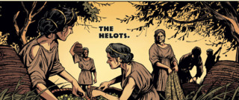**The Helot Revolt, 464 BC**

The helots were a slave population that came from the regions of **Laconia** and neighbouring **Messenia**. Helots were owned by the Spartan state and used primarily for farming; this was needed as the male Spartan population were full-time soldiers. Helots could also act as domestic slaves or personal attendants, and could even be conscripted into the army at times of need. Helots outnumbered Spartan citizens and so to maintain control, were treated brutally. For example, (an according to the ancient sources) each year the Spartan government would declare war on the helots making it lawful for a Spartan to kill a Helot. More specifically, some Spartan men who recently completed their training took part in the ***krypteia***, a practice that involved leaving Sparta and killing any Helots that were found. The Spartans were encouraged to kill the strongest Helots they could find to prove themselves and to purge the slave population of potentially dangerous members.

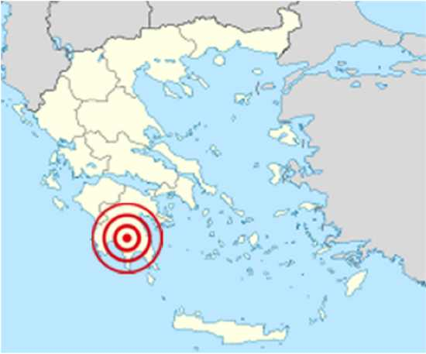In 464 BC a huge earthquake struck Sparta causing a revolt by the helots. The reaction to this revolt would be a major cause of the First Peloponnesian War:

**Prescribed Source – Herodotus 1.101-103 (p.94-96)**

Meanwhile the people of Thasos, who had been defeated in battle and were now besieged, appealed to Sparta and urged her to come to their help by invading Attica. The Spartans, without informing Athens of their intentions, promised to do so, and would have done so if they had not been prevented by the earthquake which happened then and by the simultaneous revolt and secession to Ithome of the helots and of some of the perioeci, the Thuriats and the Aethaeans. The helots were mostly descendants of the ancient Messenians, who had been enslaved in the famous war. Thus they all came to be called Messenians. So Sparta had a war on her hands against the rebels in Ithome, and the Thasians, in the third year of the siege, had to accept the Athenian terms: their walls were demolished and their navy surrendered; they were ordered to pay an indemnity immediately and to pay tribute in future; they surrendered their rights on the mainland and also the mine there.

And now the Spartans, finding that their war in Ithome showed no signs of ending, appealed for help to their allies, including Athens, and the Athenians came to Sparta with considerable force under the command of Cimon. The chief reason that they asked for Athenian help was that the Athenians had the reputation of being good at siege operations, and, after a long siege, it became clear to the Spartans that they themselves lacked experience in this department of warfare; for otherwise they would have succeeded in taking the place by assault. This expedition was the occasion for the first open quarrel between Athens and Sparta. The Spartans failing to capture Ithome by assault, grew afraid of the enterprise and the unorthodoxy of the Athenians; they reflected, too, that they were of different nationality and feared that, if they stayed in the Peloponnese, they might listen to the people of Ithome and become the sponsors of some revolutionary policy. So, while keeping the rest of their allies, they sent the Athenians home again, not saying openly what their suspicions were, but merely declaring that they had no further need of Athenian help. The Athenians, however, realized that they were not being sent away for any such honourable reason as this, and saw that in fact they had become in some way suspect. They were deeply offended, considering that this was not the sort of treatment they deserved from Sparta, and, as soon as they had returned, they denounced the original treaty of alliance which had been made against the Persians and allied themselves with Sparta’s enemy, Argos. At the same time both Argos and Athens made an alliance on exactly the same terms with the Thessalians.

Meanwhile the rebels in Ithome after ten years’ fighting were unable to hold out longer, and came to terms with Sparta, the terms being that they should have safe conduct to leave the Peloponnese and should never set foot in it again: if any of them were caught there in the future, he should be the slave of whoever caught him. There was also an oracle from Delphi which the Spartans had and which instructed them to let go the suppliant of Zeus at Ithome. So they left the country with their wives and children, and the Athenians, because of the ill feeling against Sparta which had already developed, received the exiles and settled them in the town of Naupactus, which they had recently taken from the Ozolian Locrians.

At this time Megara also joined the Athenian alliance, abandoning her alliance with Sparta because the Corinthians were attacking her in a war concerning the frontier boundaries. Thus the Athenians held Megara and Pegae, and built for the Megarians their long walls from the city to Nisea, garrisoning them with Athenian troops. It was chiefly because of this that the Corinthians began to conceive such a bitter hatred for Athens.

1. Why do you think the earthquake encouraged a revolt by the helots?
2. Why did Sparta ask for help in dealing with the revolt from Athens?
3. Why did the Spartans ask the Athenians to leave?
4. What two steps did Athens take after the Peloponnese?

**Corinth and Megara**

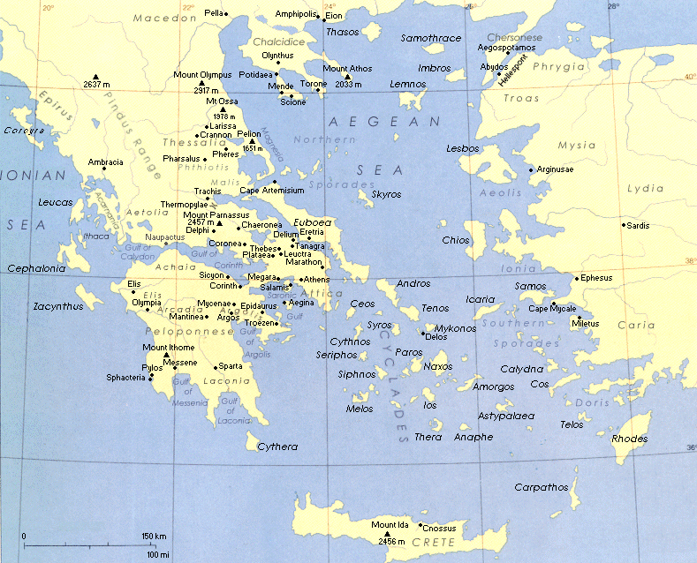A further cause of the First Peloponnesian War was a conflict fought between two of Sparta’s allies: **Corinth** and **Megara**. In the early 460s BC the two cities began a war over their borders (see Herodotus 1.103 above) and the Megarians found themselves close to defeat. At this point, Megara pulled out of the Peloponnesian League (seceded) and asked the Athenians for help.

**TASK** – look closely at the map (or a larger version if you have it). Why would Megara turn to Athens to help and why might it be advantageous for Athens to give it?

The outcome of this move from Megara was that now a member of the Peloponnesian League (Corinth) was at war with a member of the Delian League (Megara). This had the potential to turn a local conflict into a much bigger war and it also turned Athens and Corinth against one another. Today many historians refer to 460 and the decision of Megara to switch sides to Athens as the start of the **First Peloponnesian War** (460 to 446). The next fifteen years after 460 would see a series on conflicts between the members of each league with both Sparta and Athens involved at times:

**Prescribed Source – Herodotus 1.105-108 (p.94-96)**

At this time, too, the Athenians sent out a fleet and made a landing at Haliae. Here they were engaged by a force of Corinthians and Epidaurians, and the Corinthians were victorious. Later there was a sea battle of Cecryphalia between the Athenians and Peloponnesian fleets, and the Athenians were victorious.

After this was war broke out between Athens and Aegina, and there was a big battle at sea off Aegina between the Athenians and the Aeginetans, with the support of allies on both sides. The battle was won by the Athenians, who captured seventy enemy ships. They then landed on Aegina and started to besiege the place, under the command of Leocrates, the son of Stroebus. At this point the Peloponnesians, wishing to relieve Aegina, made a landing in the island with 300 hoplites who had previously been serving with the Corinthians and Epidaurians. At the same time the Corinthians and their allies seized the heights of Geraneia and moved down into the Megarid, believing that that it would be impossible for the Athenians to come to the relief of Megara, since they had two large forces already serving abroad in Aegina and in Egypt; and, they thought, if Athens did manage to relieve Megara, she would have to withdraw her troops from Aegina. The Athenians, however, did nothing of the kind. They raised in the city a force out of the old men and the very young who had been left behind and marched to Megara under the command of Myronides. Here an indecisive battle was fought between them and the Corinthians, and when the battle was broken off, each side considered that had had the advantage. However, after the Corinthians had withdrawn, the Athenians, who had in fact done best in the fighting, set up a trophy. About twelve days later the Corinthians, who had had to suffer the taunts of the older people in their own city, made their preparations, marched out, and put up a trophy of their own to prove that the victory had been theirs. The Athenians came out against them from Megara, overwhelmed the contingent that was setting up the trophy, and then engaged and defeated the rest of their enemy. As the defeated Corinthians were retreating, quite a large section of their army, coming under severe pressure and being uncertain of its route, plunged into an enclosure on someone’s estate which had a deep ditch all round it so that there was no way out. Seeing what had happened, the Athenians closed up the main entrance with their hoplites and, surrounding the rest of the enclosure with light-armed troops, stoned to death all who were inside. This was a very severe blow to the Corinthians. The main body of their army fell back to Corinth.

At about this time the Athenians began to build their two long walls down to the sea, one to Phalerum and one to Piraeus. And at the same time the Phocians started a campaign against Doris, the original homeland of the Spartans, containing the towns of Boeum, Cytinium, and Erineum. When they had captured one of these places the Spartans came to the assistance of the Dorians with a force of 1,500 hoplites of their own and 10,000 of their allies. This force was commanded by Nicomedes, the son of Cleombrotus, acting as deputy for the Spartan king Pleistoanax, who was still under age. The Spartans compelled the Phocians to come to terms and to give back the town which they had taken. They then began to think of their return journey. If they went by sea across the Gulf of Crisa, the Athenians would be able to sail up with their fleet and stop them; nor did the route across Geraneia appear to be a safe one, since the Athenians held Megara and Pegae. The passes over Geraneai are difficult ones and were always guarded by the Athenians; moreover, on this occasion the Spartans had information that the Athenians had every intention of preventing them from taking this route. It seemed best, therefore, to stay in Boeotia and wait and see what the safest line of march would be. In this course they were also influenced by the fact that there was a party in Athens who were secretly negotiating with them in hope of putting an end to democratic government and preventing the building of the Long Walls.

The Athenians marched out against them with their whole army, supported by 1,000 troops from Argos and by contingents from their other allies, making up altogether a force of 14,000 men. They made this attack partly because they thought that the Spartans were in difficulties about their way back, and partly because they had some suspicions of the plot to overthrow the democracy.

The battle was fought at Tanagra in Boeotia, and, after great losses on both sides, the Spartans and their allies were victorious. The Spartans then marched down into the Megarid, and, after cutting down some of the plantations of trees, returned home through Geraneia and past the Isthmus. The Athenians, on the sixty-second day after the battle, marched in Boeotia under the command of Myronides. They defeated the Boeotians in battle at Oenophyta and conquered the whole of Boeotia and Phocis. They pulled down the fortifications of Tanagra and took as hostages a hundred of the richest people among the Opuntian Locrians. Meanwhile they finished the building of their own Long Walls. Shortly afterwards Aegina surrendered, and was forced to destroy her fortifications, to hand over her fleet, and to agree to pay tribute in the future. Then, too, the Athenians, under the command of Tolmides, the son of Tolmaeus, sailed round the Peloponnese, burnt the Spartan dockyards, captured the Corinthian city of Chalcis, and, after making a landing at Sicyon, defeated the Sicyonians in battle.

1. Which city state did Athens go to war with and win a clear naval victory?
2. How did the Athenians manage to defend the city of Megara despite most of their army being away?
3. What defensive measures did the Athenians take in around 458 BC and what does this tell you?
4. Why was the Battle of Tanagra a turning point?
5. Was Sparta or Athens ‘winning’ by 457/56? Think carefully and explain you answer fully

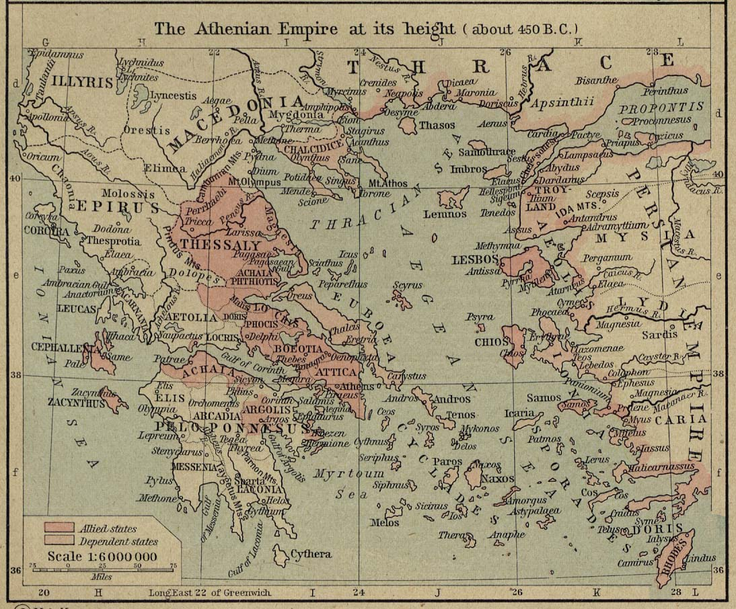 Despite the Spartan victory at the battle of Tanagra in 457 BC, Athens emerged as the stronger power and by 450 BC, the Athenian empire reached its largest ever extent. After Tanagra the Athenians returned to the region of Boeotia (see above) and won a clear victory over the local at the battle of Oinophyta. In the same year, the defeated Aeginetans (from Aegina) were forced to join the Delian League.

**Egypt**

From 460 BC the Athenians were not only involved in fighting in Hellas but also sent troops to fights against the Persians in **Egypt**. Egypt was a vital province of the Persian empire which had experienced a rebellion by Inaros, a Libyan prince. If the Athenians could add Egypt to their expanding empire this would be a huge victory; Egypt was an extremely fertile place that could supply grain whilst its location made it ideal as a trading post. Finally, if the Athenians could take Egypt, they would significantly weaken the Persians in the Mediterranean. The risk, however, was that it would involve fighting **on two fronts at the same time.**

**Prescribed Source – Herodotus 1.104 (p.96)**

About this time Inaros, the son of Psammetichus, a Libyan and the King of the Libyans bordering on Egypt, starting out from Marea, the town south of Pharos, organized the revolt of nearly the whole of Egypt from the Persian King Artaxerxes. After taking over power himself he called in the Athenians to help him. The Athenians happened to be engaged in a campaign against Cyprus with 200 ships of their own and of their allies; they abandoned this campaign, came to Egypt, and sailed from the sea up the Nile. They gained control of the river and of two-thirds of Memphis, and then attempted to subdue the remaining third, which was called the White Castle and inside which were the Persians and Medes who had escaped and those of the Egyptians who had not joined the revolt.

**Prescribed Source – Herodotus 1.109-110 (p.99)**

Meanwhile the Athenians and allied force in Egypt was still engaged, and suffered all the chances and changes of war. At first the Athenians were masters of Egypt, and the King of Persia sent to Sparta a Persian named Megabazus with money to bribe the Spartans to invade Attica and so force the Athenians to recall their fleet from Egypt. These negotiations, however, were unsuccessful, and as the money was being spent without any results, Megabazus and what remained of it were recalled to Asia. The King then sent out to Egypt another Persian, Megabazus, the son of Zopyrus, with a large army. He arrived by land, defeated the Egyptians and their allies in battle, and drove the Hellenes out of Memphis. In the end he penned them up on the island of Prosopitis and besieged them there for eighteen months. Finally he drained the channels round the island by diverting the water elsewhere. The ships were thus left high and dry; most of the island was connected to the mainland, and he captured it by marching across on foot. So, after six years of war, the great venture of the Hellenes came to nothing. Out of the whole great force a few managed to make their way through Libya and find safety in Cyrene, but nearly all were destroyed. Egypt once more passed into the control of the King of Persia, except that Amyrtaeus, the King in the marshes, still kept his independence. Because of the size of the marshes it was impossible to capture him: also the Egyptians who live in the marshes are the most warlike of their race. Inaros, the King of the Libyans, who had been the person responsible for the Egyptian revolt, was betrayed to the Persians and crucified. Meanwhile, fifty triremes from Athens and the rest of the League had sailed out to relieve the forces in Egypt. They put in at the Mendesian mouth of the Nile, having no idea of what had happened. Here they were under attack from the land by the Persian army and from the sea by the Phoenician fleet. Most of the ships were lost, though a few managed to escape. This was the end of the great expedition against Egypt made by the Athenians and their allies.

1. How did the Persians finally defeat the Athenians and their allies on Prosopitis?
2. How long had the Athenians been fighting in Egypt before their final defeat?
3. Can you calculate (approximately) how many ships the Athenians lost overall?

The defeat in Egypt was a major setback for the Athenians and in part caused them to strengthen their hold over the Delian League. They did this by moving the treasury of the League from Delos to Athens in 454/3.

**Task –** why was moving the treasury of the Delian League to Athens such a significant step?

From 454/3 onwards, the Athenians started to keep a record of the payments made by each member of the Delian League. It did this by recording 1/60 of each state’s contribution on **Tribute Quota Lists** - these were large stone columns that listed the contributions of each state the largest of which was known as the **First Stēlē**. (1/60 of each state’s contribution was meant to be dedicated to Athena).

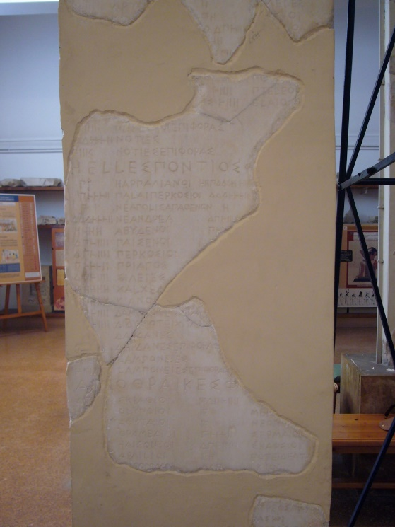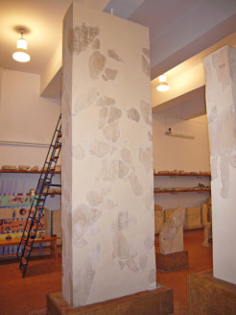

**Prescribed Source - Diodorus 12.38.2 (No. 113)**

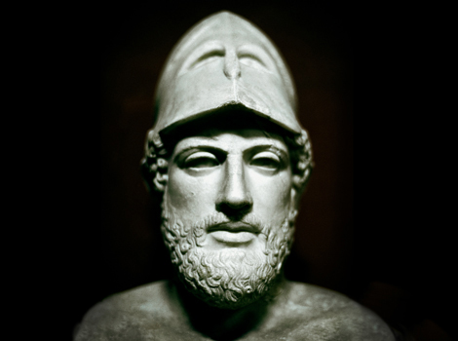The Athenians, keeping tight hold on their naval hegemony, transferred to Athens the moneys collected on Delos for common use, some 8,000 talents, and handed it over to Perikles to look after. Perikles was outstanding among the citizens for nobility, reputation, and skill in speaking. But after a time he had privately spent no small part of these moneys, and when asked to render an account he fell ill, unable to give an account of the money entrusted to him.

**Task –** Produce a one side, A4 profile on **Pericles**. Include information on his background/early life; positions held in Athens; role in the Peloponnesian Wars; death; overall significance.

**The Peace of Callias**

When the Delian treasury was moved to Athens, the city was still at war with members of the Peloponnesian League and determined to continue the fight against Persia. To focus on Persia, a five-year peace treaty was agreed with the Peloponnesians in 451, which allowed Athens to launch an attack on Persian-held Cyprus in 451/50

**Prescribed Source – Thucydides 1.112 (p.100)**

Three years later a five years’ truce was made between Athens and the Peloponnese. Having no Hellenic war on their hands, the Athenians under the command of Cimon, made an expedition against Cyprus with 200 ships of their own and of their allies. Sixty of these were detached to go to Egypt at the request of Amyrtaeus, the King in the marshes; with the rest they laid siege to Citium. Cimon’s death, however, and also a shortage of provisions made them leave Citium. Then they were sailing off Salamis in Cyprus, they fought both by land and sea with an army and a fleet of Phoenicians, Cyprians, and Cilicians. They were victorious in both battles, and then went home together with the sixty ships which had returned from Egypt.

After this the Spartans engaged in a campaign known as the sacred war. They took over the temple at Delphia and give it back to the Delphians. As soon as they had retired, the Athenians marched out, took the temple back again, and gave it back to the Phocians.

(Cimon had previously been ***ostracised*** from Athens. This was where a leading politician would be banished from the city for 10 years by the people to stop him becoming too powerful. Cimon returned after this time was up.)

The campaign against the Persians in Cyprus was an Athenian success and, according to Diodorus, it forced the Persians to ask for a peace treaty. The Athenians sent a man named Callias as their representative to these peace talks in 449 and the resulting peace became known as the ‘**Peace of Callias**’.

According to Diodorus, the following terms were agreed:

* All the Greek cities were to live under laws of their own making
* No Persian satrap was to come nearer to the sea than a three days’ journey and no Persian warship was to sail inside of Phaselis (southern coast of Turkery) or the Cyanean Rocks (near Byzantium)
* If the two points above were observed then the Athenians would not invade Persian territory

**Prescribed Source - Diodorus 12.2.1–2 (No. 52)**

The Athenians were renowned throughout practically the whole inhabited world as remarkable for bravery and glory. For they had increased their hegemony to such an extent that on their own, without the Spartans and the Peloponnesians, they had defeated the great Persian forces in contests both by land and by sea, and they so humbled the famous Persian hegemony as to compel them to make an agreement to free all the cities of Asia. But of these things we have given a quite precise and detailed account in two books, this and the proceeding…

**Prescribed Source - Diodorus 12.4.4–6; (No. 53)**

When Artaxerxes the Persian King learnt about the defeats around Cyprus, he took counsel with his friends about the war, and decided that it was in his interests to make peace with the Greeks. In consequence, he wrote to the generals in Cyprus and to the satraps [provincial governors] laying down the conditions on which they could end the quarrel with the Greeks. So those with Artabazos and Megabyzos sent ambassadors to Athens to discuss a settlement. The Athenians heard what they proposed favourably and sent ambassadors with full powers under Kallias son of Hipponikos. An agreement was made between the Athenians and their allies and the Persians about peace, whose central clauses were: that all the Greek cities in Asia be autonomous, that the Persian satraps should not come closer than three days’ journey to the coast and no long ship sail inside [west of] Phaselis and the Kyanean Rocks; that if the King and his generals observe these terms, the Athenians should not invade the land that the King ruled. Once the treaty had been concluded, the Athenians withdrew their forces from Cyprus after having achieved a brilliant victory and a most famous peace. It happened that Kimon died of illness while on Cyprus.

**The Peace of Callias – Real or Fake?**

The authenticity of the Peace of Callias has been much debated by historians. There is no mention of the peace treaty in Thucydides despite it potentially being a key event in the *Pentecontaetia* that would have helped him to account for the rise in Athenian power and growing tension within the Delian League.

Herodotus does refer to Callias having discussions with the Persians at Susa but there is no sense of a formal treaty coming out of this:

**Prescribed Source - Herodotus, 7.151-152 (p.467-468)**

There are people in Greece who say that this account is borne out by a remark made long afterwards by Artaxerxes. Callias, the son of Hipponicus, and a number of other Athenians were in Susa, the city of Memnon, on different business, and it so happened that their visit coincided with that of some representatives from Argos, who had been sent to ask Xerxes’ son Artaxerxes if the friendly relations, which the Argives had established with his father, still held good, or if they were now considered by Persia as enemies. ‘They do indeed hold good,’ Artaxerxes is said to have replied; ‘there is no city which I believe to be a better friend to me than Argos.’

The Peace of Callias was in fact denounced as a forgery by the historian **Theopompus of Chios** in the fourth century BC. He believed that the treaty was fake and had been created to emphasise the achievements of Athens. Theopompus was writing at a time when Athens was a significantly weaker power so may have been likely to exaggerate its glory days:

**Prescribed Source - Harpokration s.v. *Attikois grammasin* (No. 54)**

Doubts about the authenticity of the ‘Peace of Kallias’

Theopompos [a fourth-century historian] in book 25 of his *History of Philip* says that the treaty with the Persians is a fake, being written up not in the Attic but in the Ionic alphabet.

There is even more confusion around the Peace of Callias as the writer Plutarch mentions it but states that it was agreed after the battle of Eurymedon in the early 460s:

**Prescribed Source - Plutarch, *Cimon* 13.4–5 (No. 51)**

Conditions imposed on Persians by Kallias

This deed [Kimon’s victory at Eurymedon] so humbled the King’s pride that he made that famous peace, in which he promised that he would always keep a horse’s journey from the Greek Sea and not sail inside [west of] the Kyanean and Khelidonian islands with a long and bronze-beaked ship [i.e. a warship]. Yet Kallisthenes [late fourth-century historian] denies that the Persians made a treaty on these conditions, but says that because of the fear inspired by the defeat they acted is if such a peace was in force and kept so far away from Greece that Perikles with fifty ships and Ephialtes with just thirty could sail beyond the Khelidonians without any barbarian fleet meeting them. But Krateros in his collection of decrees [made in the early third century] includes a copy of the treaty as one that was made. And they say that the Athenians put up an altar of peace because of this treaty, and gave special honour to the ambassador Kallias.

**How convinced are you that a ‘Peace of Callias’ ever existed? Explain your answer fully.**

Today it is impossible to say categorically whether the Peace was real or not but it is clear either way that conflict with Persia did stop in the 450s.

What impact do you think the end of war with Persia would have on:

***Athens***

***The Delian League***

**The changing nature of the Delian League**

The Delian League had been formed to organise Greek islands in the Aegean and city-states in Asia-Minor into an organisation to defend against future Persian invasion and to then push back the Persians from the Greek world. With the end of conflict with Persia in the 450s (and possibly the Peace of Callias in around 449 BC) the reason for the Delian League to exist had gone.

However, the League continued after this point and what became increasingly clear was that it was in fact becoming an **Athenian Empire.**

By 450 BC, only Chios, Samos and Lesbos were providing ships for the League’s navy (in addition to Athens) but as can be seen from the comment below from Aristotle (384-322), even these members had been humbled by Athens:

**Prescribed Source - Aristotle *Politics* 1284a38 (No. 84)**

Those in positions of power do the same [i.e. weaken their rivals] with regard to cities and nations, as for example the Athenians with regard to Samos, Khios and Lesbos: for as soon as they had a firm hold over their empire, they humbled these islands contrary to agreements.

The Tribute Quota Lists also began to reflect the change in the League moving away from the idea that it was an ‘Athenian alliance’ to the idea that its members owed their allegiance to Athens, like inferior parts of an empire. The best example of this however, came in the Chalkis Decree in 446 or 455. The decree was an agreement made between the Athenians and the people of Chalkis on the island of Euboea and which was passed by the Athenian Assembly:

**TASK:**

Go to <https://www.atticinscriptions.com/inscription/IGI3/40> to read the Chalkis Decree (Prescribed Source).

1. Give three examples of responsibilities or actions owed to the Athenians by the Chalkidians:



1. Select one quote from the Chalkis Decree that best demonstrates how the Athenians turned the Delian League into an empire:

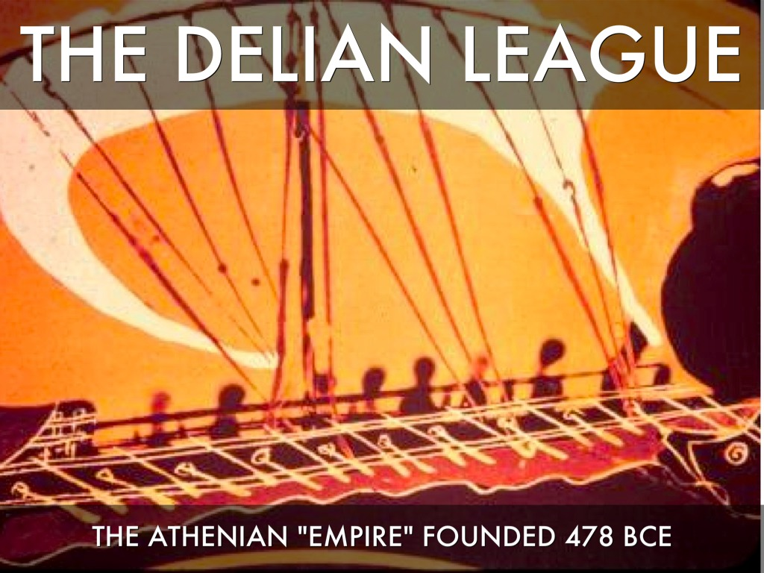Using the timeline you produced on p.13, along with your copy of the *Pentecontaetia* from Thucydides, record any examples you have found that show the Athenians oppressing or controlling other members of the Delian League?

**KEY QUESTIONS:**

1. Is it fair to accuse the Athenians of building an empire out of the Delian League?
2. How might (did) the Athenians defend themselves against this accusations?

**446 BC**

The five-year truce, agreed between the Delian and Peloponnesian Leagues in 451, did not stop further conflicts from breaking out in the Greek world. In 448 the Spartans fought a war for control of Delphi (the Sacred War) whilst in 447 the Athenians were forced to remove their forces from the region of Boeotia after military defeat.

The year 446, however, would prove crucial in the breakdown of relations between the two sides. The Athenians and Pericles found themselves dealing with two revolts at once – one on the island of Euboea and one from the city of Megara.

**RECAP** – can you remember when and why Megara had become an ally if Athens?

To support the Megarians, a Spartan-led Peloponnesian army (which included Corinthians) invaded the region of Attica under the command of the Spartan king **Pleistoanax** before quickly withdrawing. After this Pericles regained Athenian control of Euboea.

The precise reason for the Spartan withdrawal is unclear but the following accounts from Thucydides and Plutarch suggest a common explanation:

**Prescribed Source – Thucydides 5.16 (p.357-358)**

Now Athens had suffered another defeat at Amphipolis, and Cleon and Brasidas were dead – the two people who on each side had been most opposed to peace, Brasidas because of the success and honour which had come to him through war, Cleon because he thought that in time of peace and quiet people would be more likely to notice his evil doings and less likely to believe his slander of others. This was the moment, then, when even greater efforts to secure peace were made by the two statesmen who had the best claims to influence in each city, the Spartan King Pleistoanax, the son of Pausanias, and Nicias, the son of Niceratus, who had done better in his military commands than anyone else of his time. So now, while still untouched by misfortune and still held in honour, Nicias wished to rest upon his laurels, to find an immediate release from toil and trouble both for himself and for his fellow citizens, and to leave behind him the name of one whose service to the state had been successful from the start to finish. He thought that these ends were to be achieved by avoiding all risks and by trusting oneself as little as possible to fortune, and that risks could be avoided only in peace. As for Pleistoanax, he was being attacked by his enemies in connection with his restoration; whenever anything went wrong, they invariably brought his name forward in an attempt to convince the Spartans that what had happened was due to this illegal restoration of his. The charge made against him was that he and his brother Aristocles had bribed the priestess at Delphi to give oracles to the Spartan delegations which had come on various official visits, commanding them to bring home from abroad the seed of the demigod son of Zeus, or else they would have to plough with a ploughshare of silver. He was exiled because he was supposed to have been bribed to retreat from Attica, and, because of his fear of the Spartans, he had built half of his house inside the grounds of the temple of Zeus. So in the end, according to his accusers, he had induced the Spartans in the nineteenth year of his exile to Lycaeum to bring him back with the same dances and sacrifices as they had used originally in the institution of their kings at the time of the foundation of Sparta.

**Prescribed Source - Plutarch, *Pericles* 23.1–2 (No. 71)**

When Perikles included an entry of 10 talents ‘as we needed’ in his account of expenditures from his generalship [in 446/5] the people did not quibble with this or look further into the secret. But some, including the philosopher Theophrastos, have stated that Perikles had ten talents sent annually to Sparta, and that by looking after the authorities in Sparta in this way he deferred the war, not purchasing peace but time during which he could make preparations quietly and ensure that the Athenians fought better.

1. What in your opinion, and having read the two sources above, is a logical explanation for the Spartan decision to withdraw their forces from Attica in 446 BC?

By 446 BC, Athens had reached the height of its power but there were clear signs of growing tension between Athens and Sparta and their respective allies.

**GLOSSARY**

|  |  |
| --- | --- |
| **Term** | **Description** |
| **Pentecontaetia** |  |
| **Long Walls** |  |
| **Peloponnesian League** |  |
| **Delian League** |  |
| **Archon** |  |
| **Tribute Quota Lists** |  |
| **First Stēlē** |  |
| **Chalkis Decree** |  |
|  |  |
|  |  |
|  |  |
|  |  |
|  |  |
|  |  |
|  |  |
|  |  |
|  |  |
|  |  |

**KEY FIGURES**

|  |  |
| --- | --- |
| **nAME** | **Description** |
| **Aristeides** |  |
| **Cimon** |  |
| **Pausanias** |  |
| **Themistocles** |  |
| **Pericles** |  |
| **Callias** |  |
| **Pleistoanax** |  |
|  |  |
|  |  |
|  |  |
|  |  |
|  |  |
|  |  |
|  |  |
|  |  |
|  |  |
|  |  |
|  |  |