**Price Discrimination (RWS 14: Pure Monopoly Model)**

Complete the following questions

**TASK 1 - Define price discrimination in one sentence:**

|  |
| --- |
|  |

**TASK 2: ANSWER THIS MULTIPLE CHOICE QUESTION**

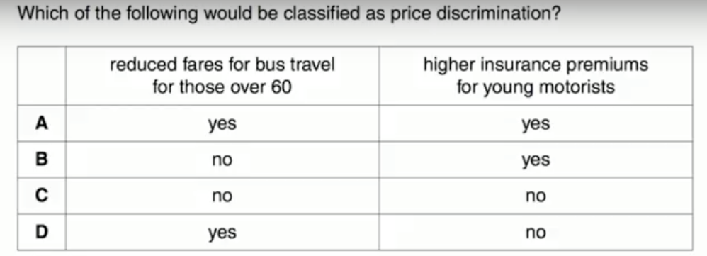

**TASK 3: Nightclub in Godalming -** A new nightclub opens up in Godalming (the only one!). The management know they face two different types of consumers, males and females. They know that males have a relatively inelastic demand curve and they know that females have a relatively elastic demand curve.

(i) Why might they make those assumptions???

|  |
| --- |
|  |

(ii) Using two diagrams (demand curves) with one representing men and one representing women, explain how the nightclub might price discriminate against men and WHY they would do this (HINT: you will be able to show this on the diagram and it is to do with ‘total revenue’).

|  |
| --- |
|  |

**TASK 4: TURN OVER AND COMPLETE THE BACK OF THE WORKSHEET**

**Pricing Strategies for Firms**

|  |  |  |  |
| --- | --- | --- | --- |
| **SCENARIOS** | | **QUESTIONS** | 1. **Why our firms following these pricing strategies do you think?** 2. **Is this a form of price discrimination and if so, what type of price discrimination?** |
| **1. Petrol Station** | This petrol station is offering cut price fuel for two days a week. |  | |
| **2. Airline travel**  Airlines charge different prices depending on the season and day of the week. | |  | |
| **3. Electricity**  For electricity, consumers get charged different tariffs depending on the quantity consumed. The first 100 units of electricity consumed are charged at a higher tariff, e.g. 25p kWh. After this first 100 units, consumers get charged a lower rate. | |  | |
| **4. Supermarket**  Firms often give coupons to selected consumers. For example, Tesco may send coupons to regular customers to get special offers, e.g. 20% off selected items. These coupons are often highly targeted to your spending habits. e.g. if you average weekly shopping bill is £50, Tesco may send you a £10 off voucher if you spend over £70. | |  | |
| **5. Hotels**  The penthouse suite at the Savoy has 5 separate rooms and a butler! The standard room has one room. The hotel charge more money for the penthouse suite than the standard room | |  | |
| **6. Rail Travel Discounts**  Students and OAPs often get discounts, such as 10% off. For rail travel, people with rail cards can get upto 33% off. (you just need to prove your age). | |  | |
| **7. Coffee Shops**  Some coffee shops offer a reward to regular consumers. If you buy nine coffees, you get the tenth free. | |  | |
| **8. Veterinary Services in Rural Areas**  Some vets will often not charge struggling farmers and then charge more for richer farmers. | |  | |

**Exam Questions on Price Discrimination**

**15 MARK EXAM QUESTION**

**“**Explain why firms, such as Apple, might be able to charge different prices for the same product in different markets.” [15 marks]

TASK: Read the answer below from a student. Using the mark scheme, what level and then mark would you give this piece of writing? If you have given full marks, you would have to explain why. If you have not given full marks, explain how the student might improve their work.

|  |
| --- |
| *Price discrimination is when a firm charges a different price to different groups of consumers for an identical good or service, for reasons not associated with costs.*  *Many different forms of price discrimination can take place such as 1st degree, 2nd degree and third degree price discrimination. However, for all these to take place certain conditions must be met.*  *First the market must be a form of imperfect competition. If there was perfect competition then price discrimination would be not possible as a producer would not be able to control their prices. There must be some level of monopoly power to allow producers the ability to price set and not price take. For example Nurofen created higher prices on the same painkiller which had the same result. This was able to occur as there was asymmetric information among consumers and some monopoly power of nurofen.*  *Another condition for price discrimination is the prevention of re-sale. If consumers can simply buy a product at cheaper prices and sell it on for a profit to a consumer who would have paid a higher price then there is no price discrimination. This re-sale could take the form of second hand shops and re-sale ticket companies such as stub-hub. These companies capitalise on this arbitrage and re-sell the good creating a profit. Prevention of re-sale could be enforced in many different ways. For example students can only receive student discounts with a legitimate student ID. Furthermore airplane and train tickets are registered to one name and ID must be shown which certifies this.*  *A key condition for price discrimination to occur is the identification of different market segments. If this is possible different groups have different price elasticities of demand (PED). Therefore the firm can charge different prices depending on the consumers sensitivity to price changes. For example they could charge higher for richer, inelastic consumers who continue buying no matter the price rise. The firm continues to gain profit as long as the marginal revenue is greater than marginal cost.*  *To gain knowledge of different groups of PED and different individual consume PED firms may have to gain information or market intelligence on consumers through means such as deep data digging in cookies and browser histories. Companies such as Amazon use this technique in order for them to suggest relevant items for each consumer with specialised deals put together based on individual consumer preference. Consumers leave a digital footprint every time they go online, this makes it cheaper and easier for many firms to engage in price discrimination.* |

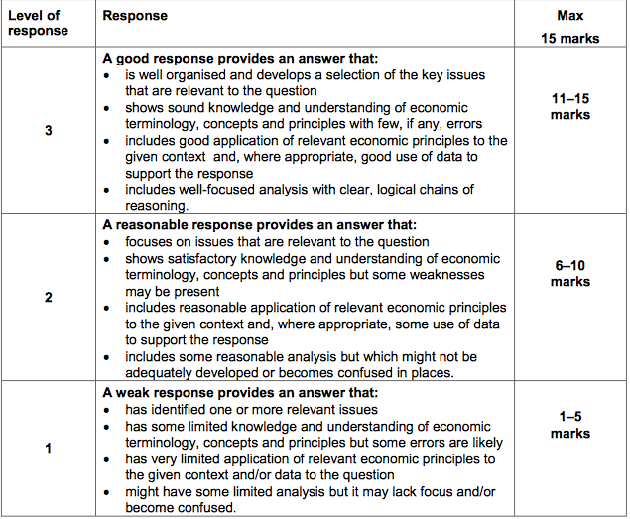

**25 MARK ESSAY QUESTION**

Discuss the view that price discrimination only benefits suppliers such as Apple. [25 marks]

TASK: How might you structure an essay on this question?

**ANSWERS**

|  |  |
| --- | --- |
| **1. Petrol Station**  This petrol station is offering cut price fuel for two days a week. | TIME OF PURCHASE   1. The petrol station isn’t even telling you which days have cut price fuel. The logic is that only the most price sensitive consumers will take the trouble to find out which two days have cut price fuel and then drive to the petrol station on those days. This takes planning and only the most price elastic consumers will buy on these cut-price days. Most consumers will not take the trouble to visit the petrol station on those two days. They will continue to buy when most convenient. 2. Yes – third degree price discrimination |
| **2. Airline travel**  Airlines charge different prices depending on the season and day of the week. | SEASONS   1. During the peak holiday season in August and Easter, the price will be higher because demand is greater and more inelastic. Flights which occur during the week e.g. Mon to Fri, will be more expensive because these are typically taken by business travellers. If you stay for over the weekend, the price will be lower, as business travellers will not want to stay over the weekend, just to get a cheaper flight. 2. Yes – 3rd degree |
| **3. Electricity**  For electricity, consumers get charged different tariffs depending on the quantity consumed. The first 100 units of electricity consumed are charged at a higher tariff, e.g. 25p kWh. After this first 100 units, consumers get charged a lower rate. | QUANTITY PURCHASED   1. The logic is that the first 100 units of electricity are essential, and therefore demand is more inelastic. However, after the first 100 units of electricity, your demand is less essential so you become more price sensitive. Therefore, the electricity company charge a lower rate. 2. Yes – 1st or 2nd degree price discrimination (1st because trying to maximize the price paid by consumers as a whole but 2nd because quantity purchased…use more and you get a discount. |
| **4. Supermarket**  Firms often give coupons to selected consumers. For example, Tesco may send coupons to regular customers to get special offers, e.g. 20% off selected items. These coupons are often highly targeted to your spending habits. e.g. if you average weekly shopping bill is £50, Tesco may send you a £10 off voucher if you spend over £70. | COUPONS   1. This is an indirect way of segmenting the market. Someone walking into the shop cannot benefit from the lower prices. It is also a clever marketing ploy to get people to come back. 2. Yes – 2nd degree (bulk buy) or 3rd degree (segmenting market) |
| **5. 5. Hotels**  The penthouse suite at the Savoy has 5 separate rooms and a butler! The standard room has one room. The hotel charge more money for the penthouse suite than the standard room | 1. The penthouse suite costs more money to run than the standard and so the price is higher.  2. Not price discrminiation because different costs for the two different rooms… |
| **5. Rail Travel Discounts**  Students and OAPs often get discounts, such as 10% off. For rail travel, people with rail cards can get upto 33% off. (you just need to prove your age). | AGE   1. Age Discounts The popularity of age discounts is that it is relatively easy to segment the market. Also, different age groups generally have different elasticities of demand. Students and OAPs have lower income than working adults and so are more sensitive to changes in price. 2. Yes – 3rd degree |
| **6. Coffee Shops**  Some coffee shops offer a reward to regular consumers. If you buy nine coffees, you get the tenth free. | LOYALTY   1. This is a reward for buying a higher quantity. For one-off visitors to a coffee shop, people are likely to be less price sensitive. 2. Yes – 2nd degree price discrimination |
| **7. Veterinary Services in Rural Areas**  Some vets will often not charge struggling farmers and then charge more for richer farmers. | INCOME   1. Firms realize that they will lose business overall. Also ethical reasons. 2. Yes – 3rd degree price discrimination |

**MC QUESTIONS 1-D**

Higher insurance for younger motorists isn’t ! Price discrimination charges different prices to different consumers for the same product for reasons not associated with costs of production.

**15 MARK QUESITONS**

**"Explain the conditions under which a business is able to engage in price discrimination" 15 Marks – the answer below is actually for this question (15 marks)**

Price discrimination is when a firm charges a different price to different groups of consumers for an identical good or service, for reasons not associated with costs.

Many different forms of price discrimination can take place such as 1st degree, 2nd degree, third degree, and the hurdle model of price discrimination. However, for all these to take place certain conditions must be met.

First the market must be a form of imperfect competition. If there was perfect competition then price discrimination would be not possible as a producer would not be able to control their prices. There must be some level of monopoly power to allow producers the ability to price set and not price take. For example Nurofen created higher prices on the same painkiller which had the same result. This was able to occur as there was asymmetric information among consumers and some monopoly power of nurofen.

Another condition for price discrimination is the prevention of re-sale. If consumers can simply buy a product at cheaper prices and sell it on for a profit to a consumer who would have paid a higher price then there is no price discrimination. This re-sale could take the form of second hand shops and re-sale ticket companies such as stub-hub. These companies capitalise on this arbitrage and re-sell the good creating a profit. Prevention of re-sale could be enforced in many different ways. For example students can only receive student discounts with a legitimate student ID. Furthermore airplane and train tickets are registered to one name and ID must be shown which certifies this.

A key condition for price discrimination to occur is the identification of different market segments. If this is possible different groups have different price elasticities of demand. Therefore the firm can charge different prices depending on the consumers sensitivity to price changes. For example they could charge higher for richer, inelastic consumers who continue buying no matter the price rise. The firm continues to gain profit as long as the marginal revenue is greater than marginal cost.

To gain knowledge of different groups of PED and different individual consume PED firms may have to gain information or market intelligence on consumers through means such as deep data digging in cookies and browser histories. Companies such as Amazon use this technique in order for them to suggest relevant items for each consumer with specialised deals put together based on individual consumer preference. Consumers leave a digital footprint every time they go online, this makes it cheaper and easier for many firms to engage in price discrimination.

**Explain why firms, such as Apple, might be able to charge different prices for the same product in different markets. [15 marks]**

Relevant issues include:

• reasons why prices may differ, eg cost differences, price discrimination

• examples of price discrimination

• the ability of the producer to exert control over supply

• the ability to separate different markets, eg through time, barriers to entry

• preventing the transfer of goods or services between markets

• the significance of different price elasticities of demand

• why cost differences, eg transport costs, may lead to price differences

• why imperfect information may allow firms to charge different prices for the same product

• why product differentiation and branding may allow a supplier to charge different prices for what is

essentially the same product.

The use of relevant diagrams to support the analysis should be taken into account when assessing the quality of the candidate’s response to the question.

The use of examples to illustrate price discrimination should also be taken into account when assessing the quality of response.

**Discuss the view that price discrimination only benefits suppliers such as Apple. [25 marks]**

Cross subsidization that bring social benefits

Brings other consumers into the market with discounts etc.

Abnormal profit leads to greater research and dynamic efficiency – future price cuts and better technology/products

<https://www.youtube.com/watch?v=Cjx8o3WH16k>

Areas for discussion include:

• the nature and examples of price discrimination

• allows the producer to convert consumer surplus into producer surplus

• how price discrimination allows the producer to increase revenue and profit compared to a single

price

• relevance of price elasticity of demand

• how price discrimination enables the producer to reduce fixed costs by spreading demand more

evenly, eg peak and off-peak rail fares

• better capacity utilisation by firms will lower costs and may lead to lower prices for consumers

• why price discrimination may increase total sales and generate economies of scale

• the use of price discrimination as a barrier to entry, reducing competition

• why price discrimination almost certainly means that some consumers will face a higher price than if

there was a single price

• the use of price discrimination to cross-subsidise loss-making services

• some consumers will benefit from lower prices and products that might not otherwise be supplied

• equity considerations related to the redistribution of income that results from price discrimination.

The use of relevant diagrams to support the analysis should be taken into account when assessing the quality of the candidate’s response to the question.

The use of examples to illustrate price discrimination should also be taken into account when assessing the quality of response.

**Impact on Producers**

* Producers benefit from increased total revenue and hopefully profit due to appropriating some or all the consumer surplus in a market.
* Profits could be used to innovate in R&D and hopefully create better brand loyalty. This should result in higher barriers to entry, more market power and higher future profitability
* The lower prices in one of the markets can be very deliberately aimed at preventing entry into this market. Entrants cannot compete with this low price and so will not be able to enter the market.
* Furthermore, the lower price should increase the chance of maintaining customer loyalty with key customers who may be more price sensitive (i.e. with elastic demand)

**BUT…**

* Need to separate markets (preventing arbitrage) may be costly and prevent price discrimination being effective at increasing profitability.
* If price discrimination is used to restrict entry of new firms due to a lower price or greater barriers to entry, this may lead to an investigation by the Competition Commission.

**Impact on Consumers & Society**

* Consumers in one market will get lower prices as compared to when a single price is charged to all consumers.
* Consumers will benefit if producers use monopoly profits to invest in innovation and

R&D as product quality should improve.

* More choice may be open to consumers, as loss-making products or services may be subsidised by other highly-profitable markets. E.g. economy class on airlines may not be economic without first-class as well.
* Under extreme assumptions (where the monopolist knows each consumer’s willingness to pay and can identify them accurately) price discrimination can be economically efficient. This is known as perfect price discrimination (1st degree) but is very rare in the real world.

**BUT…**

* Some consumers will have to pay higher prices as compared to when a single price is charged to all consumers
* The above arguments about increased profits and possibly higher barriers to entry (including use of lower prices) will result in a reduction in future competition. Remember, this may cause a fall in choice and higher prices for consumers.
* Furthermore, the strengthening of the monopolist’s market power will mean continued inefficiency (productive, allocative and X-inefficiencies)