China 1964-2017

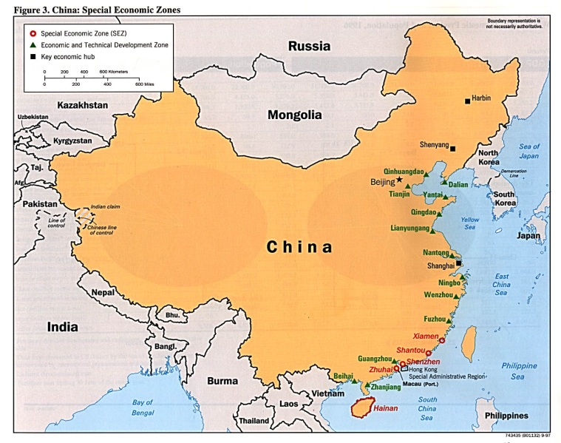  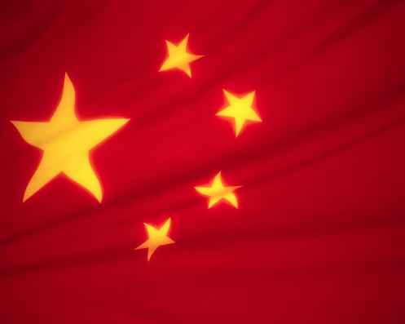 | Geography  - Same square metres as the USA  - 1.3 billion people  Economy  - Growth rate is unprecedented. In 2007 it was nine times larger than it was in 1978  - Sustainability: fast growth leads to negative environmental impacts as well as the threat of inflationary pressures  - Energy: China uses three times more energy than the global average.  - The second biggest economy in the World after the USA and within twenty years, it will be number one (at current growth rates)  - Socialist market economy where the firms are state owned  - Inequality: half of China’s population live in the west in rural areas where incomes are sometimes 12 times lower than in the Eastern and Southern urban areas.  - Currency is made artificially low by the Government, making exports cheaper to world consumers and cementing China’s export advantage. This causes tensions in the wider global economy – e.g. the USA  - China is the second largest importer of oil  - Largest exporter of goods although still largely a “final-assembly” exporter with factories controlled by Western producers
Politics
- Authoritarian communist party which has built a socialist market economy
- One party state with no elections, limited freedom of speech and recognition of basic human rights
- Sustainability – can authoritarian single party rule continue in a country with a rising middle class? Pressures for democracy?
- Second biggest military power in the world and further military build up – US Pentagon estimates Chinese spending is three times the official amount of $30 billion. Fears of an invasion of Taiwan which the USA “protects”.

Social
- The proportion of people living in towns and cities has doubled to nearly two-fifths (150 million people). This is the biggest migration in history.
- China’s one child policy began in 1978 to curb population growth for fears of a Malthusian catastrophe. Although successful in reducing population growth, it has been very controversial.

China 1964-1978: A period of uncertainty and a decline into anarchy?

Before 1964, China was emerging from “the great leap forward”, an economic and social campaign of Chairman Mao’s communist party. The idea was to use China’s vast population and to industrialise from an agricultural economy to a industrialised country. However, Chairman Mao neglected the agricultural aspects of his economy and the need for food. The result was 45 million deaths in one of the worst famines.  By 1964, Chairman Mao was under political pressure and led him to launch “the cultural revolution” which was a socio-political movement to enforce socialism by the removal of anything related to capitalism and traditional elements of Chinese culture. The result by 1976 was near anarchy in China and a large amount of Chinese suffering from torture etc.  When Mao died in 1976, Deng Xiaopeng came to power and started to reform the party towards a market orientated economy (capitalist). This officially began in 1978 when foreign investment was allowed in and an export led strategy was adopted. | 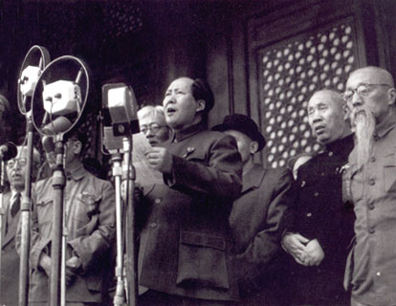  Chairman Mao in 1949

China 1978-1990: The Influx of Foreign Direct Investment and Export Led Growth
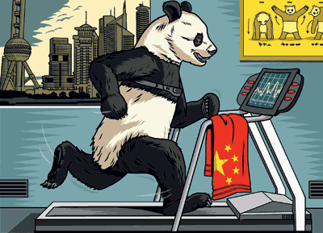 | In 1978, foreign direct investment was allowed in several “economic processing zones” or EPZ’s along the coastline of China. These EPZ’s contained tax breaks and other advantages which attracted many foreign firms who benefitted from the lower costs of production. The Chinese workforce were seen to be plentiful, hard working and cheap.  Deng also ensured that the agricultural production in rural areas increased alongside the expansion of industrialisation in the big coastal cities (roughly 14 of them).  The foreign firms brought with them technology and expertise. The exports from China (low tech manufacturing) benefitted the local urban economies which had these firms.  The private sector in China went from a complement to being an important component of the socialist economy.

China 1990-2011: The growth years
From 1990-2004, the average growth rate in China was 10% per annum on average. This was mainly due to a rapid growth in exports not just from the foreign firms who had set up factories in China but also private and state run enterprises who accept out sourcing from Western companies to manufacture components. Poverty levels (living on less than $1.25) have dropped significantly from 80% in 1978 to less than 20% in 2006 – amazing reductions. However the gini index has increased from 29.1 to 41.5 which is significant.  Criticisms might revolve around inefficient state run industries especially in petroleum and banking.  2011-2017: What does the future hold for China?  Issues with environmental sustainability, inflationary pressures, democratic pressures, growing inequality and global tensions have all led commentators to question the success of China and wonder whether it can continue to grow at its current rate for the next few decades | 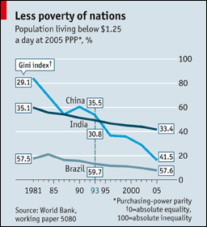
- Environmental sustainability – depletion and degradation of resources. China is the 2nd biggest importer of oil and its quest for more resources has led to African countries such as Zambia. The impact on the environment nationally has been significant with anecdotal stories of “cancer rivers” and respiratory problems being the second biggest cause of death (after smoking) in China. Recent talks on climate change in Durban have identified China as one of the worst global producers of carbon dioxide, a key contributor to global warning
- Inflationary pressures – large economic growth has led to a growing increase in inflation and this has the potential of having the biggest impact on the poor as higher prices prevent them from meeting their needs. Another cause of growing inequality. Wages are increasing significantly in concentrated urban areas as labour shortages begin. Wage rises mean foreign investors have been pulling their factories out of China and to cheaper areas (like Mexico).
- Democratic pressures – since Tiananmen Square in 1989, there have been reports of continued pressure for democratic change. Studies show that a rising income in a country and an emerging middle class start to want more of a say in how the country is run and democratic pressures are inevitable. However other reports might suggest that the Chinese people are happy with the rule of the communist party and as long as they continue to deliver growth, then jobs are provided and living standards rise.
- Growing inequality – a big problem for China is it’s growing inequality between rural and urban areas. China is sometimes called a two speed nation. On a global scale as well, working conditions for Chinese workers in so called “sweatshops” are very poor by Western standards. However China’s Government has recognised the need for distribution of wealth and part of their recent national plan was to address this very issue.
- Growing global tensions – China’s growth, wealth creation and exporting power have led it onto the World stage and allowed much more influence in negotiating over issues such as trade rules, climate change etc. China is now considered to be a major player. Tensions remain over China’s artificial lowering of their exchange rate to gain a competitive advantage as well as their desire to invade Taiwan and of course problems with countries like Tibet which they occupy currently.

There is no doubt that the money earned from exports has given China a nice fund in which to invest in new economies and move potentially from the low tech manufacturing base to more high tech manufacturing and service orientated industries. China is on track to be able to rely on its own domestic production to generate value rather than exports. However can it keep up the rate of progress it has enjoyed since 1978? Also can other countries copy the China model of EOI or is it a one off?
History of Foreign Direct Investment (and Trade) into China

The two phases of Economic growth for China
There were two phases to China’s booming growth: 1978-1992 and 1992-today. Both periods are characterized by the differing levels of FDI into China. Before 1992, FDI into China was roughly $26 billion. Foreign firms could only locate in four key EPZ’s (export processing zones) and they had to have joint ownership with a state run Chinese “enterprise”. Although there were some tax breaks as well to attract foreign firms, $26 billion is seen as a smallish amount during this time. This was especially true since the four Asian Tigers (South Korea, Hong Kong, Taiwan and Singapore had attracted significant levels of FDI and were thoroughly enjoying the subsequent export revenue and wider multiplier effects it generated

The second phase of 1992-today occurred for several reasons. The leader of the Communist part, Deng had reached the age of 88 years old and had little time left. He went on a tour of China (“The Southern Tour”) to speak to officials and audiences of the need for the Communist part to accelerate reform and emphasized the need for FDI and more private enterprise. Secondly, the Soviet Union had collapsed in 1991 and China remained (along with North Korea) the only communist state. Had the pure communism experiment (or Lenin’s vanguard socialism at least) failed?

These global and national events led to the Communisy part passing a decree which said the Chinese economy had moved from a “planned socialist commodity economy” to a “socialist market economy” in 1993. The subsequent increase in FDI was a flood of money into not just the four EPZ’s but other areas of the country as well. In 1991, there were five EPZ’s but by the end of 1992 this had increased to 8500!! FDI came not only from the traditional places of Taiwan and Singapore but also from Western multinational companys (MNC’s) such as Microsoft, Apple, GAP, Tesco, Carrefour etc. This was followed in 1997 by the movement from the small to the big state enterprise within China.

The “China dream” and “the China play”
FDI was attracted to China post 1992 due to the “China dream”; the idea that there were a possible 1 billion consumers, a huge market in which to exploit. The other reason for FDI being attracted to China was the “China play”. This was the idea to locate production of your product (t-shirts, electronic components etc.) within China’s EPZ’s where a literate workforce of one thirtieth of the cost of workers in the US or EU would produce your goods (manufacture). These would then be shifted in giant containers to a modern port where they would sell the products at Western prices for a colossal profit. Therefore the short term goal for foreign companies investing in China was “the China play” whereas “the China dream” would be the long term goal.

“Made in China”
China’s FDI has been two thirds manufacturing. 90% of FDI is along the coastal provinces and China’s growth in exports has been estimated at being 55% the result of FDI into the country. Generally the more high tech the industry, the bigger the share that is returned to China. Of specific goods, 80% of electronic and telecommunications exports are from foreigners, 70% of plastics and 60% of electrical goods. So FDI plays a very large part in the success of China. China has become the world’s workshop and by 2010 it is the world’s leading exporter.

The growth in FDI has led to greater employment and a multiplier effect into the wider economy and other industries. Poverty levels have dropped from 80% in 1980 to 20% today – an unprecedented fall. However there has been mass migration from rural areas as people move to the cities to “find their fortune”. Increasing inequality between urban and rural areas of China remain a concern for the communist party whose founding philosophy is one of egalitarianism…would Chairman Mao be rolling in his grave?

Can China overtake the world?
Obviously China’s growth over the past 25 years (with FDI playing a large part) has been extremely good for economic development and poverty reduction levels. China is now a player on the global stage etc. By 2030, if China continues to grow at it’s phenomenal rate, it could overtake the US as the biggest economy in the World. But will this last forever?
- OVER RELIANCE ON FDI? – when Britain, the US and Japan dominated world manufacturing, they had developed and owned the intellectual property of the products they exported. In other words they generated global brands such as Toyota, Sony etc. China is not in this position today and compared to large Western companies, many Chinese companies are inefficient and loss making (i.e. very little profit). Another problem is the lack of technology and innovation found within China despite accusations that they were stealing Western technology. The evidence for “technology transfer” from West to East has been non-existent. All this adds up to China being too reliant on FDI and being part of the supply chain rather than a global player within it’s own right. When wages and living standards rise, will FDI leave China and move to the next cheap option (countries in Africa?). China may be left with a gaping FDI finance hole which could bring down the economy.
- INEQUALITY AND EXPLOITATION?– obviously there is national inequality as described above with rural and urban areas obtaining stark differences in income levels. On a more local scale, inflationary pressures in the cities are leading to a housing bubble and pricing poorer people out of various markets. Globally, the Chinese workforce may have been exploited especially with the Government keen to attract more FDI, there has almost been a “race to the bottom” as the Chinese workforce are subject to possible “sweatshop” conditions - worsening health and safety and low wages as China tries to make their country attractive to Western money flows.
- SUSTAINABILITY? – growth rates caused by the explosion of FDI and subsequent multiplier effects in other industries has arguably led to huge global and national environmental issues in terms of degradation of the environment and depletion of natural resources. Will there be enough left in the future?

