ZAMBIA (1964-2017)

INTRODUCTION
At the time of independence in 1964 Zambia was a middle income country and appeared set to develop into a prosperous nation. However, the combination of a tumultuous world economy and bad mismanagement by the Government led to rapid economic decline (fall in GDP), which continued into the 1980s and 1990s. Average economic growth from 1990–1999 was the lowest in the region, and unemployment and inflation soared resulting in per capita GDP of 50% less in 1999 than they had been 25 years earlier.  - Zambia is now considered to be of ‘medium human development’, ranked 139 out of 182 countries on the UN’s human development index (Human Development Report 2016).  - 59% of Zambians were estimated to live below the poverty line in 2016, down from 68% in 1996 however there is a higher percentage of poverty in rural areas  - The majority of these people live in rural areas in households headed by women and half the children under five in the country suffer from chronic malnutrition or stunting, a figure that has worsened rather than improved over the last thirty years.  - HIV prevalence in Zambia is amongst the highest in the world – estimated at 14.3% in 2007 although it was almost an epidemic in the 80’s and 90’s..  - Healthcare remains under-resourced, and ill health is compounded by the lack of access to clean water and sanitation.  - Access to primary education by contrast has markedly improved, but the quality of the education received is far below what is needed for widespread poverty reduction and girls in particular do not perform well beyond primary school. | 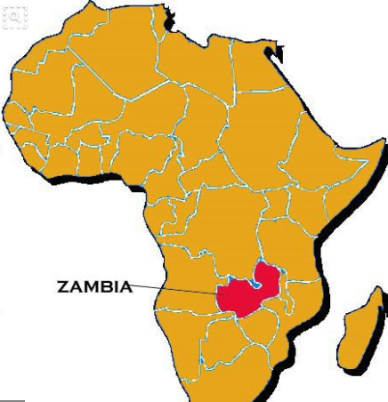  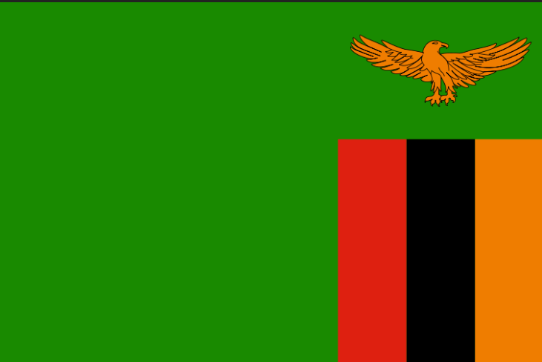

HISTORY OF ZAMBIA
Currently a land locked country in sub-Saharan Africa with a population of 13 million, Zambia is still relatively a young country. Zambia was made independent in 1964 from Britain and was led by the “freedom fighter” Kenneth Kaunda until 1991. Zambia was heralded as one of the success stories of Africa in the mid-60’s and there were high hopes for this newly formed country. Kaunda, a socialist began with socialist and protectionist policies to protect infant industry, diversify the economy to reduce reliance on Copper but at the same time exploit the copper exports of his country. From 1964-1984, Zambia was very independent with Government’s conducting 5 year plans and being accountable to this. By the 1980’s as a result of both Government policy and external factors (oil crisis), Zambia was in large amounts of debt which led to the IMF intervening and Zambia for the next 25 years had to adopt policies of Economic liberalisation from these institutions. From 1991 to 2003, Zambia was led by Fredierick Chiluba who has more recently been charged with corruption within the state. So by 2005 after a growing debt burden for 32 years, liberalised economic policies imposed by foreign powers for 22 years, a growing population and corruption within the Government ranks over the previous 15 years, Zambia’s GDP per capita had fallen, life expectancy and poverty rates had increased (especially in rural areas) and the number of people who had contracted HIV/AIDS had increased substantially (14% of the population) compared to 1964. On top of this drastic cut backs in education and healthcare damaged an already scarred workforce and population. For the past 35 years, Zambia has experienced the worst economic decline in Sub-Saharan Africa (Appolinario, 2009).

Since 2003, Zambia’s prospects had started to improve with the increase in worldwide copper prices attracting foreign investment, especially from the Chinese. Levy Mwanawasa was also elected to power in 2003 on an anti-corruption charge imprisoning and putting on trial previous ministers within the Government. As of 2005, Zambia met it’s HIPC commitments and finally qualified for full debt relief at the G8 Gleneagles summit, reducing debt from $7 billion to $500 million. Zambia’s recent growth rate in 2011 has been 7%, one of the highest in the world. Also in 2011, a new president Michael Sata was elected in a very peaceful election. Zambia has also always (on the whole) been a peaceful nation since 1964 and its model of democracy is heralded as a beacon for other countries in the region. All this points to an improving situation for Zambia demonstrated by it recently (2011) being granted lower middle income status. Further foreign investment has followed from the Chinese and other nations.

However challenges still remain. Zambia is still very reliant on the copper industry for income from abroad. The mining employment only employs 50000 people and only contributes 3% of GDP in taxation (DFID, 2011). Accusations of foreign companies investing in mines (like Glencore) and then not paying taxes to the Zambian Government are rife. HIV/AIDS is still a serious problem with 14% of the population affected and the burden on extended families still remains. The difference between rural and urban areas is still stark (OECD, 2011) therefore the rural population of Zambia are the poorest with three quarters living on less than $1 a day through subsistence farming and petty trade (DFID, 2011). Zambia, according to the Ministry of Finance has 28 donors providing ODA to Zambia – EU (14.3%), USA (10.7%), UK (9.0%), UN (8.9%), World Bank (8.7%) (OECD, 2011). It receives about $1 billion per year in foreign aid (McEwan, 2009). This is the equivalent to almost a third (29%) of Zambia’s Governmental budget (CIAFactfile, 2012) and so Zambia is still dependent on external assistance.

Zambians reliance on copper can have bad effects on the economy and this occurred in the aftermath of the Global Financial Crisis when countries stopped buying as many copper exports from Zambia and the price dropped. Zambia’s copper accounts for 70% to 80% of its exports, and due to this fall in copper prices, exports halved in 2009. The most immediate social impact was the loss of some 8,500 out of a total of some 30,000 mining jobs. A lack of income to the economy has meant less economic growth and falling output, leading to potentially greater poverty.

More recently, there has been unsettling political turmoil with the current opposition leader in jail for refusing to move aside for the current presidential incumbent! Locking up your opposition leader is a signal that Zambia’s peaceful, democratic political system may be under strain in 2017.

SWOT ANALYSIS OF ZAMBIA

Strengths  - Large copper deposits – opportunities to sell copper  - Floating exchange rates and open capital markets have given discipline to the Government  - Democratic elections since 1964 when independence occurred; quite rare for this to happen in sub-saharan Africa. Often considered one of the most stable democracies in Africa. | Weaknesses  - Large copper deposits – economy too reliant on the copper price and possible resource curse? Primary specialization.  - Lack of other industries to provide jobs and growth: For example, Salaula which are imports of donated clothing from Western countries has caused the demise of the textiles industry in the UK. Salaula is the Zambian word for this second hand clothing.  - Large numbers of rural poverty  - Landlocked country – harder to trade as no sea ports = barriers to trade  - HIV/Aids Problem means there has been an issue with ‘human capital’  - Low educational achievement  - Large GINI Co-efficient  - High inflation rate (20% in 2016)
Opportunities  - Development of mobile phone technology for banking – allows poorer individuals to save and buy  - Fast growing population – larger workforce for the future? | Threats  - Alternative technologies may replace the need for Copper in the future  - Reports of ‘MP’s being suspended’ and worries about the democratic future of Zambia. Opposition leader arrested and held for a month for not giving way to a Presidential motorcade.  - Fast growing population – strain on resources  - Copper prices falling because of lack of demand from China

CASE STUDY: Trade Liberalisation and the Textiles Industry in Zambia

History of the Zambian Textiles Industry

(1) ISI 1964 to 1984
During the Import Substitution Industrialisation (ISI) from 1964 through to 1984, Zambia’s textiles and clothing industry received substantial government support through an incentive system that favoured the entire manufacturing sector in Zambia, not just textiles. This incentive system was determined by a combination of tariffs (taxes) on imports, quotas on imports and exchange rate management by the Government to make imports more expensive. The ultimate result was to shelter the textile and clothing industry from external competition, reduce the role of the market and increase state involvement (a socialist approach). The main Government run textile producers in Zambia were called ‘Parastatals’ and they were protected by high tariffs and mostly dependent on state financing as they were considered infant industries.

Because of support from the state, Zambia’s textiles and clothing industry grew considerably between 1964 and the 1980s. As the World Bank (1984) reports, Zambia’s textiles, wearing apparel and leather contribution to total manufacturing value-added rose from 10.1 percent in 1964 to 18.4 percent in 1980. During this time, the textile and clothing industry boasted a record of over 140 companies, employing over 25,000 Zambians in the 1980s.

(2) The Zambian Debt Crisis 1974-1984
Zambia’s main export earner of foreign currency was copper mining; this is what subsidized the large Government run Parastatals of the textiles industry. The price of copper in the mid 1970’s however started to plummet (as oil prices started to rise). Huge subsidy payments to textile parastatals led to the Zambian Government getting into considerable debt so that by 1984, they were the most indebted country in sub-Saharan Africa (as a % of GDP). Zambia had to turn to the IMF for a debt relief programme which contained conditions of SAP’s (Structural Adjustment Policies). The SAP’s had a neo-liberal agenda along the lines of the Washington Consensus which required the liberalization of domestic markets; so privatization of the state run parastatals, reducing Government spending on subsidies to the parastatals and the removal of trade barriers. The IMF forced Zambia to move from an ISI strategy to an EOI trade strategy.

(3) EOI (Trade LIberalisation) 1984-2017
Did this benefit the textiles and clothing industry? The answer is complicated. The liberalisation of trade exposed most of the firms to external competition. Because of their weak base, most of them could not withstand the competition from the foreign firms and ended up closing down or re-locating to neighbouring countries where the production cost were perceived to be low. These changes all impacted negatively on the labour markets of the country. Mass closures of garment factories and scaling down of operations of the textiles sub-sector saw resultant employment levels drop from over 25,000 in the 1980s to below 10,000 by the year 2002’. Consequently, formal employment as a percentage of the labour force declined from 23.3 percent in 1990 to 8.1 percent in 2003.

Some modest results were achieved elsewhere in the economy, but the opening up of markets and the promotion of international competition is yet to lift the textiles and clothing industry in to providing jobs and income for the economy. Instead of becoming lead industries for exports, the Zambian textile and clothing industry is being challenged by cheap imports (and ‘Salaula’ – see below) and is losing large segments on the home market. Nonetheless, the textiles and clothing industry remains a sector of export interest to Zambia where the country could exploit its vast existing potential – if MEDC trade restrictions were reviewed (tariff escalation and subsidies) and maybe more protection for the textiles industries in Zambia.

In the wake of the general economic liberalization measures implemented since the 1980’s, there has been a steady erosion of purchasing power of the population and as a result domestic demand for most local products significantly reduced in the last well over 10 years of trade liberalization. This has therefore affected the textiles industry further.

So trade barriers in MEDC’s and the liberalization of Zambia’s trade markets through the structural adjustment policies has prevented diversification of the economy, increased dependence on copper and led to growing inequality and poverty in the informal sectors (despite what looks like rapid GDP growth). The growth in copper might also be a curse rather than a blessing because of ‘Dutch disease’ harming the non-copper industries.

Importance of the Zambian Textile Industry to the Economy and Society
Textiles are an important manufacturing base for a country like Zambia – it is the second biggest foreign exchange earner after mining (the first being agricultural products – tobacco, cotton etc.). No need for large R+D, labour intensive with minimal capital. Provides jobs and does not need significant education or technological resources to produce goods. Other important non-copper industries are agriculture and tourism.

Influx of Salulua
In Zambia, they call second-hand clothes from British charities salaula - 'to rummage in a pile'. For millions of Zambians living on less than $2 (£1.10p) a day, it is the only way to buy new clothes. It seems like a win-win situation. Cast-off clothes given to charity by Britons are exported to poverty-stricken Africans who otherwise cannot afford new outfits. But salaula has decimated Zambia's textile trade.

Sury Patel used to run Swarp, one of the country's biggest clothing manufacturers. In its heyday he employed more than 200 people producing 2,400 shirts a day. Today only 20 people work in Patel's factories and, instead of finely tailored shirts, Swarp's main business has been reduced to churning out cloth which sells for a pittance. Patel has been ruined. It seems far-fetched that the destruction of Patel's enterprise is caused by Britons giving clothes to charity. But economic reforms forced on Zambia by the World Bank and International Monetary Fund gave the country a stark choice: privatise state-run enterprises and open up industry to overseas competition or lose international aid.

In recent years the IMF's free-market doctrine applied throughout the developing world has lifted restrictions on imports. In a bizarre spin-off, the Zambian textile industry has seen a glut of imported second-hand clothes which UK charities cannot sell. They are exported by private companies and it is this which has, in effect, killed Zambia's clothing manufacturing base. 'We used to have 77 factories. Then comes the salaula. It's cheap, but not necessarily hygienic,' says Patel at his factory in Ndola, central Zambia. 'But it has the worse impact. We used to supply retailers with 3,500 tons of clothing annually. We are down to less than 500 tons. We have the capacity to make much more, but there is no demand.'

In 1991 there were 140 textile manufacturers across Zambia. In 2002 this had fallen to eight. Salaula has wiped out an industry, causing unemployment and reducing the tax take of a government in desperate need of revenue. In Britain, only 20 per cent of the clothes given to good causes are sold in charity shops. The rest are rejected. Much is collected by companies which grade clothes, then ship them abroad. Clothes which find their way to Zambia are also collected from charity bins outside supermarkets or on UK high streets. Charities such as Scope receive hundreds of pounds for lending their name to the clothes banks.

What is true of Zambia's textile industry also goes for its wider manufacturing base, where hundreds of thousands have lost their jobs. The malaise has had profound social effects. In 1990, 45 per cent of the population was classed as malnourished. By 2001, that had risen to 50 per cent. On the other hand, cheap clothing could be beneficial if there are no jobs and very little income. Is Saluala a short term fix to the poverty Zambia is currently facing?

