**HENRY VII**

**1485-1509**

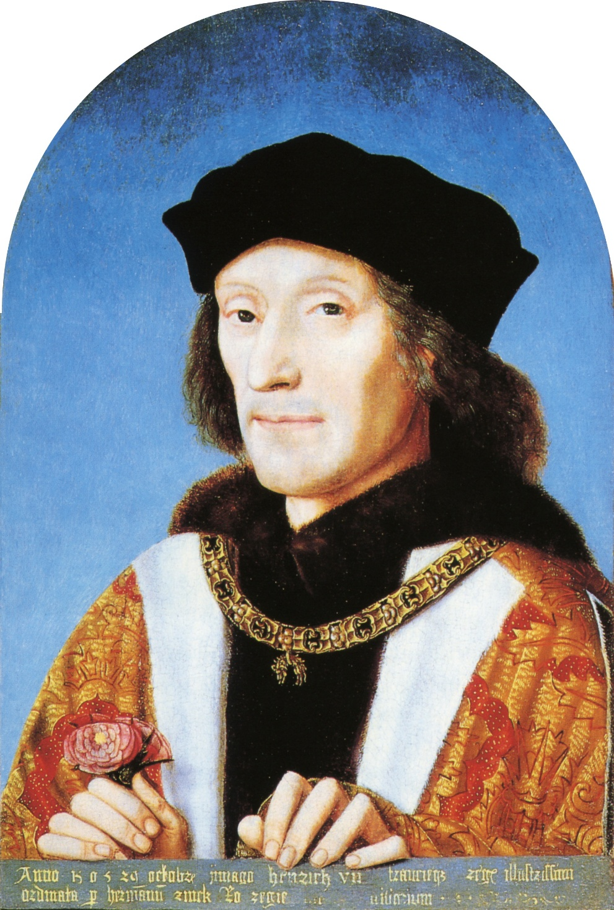

|  |  |
| --- | --- |
| **Topic 1: Henry VII** | **Tick when revised** |
| Background to Henry VII and the Wars of the Roses – Claim to the throne |  |
| Rebellions and Pretenders – Yorkist opposition, Lambert Simnel, Perkin Warbeck, Earls of Lincoln & Suffolk |  |
| Foreign Policy – Brittany, France, Spain and the Holy Roman Empire |  |
| Domestic government – Crown finances, relationship with nobility, Parliament & tax rebellions |  |

**TIMELINE**

|  |  |
| --- | --- |
| 1485 | Battle of Bosworth  Death of Richard III  Henry VII became King |
| 1486 | H married Elizabeth of York |
| 1487 | Battle of Stoke: Lincoln killed & Simnel captured |
| 1489 | Yorkshire tax rebellion  Treaty of Medina del Campo |
| 1492 | Treaty of Etaples |
| 1493 | H banned trade with Burgundy to stop support for Warbeck |
| 1495 | Sir William Stanley executed for corresponding with Warbeck |
| 1496 | Intercursus Magnus restored trade with Burgundy & ended Burgundian support for Warbeck |
| 1497 | Cornish tax rebellion  Truce of Ayton  Warbeck captured |
| 1499 | Execution of Warwick & Warbeck |
| 1501 | Arthur married Catherine of Aragon |
| 1502 | Death of Arthur |
| 1503 | Death of Elizabeth of York  Death of Margaret of Burgundy  H’s daughter Margaret married James IV of Scotland |
| 1506 | Treaty of Windsor led to capture of Suffolk |
| 1509 | Death of Henry VII |

**QUESTIONS ON HENRY VII FROM THE OLD OCR SPECIFICATION**

We are advised that these are a good guide to what you’ll be asked in the New Specification.

1. To what extent was Henry VII's foreign policy a success?
2. How effective was Henry VII at dealing with the Yorkist challenges to his throne?
3. How effectively did Henry VII deal with England's domestic problems?
4. Marriage agreements were the most important achievement of Henry VII's foreign policy". How far do you agree?
5. How serious a threat to Henry VII's rule was the Yorkist challenge?
6. "The handling of finances was Henry VII's most successful domestic achievement". How far do you agree?
7. How successful was Henry VII in achieving his foreign policy aims?
8. How effectively did Henry VII handle the nobility?
9. How successfully did Henry VII deal with the problem of the Yorkists?
10. How successfully did Henry VII deal with the domestic problems he faced?
11. How dangerous were Yorkist plots to Henry VII?
12. The avoidance of war was the most important aim of Henry VII's foreign policy". How far do you agree?
13. How successful was Henry VII in strengthening royal finances?
14. "Henry VII's foreign policy achieved little". How far do you agree?
15. "The need to secure his throne dominated the foreign policy of Henry VII". How far do you agree?
16. **How serious were the threats to Henry VII’s rule? (AS exam 2016)**

|  |
| --- |
| **In arguing that the challenges were serious,** a**nswers might consider:**  • the weakness of his claim to the throne  • the ability of Simnel to bring Henry to battle, which might have been lost as happened to Richard III.  • the foreign support that Yorkists received, particularly from Margaret of Burgundy.  • the power of the nobility in England and their financial position, Henry’s need to use bonds and recognisances.  **In arguing that the challenges were not serious, answers might consider:**  • the lack of Yorkist claimants and their reliance on Pretenders.  • the taxation rebellions did not aim to remove him from the throne.  • the success of his spy network.  • the decline in rebellions and challenges.  • Warbeck was never a serious threat, just a nuisance.   1. **“Henry VII’s main aim in foreign affairs was to avoid war”. How far do you agree? (A-Level Exam 2017)** |
|  |

**Further Reading**

Dawsonera

OCR A Level History: England 1485–1603

Author: [Nicholas Fellows, Mary Dicken.](https://www.dawsonera.com/search?sType=ALL&searchForType=2&author=%22Nicholas%20Fellows%2C%20Mary%20Dicken.%22&searchBy=0) Pages: 281 Size: 6.19 MB Format: PDF Publisher: [Hodder Education](https://www.dawsonera.com/search?sType=ALL&searchForType=0&publisherSelect=264&searchBy=0)

Published: Jun 26, 2015

<https://www.dawsonera.com/readonline/9781471836626> then Accept the terms & conditions

Access to History: The Early Tudors: Henry VII to Mary I 1485-1558

Author: [Roger Turvey.](https://www.dawsonera.com/search?sType=ALL&searchForType=2&author=%22Roger%20Turvey.%22&searchBy=0) Pages: 209 Size: 3.76 MB Format: PDF Publisher: [Hodder Education](https://www.dawsonera.com/search?sType=ALL&searchForType=0&publisherSelect=264&searchBy=0)

Published: Jul 31, 2015

<https://www.dawsonera.com/abstract/9781471838873>

England and Europe 1485-1603

Author: [Susan Doran.](https://www.dawsonera.com/search?sType=ALL&searchForType=2&author=%22Susan%20Doran.%22&searchBy=0) Pages: 152 Size: 7.32 MB Format: PDF Publisher: [Routledge Ltd](https://www.dawsonera.com/search?sType=ALL&searchForType=0&publisherSelect=33&searchBy=0)

Published: Dec 16, 2013

<https://www.dawsonera.com/abstract/9781315842189>

Books

**Mary Dicken & Nicholas Fellows, *England 1485-1603* (OCR textbook)**

Caroline Rogers. *Henry VII* (Access to History series)

Roger Turvey, *The Wars of the Roses and Henry VII: Britain 1450-1509*

Thomas Penn, *The Winter King*

David Rogerson, *The Early Tudors*

Colin Pendrill, *The Wars of the Roses and Henry VII*

Derrick Murphy, *England 1485 – 1509*

Articles

On a college computer, type <https://online.godalming.ac.uk/course/view.php?id=37> into the search box, then select “Websites, subscriptions, links”, then select “History Today” & log in as instructed.

**Henry VII, Pretenders and Rebellions**

By [Jez Ross](http://www.historytoday.com/author/jez-ross)

Published in [History Review](http://www.historytoday.com/archive/history-review/latest) [Issue 72 March 2012](http://www.historytoday.com/archive/history-review/issue-72-march-2012)

**Henry VII: Miracle King**

By [Gordon Marsden](http://www.historytoday.com/author/gordon-marsden)

Published in [History Today](http://www.historytoday.com/archive/history-today/latest) [Volume 59 Issue 3 March 2009](http://www.historytoday.com/archive/history-today/volume-59-issue-3-march-2009)

**Henry VII: Out of the Shadows?**

By [Ian Dawson](http://www.historytoday.com/author/ian-dawson)

Published in [History Review](http://www.historytoday.com/archive/history-review/latest) [Issue 22 September 1995](http://www.historytoday.com/archive/history-review/issue-22-september-1995)

**Henry VII and the Shaping of the Tudor State**

By [Sean Cunningham](http://www.historytoday.com/author/sean-cunningham)

Published in [History Review](http://www.historytoday.com/archive/history-review/latest)

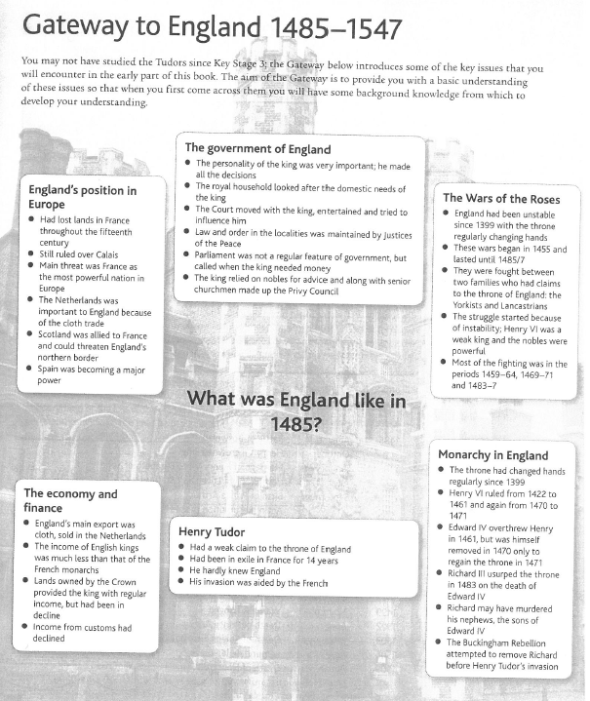

**QUESTIONS ON ENGLAND IN 1485**

Mary Dicken & Nicholas Fellows, *England 1485-1603* (OCR textbook) p5

On Godalming Online: <https://online.godalming.ac.uk/course/view.php?id=573>

England’s Position in Europe

1. Which countries were England’s traditional enemies?
2. Why were the Netherlands important to England?
3. Which country was newly emerging as a major power?

The Government of England

1. How were the roles of (a) the King & (b) Parliament different from today?
2. Who apart from the King had the most power?

The Wars of the Roses

1. What was the main reason for the outbreak of the Wars of the Roses in 1455?
2. Was the fighting continuous?

Monarchy in England

How many times & in what years did the throne change hands violently 1461-85?

Henry Tudor

Why was Henry in a weak position at the start of his reign?

The Economy & Finance

1. What was the main economic activity in England in 1485 (the answer is not on the sheet: you will have either to know it or research it)?
2. What was England’s main export?
3. In what ways was the Crown’s financial position weak?

**WARS OF THE ROSES SUMMARY**

The Wars of the Roses was between the **Lancastrians**, represented by the red rose, & the **Yorkists**, represented by the white. Both claimed the throne on the basis of descent from one of the sons of Edward III, who ruled England 1327-77.

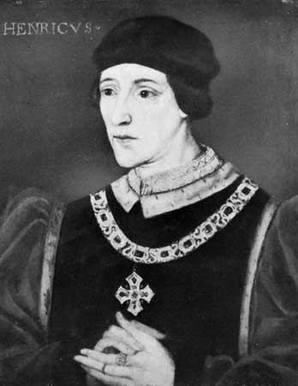The Lancastrians gained the throne in 1399 when Henry, Duke of Lancaster, made himself King Henry IV at the expense of Richard II.

Henry Tudor (known as **Earl of Richmond** until he became King Henry VII in 1485) was born in 1457 during the reign of Henry IV’s grandson **Henry VI** (right, 1422-61 & 1470-1).

In 1461, when H was only 4, Edward, Duke of York, defeated Henry VI & made himself King **Edward IV** (below left), the first of the Yorkist kings. Henry VI was imprisoned in the Tower of London.

As a Lancastrian claimant, albeit not in the main line, H Tudor was now in danger.

In 1470, with the help of the Earl of **Warwick** (so powerful that he was nicknamed “the Kingmaker”) Henry VI regained the throne & Edward IV was forced into exile. This temporarily made H safer.

In 1471, Edward IV invaded England with help from his brother in law the Duke of Burgundy. He defeated the Lancastrians at the Battle of Tewkesbury, a battle in which Henry VI’s son Edward of Lancaster was killed. Henry VI was still in London but when E IV returned to London after his victory at Tewkesbury he had Henry VI killed, thus wiping out the main Lancastrian line.

E IV retained the throne until his death in 1483 but left a 15 year old boy to succeed him as **Edward V**. E IV’s brother, Richard, Duke of Gloucester (below right), took advantage of this situation to seize the throne from his own nephew & put both E V & his younger brother, Richard, Duke of York, in the Tower of London. Richard of Gloucester, or King **Richard III** as he now called himself, executed Earl Rivers & Lord Hastings without trial for refusing to support his claim to the throne.

The **Princes in the Tower**, as they came to be known, were never seen alive after July 1483 & everyone assumed that R III had had them murdered. R was seen as a ________________ (meaning he had seized the throne by force but wasn’t entitled to it).

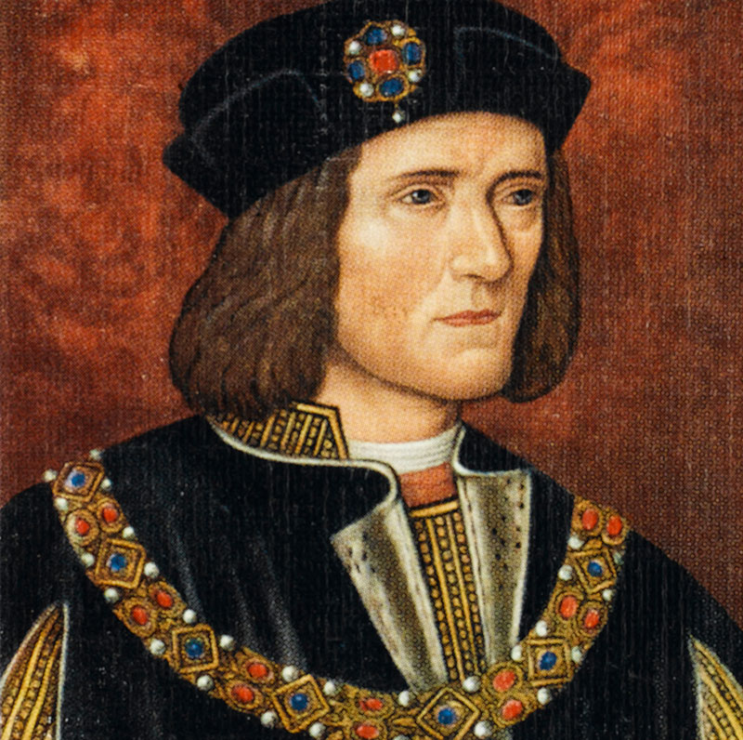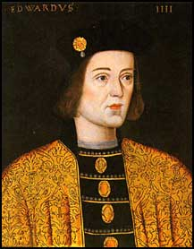

**HENRY TUDOR’S EARLY LIFE AND THE STAGES BY WHICH HE BECAME KING**

|  |  |
| --- | --- |
| 1457 | Henry Tudor was born in Pembroke, South Wales. His father had been captured by Yorkists and had died in prison a couple of months before his birth and his mother, Lady Margaret Beaufort, was only 13 years old. Henry and his mother were cared for by his uncle, Jasper Tudor. |
| 1461 | At the age of four Henry was placed in the care of Sir William Herbert, a Yorkist supporter.  *Consider who was king at the time and the reasons why Henry, a Lancastrian, should be placed in the care of a Yorkist.* |
| 1471 | Henry Vl died and Henry Tudor fled to Brittany.  *Why had Henry Tudor’s position now become so dangerous that he had to leave the country?* |
| 1483 | Richard lll was King of England by this time but there were many amongst the nobility who were no longer prepared to support him.  *What had Richard done which made him increasingly unpopular in the country?*  The Duke of Buckingham wrote to Henry and encouraged him to invade England from Brittany and take the crown from Richard lll. Henry attempted this whilst Buckingham and his allies rebelled at home. The attempt failed. Buckingham was arrested and executed and Henry returned to Brittany having not even landed in England. However Henry continued to gain more and more support from English nobles and he declared that if he became King he would marry the daughter of Edward lV.  *How would this help him win even more support and what other advantages would it bring?* |
| 1485 | Richard lll attempted to capture Henry when the Duke of Brittany became ill. Henry learnt of the plan and escaped to France. The King of France, Charles Vlll, gave him money, a fleet of ships and some mercenary soldiers which he could use to invade England.  *What reasons would there be for the French King to support a rival for the English crown?* |
| August,  1485 | On 1st August, Henry’s small fleet of ships set sail from France; they landed on the Welsh coast a week later.  On the 22nd August Henry met Richard lll at Bosworth and a battle was fought there. Henry’s army was only about half the size of Richard’s and Henry had never led an army into battle before, but against all the odds he won. Richard lll was killed and Henry became King Henry Vll. |

**“WAR WALKS” BATTLE OF BOSWORTH VIDEO QUESTIONS**

1. What did Richard III say about the Battle of Bosworth?
2. Which plain fact suggests that R may well have murdered his nephews?
3. Who supported Henry in making his claim to the throne?
4. Who funded H’s invasion of England?
5. Who formed the bulk of his army?
6. Why did he land in Wales?
7. Where was the Stanleys’ power base?
8. What was their attitude to R?
9. Why was R suspicious of Lord Stanley?
10. How big was H’s army & why did this put him at a disadvantage?
11. What could he not win without?
12. Whom do R’s supporters blame for his evil reputation?
13. Who were the most trusted nobles on each side?
14. Which noble was R not sure of & what did his soldiers show?
15. What evidence is there that the battle was turning against him even before his attack on H?
16. Whom did R succeed in killing?
17. What did Sir William Stanley do & what was the effect of this?
18. What did Lord Stanley do?
19. What was the significance of the Battle of Bosworth in English history?
20. How was R’s body treated after his death?
21. How did the outcome of the battle affect the way the story of it was written afterwards?

**Questions on Henry VII after Bosworth**

|  |
| --- |
| 1 How would H’s experiences up to & including the Battle of Bosworth affect his personality & how he behaved as King? |
| 2 What lessons did he learn from R III’s failure & his own success? |

**HENRY Vll’S FIRST STEPS TO SECURE THE THRONE**

|  |  |  |
| --- | --- | --- |
| **DATE** | **ACTION** | **SIGNIFICANCE** |
| **21st August 1485** | Henry declared that his reign had begun the day before the Battle of Bosworth. |  |
| **30th October, 1485** | This was the date of Henry’s coronation ceremony. Only after this did he summon Parliament. |  |
| **From August 1485 onwards** | Henry restored Lancastrian nobles who had lost land and titles under Richard lll. |  |
| **January 1486** | Henry married Elizabeth of York. |  |
| **Spring 1486** | Henry went on a progress to the North of the country. |  |
| **September**  **1486** | Prince Arthur was born. |  |

**If you were involved in the planning of a rebellion against Henry VII what would you consider to be essential to your success?**

|  |  |
| --- | --- |
| **1** |  |
| **2** |  |
| **3** |  |
| **4** |  |
| **5** |  |
| **6** |  |

**MINOR RISING, 1486**

Henry Vll faced a minor rising within months of his accession.

Since Bosworth, Francis Lord **Lovell**, one of Richard lll’s most loyal supporters, and the **Stafford** brothers, Thomas and Humphrey, had been in sanctuary at Colchester. (Sanctuary was the Church’s protection from the law.)

As Henry travelled North on his progress in April 1486, they broke sanctuary in order to raise rebellion. Lovell headed north and the Staffords travelled westwards to Worcester. Henry sent an armed force to meet Lovell and the rebels dispersed. Lovell fled to **Burgundy** which was a centre of **Yorkist** support as Edward lV’s and Richard lll’s sister **Margaret** was married to the Duke of Burgundy. The Staffords went into sanctuary again but this time they were arrested and sent to the Tower. Humphrey was executed but Thomas was pardoned and remained loyal for the rest of his life. This was an example of Henry calculating the value of showing mercy to some individuals.

***What do you learn about the state of England from this rising?***

**THE LAMBERT SIMNEL REBELLION 1487**

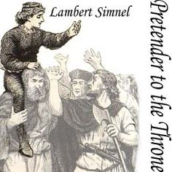Lambert Simnel (not his real name) was a 10 year old boy of humble origin who was trained by Yorkist sympathisers to impersonate the **Earl of Warwick**, son of E IV’s brother George, Duke of Clarence who died in 1478, who was imprisoned in the Tower of London.

The conspiracy started in 1486 but H did not know about it until 1487.

Simnel was merely a figurehead used by the Yorkists against H VII & when H heard of the conspiracy he paraded the real Warwick publicly through the streets of London to show Simnel was an impostor. This did not stop Simnel gaining support in **Ireland**, where he was crowned king in Dublin. The whole of Ireland was theoretically subject to the English crown but in reality royal authority was limited & the most powerful noble in Ireland, the Earl of **Kildare**, supported Simnel against H. In fact the army with which Simnel invaded England in 1487 was mainly Irish.

Simnel was also supported by R III’s sister **Margaret of Burgundy**, who hated H & was determined to overthrow him to gain revenge for her brother’s death. She paid for a formidable force of 2,000 German ____________________ (soldiers who fought for money) under the command of the able & experienced Martin Schwarz. These formed the core of Simnel’s army in the Battle of Stoke & had there been more of them, H would probably have lost the battle.

When he invaded England in June 1487 Simnel gained further support from the Earl of **Lincoln** (who probably joined the rebellion because __________________________________________________) & Lord **Lovell**, who had tried unsuccessfully to stir up a rebellion against H the year before. Both had previously been close to R III.

Most nobles & common people were **neutral** during this rebellion, waiting to see which side would win. They neither joined the rebellion nor opposed it.

The **Battle of Stoke** in June 1487 was a hard fought battle which could have gone either way, like Bosworth. As at Bosworth, H left the active command of his army to the Earl of Oxford, an ardent Lancastrian who had been in exile with H, & most of his army did not take part in the battle until the outcome was clear. The battle lasted for 3 hours & casualties were higher than at Bosworth.

Lincoln was killed in the battle & Lovell was never heard of again. Kildare survived & was allowed by H to return to Ireland where he did not support any further rebellions. Simnel’s life was spared & he was put to work in the royal kitchens.

As it turned out, this was **the last time H had to fight for his throne**.

1. Which of the key ingredients for a successful rebellion were present in this one?
2. Apart from the above points, what other evidence is there of the weakness of H’s position at this stage?
3. Why do you think H treated Simnel as he did?

1. Give the rebellion a mark out of 10 for the extent of the threat to H & explain your mark.

**THE PERKIN WARBECK REBELLION 1491-7**

|  |
| --- |
| Warbeck was a handsome Flemish youth who claimed to be **Richard, Duke of York**, the younger of the Princes in the Tower.  Why was this harder for H to deal with than Simnel’s impersonation of Warwick? |
| PW first claimed the throne in 1490 at the Duke of **Burgundy**’s court.  Why Burgundy? |
| In 1491 PW landed in **Ireland** & tried to gain support there but was unsuccessful. |
| He then went to **France** & gained support from King Charles VIII, who was in dispute with H over Brittany. |
| H ended French support for PW or any other future pretender (claimant) by making the **Treaty of Etaples** with C VIII in 1492. H had to let C keep Brittany in return. |
| PW then returned to **Burgundy**, where he was welcomed not just by Margaret but by Duke **Maximilian** of Burgundy, who was elected **Holy Roman Emperor** (in effect ruler of Germany) in 1493 & by his son **Philip** who succeeded him as Duke of Burgundy. |
| Having failed to persuade Max & Philip to stop supporting PW, H imposed a **trade embargo** (ban) on trade with Burgundy. Flanders (now northern Belgium), which was then ruled by the Duke of Burgundy, was by the far the most important market for English wool & cloth, which were England’s main exports; in fact this trade was more important than all other English trade combined.  This embargo was extremely damaging, not just to English trade generally, but to H’s own revenue in particular b/c customs duties were one of his 2 main sources of revenue.  What does this tell us about H?  H knew that the wool trade was as important to the Flemish (Flanders) merchants as it was to the English & calculated that they would put pressure on Duke Philip to stop supporting PW so trade could resume. |
| In 1495 H heard through his **spy network** that **Sir William Stanley**, who as Lord Chamberlain was responsible for his personal security, had been corresponding with PW & was considering supporting him.  Why, apart from Stanley being Lord Chamberlain, was H so shocked at this?  What do you think he did about it & why? |
| In 1495 PW tried to stir up a rebellion in **Kent** but this was easily crushed by local militia before PW even disembarked.  A brief invasion of **Ireland** also failed. |
| H’s trade embargo against Burgundy worked: in 1496, Duke Philip agreed to stop supporting PW & an agreement was signed called the **Intercursus Magnus** (Great Intercourse) which restored trade between England & Burgundy. |
| PW then fled to **Scotland**, which at that time was a separate kingdom with its own king. The Scottish king **James IV** welcomed PW to his court & married him to his cousin, Lady Catherine Gordon.  In September 1496 J provided PW with a small army to invade England in the hope of attracting Yorkist support in the North but in fact this was more of a border raid than an invasion: the Scots only advanced 4 miles into England & withdrew after only 4 days as soon as an English army appeared, having failed to gain any English support.  J then decided to abandon PW & made the **Truce of Ayton** with H in 1497. This ended Scottish support for PW or any other pretender. |
| PW was sent to **Ireland**, where he tried yet again to gain support & yet again failed.  In desperation he then landed in **Cornwall** in September 1497, hoping to exploit the fact that there had been a tax rebellion there 3 months earlier. He gained some support but he had come too late & he knew his small army would be no match for the royal army commanded by the able & experienced Lord Daubeney. He fled in panic to Hampshire, where he finally gave himself up without a battle in November 1497. |
| H put PW in the Tower of London, initially sparing his life partly b/c as a foreigner he could not be accused of treason & partly to show he wasn’t a threat.  In 1499 PW was executed partly for trying to escape & partly to reassure Spain, with whom he was negotiating the marriage of his son Arthur to Catherine of Aragon, that he had eliminated all threats to his throne. |

***Complete the table and then answer the questions which follow.***

|  |  |  |  |
| --- | --- | --- | --- |
| **Date** | **Location** | **What support did Warbeck receive and why?** | **Henry VII’s reaction** |
|  |  |  |  |
|  |  |  |  |
|  |  |  |  |
|  |  |  |  |
|  |  |  |  |
|  |  |  |  |
|  |  |  |  |

1. What methods did Henry use to prevent support for Warbeck developing?
2. Where did the most long lasting support for Warbeck come from? Why?
3. What do you consider the best evidence for Henry’s concern over the dangers from Warbeck?
4. Does Henry’s conduct of foreign policy to 1499 suggest that he was following a preconceived plan or that he was simply reacting to events?

**THE EARL OF SUFFOLK**

Following Warwick’s execution in 1499 the only remaining Yorkist with a reasonable claim to the throne was **Edmund de la Pole, Earl of Suffolk**, younger son of E IV’s sister Elizabeth (not to be confused with his daughter Elizabeth of York). As the younger brother of the Earl of Lincoln (killed at Stoke) he was treated with suspicion and he fled to **Burgundy** in 1499. It is not clear what prompted this (possibly something surrounding Warbeck or Warwick) however it seems to have surprised Henry as well. Henry persuaded Suffolk to return (an example of ‘keep your friends close & your enemies closer’ perhaps). Nevertheless Suffolk fled again in 1501. His brother Richard went with him and they sought refuge with the Emperor **Maximilian** in Burgundy. This time Henry acted more decisively and imprisoned Suffolk’s relations in England and in 1504 passed acts of attainder against those with links to him. In 1506 a storm forced Archduke Philip of Burgundy (Maximilian’s son) and his wife, Joanna of Castile, to take shelter in Weymouth, Dorset. Henry made the **Treaty of Windsor** with Philip and Suffolk was returned from Burgundy in return for a promise not to harm him. Henry agreed to support Philip in his attempt to become King of Castile. Henry VII kept this promise regarding Suffolk however Henry VIII had him executed in 1513.

Therefore it was **not really until 1506 that the Yorkists’ threats were effectively ended**. However there are levels of threat and, arguably, after Stoke the immediate threats were gone and after Warbeck and Warwick’s execution the most persistent threats were ended.

**DEATHS IN THE FAMILY**

|  |  |  |
| --- | --- | --- |
| **Date** | **Event** | **Significance** |
| 1500 | Henry Vll’s third son, Edmund died |  |
| 1502 | Prince Arthur died. Prince Henry was only 10 years old. |  |
| 1503 | Queen Elizabeth died |  |

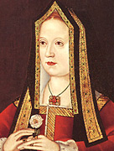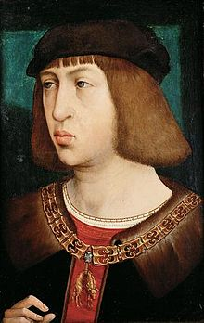

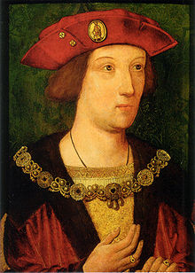Left: Prince Arthur

Middle: Elizabeth of York

Right: Philip of Burgundy, who supported Suffolk until 1506

**TAX REBELLIONS**

Yorkshire 1489

This was provoked by H trying to raise taxes to pay for a **war against France**.

This provoked unrest b/c:

* People in Yorkshire didn’t see why they should pay taxes for a war so remote from them.
* Other northern counties near the Scottish border were exempt from it b/c they were expected to pay for the defences against Scotland.
* There had been a bad harvest in 1488.
* Although the rebellion was primarily about taxation, there is some evidence of **Yorkist** involvement: it was led by the Yorkist Sir John Egremont.

In some ways it was a serious threat:

* The Earl of **Northumberland**, one of the most powerful nobles in the North, was murdered for trying to stop the rebellion.
* The taxes which provoked the rebellion were never actually collected.

On the other hand, the rebellion was **put down locally & never posed a national threat**. There was no serious unrest in the North in the rest of H’s reign.

Cornwall 1497

This was provoked by H trying to collect taxes for a **war against Scotland**; as in Yorkshire in 1489, Cornishmen saw no reason why they should pay for a war which was geographically remote from them. Resentment against corrupt local officials also seems to have been an issue.

This was a more serious threat than the Yorkshire rebellion:

* It started in Cornwall but gained support from all over the South; the rebels reached Blackheath on the far side of **London** before they were defeated.
* The **nobility & gentry** didn’t join the rebellion but neither did they oppose it; this shows that loyalty to H was still weak 12 years into his reign.
* The ferocity of H’s response (the leaders were tortured & executed) suggests that he was worried.

On the other hand:

* H only took as long to crush the rebellion as he did b/c he was concerned about a possible invasion from Perkin Warbeck. Once he raised an army he was able to crush the rebellion easily.
* There was **little sign of Yorkist involvement** in this rebellion: **the rebels blamed “evil counsellors” rather than the King himself** & when Warbeck invaded Cornwall 3 months after the rebellion he gained little support.
* H avoided any such rebellions in future by **avoiding war** so there was no reason to impose taxes.

1. In what ways did these rebellions show the limitations of H’s power?
2. How were they different from the threats posed by Lincoln, Warwick, Suffolk, Simnel & Warbeck?

**Rebellions Threat Grid**

|  |  |  |  |  |  |
| --- | --- | --- | --- | --- | --- |
| For a rebellion to succeed you need … | Simnel & Lincoln 1486-7 | Warbeck 1491-9 | Suffolk 1501-6 | Yorkshire Tax Rebellion 1489 | Cornish Tax Rebellion 1497 |
| An army |  |  |  |  |  |
| Foreign support |  |  |  |  |  |
| A good claim to the throne |  |  |  |  |  |
| Noble support |  |  |  |  |  |
| Discontent with current King |  |  |  |  |  |
| Financial backing |  |  |  |  |  |
| Good organisation & strategy |  |  |  |  |  |
| Totals |  |  |  |  |  |

**How Henry dealt with Pretenders Grid**

|  |  |  |  |
| --- | --- | --- | --- |
| **Pretender** | **Claim to Throne** | **How H dealt with him / her** | **By when** |
| Elizabeth of York |  |  |  |
| Lincoln |  |  |  |
| Simnel |  |  |  |
| Warbeck |  |  |  |
| Warwick |  |  |  |
| Suffolk |  |  |  |

**How serious a threat to Henry VII’s rule was the Yorkist challenge?**

Serious

* The weak nature of Henry VII’s claim.
* The Stafford/Lovell rebellion in 1486 showed how insecure H was at the start of his reign & that marrying Elizabeth of York did not by itself dispose of the Yorkist threat.
* In themselves, Simnel and Warbeck presented little danger but they provided a focus for the plots of others in England and overseas, such as **Margaret of Burgundy**, who financed Simnel’s army at Stoke. H was never truly secure until she died in 1503.
* **Ireland** was also sympathetic to the Yorkists; most of Simnel’s army at Stoke was Irish.
* Simnel was supported by powerful **nobles** like Kildare, Lincoln & Lovell.
* The Simnel rebellion was a threat because it forced the king into battle, which might have gone the same way as Bosworth. In fact **Stoke** was a bigger, bloodier & longer battle than Bosworth; 3,000 of H’s troops were killed & it could well have gone the other way if Simnel had had more than 2,000 German mercenaries.
* **Warbeck** was a threat as he received support from various times from France, Burgundy, the HRE & Scotland.
* H had to beat off a Scottish invasion in 1496 & his attempt to levy taxes to finance a war against **Scotland** in 1497 provoked the very serious Cornish tax rebellion.
* H had to impose a costly & unpopular **trade embargo** 1493-6 to stop Burgundy & the HRE supporting Warbeck.
* That **Sir William Stanley**, to whom H owed his throne & as Lord Chamberlain was responsible for H’s personal safety, should think it worthwhile to correspond with Warbeck showed what a threat he was.
* H’s decisions to **execute** Stanley in 1495 & Warbeck in 1499 shows he did not feel secure.
* The imprisonment & later execution of **Warwick** (& the fact that Simnel gained so much support by impersonating him) showed he was a threat.
* **Suffolk** posed a serious threat which H was lucky to be able to deal with (when Duke Philip of Burgundy was forced by a storm to land in England in 1506).

Not Serious

* The fact that R III was **killed** as well as defeated at Bosworth made the Yorkist threat much less serious than it would otherwise have been & forced the Yorkists to rely on impostors.
* Ross argues that H’s vanguard alone was sufficient to defeat Simnel at Stoke; H had more troops & they were more experienced.
* The Yorkshire tax rebellion in 1489 was not a serious threat & probably not connected to Yorkist claims to the throne anyway.
* Warbeck had to keep moving, successively to Ireland, Kent, France, Burgundy, the HRE, Scotland & Cornwall, reflecting his inability to get any **sustained** support either abroad or at home.
* The Scottish “invasion” of 1496 was little more than a border raid & Warbeck’s army in Somerset in 1497 fled without a battle, so H never had to fight seriously for his throne after Stoke.
* Warbeck’s failure to exploit the Cornish tax rebellion in 1497 (his army ran away when H’s appeared) shows that it had little to do with Yorkist claims to the throne.
* H’s sensible policies, e.g. his effective **spy network** which tracked Warbeck’s movements & discovered Stanley’s treason, reduced the threat as time went on.

CONCLUSION: Give a mark out of 10 for how serious the threat was & write a conclusion explaining this & incorporating at least 3 bullet points on each side. It should be decisive but balanced.

**How effective was Henry VII in dealing with the Yorkist challenges to his throne?**

It is likely that most answers will focus on the Simnel and Warbeck rebellions, but better answers might also consider the de la Pole threat, the Yorkshire tax rebellion and Suffolk. There might also be mention of the situation in Ireland and the general threat from Yorkist nobility who often found themselves under heavy financial burdens.

Effective

* Henry was successful as none of the challenges were able to remove him from the throne.
* The Yorkist cause was reduced to using pretenders.
* Dating the start of his reign to the day before Bosworth meant anyone who fought against him could be convicted of treason.
* Henry married the best Yorkist claimant, **Elizabeth of York** *(right).*
* Having defeated Simnel, Henry was able to show mercy and defuse the situation by parading the real Earl of Warwick; the success of his policy can be seen when Warbeck rose and failed to gain support in Ireland, unlike the Simnel rising.
* It might be argued that the decline in rebellion after the defeat of Simnel provides evidence of his success and that **Warbeck** was never more than a nuisance that Henry was largely able to nullify.
* Henry, it can be argued, did deal very successfully with Warbeck as his attempts at invasion were pathetic failures, and he was also able to keep him on the move between European courts.
* H imprisoned **Warwick** until the conspiracies of other plots provided an excuse for his execution.
* H defeated the tax rebellions in 1489 & 1497.
* H ended foreign support for pretenders through the **Treaty of Etaples** 1492, the **Intercursus Magnus** 1496, the **Truce of Ayton** 1497 & the **Treaty of Windsor** 1506..
* H used military action to put pressure on the French & Scottish kings to stop supporting Warbeck.
* The execution of Sir William **Stanley** in 1495 helped H to control the nobility by showing that nothing less than 100% loyalty would be tolerated.
* Henry was able to hand on a secure throne to his son.

Ineffective

* The **Simnel** rebellion did force Henry into battle only two years after Bosworth and it was not impossible that a similar result might have occurred.
* Sir William **Stanley**’s disloyalty in 1495 showed H was not yet secure.
* **Foreign support for the Pretenders**, particularly from Margaret of Burgundy, made it more difficult for Henry as he was unable to deal with her.
* Henry had difficulty capturing Warbeck.
* H had to make **tax concessions** because of the rebellions in 1489 & 1497.

**FOREIGN POLICY**

**Key Topics and questions**

**England’s position in Europe in 1485**

**Henry VII’s aims for his foreign policy**

**Relations with Brittany, France, Spain and Burgundy.**

**How successful was Henry VII’s foreign policy?**

**Europe in 1485**

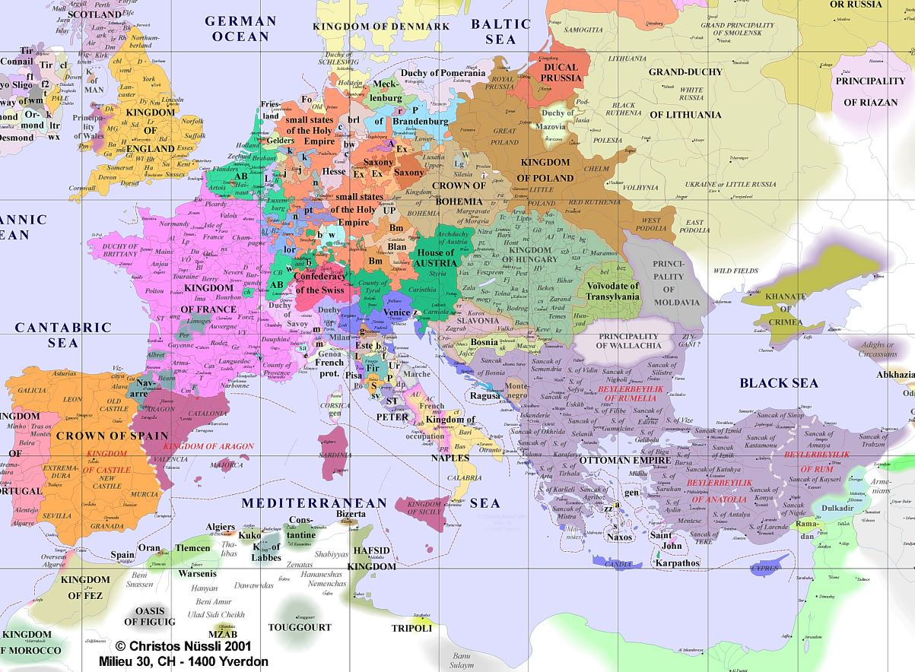

AB = territory ruled by the Duke of Burgundy

The Holy Roman Empire was an area of central Europe bordered by France to the west, Denmark to the north, Poland & Hungary to the east & the Kingdom of Naples (southern Italy) to the south.

It was centred on Germany but also included the Netherlands, Bohemia (now the Czech Republic), Austria & northern Italy.

**Task 1 - Bearing in mind the fact that Henry VII was a usurper with a very weak claim to the throne what do you think the aims of his foreign policy would have been?**

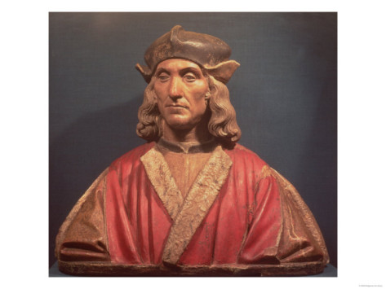

**Brittany and France**

H knew that **he would not have been able to win the throne without French support** so he was initially keen to maintain good relations with her. On his accession he immediately negotiated a one year truce with France and this was later extended to January 1489.

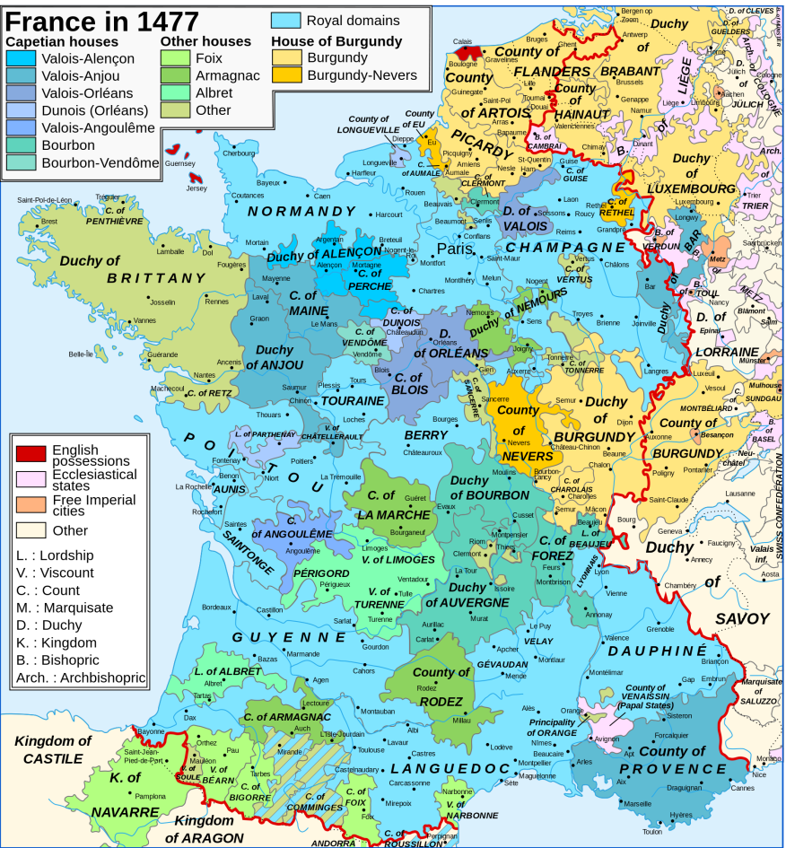

**The first major foreign policy problem of the reign concerned Brittany and France.** France’s resources in terms of manpower and revenue were about three times those of England and the French were expansionist and aggressive. They had ambitions to take over Brittany which was an independent duchy ruled over by Duke Francis. The duke was not expected to live long and he had a daughter to succeed him The French plan was that **Charles VIII** of France should marry the Duke’s daughter **Anne** and in that way Brittany would be incorporated into the kingdom of France. The Duke was prepared to resist French plans but in 1488 a French army marched into Brittany. The Duke asked Henry for help and this put Henry in a very difficult position.

Henry felt that he ought to help Brittany:

1. He had spent most of his exile in Brittany so felt a certain amount of loyalty to the Bretons.
2. He did not wish the French to take over the area as that would mean that they would control more of the coastline facing England and so would more easily be able to launch an invasion.
3. On the other hand it had been with French help that Henry had been able to win the Battle of Bosworth and he **did not want France to support his enemies**. He had negotiated a truce with the French.
4. Henry could not afford an aggressive and expensive foreign policy whilst he was still insecure on his throne.

Therefore he compromised by sending several hundred volunteers unofficially to fight on behalf of the Bretons. In July 1488 the Bretons were decisively defeated in battle by the French. The Duke signed a treaty in which he promised that his daughter would not marry without the permission of the French king. Three weeks later he died and his daughter became Duchess at the age of 12. The French immediately claimed custody of her and it looked as if their takeover was imminent.

Henry was once again in an awkward position. The acquisition of Brittany by France would make England’s main rival even more powerful. It would give valuable bases for an invasion of England, or for the French to attack merchant ships and disrupt English trade. Yet Henry couldn’t afford war and in any case he did not want to give France an excuse to support the various claimants to the English throne. He tried to use diplomacy to save the situation by finding sufficient allies to deter the French from going to war. He renewed the peace treaty he had made with Maximilian, Duke of **Burgundy** in 1487, and made a new alliance with Spain in the **Treaty of Medina del Campo in 1489.** A treaty was also made with Brittany at **Redon** in February 1489 in which the Bretons promised to pay the cost of 6,000 men Henry agreed to send to them. This was a small number and Henry was emphasising that he was only working to defend England’s interests and had no intention of taking French land.

Six thousand English soldiers were sent to defend Brittany but Henry was let down by his allies, Maximilian and Ferdinand of Spain. Finally in December 1491 the Bretons accepted defeat and the Duchess Anne was married to Charles VIII of France. Their marriage (below) spelled the end of the independence of Brittany.

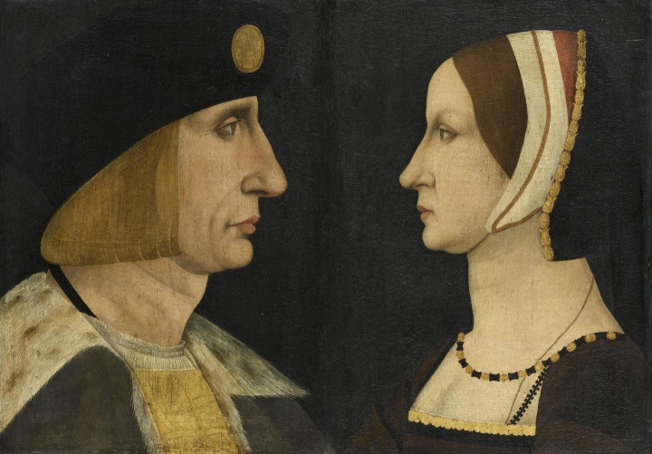

Henry was now faced with one of the most difficult decisions of his reign. He had to choose between attempting to liberate Brittany by conquering France or simply leaving Brittany to French control. **He knew that to withdraw without some show of force would appear weak and would lose him credibility at home and abroad.** He could not afford war but an aggressive move might be of benefit. It would enhance his reputation and have enough nuisance-value to persuade the French to buy him off.

In addition to this **Perkin Warbeck** had arrived in France by 1492 and had support from Charles VIII because of Henry’s involvement in Brittany.

Henry announced his intention to assert his claim to the French crown and in October 1492 a large force of 26,000 men crossed the Channel and besieged Boulogne. He had delayed his departure until late in the campaigning season (wars were not usually fought over the winter months) and so it did mean that if Henry had to fight then it would not be for long. He was reckoning on the fact that Charles would want to make peace as his real ambitions were to invade **Italy** and not to fight the English on French soil. Henry was proved right because nine days after he set foot on French soil Charles offered peace and the **Treaty of Etaples** **was agreed in 1492.**

Charles’ only concerns were to keep Brittany and get rid of Henry. He promised:

1. To give no further aid to English rebels, particularly Warbeck.
2. To pay Henry’s costs for the intervention in Brittany as well as pay an annual pension of about £5,000 a year. This was approximately 5% of the king’s annual income.

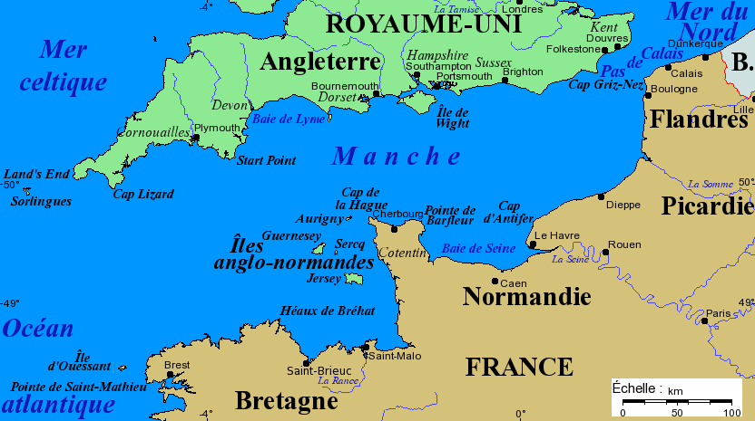

Henry had not won a glorious victory, for Brittany’s independence was lost forever and the whole of the southern side of the Channel, apart from Calais, was in French hands.

However there were some positive achievements:

1. He had **prevented Charles Vlll from helping Perkin Warbeck or any other pretender**.
2. He had secured a sizeable annual **pension** from the French worth 5% of his total income.
3. He had made a valuable alliance with Spain (Treaty of Medina del Campo, 1489).
4. He had shown that England under a Tudor king could not be completely overlooked in continental affairs.

**Task 2**

1. How was Henry’s involvement in France different from that of his predecessors?
2. List the successes and failures of the campaign.
3. Was the outcome brought about by the successes of Henry’s policies or by circumstances?
4. What do these events tell us about Henry’s skills and objectives in foreign policy?

**Spain: The Treaty of Medina del Campo (1489) and the Marriage Alliance (1501)**

Notes from ***‘The Wars of the Roses and Henry VII: Britain 1450-1509’*** – Roger Turvey

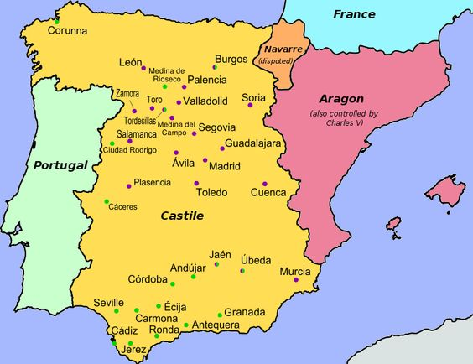Both Spain and England shared an enmity with **France**.

Spain was a major European country, especially after the marriage between **Isabella of Castile** and **Ferdinand of Aragon** (below right). This strengthened the country and made their rulers very well respected. The Spanish ruling family was one of the oldest royal families in Europe and so it was a considerable achievement for Henry VII to marry his son to Catherine of Aragon bearing in mind that Henry VII was a usurper with a very weak claim to the throne.

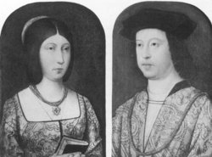It was early in 1488 that Henry suggested a marriage between his eldest son, Prince **Arthur**, and Ferdinand and Isabella’s daughter, **Catherine of Aragon**. The negotiations lasted a long time but eventually the **Treaty of Medina del Campo** was agreed in 1489:

1. Spain would offer no aid to any English rebels or pretenders to the English throne.
2. Catherine’s dowry would be double that initially offered. The Spanish agreed to pay 100,000 crowns.
3. Both nations became trading partners.
4. If either country found itself with war with France, the other was to support them immediately.

The Spanish did little to help Henry in his efforts to secure **Brittany**’s independence but Henry seemed satisfied with his relationship with Spain and continued his pro-Spanish policy throughout most of his reign.

In October 1496, Ferdinand and Henry made a further agreement for the marriage of Catherine and Arthur and in the same year Ferdinand enabled England to join the Holy League (previously called the League of Venice and formed in 1495 by the Pope, Emperor Maximilian, Ferdinand, Venice and Milan with the aim of driving the French out of Italy). Ferdinand may have been motivated by his wish to prevent Henry from drawing closer to France after the Treaty of Etaples in 1492 but Henry showed that he would not be manipulated by Ferdinand as he only joined the Holy League on condition that he would not be bound to war against France. It is to Henry’s credit that he also managed to make a commercial treaty with France whilst also maintaining good relations with his allies in the Holy League. 1496 was a very successful year for Henry as he had also concluded the Intercursus Magnus with **Burgundy**.

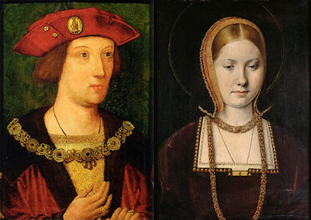The alliance with Spain was finalised in November 1501 with the **marriage** between Prince Arthur and Catherine of Aragon (right). Following **Arthur’s death** in April 1502, Henry entered into fresh negotiations to keep the alliance and in September 1502 it was agreed that Catherine should marry Prince Henry.

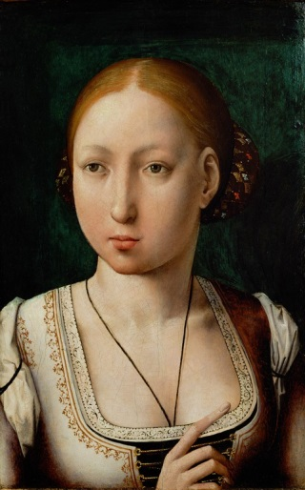In 1504 **Isabella of Castile died**. She left her country to her eldest daughter, **Joanna**, who was married to **Philip, Duke of Burgundy**. This threatened Ferdinand with the loss of much of his power and influence as his kingdom of Aragon was much smaller and poorer than Castile, so he contested Philip’s claim (taking advantage of the fact that he was far away in Burgundy) & retained control of Castile. He justified this by claiming that Joanna (his own daughter) was mad. Because relations with Burgundy were more important than relations with Spain (both because of trade and because of Burgundian support for pretenders), H sided with Philip in this dispute.

Consequently, Henry VII was not so anxious to maintain a marriage alliance between the two countries and so he claimed that the proposed marriage between Catherine and Prince Henry could not be justified as his son was under age at the time of the agreement. This led Ferdinand to make an alliance with Louis XII of France and he married the French king’s niece in 1506.

In the Treaty of Windsor in 1506 Henry recognised Philip and Joanna (right) as King and Queen of Castile and agreed to help them financially to gain control of their kingdom.

Philip reached Spain but died there later in 1506, which left Ferdinand in control. Henry VII was now keen for the marriage between Catherine of Aragon and Prince Henry to take place. However, Ferdinand was content with his French alliance and did not need English support.

Henry therefore tried to make marriage alliances for himself and his son with Burgundy and with France in an attempt to isolate Ferdinand, but he achieved nothing and in fact was side-lined as the centre of international affairs was now in Italy. This was shown by his exclusion from the **League of Cambrai** in 1508 which included both France & Spain but not England.

**Task 3** - How successful overall was H in his relations with Spain? Consider his aims & consider both successes & failures.

**England’s Relations with Burgundy**

Burgundy was a duchy in eastern France, the eastern part of which was ruled by the Duke of Burgundy independently of the King of France. 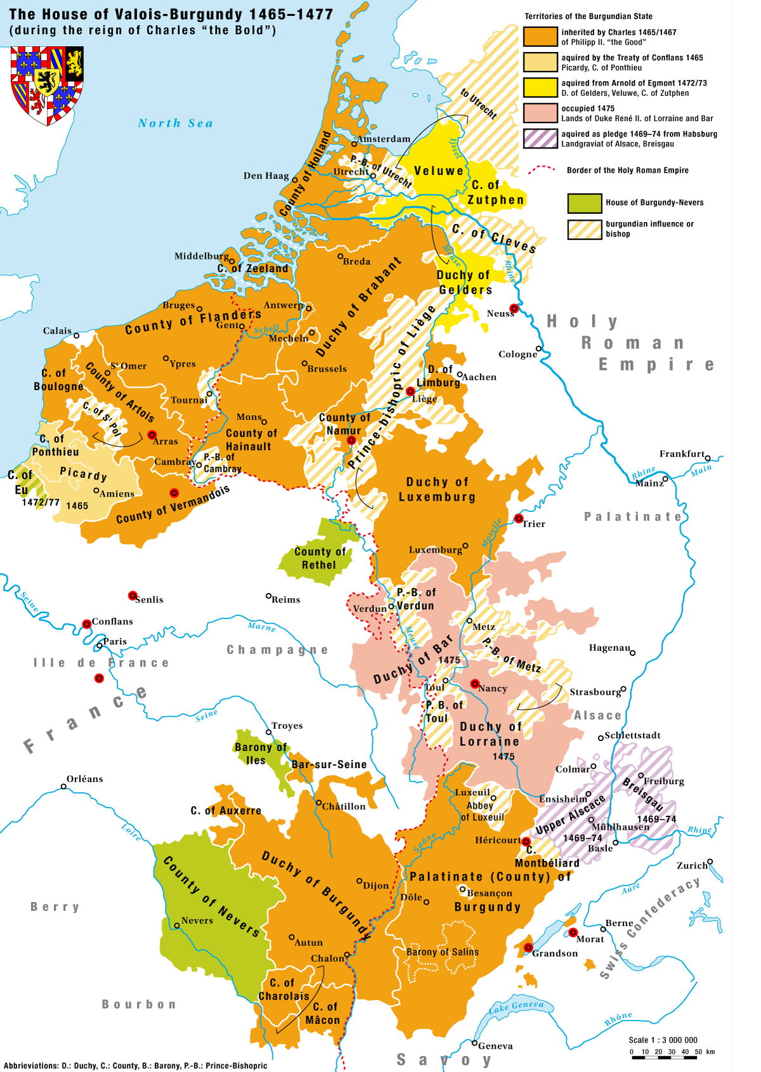

The Duke of Burgundy also ruled over most what is now Belgium & the Netherlands, including **Flanders** (now in northern Belgium) which was then the wealthiest & most industrialised part of Europe. Flanders was the most important market for England’s main export, which was wool; in fact **the wool trade with Flanders was worth more than all other English trade put together**. It was therefore vital for England’s economy as a whole & H’s royal revenue in particular (customs duties were his most important source of income) that this trade was maintained.

Unfortunately for H, Burgundy had always been **Yorkist** during the Wars of the Roses: Duke Charles had helped E IV regain the English throne in 1471 & then married E’s sister **Margaret**. Burgundy also supported R III & after Bosworth Margaret was determined to get revenge on H for her brother’s death by supporting Simnel, Warbeck & Suffolk.

H’s failure to stop Burgundian support for the **Simnel** rebellion in 1487 was **the most important foreign policy failure of his reign**, forcing him to fight for his throne at **Stoke** which was a bloodier & harder fought battle than Bosworth. Simnel’s army was mainly Irish but paid for by Burgundy, with Margaret influencing her son in law Duke **Maximilian** against H. Maximilian like Ferdinand of Aragon was notoriously unreliable (both broke their promises to support H’s efforts to prevent the French takeover of Brittany) & was willing to support H’s enemies if he thought it was in his interests to do so.

Warbeck was from Flanders & it was at the court of Burgundy that **Warbeck** first claimed the English throne in 1490 & continued support for him from Duke **Philip** (who took over as Duke of Burgundy when his father Maximilian was elected Holy Roman Emperor in 1493) forced H to impose a **trade embargo** (ban) in 1493.

**This action was very damaging to both countries but it is clear that Henry’s priority was the safety of his throne and that England’s economy was of secondary importance to him.**

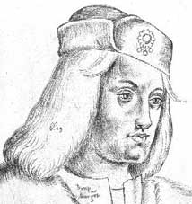But H knew the wool trade between England & Flanders was as important to Burgundy as it was to England; he therefore calculated that the merchants of Flanders would pressure on Philip to stop supporting Warbeck (right) so trade could be resumed.

H’s strategy paid off in the **Intercursus Magnus** in 1496 which restored the trade in return for Philip ending his support for Warbeck. Philip deported Warbeck to Ireland & his failure to gain support there or in Scotland or England led to his capture without a battle in 1497.

**H was therefore much more successful in cutting off foreign support for Warbeck than Simnel.**

Even after the capture of Warbeck in 1497 Margaret supported the claim to the throne of her & E IV’s nephew Edmund de la Pole, Earl of **Suffolk**, who fled from England to the Holy Roman Empire in 1501. He was sheltered by Max & supported by Margaret until her death in 1503. In 1504 Suffolk moved to the Netherlands & was sheltered by Duke Philip (right).

Philip and his wife Joanna were on their way to Castile in 1506 when they were forced by storms to land at Weymouth. Henry VII entertained them in England for three months during which time he negotiated the **Treaty of Windsor**. Philip agreed to return the Earl of Suffolk, Edmund de la Pole, to England and to make a trade agreement.

**This ended all Burgundian support for pretenders.**

**Task 4**

1. What do you understand by the term trade embargo?
2. What does the fact that Henry imposed an embargo tell us about his priorities?
3. When and why did the embargo come to an end?
4. How successful was H’s policy towards Burgundy overall?

**Scotland**

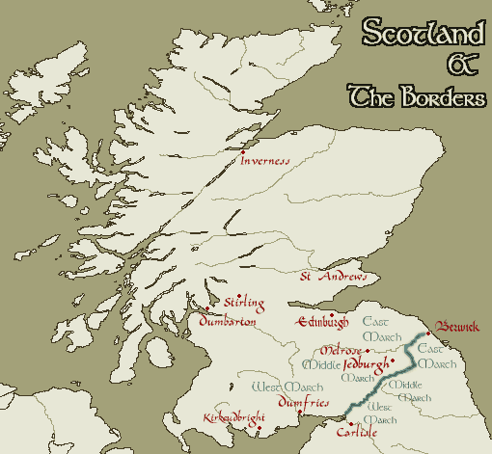

*(Notes from Flagship History,* ***England 1485-1603****)*

Until 1603 Scotland unlike Wales or Ireland was a separate kingdom with its own king. Anglo-Scottish relations were traditionally difficult but in 1486 neither Henry VII nor James III wanted trouble and so a three year truce was agreed. However, in1488 James III was assassinated and he was succeeded by the 15 year old James IV. The men ruling Scotland on behalf of the young king and in fact **James IV** himself were hostile to the English and keen to maintain the **‘auld alliance’ with France against England**. Henry viewed this as a threat to England.

James IV wanted war and the arrival of **Perkin Warbeck** in Scotland in 1496 encouraged him. It is uncertain how far, if at all, James was taken in by Warbeck but he gave him a generous pension and married him to his cousin, Lady Katherine Gordon. These actions greatly offended Henry and endangered his proposed marriage alliance with Spain. Ferdinand and Isabella were reluctant to allow their daughter Catherine of Aragon to travel to England to marry Prince Arthur when the Tudor dynasty still seemed so insecure.

In 1496 James IV launched a shortlived (4-day) border raid into England with Warbeck but it achieved nothing as Warbeck received no support there (N.B. This raid is indirectly linked with the Cornish rebellion of 1497.)

By the autumn of 1497 James IV was ready to make peace with Henry and made the **Truce of Ayton**. James agreed not to attack England but he maintained the French alliance.

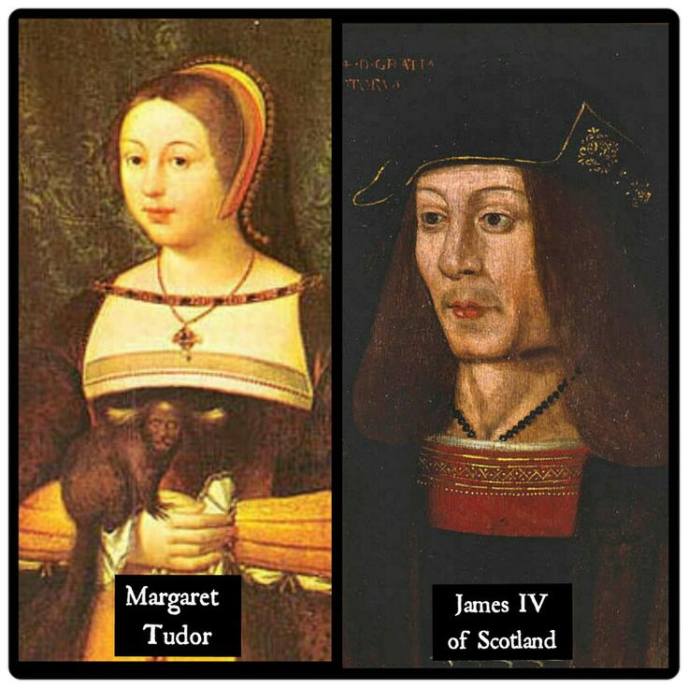

The Truce of Ayton was a great achievement for Henry as there had been no worthwhile treaty between England and Scotland since 1328. This truce, a temporary agreement to peace, was finally confirmed as a full treaty of peace in 1502. Henry’s efforts were completed with the **marriage** of his daughter **Margaret** to James IV in 1503 which led 100 years later to the union of crowns when James VI of Scotland became James I of England in 1603.

From 1497 Henry VII enjoyed peace with Scotland but the continued Scottish friendship with France remained. This was always seen as a potential threat leaving England open to invasion through the ‘back door’ i.e. her northern border with Scotland.

**Task 5**

1. Why was Scotland seen as a threat by Henry?
2. Why was 1496 a difficult year for Henry?
3. What was the significance of the Truce of Ayton? Consider Henry VII’s foreign policy aims.
4. What was the significance of the marriage alliance between James IV and Margaret? (Again consider Henry’s foreign policy aims).

**Task 8**

|  |  |  |
| --- | --- | --- |
| **DESCRIPTION OF HENRY VII’S FOREIGN POLICY** | **EVIDENCE FOR** | **EVIDENCE AGAINST** |
| Cautious/wary / defensive |  |  |
| Pragmatic  (practical/sensible)  & realistic |  |  |
| Forward thinking/  Strategically sound |  |  |
| Unambitious |  |  |
| Opportunistic |  |  |
| INSERT YOUR OWN DESCRIPTION HERE! |  |  |

**FOREIGN POLICY SUCCESS GRID**

|  |  |  |
| --- | --- | --- |
| **Country** | **Successes** | **Failures** |
| **France** |  |  |
| **Spain** |  |  |
| **Burgundy** |  |  |
| **Scotland** |  |  |

**WHAT WAS THE MOST IMPORTANT AIM OF HENRY VII’S FOREIGN POLICY?**

Securing the Throne

* 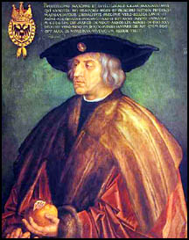**Foreign policy was the most important way to secure his throne as most support for pretenders came from abroad**, e.g. Simnel’s army in 1487 was financed by Margaret of Burgundy. H never forgot that he himself owed his throne to French support.
* Margaret of Burgundy was a constant threat until her death in 1503.
* Foreign support for pretenders was a problem throughout H’s reign; only after Burgundy surrendered Suffolk to him in **1506** was he fully secure.
* His willingness to impose a **trade embargo 1493-6** & to **bribe Maximilian** *(right)* with huge sums of money to stop Burgundy & the Holy Roman Empire supporting Warbeck shows that securing his throne was more important than financial or economic considerations.
* **All other factors link back to securing his throne**: marriages with Spain & Scotland were designed to gain international recognition of his dynasty & secure its future, while avoidance of war was designed to stop tax rebellions like those in Yorkshire in 1489 & Cornwall in 1497. Avoidance of war with France (Treaty of Etaples 1492) & Scotland (Truce of Ayton 1497) stopped support for Warbeck.

Marriages

* Marriages were important as they brought him European recognition, which was important because of his weak claim to the throne, and also gave him a Spanish alliance.
* The marriage of **Arthur to Catherine of Aragon** in 1501 was intended to cement H’s alliance with Spain & help secure Arthur’s succession to the throne.
* The marriage of **H’s daughter Margaret to James IV** in 1503 brought at least short term peace with Scotland.

Avoidance of War

* This helped H achieve other objectives like improving his finances & securing his throne. He could not have achieved financial success without avoiding war & raising taxes for war provoked **rebellions** in Yorkshire (1489) & Cornwall (1497). Avoiding war with France & Scotland enabled him to stop support for Warbeck.
* H’s invasion of France in 1492 might seem to contradict this but in fact he invaded in the autumn (too late for serious campaigning) & was clearly hoping to be bought off.
* H was unable to prevent a Scottish invasion in 1496 but the Truce of Ayton the following year showed his eagerness to avoid war with Scotland.
* H’s eagerness to avoid war with France & Scotland in the 1490s was motivated primarily by his desire to stop them supporting **Warbeck**.

Other Factors

* Knowing he had won power himself with French support, H tried until 1492 to stop France taking over **Brittany**, which could be used as a base from which to invade England.
* **Financial gain** was arguably the most important achievement given the nature of his finances and use the French pension to support this and also the development and protection of **trade**, which was secured by his treaties with Spain (Medina del Campo 1489), France (Etaples 1492), Burgundy (Intercursus Magnus 1496).

**To what extent was Henry VII’s foreign policy a success?**

Successes

* He gained international recognition through treaties with Spain, France, Burgundy & Scotland plus **diplomatic marriages** with Spain & Scotland.
* He forced **Warbeck** to keep moving in the 1490s from France to Burgundy to Scotland b/c he kept cutting off his foreign support; in the end H was able to capture him without a battle.
* H’s foreign policy was **financially** successful: he gained a French pension which added 5% to his annual income, avoided the expense of war after 1497 & boosted his customs revenue through trade agreements with France, Spain & above all Burgundy (Intercursus Magnus 1496).
* H was keen to **avoid expensive wars** and this was largely achieved; although he went to war against France over Brittany it was short-lived and Henry actually gained money through the French pension.
* By avoiding war & therefore taxation after 1497 he minimised the danger of rebellion.
* H succeeded b/c he set himself realistic objectives, focusing on **security** rather than glory (e.g. in negotiating the Treaty of Etaples in 1492).
* In the 1490s he was able to secure a trade agreement with **France** despite also maintaining good relations with Ferdinand & Maximilian through the **Holy League**.
* The **Truce of Ayton** was the first peace agreement between England & Scotland since 1328 & secured peace for the rest of H’s reign.
* The **Treaty of Windsor** in 1506 (securing custody of Suffolk) meant he & his heir were fully secure.

Failures

* 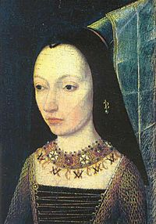He failed to cut off Burgundian support for **Simnel** in 1487, forcing him to fight the Battle of Stoke.
* He failed to prevent the French takeover of **Brittany**, partly b/c he was let down by his allies (Ferdinand & Maximilian).   This could be seen as a threat to English security.
* His attempts to raise taxes for wars against France & Scotland provoked **tax rebellions** in Yorkshire in 1489 & Cornwall in 1497.
* **Margaret of Burgundy** *(right)* supported both Warbeck & Suffolk & was a constant threat until her death in 1503.
* This forced H to impose an economically damaging **trade embargo** on Burgundy 1493-6 & to stop support for Warbeck. Although trade was restored the terms favoured Burgundy b/c H was so desperate to stop support for pretenders; he also spent huge sums bribing Maximilian to achieve this.
* He had to face a **Scottish invasion** in 1496 b/c he had failed to prevent support for Warbeck.
* Relations with **Spain** deteriorated after Isabella’s death in 1504 b/c H sided with Philip rather than Ferdinand & H was excluded from the **League of Cambrai** in 1508..
* H was not fully secure until **1506** when Burgundy handed over Suffolk into his custody.

**DOMESTIC POLICY ANALYSIS**

“Domestic policy” means:

1. Securing the throne & succession through domestic measures (as opposed to foreign policy) like the spy network, marrying Elizabeth of York, executions etc (see notes on this).
2. Financial policy.
3. Control of the nobility.

You might be asked a separate question on any of these or possibly a question on domestic policy more generally.

You could be asked a question on **which of the 3 was most crucial to H’s success**, which is difficult to answer b/c they overlapped. H himself always regarded securing his throne as the most important priority, e.g. his willingness to sacrifice trade to stop support for pretenders, & unless he kept the throne he obviously couldn’t have achieved anything else. He would have regarded financial success & control of the nobility as means to the end of securing his throne rather than as ends in themselves. On the other hand, if he couldn’t control the nobility or couldn’t afford to raise an army to fight pretenders, he would lose the throne anyway.

H himself said “the kings my predecessors, weakening their treasure, have made themselves servants to their subjects”. Foreign ambassadors (to whom H gave expensive gifts to show his wealth) noticed that H liked to be thought wealthier than he truly was b/c it would discourage people from supporting pretenders. H has often been accused of being greedy but this was b/c, as Alexander Grant has argued, he equated money with power.

Edmund Dudley noted “the King’s grace was much set to have many persons in his danger at his pleasure”; by “danger” he meant financial ruin b/c this (through the system of bonds & recogs. which Dudley enforced) was H’s favourite means of controlling the nobility. These are often seen as a money raising device but in fact their main purpose was to secure good behaviour, especially of former Yorkist nobles like Surrey & Dorset. In that sense control of the nobility was more important than finance.

**Finance Glossary**

|  |  |
| --- | --- |
| Chamber system |  |
| Feudal dues |  |
| Benevolences |  |
| Parliamentary taxation |  |
| Customs duties |  |
| Clerical taxation |  |

**HOW SUCCESSFUL WAS HENRY VII IN STRENGTHENING ROYAL FINANCES?**

**Successes**

* The use of the **Chamber system** helped H to bring finance under his personal control; he took a keen interest in accounts, payments & income. This was quicker & more efficient than the Exchequer.
* 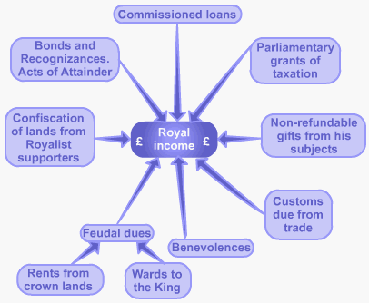He employed effective officials like **Bray, Empson & Dudley** to ensure that any money due to the Crown (e.g. fines & feudal dues) was thoroughly collected, e.g. a knighthood fee for his son Arthur & a dowry for his daughter Margaret.
* Bonds & recognisances were used to increase revenue, although their primary purpose was to ensure good behaviour.
* Compared with Edward IV (a financially successful king) H increased all revenues, especially crown lands (X4), benevolences (X2) parliamentary taxation (by 55%). Overall income was increased by 67%.
* He increased income from crown lands by seizing the estates of those who opposed him like Lincoln, Suffolk & Sir W Stanley. This plus H’s meanness with patronage & Acts of Resumption (taking back all lands given away by the Crown since the Wars of the Roses started in 1455) enabled him to quadruple revenue from **crown lands**.
* He retained his **French pension** for 17 years compared with Edward IV’s 7.
* He secured profitable trade agreements with Burgundy, France & Spain which boosted **customs** revenue, as did the new Book of Rates uprating them in 1507.
* He left a substantial **surplus** (estimated at around £100,000) for his son.
* H’s successes in raising other revenues (especially crown lands) enabled him to minimise parliamentary taxation after 1497, preventing any more tax rebellions.

**Failures**

* Raising **taxes** provoked rebellions in Yorkshire in 1489 & Cornwall in 1497, forcing H to limit them thereafter; Parliament met only once in the 2nd half of his reign. The taxes which provoked the Yorkshire rebellion had to be abandoned.
* His success in raising income compared with Edward IV was least marked with customs revenue (hampered by a **trade embargo** against Burgundy 1493-6), clerical taxation & his French pension.
* H’s desperation to cut off support for pretenders forced him to give huge sums to Maximilian (some estimates say around £300,000) to stop support for Warbeck & Suffolk.
* H’s greed, especially in the last years of his reign when Empson & Dudley extorted so much money by unfair methods, caused so much resentment that it might have provoked a **rebellion**. The execution of Empson & Dudley after H’s death showed this.

**HOW EFFECTIVELY DID HENRY VII HANDLE THE NOBILITY?**

**Glossary**

|  |  |
| --- | --- |
| Nobility |  |
| Over-mighty subjects |  |
| Bonds & Recognizances |  |
| Order of the Garter |  |
| Retaining |  |
| Royal Council |  |
| Council Learned in the Law |  |
| Gentry |  |
| Patronage |  |

**Successes**

* By dating his reign to the day before the Battle of Bosworth, H could threaten nobles who fought against him with acts of attainder (convicting them of treason) to keep them under control.
* By executing Sir William **Stanley** in 1495 he sent a clear signal to the nobility that nothing less than 100% loyalty would be tolerated.
* He **prevented the emergence of over-mighty subjects** (like Warwick in Edward IV’s reign).
* He used **bonds & recognisances** to limit the power of the nobility (e.g. Dorset was forced to show his loyalty by helping to crush the Cornish tax rebellion to get them lifted & in total 60% of the nobility were subjected to them at some stage during his reign) while at the same time winning their loyalty through the Order of the Garter.
* H was much more effective than previous kings at penalising **retaining**, e.g. Burgavenny was fined £70,000 in 1507.
* The Royal Council was used more effectively to exert control over the nobility, as were institutions like the Council Learned in the Law, Court of Requests, Star Chamber & the Councils of the North and Wales.
* H limited the power of the nobility by employing legally trained bishops (e.g. Morton, Lord Chancellor & Archbishop of Canterbury) & gentry (e.g. Sir Reginald Bray) in these institutions.
* He increased income from crown lands by seizing the estates of those who opposed him like Lincoln & Suffolk. H relied on **loyal nobles** to control parts of the country, like Bedford in Wales & Oxford in East Anglia. He also consulted them on issues like policy towards France in 1491-2. Oxford & Bedford fought with him at Bosworth & Stoke.
* 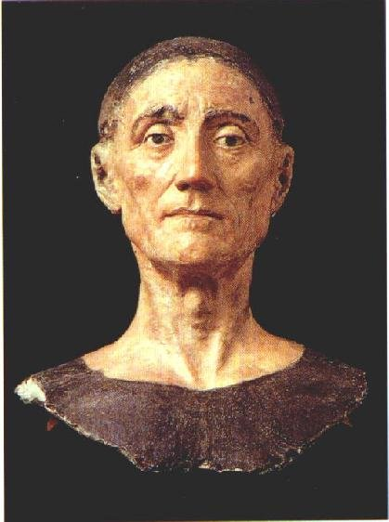He gained the support of some former **Yorkists**, e.g. Thomas Howard was restored to the earldom of Surrey for suppressing the Yorkshire tax rebellion in 1489.
* **Hardly any nobles supported rival claimants after the Simnel rebellion**; Warbeck had to rely on support from abroad.
* H’s meanness with **patronage** & Acts of Resumption (taking back all lands given away by the Crown since the Wars of the Roses started in 1455) enabled him to quadruple revenue from crown lands.
* The nobles might not have liked H (right) but they **feared** him; he was in no danger of losing the throne as John & Richard II did b/c he was much more competent than them.

**Failures**

* 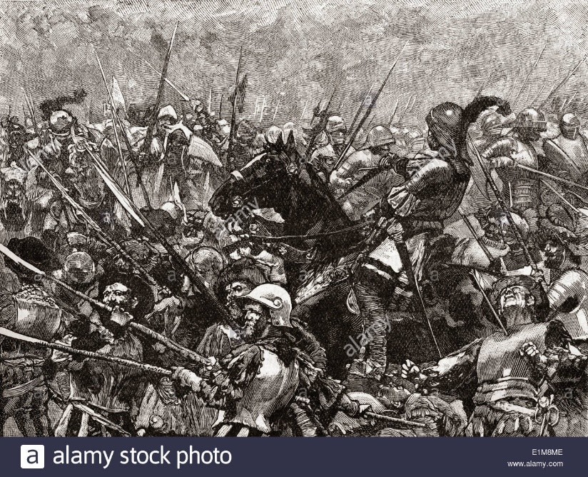The combination of Lincoln, Lovell & Kildare posed a serious threat to H in 1487, forcing him to fight a battle at **Stoke** (below) which was bigger & bloodier than Bosworth (3,000 of his soldiers were killed).
* The failure of the nobility to prevent Simnel marching across the North in 1487 & the Cornish rebels marching across the South in 1497 shows their lack of loyalty to H.
* Some historians, notably Thomas Penn, have argued that the policies enforced by **Empson & Dudley** in his last years were so oppressive that they could have provoked a rebellion.
* H became harsher & more greedy in the 2nd half of his reign (he passed 51 acts of attainder 1504-9) **despite being more secure**; this inevitably provoked resentment.
* His excessive severity against the nobility (subjecting nearly 60% of them to **bonds & recogs.)** made him v unpopular. As Christine Carpenter has pointed out, he did not discriminate between those who were dangerous & those who were not.
* H abused his feudal rights, e.g. fining the Duke of Buckingham £7,000 in 1498 for entering his inheritance without licence before he was 21.
* The frequency of H’s acts against **retaining** (1485, 1487 & 1504) suggests they were ineffective.
* The limitations H placed on the nobility (there were only 35 nobles in England in 1509 compared with 50 in 1485) & his harshness even towards loyal supporters (he fined Oxford for retaining) made him so unpopular that there might have been a **revolt** if he had reigned much longer. Both John & Richard II were deposed b/c they treated the nobility so badly.

**SPIDER DIAGRAM ON HOW HENRY VII SECURED HIS THRONE**

Include: foreign policy, imprisonment, executions, marriage, victory in battle, finance & control of the nobility

Mention all 6 dynastic rivals