**HENRY VIII & WOLSEY**

**1509-29**

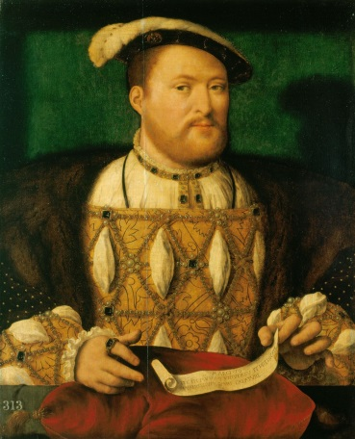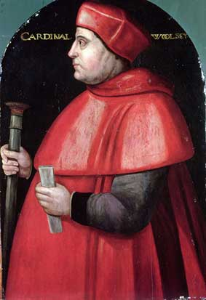

|  |  |
| --- | --- |
| **Topic 2: Henry VIII and Wolsey** | **Tick when revised** |
| Henry VIII’s personality and aims as king – Imperial and Warrior King |  |
| Foreign Policy up to 1529 – War with France, Treaty of London, Charles V and Francis I |  |
| Domestic Government under Wolsey – finances, law and social reforms |  |
| Henry’s need for an annulment by 1529 and the fall of Wolsey |  |

**Questions**

1. How successful was Henry VIII in achieving his aims as king 1509-29?
2. Assess the reasons for the fall of Thomas Wolsey in 1529.
3. How successful was English foreign policy in the period 1509-29?
4. How successful were Wolsey’s domestic policies?
5. “Henry VIII’s foreign policy 1509-29 brought little benefit for England”. How far do you agree?
6. “The most important reason for Wolsey’s fall from power was his failure to obtain a divorce for Henry VIII”. How far do you agree?
7. How successful was Henry VIII in achieving his aims in foreign policy in the period 1509-29?
8. “Henry VIII failed to achieve his aims as king in the period 1509-29”. How far do you agree?
9. Assess the reasons for Wolsey’s rise to power.
10. “Wolsey’s lack of noble support was the most important reason for his fall from power”. How far do you agree?
11. “Wolsey’s domestic policies achieved little”. How far do you agree?
12. How far do you agree that foreign policy 1515-29 failed to make England stronger as an international power?

**A-LEVEL EXAM 2017: “Wolsey’s domestic achievements were limited”. How far do you agree?**

**AS LEVEL EXAM 2017: Assess the reasons why Henry VIII wanted a divorce from Catherine of Aragon.**

**SUGGESTED READING**

Dawsonera

On the Home Page of Godalming Online, click on “Links” at the top, then “ILC Library”, then “Dawsonera” & follow the instructions.

OCR A Level History: England 1485–1603 **(official OCR textbook)**

Author: [Nicholas Fellows, Mary Dicken.](https://www.dawsonera.com/search?sType=ALL&searchForType=2&author=%22Nicholas%20Fellows%2C%20Mary%20Dicken.%22&searchBy=0) Pages: 281 Size: 6.19 MB Format: PDF Publisher: [Hodder Education](https://www.dawsonera.com/search?sType=ALL&searchForType=0&publisherSelect=264&searchBy=0)

Published: Jun 26, 2015

<https://www.dawsonera.com/abstract/9781471836626>

Articles

On the Home Page of Godalming Online, click on “Links” at the top, then “ILC Library”, then “Websites, subscriptions, links”, then follow the instructions on how to access the History Today site.

The Rise and Fall of Thomas Wolsey

By [Russel Tarr](http://www.historytoday.com/author/russel-tarr)

Published in [History Review](http://www.historytoday.com/archive/history-review/latest) [Issue 45 March 2003](http://www.historytoday.com/archive/history-review/issue-45-march-2003)

Henry VIII's Early Foreign Policy, 1509-29

By [Jez Ross](http://www.historytoday.com/author/jez-ross)

Published in [History Review](http://www.historytoday.com/archive/history-review/latest) [Issue 41 December 2001](http://www.historytoday.com/archive/history-review/issue-41-december-2001)

Books

**OCR Textbook: Nicholas Fellowes & Mary Dicken, *England 1485–1603***

Peter Gwyn, *The King’s Cardinal*

Alastair Armstrong, *Henry VIII: Authority, Nation and Religion 1509-40*

John Guy, *Cardinal Wolsey: A Student’s Guide*

**TIMELINE**

|  |  |
| --- | --- |
| 1509 | Henry VIII King  Marriage to Catherine of Aragon |
| 1510 | Empson & Dudley executed |
| 1512 | Unsuccessful attempt to invade France from Spain |
| 1513 | Introduction of subsidy  Battle of Flodden  Battle of the Spurs led to capture of Tournai & Thérouanne |
| 1514 | Peace with France  Louis XII married H’s sister Mary |
| 1515 | Wolsey Lord Chancellor & Cardinal  Louis XII died; Francis I King of France |
| 1516 | H’s daughter Mary born  Ferdinand died; Charles King of Spain |
| 1518 | Treaty of London  Tournai & Thérouanne sold back to France  Wolsey papal legate |
| 1519 | Maximilian died; Charles V Holy Roman Emperor |
| 1520 | Field of the Cloth of Gold |
| 1521 | H allied with C in Treaty of Bruges |
| 1522 | War between England & France |
| 1523 | Unsuccessful invasion of France by Suffolk |
| 1525 | Battle of Pavia  Failure of Amicable Grant  Treaty of The More with France |
| 1527 | H started trying to annul his marriage with Catherine  C’s troops occupied Rome  H allied with France in Treaty of Westminster |
| 1528 | War declared on Charles V (but no military action or even trade embargo) |
| 1529 | C decisively defeated French at Landriano  Treaty of Cambrai  Failure of legatine court  Fall of Wolsey |

**The New King**

On 21st April 1509 Henry VIII became King of England at the age of 17 years and 10 months. Many were delighted – they saw this as the beginning of a new era. Thomas More wrote a poem that said, “This day is the end of our slavery, the fount of our liberty; the end of sadness and the beginning of joy.

To stress the new era Henry had the financial advisers he had inherited from his father, Edmund **Dudley** and Sir Richard **Empson** arrested and executed within a year. These two men were most associated with implementing his father’s hated financial policies and it does demonstrate the ruthless streak that would become so evident so many times during his reign. He also announced that he would marry **Catherine of Aragon** – who for seven years – since, in fact, Arthur’s death had been trapped in England as a pawn in Henry VII’s complex diplomatic manoeuvrings.

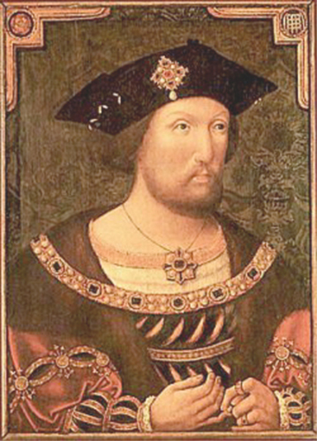His contemporaries thought that Henry was “extremely handsome” and for the time he was unusually tall at 6 foot 2 inches (average men were about 5 foot 6 or 7). His foremost passion was sport, most particularly hunting on horseback,

He liked to think of himself as a “renaissance man” and he was prepared to make efforts to become a competent musician. If the songs that have survived as his actually were written by him (which is open to doubt), then he was talented in this area, and the same can be said of his scholarship, but there is a suspicion that the hard work of reading was actually done for him by others, and he was then informed about what the books said, because he made no secret of the fact that he preferred to avoid reading and writing (even signing his name) wherever possible.

He prided himself on his intelligence, and Keith Randell says that he could “out think many members of the aristocracy” though how intelligent the bulk of the aristocracy were at the time is possibly open to doubt. John Guy describes him as possessing “an able but second-rate mind” and fully prepared to rely on clever men to do his work for him – Thomas Wolsey for example. Henry VII had been unusual for a monarch of the time, in his readiness to work hard and to be involved in every aspect of government and administration and he had been despised and disliked for it. Henry was more than happy to accept that work was something that should be done by others and not himself.

This has led to disagreements between historians as to what sort of man Henry was. The controversy has been over whether he was fundamentally strong or basically cruel because he was weak. Was he the puppet or the puppeteer? As we study Henry’s relationship with Wolsey we must determine whether he was manipulated or did he do the manipulating? One thing is certain and that is that the king was in no doubt about the matter. He ruled and he felt no doubt about that, but he didn’t see why he should waste time on the less important affairs of state.

If they were lucky his ministers could persuade the king to turn his mind to the matters that most concerned them for two short periods each day – while he was hearing Mass in the morning and when dinner was over in the evenings. Even then he was often reluctant to decide anything and especially reluctant to commit himself with a signature, so there would be weeks on end when Henry was totally unprepared to be troubled and Henrician politics were a waiting game.

**Task 1**

1. How had Henry been educated?
2. Why was the beginning of the reign of Henry VIII so welcomed?
3. In what ways was Henry VIII different from his father?
4. How is it seen that Henry exhibited a “ruthless streak, as well as a wish to be popular”?

**David Starkey’s Henry VIII**

**Estream No 1748**

*Start viewing after the first 30 minutes*

1. How old was Henry VIII when he became king?
2. How, according to Sir Thomas More, did people react to his accession?
3. Who, in More’s view, benefited most?
4. Which of Henry VII’s councillors were arrested, tried and executed?
5. What sort of background did Wolsey have and how did he rise above it?
6. What was the significance of Henry’s marriage to Catherine of Aragon in terms of foreign policy?
7. Who was Henry VIII’s role model?
8. What did Wolsey do in 1513 to earn Henry VIII’s favour?
9. Which victory did Henry win over the French that year?
10. Which French city was then captured?
11. Whom had Henry’s sister married in 1503?
12. In which battle did Surrey defeat the invading Scots in 1513?
13. How did Catherine unintentionally signify that this was a bigger victory than the Battle of the Spurs?
14. Which titles were (a) The Earl of Surrey and (b) Charles Brandon given in 1513?
15. Henry went on to make peace with France. What did he do to seal this?
16. How much greater was France than England in terms of (a) population and (b) royal revenue?

**War with France**

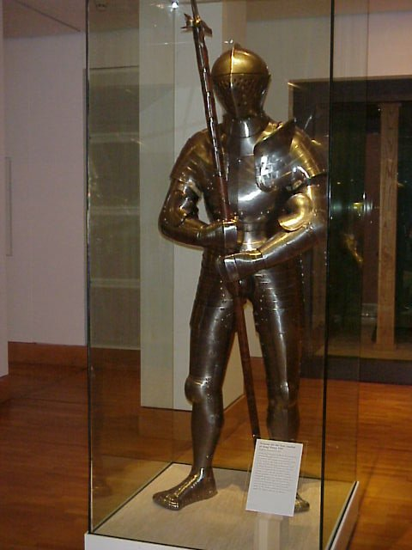Henry was set on war, but it took some time to turn his intentions into reality. A peace treaty was signed with France in March 1510 and the anti-war group, led by Henry VII’s old councillors such as Warham and Fox, retained their dominance when a Great Council discussed war in 1511. They argued that war wasted money and threatened security. When the change came it did owe something in part to Henry’s maturing ability to assert himself, but it was principally due to a change in European politics.

Pope Julius II was increasingly unhappy with the League of Cambrai, which had temporarily united the other major powers against Venice. He was concerned that the true threat to Italy came from France. After Henry sent a diplomatic mission to Rome in 1511, England was invited to join ‘the Holy League’ against France, which Ferdinand, the Pope, the Swiss and the Venetians had set up, claiming that Louis XII intended to depose the Pope.

*Right: the young Henry’s suit of armour*

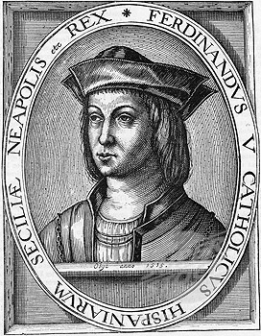**The 1512 Campaign**

Ferdinand (left) persuaded Henry to join him on an expedition to the historically English territories in Aquitaine in south-west France close to the Spanish border. The campaign led by the Marquis of Dorset proved afiasco. Ferdinand enjoyed the fact that the English were a distraction and used this opportunity to capture Navarre, but the English troops drank too much and became ill. Once Ferdinand had achieved his objective (i.e. Navarre) he made peace with France and abandoned Henry.

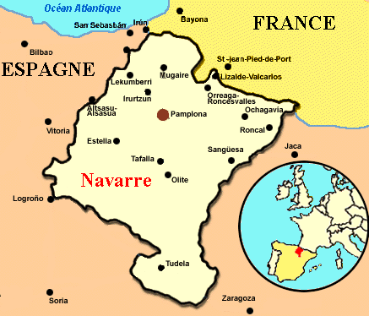The blame for the fiasco was placed on the Marquis of Dorset and Henry set about preparing an invasion of northern France. The obvious base for any offensive against France was Calais. It had been in English hands for over 150 years and made an ideal base for transporting troops. Any campaign in northern France would require an alliance with Maximilian, the Holy Roman Emperor and ruler of the wealthy cities of the Low Countries. If anything Maximilian was even more manipulative and cunning than Ferdinand, but he did agree to join the English attack on France in April 1513.

**TASK 2**

**Discuss/Answer the questions below:**

1. Why did Henry want to fight a war with France?
2. Why was it rash to take on France at this time?
3. Why, despite Henry’s councillors, did England find itself at war with France in 1512?

**The 1513 Campaign in France**

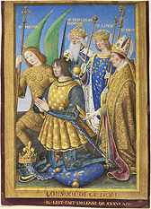The French were well aware of Henry’s planned invasion. Louis XII (right) knew himself to be vulnerable. Many of his troops were in Italy and by the standards of the day the English army of 30,000 was large and well equipped. It was the most threatening force sent to France since the battle of Agincourt. This organisational triumph was largely the work of a rising servant of the King, Thomas **Wolsey**, whose forceful and energetic personality came to be widely appreciated for the first time.

Despite the impressive quality of Henry’s army, the French had a strong alliance with **Scotland**. This was known as the ‘Auld Alliance’ James IV of Scotland was prepared to use henry’s invasion of France to his own advantage. The French were also aware that Maximilian, Holy Roman Emperor, would be an unreliable ally for Henry (which strengthened their own position).

Henry maintained the traditional English claim to the throne of France and many French provinces. In practice, his main aim was to prove himself as a fine soldier and true man of chivalry, but any conquered territory would be valuable as a bargaining counter in peace negotiations.

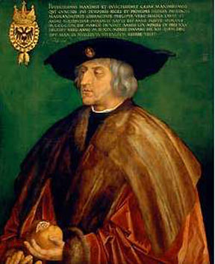On 1 August Henry marched on the fortress of Thérouanne. Thérouanne’s fortifications did not seriously threaten the English, but they did threaten the territories of Maximilian (right). Again it seems that Henry was serving his ally’s interests rather than his own.

Nevertheless, success and glory was achieved. A French force sent to relieve the town was forced to flee in undignified fashion in the so called ‘Battle of the Spurs’, giving Henry the genuine, if insignificant victory that he craved. On 22 August Thérouanne surrendered and its fortifications were destroyed. This brought little benefit to the English, but pleased Maximilian.

The next English target was the city of Tournai. Tournai was a French city entirely surrounded by Maximilian’s lands and a hundred miles from Calais. It was undoubtedly a wealthy city, but again it seems that its capture would be of benefit to Maximilian rather than Henry. If the English did capture Tournai, it was so far from the sea that maintenance of control would pose great problems and require vast expense.

On 20 September, the bombardment of Tournai began and three days later the city surrendered, passing unenthusiastically under English rule for the next five years. The English were forced to maintain a garrison and entirely re-build the defences of the city at great cost.

There is a case for regarding the campaign of 1513 as an absurd charade in which Henry was the dupe of Ferdinand and Maximilian and was effectively fighting France in the interest of countries other than his own. On the other hand, Henry had flexed his muscles and proved that England could organise a large and well equipped army. Over the next years this military success brought Henry a leading role in Europe. He had proved himself a true king in the traditional manner and Tournai was at least a valuable possession for diplomatic bargaining. It was England’s first military victory in France for seventy five years and Thomas Wolsey had provided the organisational dynamism that Henry needed.

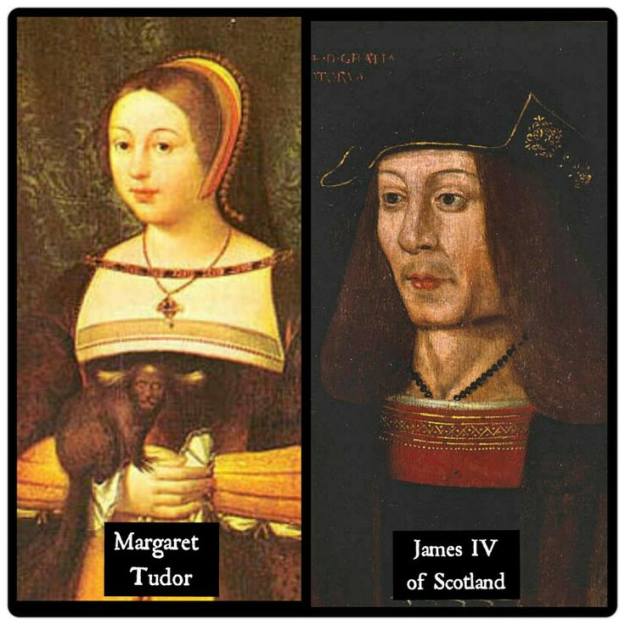**Flodden Field**

Ironically, Henry had nothing to do with England’s greatest military triumph in 1513. The Scots decided to capitalise on England’s involvement in France and attempted an invasion of England. On 9 September at Flodden Field the Earl of Surrey annihilated the army of James IV and was restored to the Duchy of Norfolk as a result. **James himself was killed** along with much of the Scottish aristocracy. Henry did not capitalise on this victory as effectively as he might, but the military threat from Scotland did dramatically diminish and Henry’s sister, **Margaret**, the widow of James IV, became Regent of Scotland.

This eliminated any Scottish threat until the 1540s.

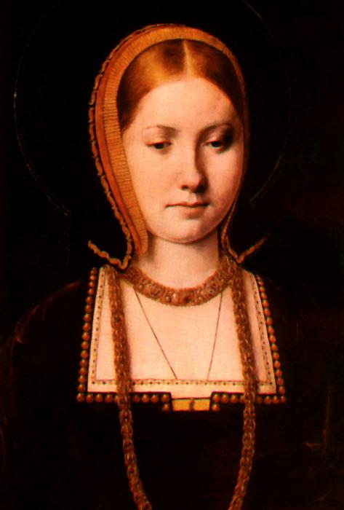Lord Howard has sent me a letter open to your Grace within one of mine, by the which you shall see at length the great victory that our Lord has sent your subjects in your absence; and for this cause there is no need herein to trouble your Grace with long writing, but, to my thinking, this battle has been to your Grace and all your realm the greatest honour that could be, and more than you should win all the Crown of France; thanked be God of it, and I am sure your Grace forgetteth not to do this, which shall be cause to send you many more such great victories, as I trust he shall do. In this your Grace shall see how I kept my promise, sending you for your banners a king’s coat. I thought to send himself unto you, but our Englishmen’s hearts would not suffer it. It should have been better for him to have been in peace than have this reward. All that God sends is for the best. My Lord of Surrey, my Henry, would fain know your pleasure in the burying of the King of Scots’ body.

Your humble wife and true servant, Catherine

Why might this letter have been a little tactless?

**Task 3: Continued questions on foreign policy**

1. What were Henry’s war aims and did he achieve them?
2. Was the 1513 campaign a success? Give your reasons for your answer. (7)

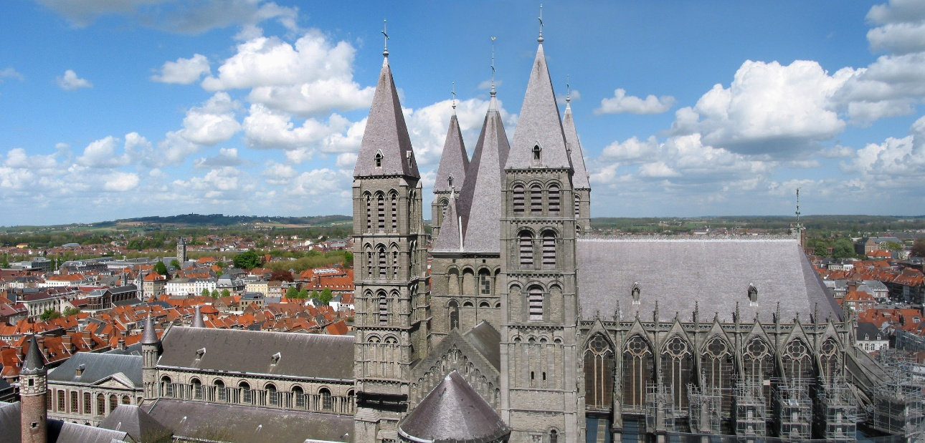

**Peace with France 1514**

In 1514 Henry was forced to make peace with France because both Ferdinand and Maximilian were negotiating with Louis behind Henry’s back. The Anglo-French treaty of 1514 gave England possession of **Tournai** and Louis agreed to pay the arrears of the English **pension** he had given Henry VII. The treaty was sealed with the **marriage** of Henry’s younger sister Mary to the elderly Louis XII. Henry also proposed a joint Anglo-French attack on Spain to drive Ferdinand out of Navarre and claim Castile for Catherine. Although unrealistic and unfulfilled it does show that Henry was rather annoyed with his double dealing father in law. Thomas Wolsey was responsible for the successful negotiation of this treaty and Henry had proved that he was a force to be reckoned with on the European stage.

**New kings in Europe**

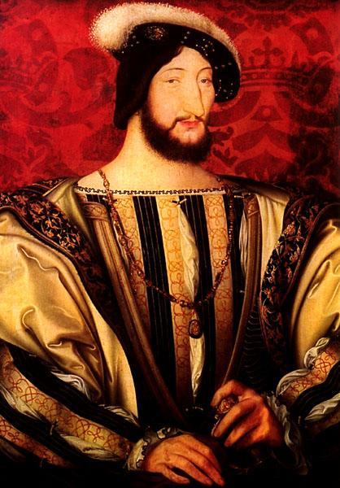

In 1515 Louis XII died shortly after marrying Mary and his nephew **Francis I** (right) took over. He was as talented and ambitious as Henry. Rivalry was intense from the start as Francis pulled off a very public coup, helping Henry’s best friend, the Duke of **Suffolk** to marry **Mary**, (the dowager queen of France). Francis pretended he did this to help smooth the course of true love, but actually of course it meant that Henry lost a very prestigious pawn in the dynastic marriage market, as well as suffering the insult of having his sister and friend marrying without his permission. Worse still Francis very soon started to stir up trouble in **Scotland** by sending the Scottish claimant, the Duke of Albany to overthrow the regency government of Henry’s sister Margaret.

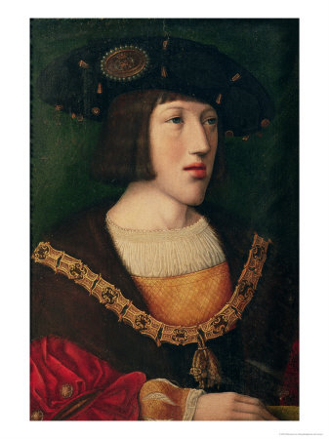A year later a third young and powerful ruler made his entrance onto the international scene when Ferdinand of Spain died. His grandson **Charles of Habsburg** (below right), who had been Duke of Burgundy since Philip’s death in 1506, now became King of **Spain** as well. It was also highly likely that he would become Holy Roman Emperor when his other grandfather, Maximilian died. This would make him ruler of the largest personal empire that Europe had seen since Roman times. He saw little reason to engage with England and made peace with France (so that he could travel down to Spain without worrying).

Henry was painfully aware that both **Charles and Francis had far more resources than he did and that it was unlikely he could challenge them successfully in battle**. As a consequence he would have to seek international glory (for which he yearned) through means other than warfare.

Wolsey was by now a senior figure at his court and there has been much debate as to whose ideas were guiding policy over the next few years. Certainly at the end of 1517 England was isolated and excluded from important concerns in Europe and it seems that Wolsey saw a means of restoring the appearance at least of English importance by holding a peace conference in London.

**Treaty of London 1518**

Since the beginning of 1518 the Pope had been calling for a western crusade against the growing power of Muslim Turks. The Ottoman Empire was growing and now they seemed to be targeting the coast of Europe. The major European countries began to consider how to deal with this threat and in an amazing victory of international diplomacy, Wolsey called for an alliance of Christian powers and twenty European representatives arrived in London. Here Wolsey achieved a notable success for Henry in which he was seen to be at the heart of international affairs. All the major European powers arrived and agreed not to attack one another in some sort of “pact of eternal peace” and that they would come to the aid of any that were under attack.

The treaty enhanced Henry’s status in Europe and made him seem almost as important as the other young kings, Francis and Charles.

However:

* Henry had no choice but to pose as peacemaker b/c he **couldn’t afford war**.
* This lack of money forced him to sell **Tournai & Thérouanne** back to the French for much less than it had cost him to capture & fortify them so no lasting gain resulted from the apparently successful campaign in 1513.
* The election of **Charles** as **Holy Roman Emperor** following Maximilian’s death in 1519 (he was Charles V as HRE but Charles I as King of Spain) completely upset the European balance of power b/c it meant that b/c he was Duke of Burgundy, King of Spain & HRE all rolled into one France was now completely surrounded by territory controlled by him. Francis was bound to try to break out of this encirclement, **making war & therefore the swift collapse of the Treaty of London inevitable**.

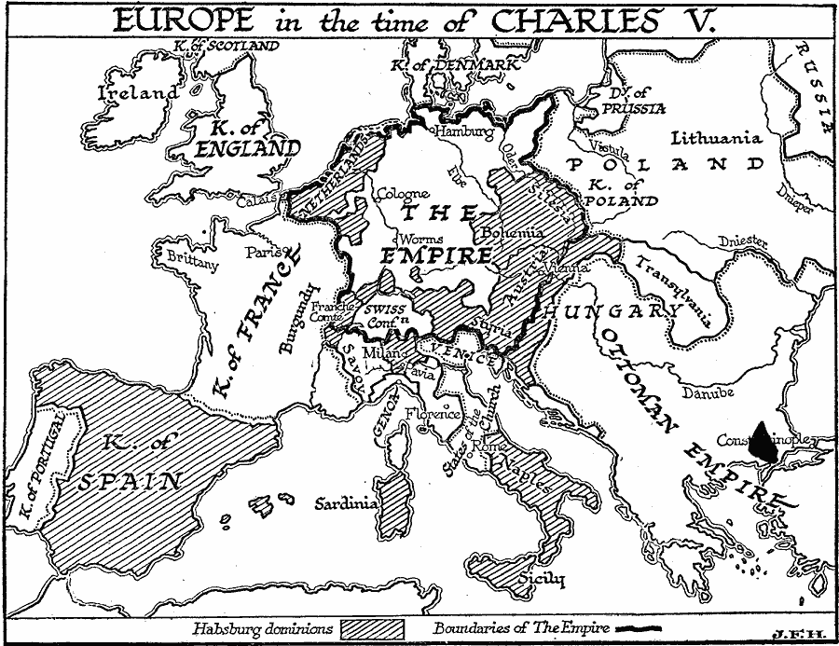

Note that C controlled Naples & Austria & claimed Milan as well as being Duke of Burgundy, King of Spain & HRE.

|  |  |
| --- | --- |
| **Criteria** |  |
| Whether the Treaty kept the peace |  |
| How long it lasted |  |
| Whether it brought prestige to Henry, Wolsey or England |  |
| How it was viewed by the rest of Europe |  |
| Whether the negotiation itself was a success |  |

1. Assess how far the Treaty met each of the above criteria.
2. Write a paragraph taking into account all the above factors in which you assess the value of the Treaty of London.

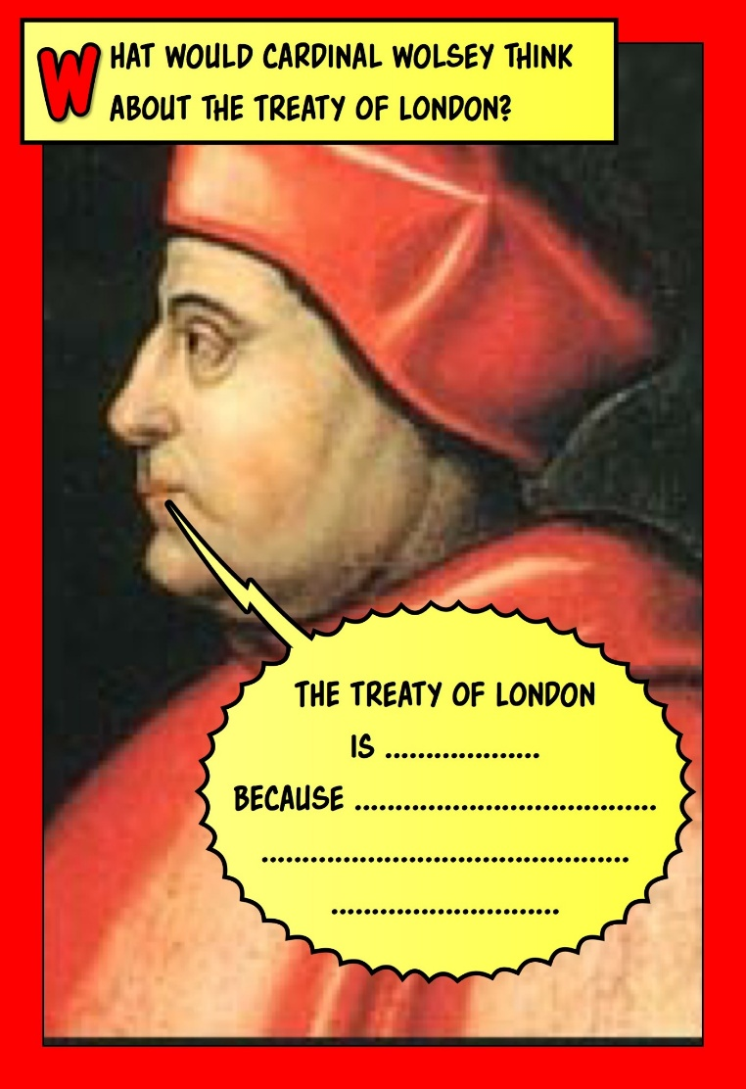

**TASK 8 In what ways did the personality and ambitions of Henry Vlll influence England’s relations with her neighbours in the first decade of his reign?**

In the table below you will see a list of Henry’s ambitions as well descriptions of his personality. Below this there is a selection of evidence which could be used as support. Try to match them by filling in the empty column in the table.

|  |  |
| --- | --- |
| Desire for glory |  |
| Military success |  |
| Hero-worship of Henry V |  |
| Desire for prestige |  |
| Warlike |  |
| Anti-French |  |
| Claim to be King of France |  |
| Devotion to the Papacy |  |
| Rejection of Henry Vll’s peaceful approach |  |
| Rivalry with Francis l |  |
| Naivety and inexperience |  |
| Use of Wolsey |  |
| Alliance with Spain |  |
| Ignoring Scotland |  |

Campaign in Gascony, 1512. Battle of the Spurs, 1513

Field of the Cloth of Gold, 1520 Therouanne, Tournai

Conflict with Scotland, 1513 Holy League, 1511

Marriage to Catherine of Aragon, 1509 Treaty of London, 1518

Campaign to France, 1513 Negotiations, 1515-1517

Treaty with France, 1514

Exploitation of Henry by Ferdinand and Maximilian

Franco-Scottish alliance

**Field of the Cloth of Gold 1520**

By 1520 it was clear that war between Francis I & Charles V was inevitable. This was bad news for Henry & Wolsey b/c it meant that that the Treaty of London had broken down but H was now in a strong position b/c both F & C wanted him as an ally against the other. Remembering how both Ferdinand & Maximilian had let him down in the past, H took his time, waiting to see who would make him the best offer.

In 1520 Henry and Francis met at the Field of the Cloth of Gold, near Calais. This meeting was spectacular. It lasted for a fortnight and was participated in by a large portion of the ruling elite of both countries. The two kings vied strenuously to create as splendid an impression as possible and the cost was enormous (roughly as much as Henry’s entire annual income). Its centrepiece was a temporary palace to accommodate the king and a handful of his leading courtiers – the rest of the party lodged in discomfort in a settlement of about 800 tents. It drew sightseers from far and wide also attracted by the fountains dispensing free wine, and it confirmed Wolsey in Henry’s favour as it made him appear as a very important European monarch.

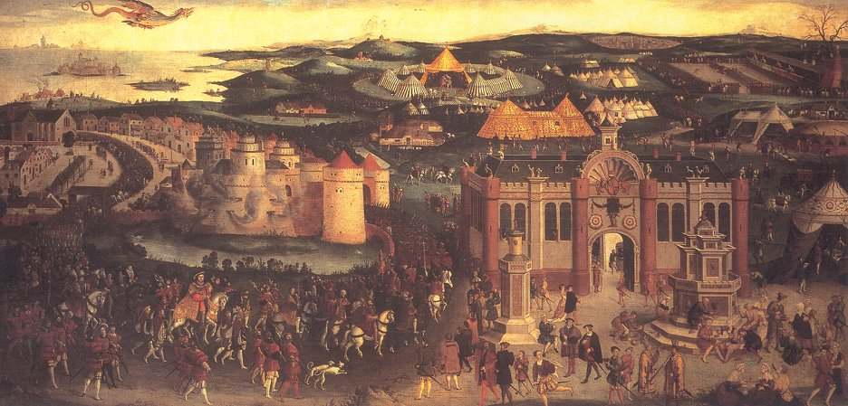

What were the likely motives of Henry VIII spending so much money on a building that was to be demolished after a fortnight?

It seems that the meeting **achieved nothing of lasting significance**. Henry and Francis probably viewed the occasion as no more than an opportunity to impress. Meetings between Henry and **Charles** were arranged to take place both before and after the Field of Cloth of Gold so that the clear message could be given that there was no English partiality towards France. Very soon it became evident that maintaining neutrality was going to be extremely difficult as the situation became more tense. In August 1521 Wolsey made a settlement with Charles V in the **Treaty of Bruges**. The agreement was that an English force would invade France if they declared war on Charles. The trouble was that this war did not seem to benefit any specific English interests and it was plainly going to be expensive and therefore require an increase in taxation – it seems that Wolsey hoped that if he played a delaying game he might get away without having to turn up for any action.

**What should Henry do?**

Ally with France.

1. They were the slightly less powerful of the two rivals and would probably be more grateful.
2. He might have acquired some land near England.
3. An Anglo-French alliance is the only way of stopping Habsburg dominance.
4. A deal with Charles could mean the French allying with Scotland.

Ally with Charles V

1. England’s traditional enmity with France
2. Marriage to Catherine of Aragon
3. The important wool trade with Burgundy (territory ruled over by Charles V)
4. French interference in Scotland
5. Henry hoped that his daughter would marry Charles V. He may have been concerned at this early stage about the lack of a male heir and was providing for the succession by ensuring that his daughter had a powerful husband who would enforce her claim to the English throne.
6. There was papal pressure on Henry to ally with Charles V.

Keep out of it

1. The conflict between Francis & Charles was fought mainly in Italy so England’s vital interests were not really involved.
2. C’s power was balanced by the problems he had to face (as well as the French, he faced internal revolts in Spain & Flanders, attacks on the Spanish coast by Moorish pirates, the spread of Protestantism in Germany & the Turkish threat in Hungary & the Eastern Mediterranean). There was therefore a rough balance of power between F & C so there was no real need for Eng. to get involved.
3. Trade with France was 2nd in importance only to trade with Flanders (ruled by C) so it made economic sense to be on good terms with both.
4. H didn’t have the financial resources to compete with either C or F.

What do **you** think?

Do you think Henry would accept your advice? Give reasons for your answer.

**ENGLISH FOREIGN POLICY 1522-7**

The Anglo-French War 1522-5

War started in 1522 following a further agreement between H & C in which C promised to support an English invasion of France with 40,000 men, compensate H for the French pension he would lose & marry H’s daughter Mary (who was only 6 at the time, 16 years younger than C).

In July **1522**, the English raided northern France from [Calais](https://en.wikipedia.org/wiki/Calais), burning and looting the countryside but failing to engage the French army in battle or capture any important towns.

In **1523** H & C planned to invade northern France simultaneously, also counting on support from the Duke of **Bourbon**, a French noble who had rebelled against Francis I. On 18 September 1523, a massive English army under the [Duke of **Suffolk**](https://en.wikipedia.org/wiki/Charles_Brandon,_1st_Duke_of_Suffolk) advanced into French territory from Calais; the simultaneous invasion by C’s troops from Flanders distracted the French & Suffolk was able to get within 50 miles of Paris.

However, the invasion failed:

* As in 1522, the English army devastated the countryside but failed to defeat the French in battle. In October 1523 Suffolk decided his army was not strong enough to capture Paris & returned to Calais.
* Bourbon gained far less support from other French nobles than H & Wolsey had expected.
* For both the above reasons, **C lost interest in the invasion & withdrew his support**.

Wolsey, who had always been less keen than H to invade France (though as always he had to bow to the King’s wishes & try to raise a subsidy to finance it), became disillusioned with the alliance with C V & opened secret negotiations with France in 1524.

The Battle of Pavia 1525 and the French Alliance

But luck did not favour Wolsey**. In February 1525 Charles secured the decisive victory** that Wolsey had estimated to be so unlikely.

In a battle that took place outside the walls of Pavia, in northern Italy, **the French army was totally destroyed and Francis I was captured.** This obviously put Charles in a supreme position. Henry VIII was not slow to seek advantage of this, by offering himself as a replacement king in France. He suggested that France should be broken up, with Charles and Bourbon receiving parts to which they could reasonably lay claim, and Henry taking the remainder along with the title King of France.

H ordered Wolsey to raise the money for an invasion of France but the so-called **“Amicable Grant”(**in effect a huge tax demand without parliamentary approval) provoked so much resistance that it had to be abandoned. Once again as in the Treaty of London H was **forced to make peace b/c he could not afford war**.

In any case **C had no interest in H’s plan**. There was nothing Henry could do to hurt him, and it would have been crazy to replace one powerful and ambitious King of France for another one who controlled extensive territories on both sides of the Channel. H had contributed nothing to C’s victory so C owed him no favours. In 1526 he **broke his promise to marry H’s daughter Mary**.

Seeing no advantage in continuing the alliance with C, Eng. changed sides. In 1525 Wolsey negotiated the **Treaty of The More** in which H agreed to support F against C in return for a French pension of £20,000 a year.

When F was released from C’s custody in 1526 he formed a league of Italian states, the League of Cognac, to expel C from Italy. In doing so he was breaking a holy oath he had sworn to keep the peace but the pro-French Pope Clement VII (who saw C’s dominance in Italy as a threat to his own Papal States) released him from this oath on the grounds that he had been forced to swear it against his will.

The League of Cognac failed disastrously: C’s forces defeated both the French & the Pope & occupied **Rome** in 1527. This prompted H & F to sign the **Treaty of Westminster** confirming their alliance against C.

**The Diplomatic Revolution of 1525 – Pavia, the turning point in English Foreign Policy**

|  |  |
| --- | --- |
| 1525 February | Charles defeated the French at the Battle of Pavia in Northern Italy. 10,000 French soldiers were killed and the Francis I was captured. |
|  | **SO …** |
| 1525 | Henry attempted to persuade Charles to make a decisive joint assault on France which would led to Henry being crowned king of France |
|  | **SO…** |
| 1525 March | Wolsey gave orders to raise the Amicable Grant to pay for Henry’s proposed invasion of France. The Grant led to rebellion and it was abandoned |
|  | **AND** |
| 1525 | Charles refused to attack France and withdrew from the proposed marriage between himself and Henry’s daughter Mary. |
|  | **SO…** |
|  | Having been rejected by Charles, England needed to make a fundamental change of policy towards France. |
|  | **SO…** |
| 1525 August | Anglo-French Treaty of the More – a friendship treaty |
| 1526 January | Charles V forced the Treaty of Madrid on Francis I. Francis immediately rejected the treaty on his release and looked to form a coalition against Charles. |
|  | **SO…** |
| 1526 May | The League of Cognac was formed against the Holy Roman empire. The League was made up of France, Venice, the Papacy, Florence and the Duke of Milan  England joined in September 1526 as a ‘protector’, but not as a member because she could not afford to. |
| 1527 April | Anglo-French Treaty of Westminster |
| 1527 August | Treaty of Amiens – an Anglo-French agreement to attack Charles V |
|  | **SO…** |
|  | The aftermath of Pavia had forced England to end its old enmity with France. The new Anglo-French friendship was cemented by the Treaties of the More, Westminster and Amiens. France and England did not go to war again until 1543. |

**Why was Henry Vlll’s foreign policy so unsuccessful in the decade that followed the Treaty of London (1518)?**

**Look at each of the points in the table below and give some detailed evidence to support each point. If you can think of any other reasons to explain Henry’s lack of success then do add them.**

|  |  |
| --- | --- |
| The size and relative power of England compared to France and Charles V’s empire. |  |
| Europe was dominated by the Habsburg-Valois conflict from 1519 and England was unable to compete. |  |
| Henry had limited financial resources. |  |
| After 1525 the French were unable to weaken Charles’ power in Italy. |  |
| Henry and Wolsey made errors and misjudgements. |  |
| Henry had unrealistic aims in his foreign policy. |  |

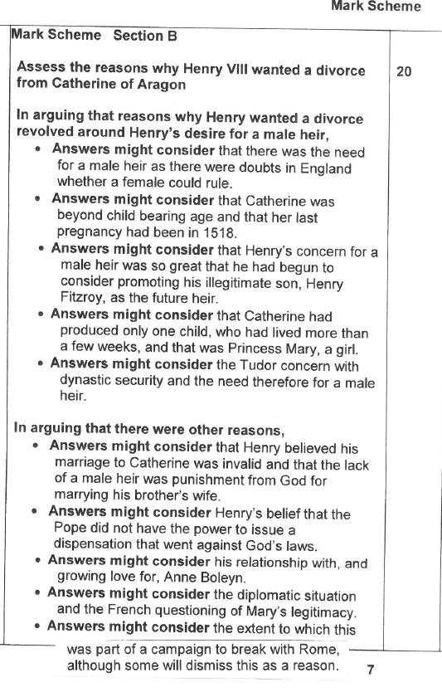

**Henry VIII’s Great Matter** – **the origins of the annulment of the marriage to Catherine of Aragon**

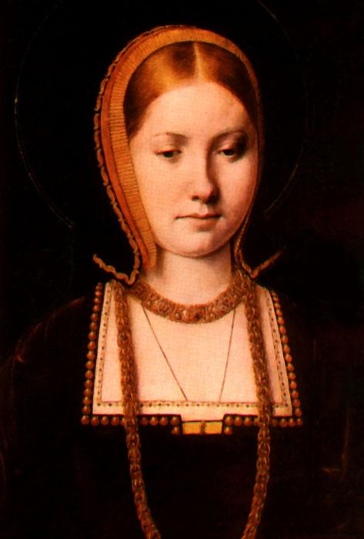Henry married Catherine of Aragon in 1509 after first obtaining a dispensation from Pope Julius ll to marry this brother’s widow. A dispensation (special permission to break church law) was necessary because it was normally against the law of the Church to marry a brother’s widow. Catherine became pregnant several times but all her babies were stillborn or only lived for a short while, apart from **Mary**, who was born in 1516.

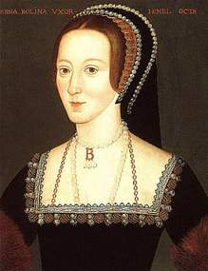In 1524 Catherine hit forty and it became plain that she was not going to have the longed for **son**. Nevertheless H did not start to consider annulling his marriage to her until **1527** when he fell in love with **Anne Boleyn**, fifteen years his junior.

Henry was genuinely convinced that God had chosen him to be king and therefore the lack of an heir must be some kind of punishment and he must seek to put this right.Henry used a verse from a Book in the Old Testament, Leviticus, Chapter 20, verse 21 (“if a man shall take his brother’s wife, it is an unclean thing ….they shall be childless”) to argue that his marriage was sinful because he had married his brother’s widow. However, Leviticus uses the word “take” not “marry” and so the implication is that a man would only be committing a sin if he committed adultery with his brother’s wife and there is no reference at all to marriage to a brother’s widow. Nor was Henry’s marriage childless; he had a daughter. Even worse from Henry’s point of view, the book of Deuteronomy actually commanded a man to marry his brother’s widow in order to provide for her. The biblical evidence was ambiguous to say the least. Henry used the biblical arguments but his prime conviction was based on the fact that he had no son. God must be angry. However, these arguments only became strong when he became besotted with Anne Boleyn in 1527.

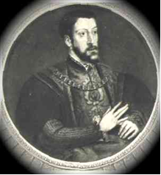

Discussions over biblical interpretation would normally have been irrelevant as popes understood kings’ requirements for a male heir and normally provided a required annulment. In addition to this some German Princes were at the time becoming Protestant and leaving the Catholic Church. The Pope would have wished to avoid Henry doing this at all costs.

The real problem here was that Pope Clement Vll, since the **Sack of Rome** in 1527, was controlled by **Charles V**, who as Catherine’s nephew was determined to prevent the annulment in order to protect his family’s honour. If the annulment was granted his cousin Mary would become illegitimate.

1. What does Leviticus state and what does Deuteronomy command? Why do you think Henry was so convinced that it was Leviticus that was right?
2. What had happened in 1527 to make it particularly complicated for Wolsey to secure papal dispensation for an annulment? Please show you know what papal dispensation and annulment mean.
3. Why was it so important for Wolsey that he secured the annulment?

Wolsey’s Failure 1527-9

H’s pressing need for the annulment, which was clear by 1527, left Wolsey with **no choice but to ally with France**, because England had no power in Italy & only the French had the military force to expel C from Rome & free the Pope from his control.

However, this failed completely:

* England declared war on C V in 1528 but this had no effect because H couldn’t afford to raise an army big enough to threaten C. He couldn’t even afford to ban trade with Flanders as H VII had which was the only other way of hurting C because the trade was too important to England.
* C won a decisive victory over the French at **Landriano** in 1529.
* Francis then made the **Treaty of Cambrai** with C in 1529 which meant there was no chance of any further French help to secure the annulment. The Pope was firmly under C’s control & H was completely isolated.

Wolsey’s other tactic to secure the annulment by holding a **legatine court** (over which he would preside as papal legate) to settle it in England also failed. Pope Clement VII agreed to this but deliberately stalled Wolsey by sending his own representative, Cardinal Campeggio, to preside over the court with Wolsey. Clement, still under C’s control, couldn’t agree to the annulment so he instructed Campeggio to delay as long as possible. The case was adjourned in July 1529 & in October Clement recalled the case to Rome.

**Thus by October 1529, both Wolsey’s strategies to secure the annulment, the French alliance & the legatine court, had definitively failed & his downfall was inevitable.**

**Fill in the gaps using the words in italics**

**WOLSEY’S POLICIES TO SECURE THE ANNULMENT**

***Campeggio, Cognac, Catherine, Sack of Rome, Cambrai, Pavia, French, the Holy Roman Emperor, nephew, More, money, Wolsey, Westminster, England, papal legate***

1. **The French alliance**

In 1525 at the Battle of _________ in Northern Italy, the French army was totally destroyed and Francis l was captured. This meant that Charles V was in an overwhelmingly dominant position in Europe. Henry saw this as an opportunity to gain _________ territory and the crown and so he proposed an invasion with Charles V. Unfortunately for Henry, Charles did not wish to do this – he wanted peace with France – and Henry could not attack France on his own as he lacked sufficient ________. When Charles made it plain he despised Henry, Wolsey and Henry switched sides in the Treaty of ___________________ in 1525.

Wolsey encouraged the formation of an anti-imperial alliance, the League of _________ in 1526, in order to reverse the outcome of Pavia. In 1527 the Treaty of _________________ was signed with the French. By this time the issue of Henry’s marriage/annulment was assuming greater importance.

The _______ of_______ took place in 1527. This gave Charles control of the Pope in addition to his dominance of Northern Italy. This made the chances of Henry having his marriage annulled even more remote since Charles was Catherine of Aragon’s _______________.

England declared war on ____ _____ ________ ___________ in 1528 but this was little more than a gesture. The Treaty of _______________ was agreed between Francis l and Charles V in 1529. _______ was ignored.

1. **The Legatine Court**

Wolsey tried to persuade the Pope to set up a commission in England that would give him the necessary powers to make a decision. The Pope finally agreed to this in 1528. He appointed _________ and C___________ to try the case jointly. C____________ arrived in England in September 1528 but he had secret instructions from the Pope not to reach a decision. He dared not offend Charles V. C____________ delayed matters as much as possible and tried to persuade C__________ to enter a nunnery which would have solved the problem.

In the summer of 1529 the legatine court with ________ and C______________ presiding opened at Blackfriars in London. From the beginning C_______________ refused to recognise the authority of the court and on 18th July the Pope recalled the case to Rome.

NB Since Wolsey was a Cardinal and _______ __________ it was only natural to expect him to secure the annulment as this was a church matter.

**HOW SUCCESSFUL WAS HENRY VIII IN ACHIEVING HIS AIMS IN FOREIGN POLICY IN THE PERIOD 1509-29?**

Successes

* Henry did make his mark on Europe and the defeat of the French at the **Battle of the Spurs** did give him glory & led to the capture of **Tournai** & Thérouanne. This was a victory for his policy of allying with Maximilian against France.
* H forced the French king Louis XII to pay him a **pension** & marry his sister Mary in 1514.
* H achieved a decisive victory at **Flodden** in 1513; James IV was killed, H’s sister Margaret became Regent of Scotland & there was no further threat from Scotland until the 1540s.
* H showed his desire to be a seen as a Renaissance king by favouring Erasmus & posing as the peacemaker of Europe in the **Treaty of London** in 1518.
* H secured the appointment of Wolsey as a cardinal in 1515.
* Henry also achieved his glory through the peace conferences that Wolsey organised, especially the **Field of the Cloth of Gold** in 1520. H enjoyed being able to choose whether to ally with Francis I or Charles V 1520-1.

Failures

* His aim to repeat the glories of Edward III & Henry V were not achieved; he **never achieved any significant or lasting gains in France** despite spending vast sums of money. The refusal to pay the Amicable Grant showed his subjects recognised this.
* Incompetent leadership led to the failure of the invasion of France in **1512**.
* The glory he got from the Battle of the Spurs was exaggerated & **Tournai & Thérouanne had to be sold back** after only 5 years for much less than it cost to capture & fortify them. **Maximilian** let H down despite the money he gave him.
* Louis XII’s **marriage** to Mary was shortlived & by allowing her to marry Suffolk H missed a chance to secure another diplomatically advantageous marriage.
* The most significant English victory in H’s reign was at Flodden in 1513 & **he wasn’t even there**.
* Peace was not H’s preferred policy so whatever prestige he got from the peace conferences Wolsey organised was limited. **Neither the Treaty of London nor the Field of the Cloth of Gold produced any lasting results**.
* His **invasions of France 1522-3 were failures**: C V was unimpressed & deserted H, so he got no compensation for the French pension he had lost & the proposed marriage between C V & H’s daughter Mary never took place.
* H was unable to take advantage of the French defeat at **Pavia** b/c of the failure of the Amicable Grant & C’s lack of interest in supporting him, forcing H to sign a treaty with France.
* In fact Charles’s victory at Pavia lessened Henry’s influence and also led to the final failure over his **annulment**.
* 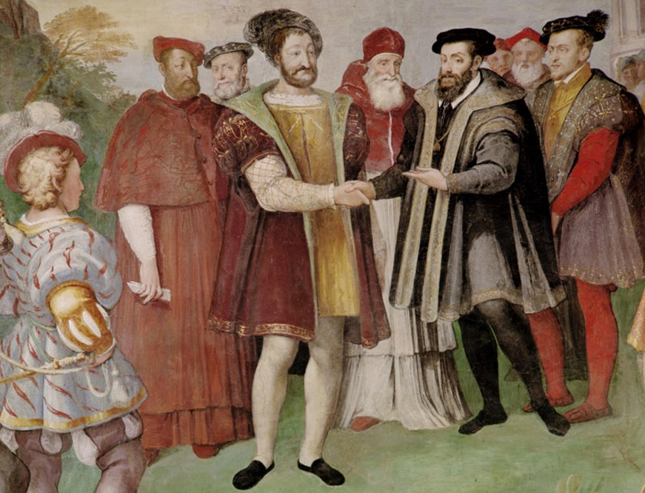The appointment of Wolsey as Cardinal had little effect & H never succeeded in securing his election as Pope, which showed his lack of influence in Europe & contributed to his failure to obtain the annulment.
* All H’s efforts to secure papal consent for the annulment failed, both in terms of theological arguments & diplomatic efforts; the **Treaty of Cambrai** between F & C & the collapse of the legatine court, both in 1529, sealed his failure & the dismissal of Wolsey in the same year showed H recognised this.
* The Treaty of Cambrai (right) showed how isolated & lacking in influence England truly was at the end of this period.

**‘Henry VIII’s foreign policy from 1509 to 1529 brought little benefit for England.’ How far do you agree?**

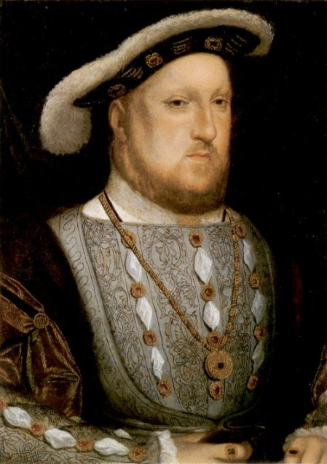Candidates should consider what the achievements of Henry’s foreign policy were and can then use this as a basis to discuss their benefit. The territorial gains of Thérouanne and Tournai brought little other than prestige and although they gave hope to Henry’s dream of obtaining the French throne, they were never built upon. In many ways victory at Flodden was more significant as it reduced the Scottish threat. There is likely to be some discussion of the benefits of the Treaty of London and the Field of the Cloth of Gold, which although they put England at the centre of the European stage and made her appear to be a major power, brought little of substance. Candidates may consider the alliances made at various stages with France and Spain and whether they brought any gain other than prestige and some might suggest that the number of times Henry was let down by allies was a reflection of England’s limited power and this was made very evident at the end of the period. It is possible that some will argue one achievement was having Wolsey made Cardinal and that even this brought no gain as he was unable to bring about the divorce. Candidates may conclude, as did much of the population by their refusal to pay the Amicable Grant, that there was little gain from Henry’s aggressive policy.

**ASSESS THE REASONS FOR WOLSEY’S RISE TO POWER**

* W rose despite his humble background through sheer ability, both intellectual & administrative, & an extraordinary capacity for hard work.
* For a poor boy with his academic ability the Church offered a valuable career ladder.
* Unlike his father H was bored by detailed financial & administrative work & was happy for W to take care of this for him, especially as W had the tact & charm to ensure that any discussion of govt. business was as short & agreeable as possible.
* W’s appointment as Almoner at the start of H VIII’s reign gave him a seat on the Royal Council.
* Recognising what H wanted, W argued in favour of war with France agt. more cautious councillors like Warham & Fox who advocated the continuation of H VII’s peace policy. This led to W replacing Warham as L Chancellor in 1515.
* The introduction of the subsidy in 1513 significantly boosted tax revenue & made it possible for H to win military glory in France.
* W’s diplomatic skill enabled H to pose as the peacemaker of Europe in the Treaty of London in 1518 & to consider offers from both Francis I & Charles V to ally with him 1520-1 before getting an alliance with C in 1521.

Russel Tarr in [History Review](http://www.historytoday.com/archive/history-review/latest) [Issue 45 March 2003](http://www.historytoday.com/archive/history-review/issue-45-march-2003):

**How was Wolsey able to rise to power so quickly under Henry VIII?**

i) Luck

Wolsey was very much a man in the right place at the right time. The new King was young, fun-loving and, truth be told, rather lazy. His conception of Kingship was embodied in all-action heroes like King Henry V rather than frugal administrators like his own father, Henry VII. Nevertheless, he was not prepared to leave the affairs of state in the hands of his father's great servants, whom he found (typically enough for a teenager) old, boring, and behind the times. Empson and Dudley, his father's hated tax collectors, were executed; Foxe and Warham were rapidly reaching retirement age and were encouraged out of court with a series of withering insults by Wolsey. By 1519, the Venetian ambassador, Giustiniani, was summing up the situation well when he told Francis I of France 'that King Henry devoted himself to pleasure and ease and left the cares of the State to the Cardinal'.

ii) Charm

Nevertheless, it cannot be denied that Wolsey made the most of the opportunities given to him. He had the great ability to gauge his audience, to flatter and to be entertaining. He had a 'special gift of natural eloquence' (Cavendish) … Wolsey was a man who enjoyed the fine things of life. He was sociable, witty and convivial, a sponsor of musicians and artists. Polydore Vergil, the Tudor historian, gives us a glimpse into his tactics when he tells us that whenever the Cardinal wanted something from Henry, he 'brought out some small present or other … and while the King was admiring it intently, Wolsey would adroitly bring forward the project on which his mind was fixed'. He was, in modern day terms, a 'schmoozer' who was good at 'networking'.

iii) Opportunism

Wolsey's charm expressed itself most effectively in, shall we say, a certain flexibility of outlook. He had initially been opposed to Henry VIII's ideas of a war with France, for example, but when it became clear that the King was not prepared to budge on the issue he quickly became the greatest enthusiast of the idea! Cavendish picked up on this aspect of Wolsey's character when he described him as the 'most earnest and readiest among all the council to advance the King's only will and pleasure without any respect to the case'. Morally, this is a questionable trait; politically - then as now - it is a gift.

iv) Intelligence

Wolsey was much more, however, than a mere yes-man. Put in charge of the French expedition, he immediately demonstrated truly phenomenal organisational skills which Henry VIII was swift to notice … He always prided himself on being the 'boy bachelor' who had got his first degree at the age of 15 and who had recognised that a career in the Church was 'the best highroad to fame and fortune for anyone born without privilege' (Elton).

v) Industry

Not only was the quality of Wolsey's work of a high standard, he had an insatiable appetite for it. In one famous episode Henry allegedly ordered Wolsey to travel into Flanders as a special envoy to the court of the Emperor Maximillian. Wolsey went into overdrive to prove his worth: within three days he had been there and back. The king, believing that he was still preparing to leave, then upbraided him for his tardiness before being told the truth of the matter. The Venetian ambassador relates that Wolsey 'transacted alone the same business as that which occupied all the magistrates, offices and councils of Venice, both civil and criminal'. This was very notable when most people (following the example of the King) were happy to saunter along at a much gentler pace. It even got to the stage where Henry had to encourage him to take a holiday ('to the intent that you may the longer endure to serve us') - this was one of the few demands which Wolsey felt able to ignore without much fear of retribution from his master.

What does all the above evidence suggest was the **main overall** reason for Wolsey’s rise?

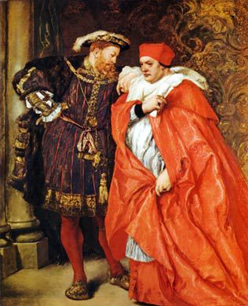

**WOLSEY’S DOMESTIC POLICY**

**Glossary**

|  |  |
| --- | --- |
| Lord Chancellor |  |
| Conciliar courts |  |
| Common law |  |
| Civil law |  |
| Court of Chancery |  |
| Court of Star Chamber |  |
| Court of Requests |  |
| Enclosures |  |
| Acts of Resumption |  |
| The subsidy |  |
| Amicable Grant |  |
| Cardinal |  |
| Papal legate |  |
| Abbot |  |
| Non-residence |  |
| Pluralism |  |
| Nepotism |  |
| Simony |  |
| Clerical celibacy |  |

**The Law**

|  |  |
| --- | --- |
| **SUCCESSES** | **FAILURES** |
| Wolsey improved the legal system, increasing the number of cases heard in Star Chamber, Chancery & Requests & therefore the availability of justice for all. | But started using the law for his own advantage, against people like Sir Robert Sheffield whom he had a personal grudge against. |
| Wanted justice for the poor, so he set up the Court of Requests, which reduced the chance of a rebellion as the poor were getting treated more fairly. | Abandoned cases where his own position was threatened – therefore not following aim of fair and equal punishment. |
| Wolsey used civil law over common law therefore allowed the avoidance of high legal fees for the poor. | Actions can be seen as a vendetta against the nobility and gentry – potentially could start turning nobility against him. |
| Conciliar courts were quicker and more efficient, fulfilling his aims for better law enforcement. | Didn’t ensure that these changes stayed in effect after he left office. |
| Gained a reputation as a legal reformer and in terms of domestic policy his greatest achievements perhaps lay in this area. | The Court of Chancery, Wolsey’s impact was limited there was only a slight increase in the number of cases, 500 – 535; due to Wolsey’s focus on other duties. |
|  | The courts couldn’t cope with the number of cases which did limit the effectiveness of justice. |

**SOCIAL POLICY**

Successes

* Wolsey’s prosecution of **enclosures**, which divided up common land between landowners at the expense of the landless poor who relied on common land, enabled him to pose as a social reformer who cared about the poor.
* He also prosecuted engrossing, i.e. hoarding grain to create a shortage & thereby drive the price up.
* 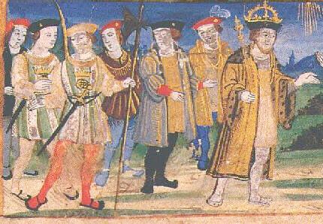Legal action was taken 1518-29 against 264 landowners, of whom 222 were brought to court & 188 verdicts were reached. Some were forced to rebuild houses they had knocked down & return enclosed land to common use.

Failures

* W’s anti-enclosure policy made him unpopular with the politically dominant **nobility & gentry** (pictured right), whose livelihood depended on landownership.
* W was forced to accept all existing enclosures in 1523 in return for getting the subsidy he needed to enable H to invade France; W had to put the King before the poor.

**WOLSEY & THE NOBILITY**

Successes

* He served the King well by eliminating threats to the throne like the Duke of **Buckingham**, who was executed in 1521.
* Peter Gwyn argues that for the most part he co-operated effectively with the nobility, e.g. the Dukes of **Norfolk & Suffolk** quarrelled with each other more often than with him & sometimes tried to enlist his help against each other.
* The nobles respected his power & influence, e.g. e.g. the Earl of Worcester gave him gifts & several nobles sent their sons to be brought up in Wolsey’s household.

Failures

* Many of the nobles resented the fact that a “butcher’s son” had more power & wealth than they did; they were quick to turn against him when he lost the King’s favour in 1529 for failing to secure the annulment.
* They accused him of using the courts against them, e.g. the Court of **Chancery** against enclosures.
* His attempt to reduce the influence of the younger nobles through the **Eltham Ordinances** in 1526 failed.

**FINANCE & PARLIAMENT**

Successes

* The **Act of Resumption** in 1515 restored some of the land to the Crown which Henry VIII had given away in over-generous patronage.
* Wolsey raised over £322,000 in subsidies, £240,000 through taxation and £260,000 in forced loans.
* He increased annual revenue even compared with Henry VII.
* The **subsidy** was considered as a success as it was better in most ways then other methods of taxation and provided a more realistic valuation of wealth. Introduced in 1513, it enabled Henry to defeat France & was a key factor in Wolsey’s rise to power.
* Taxation was 50% higher in the 1520s than in the previous decade, which itself had seen the highest taxation for nearly 100 years.

Failures

* The increases in revenue achieved by Wolsey were insufficient to make up for the rise in government **expenditure** to £1.7 million between 1509 and 1520.
* Wolsey mismanaged the 1523 **Parliament**, failing to raise enough taxation to achieve military success in France; this influenced his disastrous decision to try to impose the **Amicable Grant** without parliamentary consent.
* The ‘Amicable Grant in 1525 was a non-parliamentary tax (& therefore probably illegal) which provoked so much opposition that it had to be abandoned. This meant Henry was unable to invade France & Henry denied all knowledge of it, making sure Wolsey took the blame.
* Most of the population had to pay for more taxes in the 1520s than in any other decade in the sixteenth century except the 1540s, and this is the main reason why Wolsey was so unpopular with the political and propertied classes by the end of his career.
* Despite all these tax increases the French king according to Starkey had x10 Henry’s revenue, Charles V even more.

**Wolsey and the Church**

**Successes**

* His income was six times that of the richest noble, almost all of which came from the church.
* He became papal legate in 1518 which meant that he could override the archbishop of Canterbury.
* He was the most powerful churchman in England.
* He was abbot of St Albans, the richest abbey in England.
* He did dissolve twenty small monasteries in order to improve the self-discipline and lifestyle of the monks.
* he used the income from these institutions to finance a grammar school in Ipswich and a college at Oxford
* He aimed to dissolve some monasteries and use the proceeds to found new dioceses (an area over which a bishop presided), in the hope that the new bishops along with those previously appointed would be able to combat heresy more effectively.
* [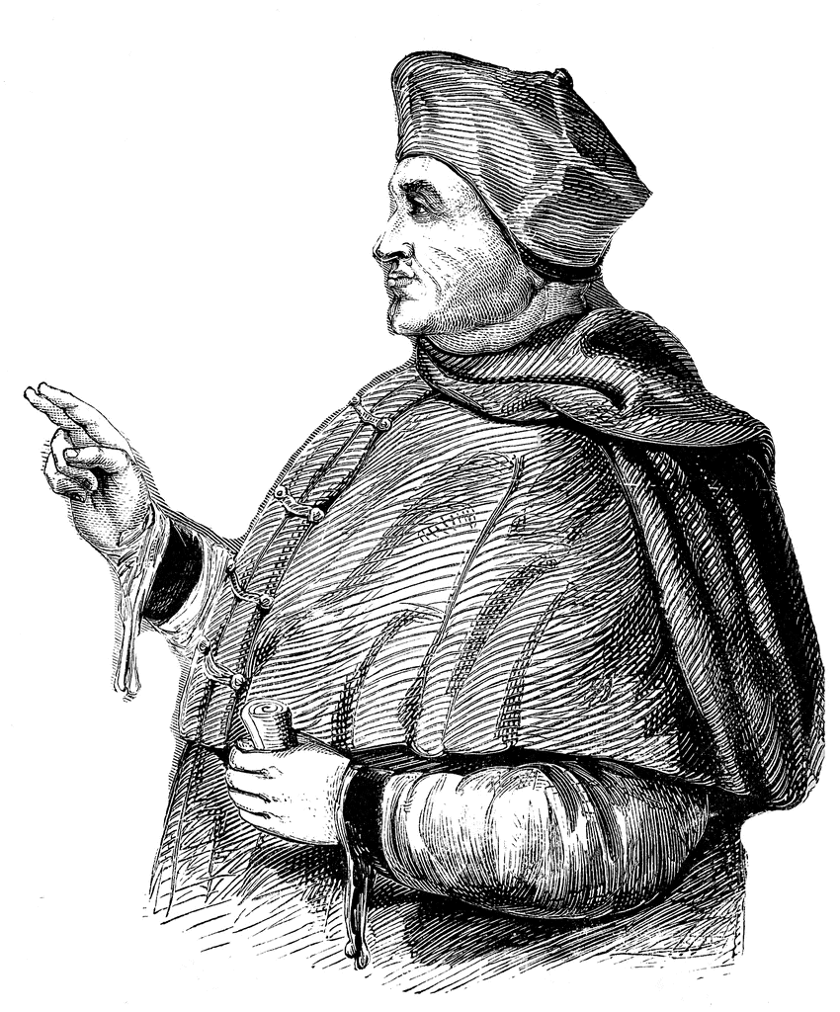](http://www.google.co.uk/url?sa=i&rct=j&q=&esrc=s&frm=1&source=images&cd=&cad=rja&uact=8&ved=0ahUKEwji58DFgbvJAhUB6xQKHYFtDxIQjRwIBw&url=http://etc.usf.edu/clipart/200/262/wolsey_1.htm&psig=AFQjCNF4NkIjkdYM-6GNxZ5dFJUiFh-UwQ&ust=1449071303112252)The church became more centralised under his control- churchmen became used to orders from the crown

**Failures**

* Wolsey did little in the way of church reform.
* Wolsey neglected the Church because he was too busy working for the King.
* Self-glorification by founding a school in his own home town and calling the foundation at Oxford ‘Cardinal College’.
* His taxation of the clergy was at a much higher level than ever before to pay for the King’s wars & the clergy paid more head than the laity.
* His failure to secure the annulment resulted in him being seen as a failure by everyone (H, the nobility & both the Aragon & Boleyn factions) & led to his rapid fall from power.

**All this indicates that Wolsey was first and foremost the King’s Cardinal rather than the Pope’s or God’s.**

He practised many of the abuses which needed reform:

* ***Non-residence****-* He was archbishop of York for 16 years without going there.
* He was a ***pluralist*** because he held more than one position within the Church at any one time. He was Archbishop of York as well as holding one other bishopric (successively Lincoln then Durham then Winchester) as well as being Abbot of St Albans. This gave him a salary of £35,000.
* He was guilty of***nepotism:*** his daughter became a nun at Shaftesbury Abbey and his son was given several archdeaconries with a combined income of about £2,700 a year.
* He was also involved in ***simony*** (the buying and selling of church positions ) because he appointed non-resident Italians to English bishoprics, paid them a fixed income and then pocketed the rest of the diocesan revenues himself.
* Clergy were supposed to be ***celibate*** but he had a mistress by whom he fathered at least 2 children.

**Fill in the following table, giving Wolsey a mark out of 10 for each policy & an overall mark followed by an explanation of how you arrived at the mark you gave**

|  |  |  |
| --- | --- | --- |
| **Policy** | **Mark** | **Explanation** |
| **Law** |  |  |
| **Social Policy** |  |  |
| **Nobility** |  |  |
| **Finance & Parliament** |  |  |
| **Church** |  |  |
| **Overall** |  | Concluding paragraph: |

**HOW SUCCESSFUL WERE WOLSEY’S DOMESTIC POLICIES?**

Successes

* H obviously regarded him as a success b/c he gave him so much **wealth & power** (including promotion to Bishop of Winchester, Archbishop of York & Lord Chancellor with an annual income of £35,000) & kept him as chief minister for 14 years (1515-29); no one else ever achieved this.
* 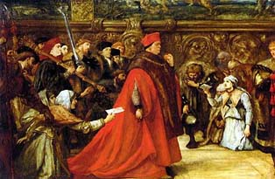Peter Gwyn argues that he had a good relationship with the **nobility**, pointing out that many of them sent their sons to be brought up in his household & that Norfolk & Suffolk sometimes asked him to arbitrate in disputes between them. The nobility only professed hostility towards him after he lost the King’s favour over the annulment.
* As **Lord Chancellor** Wolsey improved the legal system, increasing the number of cases heard in Star Chamber, Chancery & Requests & therefore the availability of justice for all.
* Wolsey’s policy towards enclosures & engrossing showed a genuine desire to help the poor.
* The **subsidy** led to a significant increase in tax revenue, enabling H to win a prestigious victory in France.
* His policy of dissolving small, unviable monasteries to fund his college at Oxford & school at Ipswich showed his commitment to **education** & church reform.

Failures

* His power & wealth (coupled with his lowly social origins) inevitably attracted the jealousy of the **nobility**, especially as he tried to restrict the influence of the younger nobles through the Eltham Ordinances. This contributed to his downfall.
* The **Amicable Grant** provoked so much resistance that it had to be abandoned & Wolsey was blamed for its failure, which meant H missed the opportunity to exploit C V’s victory at Pavia. In general W could not raise enough money to enable H to win any significant victories in France.
* W’s policy towards **enclosure** achieved no lasting success & had to be abandoned b/c of lack of money.
* 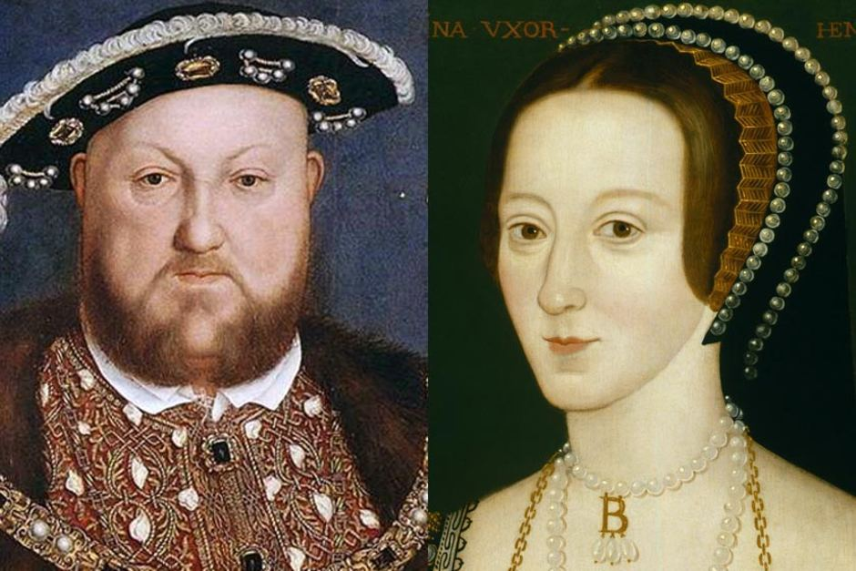Similarly, the **courts** could not cope with the increase in their caseload which his policies helped to generate.
* W’s dissolution of a few small monasteries to fund his pet education projects was on too small a scale & arguably just an “ego trip”, missing an opportunity for much more fundamental reform.
* As a wealthy absentee pluralist who exploited the **Church** for financial & political gain, W exemplified everything which was wrong with the pre-Reformation Church. In fact the abuses he practised & his failure to secure the annulment discredited the Church in the eyes of H & the nobility & caused the attacks on it from 1529 onwards.
* His failure to secure the **annulment** resulted in him being seen as a failure by everyone (H, the nobility & both the Aragon & Boleyn factions) & led to his rapid fall from power.

**Who was responsible for Wolsey's fall from power?**

Russell Tarr in [History Review](http://www.historytoday.com/archive/history-review/latest) [Issue 45 March 2003](http://www.historytoday.com/archive/history-review/issue-45-march-2003)

… The bare facts of Wolsey's fall are straightforward enough. Henry VIII became infatuated with Anne Boleyn; he wanted the annulment of his marriage to his barren wife, Katherine of Aragon; Wolsey's failure to secure this annulment led to most of his offices being stripped from him in 1529. He died in Leicester the following year whilst journeying to London to face charges of Praemunire (which effectively means treason by a churchman). Nevertheless, the question as to who was primarily responsible for this spectacular fall from grace is much more difficult to answer: was it a 'Boleyn faction', King Henry VIII, or Wolsey himself?

**i) The 'Boleyn Faction'?**

David **Starkey** has argued that there was a continuous battle between the Council (under Wolsey) and the court (under the 'minions' - Henry's' hangers-on') for favour and influence with the King. In Starkey's words, 'The struggle for control between the two was continuous and bitter'. The Gentlemen of the Chamber (the King's private quarters) were close friends of Henry and were given official status in 1518, so Wolsey frequently sent them on diplomatic missions abroad and even secured their expulsion from court in 1519. Nevertheless, they were back at the centre of things soon enough, and in 1526 Wolsey's Eltham Ordinances sought to reduce the Gentlemen of the Bedchamber from 12 to six. The execution of the Duke of Buckingham in 1521 is also seen as the result of Wolsey's desperate attempts to curtail the growing influence of a faction which was gravitating towards Anne Boleyn and which was constantly feeding Henry anti-Wolsey propaganda in a concerted attempt to undermine his position. It is certainly true that Anne Boleyn was a very strong character who quickly came to despise Wolsey (as she stated in one of her letters to him, 'I have put much confidence in your professions and promises, in which I find myself deceived'). Eric **Ives**, her biographer, calls Wolsey's fall 'first and foremost Anne's success', whilst Randell points towards Henry's rather tardy decision to dismiss his minister as proof of his residual affection for the man.

**ii) Henry VIII?**

For some historians, faction clearly remains half fact, half fiction. Peter **Gwyn**, for example, has argued that the influence of the Boleyn group has been overstated. The Expulsion of the Minions and the Eltham Ordinances were merely part of an efficiency drive, he argues; Buckingham was not victimised, but clearly engaged in treasonable activities such as illegal retaining.

The real architect of Wolsey's fall, by this reckoning, is Henry VIII himself: outraged at his Cardinal's **failure to secure an annulment** of the Aragon marriage, he brought his servant down in a fit of pique … More problematic was the fact that Henry refused to follow Wolsey's wise advice regarding how to construct his legal case. Henry had originally been allowed to marry his brother's widow following a special dispensation from Pope Julius II, dispensation which removed not only the 'Impediment of Public Honesty' created by the kinship of Henry and Katherine, but also the 'impediment of affinity' created by the supposed consummation of the marriage between Arthur and Katherine (which the Queen always denied took place). Henry's whole case was based on the argument that the Pope had acted outside his authority (*ultra vires*) in waiving the 'impediment of affinity'. Wolsey, however, felt it would have made more sense to argue that Arthur's marriage never had been consummated; therefore the dispensation had been founded on a mistake and was void, as was the marriage which followed from it. This would have turned Catherine's protestations to advantage and would have allowed the Pope to grant an annulment without any loss of face. Unfortunately, Wolsey was away in Europe when Henry got the wheels turning, and by the time he returned such a *volte-face* was impractical.

Much more important than any of these ideas, though, is the fact that the **international situation** made his position impossible. Following the Sack of Rome by Imperial forces in 1527, Pope Clement VII could not afford to anger Katherine of Aragon's nephew, the emperor Charles V. For all his brinkmanship, there was no way on earth that Wolsey could compete with this, but Henry was arguably too short-sighted to acknowledge the fact. Wolsey himself realised the likely consequences: 'If the Pope is not compliant, my own life will be shortened'.

**iii) Wolsey himself?**

… (the) Cardinal as many other people saw him (was) proud, arrogant, even traitorous - and once these voices became dominant Wolsey's position became untenable. His rise had been spectacular; his maintenance of that position wondrous; but his fall was breathtaking.

**THE FALL OF WOLSEY**

Wolsey was sacked in 1529 & died in 1530 without ever regaining royal favour.

Unpopularity

* Supporters of Anne Boleyn were hostile to Wolsey because of his **failure** to secure the annulment and the fact that he was competing with Anne for the king’s attention.
* Supporters of Catherine of Aragon were hostile because he had **tried** to secure the annulment.
* Wolsey quarrelled with Henry over the foundation of his school in Ipswich & with Anne over who should be Abbess of Wilton.
* He also failed to gain support of the **nobles**, partly because he had introduced many policies that were very harsh against the nobles so many resented him and also because he had worked his way up from lowly origins so he was viewed by the nobles to have stolen their power from them. They resented his attempt to exclude them from power through the **Eltham Ordinances** in 1526.
* Wolsey was hated for the high **taxes** he imposed, especially the Amicable Grant.
* As a wealthy & corrupt churchman he attracted anticlerical resentment.
* In the **House of Commons**, gentry hated his prosecution of enclosures & common lawyers resented his encouragement of civil as opposed to common law which threatened their business.

Failure to get the Annulment

* This became **Henry’s main aim**, as it would enable him to get a male heir and create a dynasty as well as the fact that he had fallen in love with Anne Boleyn.
* After the **Sack of Rome** in 1527, The Pope was under the control of Charles, who was Catherine of Aragon’s nephew. For this reason, he would not allow the annulment to happen, as it would make his cousin illegitimate and dishonour his family name.
* As a Cardinal and a Papal Legate Wolsey was responsible for securing the annulment because it was a church matter & he had connections with the Pope.
* The first way that Wolsey tried to secure the annulment was through the Anglo-French alliance, because Francis was the only person that had the necessary resources to take on Charles. However the **Treaty of Cambrai** was agreed in 1529 between Francis and Charles which ended any prospect of France being able to free the Pope from Charles’s control.
* Then Wolsey tried to use the **legatine court** by trying to persuade the Pope to let him preside over it in England. The Pope agreed to it being held in England, however he sent Campeggio to preside over it as well, and Campeggio would look out for the Pope’s own interests, just as Wolsey was looking out for Henry’s. This meant that the annulment would never happen as they would never be able to agree on anything.
* The failure to secure the annulment meant the king lost patience with him, it was the final straw for Henry which meant that Wolsey’s downfall was inevitable.
* Before 1529, most nobles (e.g. the Dukes of Norfolk & Suffolk) co-operated with Wolsey; **it was only after he lost Henry’s favour because of his failure to secure the annulment that everyone turned against him**.
* His unpopularity with both Catherine & Anne’s supporters was obviously connected with the annulment.

**Please write a conclusion to this essay taking account of both Tarr’s analysis & the above arguments.**

**Make it clear what you think was the MAIN reason for Wolsey’s fall, including a consideration of whether his unpopularity with the nobility was the main factor.**

**HOW SUCCESSFUL WAS HENRY VIII IN ACHIEVING HIS AIMS AS KING 1509-29?**

|  |  |
| --- | --- |
| **SUCCESSES** | **FAILURES** |
| **Domestic**   * H showed that he was a very different king to his father through the execution of Empson and Dudley. * His anti-French foreign policy & generosity with patronage (e.g. the creation of the Dukes of Norfolk & Suffolk) won the allegiance of the nobility while at the same time the executions of Suffolk in 1513 & Buckingham in 1521 showed that he would not tolerate threats to his throne. * The introduction of the subsidy in 1513 was a significant boost to royal revenue. | **Domestic**   * H quickly wasted the surplus his father had so carefully accumulated. * The Amicable Grant in 1525 provoked so much opposition that it had to be abandoned. * H’s marriage was a failure, endangering the succession: Catherine produced only a daughter & H’s only son was illegitimate. |
| **Foreign**   * H showed his desire to be a seen as a Renaissance king by favouring Erasmus & posing as the peacemaker of Europe in the Treaty of London in 1518. * H secured the appointment of Wolsey as a cardinal in 1518. * Henry did make his mark on Europe and the defeat of the French at the Battle of the Spurs did give him glory & led to the capture of Tournai & Thérouanne. This was a victory for his policy of allying with Maximilian against France. * H forced the French king Louis XII to pay him a pension & marry his sister Mary. * H achieved a decisive victory at Flodden in 1513; James IV was killed, H’s sister Margaret became Regent of Scotland & there was no further threat from Scotland until the 1540s. * Henry also achieved his glory through the peace conferences that Wolsey organised, especially the Field of the Cloth of Gold in 1520. H enjoyed being able to choose whether to ally with Francis I or Charles V 1520-1. | **Foreign**   * His aim to repeat the glories of Edward III & Henry V were not repeated; he never achieved any significant or lasting gains in France despite spending vast sums of money. The refusal to pay the Amicable Grant showed his subjects recognised this. * He was let down by Ferdinand in 1512, leading to the failure of his invasion of France that year. * The glory he got from the Battle of the Spurs was exaggerated & Tournai & Thérouanne had to be sold back after only 5 years for much less than it cost to capture & fortify them. Maximilian let H down despite the money he gave him. * Louis XII’s marriage to Mary was shortlived & by allowing her to marry Suffolk H missed a chance to secure another diplomatically advantageous marriage. * The most significant English victory in H’s reign was at Flodden in 1513 & he wasn’t even there. * Peace was not H’s preferred policy so whatever prestige he got from the peace conferences Wolsey organised was limited. Neither the Treaty of London nor the Field of the Cloth of Gold produced any lasting results. * His invasions of France 1522-3 were failures: C V was unimpressed & deserted H, so he got no compensation for the French pension he had lost & the proposed marriage between C V & H’s daughter Mary never took plce. * H was unable to take advantage of the French defeat at Pavia b/c of the failure of the Amicable Grant & C’s lack of interest in supporting him, forcing H to sign a treaty with France. * In fact Charles’s victory at Pavia lessened Henry’s influence and also led to his final failure over his divorce. * The appointment of Wolsey as Cardinal had little effect & H never succeeded in securing his election as Pope, which showed his lack of influence in Europe & contributed to his failure to obtain the annulment. * All H’s efforts to secure papal consent for the annulment failed, both in terms of theological arguments & diplomatic efforts; the Treaty of Cambrai between F & C & the collapse of the legatine court, both in 1529, sealed his failure & the dismissal of Wolsey in the same year showed H recognised this. * The Treaty of Cambrai showed how isolated & lacking in influence England truly was at the end of this period. |