**EDWARD VI 1547-53**

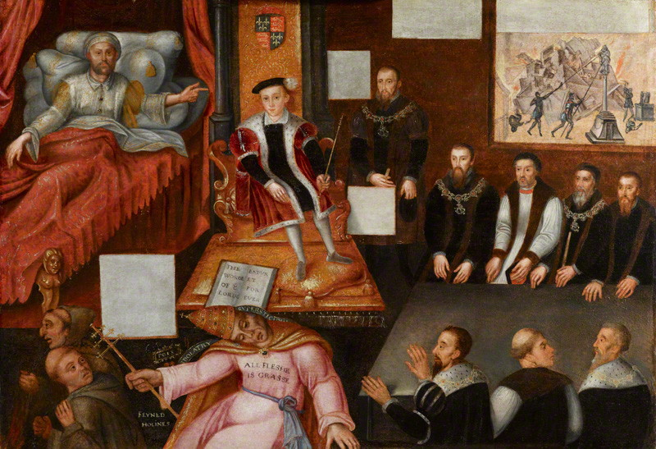

|  |  |
| --- | --- |
| **Topic 4: Edward VI, 1547-1553** | **Tick when revised** |
| Stability of his reign – Minority reign, rule of Somerset and Northumberland, the Devise |  |
| Religious change – Act of Uniformity, dissolution of Chantries, extent of change by 1553 |  |
| Rebellion and Unrest – the Western (Prayer book) and Kett’s rebellions of 1549, Lady Jane Grey 1553 |  |

**Timeline**

|  |  |
| --- | --- |
| 1547 | Henry VIII died & Edward VI succeeded him (January)  Edward Seymour became Lord Protector & Duke of Somerset (February) |
| 1549 | Act of Uniformity imposed new Book of Common Prayer, making the Church of England officially Protestant for the first time (January)  Western Rebellion broke out (June)  Norfolk Rebellion broke out (July)  End of Somerset’s Protectorate (October) |
| 1550 | John Dudley (then Earl of Warwick) took control of the Privy Council as Lord President of the Council (February) |
| 1551 | Dudley became Duke of Northumberland (October) |
| 1552 | Somerset executed (January)  New Act of Uniformity imposed a more radically Protestant Book of Common Prayer (March) |
| 1553 | Edward VI died (July) & Mary became Queen after defeating Northumberland’s attempt to put Lady Jane Grey on the throne |

**RECOMMENDED READING**

Books

**Official OCR textbook: Mary Dicken & Nicholas Fellows, *England 1485-1603*, 2015**

Available on Dawsonera: On the Home Page of Godalming Online, click on “Links” at the top, then “ILC Library”, then “Dawsonera” & follow the instructions.

<https://www.dawsonera.com/abstract/9781471836626>

Chris Skidmore, *Edward VI: The lost King of England,* 2007

[Nigel Heard & Roger Turvey,](https://www.amazon.com/Edward-VI-Mary-Mid-tudor-1540-58/dp/0340912529/ref=sr_1_9?s=books&ie=UTF8&qid=1481559871&sr=1-9&keywords=mid+tudor+crisis" \o "Edward VI and Mary: A Mid-tudor Crisis?, 1540-58 (Access to History)) *[Edward VI and Mary: A Mid-Tudor Crisis? 1540-58](https://www.amazon.com/Edward-VI-Mary-Mid-tudor-1540-58/dp/0340912529/ref=sr_1_9?s=books&ie=UTF8&qid=1481559871&sr=1-9&keywords=mid+tudor+crisis" \o "Edward VI and Mary: A Mid-tudor Crisis?, 1540-58 (Access to History))*[(Access to History)](https://www.amazon.com/Edward-VI-Mary-Mid-tudor-1540-58/dp/0340912529/ref=sr_1_9?s=books&ie=UTF8&qid=1481559871&sr=1-9&keywords=mid+tudor+crisis" \o "Edward VI and Mary: A Mid-tudor Crisis?, 1540-58 (Access to History))

2006

Articles

On the Home Page of Godalming Online, click on “Links” at the top, then “ILC Library”, then “Websites, subscriptions, links”, then follow the instructions on how to access the History Today website:

**Edward VI**

By [Matthew Christmas](http://www.historytoday.com/author/matthew-christmas)

Published in [History Review](http://www.historytoday.com/archive/history-review/latest) [Issue 27 March 1997](http://www.historytoday.com/archive/history-review/issue-27-march-1997)

**Edward VI: A New Look at the King and his Reign**

By [Jennifer Loach](http://www.historytoday.com/author/jennifer-loach)

Published in [History Review](http://www.historytoday.com/archive/history-review/latest) [Issue 35 December 1999](http://www.historytoday.com/archive/history-review/issue-35-december-1999)

**A Lamb in Lion’s Garb: Evolving perspectives on Edward VI**

By [John Matusiak](http://www.historytoday.com/author/john-matusiak)

Published in [History Review](http://www.historytoday.com/archive/history-review/latest) [Issue 48 March 2004](http://www.historytoday.com/archive/history-review/issue-48-march-2004)

**Edward VI and Mary Tudor: Protestant King and Catholic Sister**

By [Judith Richards](http://www.historytoday.com/author/judith-richards)

Published in [History Review](http://www.historytoday.com/archive/history-review/latest) [Issue 59 December 2007](http://www.historytoday.com/archive/history-review/issue-59-december-2007)

**Was Lord Protector Somerset ('The Champion for the Commonwealth') Responsible for Kett's Rebellion?**

By [Jez Ross](http://www.historytoday.com/author/jez-ross)

Published in [History Review](http://www.historytoday.com/archive/history-review/latest) [Issue 70 September 2011](http://www.historytoday.com/archive/history-review/issue-70-september-2011)

**The Rise of John Dudley, Duke of Northumberland**

By [Barrett L. Beer](http://www.historytoday.com/author/barrett-l-beer)

Published in [History Today](http://www.historytoday.com/archive/history-today/latest) [Volume 15 Issue 4 April 1965](http://www.historytoday.com/archive/history-today/volume-15-issue-4-april-1965)

**Northumberland**

By [Mark Rathbone](http://www.historytoday.com/author/mark-rathbone)

Published in [History Review](http://www.historytoday.com/archive/history-review/latest) [Issue 44 December 2002](http://www.historytoday.com/archive/history-review/issue-44-december-2002)

**Re-Trying the Case for the 'Good Duke'**

By [John Matusiak](http://www.historytoday.com/author/john-matusiak)

Published in [History Review](http://www.historytoday.com/archive/history-review/latest) [Issue 50 December 2004](http://www.historytoday.com/archive/history-review/issue-50-december-2004)

**The Unknown Tudors Video**

Up to 54 mins on E stream (but that contains adverts) If you see it on Youtube it takes 45 mins.

1. How long had Henry VIII been trying to father a male heir?
2. Why did triumph turn to tragedy?
3. Where did Edward spend his infant years?
4. Why did Mary and Elizabeth appear in the picture of the family painted in 1544?
5. How do we know so much about Edward?
6. Who was Edward’s teacher?
7. What was significant about Cox?
8. How Protestant did Edward become?
9. When did Henry die and how did Edward react?
10. How was Henry presented to his son?
11. What happened to Henry’s plan for a balanced council to rule for Edward?
12. What was so controversial about Edward’s coronation?
13. What were churches still like?
14. What did the Government decide about the Church?
15. Who was Edward’s best friend with whom he was brought up?
16. Where did real power lie?
17. What did Somerset’s stinginess provide?
18. What provoked rebellion in the West Country?
19. Where was the King when trouble entered into Edward’s own court?
20. What caused Edward to grow up?
21. How did Edward regard the death of his uncle?
22. How old was Edward when he began to rule?
23. What did Edward’s coldness and confidence lead to?
24. What particularly divided them?
25. What happened when the Holy Roman Emperor asked Edward for special dispensation for Mary to say mass?
26. What comes across strongly in Edward’s chronicle?
27. What was Edward’s most decisive move towards Protestantism?
28. What showed how broke his government was?
29. What did Edward want to achieve?
30. What had happened by April 1553?

1. When he knew he was dangerously ill what worried him?
2. What did he do in his “device” for the succession?

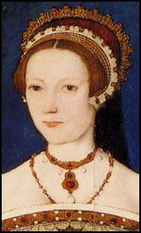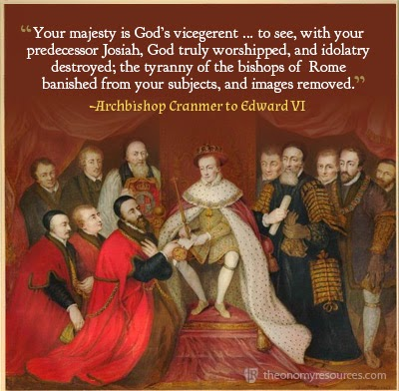

Edward Seymour, Duke of Somerset & Lord Protector 1547-9

Edward Seymourwas the eldest brother of Queen Jane Seymour, the third wife of King Henry VIII and mother of his heir Edward. This meant that he was uncle to Edward and after a victory over the Scots at Solway Moss in 1542 was in great favour with Henry VIII in his final days. He was a Protestant and very ambitious. When Henry died, Seymour and his close ally and secretary, William Paget, who had custody of the will, kept Henry’s death a secret while they gathered support for Seymour as leader of the Council. Henry died on the 28th January 1547, but it was not announced until February 1 when Seymour and Paget summoned the nobility to announce that Seymour had been made leader of the Council and was now to be called Lord Protector, Duke of Somerset and to acquire lands to support his new position.

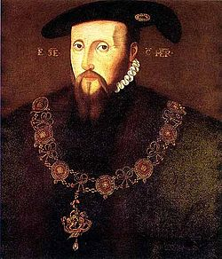This meant that he was in effect Regent, or ruler. He was very autocratic, i.e. he tried to rule as much as possible by himself & consulted the Privy Council & Parliament as little as possible.

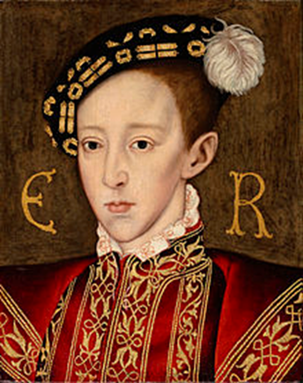

The Tudor Succession

In December 1546, a month before he died, Henry VIII made a will which confirmed the 1544 Succession Act:

“We will that, immediately after our departure out of this present life, our said son Edward shall have and enjoy the said imperial crown and realm of England … And for lack of .. issues or heirs, the said imperial crown … shall wholly remain and come to our .. daughter Mary and the heirs of her body lawfully begotten … for default of issue of our daughter Mary, the said imperial crown shall wholly remain and come to our .. daughter Elizabeth”.

Please explain in your own words what this meant:

**HOW SERIOUS WERE THE PROBLEMS CAUSED BY THE MINORITY OF EDWARD VI?**

Edward was 9 when he became King & only 15 when he died, so he never came of age as King. He never had any children.

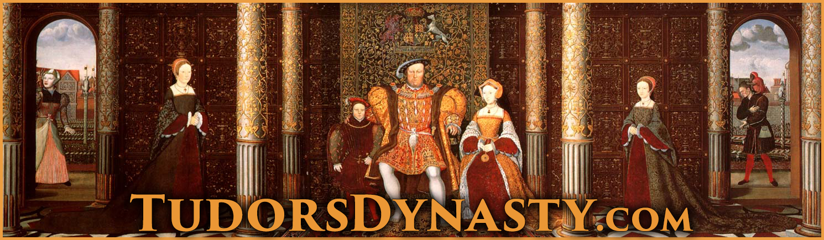

Serious

* Royal minorities had caused problems before: there had been civil wars in the reigns of both Henry III, who became King at the age of 9 in 1216, & Edward V, who became King at 12 in 1483. E V had lost the throne to his uncle Richard III after only 3 months & was almost certainly murdered by him.
* As a child king, E obviously did not have the authority his father had had, nor could he intimidate people as H had done through the Treason Act & over 300 executions for opposing the Reformation.
* This problem was compounded by Somerset’s decision to **repeal H’s Treason Act & the heresy laws**, which caused an upsurge of religious unrest.
* As **Lord Protector** Somerset did not have the same authority an adult king would have had, partly as his title went against H’s wishes (expressed in his will) for a balanced Regency Council.
* The outbreak of serious **rebellions** in the South West & Norfolk in 1549 which resulted in the fall of Somerset showed how govt. authority had been undermined.

Not Serious

* Henry III (1216-72), Richard II (1377-99) & Henry VI (1422-61) had all succeeded to the throne as minors but retained their throne into adulthood.
* E was not sickly until his final illness in 1553 so the general assumption was that he would live to become an adult king & have an heir as Henry III & Henry VI had done.
* Henry VII & VIII had established a **strong Tudor dynasty** by 1547 & no one challenged E’s right to the throne, including the rebels of 1549.
* As E’s uncle & following his victory over the Scots at Solway Moss it was logical that Somerset should be L Protector. In a country used to monarchy, it made sense to have a Protector rather than rule by a Regency Council which might have difficulty reaching agreement.
* The crisis of 1549, including the rebellions & the fall of Somerset, were caused more by **Somerset’s incompetence** & underlying **religious & economic problems** rather than by the royal minority as such.
* Following the crisis of 1549, **Northumberland** restored stability 1550-3 & there was no further unrest until it became clear that E was dying.

**POLITICAL RIVALRY IN EDWARD VI’S REIGN**

Secretary of state Sir William Paget wrote 2 critical letters to Somerset in May & July 1549:

**Source A**

“A king which shall give men occasion to discourage to say their opinions frankly receiveth thereby great hurt and peril to his realm. But a subject in great authority, as Your Grace is, using such fashion, is like to fall in great danger and peril of his own person, beside that to the wellbeing of the nation”.

**Source B**

“The King’s subjects out of all discipline and all obedience, and care neither for you nor the King. What is the cause? Your softness, your wish to be good to the poor … A society is maintained by religion and law. Look carefully to see whether you have either law or religion, and I fear you shall find neither. I know that in the matter of your treatment of the common people every man in the Council dislikes your proceedings and wished it were otherwise”.

1. What point is Paget making about Somerset’s treatment of the Privy Council in A?
2. What do these sources suggest was the main reason for Somerset’s downfall?
3. [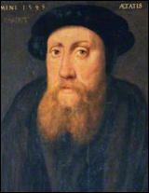](http://www.google.co.uk/url?sa=i&rct=j&q=&esrc=s&source=images&cd=&cad=rja&uact=8&ved=0ahUKEwjljPS2xOTQAhVHuhoKHRkZAeoQjRwIBw&url=http://spartacus-educational.com/William_Paget.htm&psig=AFQjCNHxKpCKwMEQnJzIRWC49c_zT0DjCA&ust=1481284325381405)Given the content of Source B, the fact that Paget (below right) was formerly an ally of Somerset & that he was writing a letter to him, how useful would these sources be to an historian assessing the reasons for Somerset’s fall?

Reasons for Somerset’s Fall in October 1549

* Somerset’s aggressive behaviour turned the **Privy Council** against him, including Sir William Paget, once his trusted adviser, & former supporters like the Earl of Warwick (later Duke of Northumberland). **Warwick** (later the Duke of Northumberland) led the coup against him, alleging (according to Richard Grafton’s chronicle) that he “ignored the advice of his councillors” & “told untruths about the council to the king”.
* Paget also criticised Somerset’s handling of the social & economic problems England faced & blamed him for the **rebellions**. The King himself wrote that the 1549 risings began "because certain commissions were sent down to pluck down enclosures".
* Somerset’s **religious** policy provoked unrest in Yorkshire, Hampshire & Oxfordshire & outright rebellion in Devon & Cornwall; Paget warned Somerset that “the use of the old religion is forbidden by a law, but the use of the new is not yet printed in the stomachs of 11 out of 12 parts of the realm”.
* Som. even **executed his own brother** (Thomas Seymour, Baron Seymour of Sudeley) in 1549 for treason. Thomas had tried to manipulate Princess Elizabeth (by seducing her) & the King (by giving him pocket money); the final straw was trying to break into the royal apartments with a loaded pistol.
* Warwick brought Somerset down by allying with his enemies like the Earl of **Southampton**, a religious conservative who had always disliked Somerset.

Why did political instability continue from October 1549 onwards?

* Both Som. & his opponentss accused each other of treason & **armed their servants** so they could seize or retain power by force.
* Som. tried to retain power by **kidnapping the King** & taking him to Windsor Castle, in effect imprisoning him in the hope that he could claim to act in the King’s name. This failed b/c E, despite being only 12 years old, refused to support him.
* Even after Som. was forced to resign, there was **rivalry for power between Warwick & the religiously conservative councillors** led by the Earls of Arundel & Southampton.
* Warwick managed to outmanoeuvre his opponents by promoting his supporters, allying with the Protestants, including Som. (who was restored to the Privy Council in 1550) & winning the support of religiously uncommitted opportunists like Paget & Petre.
* Far from being grateful to Warwick for his restoration to the Privy Council, **Somerset** was still bitter at Warwick for engineering his downfall as L Protector in 1549 so he plotted against him. Warwick (who made himself Lord President of the Privy Council in 1550 & Duke of Northumberland in 1551) had Som. executed in 1552; according to a contemporary letter, he was accused of inciting rebellion & plotting to murder Northumberland; “the whole Council decided that they would no longer endure the excessive arrogance of the Duke of Somerset”.

**Source C**

The whole Council decided that they would no longer endure the excessive arrogance of the Duke of Somerset, which made it quite clear that if he were released from imprisonment, he would raise rebellions, which would endanger the whole kingdom. Everyone knew he was the cause of his brother’s death.

*Francis Bourgoyne, a contemporary living in London, writing a private letter in January 1553.*

How useful would this source be to an historian studying the reasons for the continuing unrest in England 1549-52?

**SOMERSET / NORTHUMBERLAND COMPARISON**

|  |  |  |
| --- | --- | --- |
|  | **Somerset 1547-9** | **Northumberland 1550-3** |
| Style of Government | Made himself Lord Protector & ruled arrogantly, often disregarding the views of the Privy Council, losing their confidence as a result. United Warwick (later Nthumb.) & the conservatives against him, leading to his downfall in 1549.  Paget accused him of bullying councillors. | Ruled as Lord President of the Privy Council & was careful to retain the confidence of his fellow councillors, especially moderates like Paget.  He outmanoeuvred the conservatives led by Southampton & then executed Somerset in 1552 when he tried to overthrow him. |
| Treatment of the King | Kidnapped E & took him in Windsor Castle; tried to manipulate him but had to resign when E refused to co-operate. | Encouraged E to participate in govt., e.g. by setting the agenda for Privy Council meetings, & his religious policy was influenced by E’s strongly Prot. views. |
| Rebellions | Accused by his Privy Councillors of encouraging the peasants to take the law into their own hands with his anti-enclosure commissions & was therefore blamed for the rebellions & unrest in 1549, resulting in his downfall in October that year. | As Earl of Warwick Nthumb. gained credit for crushing the Norfolk Rebellion.  Prevented future rebellions (despite harvest failures 1549-51 & a crash in the cloth trade in 1551) by imposing the death penalty for unlawful assemblies of 12 or more people to overthrow enclosures or demand price or rent reductions & establishing a militia commanded by a lord lieutenant in each county.  He also passed laws to protect arable farming, relieve the poor & stop lending at extortionate interest rates. |
| Foreign Policy | Despite his victory over the Scots at Pinkie in 1547, Som. was unable to prevent Mary, Queen of Scots sailing to France in 1548 so she could marry the eldest son of the new French king Henry II rather than E VI.  His policy of continuing the wars agt. France & Scotland, including trying to hold Boulogne against the French, cost £1.3 million & bankrupted the Crown. | Ended the wars with France & Scotland, selling Boulogne back to the French for £140,000 & abandoning the betrothal of E to MQS.  The potential union of crowns between France & Scotland threatened England in the future but not immediately, especially as war broke out between Henry II & Charles V in 1551.  Strengthened the navy & England’s defences against both France & Scotland. |
| Finance | His aggressive foreign policy bankrupted the Crown despite desperate attempts to raise money by debasing the coinage (causing disastrous inflation which contributed to the unrest & rebellions in 1549) & selling monastic & chantry land (thereby virtually wiping out the potential benefit to the Crown of dissolving the monasteries & chantries). | Recognised the necessity of making peace with France & Scotland so he could end the debasement of the coinage & reduce the Crown’s debt.  By 1553 he had reduced it to below £200,000 by improving financial administration, reducing expenditure & selling crown & church land. |

What does the comparison between Somerset & Northumberland tell you about the reasons for political instability in England during the reign of Edward VI?

**HOW SERIOUSLY DID THE ATTEMPT TO ALTER THE SUCCESSION IN 1553 THREATEN THE SECURITY OF THE TUDOR DYNASTY?**

Seriously

* It could be argued that **Northumberland** (below right) acted as an “overmighty subject”, putting his own ambition & interests above the security of the Crown. He married Lady Jane Grey to his son Lord Guildford Dudley & then persuaded the dying 15 year old King to alter his “Device for the Succession” in Jane’s favour.
* Jane’s claim as the granddaughter of H’s sister Mary was clearly inferior to that of H VIII’s eldest daughter Mary; she knew this & did not want to be queen but was manipulated by Nthumb.
* 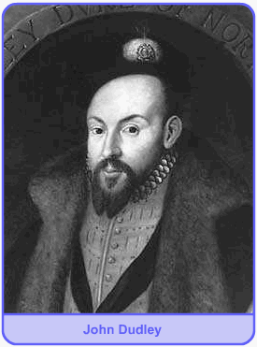Legally the Succession Act of 1544 clearly overruled the “Device” of a 15 year old king which was never approved by Parliament. It also superseded the acts of 1534 & 1537 (quoted by the Privy Council in a letter to Mary just after E’s death) which had excluded Mary from the succession.
* In June 1553, knowing E was dying, Nthumb. forced the Privy Council & other notable people to sign articles supporting Jane. When E died on 6 July Nthumb. kept his death secret for 2 days & forced leading London citizens to sign E’s “Device”.
* Conversely, it can be argued that it was **Edward** himself who threatened the security of his own dynasty by trying to interfere with the succession for religious reasons; he was quoted as saying, “if our sister Mary were to be queen, it would all be over for the religion we have established”.
* Similarly Archbishop **Cranmer** showed disloyalty to the dynasty he was appointed to serve for religious reasons & b/c he knew Mary would burn him as a heretic. His later claim that “I never liked” E’s will & “if by any means possible it had been in my power to have prevented the making of that Will, I would have done it” was an obvious lie.
* There was a real threat that the succession dispute in 1553 could have provoked not just a civil war but also a **foreign invasion**: Nthumb. discussed with the French ambassador the possibility of French military aid against the half-Spanish Mary, while Mary herself requested help from her nephew Charles V.

Not Seriously

* If Nthumb. was the main author of the attempt to interfere with the succession he was remarkably & uncharacteristically **incompetent** in how he set about it: he did not have an army available to support Jane (in fact he had disbanded his army in 1552), he failed to prevent Mary escaping to East Anglia & he also neglected to organise a propaganda campaign against her.
* The nobility & gentry had a vested interest in supporting the principle of **legitimate inheritance**, on which their right to their own property depended; it was therefore never likely that they would support Jane against Mary.
* **Mary** acted quickly & decisively to secure her rightful position by escaping to East Anglia, proclaiming herself Queen, sending letters to the Privy Council & important towns asserting her claim & quickly raising a large army.
* As soon as Nthumb. left London to confront Mary, the Privy Council went over to her & many of his soldiers deserted despite being offered higher pay, showing how strong **loyalty to the rightful heir** was. In fact so many of his army deserted that Nthumb. had to give up & declare Mary Queen himself instead of fighting her.
* The religious divisions in England mattered less than her legitimacy: she was greeted with enthusiasm in London despite the presence of many Protestants there. Some historians have argued that Mary herself underestimated the extent to which her success was due to her legitimacy rather than her religion.

**SOURCES ON THE SUCCESSION CRISIS OF 1553**

**Source D**

Most lamentably mourning and moaning himself unto you Highness, Thomas Cranmer, though unworthy to write to your Highness, am now obliged, with a most penitent heart, to ask mercy and pardon for my great and serious offence in upholding the last Will of our late Sovereign Lord, King Edward VI, which God knows I never liked. And if by any means possible it had been in my power to have prevented the making of that Will, I would have done it.

And whereas it is contained in two Acts of Parliament, as I understand, that I with the Duke of Northumberland did devise the deprivation of your Majesty from your Royal Crown, it is untrue. For the Duke never said anything to me to get me to agree to such a thing.

His heart was such toward me that he would never trust me in such a matter, or ever think I could be persuaded by him. It was others of the Council, as well as the King, that persuaded me, as the Duke was not present.

*Letter from Thomas Cranmer, the Protestant Archbishop of Canterbury, to Mary, 1553.*

**Source E**

The Duke (Northumberland) said the King had told him that he had well considered the Act in which it was ordained that whoever recognised Mary, or Elizabeth her sister, as heir to the Crown were to be considered traitors, seeing that Mary had disobeyed the King her father and her brother and was, moreover, a chief enemy to the Word of God and that both were illegitimate. Therefore the King declared that he would disinherit them. Before his death, he commanded his Council that they should carry this into effect.

The Duke of Northumberland added that I was the heir nominated by his Majesty … On hearing this I remained stunned. Those present can witness that I fell to the ground weeping piteously and lamenting not only my own insufficiency but the death of the King.

*Letter from Lady Jane Grey to Mary, August 1553.*

**Source F**

Today the Duke of Northumberland was executed.

As I hear, he confessed himself worthy to die because he was a great helper of this false religion … thanking God that he could now call himself a Christian, for this 16 years he had been none.

A great number turned with his words.

*Letter from William Dalby, a London merchant, 22 August 1553.*

**1** How useful would Sources D & E be to an historian trying to assess who was responsible for the attempt to exclude Mary from the succession in 1553? Consider why Jane & Cranmer wrote what they did.

**2** What would you infer from Source F about Dalby’s religious views?

**3** Why would Northumberland have said what he did despite knowing he would die anyway?

Study the three sources below and then answer **both** questions:

**1** Use your knowledge of political developments in the reign of Edward VI to assess how useful Source 1 would be to an historian trying to assess the causes of the succession crisis in 1553. **[10]**

**2** Using these three sources in their historical context, assess how far they support the view that the succession crisis of 1553 posed a serious threat to the stability of the Tudor dynasty. **[20]**

**Source 1**

The Duke of Northumberland was an ambitious man. After a notable victory outside Norwich in 1549 against the peasants, who had been stirred up against the better sort by idle men, Northumberland sought to control both the King and the kingdom. In 1553 the King showed signs of imminent death. He dared not make any protests, but fell in with the Duke’s wishes to alter the succession. The dying king spoke to the nobles and lawyers; “It is our resolve, with the agreement of our noblemen to appoint as our heir our dear cousin Jane. For if our sister Mary were to be queen, all would be over for the religion we have established.”

*Robert Wingfield, “The Life of Mary Queen of England”, 1553. Wingfield was a Catholic gentleman & ardent supporter of Mary.*

**Source 2**

We advise you that our Sovereign Lady Queen Jane is possessed of the crown, not only by good order of old ancient records of this realm, but also by the late King Edward’s letters signed with his own hand and sealed with the Great Seal of England, with nobles, councillors and judges agreeing to these letters. We must remind you that owing to the divorce between King Henry VIII and your mother, in accordance with the law of God and confirmed by Acts of Parliament (1534 and 1537) you are illegitimate and unable to inherit the crown.

*Letter from the Privy Council, at that time dominated by Northumberland, to Mary, 9 July 1553.*

**Source 3**

After a while the Duke (Northumberland), speaking for all of them, thanked your Majesty very humbly for all the generous offers which you are pleased to make them. They desire to ask your aid and to employ your forces when occasion presents itself.

*Letter from Antoine de Noailles, the French ambassador, to his master Henry II, 7 July 1553.*

**Questions to consider:**

1. Why might Wingfield want to hold Nthumb. rather than the King responsible for the attempt to interfere with the succession?
2. The Act of Succession in 1534 barred Mary from the succession in favour of Elizabeth & any other children H VIII might have by Anne Boleyn. The 1537 act barred both Mary & Elizabeth in favour of Edward or any other children H might have by Jane Seymour. Was this the last word on the succession? How much weight would E’s will & the signatures of “nobles, councillors and judges” have, bearing mind the content of Source 1 & the political situation at the time that Source 2 was written?
3. Why would the French king offer to support Nthumb. against Mary? How does the provenance of Source 3 (a letter from the French ambassador to his king) affect its usefulness? Would it be a private or a public document?

**Using these sources in their historical context, assess how far they support the view that religion was the most important factor determining whether people supported Mary or Jane in 1553**

**Source 1**

Partly because of the right of Mary’s title and partly because of the malice that the people bore to the Duke of Northumberland for the death of the Duke of Somerset and his other cruelty, the majority of the commons with some nobles sided with Lady Mary.

*From an anonymous account of events, which the Protestant propagandist John Foxe later used as a source for his “Acts and Monuments” in the mid 1550s.*

**Source 2**

Immediately I heard of Edward’s death, I sorrowfully left Greenwich … I did not love Catholicism but detested the wicked plan to exclude rightful heirs … there was no need to injure Mary in this way.

*From “A Poetical Autobiography of Sir Nicholas Throckmorton”, written before 1571.*

**Source 3**

Mary withdrew into Norfolk and Suffolk where she understood the Duke’s name to be much hated for subduing the rebels under King Edward … The first to resort to her were the Suffolk men who, being always forward in promoting the proceedings of the gospel, promised her their aid provided she would promise them no innovations would be made in religion. She agreed.

*John Foxe, “Acts and Monuments”, Volume 6, written in the mid 1550s.*

**Source 4**

I dined at Partridge’s house with my Lady Jane …

“I beg you”, said Lady Jane, “do they have mass in London?”

“Yes”, I said, “in some places”.

“Who would have thought”, she said, “the late Duke would have undergone such a sudden conversion?”

… She said, “He has ruined me and my family by his great ambition … He raised a force against the Queen and is hated by the commons for doing so … his life was wicked and full of deceit”.

*The Tower Chronicle, 29 August 1553, written by an officer of the Tower of London.*

**OCR QUESTIONS ON THE 1553 SUCCESSION CRISIS**

1. **Use your knowledge of the Succession Crisis of 1553 to assess how useful Source A is as evidence of the reasons for the attempt to exclude Mary from the succession.**
2. **Using these 3 sources in their historical context, assess how far they support the view that the attempt to exclude Mary from the throne in 1553 was a serious threat to the Tudor dynasty.**

**Source A: The Privy Council rejects Mary’s claim to the throne**

Our answer is to inform you that our said sovereign Lady Jane is after the death of King Edward VI in possession of the imperial crown of this realm, not only by good order of old laws of this realm, but also by your late King’s open letters signed with his own hand and sealed with the great seal of England in the presence of many nobles, councillors and judgers. For many acts of parliament have made you illegitimate and unable to inherit the imperial crown of this realm.

*(The Privy Council, letter to Mary Tudor, 9 July 1553)*

**Source B: An anonymous writer recounts the reaction to the proclamation of Jane Grey as Queen**

After King Edward’s death the Council proclaimed Lady Jane as queen. But, partly because of the right of Mary’s title and partly because of the malice that the people bore to the Duke of Northumberland for the death of the Duke of Smerset and his other cruelty, the majority of the commons with some nobles sided with Lady Mary, who proclaimed herself queen.

*(From an anonymous account of events which John Foxe later used as a source for “Acts and Monuments” in the mid 1550s)*

**Source C:**

Sorrowfully, from Grenwich I did straight depart

To London, to a house which bore our name.

My brothers guessed by my heavy heart

The King was dead, and I confessed the same; The covering up of his death I did report,

Their meaning to proclaim Queen Jane I told.

And, though I did not like the religion (Roman Catholicism)

In my mind that wicked motion

to displace right heirs I did detest.

Causeless to proffer any injury

I meant it not, but sought for remedy.

*(Political autobiography of Sir Nicholas Throckmorton, written before 1571)*

**RELIGION**

Early Changes 1547-9

[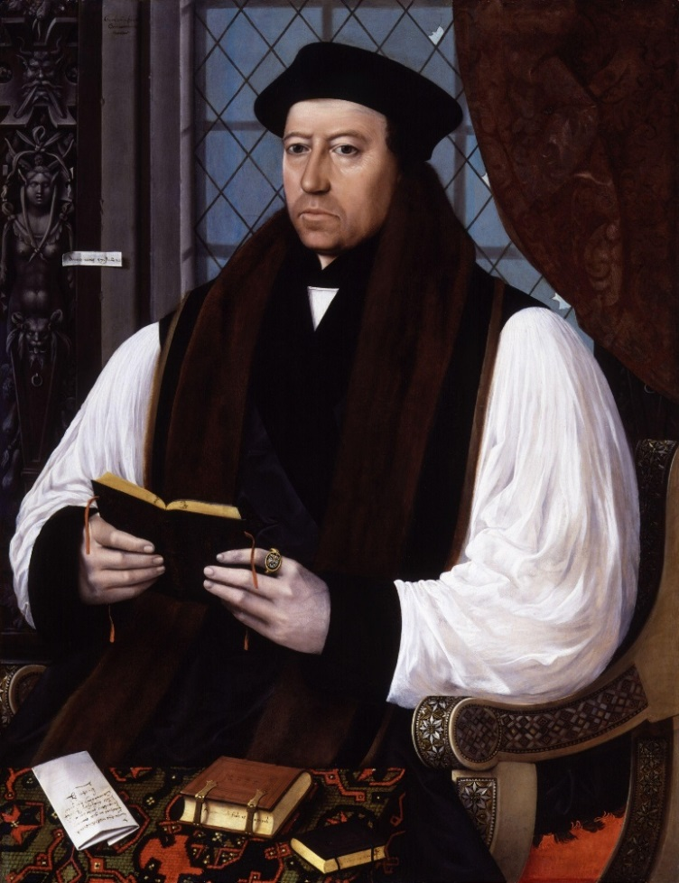](http://www.google.co.uk/url?sa=i&rct=j&q=&source=imgres&cd=&cad=rja&uact=8&ved=0ahUKEwiM8rOOh-HKAhUH7BQKHWjaCKkQjRwIBw&url=https://en.wikipedia.org/wiki/Thomas_Cranmer&psig=AFQjCNF4ljQJ6evH4pMx1Qw_YF5HvgqSuQ&ust=1454776551248913)In July Thomas **Cranmer**, the Protestant Archbishop of Canterbury (below right), published a **Book of Homilies** (model short sermons in English for use by parish clergy). They included a homily on salvation by faith alone (not faith & good works) which 2 conservative bishops, Bonner of London & Gardiner of Winchester, were imprisoned for objecting to.

Also in July 1547 **Royal Injunctions** ordered that:

* Copies of the Book of Homilies (which provided the clergy with model sermons) & of Erasmus’s Paraphrases (a summary of the New Testament translated into English) were to be placed in every parish church.
* Clergy must conduct their services in English, preach every Sunday & keep a copy of the English Bible in their church.
* “Superstitious” images must be removed (in February 1548 it was ordered that all images must be removed & it was further ordered in December 1549 that any remaining images must be destroyed).

In autumn 1547, Parliament passed an act dissolving the **chantries**, justifying this by claiming that belief in prayers for the dead & purgatory were superstitious. In total over 3,000 chantries were dissolved, a significant change b/c the amount of money invested in chantries had been rising steadily right up to the break with Rome.

The **repeal of the Treason Act** **& the heresy laws** (Including the Act of the 6 Articles) in 1547 enabled more freedom of religious debate, with increasingly radical ideas circulating, including attacks on the Mass. In some places there were iconoclastic attacks on images on the grounds that they were idolatrous & superstitious.

Somerset issued a series of **proclamations** between January and April 1548 to restore order and limit who could preach. However it appears that the impact of these proclamations was limited. In September 1548 the Council had to ban all public preaching. They even ordered that the Latin Mass should continue to be used until Cranmer could write a new Protestant Book of Common Prayer in English to replace it.

The Act of Uniformity 1549

In January 1549 they issued an Act of Uniformitystating that

* Sacraments now consisted of just communion, baptism, confirmation, marriage and burial.
* Clergy could marry.
* Singing masses for the dead was not approved.
* Services were to be in English, using the new **Book of Common Prayer** instead of the Latin Mass.
* Laity could receive both bread and wine at communion.

A few Catholic practices remained:

* Some Holy Days were still respected.
* The Catholic belief in purgatory was not condemned.

To help enforce these changes, bishops were ordered to carry out visitations (inspections) to check how many people in their dioceses (the area they were bishops of) knew the Lord’s Prayer & the 10 Commandments.

Limitations.

* Somerset himself was only a moderate Prot. & as Lord Protector did not have the same authority as a King.
* [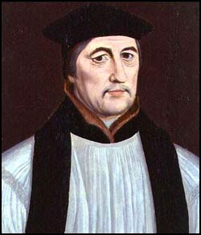](http://www.google.co.uk/url?sa=i&rct=j&q=&esrc=s&source=images&cd=&cad=rja&uact=8&ved=0ahUKEwjZhqXixeTQAhUDWhoKHZvLAzAQjRwIBw&url=http://www.luminarium.org/encyclopedia/gardiner.htm&bvm=bv.140915558,d.ZGg&psig=AFQjCNGFBBPC5S0AXB8FMT02SR02UAMIcg&ust=1481284723645497)The bishops were divided, with many (especially Gardiner of Winchester, right) opposed to change.
* The lower clergy & common people were predominantly against change, especially in the North & West.
* Protestantism was not imposed until the passage of the Act of Uniformity in 1549.
* The main reason for the dissolution of the chantries was to raise money for the war against Scotland.
* Somerset feared that the increased freedom of debate & iconoclasm could cause disorder, so a series of proclamations (announcements) were made between January & April 1548 to restore order & limit those who could preach. When these had only a limited effect, the Privy Council (roughly equivalent to the modern Cabinet) felt compelled to ban all public preaching, even though this obviously restricted the spread of Prot. ideas.
* Fast & Holy Days remained & the veneration of saints was discouraged rather than banned.
* [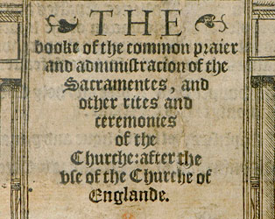](http://www.google.co.uk/url?sa=i&rct=j&q=&esrc=s&frm=1&source=images&cd=&cad=rja&uact=8&ved=0ahUKEwiErcfOh-HKAhWKcRQKHSynD2AQjRwIBw&url=http://www.manifoldgreatness.org/index.php/before/edward-vi/&psig=AFQjCNHoWkQ6atIfgZEJ8sELoWavkxsZVw&ust=1454776675334656)5 of the 7 Catholic sacraments were retained.
* The new **Book of Common Prayer** was only moderately Prot., following Martin Luther’s belief in the **real presence** of the body & blood of Christ in the communion bread & wine rather than the more radical belief of the Swiss reformer Zwingli in a purely symbolic presence. The wording of the new communion service was so conservative that even Bishop Gardiner felt able (albeit reluctantly) to endorse it.
* In the diocese of Gloucester, only 50% of the clergy (never mind the laity) knew the 10 Commandments.
* The changes provoked unrest in Yorkshire, Hampshire & Oxfordshire & outright **rebellion** in Devon & Cornwall; Somerset was forced out of power as a result of this. Many senior politicians feared the changes had gone too far: Sir William Paget warned Somerset that “the use of the old religion is forbidden by a law, but the use of the new is not yet printed in the stomachs of 11 out of 12 parts of the realm”.

The Change in the Interpretation of Communion between the 1549 & 1552 Prayer Books

**Source G**

Grant us therefore Gracious Lord so to eat the flesh of your dear Son Jesus Christ, and to drink his blood, that we may continually dwell in him, and he in us, Amen.

And the minister, delivering the Sacrament of the body of Christ, shall say:

The body of our Lord Jesus Christ, which is given for you, preserve your body and soul unto everlasting life.

And the minister delivering the Sacrament of the blood, and giving it to everyone to drink, shall say:

The blood of our Lord Jesus Christ which was shed for you, preserve your body and soul unto everlasting life.

*The Book of Common Prayer, 1549*

**Source H**

Hear us O Merciful Father we beg you; and grant that we receiving these your gifts of bread and wine, according to Christ’s example, in remembrance of his death, may share in his most blessed body and blood.

And when the minister delivers the bread, he shall say:

Take and eat this, in remembrance that Christ died for you …

And when the minister delivers the cup, he shall say:

Drink this in remembrance that Christ’s blood was shed for you, and be thankful.

*The Book of Common Prayer, 1552*

Explain in your own words the difference between the 2 Prayer Books, highlighting a short quotation from each to illustrate your argument.

**RELIGIOUS POLICY 1549-53**

Somerset was ousted from power in October 1549 & for the next 3 months the religious future was uncertain. By January 1550, however, John Dudley, Earl of Warwick (later Duke of **Northumberland**) had seized power as Lord President of the Privy Council. The leading conservative nobles, the Earls of Arundel & Southampton, were excluded from the Privy Council & Nthumb. decided to pursue a more radical Protestant policy:

* A new **Ordina**l in January 1550 changed the ordination of new clergy in a Prot. direction.
* Also in 1550, Parliament passed an act “for abolishing and putting away” of **images & mass books**, so clergy would have no choice but to use the new Book of Common Prayer in English as opposed to the Latin Mass. All remaining images in parish churches were ordered to be “defaced and destroyed”.
* In 1551 conservative bishops liker Gardiner of Winchester were removed & replaced by Prots. so that for the first time a majority of **bishops** were Prots., including some radicals like Hooper of Gloucester who was against the retention in the Book of Common Prayer of the swearing of an oath to saints & the requirement for clergy to wear special communion robes.
* In January 1552 a new **Treason Act** was passed (replacing the one repealed in 1547), reiterating that denial of the royal supremacy over the Church was treason.
* In March 1552 a new **Act of Uniformity** was passed to enforce a new Book of Common Prayer which was significantly more radical than the 1549 version. In particular it adopted the Zwinglian belief that the bread & wine merely **symbolised** the body & blood of Christ, rejecting the idea (shared by Catholics & Lutherans) of a real presence.
* To enforce this, the Act of Uniformity (unlike its predecessor in 1549) made **church attendance compulsory** for the first time & declared that any clergy refusing to use the new Book of Common Prayer would be imprisoned for 6 months.
* In 1553 the **42 Articles** declared the doctrine of the Church of England to be emphatically Prot., affirming the Prot. doctrine of salvation by faith alone & denying the Cath. belief in free will & salvation by good works.

Sources on the Progress of Protestantism

**Source I**

The use of the old religion is forbidden by a law, and the use of the new is not yet printed in the stomachs of eleven out of twelve parts of the realm.

*Letter from Sir William Paget to Somerset, July 1549.*

**Source J**

You must teach that the salvation of people results from faith in Jesus Christ, not by the merit of good works.

You must condemn the idea of prayers for the dead and worshipping of saints and images.

You must teach that at communion there is no changing of the bread and wine into the body and blood of Christ.

*Instructions by Bishop Hooper to his clergy, 1552.*

1. Why did Catholics believe in “prayers for the dead” & why did Protestants condemn them?
2. What did Catholics call the “changing of the bread and wine into the body and blood of Christ”?
3. Does J support or contradict I? Explain your answer.
4. Why do you think Hooper focused on the Catholic beliefs mentioned in J rather than others?

**TO WHAT EXTENT WAS ENGLAND A PROTESTANT COUNTRY BY THE DEATH OF EDWARD VI IN 1553?**

Protestant

* **Eng. became officially Prot. for the first time**; as David Loades has put it, “it was highly artificial & imposed by authority; nevertheless it was successfully imposed”. This was due to the influence of politicians like Somerset & Northumberland, bishops like Cranmer & Hooper & foreign reformers like Martin Bucer. According to Ronald Hutton, “The machinery of coercion and supervision deployed by the government was so effective that for most parishes passive resistance was simply not an option”.
* According to Ronald Hutton, the evidence of surviving churchwardens’ accounts suggest that the 1552 Book of Common Prayer was implemented within the timeframe set by Parl., including the replacement of stone altars (symbolising the real presence in communion) with wooden communion tables. Even the Cath. historian Eamonn Duffy says of the common people, “used to obedience, many of them accepted the changes, however unwelcome, as unavoidable”.
* Evidence from wills suggests that Prot. belief was stronger in **London, the South East & East Anglia** than in the North & West.
* It was most popular with people who were **young, educated or involved in trade** with the Netherlands or Germany.
* In some parts of the Thames Valley surviving traces of **Lollardy** ( a pre-Reformation heretical group who circulated extracts from the Bible in English) made some people more receptive to Protestantism.

Apathetic

The religious changes since 1529 seem to have left many clergy & laity confused, apathetic & indifferent, inclined neither to welcome the changes nor oppose them. Most of the clergy continued to serve under Henry VIII, Edward VI & Mary despite all the changes.

Catholic

* Edward was only King for 6 years & England officially Prot. for 4 (1549-53) before Mary restored Catholicism. The 1552 Act of Uniformity only lasted a year & E died before the 42 Articles could be imposed. There wasn’t enough **time** to make England truly Prot.
* Duffy has claimed that many parishes kept or hid as many **images** & as much church plate (silver cups for communion wine etc) as they could rather than destroying them. According to Hutton, “Catholic practices retained their vitality in the parishes until the moment they were proscribed … accounts suggest that Tudor parishioners were reluctant to implement any religious changes”.
* 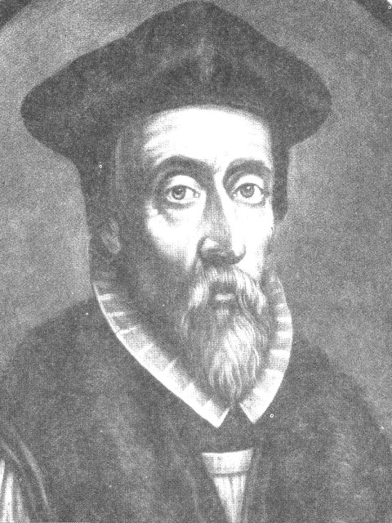The fact that Hooper (right) felt the need to urge his clergy to preach against salvation by good works, prayers for the dead, transubstantiation & the worship of saints & images suggests that such **Cath. beliefs** were still popular.
* The Prot. Martin Bucer admitted, “the bishops have not yet agreed on Christian doctrine, let alone the rules of the Church, and very few parishes have qualified clergymen. Sometimes the clergy read the service rapidly, so that the ordinary people have no more understanding of it than if it were in Latin rather than English”
* In 1550 Parliament complained that alongside the Book of Common Prayer “are still practised corrupt, untrue and superstitious ceremonies, which allow some to attack the order and meaning of the Prayer Book and encourage great diversity of opinion”. In 1552 Parl. made church attendance compulsory b/c “a great number of people in this realm wilfully and damnably refuse to come to their parish churches”.
* Sir William Paget warned Somerset that “the use of the old religion is forbidden by a law, but the use of the new is not yet printed in the stomachs of 11 out of 12 parts of the realm”.
* Cath. belief was especially strong among **older, less educated people in the North & West**; but even in Kent only 8% of wills in E’s reign were explicitly Prot.
* Only 20% of the clergy **married** & there seems to have been hostility from many of the common people to married clergy & (even more so) their wives.

**AS LEVEL EXAM QUESTION ON THE IMPACT OF THE EDWARDIAN REFORMATION**

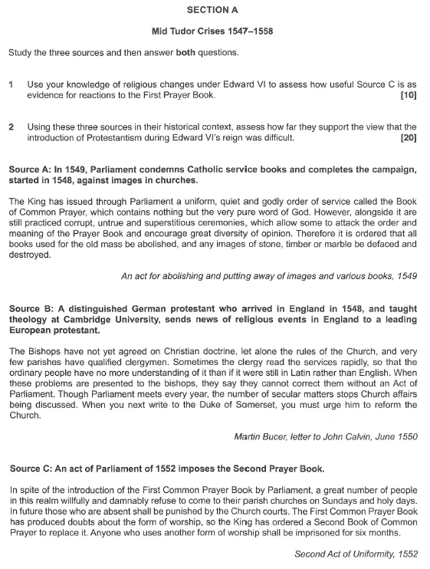

**MARK SCHEMES**

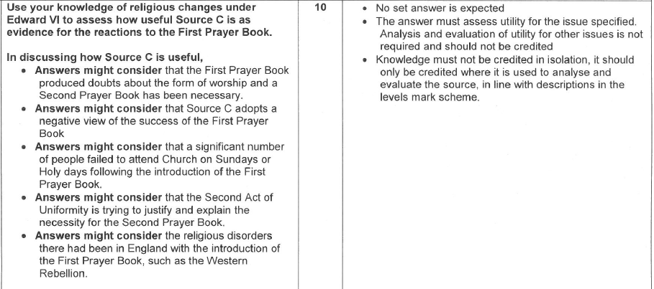

Apart from the above, you also need to consider:

1. Would Parliament (then Protestant dominated) have any reason to admit that there was popular resistance to Protestantism if it were not true?
2. Would they have any motive to exaggerate such opposition?

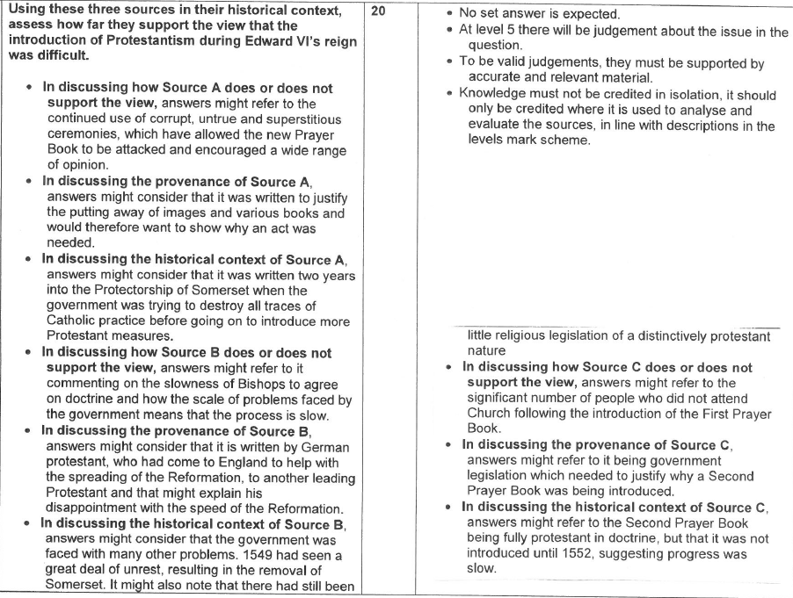

**ESSAY PLAN**

**1** In judging the usefulness of Source B, you need to consider:

* Whether the fact that Bucer was a foreigner makes the source more or less useful (does it make him more or less biased & more or less well informed)?
* Look at the **content** of the source: would Bucer have any reason to write these things if they were not true? Is the content affected by his Prot. bias?
* Source A is a letter (probably a private letter) to a fellow Prot. reformer; does this make it more or less useful than if it were intended for publication or written to a Catholic or some one religiously uncommitted?

**2** You need to write an essay using **both** the sources **&** the analysis on pp4-5 to decide whether England was strongly Prot. by 1553.

You should write an **introduction** summarising in about 2 sentences whether you & the sources agree with the statement.

Then you should cover fully the evidence from the sources & own knowledge (from the analysis & other relevant points in the booklet) which **supports** the statement, i.e. that Eng. was strongly Prot. by 1553. You should lead with the sources & then follow up with own knowledge.

Then do the same for evidence **against** the statement.

At the end there needs to be a **conclusion** using both sources & own knowledge & considering evidence both for & against the statement.

You need to include **all** the bullet points in the analysis but focus particularly on those which relate to the sources:

A: whether bishops & parish clergy supported Prot. (see the 3rd bullet point on Religious Policy 1549-53 on p16 & the 2nd bullet point from the bottom on p15 as well as the analysis on pp17-18).

B: the impact of the new Book of Common Prayer in 1549, the extent to which parishes complied with the changes as ordered & the extent to which Cath. beliefs continued to be popular.

C: explain why you think & why Parl. thought people weren’t coming to church & why they felt the need (for the first time in English history) to make church attendance compulsory & to imprison clergy who used any service other than the new Book of Common Prayer. Also look at the bullet point on the 1552 Act of Uniformity (3rd from bottom)on p16 to assess why Parl. felt it would cause less doubt that the 1549 act.

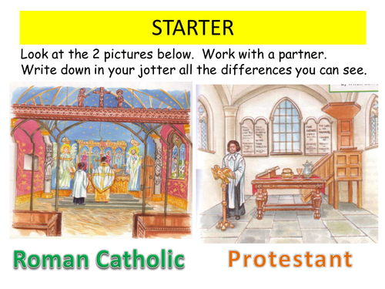

**EDWARD VI: REBELLION & UNREST**

**WHY WAS THERE A SOCIAL & ECONOMIC CRISIS AT THIS TIME & HOW SERIOUS WAS IT?**

Inflation

The underlying cause was the dramatic **rise in population** from around 1500, the first significant rise since the Black Death in the mid 14th century. Between 1525 & 1551 alone the population rose by around 30%.

This caused rampant inflation b/c the rising population demanded more goods than 16th century English agriculture & industry could supply. In the 1540s alone prices more than doubled.

Inflation was also aggravated by the policies of Henry VIII & Somerset of **debasing the coinage** (reducing the amount of gold or silver in each coin so more coins could be minted with the same amount of gold or silver) to raise money for foreign wars. This caused inflation b/c it meant there was more money chasing the same amount of food.

**Food** (& especially bread) prices rose especially fast b/c:

* As the amount of land cultivated increased in an attempt to meet the growing demand for food, less fertile land had to be used.
* There was no improvement in agricultural techniques (fertilisers, crop rotation, selective breeding) to raise production to meet the demand.
* 6 of the harvests between 1547 & 1558 failed to produce enough food to feed the growing population.
* There was a switch from arable (crop) to sheep farming b/c the wool trade was so profitable.

This inflation led to a **fall in the living standards** of the poor b/c wages rose more slowly than prices or rents; with the rising population there were plenty of workers & tenants available so employers could pay low wages & landlords could raise their rents. This meant that **the rich got richer as the poor got poorer** b/c the population rise benefited employers & landlords at the expense of workers & tenants.

Other Causes of Poverty

* **[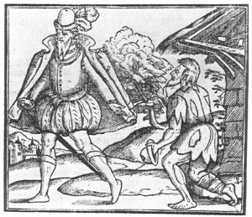](http://www.google.co.uk/url?sa=i&rct=j&q=&esrc=s&source=images&cd=&cad=rja&uact=8&ved=0ahUKEwjz6auv9KLKAhXG6RQKHStxADoQjRwIBw&url=http://www.exploringsurreyspast.org.uk/themes/subjects/crime/surreys_jps/4_magistrates/&psig=AFQjCNEgHlxkpi6T6YcOW7Rd0jpdHDChNA&ust=1452641205366751)**The population growth created a younger population with a higher % of dependent children who consumed without producing.
* Sheep farming employed fewer people than arable farming.
* **Enclosures** (putting up fences or hedges around land which had previously been open) were often associated with the switch from arable to sheep farming; they also led to the loss of common land which landless labourers relied on to graze their animals.
* A **depression in the wool & cloth trade** caused further unemployment & poverty. Wool was England’s main export & the manufacture of wool into cloth was the 2nd most important employer after agriculture.
* England (like many African countries today) had a **subsistence economy** in which around half the population only produced just enough to live on & would be plunged into poverty by bad harvests or unemployment.
* The Dissolution of the Monasteries led to increased unemployment & reduced charity, but only to a marginal extent b/c the monasteries had spent only 3% of their income on charity.

**Source A**

**A clergyman identified some major economic grievances in his book *The Jewel of Joy* written in 1548. The author, Thomas Becon had been chaplain to Somerset.**

See how rich men, especially sheep owners, oppress the King’s subjects by enclosing the common pasture and filling it with their sheep. How many sheep they have! Yet when was wool so expensive, or mutton so great a price? If this goes on, the people will die of cold or starve to death. For these greedy wolves will either sell their wool and their sheep at their own high price, or else not at all.

Thomas Becon, *The Jewel of Joy*, 1547-8

**Source B**

**A social commentator attacks the rise of oppressive landlords.**

Many landlords oppress the common people. They have increased their rent, so that they charge £40 rather than 40 shillings (£2) for a new lease and £5 not 5 nobles (nearly £2) for its annual rent, so now we pay more to them than we earn. The result is that many thousands of us who once lived honestly upon our labour must now beg or borrow, or rob or steal, to get food for poor wives and children.

*A Supplication of the Poor Commons*, 1546

**Question: how useful would these sources be to an historian investigating the causes of the social & economic crisis in mid Tudor England?**

**Why do you think contemporary explanations like those in Sources A & B differ so much from modern ones?**

**IN WHAT WAYS DID THE SOCIAL & ECONOMIC PROBLEMS CONTRIBUTE TO UNREST?**

Somerset’s government showed its fear that the social & economic problems would cause unrest by doing 2 things:

1. They passed a brutal **Vagrancy Act** in 1547 condemning vagrants (“sturdy beggars”, i.e. those who were able to work but were caught begging, the assumption being that they chose not to work b/c they were lazy) with 2 years’ forced labour (slavery) for the first offence & lifetime slavery for the 2nd. This reflected the contemporary view (held especially by the nobility & gentry who dominated Parliament) that unemployment was caused by idleness & that “sturdy beggars” posed a threat to law & order.
2. They set up **enclosure** **commissions** to travel from county to county investigating enclosures & prosecuting landowners who had enclosed land illegally. This reflected the view of “commonwealth” writers like Thomas Becon (see Source A) & John Hales, who led the enclosure commissions, that the greed of rich landlords & employers was the main cause of the growing poverty in England & that stopping enclosures was the best way to combat this. On this issue (unlike vagrancy) Som. was out of touch with the landowners who dominated Parliament, who refused to pass any acts against enclosures, forcing Som. to use proclamations to set up the enclosure commissions instead.

Usefulness Question

**Place the 3 sources below (C, D & E) in order of usefulness & explain your answer, referring to all 3.**

**Source C**

**A leading Protestant bishop comments on the causes of the unrest & rebellions in 1549**

You preachers, I urge you to speak against greed and criticise those great men and men of power who oppress the poor. Greed was the cause of the rebellion last year, by both gentlemen (landowners) and common people. The people thought they had the right to things they desired. The gentlemen wanted to keep what they had, so they rebelled or disobeyed the king’s orders. Thus both sides were greedy and both sides rebelled.

Hugh Latimer, sermon preached in 1550

**Source D**

**A Protestant clergyman & Commonwealth writer looks at the causes of the unrest & rebellions in 1549.**

Rebellion is a dangerous disease and its causes must be rooted out. If I should ask a poor man what is the cause of rebellion, he will blame the great farmers, lawyers, gentlemen, knights and lords. Men of greed: men who take our houses from us and enclose our commons. If I should ask these greedy men what is the cause of rebellion, they will say that the peasants are too wealthy, they are disobedient, they would destroy gentlemen. They will try again to compel the King to grant their requests and will be punished for it, as happened last year”.

Robert Crowley, *The Way to Wealth*, 1550

**Source E**

**The head of Somerset’s anti-enclosure commissions responds to accusations that the activities of his commissions caused the rebellions of 1549**

Was there not, long before this Commission against enclosures was sent forth, a rising in Hertfordshire for the commons of Northaw and Cheshunt? Can it be denied that the first rising this year (1549) was in Somerset from where it entered into Gloucestershire and many other places? This was before the places where I was with the Commission were infected with insurrection. And yet, in many places where we were, where the people had just cause of grief and have complained a great many years without remedy, they have been very quiet and showed themselves most humble and obedient subjects.

But if the cause of these seditions for the commons be sought, it shall be well seen that it springs from the greediness of the men who slander me.

John Hales, 1549

**WHY WAS THERE SO MUCH UNREST IN 1549?**

From March to August 1549 there was unrest in 25 counties all over the South & Midlands of England, as follows:

|  |  |
| --- | --- |
| March | Lincolnshire |
| May | 5 southern counties from Somerset to Essex + Staffordhire |
| June | Devon & Cornwall (the Western or “Prayer Book” Rebellion) |
| July | The Norfolk (or Ket’s) Rebellion + 7 southern counties north of London + Warwickshire & Yorkshire |
| August | Leicestershire & Rutland |

There was no serious unrest in the North except in Yorkshire in July.

Only in the South West (Devon & Cornwall) in June & in Norfolk in July did the unrest flare up into a full-scale intervention requiring the sending of a royal army to put it down; elsewhere the unrest was put down by local nobility & gentry, e.g. the Earl of Arundel in Sussex.

The causes of this unrest were:

1. **Government weakness**. The King was only 11 & as Lord Protector Somerset did not have the same authority an adult king would have had, so people felt less afraid to rebel than in Henry VIII’s reign. The fact that Som. had ordered the clergy to preach about the sin of rebellion & the fact that at one stage Edward VI had to ride in public through the streets of London to dispel rumours of his death show this.
2. **Social & economic problems**. There is clear evidence of unrest against enclosures in Lincolnshire, Hertfordshire, Cambridgeshire , Suffolk, Kent & even Surrey, where local peasants threw down enclosures at Witley before marching on Godalming!
3. **Religion**. There is clear evidence of religious unrest, often led by priests, in Yorkshire (the Seamer rising), Oxfordshire, Hampshire & Northamptonshire.

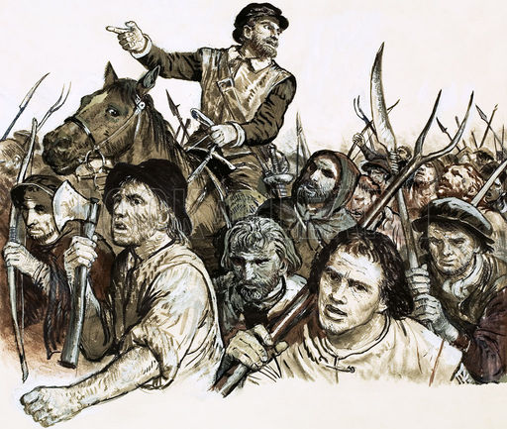

Questions.

1. **Read the sources below & highlight the passages which refer to (a) religion & (b) social & economic causes.**
2. **Place them in order of usefulness, explaining your answer by referring to all 3.**

**Source F**

The people began to rise up in Wiltshire, where Sir William Herbert did put them down, over-run and slay them. Then they rose up in Sussex, Hampshire, Kent and elsewhere, where by fair persuasions they were often satisfied, but again, because certain commissioners were sent to put down enclosures, they did then rise up again.

Because there was a rumour that he (E meant himself here) was dead, he rode through London.

After that, they rose up in Oxfordshire, Devonshire, Norfolk and Yorkshire.

Once they were crushed, the Privy Council, about nineteen of them, were gathered in London to meet with the Lord Protector and to make him amend some of his disorders.

Edward VI, *Chronicle*, writing in 1550 about what happened in 1549.

**Source G**

The revolt of the peasants has increased and spread, so that now they have risen in every part of England, asking for things just and unjust. They demand they may use the land that once used to be public property and that land leased to them shall be considered to be of the same value now as in the time of Henry VII, who died in 1509. This last request is very difficult to meet. In Kent and Essex the risings ended when foodstuffs were taxed at a reasonable price. There is no mention of religion made among any of them, except in Cornwall and Norfolk.

Francois van der Delft, Charles V’s ambassador in England, writing to his master on 19 July 1549

**Source H**

There is news of major uprisings against the government in England and that the King has retreated to a strong castle (Windsor) outside London. The cause of this is the common land, as the great landowners occupy the pastures of the poor people. The rebels also require the return of the mass, together with the religion as it stood on the death of Henry VIII. The government, wishing to apply a remedy, put upwards of 500 persons to the sword, sparing neither women nor children.

Matteo Dandolo, Venetian ambassador, writing to the Venetian Senate on 20 July 1549

**WHY DID THE WESTERN REBELLION BREAK OUT IN JUNE 1549?**

This rebellion broke out in Devon & Cornwall in June 1549 & was not suppressed until August.

By 20 June the Cornish & Devon rebels had joined forces at Crediton in Devon.

Religion.

The rebellion is traditionally known locally as the “Prayer Book Rebellion” & does seem to have been provoked by the introduction of the new Protestant **Book of Common Prayer**. Most Cornish peasants at this time still spoke Cornish (a Celtic language like Welsh) & the rebels said that they did not understand English.

There was evidence of religious tension in Cornwall even before 1549: in 1548 a Prot. archdeacon called William Body was murdered at Helston when he tried to enforce the destruction of images in local churches.

The trouble in June 1549 started in Bodmin, the county town of Cornwall, with a demonstration against the new Book of Common Prayer. But the main uprising started at Sampford Courtenay in Devon where on Whit Monday the congregation prevented the reading of the Book of Common Prayer & forced the priest to use the old Latin Mass instead.

The rebellion seems to have started by **priests** like Robert Welch who then persuaded Humphrey Arundell, a local gentleman with military experience, to lead them.

When the rebellion was crushed the priests involved were publicly hanged in their “popish” mass vestments.

The rebels’ initial **demands** have been lost but the 2nd set, as preserved in the libraries at Lambeth Palace & Corpus Christi College Oxford, were predominantly religious:

**Source J**

We demand the laws of Henry VIII concerning the Six Articles to be used again as they were during his reign.

We demand the Mass in Latin as it used to be & celebrated by the priest without anyone communicating with him (i.e. communion in one kind only for the laity).

We demand holy bread and holy water every Sunday, palms and ashes at the appropriate times and images to be restored in every church.

We will not have the new service because it is like a Christmas game, but we want our old service of Matins, Mass and Evensong and procession in Latin, not English.

We demand every preacher in his sermon and every priest at mass to pray for the souls in purgatory as used to be the case.

Questions on Source J

1. Why would the government be offended by the tone of these demands?

2. Who do you think wrote them?

3. How useful is this source to an historian trying to assess why the rebellion broke out?

**Source K**

In a letter written for him by Somerset, Edward VI replied to the rebels as follows:

You say certain Cornishmen are offended because they do not have their service in Cornish, since they understand no English.

You object that religious changes were made without my knowledge. But I deny this and affirm that the Prayer Book is according to Scripture and the Word of God.

You demand that the tax granted to me by Parliament on cloth and sheep should be cancelled.

You complain of the shortage of food and other things.

Questions on Source K

1. How useful is this source to an historian trying to assess why the rebellion broke out?
2. How does this source compare with the previous (J) in terms of what it says about the causes of the rebellion?

Social & Economic Causes.

As Source K shows, there is evidence of social & economic grievances in the initial rebel demands, in particular for the cancellation of the tax on sheep & cloth which would have hit Devon particularly hard because of the importance of sheep farming there.

Although Humphrey Arundell provided some gentry leadership, there is also much evidence that this was a rebellion of peasants against gentry:

* The Cornish rebels attacked & robbed the gentry at St Michael’s Mount & at Bodmin they shouted: “kill the gentlemen!”
* In Devon the rebels killed William Hellyons., a gentleman who tried to stop them & force them to go home. They also attacked & plundered Trematon Castle.
* The historian Barrett Beer has written of “a widening cleavage between the landowning gentry and the masses of working men and women”.
* The city authorities in Exeter denied access to the rebels & recruited guards from the wealthier elements of the population to hold the city against the rebels. One citizen described the rebels as “refuse, scum and the rascals of the whole county”. They feared that the poor within the city might support the rebels & bribed them with cheap food & poor relief to prevent them from doing so.
* Even the commander of the royal army which defeated the rebels criticised the local gentry for making the peasants pay extortionate rents, abandoning the traditional concept of “good lordship”.

Political Causes.

The downfall of the Courtenay family in 1538 created a power vacuum in Devon & Cornwall; with no dominant local noble, the gentry were leaderless.

**WHY DID THE NORFOLK REBELLION BREAK OUT IN JULY 1549?**

This rebellion started with riots against enclosures at Attleborough in Norfolk but escalated into a full scale rebellion when Robert Kett, a prosperous local farmer, took over the leadership in early July. The rebellion was not crushed until the end of August.

The Demands

These included:

1. No Lord should pasture animals on the commons (a reference to an effect of enclosure).
2. Common land to be safeguarded against enclosures.
3. Rents & prices of copyhold land, meadowland and the marshes should be set at the 1485 level.
4. Land that was held in freehold should not be converted to copyhold (a form of tenancy which would benefit gentry at peasants’ expense).
5. No man worth £401 or over a year to keep cattle or sheep except for their own subsistence (a direct attack on gentlemen farmers).
6. Clergy should be resident in their parishes & be able to preach the Word of God; if not, they should be removed.
7. Lower the tax levied on the inheritance of the land.
8. If priests or vicars earn above £10 a year they should teach the poorer children.
9. Parishioners (not nobles or gentry) should have the right to choose their own priests.
10. A reduction in tithes (10% of his annual produce, paid by a peasant to his local priest or in some cases, following the Dissolution of the Monasteries, the lord of the manor).
11. An end to serfdom (a system whereby peasants were bound to work for a particular lord or gentleman) “for God made all free with his precious bloodshedding”.
12. The system of law enforcement by gentry acting as Justices of the Peace to be replaced by commissions elected by the peasants.

Questions:

* 1. How do these demands compare with those of the rebels in Devon & Cornwall?
  2. Do they seem to you to be a more or less useful guide to the true causes of the rebellion than those in Devon & Cornwall? Explain your answer.

Social & Economic Grievances.

* The unrest started in Attleborough & Wymondham as riots against enclosures, directed especially against a local lawyer, John Flowerdew.
* These riots started when the news reached Attleborough that Hales’ anti-enclosure commission would soon be coming to Norfolk. This, as opponents of Somerset’s anti-enclosure policy argued at the time, encouraged the peasants to take the law into their own hands.
* There was peasant anger that gentry were grazing large flocks of sheep on common land, exhausting the land or even forcing the peasants off it.
* As in Devon & Cornwall there were complaints about excessive rent rises.
* Serfdom was still practised on some of the Duke of Norfolk’s estates.
* There were local grievances like fishing rights, both in rivers & off the coast.
* There was resentment at the way that local gentry & lawyers (like Flowerdew) abused their positions of power in local govt. to enrich themselves at the peasants’ expense. This explains the demand for commissions elected by peasants to take control of local government.
* The depression in the cloth trade hit Norfolk, especially Norwich, more seriously than virtually anywhere else in England.
* In Norwich, where only 6% of the population owned 60% of the wealth, some rich men’s houses were set on fire.
* Several gentry were attacked & Lord Sheffield was beaten to death (like Hellyons in Devon) .
* John Guy has described the rebellions & unrest in 1549 as the nearest England has come to class warfare.

Treatment of the Gentry.

Calling themselves “the King’s Commissioners at Mousehold Heath”, the rebels set up a camp at Mousehold Heath just outside Norwich.

As this title suggests, they claimed to be acting in the King’s name & to maintain a system of discipline & justice in their camps at Mousehold Heath & elsewhere. They prefaced their demands with “We pray your Grace …” rather than “We will have …” as the rebels in Devon & Cornwall did. They issued promissory notes that they would pay for requisitioned food & drink in imitation of govt. practice. They put gentry who they claimed had acted illegally on trial before the “Tree of Reformation” on Mousehold Heath.

Nevertheless, there is no doubt that some gentry were ill treated & some wealthy citizens in Norwich had their houses plundered.

Kett & the other rebel leaders did not survive to tell their side of the story so the most detailed account we have is from “Commotion in Norfolk” written by a local gentleman called Nicholas Sotherton.

Here are 2 extracts:

**Source L**

Those gentlemen they captured they brought to the Tree of reformation where they asked the people what they wanted to do with them: some cried hang them and some kill them. Some, who were unable to hear, shouted like the rest and when asked why they did that, answered that they copied their fellows.They also pushed their weapons into the gentlemen in order to kill some of those brought to them and they did this with such malice that one Mr Wharton, who was being guarded by a line of men on both sides all the way from the tree to the city, was pricked with their spears and other weapons on purpose to kill him. Moreover, the rest of the gentlemen they imprisoned were bound with chains and locks and they appointed guards to prevent them from escaping.

**Source M**

They (the rebels) were so shameless and so desperate that the poor vagabond boys, trouserless and bare arsed, came among the thicket of the arrows and … most shamefully turned up their bare bottoms against those who did the shooting”.

Evaluating these sources in their historical context, how useful do you think they would be to an historian studying the Norfolk Rebellion?

[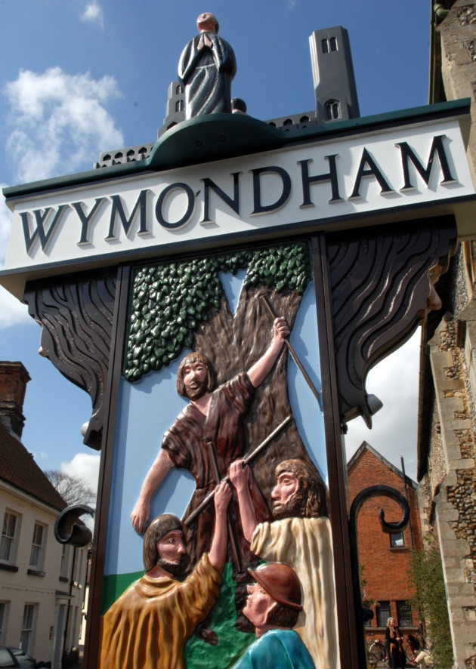](http://www.google.co.uk/url?sa=i&rct=j&q=&esrc=s&frm=1&source=images&cd=&cad=rja&uact=8&ved=0ahUKEwijl-Pjq4vLAhXHvBQKHaLECOMQjRwIBw&url=http://www.eveningnews24.co.uk/news/race_is_on_to_help_save_wymondham_bookshop_1_2712053&psig=AFQjCNHr5o4I8nbBS_QaUVJpD_LB9chqCg&ust=1456229477480515)

Religion

Unlike the rebels in Devon & Cornwall, the Norfolk rebels seem to have been Prot. & anticlerical:

* They used the Book of Common Prayer in their camp at Mousehold Heath & made no demands for the restoration of Catholicism.
* They demanded that the clergy preach the Word of God, teach poor children & be accountable to local peasants rather than the lord of the manor. They also demanded a reduction of tithes.

Political Causes.

As in Devon & Cornwall, the political disgrace of the Duke of Norfolk in 1546 (not reversed until Mary’s reign) created a local power vacuum which left the local gentry leaderless.

**HOW SERIOUSLY DID THE 1549 REBELLIONS THREATEN THE GOVERNMENT & WHY WERE THEY DEFEATED?**

|  |  |  |
| --- | --- | --- |
|  | Serious | Not serious |
| Western | All attempts by local gentry to disperse the rebels failed; on 20 July Cornish rebels joined Devon rebels at Crediton, taking the govt. by surprise  The royal army was slow to reach Devon b/c it had to put down unrest in Oxfordshire & Buckinghamshire first  Somerset had to offer them a pardon but they still refused to disperse (they were not fooled like the Pilgrims of Grace). Troops had to be diverted from Scotland & mercenaries employed to put rebellion down.  It took at least 3 battles to defeat the rebellion; Lord Grey, who had fought in Scotland, said the battle at Clyst Heath was the most ferocious he had ever taken part in.  There were more executions than in Norfolk b/c the govt. saw the rebellion as a serious threat to its religious policy, hence the hanging of rebellious priests in their mass vestments. | The King’s position was not threatened.  There was virtually no gentry leadership (unlike the Pil. Of Grace).  The rebels failed to take Exeter (whereas the Norfolk rebels did take Norwich).  They made no attempt to march on London to gain more support despite widespread unrest elsewhere.  Once the govt..had enough troops available, the rebels were no match for them. |
| Norfolk | Strong leadership, not just from Kett but also other important men like Thomas Aldryche & the Mayor of Norwich, Thomas Cod  Norwich (then England’s 2nd city) captured  The rebels had an army of 16,000 men; the Marquis of Northampton was too intimidated to fight them.  Somerset had to offer them a pardon but they still refused to disperse (they were not fooled like the Pilgrims of Grace).  Troops had to be diverted from Scotland & mercenaries employed to put rebellion down. | The King’s position was not threatened; in fact the rebels called themselves “the King’s Commissioners”.  There was virtually no gentry leadership (unlike the Pil. Of Grace).  Kett made the mistake of moving from his well fortified camp at Mousehold Heath to Dussindale, where his.unwise decision to take on Warwick’s army led to defeat.  Once the govt..had enough troops available, the rebels were no match for them.  The fact that only 50 rebels were executed (fewer than in Devon & Cornwall) suggests they weren’t seen as a serious threat. |
| General | The King was a minor & as Lord Protector Somerset did not have the same authority an adult king would have had.  With wars against France & Scotland, there was a danger of a foreign invasion to coincide with the rebellions.  There was unrest in at least 26 counties in 1549, reflecting widespread religious & economic grievances.  The nobility were sufficiently concerned to support the overthrow of Somerset in October 1549, blaming him for provoking rebellions through his anti-enclosure policy & failing to suppress them.  Even after Somerset’s fall, there was further unrest in the South West, Nottinghamshire & Kent in 1550. | In most counties the unrest was contained, either by negotiation, as in Sussex where the Earl of Arundel persuaded the rebels to disperse by granting many of their demands, or by force, as in Northamptonshire where local gentry used their retainers to put down the unrest. The Earl of Shrewsbury contained the unrest in Shropshire, Derbyshire & Nottinghamshire. |

**Study the three sources below and then answer both questions on a separate piece of paper.**

**1 Use your knowledge of the Western Rebellion in 1549 to assess how useful Source A is as evidence of the causes of this rebellion. [10]**

**2 Using these three sources in their historical context assess how far they support the view that social & economic discontent was the main cause of the rebellions and unrest in England in 1549. [20]**

**Source A**

We demand the laws of Henry VIII concerning the Six Articles to be used again as they were during his reign.

We demand the Mass in Latin as it used to be & celebrated by the priest without anyone communicating with him (i.e. communion in one kind only for the laity).

We demand holy bread and holy water every Sunday, palms and ashes at the appropriate times and images to be restored in every church.

We will not have the new service because it is like a Christmas game, but we want our old service of Matins, Mass and Evensong and procession in Latin, not English.

We demand every preacher in his sermon and every priest at mass to pray for the souls in purgatory as used to be the case.

Transcript of the 2nd set of rebel demands of the Western rebels, 1549, in the libraries of Lambeth Palace & Corpus Chisti College Oxford.

**Source B**

There is news of major uprisings against the government in England and that the King has retreated to a strong castle (Windsor) outside London. The cause of this is the common land, as the great landowners occupy the pastures of the poor people. The rebels also require the return of the mass, together with the religion as it stood on the death of Henry VIII.

Matteo Dandolo, Venetian ambassador, writing to the Venetian Senate on 20 July 1549.

**Source C**

The King’s subjects out of all discipline and all obedience and care neither for you nor the King. What is the cause? Your softness, your wish to be good to the poor. It is a pity that your gentle approach should cause such evil as the rebels now threaten … in the matter of your treatment of the common people every man in the Council dislikes your proceedings and wished it were otherwise.

Sir William Paget, letter to Somerset in July 1549.