**THE REIGN OF MARY I 1553-8**

**AS LEVEL**

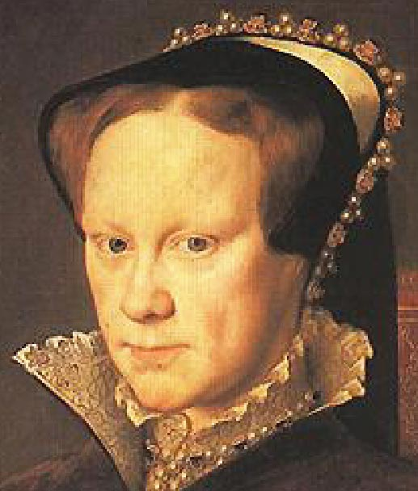

|  |  |
| --- | --- |
| **Topic 5: Mary, 1553-1558** | **Tick when revised** |
| Stability of her reign – A female monarch, marriage to Philip, factional fighting |  |
| Religious change – support for opposition to religious changes, Catholic restoration/persecution |  |
| Rebellion and Unrest – Wyatt’s rebellion |  |

**Timeline**

|  |  |
| --- | --- |
| **1553** | 6 July - Death of Edward and Devise for the succession bastardised Mary and Elizabeth and announced that Lady Jane Grey would succeed to the throne.  10 July – against her wishes Lady Jane declared queen.  Mary marches on London to widespread acclaim and London declares her queen on 19th July  October – First Statute of Repeal – reversing ALL the religious legislation passed by Edward. |
| **1554** | Jan – Leaks of a plot to prevent Mary’s intended marriage to the heir of the throne of Spain.  Wyatt rebellion – taking advantage of discontent among weavers in Kent. 3 Feb Wyatt unable to get across London Bridge – result – rebellion crushed  12th February - Lady Jane Grey and her husband executed to prevent her being the focus for further rebellion. Elizabeth also arrested and imprisoned in the Tower.  May – Elizabeth freed  July – Marriage to Philip of Spain. |
| **1555** | Second Statute of Repeal (revival of the heresy laws)  Bishops Hooper Latimer and Ridley are among those burnt for heresy.  Mary thinks she is pregnant – but no baby arrives.  September - Philip left for business in the Netherlands. Soon afterwards his father abdicates as HRE and he becomes King of Spain. |
| **1556** | Cranmer burnt.  Worst harvest of the century, |
| **1557** | March – Philip returns to England for 4 months. Involves Mary in Spanish war against France. |
| **1558** | 7 January – Calais surrendered to the French  March – Mary again convinced she is pregnant and makes a will excluding all but her own children from the succession.  In fact it is probably stomach cancer and Mary dies 17th November.  Her half sister, Elizabeth succeeds to the throne. |

**RECOMMENDED READING**

Books

**Official OCR textbook: Mary Dicken & Nicholas Fellows, *England 1485-1603*, 2015**

Available on Dawsonera: On the Home Page of Godalming Online, click on “Links” at the top, then “ILC Library”, then “Dawsonera” & follow the instructions.

<https://www.dawsonera.com/abstract/9781471836626>

[Nigel Heard & Roger Turvey,](https://www.amazon.com/Edward-VI-Mary-Mid-tudor-1540-58/dp/0340912529/ref=sr_1_9?s=books&ie=UTF8&qid=1481559871&sr=1-9&keywords=mid+tudor+crisis" \o "Edward VI and Mary: A Mid-tudor Crisis?, 1540-58 (Access to History)) *[Edward VI and Mary: A Mid-Tudor Crisis? 1540-58](https://www.amazon.com/Edward-VI-Mary-Mid-tudor-1540-58/dp/0340912529/ref=sr_1_9?s=books&ie=UTF8&qid=1481559871&sr=1-9&keywords=mid+tudor+crisis" \o "Edward VI and Mary: A Mid-tudor Crisis?, 1540-58 (Access to History))*[(Access to History) 2006](https://www.amazon.com/Edward-VI-Mary-Mid-tudor-1540-58/dp/0340912529/ref=sr_1_9?s=books&ie=UTF8&qid=1481559871&sr=1-9&keywords=mid+tudor+crisis" \o "Edward VI and Mary: A Mid-tudor Crisis?, 1540-58 (Access to History))

Anna Whitelocke, *Mary Tudor: England’s first Queen*, 2016

[David Loades,](https://www.amazon.com/Mary-Tudor-David-Loades/dp/1445660199/ref=sr_1_4?s=books&ie=UTF8&qid=1481559679&sr=1-4&keywords=mary+tudor" \o "Mary Tudor) *[Mary Tudor](https://www.amazon.com/Mary-Tudor-David-Loades/dp/1445660199/ref=sr_1_4?s=books&ie=UTF8&qid=1481559679&sr=1-4&keywords=mary+tudor" \o "Mary Tudor)*[, 2017](https://www.amazon.com/Mary-Tudor-David-Loades/dp/1445660199/ref=sr_1_4?s=books&ie=UTF8&qid=1481559679&sr=1-4&keywords=mary+tudor" \o "Mary Tudor)

Articles

On the Home Page of Godalming Online, click on “Links” at the top, then “ILC Library”, then “Websites, subscriptions, links”, then follow the instructions on how to access the History Today website:

**Edward VI and Mary Tudor: Protestant King and Catholic Sister**

By [Judith Richards](http://www.historytoday.com/author/judith-richards)

Published in [History Review](http://www.historytoday.com/archive/history-review/latest) [Issue 59 December 2007](http://www.historytoday.com/archive/history-review/issue-59-december-2007)

**The Reign of Mary Tudor - A Reassessment**

By [Michael Hutchings](http://www.historytoday.com/author/michael-hutchings)

Published in [History Review](http://www.historytoday.com/archive/history-review/latest) [Issue 33 March 1999](http://www.historytoday.com/archive/history-review/issue-33-march-1999)

**Mary Tudor - A Life**

By [Diarmaid MacCulloch](http://www.historytoday.com/author/diarmaid-macculloch)

Published in [History Today](http://www.historytoday.com/archive/history-today/latest)

**Mary Tudor and the Re-Catholicisation of England**

By [Jennifer Loach](http://www.historytoday.com/author/jennifer-loach)

Published in [History Today](http://www.historytoday.com/archive/history-today/latest) [Volume 44 Issue 11 November 1994](http://www.historytoday.com/archive/history-today/volume-44-issue-11-november-1994)

**Fires of Faith: Catholic England Under Mary Tudor**

By [Richard Wilkinson](http://www.historytoday.com/author/richard-wilkinson)

Published in [History Today](http://www.historytoday.com/archive/history-today/latest)[History Review](http://www.historytoday.com/archive/history-review/latest) [Issue 65 December 2009](http://www.historytoday.com/archive/history-review/issue-65-december-2009)

**Mary I: England's Catholic Queen**

By [Linda Porter](http://www.historytoday.com/author/linda-porter)

Published in [History Today](http://www.historytoday.com/archive/history-today/latest) [Volume 62 Issue 10 October 2012](http://www.historytoday.com/archive/history-today/volume-62-issue-10-october-2012)

**Evidence on Mary’s Character and Personality**

**Source A**

She is of low stature, with a red and white complexion and very thin; her eyes are white and large, and her hair reddish; her face is round, with a nose rather low and wide; and were not her age on the decline, she might be called handsome rather than the contrary. She is not of a strong constitution, and of late she suffers from headaches and serious affection of the heart, so that she is often obliged to take medicine, and also to be blooded. She is of very spare diet, and never eats until 1 or 2 p.m. although she rises at daybreak, when, after saying her prayers and hearing mass in private, she transacts business incessantly, until after midnight, when she retires to rest; for she chooses to give audience not only to all the members of her Privy Council and to hear from them every detail of public business, but also to all other persons who ask it of her. Her Majesty’s countenance indicates great benignity and clemency. She is endowed with excellent ability, and more than moderately read in Latin literature, especially with regard to Holy Writ; and besides her native tongue she speaks Latin, French and Spanish, and understands Italian perfectly, but does not speak it.

…Her Majesty takes great pleasure in playing on the lute and spinet, and is a very good performer on both instruments; and indeed before her accession she taught many of her maids of honour. But she seems to delight above all in arraying herself elegantly and magnificently…

*Giacomo Soranzo, the Venetian Ambassador to England in 1554 when Mary was 38.*

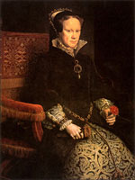**Source B**

**…** not only is she brave and valiant, unlike other timid and spiritless women, but so courageous and resolute that neither in adversity nor peril did she ever even display or commit any act of cowardice or pusillanimity, maintaining always, on the contrary, a wonderful grandeur and dignity, knowing what became the dignity of a sovereign… it may be said of her, as Cardinal Pole says with truth, that in the darkness and obscurity of that kingdom she remained precisely like a feeble light buffeted by raging winds for its utter extinction, but always kept burning and defended by her innocence and lively faith, that it might shine in the world as it now does shine.

*Giovanni Michiel, Venetian Ambassador to England in 1557 when Mary was 43.*

**Source C**

I am come to you in mine own person to tell you that which already you see and know; that is how traitorously and rebelliously a number of Kentish men have assembled themselves against both us and you. Their pretence (as they said at the first) was for a marriage determined for… and it appeared then unto our said Council that the matter of the marriage seemed to be but a Spanish cloak to cover their pretended purpose against our religion.

Now, loving subjects, what I am ye right well know. I am your Queen, to whom at my coronation when I was wedding to the realm and laws of the same… you promised your allegiance and obedience unto me… And I say to you, on the word of a prince, I cannot tell how naturally the mother loveth the child, for I was never the mother of any, but certainly if a prince and governor may as naturally and earnestly love her subjects as the mother doth love the child, then assure yourselves that I, being your lady and mistress, do as earnestly and tenderly love and favour you…

…And on the word of a Queen, I promise you, that if it shall not probably appear to all the nobility and commons… that this marriage shall be for the high benefit and commodity of the realm, then I will abstain from marriage while I live. And now, good subjects, pluck up your hearts, and like true men, stand fast against these rebels… and fear them not, for, I assure you, I fear them nothing at all.”

*Mary’s speech at the Guildhall in London in January 1554 at the time of Wyatt’s rebellion*

**Task 1**

1. What are the strengths and weaknesses of ambassadorial reports as evidence?
2. What do sources A and B tell you about Mary?
3. What can be deduced about Mary from source C?
4. What do you deduce about attitudes to women from all these sources?

**Starkey “**The Unknown Tudors” – Mary’s “peculiar apprenticeship”

Estreamhttp://estream.godalming.ac.uk/View.aspx?ID=689~3K~VJNDwF

58 mins 34 seconds in (after Edward)

1. How long had Henry and Catherine been married when Mary was born?
2. Why was it a problem that the heir was a girl?
3. Who was she betrothed when aged two?
4. Who was Catherine of Aragon descended from?
5. How was Mary treated as a child?
6. How did Catherine try to prepare her daughter for her role as queen?
7. Where was Mary sent to train her for ruling?
8. How old was she when disaster struck and what was the disaster?
9. Who came up with the solution to the problem of Henry’s divorce?
10. What did Mary have to endure as a young woman?
11. What did Henry think of the treatment given to Mary?
12. What happened in 1536 to transform her life?
13. What did Mary think might happen when Anne died?
14. What did Henry demand Mary do to obtain his forgiveness?
15. Why did she sign the paper accepting his supremacy?
16. What was her pay off?
17. What did Henry leave her in his will?
18. Why couldn’t she just relax and enjoy her new estate?
19. What happened to her when she was thirty one?
20. When did Edward make attending the mass illegal?
21. Why did Mary’s adviser disapprove of her idea of flight?

(Adverts 1 hour 23.40 to 1 hr 27.36)

1. When did Edward die?
2. How did Mary act when she heard Lady Jane Grey had been declared queen?
3. Why did even Protestants welcome her?
4. How old was she when she became queen?

**Acting like a Tudor**

When Mary heard that her brother was dying she cleverly ignored Northumberland’s summons to London and went instead, to Norfolk and raised troops to support her bid for the throne. She based herself at Framlingham Castle (below) where thousands flocked to her standard – even Protestant leaders got caught up in the momentum, dismayed at the illegitimate attempt to impose an unknown queen instead of the Tudor heir established by Henry in a law passed by Parliament..

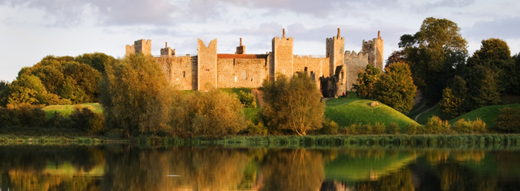

Within 2 weeks of the death of Edward, a significant majority of the councillors had agreed that Mary should be proclaimed Queen – Northumberland capitulated in Cambridge, after Mary’s march on the city. Te Deums were sung throughout London, bonfires lit, altars restored.

**The First Queen – problems she faced**

The reason Henry had been so desperate for a son was because the only experience England had of a Queen inheriting in her own right had been in the twelfth century. It had resulted in civil war as many had refused to accept Matilda and preferred her cousin Stephen instead.

Reasons why having a queen was feared were:

1. A woman would not be able to lead men into battle.
2. A woman was not thought strong enough to control mighty nobles.
3. Nor was it thought that a woman would be clever enough to make the decisions of government she would need to make.
4. Worst of all, a woman would need to marry to have an heir, but women were regarded as subservient to their husbands.

* If she married an Englishman it would increase the power of her husband’s family.
* If she married a foreigner it was feared that the England would be dominated by another country.

**Task 2 - Put these in order of significance and explain which really might pose a serious problem for Tudor England.**

**Philip of Spain**

For Mary marriage was her dearest wish. Although they had never met, Philip of Spain, son of Charles V (who was both Holy Roman Emperor & King of Spain) represented Spain and Catholicism, both of which were very important to her (remember her mother was Spanish so she was half Spanish herself). She believed the marriage would give her happiness and an heir. Philip was 26, (11 years younger than she was) already a widower with a child and he was persuaded by his father that marriage to the English queen would overawe France and therefore strengthen their position on the continent.

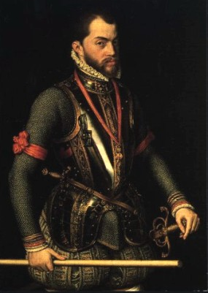Mary was crowned by Bishop Gardiner on 1 October 1553 according to old Catholic rites. Marriage was clearly the next most important concern for Mary and Gardiner and others in her Council wanted Mary to marry **Edward Courtenay**, because he was English and descended from Edward IV. His father had been executed by Henry and he had been in prison ever since – for his royal blood and Catholic sympathies. Unfortunately, Courtenay was socially awkward, unreliable in religion, weak and lacking in common sense.

He was no competition for Philip. 10 days after her coronation Mary was presented with a formal proposal of marriage by the Spanish and Imperial ambassador, Simon Renard. At the end of the month Mary formally accepted the proposal and spent the next few weeks gazing longingly at this Titian portrait of her future husband.

Unfortunately the Spanish marriage proposal stirred up a furore among the English, seeing Spanish power as a threat to English liberty and commercial interests. In November a parliamentary delegation tried to dissuade her. Eventually she persuaded both her Council and parliament that she would protect English rights and in fact the marriage treaty was extraordinarily favourable to England.

**The Marriage Treaty**

Philip was to have the title of King of England, but not to have any of the powers.

**Task 3**

**Source D The Act of Parliament setting out the Treaty of Queen Mary to Philip of Spain 1554**

This treaty greatly honours and benefits England. The prince shall enjoy jointly, the style and honour of King. He shall happily help administer England, preserving its rights, laws, privileges and customs. The queen shall have total control of all offices lands and revenues, and grant them to natural born Englishmen. Sincere friendship with Spain will be happily established forever, God willing, to benefit their successors. Should no children be born and the Queen die before him, he shall accept the lawful heir. The prince shall take no jewels abroad, nor ships, guns or supplies. He shall renew defences of the realm. By this marriage, England shall not entangle in war, and the prince shall observe England’s peace with France.

Read Source D and make a list of the ways the treaty was favourable to England.

**Wyatt’s revolt**

Despite the reassurances obtained by the treaty it did not prevent rebellion.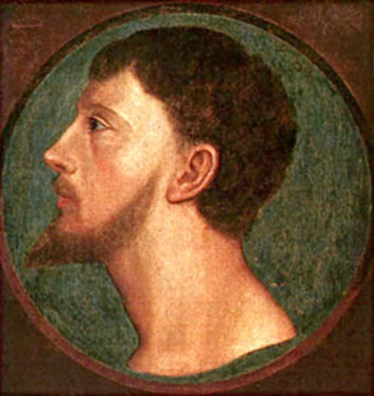 Four concerted risings were planned for March by men who had formerly supported Northumberland. One rising was to be in Devon to be led either by Courtenay or Sir Peter Carew; one in Leicestershire led by the Duke of Suffolk; one in Kent led by Sir Thomas Wyatt; and one on the Welsh borders led by Sir James Croft. Courtenay was petulant at being passed over by Mary in favour of Philip, and it was thought a good idea by Protestants to dislodge Mary in favour of Elizabeth who they would then marry to Courtenay. However, when the Spanish ambassador heard rumours and told Gardiner, the bishop persuaded Courtenay to divulge the details of the conspiracy. This forced the rebels into premature action and only Kent succeeded in putting a force into the field in January 1554.

This was only six months after the defeat of the Lady Jane Grey affair and can be used as further **evidence of the unrest caused by a female ruler**.

**Task 4**

**Source E Wyatt’s proclamation 25 January 1554**

We write to you as friends, neighbours and Englishmen, concerning Queen Mary’s intention to marry a foreigner, and request you to join us to prevent this. We swear to you before God that we seek no harm to the Queen, but merely wish her better advice. Our wealth and health depend on it. A hundred armed Spaniards have already arrived at Dover and travelled through Kent on their way to London. We require you to assemble with as much support as possible to help us protect liberty and the commonwealth.

Wyatt, a military expert raised three thousand men. He whipped up anti-Spanish feeling by playing on fears of being dragged into war on Spain’s behalf and here he posed as the rescuer of the Queen from foolish advice.

**Source F John Proctor, a writer for the government, explains how Wyatt described the Spanish arrival in England in his “Historie of Wyate’s Rebellion, 1554”**

Beware, the Spaniards have already arrived at Dover, at one count they number a hundred, they are moving on to London, in companies of ten, four and six, with harness, arquebuses, and helmets, with torches, the first company have already reached Rochester

**Source G Proclamation by the rebels**

Because you are our friends and because you are Englishmen you will join with us, as we will with you until we die, in this cause protesting unto you before God. We seek no harm to the Queen, but better counsel and councillors.

1. How are the Spaniards portrayed in Sources E and F?
2. Why might they be portrayed in this way?
3. How useful are the sources as evidence of feelings towards the Spanish marriage?

**Source H op. cit. John Proctor**

Wyatt, proceeding in his detestable purpose armed himself and as many as he could. And, considering that the restoring of the newly-forged religion was not a cause general enough to attract all sorts to support him, he determined to speak no word of religion but to make the colour of his commotion only to withstand strangers and to advance liberty.

1. Why might the government want to portray the unrest as due to religion?

Causes of the Wyatt Rebellion

There is some evidence that the Spanish marriage was, as Mary said, “but a Spanish cloak to cover their pretended purpose against our **religion**”:

* The leaders of the 4 planned rebellions all had Protestant sympathies.
* The areas where Wyatt gained most of his support, around Maidstone & Cranbrook in Kent, had a reputation for religious radicalism.
* No Catholics of any importance supported the rebellion.
* When the rebels reached London they attacked the property of Stephen Gardiner, Mary’s Catholic Bishop of Winchester (even though he opposed the marriage).

**Economic** factors may have played a part b/c Kent (especially the Cranbrook area, where many of the rebels came from) was badly affected by the slump in the cloth trade in the 1550s.

Some historians have argued that **political** motives played a part b/c most of the rebel leaders had played a prominent role in local politics in E VI’s reign but had lost power under Mary & saw rebellion as the only way to regain their power.

It is clear from Mary said (see above) that she & other govt. spokesmen like John Proctor in Source H emphasised religion as a cause of the revolt, while Wyatt himself played down religion & emphasised the marriage; he even told his followers, “you may not so much as name religion, for that will withdraw from us the hearts of many”.

Taking account of the above evidence, what do you see as the main cause of the rebellion? Give reasons for your answer.

Why did it fail?

It is possible that Wyatt could have succeeded if he had moved quickly on London and compelled Mary to abandon her plans or replaced her with Elizabeth, as the government gave him opportunities. The London militia confronted Wyatt on the left bank of the Medway but then moved over to his side. He defeated the octogenarian Duke of Norfolk. Wyatt now had ships cannon and an army. Why then did he fail?

Part of the answer lies in Mary’s own response. She refrained from appealing to Charles V, realizing perhaps that foreign troops would have played into Wyatt’s hands. She also remained in London and ordered the fortification of the city. On 1 February Mary issued a personal appeal from the Guildhall (see p.3) and played on Londoners’ fears of attack, winning over support from neutral councillors. Above all she benefitted from Wyatt’s error diverting his forces to take Cooling Castle held by Lord Cobham. The castle surrendered, but Wyatt had lost a day and was late in reaching the Thames at Southwark where London Bridge had been fortified. He did not manage to cross the Thames for another six days, only to meet formidable defences in Kensington and Fleet Street.

Elizabeth was arrested on 9th February for alleged complicity with the rebels. The Spanish ambassador encouraged Mary to execute both Courtenay and Elizabeth to secure her throne, but Elizabeth had avoided involvement and there was no evidence to implicate her so she managed to survive this very dangerous moment. Nearly a hundred were executed including Lady Jane Grey, her husband Guildford Dudley, Carew, Suffolk (Lady Jane’s father who was responsible for one of the failed risings) and Wyatt himself.

**Task 5**

**Source J –** Wriothesley’s chronicle for 1554

On 1 February the Queen went to the Guildhall and declared to the audience the wicked plan of the traitor Wyatt, which was utterly to deprive her of her crown, and to ransack the city. She spoke so nobly, with so good spirit and with so loud a voice, that all the people might hear her Majesty, and were comforted in their hearts with so sweet words which made them weep with joy to hear her Majesty speak. On 3 February the Queen appointed Lord William Howard to be Captain General, with the Lord Mayor for the defence of the city.

1. Read source J. What evidence is there in the source that it was Mary’s actions that helped to defeat Wyatt?
2. What can you deduce about the writer of this source? How does this affect his view of events?

**Source K – A Spanish Courtier’s letter 17 August 1554**

The English hate us Spaniards worse than they hate the devil, and treat us accordingly. The Queen’s councillors say publicly that Parliament will prevent Prince Philip from leaving the kingdom without the Queen’s and their consent; for they think this realm good enough for Philip without having any other. The English are so bad and fear God so little that they handle the Spanish friars shamefully, so that the poor men do not dare leave their lodgings.

**Source L –** The Imperial Ambassador, Simon Renard, writing to Charles V 18 September 1554

No attention is paid to the law; the Queen and her Council are neither respected nor obeyed nor feared. The people say that King Philip is not going to employ Englishmen, though he agreed to so in the marriage treaty. They say he is sending for 10,000 Germans and 10,000 Spaniards to land in this country. They also say that monasteries will be set up again and that the Pope will control religious affairs. They proclaim that they are to be enslaved, for the Queen is a Spanish woman at heart and thinks nothing of Englishmen.

1. Read sources K and L and explain how the Spanish were perceived by the English.
2. How similar are the views of the two sources about Spaniards?
3. In what ways might the views of both passages might be limited?
4. What do these sources suggest about the reasons for the Wyatt Rebellion?

**FACTION AND INSTABILITY**

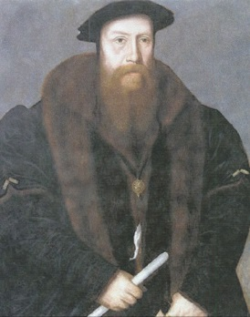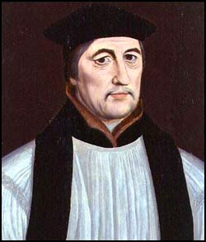There was factional rivalry within the Privy Council between Sir William Paget (below left) who supported the Spanish marriage & Stephen Gardiner (below right) who opposed it despite having been restored as Bishop of Winchester & appointed Lord Chancellor. But this does not appear to have had much impact on the government of the country. Some historians have argued that the size of Mary’s Council and the divisions within it made it ineffective, but in fact it was very rare for all the councillors to meet together and average gatherings were no bigger than those under Northumberland. The efficiency of council meetings was further aided by three developments:

1. The establishment of committees in 1554 which excluded the casual councillors.
2. The establishment in 1555 of an ‘Inner Council’.
3. Philip’s departure in 1555 and the death of Gardiner (below right) which allowed Paget (below left) to dominate and establish a conciliar form of government.

**HOW EFFECTIVE WAS MARY’S GOVERNMENT?**

* Because of her early death M **failed to restore Catholicism on a permanent basis** (see the section on religion later in this booklet).
* The **marriage** to Philip II was undoubtedly a failure: it provoked the Wyatt Rebellion, did not produce the Cath. heir M so desperately wanted &, exactly as M’s critics had feared, involved England in a war against France which served Spain’s interests, not hers, & led to the loss of Calais in 1558.

**Yet in many ways M’s govt. was highly effective &, in financial & military matters, laid the foundations for Elizabeth’s reign:**

* 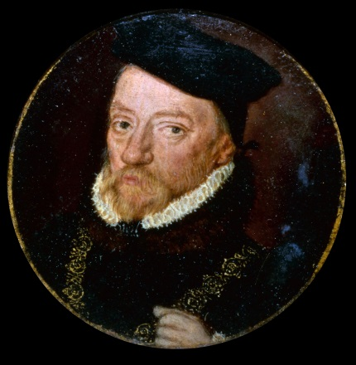M **succeeded in restoring Cath.** with little opposition from Parl. &, in many areas, the return of the old religion was welcomed with enthusiasm. Her Archbishop of Canterbury, Cardinal Pole, had constructive plans for church reform which would undoubtedly have succeeded if they had been given more time.
* There were **no rebellions after Wyatt** despite mounting economic problems, including a succession of bad harvests & a continued decline in the wool trade.
* The Marquis of Winchester (right), who served as Lord Treasurer under E VI & Elizabeth as well as M, providing continuity in **financial** policy, trebled customs revenue by introducing a new Book of Rates in 1558 & increased crown land revenue by £40,000 a year.
* The French war had some beneficial side effects, including improvements in the Navy & the Militia & Arms Acts in 1558 which laid the foundations for the Elizabethan **defence** system

**Task 6**

**Source M – The Venetian ambassador writing to the Senate s of Venice May 1557**

Knowing of the divisions among her councillors, the Queen, in order not to be deceived, ordered that Cardinal Pole should have everything referred to him, since she trusts him and distrusts almost all others. The Catholic religion seems daily to increase and take root, through the Queen’s authority and the Cardinal’s diligence. Monasteries are being built, churches are full, the ancient rites and ceremonies are again performed. But except for a few, most pretend to reject Protestantism and on the first opportunity would return to it. The Queen is greatly grieved by the conspiracies and plots formed against her daily. When she punishes the ringleaders, she provokes hatred since the offenders are excused by almost everyone.

**.**

1. What is the ambassador’s view of the Council and events in England?
2. How does this challenge the view in the text above?
3. Why might the ambassador have such views?
4. What are the problems in relying on the views of ambassadors? How might this affect the reliability of their evidence?

One of Mary’s hopes from her marriage to Philip was to secure a Catholic succession but that did not occur, in part because of Mary’s age, but also because Philip could not spend very much time in England. She was also unable to persuade her sister to become a genuine Catholic and promise to maintain Catholicism in event of her succession.

**TO WHAT EXTENT DID THE CHALLENGES TO MARY THREATEN THE STABILITY OF THE MONARCHY?**

* Lady Jane Grey was actually proclaimed Queen with the support of her predecessor & (apparently) of the Privy Council.
* If Northumberland had managed to seize Mary before she fled to Norfolk or if she had not acted so quickly to escape & rally support, the Lady Jane Grey conspiracy might well have succeeded.
* If all 4 of the rebellions against the Spanish marriage had taken place or if Wyatt had not delayed his march on London by besieging Cooling Castle (he did in any case reach the city gates in London) the Wyatt rebellion could have succeeded, either in forcing her to change her choice of husband or perhaps even replacing her with Elizabeth.
* The fact that the London militia defected to Wyatt, shouting “we are all Englishmen!” showed how unpopular the Spanish marriage was.
* Mary was only saved by the loyalty of a few nobles (like the Duke of Norfolk, by then in his 80s) & their retainers. Penry Williams has claimed, “a crucial episode in Tudor history was thus determined with most of the political nation standing aside”.
* The fact that there were very few executions (except Northumberland) after the Grey conspiracy & fewer than 100 after Wyatt (compared with 178 following the Pilgrimage of Grace, which never got near London) suggests that Mary’s govt. did not feel strong enough to be as brutal as Henry VIII had been.

**BUT:**

* The fact that support for Lady Jane Grey melted away so quickly as soon as Mary proclaimed herself Queen & rallied support showed how strong support was for the legitimate heir, showing the underlying stability of the Tudor monarchy.
* The fact that Lady Jane Grey’s life was spared until after the Wyatt Rebellion & that there were relatively few executions after Wyatt could be seen as evidence that the govt. didn’t feel seriously threatened.
* Mary acted promptly & decisively both against Jane in 1553 (when she fled to Norfolk & rallied support there) & against Wyatt in 1554 (when she wisely ignored the advice of her councillors & stayed in London to rally support there), showing her determination & political skill.
* Memories of the Wars of the Roses in the previous century & the hatred towards the gentry shown by the 1549 rebels (in both the South West & Norfolk) made the gentry reluctant to support any rebellion for fear that it would lead to a breakdown of law & order, threatening both their property & their social status.
* Despite the factional rivalry between Paget & Gardiner over the Spanish marriage, M’s Privy Council generally governed effectively, especially in terms of increasing royal revenue, & there were no further rebellions after Wyatt despite the bad harvests & trade depression.

**RELIGION**

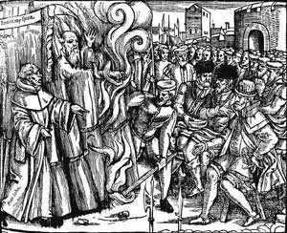

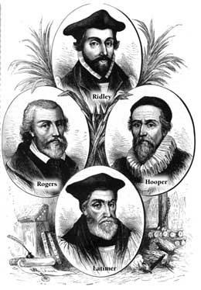

All burnt in 1555

|  |  |
| --- | --- |
| **1553** | **August** – Proclamation that Mary ‘mindeth not to compel any of her said subjects thereunto until such time as further order by common assent may be taken therein”  Nevertheless many prominent Protestant clergy deprived of their livings.  **September –** A**rchbishop Cranmer arrested.**  Hugh Latimer, John Hooper, Nichol Ridley, John Rogers and others imprisoned.  **Autumn** – Parliament met and refused to repeal the Act of Supremacy.  Parliament did pass an Act of Repeal which undid all the Edwardian Reformation & revived the Mass, ritual worship and clerical celibacy. This restored the Church to what it had been in 1547 under the Act of Six Articles.  **December** – Mary gave up the title of the Supreme Head of the Church |
| **1554** | **Jan** – Mass exodus of Protestants to Germany and Switzerland (approx 800)  **March –** Royal Injunctions issued ordering bishops to suppress heresy, remove married clergy, re-ordain clergy who had been ordained under the English Ordinal, restore Holy Days, processions and ceremonies. Bishop Gardiner began to deprive married priests of their livings. In the diocese of Norwich 243 priests lost their posts, 90 in Bath and Wells. Eventually 10 – 25% of clergy were deprived for having married, although some were reinstated when they put their wives aside.  Gardiner also replaced the Protestant bishops of Gloucester, Hereford, Lincoln and Rochester with committed Catholics.  **A**pril – **Parliament** initially rejected the reintroduction of heresy laws, but agreed when promised that former monastic land would not be restored to the Church.  **November** - Cardinal Pole returned to England; the sentence of excommunication was lifted from England. Parliament passed the Second Act of Repeal, which undid all anti-papal legislation since 1529 and the beginning of Henry’s Reformation. |
| **1555** | **January –** Mary appointed a commission to consider refounding some religious houses.  **February -** John Rogers, a biblical translator, became the first Protestant martyr when he was burnt under the restored heresy laws.  **October -** Bishops Hooper Latimer and Ridley are among those burnt for heresy.  **November** – Cranmer deprived of see of Canterbury and replaced by Reginald Pole. |
| **1556** | **January and February –** London Synod met under Pole and issued Twelve Decrees on clerical discipline against abuses such as absenteeism, pluralism, simony and heresy. Refounding of Benedictine House at Westminster and many more Protestants burnt.  **March -** Cranmer recanted all retractions and was burnt in Oxford (plunging his hand into the fire to punish it for having signed false retractions).  Cardinal Pole argued with Pope Paul IV and was deprived of his position as papal legate. Mary gets him consecrated as new Archbishop of Canterbury anyway. |
| **1557** | Refounding of some small religious houses.  **June –** Pole was recalled to Rome to answer charges of heresy. Mary refused permission for him to go and rejected his replacement as legate. |
| **1558** | **November** – Five Protestants burnt in Canterbury. About 285 people had been executed since 1555 – more than had been executed in France and Spain together in any comparable period.  Mary died 17th November as coincidentally did Reginald Pole (later the same day)  Her half sister, Elizabeth, succeeded to the throne. |

Mary had been brave enough to resist enormous pressure from her half brother Edward to abandon the Catholic Mass and she assumed that the tidal wave of support that brought her into power was partly an endorsement of her religious faith so it was always a certainty that she would try to return England to Catholic ways.

If she tried to return to the pre-Reformation situation entirely, this would be hard to do when there was little money and much of the church property had been bought and gave many a vested interest in keeping it. .

Unfortunately Mary was so convinced that restoring England to Catholicism was right that she was not prepared to compromise and her reputation was tarnished permanently by the number of Protestants that were burnt for heresy in her brief reign

.

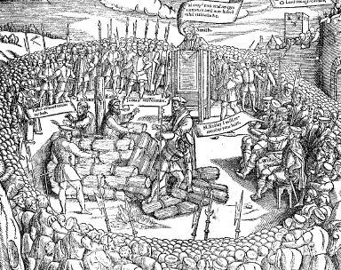

The execution of Bishops Latimer and Ridley in 1555 from John Foxe’s *Book of Martyrs*

**Factors that would hinder a Catholic restoration**

1. The nobility & gentry who had bought **monastic & chantry lands** were determined to keep them.
2. **Bishops**, who would normally be the driving force behind reform, were all Protestant at the beginning. Later in the reign (after several had been burnt) there were some lengthy vacancies, especially from 1557 when Pope Paul IV refused to confirm Marian appointments owing to sour relations with her Archbishop Pole. Six sees (bishoprics) were vacant for most of Mary’s reign.
3. 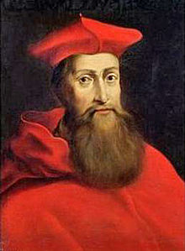Initially her Archbishop of Canterbury (leading bishop in England) was Thomas **Cranmer**, an ardent reformer. Cranmer was arrested in September 1553 but not replaced until over 2 years later in November 1555.
4. Mary’s choice to replace him was Reginald **Pole** (right), who was unfamiliar with England having been in exile since Henry’s reign b/c of his refusal to accept the royal supremacy. Pole did not return to England as papal legate (the Pope’s representative) until November 1554, over a year after Mary became Queen, & could not take over as Archbishop of Canterbury until November 1555. He was further hindered by the hostility of the anti-Spanish Pope Paul IV, who sacked him as papal legate in March 1556.
5. Mary made Pole not only Archbishop but also a government advisor and he could not give the Church his full attention owing to his responsibility for seeking peace between the Habsburgs and the French.
6. 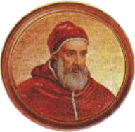Pope Julius III had been a friend of Pole’s but he was replaced by **Pope Paul IV** (below) who was fiercely hostile to the Habsburgs and therefore Philip Habsburg’s wife, Mary and her archbishop Pole and demanded he come to Rome to answer charges of heresy (Mary protected him and would not let him go).
7. Pole’s scheme to overhaul church finance required two huge surveys – pensions to former monks and clergy and poor benefices – and it proved slow and complicated.
8. Princess Elizabeth provided a focus for Protestant discontent.
9. The Marian government failed to realise the potential for propaganda. Critical publications outnumbered works that supported Mary two to one.
10. Propaganda opportunities were not seized – for instance nothing was made of debates between leading Protestants and Catholics in Oxford (1554) or recantations by people such as Sir John Cheke, and they assumed burning would deal with heresy. In fact that gave a propaganda tool – and martyrs for the Protestant cause.

**Nothing daunted Mary began to make England officially Catholic almost as soon as she took the throne.**

**Task 6**

**Source A August 16th 1553 Proclamation by Mary**

Her Majesty will observe the Catholic religion she has professed all her life and desires that all her subjects would quietly follow suit. However she will not compel any to this until further decisions are made. She commands her subjects to live together in Christian charity, avoiding the new and devilish terms of papist and heretic, and trying to live peaceful Christian lives. Any man who stirs up the people to disorder will be severely punished. Printers have published books and ballads written in English which discuss controversial religious teaching. Let nobody do so in future without the Queen’s express permission.

1. What does this source show us about Mary’s religious opinions?
2. According to the source what appears to be Mary’s major concern? Why might this be the case?
3. What does this suggest were her intentions for religion in England under her rule?

She was welcomed with great enthusiasm. Bells were rung and Parliament opened with a sung mass, even though it was still officially illegal. At Oxford chalices reappeared and on 23rd August an altar and cross were set up at St. Nicholas Cole Abbey in London where a mass was said and this practice was followed by six other churches in the capital the next day. In contrast to Lady Jane Grey’s procession to be crowned large numbers turned out for Mary’s coronation, suggesting that her rule was welcome.

Her initial welcome may have suggested that restoring England to Catholicism would be easy, but there were some serious obstacles to be overcome. These problems were recognised by her advisers. Gardiner (who had written “On True Obedience” in the 1530s defending the royal supremacy) was uncertain about restoring papal authority and the Imperial ambassador, Simon Renard, expressed concern about trying to restore former monastic property.

**Task 7**

**Source B A Yorkshire priest, Robert Parkyn in his book *Narrative of the Reformation***

In August Queen Mary issued a proclamation licensing priests to say mass in Latin after the ancient custom used in her father’s day. Then the holy Church began to rejoice, singing praise to God with heart and tongue. But many heretics did not rejoice at all. It was a joy to hear and see those sinful priests who had lived their lives immorally with their whores look so dismayed. They were commanded to forsake their mistresses and do open penance according to canon law, which then took effect.

1. What does the source tell us about what Robert Parkyn thought about the religious changes under Mary: What evidence is there in the source to support your view?
2. What are the limitations of Parkyn’s view about religious developments?
3. What are the strengths of Parkyn’s view about religious developments?

Parliament met in October 1553 but refused to repeal the Act of Supremacy, suggesting that there was some genuine anti-papal feeling. However it did pass an Act of Repeal which undid the changes made under Edward and restored the religious situation to that of 1547 under the Act of Six Articles. By the end of the year Mary had also given up her title as Supreme Head of the Church.

When Mary used the royal prerogative to suspend the Second Act of Uniformity and restore the Mass there was no serious opposition. Signs of disaffection do not necessarily suggest great hostility to her reforms. Wyatt’s rebellion took place before Mary had carried out any significant religious changes and before any real persecution of Protestants so this probably is **due to noble self-interest and anti-Spanish feeling rather than Protestant sentiment. However, there was some disquiet at her changes.**

**Task 8**

**Source C - A royal messenger, cousin of the former Lord Chancellor Lord Wriothesley records an eye witness account of events in London.**

On Sunday, a villainous event took place in Cheapside. A dead cat was hanged on the post of gallows, dressed in cloth like the vestment of a priest at mass with crosses front and back. Its head was shaved, a bottle was nearby and between its front paws was a piece of paper like a consecrated wafer. It was taken to Bishop Bonner of London who showed it to the audience attending the sermon at St. Paul’s Cross. The Lord Mayor offered a reward to anyone naming the culprit. Inquiries were made and several personas were imprisoned under suspicion.

**Source D** – A committed Protestant, Rose Hickman, the wife of a wealthy merchant, recalls her experiences early in Mary’s reign, writing in old age under Elizabeth I in her book *Memoir of Protestant Life under Mary I* 1610

When Queen Mary came to the crown, the idolatrous mass was established and cruel persecution began of good Christians who refused to accept popery. We sheltered many in our house in London. My husband smuggled some of these good Christians overseas, helping them with money. When it was proclaimed that everyone should receive the popish sacrament, I went to the bishops who were imprisoned in Oxford and later martyred, to ask whether my child should be baptised by the popish ritual. They said that he could, but advised me rather to go overseas. Afterwards I left for Antwerp.

1. Compare sources C and D as evidence for religious opposition in the reign of Mary I.
2. Why is it so difficult to establish the extent of support Protestantism during this period?

During 1554 about 800 committed Protestant left England and went into exile. However, this was not really an option for the less well-off. Royal Injunctions introduced in the spring of 1554 restored Catholic practices such as Holy Days, processions and ceremonies and led to large numbers of married clergy being sacked unless they abandoned their wives. The Protestant bishops were also removed from their positions. These actions did not provoke much opposition, but when Mary tried to restore the heresy laws Parliament did not agree until promises were made that former monastic lands would not be restored to the Church. While some historians use this as evidence that there was opposition to the changes, it is probably safer to say it was opposition to the threat of losing the land that had been acquired since the dissolution of the monasteries.

**Reform**

* Mary and her new Archbishop Pole realised the need to reform the Church to deprive Prots. of ammunition with which to attack it. So, Pole ordered the bishops to inspect their dioceses regularly & the London Synod of 1555 drew up **Twelve Decrees** which sought to eradicate abuses such as absenteeism or priests getting jobs through nepotism rather than ability.
* Pole commissioned new publications to help the clergy, a newly edited Catholic translation of the **New Testament** into English and a **Book of Homilies** (short sermons), replacing Cranmer’s Protestant version.
* Most importantly Pole saw that it was vital to **educate** the Catholic clergy and when the bishops visited their clergy he wanted them to check up on how well educated they were. He wanted **seminaries** to be established to train priests and cathedral schools were founded or reformed at Durham, Lincoln, Wells and York. On the death of Gardiner in 1556 Pole replaced him as Chancellor of Cambridge University, shortly afterwards followed also by becoming chancellor of Oxford, and this provided a link between the government and the universities. Pole also helped found two new colleges, at Cambridge and Oxford.

**Censorship**

The trouble with these policies was that they would inevitably take **time** to have an impact, and time was not something Mary had. Not that she knew that, of course, but she did know she was impatient for transforming the country back and so she used other harsher methods also such as censorship.

* Two of her earliest proclamations forbade the printing of seditious rumours (28 July 1553) and the ‘printing of false fond books, ballads, rhymes and other lewd treatises… concerning doctrine in matters now in question’ (18th August 1553).
* There was an index of proscribed writers (just as they had in Spain).
* Towards the end of her reign it was declared that the possession of treasonable books would result in the death penalty. They were getting increasingly draconian because they were not succeeding in stamping out the flood of Protestant literature that was managing to circulate despite these laws and proclamations.

**Burnings**

In December 1554 the **heresy laws** were restored; this meant that Protestants could now be burnt for heresy.

They began in February 1555 when John Rogers, a biblical translator, was the first to be burnt. By the time Mary had died in 1558, **285** Protestants had been burnt. Most burnings were in the south-east, London, Canterbury and Colchester. It is largely the work of John **Foxe** in his *Acts and Monuments,* more commonly known as the ***Book of Martyrs*** which has coloured subsequent understanding of the Marian burnings. Foxe was a Protestant who went into exile under Mary and returned when Elizabeth ascended the throne. His book became a best seller, in fact for 300 years after it was written the second most read book in England after the Bible, and Elizabeth ordered a copy placed in every church. It was his writing that suggested there was considerable opposition to Mary’s reforms – but given his background and when he was writing what do you think might have been his purpose in writing this book? **It is also important to remember that it was not published until after Mary’s death so it had no impact during her lifetime.**

**Some facts and figures**

* 285 people were burned to death in 46 months.
* Five were bishops.
* 51 were women.
* Alice Downs a 60 year old widow, was burned with 5 other people outside Colchester on 2 August 1557.
* The burnings were mainly in the South-East, nearly half of them in London, Canterbury and Colchester.
* Many of them were young and of lower orders (richer Protestants tended to escape to Europe).
* 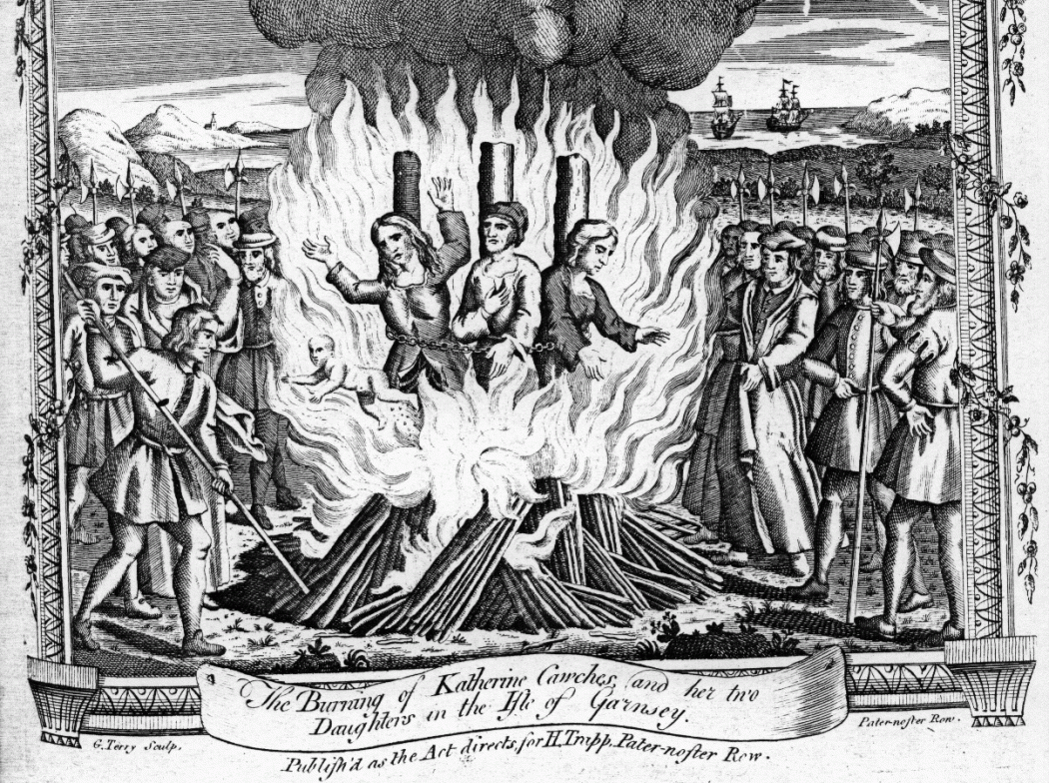In the 16th century thousands of people were killed throughout Europe in the name of faith.

**Task 9**

**Source D – Simon Renard (the Imperial ambassador) wrote to King Philip who was abroad in February 1555.**

The people of London are murmuring about the cruel enforcement of the recent Acts of Parliament against heresy, which has now begun, as shown publicly when a certain Rogers was burnt yesterday. Some of the onlookers wept; others prayed to God to give them strength and patience to bear the pain and not convert back to Catholicism. The haste with which the bishops have proceeded in this matter may well cause a revolt. If the people got the upper hand, not only would the cause of religion be again threatened, but the persons of your Majesty and the Queen might be in peril.

**Source E – A Protestant clergyman writing in the reign of Elizabeth I gives an account of the execution of Dr. Rowland Taylor, vicar of Hadleigh in Suffolk. The execution took place in February 1555.**

Taylor was brought to Hadleigh bridge, where a poor man with five children stood They held up their hands, and he said, “Oh dear father and good shepherd, Dr. Taylor, God help you, just as you have often helped me and my poor children!” The streets were full on both sides with men and women of the town and country who waited to see and bless him. When they saw his reverend and ancient face, with a long white beard, they wept and cried out “God save you, good Dr Taylor!”

John Foxe *Acts and Monuments* first published 1563 and commonly referred to as *Foxe’s book of martyrs*

**Source F – The burning of the bishops Latimer and Ridley**

Upon the north side of the town, in the ditch against Balliol College the place of execution was appointed... Then Dr Smith... began his sermon to them upon this text of St. Paul, ‘If I yield my body to the fire to be burnt, and have not charity, I shall gain nothing thereby’... He cried to the people to beware of them, for they were heretics and died out of the church. And ... he declared their diversity in opinions as Lutherans, Zwinglians, of which sect they were he said, and that was the worst... He ended with a very short exhortation to them to recant, and come home again to the church, and save their lives and souls, which else were condemned... They brought a faggot, kindled with fire and laid the same down at Dr Ridley’s feel. To whom master Latimer spoke in this manner: ‘Be of good comfort, master Ridley, and play the man. We shall this day light such a candle, by God’s grace, in England, as I trust shall never be put out’.

John Foxe *Acts and Monuments* first published 1563 and commonly referred to as *Foxe’s book of martyrs*

1. Study Sources D to F and explain what we learn from sources about those persecuted and the reaction to these burnings.
2. What language does Foxe use to win sympathy from his readers?
3. Foxe was an exiled Protestant, highly critical of Mary. Historian R Tittler says, “Foxe’s detailed and carefully compiled account of nearly all the executions still evokes strong images and heightened emotions. It cannot be insignificant that the work enjoyed at least five editions in its first quarter century” but bear in mind when it was written.

Explain why Foxe’s writing is useful to historians and why it has also made the job of an objective judgement on Mary more difficult.

1. What do Latimer’s words in Source F suggest might be the effect of the burning? How is this supported by Renard in Source D?

**Task 10**

Examine the decisions Mary used for her restoration and evaluate their impact. Use The Early Tudors pages 191 – 196 and the notes in this booklet on pages 17 – 18 and 21-22

**Restoring Catholicism – How successful were the following actions?**

|  |  |  |
| --- | --- | --- |
| **Decision** | **Evidence** | **How successful?** |
| **Appointment of Cardinal Pole**  *Booklet p21* |  |  |
| **Catholic Propaganda** pamphlets and books –  *Textbook p305* |  |  |
| **Censoring Protestant literature**  *Textbook p305* |  |  |
| **Improving standards of clerical education**  *Booklet pp25, 37* |  |  |
| **Reinstating celibacy and getting rid of priests’ wives.**  *Booklet pp19,23* |  |  |
| **Replacing Edward’s bishops**  *Booklet p20*  *Textbook p310* |  |  |
| **Monasteries = revival of small houses**  *Booklet pp19,39* |  |  |
| **Financial constraints on restoration**  *Textbook p310* |  |  |
| **The Burnings** |  |  |
| **What kind of people and where?**  *Textbook p310* |  |  |
| **Were there signs that it was working?**  *Textbook p308* |  |  |

**Task 11 Secondary evidence for you to consider**

Look at contrasting evidence from two documentaries. One says Mary is one of the most evil women in history. The following one with David Starkey is more sympathetic

. [**https://www.youtube.com/watch?v=JggAIlVVBzA**](https://www.youtube.com/watch?v=JggAIlVVBzA)

1. What did the mass mean to Mary?
2. What did Mary feel about Anne Boleyn?
3. What was the impact of the constant psychological strain?
4. What did Mary always fear?
5. How did the country celebrate Edward’s birth?
6. What kind of Protestant was Edward?
7. What sparked Mary’s conspicuous disobedience to her brother?
8. What turned Mary into a pale bitter woman?
9. Who supported Mary’s stand on Catholicism?
10. What made the people want Mary?
11. Why didn’t she mention religion?
12. What was her plan when she seized power?
13. Why was Philip crestfallen at marrying Mary?
14. What is the result of Wyatt’s rebellion?
15. What did Mary intend to do to the Church of England?
16. What did Mary define heresy as?
17. Why did she reintroduce burning at the stake?
18. Who got burnt?
19. Why do the historians think that she has phantom pregnancies?
20. Who does she blame for the breakup of her parents’ marriage? What crimes did Mary think him guilty of?
21. Why do Catholics think that her punishment of him was “bad form”?
22. How many people got burnt altogether? How did this compare with the Spanish inquisition?
23. Why did this make Protestantism more credible?
24. What must she have felt about her legacy when she died?

<http://estream.godalming.ac.uk/View.aspx?ID=689~3K~VJNDwF>

1hour 30 mins

1. What did Mary first do on becoming Queen?
2. What was the first act she passed?
3. Why did the people of England worry about her marrying a Spanish king?
4. How did Mary deal with the approach of Wyatt?
5. What did she do with Elizabeth?
6. What did Mary think of her new husband?
7. How long had England been separated from Rome?
8. Why had monasteries been destroyed?

**ADVERTS 1 hr 41.12 – 1 hr 44.53**

1. What happened to the baby she expected in 1555?
2. What did Philip do?
3. How did Mary decide to treat stubborn Protestants?
4. Who recorded the stories of the burnings?
5. Why was Mary so committed to burning heretics?
6. Why should Cranmer have escaped burning?
7. How did Cranmer’s death damage Mary more than his life?
8. Why wouldn’t Mary acknowledge Elizabeth as her heir?
9. What happened for the third year in a row in 1558?
10. What was her final humiliation?
11. When did Mary die?
12. How was she cheated in death?

**SOURCE QUESTION**

**Source G:** A Yorkshire priest and firm supporter of Roman Catholicism notes the restoration of Catholic services in 1553-54

From August 1553 in many places in Yorkshire, priests were very glad to say mass in Latin according to the fervent zeal and love they had unto God and his laws. Holy bread and water was given altars were rebuilt, pictures and images set up once more. The English service was voluntarily laid aside and the Latin taken up again and all without compulsion of any Act or law, but merely on the wish of Queen Mary. And all the old ceremonies were used regularly, once the Lord Cardinal Pole arrived in this realm in November 1554.

Robert Parkyn *Narrative of the Reformation, 1532-54*

**Source J The Spanish ambassadors in England report to Emperor Charles V on the controversial subject of the ownership of former church lands by lay people 8 August 1554**

We decided that we should write to your Majesty that Cardinal Pole had better be persuaded to be patient for a little longer until we see how matters are going to turn out here. Above all, before coming to England, he must clear up the business of the position of the holders of church property. The present possessors must be reassured that they will not have to hand back these lands, otherwise we shall never achieve the desired result. Unless he takes this advice he will run great risks himself and make the whole religious question much more difficult.

Study the three sources and then answer **both** questions.

**1** Use your knowledge of the stability of the monarchy from 1547 to 1558 to assess how useful Source G is as evidence of the degree of success achieved by Mary in restoring Catholicism. **[10]**

**2** Using these three sources in their historical context, assess how far they support the view that England was a strongly Catholic country by 1558. **[20]**

1. Think of the adjective about the restoration of Catholicism that might use after reading each source. Copy and complete the table below.

|  |  |
| --- | --- |
| **Source G** | For example, *pleased, welcoming, enthusiastic, eager, freely* |
| **Source H** |  |
| **Source J** |  |

1. Now think about what parts of the source support these adjectives and complete the table below.

|  |  |
| --- | --- |
| **Source G** | For example, *pleased to say mass in Latin …merely on the wish of Queen Mary*  *Welcominall the old ceremonies were used regularly, once the Lord Cardinal Pole arrived in this realm in November 1554.*  *enthusiastic as they did not wait for laws to be passed but voluntarily laid aside English services.*  *eager of “the fervent zeal and love they had unto God and his laws”, ,*  *freely because they did not need compulsion of any Act or law* |
| **Source H** |  |
| **Source J** |  |

1. Now think if there is any knowledge that you have after reading the chapter that might either support or challenge the view.

|  |  |  |  |
| --- | --- | --- | --- |
| **Source G** | Enthusiastic as they did not wait for laws to be passed but voluntarily laid aside English services | **Corroborated by** evidence that  bells greeted Mary’s accession, in London | **However**  There is also evidence that about 800 Protestants went into exile rather than stay underC atholic rule. |
| **Source H** |  |  |  |
| **Source J** |  |  |  |

1. Is there anything in the **provenance** that you need to take into account when assessing these pieces of evidence which give different views about support?

**Provenance chart**

|  |  |  |  |  |  |
| --- | --- | --- | --- | --- | --- |
| **Source** | **Purpose** | **Author** – are they in a position to know? | **Nature**  What is it? | **Date** | **Audience**  Who is designed to hear this news – what prejudice might they have? |
| **Source G** |  |  |  |  |  |
| **Source H** |  |  |  |  |  |
| **Source J** |  |  |  |  |  |

1. Which do you think is the most useful source here for understanding attitudes towards the restoration in the 1550s?
2. Using these three sources in their historical context assess how far they support the view that England was a Catholic country by the time of Mary’s death in 1558. (20)

(Do this on separate paper)

**TO WHAT EXTENT HAD MARY SUCCEEDED IN MAKING ENGLAND A CATHOLIC COUNTRY BY 1558?**

Successes

* In bringing back the Mass & Catholic doctrines like transubstantiation & clerical celibacy, Mary was returning to her father’s policy; in the history of religious policy 1529-58, it was the shortlived enforcement of Protestantism under E VI (from the first Act of Uniformity in 1549 until his death in 1553) which seems out of place. M therefore had a **strong base** on which to build.
* Robert Parkyn, a Cath. priest in Yorkshire, wrote, “from August 1553 in many places in **Yorkshire**, priests were very glad to say mass in Latin... Holy bread and water was given, altars were rebuilt, pictures and images set up once more. The English service was voluntarily laid aside and the Latin taken up again, and all **without compulsion**”.
* It is not true that M relied solely on persecution to restore Catholicism. Cardinal Pole, her Archbishop of Canterbury, had **constructive plans for reform**, such as a crackdown on clerical abuses like pluralism & non-residence, a Cath. translation of the New Testament, a Cath. Book of Homilies (short sermons) & a seminary (priests’ training college) in each diocese (the area controlled by a bishop). There is no reason to doubt that these policies would have been successful if they had been given more time.
* In any case the **burnings may not have been as unpopular as is often assumed**. It is true that the local authorities in London ordered the burnings to be held in the mornings to reduce the crowds, but this may have been due to to a fear of the general disorder which often attends such large gatherings (e.g. pickpocketing) rather than fear of demonstrations in support of the victims. Similarly orders sent out to JPs to urge them to prosecute heretics need to be seen in the context of similar orders to enforce legislation against vagrancy & other social problems. It needs to be remembered that JPs were local gentry who were unpaid & there was no police force so all govt. policy was difficult to enforce at local level. Christopher Haigh has concluded, “the persecution of Protestants was not a success; nor was it a disaster. If it did not help the Cath. cause, it did not do much harm”. There is certainly no evidence of people being converted to Prot. by witnessing the burnings.
* **Parliament** readily agreed to the restoration of the Mass in 1553.
* The restoration of the heresy laws in 1554 was only delayed b/c MPs feared that the monastic lands many of them had purchased would have to be given back. Once that issue was resolved, the heresy laws were passed & the burnings could begin.
* There is evidence from churchwardens’ accounts in different parts of the country (e.g. Stanford-in-the-Vale in Berkshire & Morebath in Devon) that **parishes** were quick to restore altars, images, mass vestments etc despite the considerable cost of doing so. The churchwarden of Stanford-in-the-Vale recorded his delight in “the old order being restored to its full glory” following “the time of schism when this realm was divided from the Catholic Church” in E VI’s reign.
* The fact that Mary emphasised the role of religion in an attempt to rally support against the Wyatt Rebellion while Wyatt himself wrote privately to his supporters, “you may not so much as name religion, for that will withdraw from us the hearts of many”, shows that **the Spanish marriage was much more unpopular than the restoration of Cath.** The Wyatt Rebellion cannot be taken as evidence of popular Prot. as the Western (“Prayer Book”) Rebellion can of popular Cath.
* On balance the evidence suggests that **M’s policies were succeeding** & ultimately failed, not b/c her policies were unpopular or poorly thought out but b/c she died too early & failed to leave a Cath. heir, enabling Elizabeth to restore Prot. The length of time it took Elizabeth to make England truly Prot. (the whole 45-year reign as far as Lancashire was concerned, according to Christopher Haigh) emphasises how much M achieved in such a short time.

Failures

* Like the Prot. religious changes in E’s reign, M’s policies (especially Pole’s plans for long term reform) did not have enough **time** to make an impact before they were reversed.
* The determining factor in the English Reformation was **obedience** (based on a combination of loyalty & fear) to the monarch. M’s success in claiming the throne owed more to the fact that she was the legitimate heir than to her religion. England avoided the religious conflict which broke out in France or Germany b/c most people put obedience to the monarch first. This meant that most people complied with the restoration of Cath. under M but did not resist the enforcement of Prot. under Elizabeth. **M therefore failed to make England strongly enough Cath. by 1558 to prevent Elizabeth restoring Prot.**
* Just as Prot. sources admitted the lack of progress of Prot. in E’s reign, Cath. sources in M’s show the survival of Prot. in **London & the South East**. A royal messenger reported the hanging of a cat dressed as a Cath. priest in London, while even Charles V’s ambassador admitted, “the people of London are murmuring about the cruel enforcement of the recent Acts of Parliament against heresy … The haste with which the bishops have proceeded in this matter may well cause a revolt”. A Cath. priest in Essex reported to his bishop that Prots. “not only absent themselves from church services, but daily they lure away many others who had outwardly conformed. They assemble together at the time of Sunday service, sometimes in one house, sometimes in another, where they hold their private conventicles (meetings) and schools of heresy … Priests are abused in the streets, the sacrament of the altar is blasphemed and criticised in every alehouse. Prayer and fasting are ignored”.
* M could restore the Mass, clerical celibacy, the papal supremacy etc but not the **monasteries or chantries** b/c the gentry who had bought their lands were determined to hold onto them.

**GLOSSARY**

|  |  |
| --- | --- |
| **WORD** | **EXPLANATION** |
|  |  |
|  |  |
|  |  |
|  |  |
|  |  |
|  |  |
|  |  |
|  |  |
|  |  |
|  |  |
|  |  |
|  |  |
|  |  |
|  |  |
|  |  |
|  |  |
|  |  |
|  |  |
|  |  |
|  |  |
|  |  |
|  |  |
|  |  |
|  |  |
|  |  |
|  |  |
|  |  |
|  |  |
|  |  |
|  |  |
|  |  |
|  |  |
|  |  |
|  |  |
|  |  |
|  |  |
|  |  |
|  |  |
|  |  |
|  |  |