**WATER AID (2016) – Media Language Analysis**

*Consider the product’s codes and conventions, and how media language influences meaning in the advert:*

|  |  |  |
| --- | --- | --- |
| **Camera angles, framing & movement** | **Denotation** | **Connotation & Roland Barthes’s Codes (semiotics)** |
| **Mise-en-scene** |  |  |
| **Editing** |  |  |
| **Sound (diegetic & non-diegetic)** |  |  |
| **Written Codes** |  |  |

Now watch the following two charity adverts*;* [*Barnardos – Believe in Me*](https://www.youtube.com/watch?v=XnIcd4uJHao)  (2015) and [*Save the Children – Tomorrow*](https://www.youtube.com/watch?v=rL7gZ9alh4o) (2015).

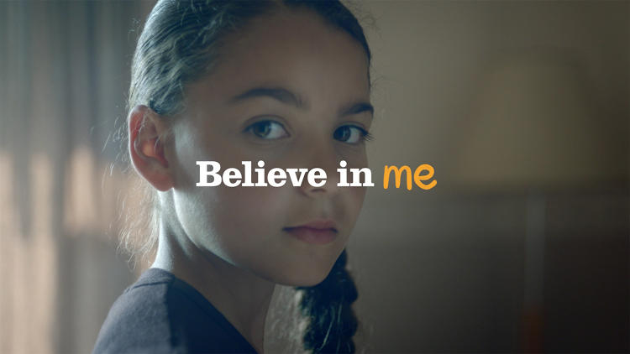 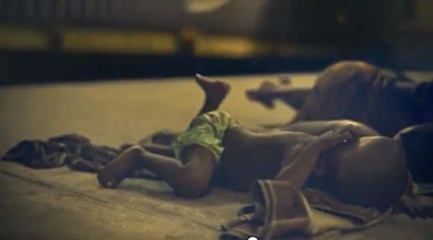

How do these adverts both use **media language**?

How are they similar to *Water Aid* in relation to their **generic** conventions? In what ways do they **subvert** the **generic** **expectations** of a charity ad?

Now apply **Bathes’** **semiotic** **codes** to both ads? How do the codes help **connote** ideas of the two causes?