**The Battle of Salamis, 480 BC**

TAken from [www.ancient.eu/salamis/](http://www.ancient.eu/salamis/)

THE TRIREME

Both sides had very similar ships - the triremes (*triērēis*) - which were 40-50 ton wooden warships up to 40 m long. Light, streamlined, and manoeuvrable, they were powered in battle by 170 oarsmen split in three ranks down each side of the ship. Able to rapidly accelerate, break, zigzag, and turn 360 degrees in just two ships’ lengths, good seamanship could place the vessel to best advantage and employ the principal strategy of naval **warfare** at that time which was to ram the enemy, making full use of the bronze ram fitted to the prow of the vessel. Triremes also carried a small complement of soldiers, at least 10 hoplites and four archers. The Persians generally carried more - 14 combatants and 30 Medes armed with bow, spear, and sword. These extra troops came into their own when at close quarters with the enemy and in the case of boarding an enemy vessel.

Triremes had a weakness in that they could only operate effectively in relatively calm seas with waves less than 1 m high; otherwise, water would enter via the oar-ports and flood the ship. Also, they had to stay close to shore as each night they needed to be beached if the light wood was not to become water-logged, significantly reducing the speed performance of the vessel. In addition, there was very little space on board for provisions and no room to sleep so the crews had no choice but to land each night. Prior to the battle the Greek ships were beached at several bays on the island of Salamis from Cynosoura to Paloukia. Here too were much of the evacuated populace of Athens and Attica. The Persians, meanwhile, were stationed at the Phaleron Bay, less than 10 km away across the Saronic Gulf and close to the captured **Piraeus**.

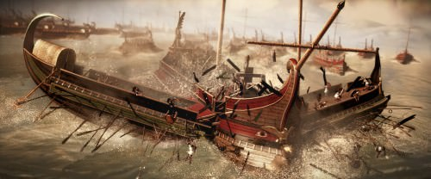

[Trireme Ramming](https://www.ancient.eu/image/1212/)

STRATEGIES

Commanders led from the front and each would have been on his own ship at the heart of the battle. From there, manoeuvres could be signalled to other ships in the fleet using flags and trumpets. However, once the battle got fully underway, naval conflicts became a case of a single ship against a single opponent rather than precisely coordinated manoeuvres.

Prior to full engagement between the opposing fleets, there were two principal strategies employed by the more able commanders. The first was sailing around the enemy line (*periplous*) and the second was smashing through gaps in the enemy line and attacking from their rear flank (*diekplous*). Both were designed to get one’s ship in a position to ram the weakest point of the enemy - the side or stern quarter. The objective was to puncture a hole in the enemy vessel or break a sufficient number of their oars to disable the ship. To avoid damaging one’s own oars, crews were drilled to withdraw them in a matter of seconds (usually on only one side of the ship whilst the other side maintained the momentum of the vessel). As a defence against these two tactics, an able commander would ensure one of his flanks was closed off by shallows or coastline and ensure his crews were sufficiently drilled to maintain close order. In open water the ships could be organised in a defensive circle or an arc (more practical with larger fleets) with prows pointing outwards (*kyklos*).

THE BATTLE

The actual details of the battle are sketchy and often contradictory between ancient sources. Nevertheless, presenting the most commonly agreed upon elements, the first action of the battle was the defection of two Ionian ships to the allied Greek fleet. Themistocles, perhaps sending messages to the pro-Persian Greek state fleets, had hoped for more such defections but no others occurred. One such ship from Tenos informed the Greeks that the Persians were amassing in the straits, blocking in the Greek fleet. The Persians had moved into position overnight, hoping to surprise the enemy, but this strategy was unlikely to be successful considering the short distances involved and the noise made by the rowers. There is also the possibility that Themistocles had sent messages to Xerxes intimating the fragile Greek alliance was breaking up and the fleet was about to retreat.

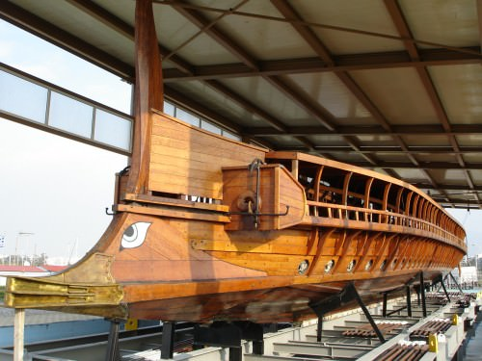

Trireme Hull with Bronze Ram

Probably, the two fleets aligned along an oblique east-west axis with the Persians close to the mainland shore with both fleets having a friendly shore behind them. Indeed, proximity to the opposite mainland shore would have been avoided by the Greek ships due to Xerxes’ positioning there of a contingent of his archers. On the western (right) wing the Phoenicians faced the Athenians and the Ionians against the Spartans. On the left flank of the Persians were the Carians and Dorians. Behind the main Greek line, the Aegina contingent and some of the Athenian ships waited in reserve. The Corinthians were stationed to the west of the battle lines protecting the passage to **Eleusis** whilst the pro-Persian Cyprians, Cilicians, and Hellespontines held back to the south, guarding the exit to Piraeus. According to Diodorus Siculus, Xerxes sent his Egyptian fleet to seal off the straits between Salamis and Megara and engage any Greek ships breaking off from the main fleet.

Overlooking from his command post in the early morning, Xerxes would have seen not a fleet about to retreat but the Greeks positioned two-ships deep along a 3 km long curve, perhaps presenting a line of 130 ships against the Persian main front of 150 ships, three ships deep. The Persians advanced, becoming more closely packed as they aligned themselves with the enemy’s narrower front. The Greeks held position, drawing the Persians into an ever tighter confine. Ships began to ram each other and in the tight space they would have struggled to disengage. Then the armed soldiers on board would have come into their own with hoplites and archers fighting on the decks much as in a land battle. With more Persian ships pressing in from the rear and the Corinthians joining from the side, there must have been a chaos of broken ships and drowning men - particularly amongst the Persians who had no shore to retreat to and most probably could not swim.

With more space to manoeuvre, the Greek ships were able to pick off the closely packed Persian vessels which could not retreat because their lines were now several ships deep. By the afternoon, Greek victory was assured and the remaining Persian ships retreated to **Asia Minor**. The final stage of the battle was the transferral of the Greek **hoplite** force on Salamis over to the mainland which then made short work of the Persian land forces.

Once again the cryptic oracle of **Apollo** at **Delphi** had been proved right: ‘only a wooden **wall** will keep you safe’. As at Artemision, the wooden ships of the combined Greek fleet had, for a second time, rebuffed the Persian advance.

THE AFTERMATH

Following defeat, Xerxes returned home to his palace at Sousa and left the gifted general Mardonius in charge of the invasion. The Persian position was still strong despite the defeat - they still controlled much of Greece and their large land army was intact. After a series of political negotiations, it became clear that the Persians would not gain victory on land through diplomacy and the two opposing armies met at **Plataea** in August 479 BCE. The Greeks, fielding the largest hoplite army ever seen, won the battle and finally ended Xerxes’ ambitions in Greece.

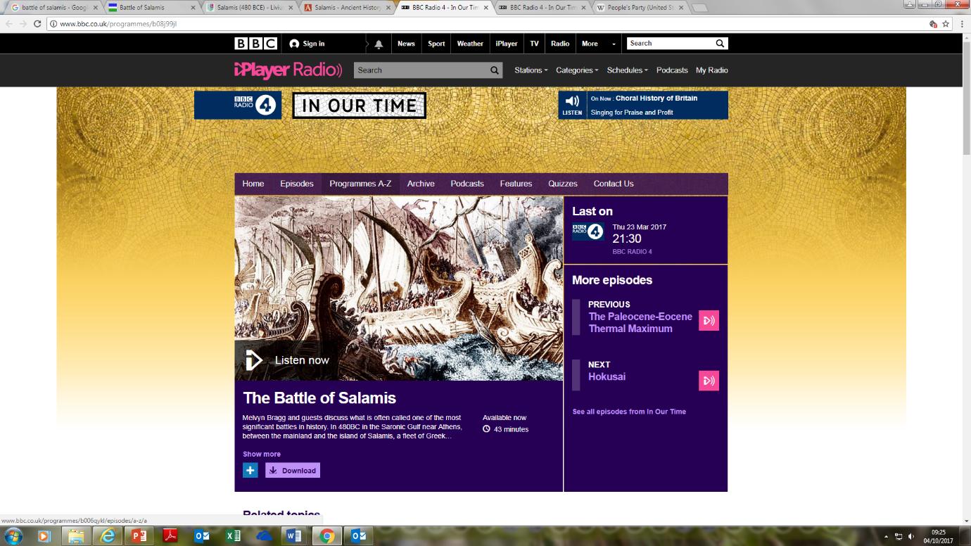

**EXTENSION ACTIVITY**

To gain a more detailed understanding of the Battle of Salamis and the historical debate surrounding its importance, listen to the Radio 4 *In Our Time* episode ‘The Battle of Salamis’.

This can be found at <http://www.bbc.co.uk/programmes/b08j99jl> or by searching ‘In our time, Salamis’.